# Lab 3: 09/21/23 - Anand Srinivasan & Malia Kuo

## Our first step was to try to create circuits that included each of the components (led light, button, switch, joystick) in a working manner

Step 1: Creating circuit to light led

* 5v → positive rail → resistor → led → negative rail → ground

Step 2: Creating circuit with switch to LED

* 5v → positive rail → resistor →switch → led → negative rail → ground

Step 3: Creating circuit with button to LED

* 5v → positive rail → resistor → button → led → negative rail → ground

Step 4: Creating circuit with button -> LED and switch to LED

* One side of breadboard:
  + 5v → positive rail → resistor → button → led → negative rail → ground
* Other side of breadboard:
  + 5v → positive rail → resistor →switch → led → negative rail → ground

Step 5: Creating circuit with joystick -> Led (using joystick as button)

* 5v → positive rail → resistor → 5v+ joystick, sv joystick → led → negative rail → ground

## Next steps (not reached in lab period):

* Connect circuit to GPIO to allow program to read input from different components (button, switch, joystick).

We eventually created a circuit to read input from the button, switch, and joystick (see picture below).

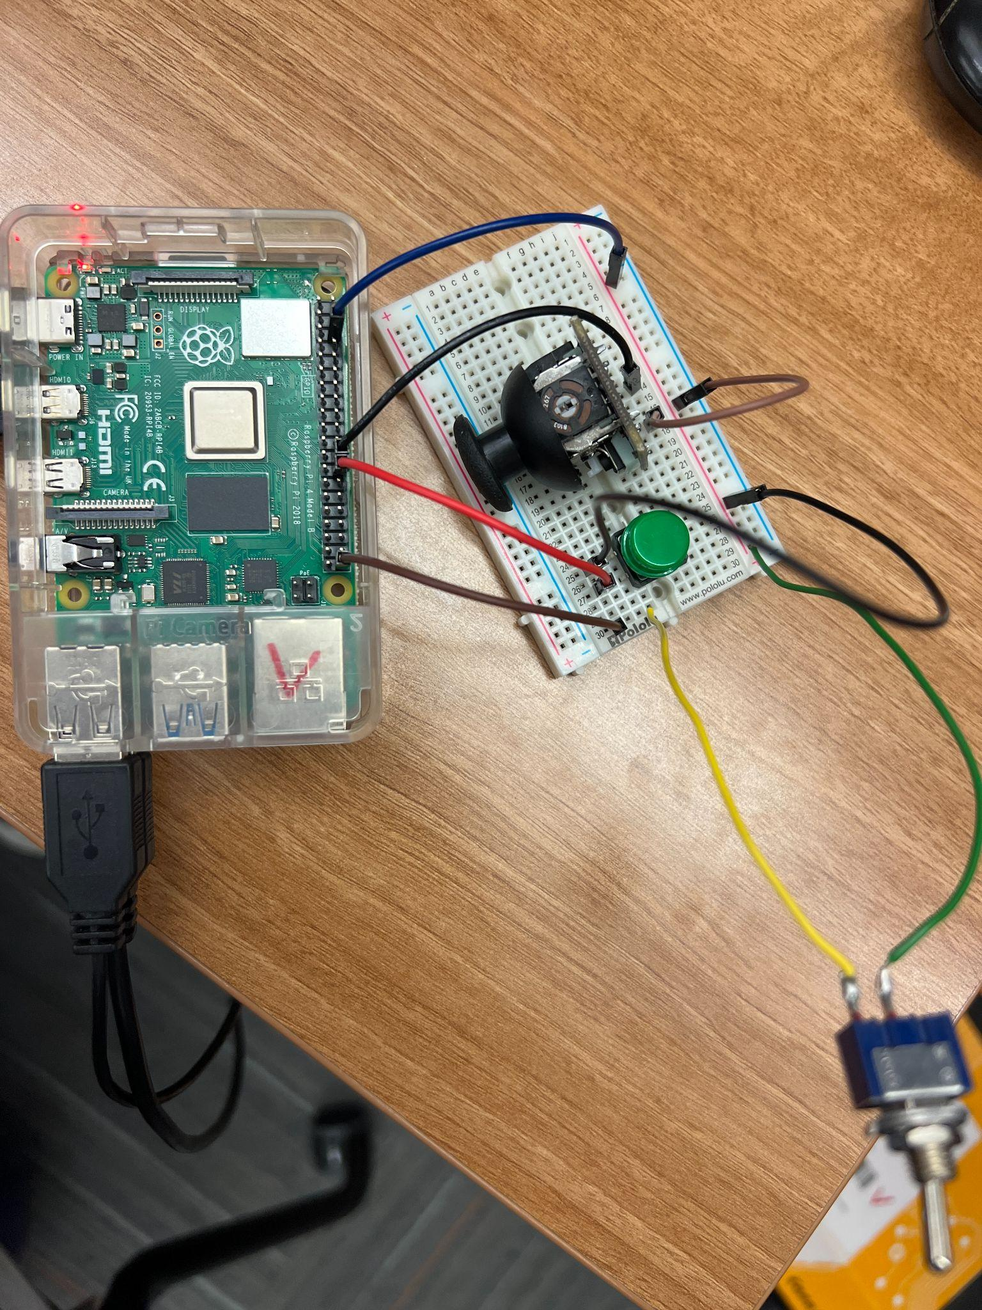

These webpages were a useful references: <https://www.raspberrypi.com/documentation/computers/raspberry-pi.html>

<https://projects.raspberrypi.org/en/projects/physical-computing/9>

**Python code** for reading in input:

from gpiozero import Button

switch = Button(21)

button = Button(7)

joystick = Button(8)

while True:

if (switch.is_pressed):

if (joystick.is_pressed):

if (button.is_pressed):

print("Mode 3")

else:

if (button.is_pressed):

print("Mode 1")

else:

if (button.is_pressed):

print("Mode 2")