E-Commerce Platform - Architecture Runbook
Document Version: 1.0
Last Updated: January 2025
Classification: Production Documentation
Target Audience: DevOps Engineers, Solution Architects, Security Teams

Table of Contents
- Executive Summary
- System Overview
- Architecture Components
- API Endpoints
- Data Architecture
- Security Architecture
- Deployment Guide
- Operational Procedures
- Monitoring and Logging
- Troubleshooting

Executive Summary
This document describes the architecture and operational procedures for our enterprise e-commerce platform. The system is built on AWS serverless technologies, providing a scalable and cost-effective solution for managing users, products, orders, and payment processing.

Key Metrics
- 11 API Endpoints across 4 business domains
- 11 Lambda Functions handling business logic
- 4 DynamoDB Tables for data persistence
- Serverless Architecture for automatic scaling
- REST API for client integration

Technology Stack
- Compute: AWS Lambda (Python 3.11)
- API Management: Amazon API Gateway
- Data Storage: Amazon DynamoDB
- Monitoring: Amazon CloudWatch
- Infrastructure: Terraform (Infrastructure as Code)

System Overview

Business Context
The e-commerce platform provides comprehensive functionality for online retail operations:
- Customer Management: User registration, profile management, and account operations
- Product Catalog: Product listing, search, and detail retrieval
- Order Processing: Order creation, tracking, and history management
- Payment Processing: Payment transaction handling and financial reporting

Architecture Principles
The platform is designed with the following principles:
- Serverless-First: Leveraging AWS Lambda for compute to minimize operational overhead
- API-Driven: RESTful API design for easy integration with web and mobile clients
- Scalable: Auto-scaling capabilities through serverless architecture
- Cost-Optimized: Pay-per-use pricing model with DynamoDB and Lambda
- Cloud-Native: Built specifically for AWS cloud infrastructure

Architecture Components

Architecture Diagram
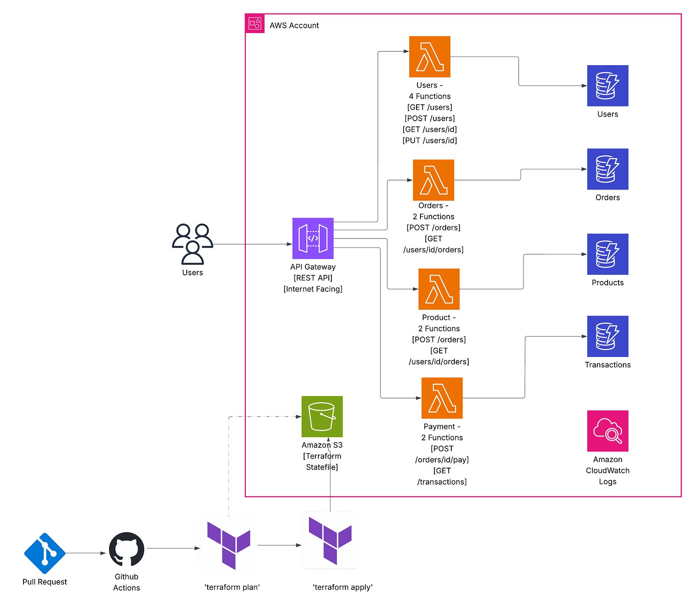

High-Level Architecture
Internet Clients
↓
API Gateway (REST API)
↓
Lambda Functions (11 functions)
↓
DynamoDB Tables (4 tables)
↓
CloudWatch Logs

Component Details

API Gateway
- Type: REST API
- Endpoints: 11 total endpoints
- Protocol: HTTPS
- Stage: Production deployment stage
- CORS: Enabled for cross-origin requests

Lambda Functions
- Runtime: Python 3.11
- Deployment: Single deployment package for all functions
- Execution Role: Shared IAM role across functions
- Timeout: Varies by function (15s - 180s)
- Memory: Varies by function (128MB - 3008MB)

DynamoDB Tables
- Billing: Mixed (Provisioned and Pay-per-request)
- Capacity: Configured per table based on expected load
- Indexes: Global Secondary Indexes for query optimization
- Backup: Standard AWS backup capabilities

CloudWatch
- Logs: Centralized logging for all Lambda functions
- Retention: Configured per function log group
- Metrics: Standard Lambda and DynamoDB metrics

API Endpoints

User Management Endpoints

List Users
- Method: GET
- Path: /users
- Function: list-users-function
- Description: Retrieves a list of all users with pagination support
- Query Parameters:
  - limit: Maximum number of results (default: 1000)
  - lastKey: Pagination token for next page

Get User
- Method: GET
- Path: /users/{userId}
- Function: get-user-function
- Description: Retrieves detailed information for a specific user
- Path Parameters:
  - userId: Unique user identifier

Create User
- Method: POST
- Path: /users
- Function: create-user-function
- Description: Creates a new user account
- Request Body:
- {
"name": "string",
"email": "string",
"status": "string"
}

Update User
- Method: PUT
- Path: /users/{userId}
- Function: update-user-function
- Description: Updates an existing user’s information
- Path Parameters:
  - userId: Unique user identifier
- Request Body: Partial user object with fields to update

Delete User
- Method: DELETE
- Path: /users/{userId}
- Function: delete-user-function
- Description: Removes a user from the system
- Path Parameters:
  - userId: Unique user identifier

Product Catalog Endpoints

List Products
- Method: GET
- Path: /products
- Function: list-products-function
- Description: Retrieves product catalog with optional filtering
- Query Parameters:
  - category: Filter by product category
  - limit: Maximum number of results (default: 500)

Get Product
- Method: GET
- Path: /products/{productId}
- Function: get-product-function
- Description: Retrieves detailed information for a specific product
- Path Parameters:
  - productId: Unique product identifier

Order Management Endpoints

Create Order
- Method: POST
- Path: /orders
- Function: create-order-function
- Description: Creates a new order for a user
- Request Body:
- {
"userId": "string",
"items": [
{
"productId": "string",
"quantity": number
}
]
}

Get User Orders
- Method: GET
- Path: /users/{userId}/orders
- Function: get-user-orders-function
- Description: Retrieves order history for a specific user
- Path Parameters:
  - userId: Unique user identifier
- Query Parameters:
  - status: Filter by order status

Payment Processing Endpoints

Process Payment
- Method: POST
- Path: /orders/{orderId}/payment
- Function: process-payment-function
- Description: Processes payment for an order
- Path Parameters:
  - orderId: Unique order identifier
- Request Body:
- {
"userId": "string",
"amount": number,
"paymentMethod": "string",
"cardNumber": "string",
"cvv": "string",
"expiryDate": "string"
}

Get Transactions
- Method: GET
- Path: /transactions
- Function: get-transactions-function
- Description: Retrieves financial transaction records
- Query Parameters:
  - userId: Filter by user
  - startDate: Filter by date range
  - endDate: Filter by date range
  - limit: Maximum number of results (default: 1000)

Data Architecture

DynamoDB Tables

Users Table
- Name: {environment}-users-table
- Billing Mode: Provisioned
- Read Capacity: 5 RCU
- Write Capacity: 5 WCU
- Primary Key: userId (String)
- Attributes: userId, name, email, status, createdAt
- Use Case: Stores user account information and profiles

Products Table
- Name: {environment}-products-table
- Billing Mode: Provisioned
- Read Capacity: 10 RCU
- Write Capacity: 2 WCU
- Primary Key: productId (String)
- Global Secondary Index: CategoryIndex
  - Hash Key: category
  - Read Capacity: 3 RCU
  - Write Capacity: 1 WCU
- Attributes: productId, name, category, price, stock, description
- Use Case: Product catalog and inventory management

Orders Table
- Name: {environment}-orders-table
- Billing Mode: Pay-per-request
- Primary Key:
  - Hash Key: orderId (String)
  - Range Key: userId (String)
- Global Secondary Index: UserOrdersIndex
  - Hash Key: userId
  - Range Key: orderStatus
- Attributes: orderId, userId, items, totalAmount, orderStatus, createdAt, updatedAt
- Use Case: Order tracking and management

Transactions Table
- Name: {environment}-transactions-table
- Billing Mode: Provisioned
- Read Capacity: 100 RCU
- Write Capacity: 50 WCU
- Primary Key:
  - Hash Key: transactionId (String)
  - Range Key: timestamp (String)
- Global Secondary Index: UserTransactionsIndex
  - Hash Key: userId
  - Range Key: timestamp
  - Read Capacity: 50 RCU
  - Write Capacity: 25 WCU
- Attributes: transactionId, orderId, userId, amount, paymentMethod, status, timestamp
- Use Case: Financial transaction records and reporting

Data Flow Patterns

User Registration Flow
- Client sends POST request to /users
- API Gateway routes to create-user-function
- Lambda generates unique userId
- User data written to Users table
- Response returned to client

Order Creation Flow
- Client sends POST request to /orders
- API Gateway routes to create-order-function
- Lambda validates user exists in Users table
- Lambda retrieves product details from Products table
- Lambda calculates order total
- Order record written to Orders table
- Response returned to client

Payment Processing Flow
- Client sends POST request to /orders/{orderId}/payment
- API Gateway routes to process-payment-function
- Lambda retrieves order from Orders table
- Lambda processes payment information
- Transaction record written to Transactions table
- Order status updated in Orders table
- Response returned to client

Security Architecture

IAM Configuration

Lambda Execution Role
- Role Name: {environment}-user-api-lambda-role
- Trusted Entity: lambda.amazonaws.com
- Attached Policies:
  - AWSLambdaBasicExecutionRole (AWS Managed)
  - Custom DynamoDB access policy
  - Custom CloudWatch logging policy

DynamoDB Access Policy
The Lambda functions have the following DynamoDB permissions: - dynamodb:GetItem - dynamodb:PutItem - dynamodb:UpdateItem - dynamodb:DeleteItem - dynamodb:Query - dynamodb:Scan
Resources: All four DynamoDB tables and their indexes

CloudWatch Logging Policy
Lambda functions can write logs to CloudWatch: - logs:CreateLogGroup - logs:CreateLogStream - logs:PutLogEvents

API Gateway Configuration

CORS Settings
- Allowed Origins: *
- Allowed Methods: GET, POST, PUT, DELETE, OPTIONS
- Allowed Headers: Content-Type, Authorization

Request/Response Configuration
- Content Type: application/json
- Integration Type: AWS_PROXY (Lambda Proxy Integration)
- Timeout: 29 seconds (API Gateway maximum)

Operational Procedures

Monitoring

CloudWatch Metrics
Monitor the following key metrics:
Lambda Functions: - Invocations - Duration - Errors - Throttles - Concurrent Executions
DynamoDB Tables: - ConsumedReadCapacityUnits - ConsumedWriteCapacityUnits - UserErrors - SystemErrors - ThrottledRequests
API Gateway: - Count (total requests) - 4XXError - 5XXError - Latency

Log Analysis
Lambda function logs are available in CloudWatch Logs:
# View logs for a specific function
aws logs tail /aws/lambda/prod-get-user-function --follow
# Search for errors
aws logs filter-log-events \
--log-group-name /aws/lambda/prod-process-payment-function \
--filter-pattern "ERROR"

Backup and Recovery

DynamoDB Backups
DynamoDB tables use AWS’s built-in backup capabilities:
# Create on-demand backup
aws dynamodb create-backup \
--table-name prod-users-table \
--backup-name users-backup-$(date +%Y%m%d)

Disaster Recovery
In case of data loss or corruption:
- Identify the affected table
- Restore from the most recent backup
- Verify data integrity
- Update application if necessary

Scaling Considerations

Lambda Scaling
- Lambda automatically scales based on incoming requests
- No manual intervention required for compute scaling

DynamoDB Scaling
- Provisioned Tables: Monitor capacity metrics and adjust RCU/WCU as needed
- Pay-per-request Tables: Automatically scales with demand

Resource Naming Convention
All resources follow this naming pattern:
{environment}-{resource-type}-{domain}
Examples: - prod-users-table - prod-get-user-function - /aws/lambda/prod-create-order-function

Terraform State Management
Terraform state is stored in S3: - Bucket: terraform-statefile-bucket-0503 - Key: security-agent-demo/terraform.tfstate - Region: us-east-1

Monitoring and Logging

CloudWatch Log Groups
Each Lambda function has a dedicated log group:
Function | Log Group | Retention
get-user | /aws/lambda/{env}-get-user-function | 60 days
create-user | /aws/lambda/{env}-create-user-function | 30 days
update-user | /aws/lambda/{env}-update-user-function | 14 days
delete-user | /aws/lambda/{env}-delete-user-function | 7 days
list-users | /aws/lambda/{env}-list-users-function | 90 days
list-products | /aws/lambda/{env}-list-products-function | 30 days
get-product | /aws/lambda/{env}-get-product-function | 14 days
create-order | /aws/lambda/{env}-create-order-function | 365 days
get-user-orders | /aws/lambda/{env}-get-user-orders-function | 60 days
process-payment | /aws/lambda/{env}-process-payment-function | 2555 days
get-transactions | /aws/lambda/{env}-get-transactions-function | 1 day

Log Format
Lambda functions log in JSON format for easy parsing:
{
"timestamp": "2025-01-14T10:30:00Z",
"level": "INFO",
"requestId": "abc-123-def",
"message": "Processing request for user lookup",
"userId": "user123"
}

Performance Monitoring
Key performance indicators to monitor:
- API Response Time: Target < 500ms for GET requests
- Lambda Duration: Monitor against configured timeout
- DynamoDB Latency: Target < 10ms for GetItem operations
- Error Rate: Target < 0.1% for all endpoints

Troubleshooting

Common Issues

DynamoDB Throttling
Symptoms: - ProvisionedThroughputExceededException errors in logs - Increased latency for database operations
Resolution: 1. Check CloudWatch metrics for consumed capacity 2. Increase provisioned capacity for affected table 3. Consider switching to pay-per-request billing mode

Lambda Timeout
Symptoms: - Task timed out after X seconds in logs - 504 Gateway Timeout responses from API
Resolution: 1. Review function logs to identify slow operations 2. Optimize database queries 3. Increase function timeout if necessary 4. Consider breaking complex operations into smaller functions

API Gateway Errors
Symptoms: - 4XX or 5XX errors from API endpoints - CORS-related errors in browser console
Resolution: 1. Verify request format matches API specification 2. Check Lambda function logs for detailed error messages 3. Verify CORS configuration if browser-based 4. Ensure API Gateway has permission to invoke Lambda

Health Checks
Perform regular health checks:
# Test all endpoints
curl $API_ENDPOINT/users
curl $API_ENDPOINT/products
curl $API_ENDPOINT/transactions
# Check Lambda function status
aws lambda get-function --function-name prod-get-user-function
# Check DynamoDB table status
aws dynamodb describe-table --table-name prod-users-table

Support Escalation
For issues that cannot be resolved:
- Gather relevant logs and metrics
- Document steps to reproduce
- Contact AWS Support with case details
- Escalate to development team if application-specific

Document Control
This architecture runbook provides comprehensive documentation for the e-commerce platform infrastructure and operations. Keep this document updated as the system evolves.

