$$ANN-session-3$$

$Neuron$

$How Neuron works$

$Layers$

$Input layers-hidden layers-output layers$

$Exepect input layers all other layers are having weights and bias$

$How to get total parameters$

$How to choose weights$

$what is the importance of activation$

$How to choose hidden layers$

$How to choose hidden layer neurons$

$How to speed up the process$

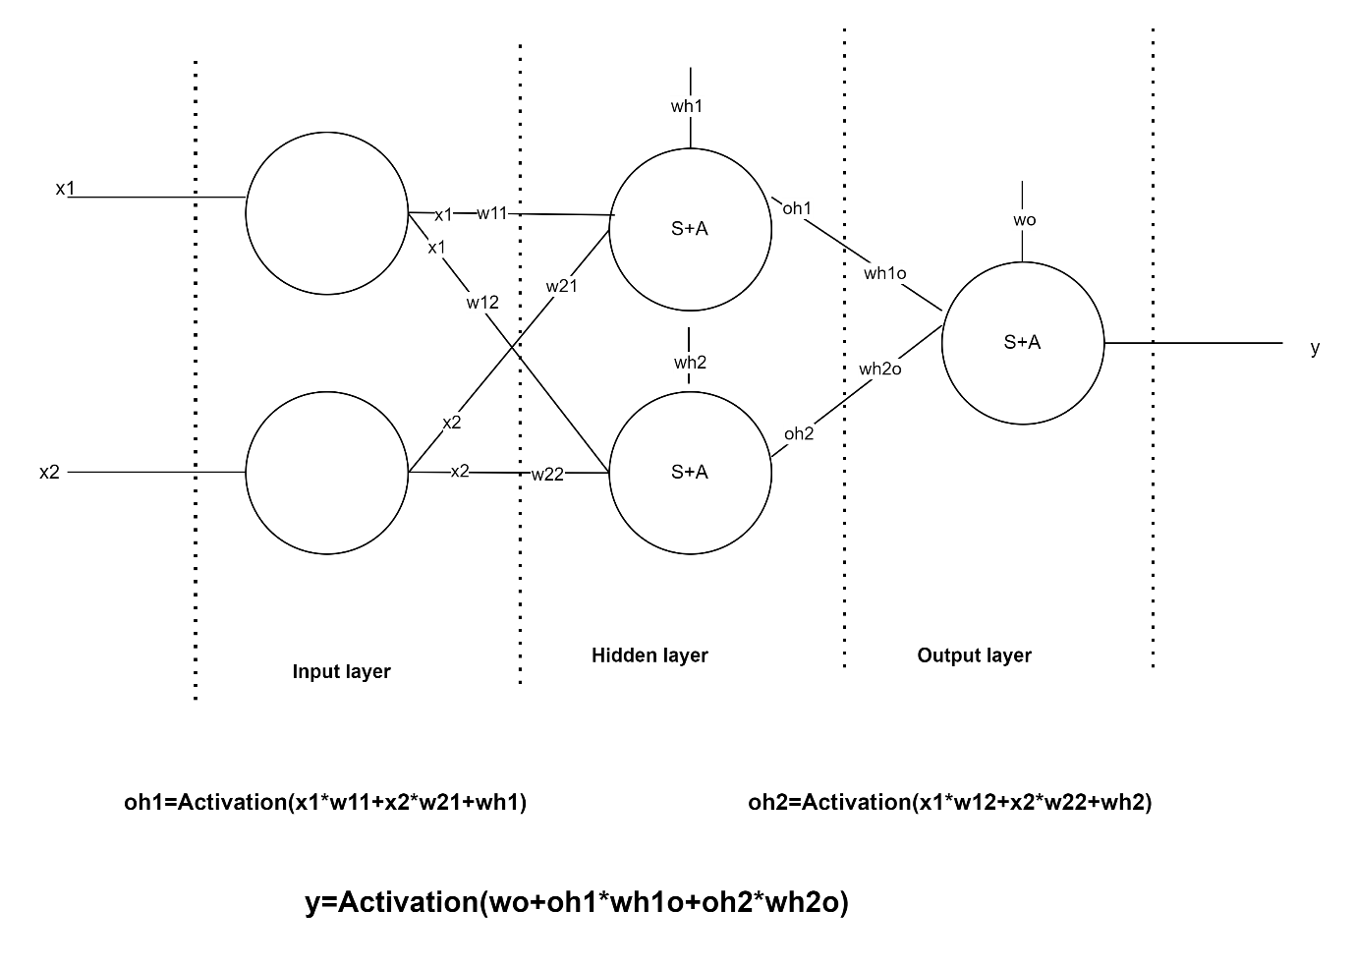

$$Artificial Neural Netowrk(ANN)$$

$Multi layer Perceptron\left(MLP\right): Input-Hidden-Output$

$Deep Neural Network\left( DNN\right):Input-h1-h2-h3-output$

$$Goal:$$

$$we need to reduce the cost function by providing suitable weights$$

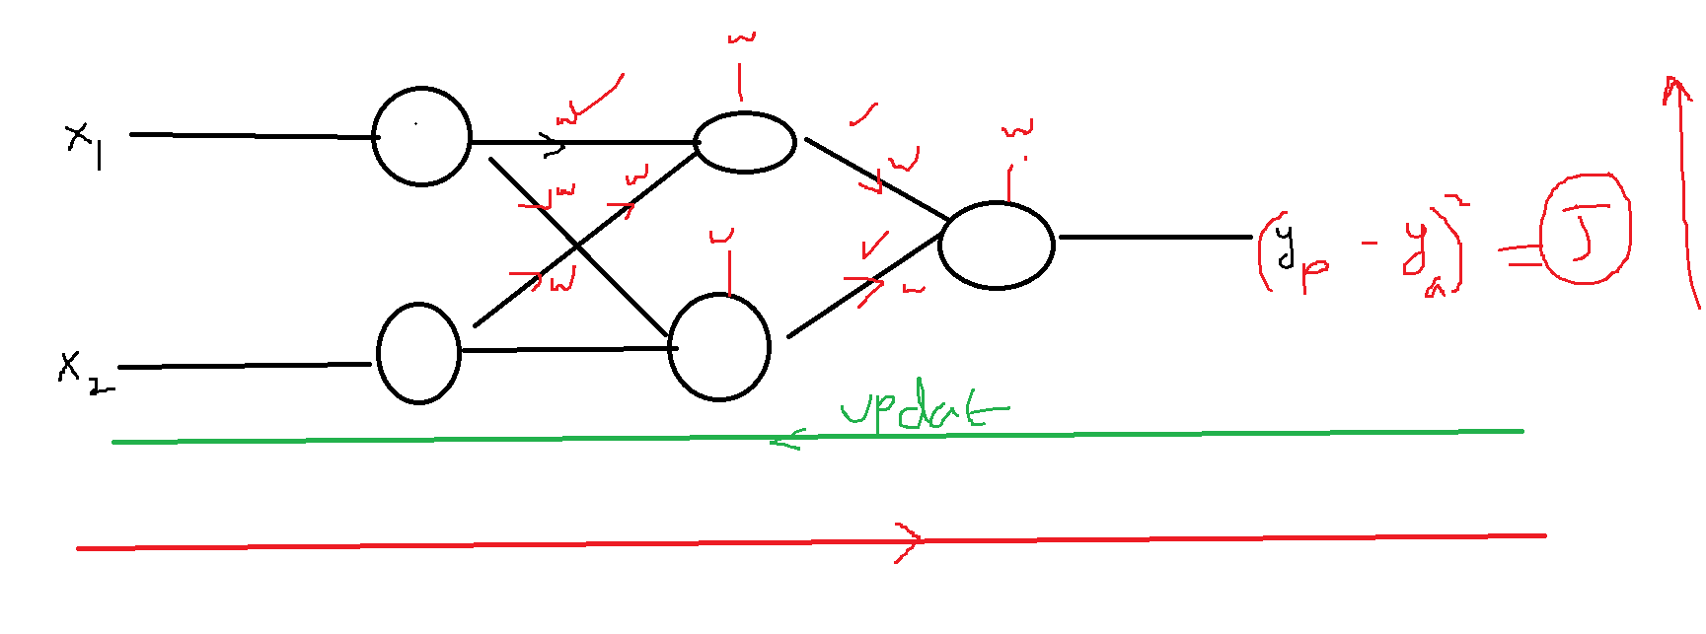

$Initially the weights and bias in each layer provided randomly$

$Inputs are pass through the each layers and multiply with weights$

$$it gives one output.$$

$This is called Forward prpogation.$

$This output will compare with actual value, and it calculates the error$

$due to randomly initialised Weights, the error will be high$

$The error high because of each layer weights and bias$

$This is called as Credit assignment$

$We need to go back and update the weights and bias of each layer$

$This is called as Back prpogation$

$This process will continue till the weights will remain same, the error will be setteled$

$$The weights will update in one iteration,$$

$$Iteration=Forward prpogation+Backward prpogation$$

$$Epoch=FP+BP$$

$$Epoch: Full data pass through the Neural Network weights, calculate the error$$

$and update the weights using back prpogation$

$$How to Update the weights:$$

$$Gradient Descent algorithm$$

$$Gradient descent algorithm is used to identify the minimum point of equation$$

$$Gradient=slope$$

$$descent=decreasing$$

$$slope decreasing means we are getting the minum point$$

$$Y=X^{2} minimum point$$

$$Step-1: we randomly assume x=4 is a minimum point$$

$$step-2: but at x=4 we are seeeing a slope :$$

$Y=X^{2}$

$$y^{'}=2*x$$

$$y^{'}=2*4=8$$

$$For the minimum point the slope equal to zero$$

$$x=4 is not a minimum point for x^{2}$$

$$step-3:Choose the new x$$

$x_{new}=x_{old}-\left(slope value\right) ( if slope is postive)$

$x_{new}=x_{old}+\left(slope value\right) (if slope is negative)$

$$x_{new}=x_{old}-\left(slope value\right)$$

$$x_{new}=4-8=-4$$

$$Step-4: we are performing here step-2 operation$$

$calculate the slope at new x value=-4$

$$y^{'}=2*x$$

$$y^{'}=2*-4=-8$$

$$For the minimum point the slope equal to zero$$

$$x=-4 is not a minimum point for x^{2}$$

$$Step-5: choose the new x we are performing step-3 operation$$

$$x_{new}=x_{old}-\left(slope value\right)=-4-\left(-8\right)=-4+8=4$$

$$In order to control this ocillation$$

$x_{new}=x_{old}-learningrate*\left(slope value\right)$

$$x_{new}=x_{old}-lr*\left(slope value\right)$$

$$x_{new}=4-0.2*8=4-1.6=2.4$$

$$W_{new}=W_{old}-α*{\left.\frac{∂J}{∂W}\right|}_{W=w_{old}}$$

$$α=learning rate: \left(0,1\right)$$

$$α=0 means no learning: weights will not update$$

$$α=1 means fast learning:weights are never setteled or never convergence$$

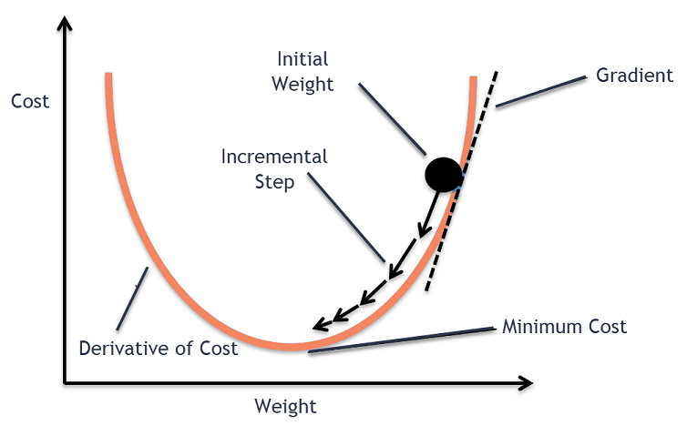

$To update the weights we are using gradient descent algorithm$

$Batch Gradient descent$

$we are passing all the data at a time through the Neural network$

$calculate the error$

$update the weights using GD through back prpogation$

$Auume that we have 10k observations are there$

$In order to update the weights we need to pass all 10k observations$

$Complexity increases ,$

$for one epoch means to pass all 10k observations$

$epoch means pass the all the data:$

$we are using updated weights for next iteration$

$$when we complete pass all the data$$

$Mini batch gradient secent$

$Divide the data into batches$

$10k observations divided into 10 batches, each batch has 1000 observations$

$will pass 1000 samples to the network, we calculate the output$

$we calculate the error, we update weights$

$we will use these updated weights for next 1k samples$

$here also one epoch means all 10batches should commplete$

$Stocastic Gradient descent:$

$$here will pass each observation and update the weights$$

$That weigh is used for next observation$

|  |  |  |
| --- | --- | --- |
|  | $$Complexity$$ | $$Convergence$$ |
| $$Batch$$ | $$High$$ | $$Good$$ |
| $$Mini batch$$ | $$Optimal$$ | $$Optimal$$ |
| $$Stochastic$$ | $$less$$ | $$Noisy$$ |

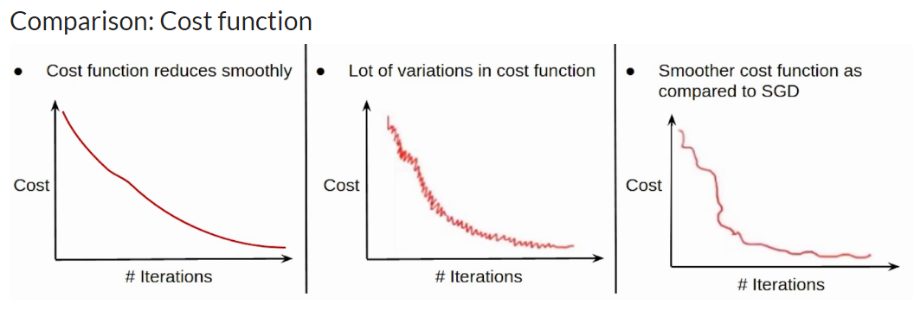

sir in batch how many epoch are there

epoch = complete one iteration

you need to complete all the data

10k ==== > 10 batches

1 epoch : 10

You choose 20 iteratios / 20 epochs

Epoch: 1 batchs 1/10 2/10 3/10 4/10 5/10 6/10 7/10 8/10 9/10 10/10

Epoch 2 1/10 2/10 3/10 10/10

Batch =10k= 1 epochMini batch == 10 splits == 1 epochsstochastic === 10k epochsI am right at this....?

1 epoch = complete all the data

Then what is the benefit of mini batch, if mini batch epoch is all data

1 epoch = complete all the data

How you are passing the data

Batch gradient :

1epoch = 1 batch

Mini batch : 10 batches

1 epoch= 10 batches

So for stochastic epoch will be there sir ?

10000 observations

One observation we are passing, we are updating the weights

The new weights is used by second observation

10 epochs

Epoch:1 1/10k 2/10k 3/10k 4/10k 10k/10k

Epoch2= 1/10k

10k/10k

epoch means complete flow of data through neural network..

how we are passing

batch means in how many parts we r divinding and passing the data.