**SUPERSET -ID: 6364597  
NAME: SRINJOY PAUL**

**WEEK -1 DESIGN PATTERNS AND PRINCIPLES   
HANDSON**

**Exercise 1: Implementing the Singleton Pattern:**

**CODE:-**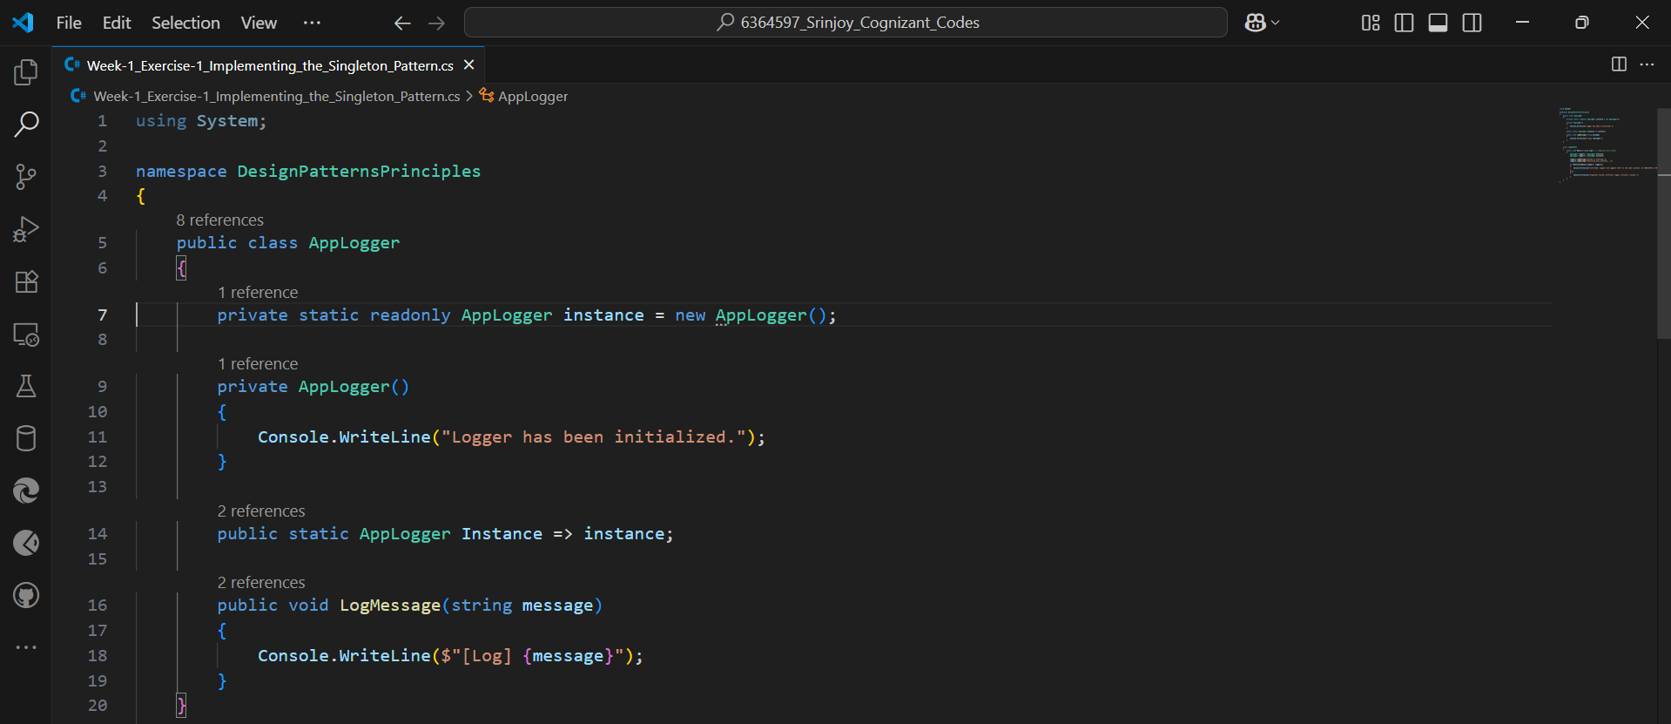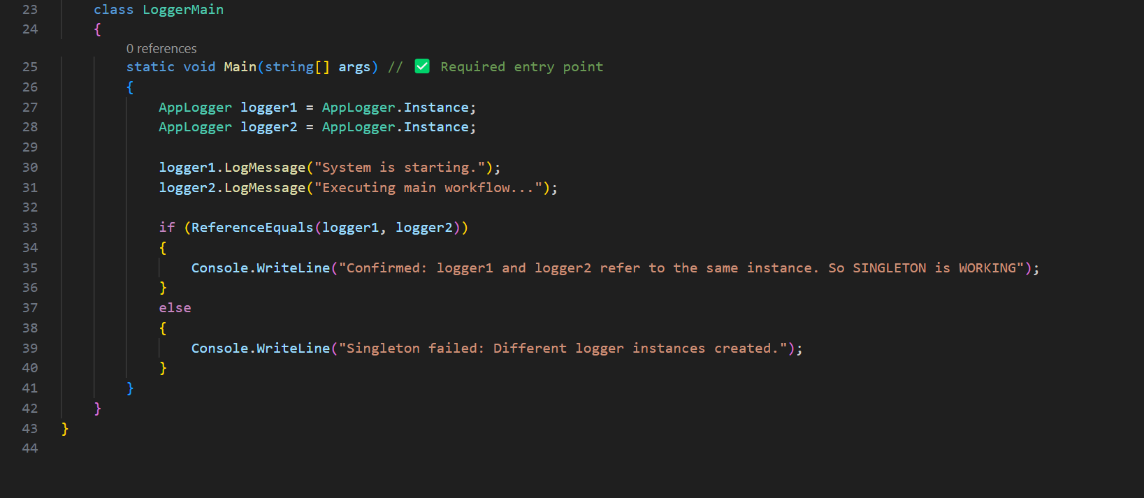

**Output:**



**Exercise 2: Implementing the Factory Method Pattern:**

**Code:**

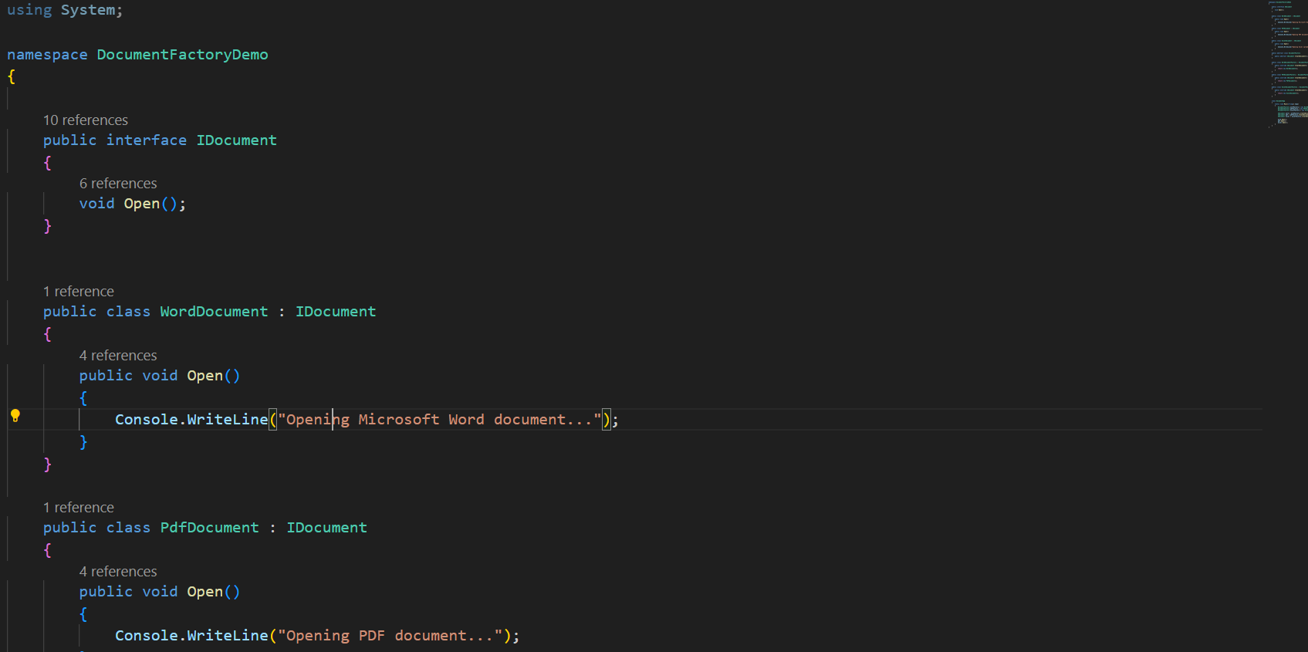

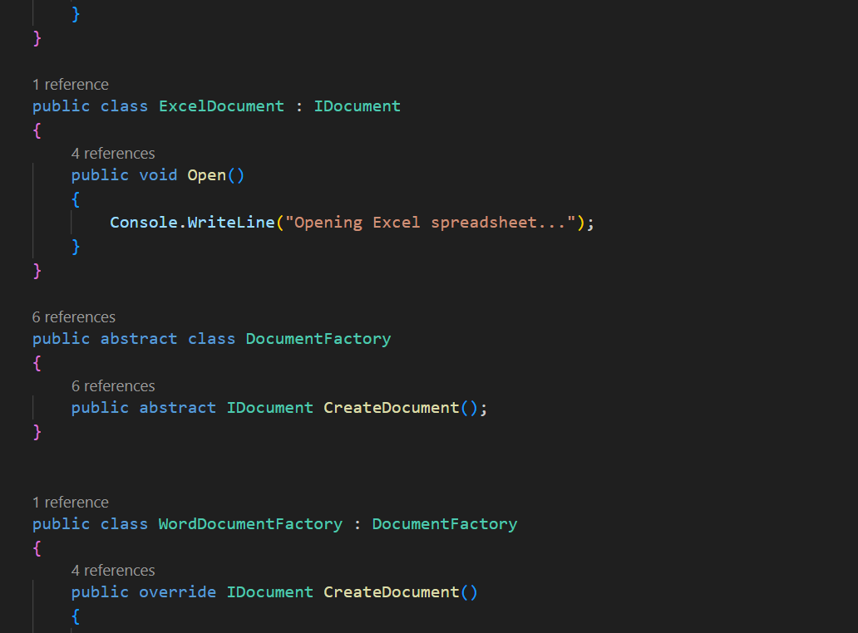

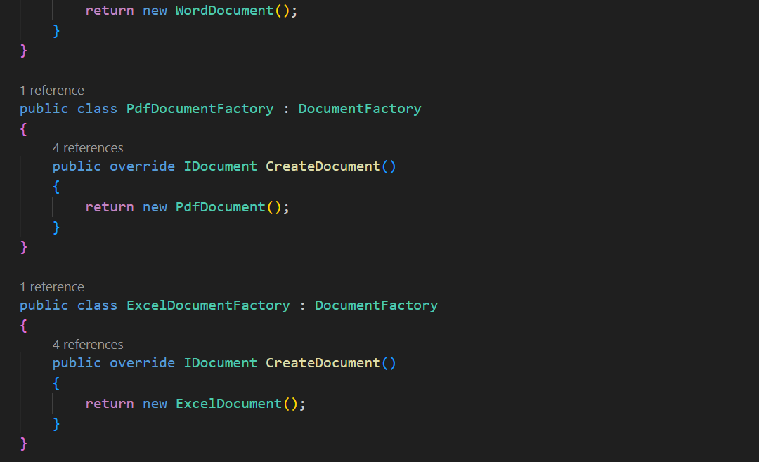

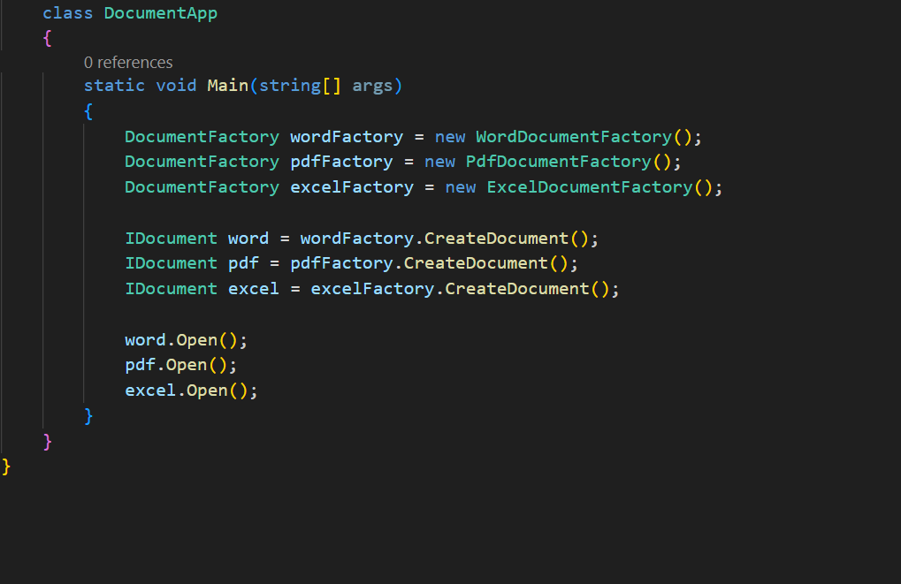

**Output:**