**Superset-Id: 6364597  
Name: SRINJOY PAUL**

**WEEK-2 ADVANCED SQL HANDSON  
(Stored Procedure)**

**Exercise 1: Create a Stored Procedure:**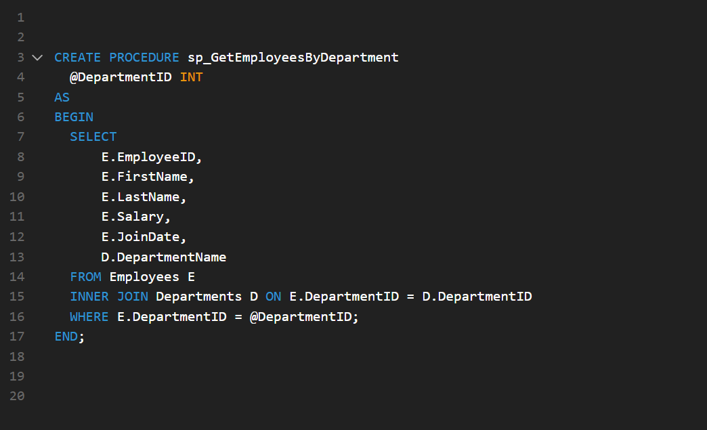

**Exercise 5: Return Data from a stored Procedure:**