**Superset-Id: 6364597  
Name: SRINJOY PAUL**

**WEEK- 2 Moq Hands On**

## **TASK-1:**

- IMailSender.cs

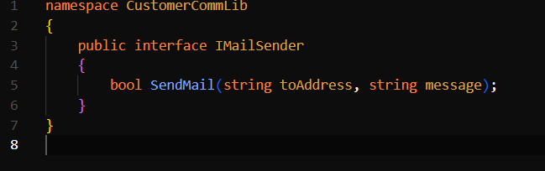

- MailSender.cs

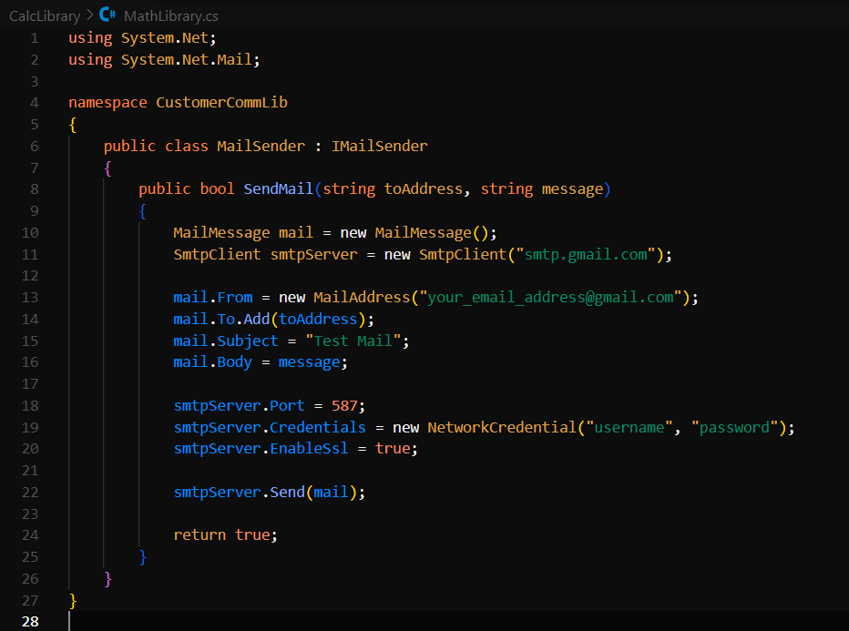

- CustomerCom.cs

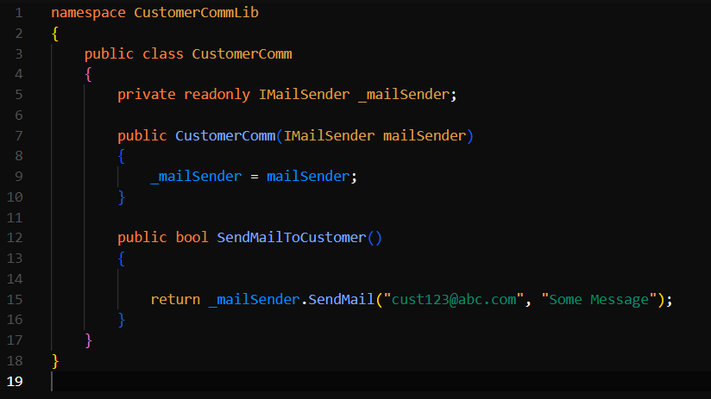

## **TASK- 2:**

- CustomerCommTests.cs

