Documentation


NAME: Srinjohn Banerjee
Course: B.SC(H)ANCS
SECTION: A
Sem: 3rd year,5th semester
S.CODE: BWU/BNC/23/014

ACKNOWLEDGEMENT
I would like to show my gratitude to our beloved instructor Mr Apratim Sir from AEM Technologies kolkata for his guidance through out the project.

I would also like to show my special thanks to our beloved HOD Mr. Anirban Lahiri Sir for providing me this opportunity to learn through this project.

Introduction

We apply the concept of continuous development so that every time the code is pushed to GitHub the website gets automatic updates reducing manual efforts.

INDEX
1. objective

2. Phases of project

3. Install the pre requisites

4. CONTENTS

5. conclusion

6. Bibliography
1.objective:applying the concept of continious deployment in azure app service while hosting a static html website of dotnet8.0 framework.

2.Phases of project:
i.Making the website.
ii.Creating a github repository.
iii.Applying continious deployment using git in local repository.
iv.Integrating azure app service with github the github repository (creating an app service plan followed by hosting the webapp in azure app service:
-configure it.
-make changes in deployment center.)

3.Install the pre requisites:
i.SDK 8.0.412 link -> https://dotnet.microsoft.com/en-us/download/dotnet/8.0
ii.C# v2.84.19 extention for vscode
iii.Code Runner v0.12.2 extention for vscode
iv.C# Dev Kit v1.30.44 extention for vscode
v.Azure Resources v0.11.1 and Azure App Service v0.26.3 extention for (connect your azure account to vscode upon installation).
vi.Git 2.48.1

4.CONTENTS
Phase i:
For making the static website
a. Open the VScode ->Create a folder ->named "cloud project continious deployment" ->open it in VScode ->Open the terminal in vscode ->type the command "dotnet new webapp --framework net8.0".
b.click "index.html" file ->change the link to youtube's link and write youtube close to the a-tag. ->then in the terminal type "dotnet run --url=https://localhost:5001" -> then follow the link to check if the webapp working properly or not. ->press ctrl +c to terminate the hosting.

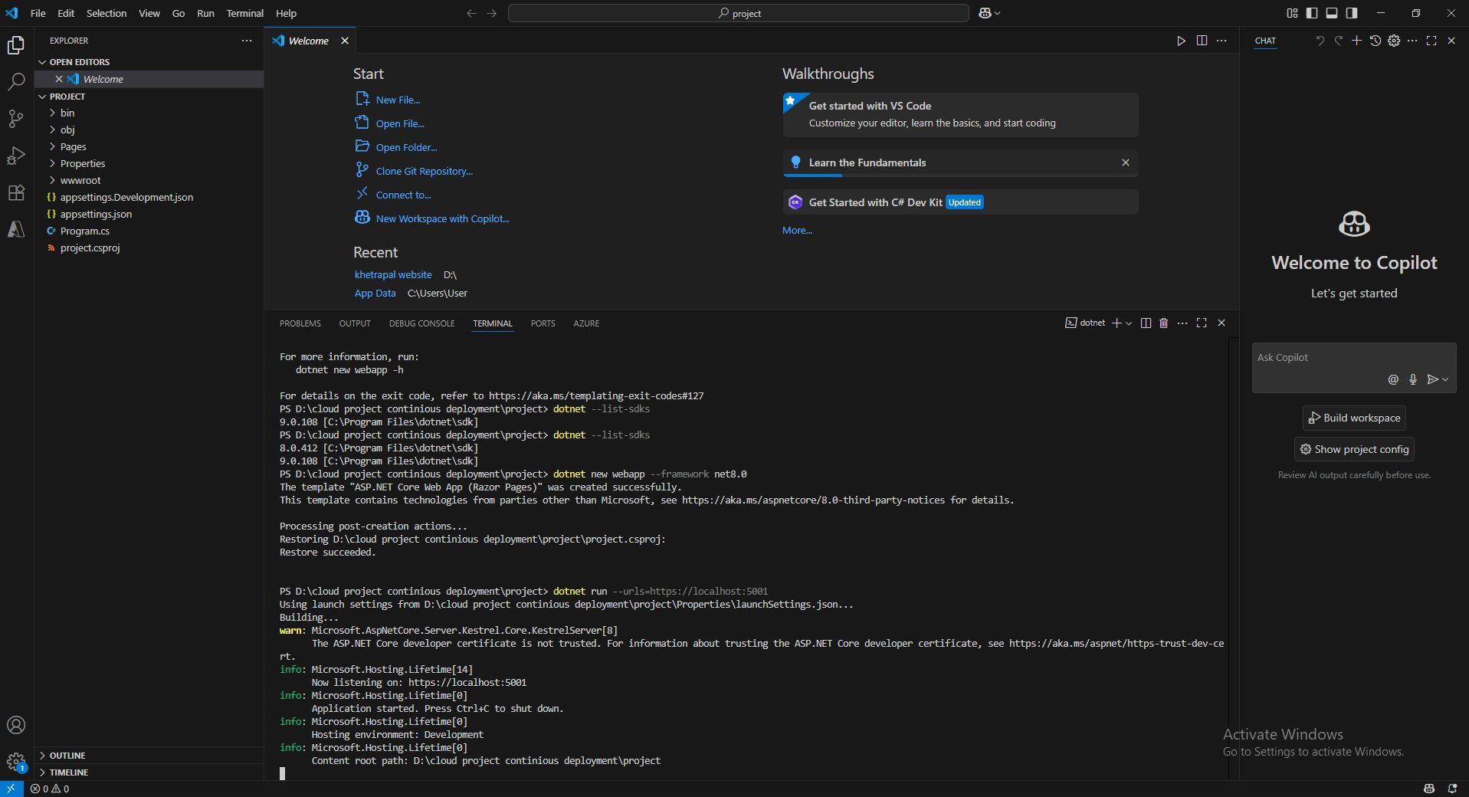
outcome:our static website completed.
Phase ii:
a.make a github repository named "cloud-project-continuous-deployment",make it public and add a readme file.

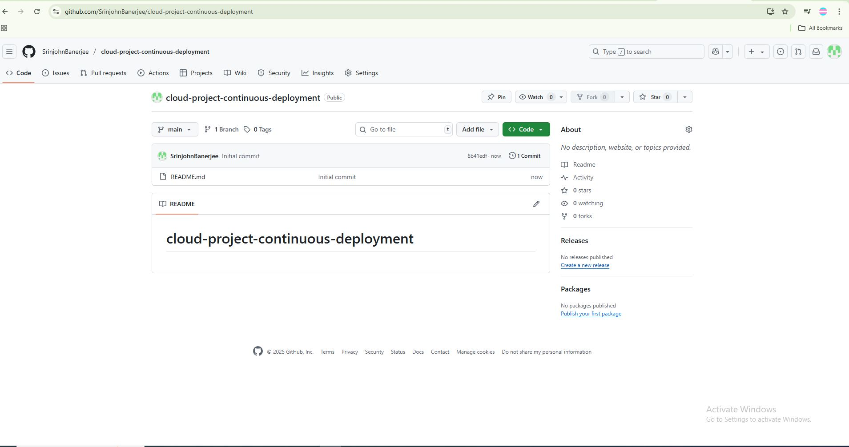
outcome:our github repository is made.
Phase iii:
a.we need to initialize a local repository in the current directory using the command "git init".
b.now we add the contents of the webapp into the repository from the local directory using the command "git add ." whenever we synchronise the local repository with the github repository all the contents shall be there.

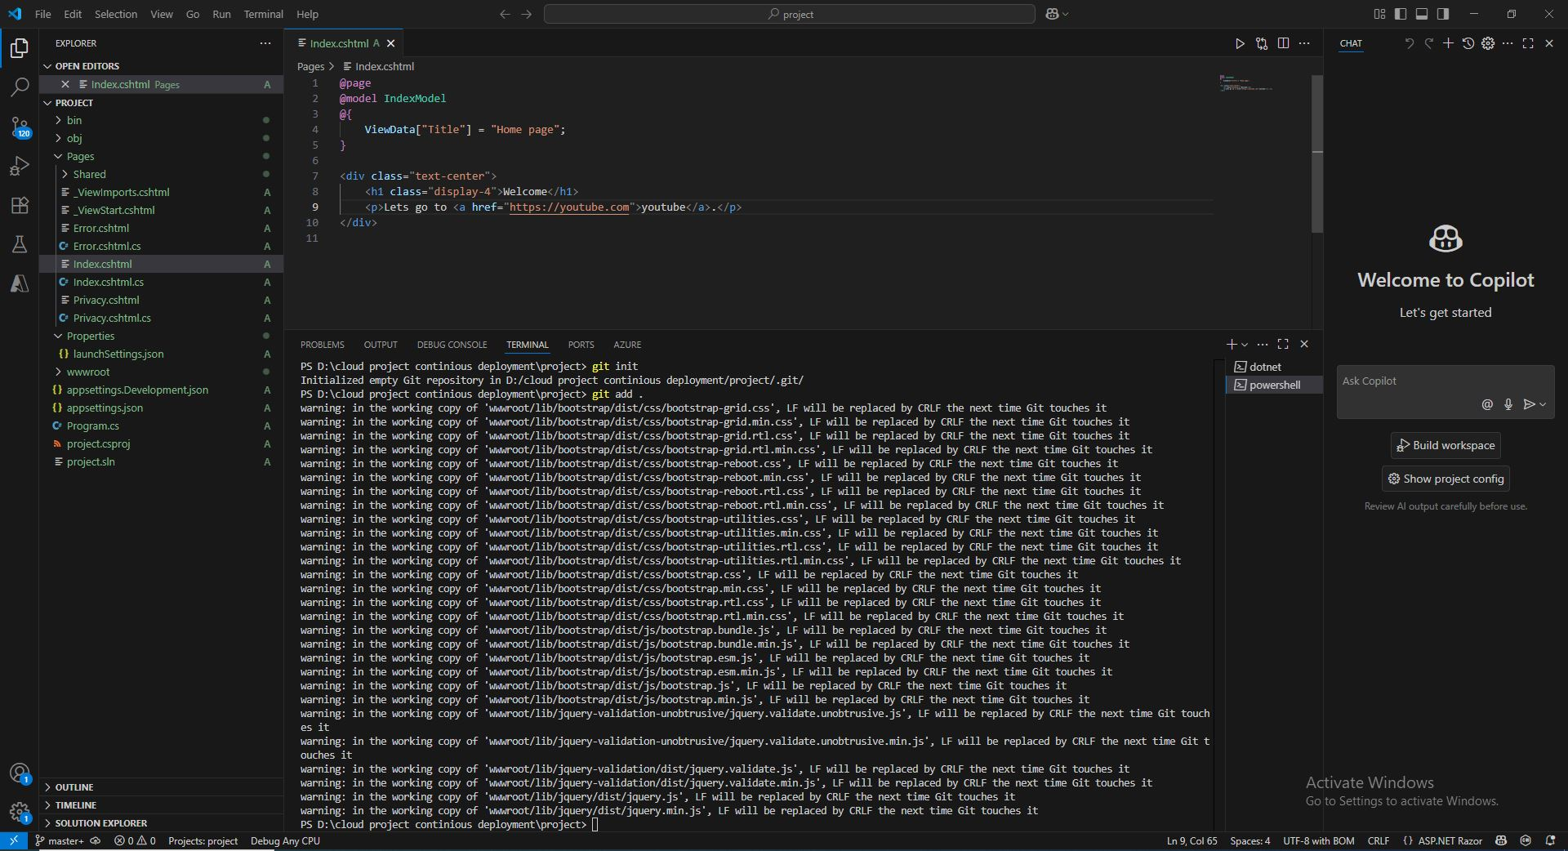
c.we then add a remark initial commit using the command "git commmit -am "Initial commit"".
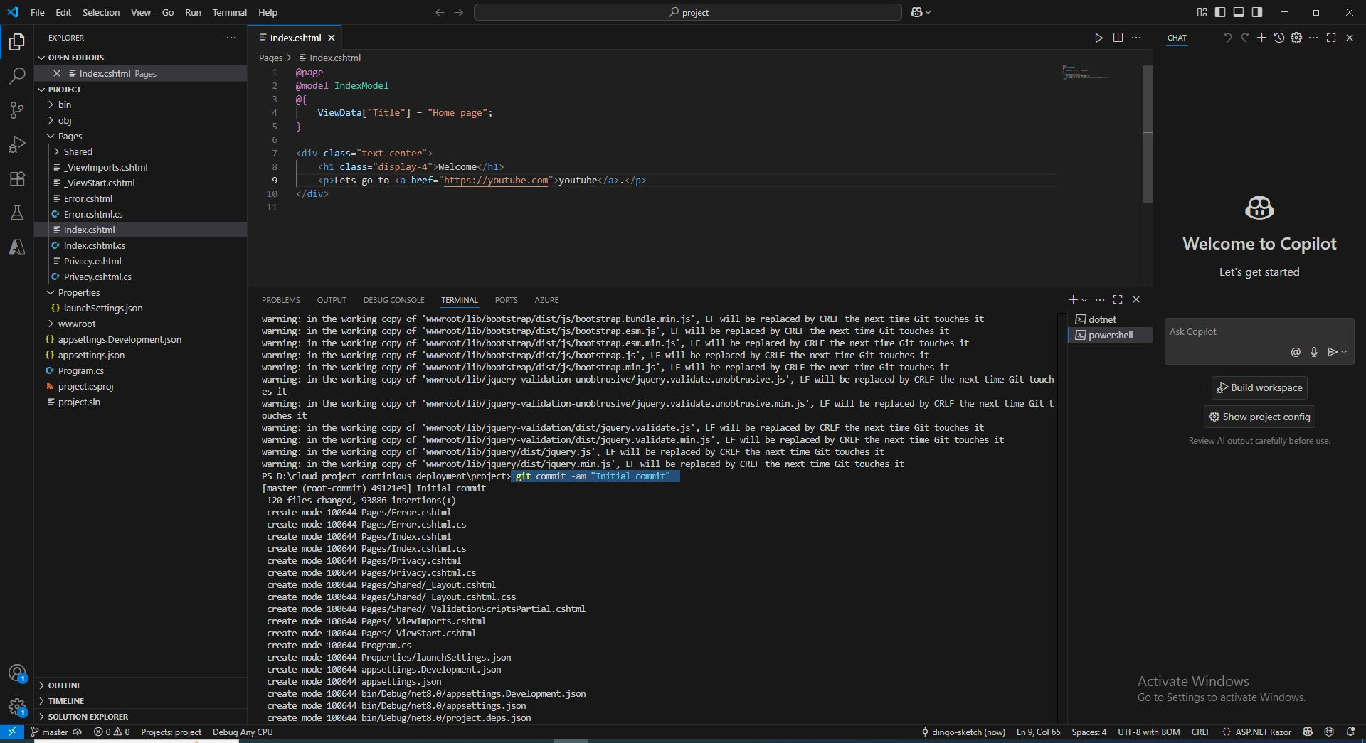

d.we then declare that the remote path is https://github.com/SrinjohnBanerjee/cloud-project-continuous-deployment and will be the origin -> "git remote add origin https://github.com/SrinjohnBanerjee/cloud-project-continuous-deployment".
e."git remote -v show" we can use this command to see how many repository we are having currently.we can use this command if we want to.
f."git branch -M main" we then create the main branch of our repository.
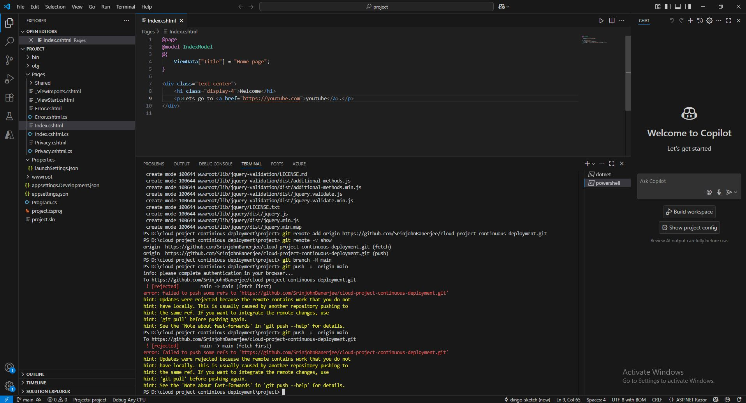
g."git push -u origin main"(if using this command gives error then at first we need to use the pull command -> "git pull origin main -allow unrelated histories" and then again try the command->"git push -u origin main"). also after the command"git push -u origin main" can might have to give our authorization permissions and credentials.
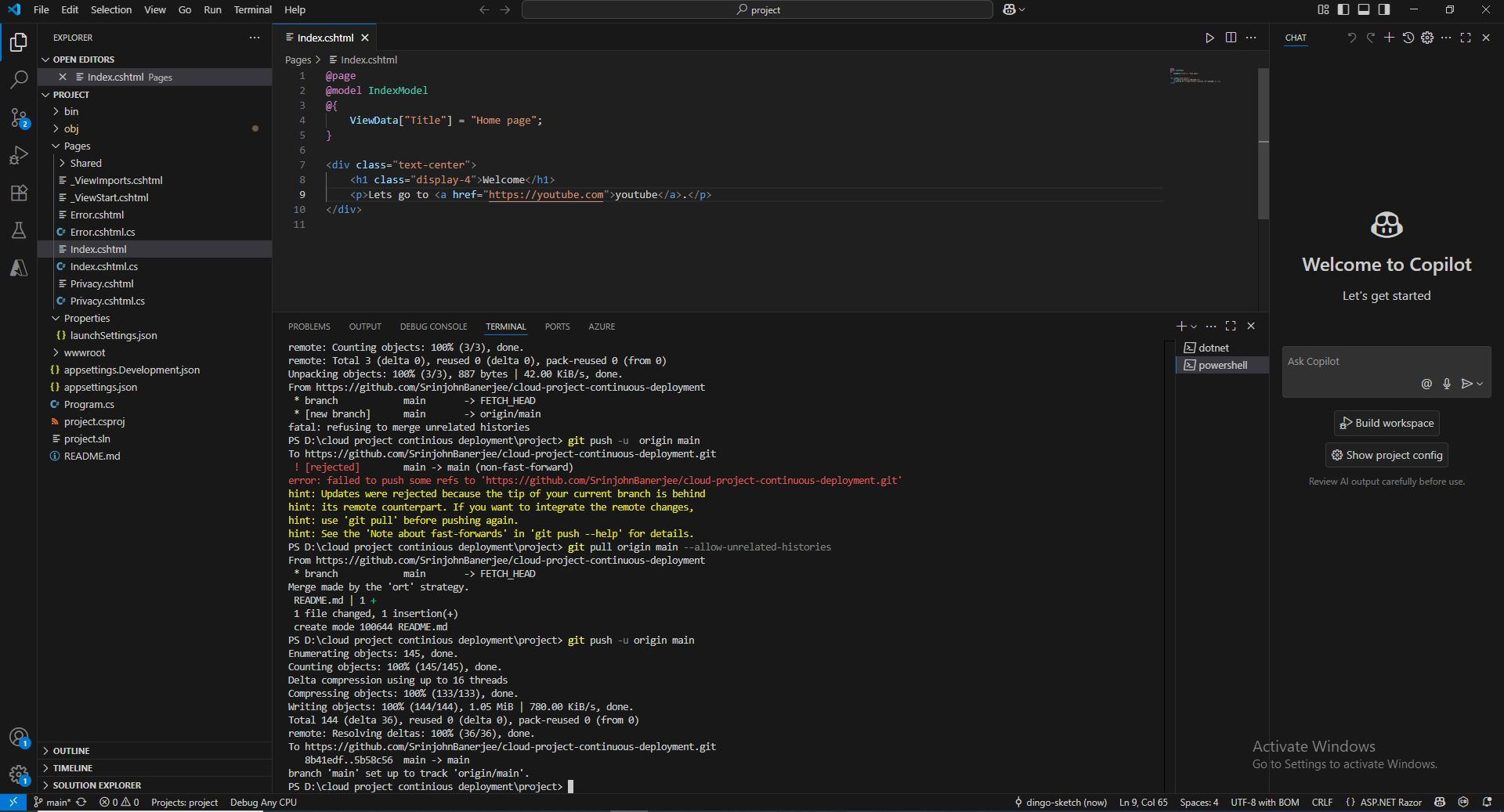
outcome:we will see that our contents of the webapp is in the github repository.

Phase iv:
a."https://aka.ms/az900/sandbox" go to the given link and then go to explore learn sandbox then click activate sandbox
b.then after the sandbox is activated click azure portal.
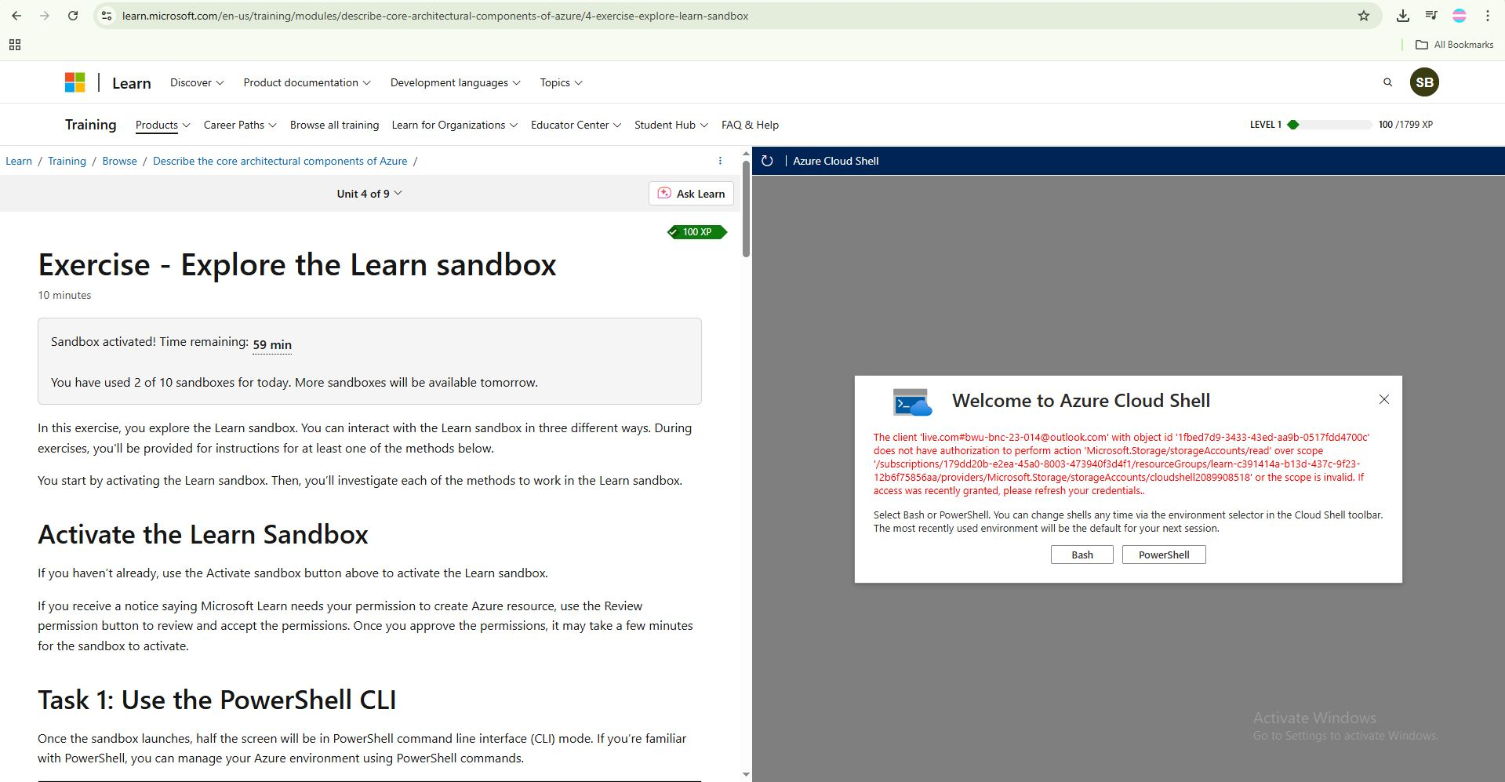
c.type in the global search bar -> "app service plan" -> click create -> in the subscription put the resource group available and put the name "Project-continioud-deployment".
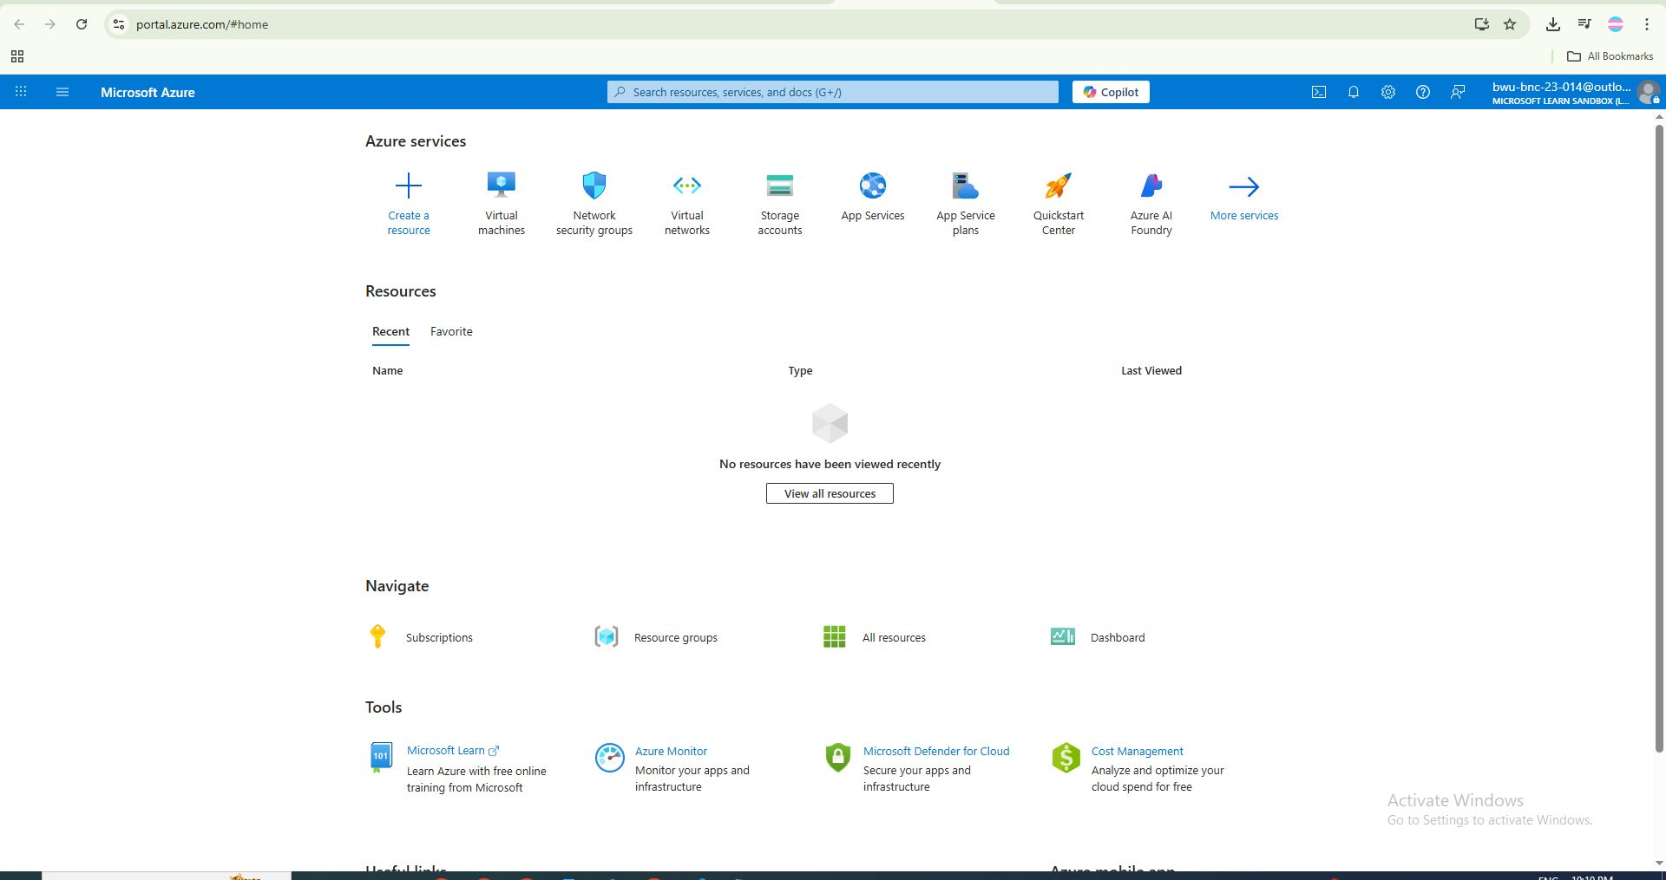
d.choose Os as windows ->region as central India.->keep the pricing plan as shown in the image.
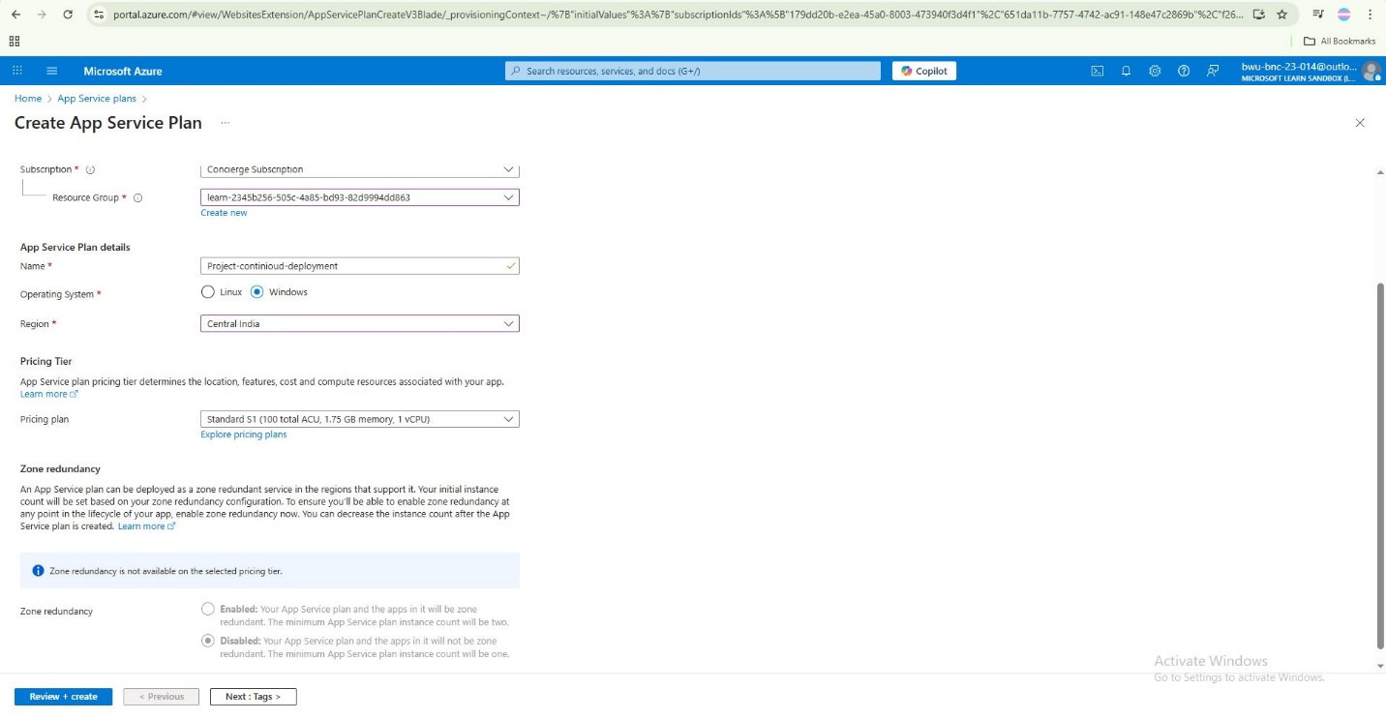
e.click on "review+create". after the validation is passed click on create.
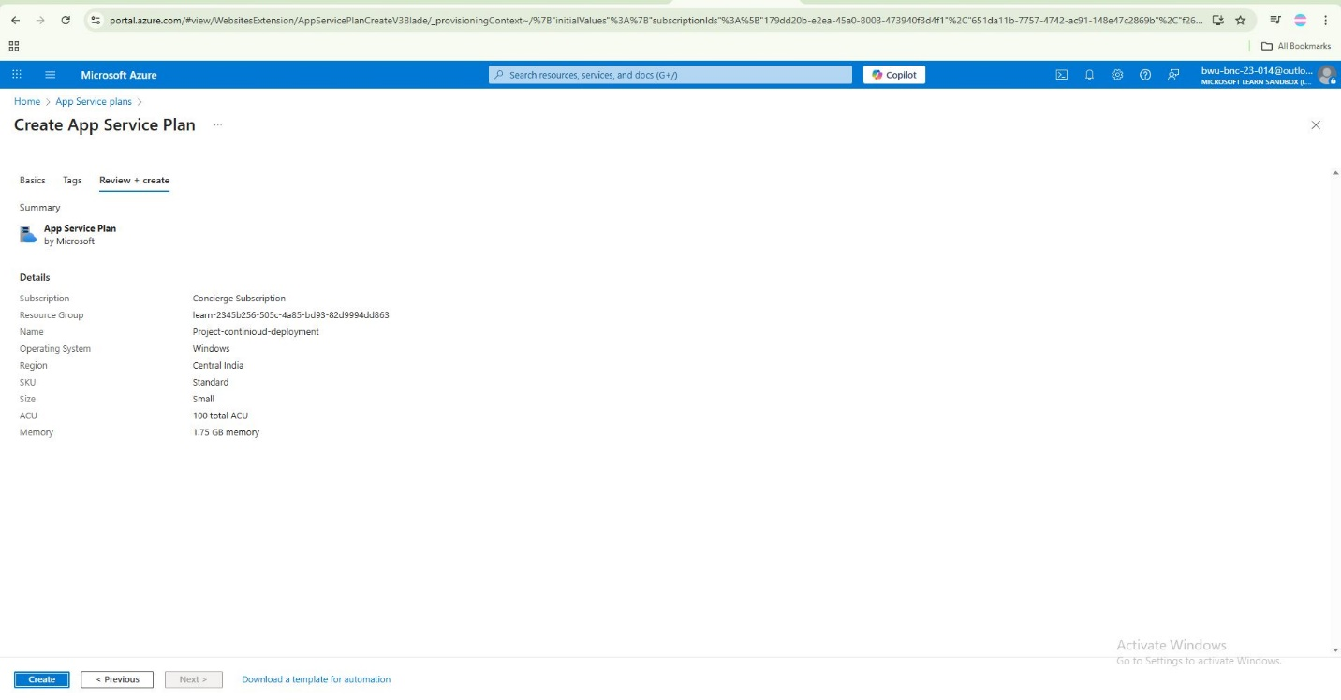
(note:azure app service plan provide us the hardware.)
f.then type "app services"-> click create ->click "webapp" -> then choose the subscription ->then type the name "SRINJOHNWEBAPP"-> in public choose code -> in runtime stack choose .NET 8 (LTS) -> IN OS CHOOSE "WINDOWS" -> in region choose "central india"->keep the plan as shown in the picture.
g. in the other tabs nothing need to change and we will enable the deployment later on.->click "create".
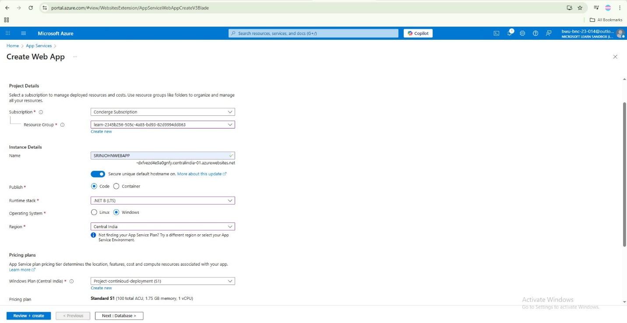

Now we need to click "app services" and go to SRINJOHNWEBAPP.
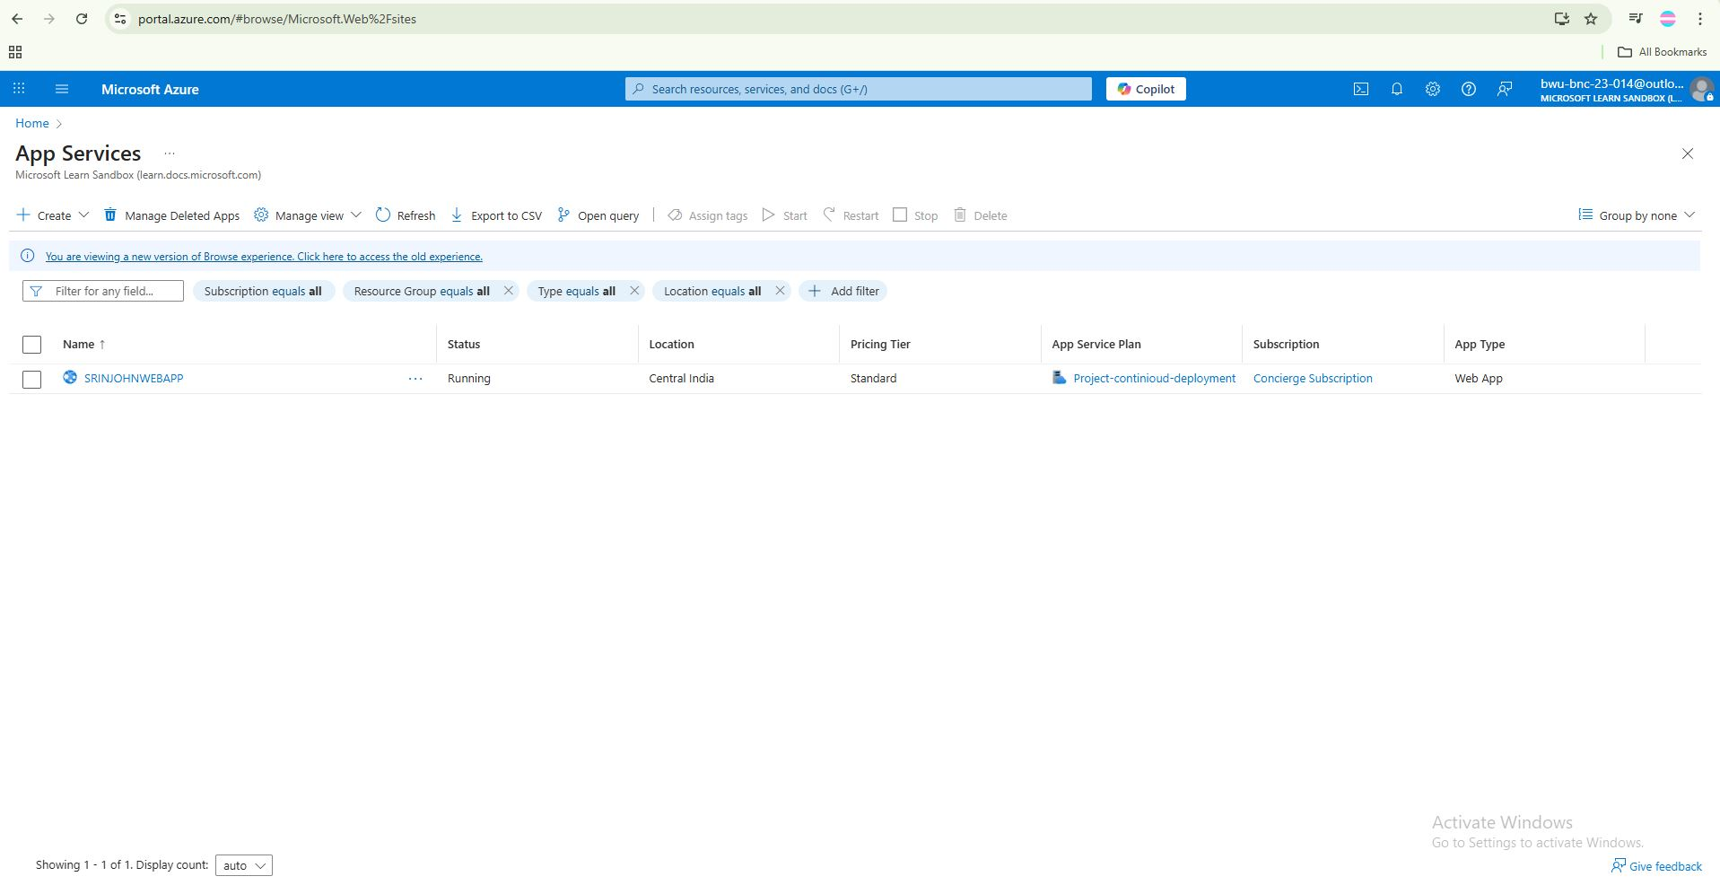
-go to settings -configurations -keep the scm basic auth publishing credentials and ftp basic auth publishing credentials on. ->click save.
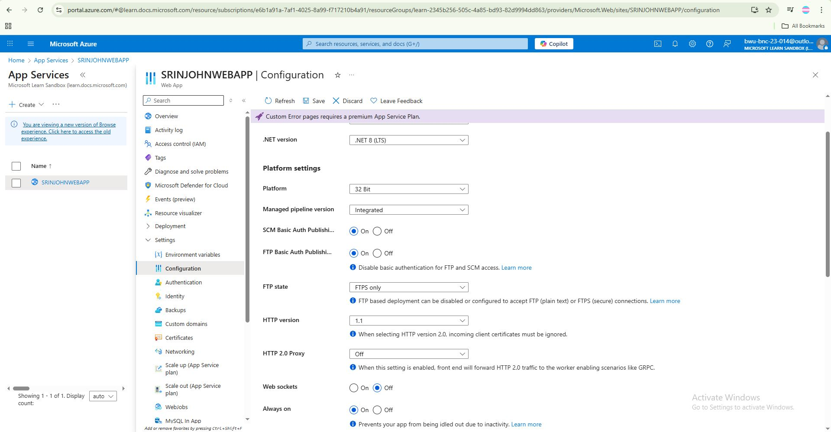
-go to deployment center ->choose the source as github ->we need to signin with our github account here. ->and choose the organisation (here my name)->select the branch as "main".->in authentication choose "basic authentication"->save.
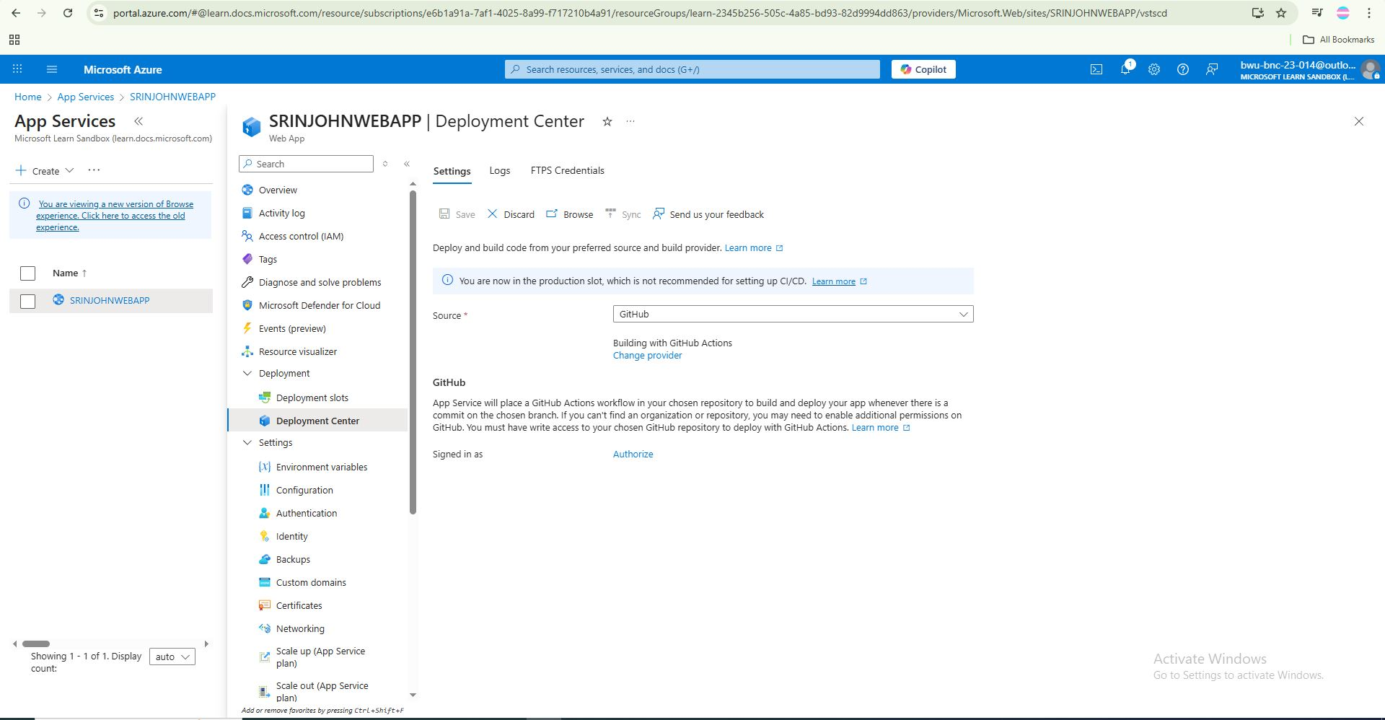

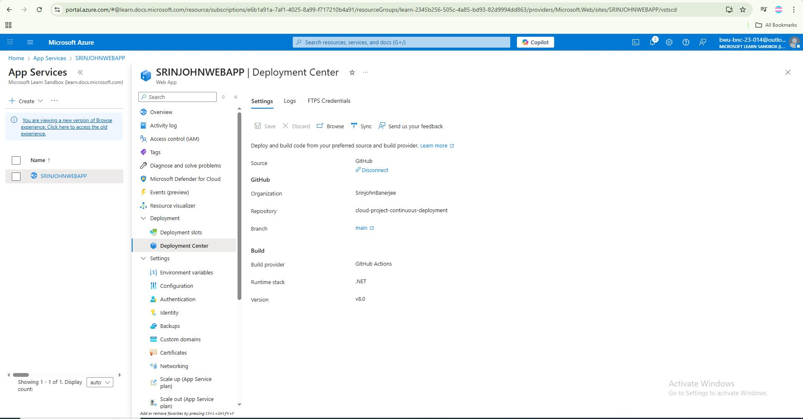
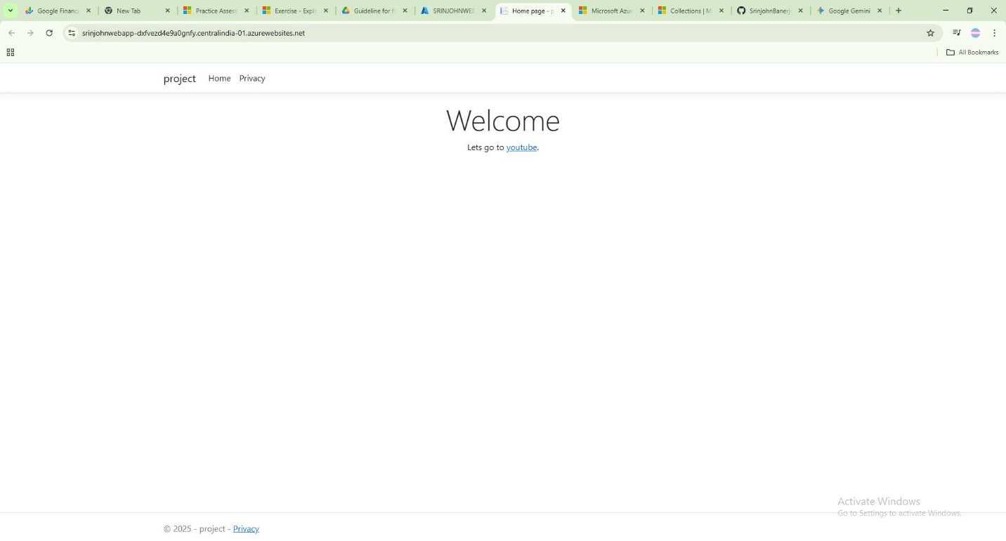
outcome:if we now click on browse in the app service’s SRINJOHNWEBAPP we will be directed to our webapp that we deployed.

5.Conclusion
In this project we demonstrate the use of Azure App Service for hosting and continious deployment of a Static web page which was made in the terminal of VS code.

6.Bibliography
1.github-https://github.com/SrinjohnBanerjee/cloud-project-continuous-deployment
2.deployment best practices- https://learn.microsoft.com/en-us/azure/app-service/deploy-best-practices
3. Microsoft Docs – .NET 8.0 Overview
https://learn.microsoft.com/en-us/dotnet/core/whats-new/dotnet-8

