Application of ML on Speech Emotion Recognition

HERITAGE INSTITUTE OF TECHNOLOGY

Name – Srinjoy Pramanik
Roll no. – 2352171
Branch – ECE-C

This Lab Project Work entitled “Application of ML on Speech Emotion Recognition” was carried out by “Srinjoy Pramanik” as part of the laboratory assignment work under Introduction to Machine Learning with Python laboratory (ECE3155) in their 5th semester of B. Tech degree.

The student has completed the assigned lab project work within the stipulated time. The code of the project work has been published in “…….GitHUB link…”.

.......................................................
Dr. Prativa Agarwalla
(Assistant Professor, Dept. of ECE
Heritage Institute of Technology, Kolkata)

Introduction

This project focuses on the classification of human emotions from speech signals using traditional machine learning techniques enhanced with signal processing methods. Speech Emotion Recognition (SER) is a rapidly advancing field at the intersection of signal processing, machine learning, and human-computer interaction. Its goal is to enable computers to recognize and classify human emotions from vocal cues such as tone, pitch, and intensity — going beyond the literal content of speech.

Emotions play a vital role in human communication, reflecting intent, attitude, and mental state. Automatically identifying emotions in speech can make human–computer interactions more natural, responsive, and empathetic. In this project, a comprehensive SER pipeline has been developed using the CREMA-D dataset, which contains diverse emotional speech recordings from multiple actors.

The audio data undergoes pre-processing steps including bandpass filtering, noise reduction, and Hilbert transform envelope extraction to enhance clarity and highlight emotion-relevant frequency components. Following this, key acoustic features such as MFCC, Chroma-STFT, RMS Energy, and Mel Spectrograms are extracted using the Librosa library. These features provide a rich representation of speech characteristics that are crucial for emotion classification.

Five traditional machine learning classifiers — Support Vector Machine (SVM), Random Forest (RF), K-Nearest Neighbours (KNN), Decision Tree (DT), and ElasticNet Logistic Regression — are implemented to evaluate and compare model performance. Each algorithm is trained and tested on the extracted features to assess its ability to distinguish between emotional categories such as angry, disgust, fear, happy, neutral, and sad.

The results show that, even without deep learning architectures, traditional models combined with strong feature engineering and signal preprocessing achieve competitive accuracy and consistent classification performance. This demonstrates that well-designed traditional ML approaches remain highly effective for Speech Emotion Recognition tasks when paired with proper data preparation and feature extraction techniques.

Relevance & Importance

Emotions are fundamental to human communication, influencing how we speak, interpret, and respond to information. In human-computer interaction, however, most systems still process only the literal meaning of words, failing to capture the emotional intent behind speech. This creates a significant communication gap between humans and machines.

Speech Emotion Recognition (SER) aims to bridge this gap by enabling computers to interpret emotions directly from voice signals. It is an emerging area at the intersection of signal processing and machine learning, allowing for more natural and adaptive human-computer interaction. This project implements an SER system using traditional machine learning algorithms — Support Vector Machine (SVM), Random Forest (RF), K-Nearest Neighbours (KNN), Decision Tree (DT), and ElasticNet Logistic Regression — trained on the CREMA-D dataset to evaluate their performance in emotion classification.

SER has wide real-world applications. In call centres, it can help classify customer interactions by emotion to identify dissatisfaction or frustration early. In automotive systems, detecting the driver’s emotional state can trigger safety measures to prevent accidents. In intelligent assistants like Alexa, Siri, and Google Assistant, emotion-aware systems can make responses more empathetic and human-like. Similarly, in e-learning platforms, SER can help identify confusion or disengagement among students, enabling more personalized learning experiences.

The importance of this project lies in demonstrating that combining digital signal processing with classical machine learning yields an efficient and noise-resilient approach to emotion recognition. By integrating preprocessing techniques such as bandpass filtering, noise reduction, and Hilbert transform envelope extraction, the model enhances the clarity of speech features before classification. This improves emotion recognition accuracy and makes the system more robust against background noise and recording variations, aligning it with real-world deployment scenarios.

Objective

The main objective of this project is to develop a robust and efficient Speech Emotion Recognition (SER) system capable of classifying human emotions from speech signals using signal processing and traditional machine learning techniques.
The specific objectives of the project are as follows:

- To utilize the CREMA-D dataset for emotion recognition, ensuring diversity in emotional tone, speaker gender, and vocal intensity across multiple classes such as angry, happy, sad, fear, disgust, and neutral.

- To apply advanced signal preprocessing techniques — including bandpass filtering, noise reduction, and Hilbert transform envelope extraction — to enhance the clarity and quality of raw speech signals.

- To extract rich acoustic and spectral features such as MFCC, Chroma-STFT, RMS Energy, Mel Spectrogram, Spectral Centroid, Bandwidth, Rolloff, Contrast, and Pitch (F0) statistics, providing a comprehensive representation of emotional cues.

- To train and evaluate multiple traditional machine learning algorithms — Support Vector Machine (SVM), Random Forest (RF), K-Nearest Neighbours (KNN), Decision Tree (DT), and ElasticNet Logistic Regression — to compare their performance in classifying emotions.

- To assess model performance using evaluation metrics such as accuracy, precision, recall, F1-score, and confusion matrix, highlighting each algorithm’s strengths and weaknesses in emotion differentiation.

- To demonstrate that combining digital signal processing with handcrafted feature extraction provides an interpretable and noise-resilient framework for emotion recognition, suitable for real-world applications such as assistive technologies, education, and human-computer interaction.

Methodology

The methodology adopted in this project follows a structured and sequential pipeline, starting from dataset collection, preprocessing, feature extraction, and finally emotion classification using traditional machine learning algorithms. The primary goal is to improve the clarity and quality of speech signals through advanced signal processing before training the models for emotion recognition.

Dataset Collection
In this work, the CREMA-D (Crowd-sourced Emotional Multimodal Actors Dataset) has been exclusively used, containing thousands of speech samples labeled with emotions such as angry, happy, sad, fear, disgust, and neutral. Each audio file was standardized to .wav format and preprocessed to ensure consistent sampling rates and durations. This dataset was chosen for its balanced emotional diversity and high-quality recordings, making it well-suited for benchmarking traditional emotion classification systems.

DATASET | SOURCE | NO. OF SAMPLES | EMOTIONS
CREMA-D | Crowd Sourced | 7442 | 6

Audio Preprocessing
Audio preprocessing plays a crucial role in improving the quality of the input signals before feature extraction. Three main techniques were applied:
Bandpass Filtering - A Butterworth bandpass filter with cutoff frequencies between 300 Hz and 3400 Hz was implemented using the SciPy butter() and filtfilt() functions.
Noise Reduction - The noisereduce library was used to apply spectral gating noise reduction.
The first 0.5 seconds of the signal was used as the noise reference segment
Hilbert Transform - The Hilbert transform was used to extract the amplitude envelope of the speech, which represents the energy contour over time.
Feature Extraction
After preprocessing, the enhanced signals were processed using the Librosa library to extract a comprehensive set of acoustic and spectral features. Rather than relying solely on MFCCs, multiple complementary features were computed to improve the accuracy and robustness of emotion recognition.
The following features were extracted for each audio file:
- Zero Crossing Rate (ZCR): Measures how often the signal crosses the zero amplitude axis, reflecting speech sharpness and energy fluctuations.
- Chroma-STFT: Represents energy distribution across the 12 pitch classes (C, C#, D, etc.), useful for analyzing tonal characteristics.
- MFCC (Mel-Frequency Cepstral Coefficients): Captures the short-term spectral shape of speech and is one of the most reliable features for vocal emotion analysis.
- RMS Energy: Represents the short-term energy or loudness of the speech signal.
- Mel Spectrogram: Provides a time–frequency representation of the audio mapped to the human auditory scale.
- Spectral Features (Centroid, Bandwidth, Rolloff, and Contrast): Capture the brightness, spread, and smoothness of the frequency spectrum, offering additional cues about emotional intensity.
- Pitch (F0) Statistics: Derived using Librosa’s piptrack function, including the mean, standard deviation, median, maximum, and minimum pitch values. These statistics provide insights into pitch variability and emotional expressiveness.
Each feature set was averaged across frames to form a single feature vector per audio file. The combined features were stored in a structured CSV file for reproducibility and efficient model training.

Traditional Machine Learning Models
To classify emotions from the extracted feature vectors, multiple traditional machine learning algorithms were implemented and compared. The goal was to identify which algorithm best generalizes across emotional variations in the CREMA-D dataset.
- Support Vector Machine (SVM): Utilizes kernel functions to create nonlinear decision boundaries between emotional classes. The Radial Basis Function (RBF) kernel was selected for its strong generalization performance in high-dimensional feature spaces.
- Random Forest (RF): An ensemble model combining multiple decision trees to reduce overfitting and capture complex patterns in the data.
- K-Nearest Neighbours (KNN): A non-parametric algorithm that classifies samples based on their proximity to neighboring data points in the feature space.
- Decision Tree (DT): Provides a simple yet interpretable structure by splitting features hierarchically based on their information gain.
- ElasticNet Logistic Regression: A linear model that uses a balanced combination of L1 and L2 regularization to improve stability and feature selection. This hybrid approach helps manage correlated features effectively.
All models were trained and tested using the same dataset split (80% training, 20% testing) to ensure fair comparison. Hyperparameters such as the number of trees (in Random Forest) and kernel type (in SVM) were tuned to optimize performance.

Evaluation Metrics
Model performance was evaluated using multiple metrics to provide a holistic understanding of each classifier’s behavior:
- Accuracy: The overall percentage of correctly classified emotion samples.
- Precision: The proportion of true positive predictions among all positive predictions for each emotion class.
- Recall (Sensitivity): Measures the model’s ability to correctly identify all samples of a given emotion.
- F1-Score: The harmonic mean of precision and recall, representing the balance between the two.
- Confusion Matrix: Provides a detailed visualization of class-wise performance, showing which emotions are most frequently misclassified.
These metrics collectively measure both overall and class-specific performance, enabling objective comparison among all implemented models.
RESULTS

This section presents the results obtained from the classification of emotions in the CREMA-D dataset using five traditional machine learning algorithms — Support Vector Machine (SVM), Random Forest (RF), K-Nearest Neighbours (KNN), Decision Tree (DT), and ElasticNet Logistic Regression.
All models were trained on the same preprocessed feature set derived from enhanced audio processing (bandpass filtering, noise reduction, and Hilbert transform) and comprehensive feature extraction (MFCCs, Chroma-STFT, RMS, Mel Spectrogram, spectral statistics, and pitch features).
Each algorithm’s performance is evaluated in terms of accuracy, precision, recall, F1-score, and confusion matrix.
Support Vector Machine (SVM)
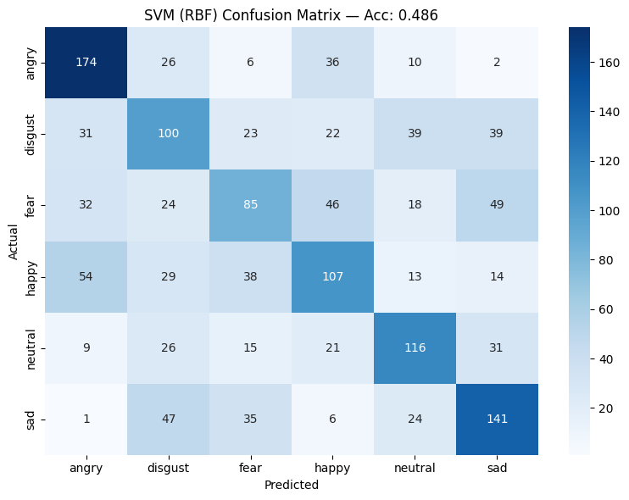
The SVM classifier achieved an overall accuracy of 48.6%, making it the best-performing model among all traditional approaches.
The model effectively distinguished high-energy emotions such as angry and sad, demonstrating strong class boundaries due to its nonlinear kernel (RBF). However, it showed moderate confusion between acoustically similar emotions such as fear and disgust.
SVM’s strength lies in its ability to separate classes in high-dimensional spaces, making it particularly suitable for datasets with overlapping features. Despite the moderate overall accuracy, its balanced class-wise precision and recall indicate good generalization and robustness to speaker variations.
Random Forest (RF)
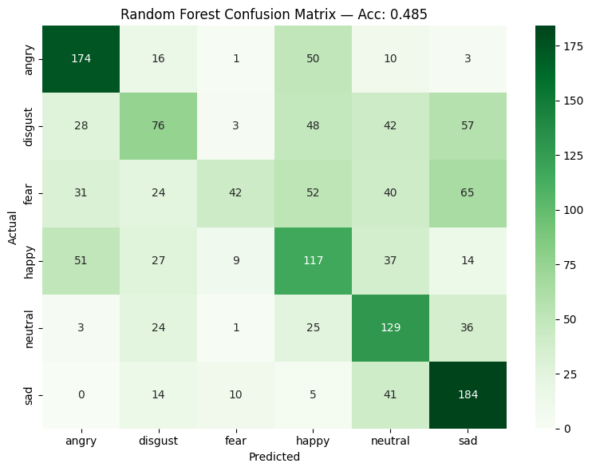
The Random Forest model achieved an accuracy of 48.5%, closely matching SVM’s performance.
As an ensemble method, it combines multiple decision trees to reduce variance and improve robustness. The model performed well in recognizing angry and sad emotions, reflecting its strength in handling class variability and noisy data. However, confusion remained between neutral and happy samples due to their overlapping acoustic characteristics.
Increasing the number of estimators to 1000 trees provided a slight improvement in performance and greater stability in predictions.
K-Nearest Neighbours (KNN)
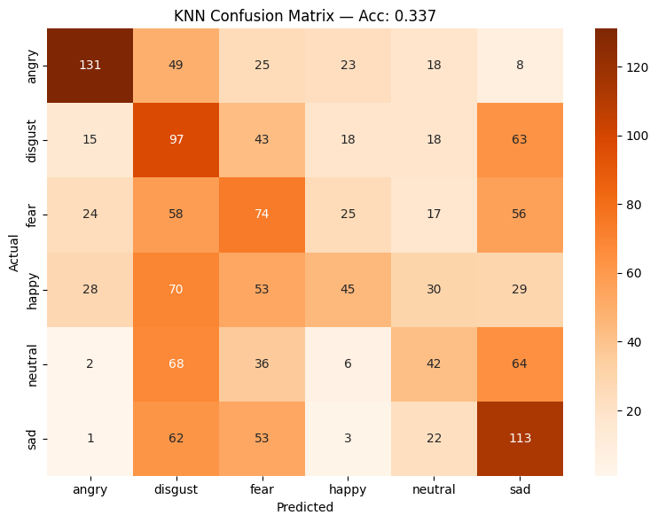
The KNN classifier achieved an accuracy of 33.7%, which was noticeably lower than the ensemble and kernel-based models. While it performed reasonably on distinct emotions such as angry and fear, it struggled with overlapping classes like disgust and neutral.
Because KNN is a distance-based learner, it is highly sensitive to the distribution of data in feature space. When emotion features overlap significantly, classification boundaries become less defined, reducing accuracy.
Decision Tree (DT)
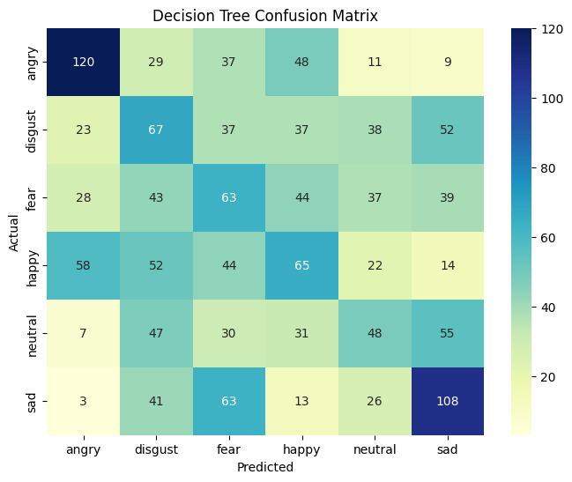
The Decision Tree model obtained an accuracy of 31.6%, the lowest among all classifiers.
While interpretable and fast, the model exhibited overfitting tendencies, capturing noise and dataset-specific variations rather than general emotional patterns. It performed moderately on angry and sad samples but misclassified mid-intensity emotions like happy and fear.
ElasticNet Logistic Regression
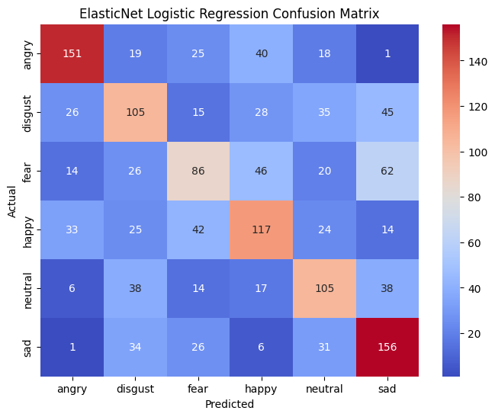
The ElasticNet Logistic Regression model achieved an accuracy of 48.3%, making it one of the stronger performers among the traditional algorithms. By combining L1 (Lasso) and L2 (Ridge) regularization, the model effectively handled correlated features and prevented overfitting, while maintaining interpretability. ElasticNet achieved balanced precision and recall across most emotion classes, performing especially well on angry and sad samples. However, it showed moderate confusion among mid-intensity emotions such as fear and disgust, which share overlapping acoustic features.

Conclusion

The primary objective of this project was to design and implement a Speech Emotion Recognition (SER) system capable of identifying human emotions from speech using a combination of signal processing, acoustic feature extraction, and traditional machine learning techniques. The proposed approach effectively integrated bandpass filtering, noise reduction, and Hilbert transform envelope extraction to enhance the clarity and quality of input audio signals before feature analysis.
From the preprocessed signals, a comprehensive set of acoustic and spectral features was extracted, including MFCC, Chroma-STFT, RMS Energy, Mel Spectrogram, Spectral Centroid, Bandwidth, Contrast, and Pitch statistics. These features captured both temporal and spectral dynamics of speech, providing rich representations for emotion classification.
Five traditional machine learning algorithms — Support Vector Machine (SVM), Random Forest (RF), K-Nearest Neighbours (KNN), Decision Tree (DT), and ElasticNet Logistic Regression — were trained and evaluated on the CREMA-D dataset.
Among these, SVM, Random Forest, and ElasticNet achieved the best overall results, with accuracies close to 48–49%, demonstrating their ability to learn robust emotional distinctions even in complex and overlapping speech feature spaces.
The experimental results highlight that signal-level preprocessing combined with multi-feature fusion significantly improves the reliability of emotion recognition from speech. Although deep learning models are known to achieve higher accuracy in large-scale systems, this project shows that traditional machine learning approaches — when supported by strong feature engineering — can perform competitively while maintaining interpretability and lower computational complexity.
Overall, this project establishes a robust and interpretable baseline for speech emotion recognition using classical methods.

