
BONA FIDE: AI-ASSISTED INSURANCE EVIDENCE PRESERVATION SYSTEM
21CSP302L - PROJECT
Submitted by
T SAALINI [RA2411003010149]
ADITI TAKUR [RA2411003010186]
AYUSH SAXENA [RA2411003010179]
AKSHAT JHA [RA2411003010072]
Under the Guidance of
[GUIDE NAME]
([Designation], Department of Computational Intelligence)
in partial fulfillment of the requirements for the degree of
BACHELOR OF TECHNOLOGY
in
COMPUTER SCIENCE AND ENGINEERING
with specialization in [SPECIALIZATION NAME]
DEPARTMENT OF COMPUTATIONAL INTELLIGENCE
COLLEGE OF ENGINEERING AND TECHNOLOGY
SRM INSTITUTE OF SCIENCE AND TECHNOLOGY
KATTANKULATHUR - 603 203
[MONTH YEAR]


Department of Computational Intelligence
SRM Institute of Science & Technology
Own Work Declaration Form
This sheet must be filled in (each box ticked to show that the condition has been met). It must be signed and dated along with your student registration number and included with all assignments you submit - work will not be marked unless this is done.
To be completed by the student for all assessments
Degree/ Course : | B.Tech - Computer Science and Engineering (with specialization in [SPECIALIZATION NAME])
Student Name : | T Saalini, Aditi Takur, Ayush Saxena, Akshat Jha
Registration Number : | RA2411003010149, RA2411003010186, RA2411003010179, RA2411003010072
Title of Work : | Bona Fide: AI-Assisted Insurance Evidence Preservation System

I / We hereby certify that this assessment complies with the University's Rules and Regulations relating to Academic misconduct and plagiarism, as listed in the University Website, Regulations, and the Education Committee guidelines.
I / We confirm that all the work contained in this assessment is my / our own except where indicated, and that I / We have met the following conditions:
☐ Clearly referenced / listed all sources as appropriate
☐ Referenced and put in inverted commas all quoted text (from books, web, etc.)
☐ Given the sources of all pictures, data etc. that are not my own
☐ Not made any use of the report(s) or essay(s) of any other student(s) either past or present
☐ Acknowledged in appropriate places any help that I have received from others (e.g. fellow students, technicians, statisticians, external sources)
☐ Complied with any other plagiarism criteria specified in the Course handbook / University website
I understand that any false claim for this work will be penalized in accordance with the University policies and regulations.
DECLARATION:
I am aware of and understand the University's policy on Academic misconduct and plagiarism and I certify that this assessment is my / our own work, except where indicated by referring, and that I have followed the good academic practices noted above.
_______________ | _______________ | _______________ | _______________
T Saalini  RA2411003010149 Date: | Aditi Takur  RA2411003010186 Date: | Ayush Saxena  RA2411003010179 Date: | Akshat Jha  RA2411003010072 Date:

If you are working in a group, please write your registration numbers and sign with the date for every student in your group.
SRM INSTITUTE OF SCIENCE AND TECHNOLOGY
KATTANKULATHUR - 603 203
BONAFIDE CERTIFICATE
Certified that 21CSP302L - Project report titled “Bona Fide: AI-Assisted Insurance Evidence Preservation System” is the bonafide work of “T SAALINI [RA2411003010149], ADITI TAKUR [RA2411003010186], AYUSH SAXENA [RA2411003010179], AKSHAT JHA [RA2411003010072]” who carried out the project work under my supervision. Certified further, that to the best of my knowledge the work reported herein does not form any other project report or dissertation on the basis of which a degree or award was conferred on an earlier occasion on this or any other candidate.

<<Signature>>  SIGNATURE  [GUIDE NAME]  SUPERVISOR  [Designation]  DEPARTMENT OF COMPUTATIONAL INTELLIGENCE | <<Signature>>  SIGNATURE  DR. R. ANNIE UTHRA  PROFESSOR & HEAD  DEPARTMENT OF COMPUTATIONAL INTELLIGENCE

EXAMINER 1 | EXAMINER 2
Name & Signature | Name & Signature
ACKNOWLEDGEMENTS
We express our humble gratitude to Dr. C. Muthamizhchelvan, Vice-Chancellor, SRM Institute of Science and Technology, for the facilities extended for the project work and his continued support.
We extend our sincere thanks to Dr. Leenus Jesu Martin M, Dean-CET, SRM Institute of Science and Technology, for his invaluable support.
We wish to thank Dr. Revathi Venkataraman, Professor and Chairperson, School of Computing, SRM Institute of Science and Technology, for her support throughout the project work.
We encompass our sincere thanks to Dr. M. Pushpalatha, Professor and Associate Chairperson - CS, School of Computing, and Dr. C. Lakshmi, Professor and Associate Chairperson - AI, School of Computing, SRM Institute of Science and Technology, for their invaluable support.
We are incredibly grateful to our Head of the Department, [Name, Designation & Department], SRM Institute of Science and Technology, for the suggestions and encouragement at all the stages of the project work.
We want to convey our thanks to our Project Coordinators, Panel Head, and Panel Members, Department of Computational Intelligence, SRM Institute of Science and Technology, for their inputs during the project reviews and support.
We register our immeasurable thanks to our Faculty Advisor, [Faculty Advisor Name], Department of [Dept. Name], SRM Institute of Science and Technology, for leading and helping us to complete our course.
Our inexpressible respect and thanks to our guide, [Guide Name], Department of [Dept. Name], SRM Institute of Science and Technology, for providing us with an opportunity to pursue our project under his / her mentorship. He / She provided us with the freedom and support to explore the research topics of our interest.
We sincerely thank all the staff members of [Dept. Name], School of Computing, SRM Institute of Science and Technology, for their help during our project. Finally, we would like to thank our parents, family members, and friends for their unconditional love, constant support and encouragement.
T Saalini
Aditi Takur
Ayush Saxena
Akshat Jha
ABSTRACT
Insurance claim handling depends on physical and documentary evidence such as vehicle photographs, repair appraisals, inspection records and recorded statements. Much of this evidence can be lost or altered by routine business events: once a repair is authorised, the damaged vehicle is repaired and its pre-repair condition can no longer be photographed or inspected. When a claim later becomes disputed, missing evidence weakens the insurer's position and can carry legal consequences. Claims platforms record documents, but they rarely tell a claim handler which required evidence is still outstanding and which upcoming event will make it unrecoverable.
This report presents Bona Fide, a prototype evidence-preservation layer for personal-auto insurance claims. Its core is a deterministic preservation engine: for every claim it compares the required evidence checklist with the evidence already satisfied, selects the outstanding items whose expiry trigger matches the claim's upcoming business event (RepairAuthorization or ClaimClosure), and assigns a LOW, MEDIUM or HIGH risk level for zero, one, or two or more at-risk items. AI is used only as advisory input. A separate, stateless AI service classifies uploaded documents into the evidence taxonomy and screens them for litigation signals (attorney representation, demand letters, records requests), using a keyword-based deterministic provider by default and an optional locally hosted Ollama language model. An optional vision model can describe observable vehicle damage in photographs.
Human-in-the-loop controls are enforced in code: results below a 0.85 confidence threshold, or produced while the AI service is unavailable, are routed to manual review and never satisfy evidence; a litigation signal can only propose a preservation hold, which becomes active solely through an explicit confirmation; overrides of a preservation rule require a justification. Every significant action is written to an append-only preservation log. The system is implemented with React 18 and Vite, two FastAPI services, PostgreSQL with SQLAlchemy and Alembic, and local document storage. Applied to the five synthetic demonstration claims, the engine reproduces the intended outcomes, including HIGH risk with three at-risk items for claim CLM-10042. The repository contains 169 automated test functions. Bona Fide is a proof of concept: it does not implement authentication, tamper-evident logging, hold release or integration with a commercial claims platform, and it has not been evaluated on real claim data.
Keywords: insurance claims, evidence preservation, litigation hold, deterministic rules, document classification, human-in-the-loop, audit trail, FastAPI, PostgreSQL.
TABLE OF CONTENTS
CHAPTER NO. | TITLE | PAGE NO.
 | ABSTRACT | v
 | TABLE OF CONTENTS | vi
 | LIST OF FIGURES | x
 | LIST OF TABLES | xi
 | ABBREVIATIONS | xii
1 | INTRODUCTION | 1
 | 1.1 Introduction to Project | 1
 | 1.2 Problem Statement and Description | 2
 | 1.3 Motivation | 3
 | 1.4 Sustainable Development Goal of the Project | 4
 | 1.5 Aim of the Project | 4
 | 1.6 Objectives of the Project | 4
 | 1.7 Scope of the Project | 5
 | 1.8 Significance of the Project | 6
2 | LITERATURE SURVEY | 7
 | 2.1 Overview of the Research Area | 7
 | 2.2 Existing Models and Frameworks | 7
 | 2.2.1 RULE-BASED DECISION SYSTEMS | 7
 | 2.2.2 DOCUMENT CLASSIFICATION | 8
 | 2.2.3 TEXT EXTRACTION AND OPTICAL CHARACTER RECOGNITION | 8
 | 2.2.4 LARGE LANGUAGE MODELS | 8
 | 2.2.5 HUMAN-IN-THE-LOOP PROCESSING | 9
 | 2.2.6 AUDIT LOGGING | 9
 | 2.2.7 APPLICATION ARCHITECTURE | 9
 | 2.3 Limitations Identified from Literature Survey (Research Gaps) | 10
 | 2.4 Research Objectives | 11
 | 2.5 Product Backlog (Key User Stories with Desired Outcomes) | 11
 | 2.6 Plan of Action (Project Road Map) | 12
3 | SPRINT PLANNING AND EXECUTION METHODOLOGY | 14
 | 3.1 Sprint I - Foundation: Data Model and Preservation Engine | 14
 | 3.1.1 OBJECTIVES WITH USER STORIES OF SPRINT I | 14
 | 3.1.2 FUNCTIONAL DOCUMENT | 15
 | 3.1.3 ARCHITECTURE DOCUMENT | 15
 | 3.1.4 OUTCOME OF OBJECTIVES / RESULT ANALYSIS | 16
 | 3.1.5 SPRINT RETROSPECTIVE | 17
 | 3.2 Sprint II - Core API and Standalone AI Service | 17
 | 3.2.1 OBJECTIVES WITH USER STORIES OF SPRINT II | 17
 | 3.2.2 FUNCTIONAL DOCUMENT | 17
 | 3.2.3 ARCHITECTURE DOCUMENT | 18
 | 3.2.4 OUTCOME OF OBJECTIVES / RESULT ANALYSIS | 19
 | 3.2.5 SPRINT RETROSPECTIVE | 19
 | 3.3 Sprint III - Frontend and Human-in-the-Loop Workflows | 19
 | 3.3.1 OBJECTIVES WITH USER STORIES OF SPRINT III | 19
 | 3.3.2 FUNCTIONAL DOCUMENT | 19
 | 3.3.3 ARCHITECTURE DOCUMENT | 20
 | 3.3.4 OUTCOME OF OBJECTIVES / RESULT ANALYSIS | 20
 | 3.3.5 SPRINT RETROSPECTIVE | 20
 | 3.4 Sprint IV - Document Intelligence | 21
 | 3.4.1 OBJECTIVES WITH USER STORIES OF SPRINT IV | 21
 | 3.4.2 FUNCTIONAL DOCUMENT | 21
 | 3.4.3 ARCHITECTURE DOCUMENT | 21
 | 3.4.4 OUTCOME OF OBJECTIVES / RESULT ANALYSIS | 21
 | 3.4.5 SPRINT RETROSPECTIVE | 22
4 | SYSTEM DESIGN AND ARCHITECTURE | 23
 | 4.1 Functional Document | 23
 | 4.2 Architecture Document | 24
 | 4.2.1 FRONTEND LAYER | 25
 | 4.2.2 CORE APPLICATION LAYER | 25
 | 4.2.3 AI SERVICE LAYER | 25
 | 4.2.4 DATA AND STORAGE LAYER | 25
 | 4.3 Database Design | 26
 | 4.4 Algorithms and Workflow | 27
 | 4.4.1 EVIDENCE-PRESERVATION RISK ASSESSMENT | 27
 | 4.4.2 DOCUMENT UPLOAD AND TEXT EXTRACTION | 28
 | 4.4.3 DOCUMENT CLASSIFICATION AND HUMAN REVIEW | 29
 | 4.4.4 LITIGATION-SIGNAL HANDLING | 30
 | 4.4.5 PRESERVATION-HOLD STATE MACHINE | 30
 | 4.4.6 OVERRIDE WORKFLOW | 31
 | 4.4.7 DOCUMENT DELETION SAFEGUARDS | 31
5 | IMPLEMENTATION | 32
 | 5.1 Frontend Implementation | 32
 | 5.1.1 CLAIMS DASHBOARD | 32
 | 5.1.2 CLAIM DETAIL PAGE | 32
 | 5.1.3 API COMMUNICATION | 33
 | 5.2 Backend Implementation | 33
 | 5.2.1 LAYERING AND TRANSACTIONS | 33
 | 5.2.2 CLAIM CREATION AND EVIDENCE MANAGEMENT | 33
 | 5.2.3 PRESERVATION ANALYSIS SERVICE | 33
 | 5.2.4 DOCUMENT HANDLING | 34
 | 5.2.5 HOLDS, OVERRIDES AND AUDIT TRAIL | 34
 | 5.3 AI Service Implementation | 34
 | 5.3.1 PROVIDER ABSTRACTION | 34
 | 5.3.2 DETERMINISTIC PROVIDER | 35
 | 5.3.3 OPTIONAL LANGUAGE-MODEL PROVIDER | 35
 | 5.3.4 OPTIONAL VISION PROVIDER | 36
 | 5.4 Security and Validation | 37
6 | RESULTS AND DISCUSSIONS | 38
 | 6.1 Project Outcomes | 38
 | 6.1.1 IMPLEMENTED FEATURE SUMMARY | 38
 | 6.1.2 REPRESENTATIVE WORKFLOW: CLAIM CLM-10042 | 39
 | 6.1.3 CLASSIFICATION EXAMPLES | 39
 | 6.2 Testing and Validation | 40
 | 6.2.1 AUTOMATED TEST SUITE | 40
 | 6.2.2 FUNCTIONAL TEST CASES | 42
 | 6.3 Limitations and Discussion | 42
7 | CONCLUSION AND FUTURE ENHANCEMENT | 44
 | 7.1 Conclusion | 44
 | 7.2 Future Enhancements | 44
 | 7.2.1 AUTHENTICATION AND ROLE-BASED AUTHORISATION | 44
 | 7.2.2 HOLD RELEASE WORKFLOW | 45
 | 7.2.3 TAMPER-EVIDENT AUDIT LOGGING | 45
 | 7.2.4 EVALUATION ON LABELLED DATA | 45
 | 7.2.5 RICHER EXTRACTION AND OCR | 45
 | 7.2.6 CONFIGURABLE EVIDENCE POLICIES | 45
 | 7.2.7 INTEGRATION WITH CLAIMS PLATFORMS | 45
 | 7.2.8 DEPLOYMENT HARDENING AND MONITORING | 45
 | REFERENCES | 46
A | CODING | 49
B | PROJECT SCREENSHOTS | 57
C | ADDITIONAL DOCUMENTATION | 59
D | PLAGIARISM REPORT | 61
LIST OF FIGURES
FIGURE NO. TITLE PAGE NO.
1.1 Conceptual Overview of the Bona Fide Evidence-Preservation Workflow 2
2.1 Project Road Map 13
3.1 Sprint I Module Structure 16
3.2 Two-Transaction Document Classification Workflow 18
3.3 Frontend Component Hierarchy 20
4.1 Overall System Architecture of Bona Fide 24
4.2 Entity-Relationship Diagram 27
4.3 Preservation Risk Assessment Algorithm 28
4.4 Document Upload and Extraction Pipeline 29
4.5 Document Classification Status Lifecycle 30
4.6 Preservation-Hold State Transitions 31
5.1 Text Provider Selection and Fallback 35
5.2 Image Analysis Pipeline 36
6.1 Missing and At-Risk Evidence for the Five Seed Claims 39
LIST OF TABLES
TABLE NO. TITLE PAGE NO.
1.1 Project Objectives 5
2.1 Comparison of Existing Approaches and Their Relevance to Bona Fide 10
2.2 Product Backlog 11
2.3 Road Map Phases and Deliverables 13
3.1 Summary of Sprints 14
3.2 PersonalAuto Evidence Taxonomy and Expiry Triggers 15
3.3 Preservation Engine Results on the Seed Claims 17
3.4 Core REST API Endpoints (prefix /api/claims) 17
4.1 Functional Requirements 23
4.2 Non-Functional Requirements 24
4.3 Technology Stack 25
4.4 Database Tables and Their Purpose 26
4.5 Evidence Risk Classification 28
5.1 Implemented Controls and Required Production Controls 37
6.1 Verification Status of Major Features 38
6.2 Deterministic Provider Output on Sample Texts 40
6.3 Executed Validation Checks (File Validation and Findings Extraction) 41
6.4 Automated Test Inventory 41
6.5 Functional Test Cases 42
ABBREVIATIONS
AI Artificial Intelligence
API Application Programming Interface
CORS Cross-Origin Resource Sharing
CRUD Create, Read, Update, Delete
CSS Cascading Style Sheets
DB Database
ER Entity-Relationship
ESI Electronically Stored Information
FK Foreign Key
HITL Human-in-the-Loop
HTTP Hypertext Transfer Protocol
JSON JavaScript Object Notation
JSONB Binary JSON (PostgreSQL data type)
LLM Large Language Model
MIME Multipurpose Internet Mail Extensions
MVP Minimum Viable Product
NIST National Institute of Standards and Technology
OCR Optical Character Recognition
ORM Object-Relational Mapping
OWASP Open Worldwide Application Security Project
PDF Portable Document Format
PK Primary Key
REST Representational State Transfer
SDG Sustainable Development Goal
SHA Secure Hash Algorithm
SQL Structured Query Language
TXT Plain-text file
UI User Interface
URL Uniform Resource Locator
UTF-8 Unicode Transformation Format, 8-bit

CHAPTER 1
INTRODUCTION

1.1 Introduction to Project
Insurance claim handling is an evidence-driven process. To settle a personal-auto claim, an insurer relies on vehicle photographs, a police or incident report, a repair appraisal, a vehicle inspection, a recorded statement from the claimant and a repair estimate. Commercial claims platforms such as Guidewire ClaimCenter manage the claim lifecycle, financials and correspondence [1], and they store documents attached to a claim. What such systems typically do not provide out of the box is an explicit, claim-level answer to a narrower question: which required evidence is still missing, and which upcoming business event will make it impossible to collect?
That question matters because evidence in a motor claim is perishable. The clearest example is repair: once a repair is authorised and carried out, the damaged vehicle no longer exists in its post-loss condition, so pre-repair photographs, an independent appraisal and a physical inspection can no longer be obtained in their original form. Claim closure is a second such event, after which supporting material may no longer be actively gathered. If the claim later becomes contested, for example after the claimant retains counsel, the insurer may be asked to show that relevant evidence was preserved. In United States litigation, parties that reasonably anticipate litigation are expected to preserve relevant information, and the failure to preserve electronically stored information can lead to court-imposed measures [2,3].
Bona Fide is a prototype that addresses this gap. It models each claim's evidence requirements, links every requirement to the business event that would make it unrecoverable (its expiry trigger), and evaluates the claim against its upcoming business event to determine a preservation risk level. Around this deterministic core it adds document intake, AI-assisted document classification and litigation-signal detection, a preservation-hold workflow that always requires human confirmation, a justified override mechanism, and an append-only audit timeline. Fig. 1.1 gives a conceptual overview of how these parts relate.
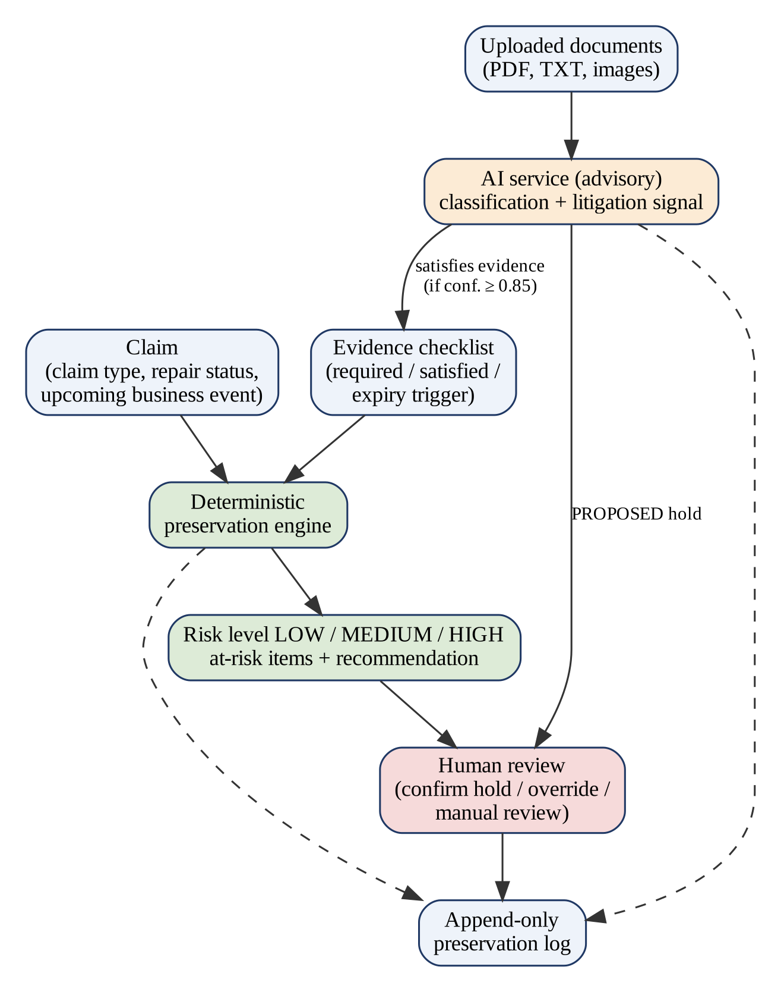
Fig. 1.1: Conceptual Overview of the Bona Fide Evidence-Preservation Workflow
A defining design decision is the separation between what is authoritative and what is advisory. The preservation risk is produced by pure, deterministic functions with no dependency on AI or on network services, so it is reproducible and explainable. Document classification and litigation detection are delegated to a separate AI service whose output can only influence the claim when it clears a confidence threshold, and even then it can never activate a preservation hold on its own. In this sense Bona Fide is a decision-support tool for claim handlers, not an autonomous decision-maker.

1.2 Problem Statement and Description
Claim handlers manage many open claims at once, and each claim moves through business events such as repair authorisation and closure. The evidence obligations attached to these events are usually implicit: they live in guidelines and in the experience of the adjuster rather than in the system. As a result, a repair can be authorised while pre-repair photographs or the appraisal are still outstanding, and the gap is noticed only when the evidence is needed. Separately, documents that signal a likely dispute, such as an attorney-representation letter or a records request, may arrive with other correspondence without triggering any preservation action.
The problem addressed by this project can therefore be stated as follows: to design and implement a system that, for each insurance claim, identifies required evidence that is still outstanding, determines which of it will become unrecoverable at the claim's next business event, expresses the resulting preservation risk in an explainable form, and supports document-driven preservation decisions with human oversight and a complete audit trail. The system should answer the following operational questions:
• Which evidence items does a claim of this type require, and which of them are satisfied?
• Which outstanding items are bound to the upcoming business event and are therefore at risk?
• How severe is the preservation risk, and what action is recommended before the event occurs?
• Does an uploaded document satisfy one of the outstanding evidence requirements?
• Does an uploaded document indicate possible litigation that warrants a preservation hold?
• Who confirmed a hold or overrode a preservation rule, when, and with what justification?
The scope of the problem is deliberately bounded. The prototype covers personal-auto claims with a fixed six-item evidence taxonomy and two expiry triggers, uses synthetic claim data only, and runs as a standalone web application. Integration with a production claims platform, authentication and enterprise deployment are outside the scope of this work and are discussed as future enhancements.

1.3 Motivation
The first motivation is the cost of irreversibility. Most claim-processing errors can be corrected later, but evidence lost to an authorised repair cannot. A system that raises a warning before the irreversible event, and states precisely which items are affected, shifts preservation from an after-the-fact concern to a routine check performed while there is still time to act.
The second motivation is trust in automation. Machine-learning techniques have long been applied to insurance claims, for example to automobile claim fraud detection [4], and large language models now make it easy to classify free-text documents. However, model outputs can be wrong or overconfident, and in a workflow with legal significance an incorrect automated action is costly. Published guidance on human-AI interaction recommends making clear what a system can do, how well it does it, and supporting efficient correction and dismissal [5]. Bona Fide is motivated by the goal of combining useful AI assistance with deterministic rules and explicit human checkpoints rather than replacing human judgement.
The third motivation is accountability. When a hold is confirmed or a preservation rule is overridden, the reasons and the actor need to be recorded so that the decision can be reviewed later. Finally, the project offered the team a practical setting in which to apply software-engineering practice, including layered architecture, schema migrations, transactional design and automated testing, to a domain problem connected to the Guidewire InsuranceSuite ecosystem.

1.4 Sustainable Development Goal of the Project
The project relates most closely to United Nations Sustainable Development Goal 16, which calls for access to justice for all and for effective, accountable and inclusive institutions [6]. Preserving relevant evidence supports fair resolution of disputes, and a traceable record of preservation decisions supports institutional accountability within an insurer.
This connection is indirect and should not be overstated. Bona Fide has not been deployed and its effect on dispute outcomes, institutional accountability or access to justice has not been measured. The SDG alignment is therefore presented as the intended area of contribution of the design, not as a demonstrated outcome.

1.5 Aim of the Project
The aim of the project is to design, implement and test a prototype evidence-preservation layer for personal-auto insurance claims that computes an explainable, deterministic preservation risk for every claim, uses AI only as advisory input for document classification and litigation detection, keeps a human in control of every preservation hold and override, and records all significant actions in an append-only audit trail.

1.6 Objectives of the Project
The objectives derived from this aim are listed in Table 1.1. Each objective is traced to its implementation in later chapters.
Table 1.1: Project Objectives
No. | Objective | Realised in
O1 | Represent claims and a configurable evidence taxonomy that maps each evidence type to an expiry trigger. | Sections 3.1, 4.3
O2 | Identify missing evidence (required and unsatisfied) for every claim. | Section 4.4.1
O3 | Identify at-risk evidence whose expiry trigger matches the claim's upcoming business event and classify risk as LOW, MEDIUM or HIGH. | Sections 3.1, 4.4.1
O4 | Accept document uploads safely (type allow-list, signature check, size limit) and extract text from PDF and TXT files. | Sections 3.4, 5.2
O5 | Classify documents into the evidence taxonomy and detect litigation signals through a replaceable AI provider layer with a deterministic fallback. | Sections 3.2, 5.3
O6 | Route low-confidence or unavailable AI results to manual review and prevent them from changing claim state. | Section 4.4.3
O7 | Support a preservation-hold workflow in which AI can only propose and a human must confirm. | Section 4.4.5
O8 | Support justified, attributed overrides of a preservation rule. | Section 5.2
O9 | Record every significant action in an append-only preservation log exposed as a claim timeline. | Sections 4.3, 5.2
O10 | Verify behaviour with automated unit, API and component tests. | Section 6.2

1.7 Scope of the Project
The implemented scope of the current prototype comprises the following capabilities, each of which was verified against the source code of the project repository:
• Claim listing, claim detail and creation of new PersonalAuto claims, with the six-item evidence checklist generated automatically from the evidence taxonomy.
• Deterministic preservation analysis (missing evidence, at-risk evidence, risk level, explanation and recommendation), available read-only and as an audited action.
• Document intake through pasted text or real file upload (JPG, JPEG, PNG, WebP, PDF and TXT up to 10 MB), with PDF text extraction, an optional OCR fallback for scanned PDFs and regular-expression findings for repair cost and incident date.
• Document classification and litigation-signal detection through a standalone AI service with a deterministic keyword provider and an optional Ollama language-model provider.
• Optional image analysis of vehicle photographs through an Ollama vision model, disabled by default.
• Preservation holds with PROPOSED and ACTIVE states, manual or AI-triggered proposal and human confirmation.
• Justified overrides, soft deletion of documents with deletion safeguards, and an append-only preservation log rendered as a timeline.
• A React web interface, two FastAPI services, PostgreSQL persistence managed by Alembic migrations, and local file storage behind a storage abstraction.
The following are explicitly outside the implemented scope: user authentication and server-enforced authorisation, a release transition for preservation holds (the RELEASED state exists in the data model but no operation produces it), tamper-evident or cryptographically protected logging, multi-tenant or cloud deployment, and any integration with Guidewire ClaimCenter or another production claims platform. The repository's architecture document lists authentication, cloud deployment and real Guidewire integration as out of scope for the MVP.

1.8 Significance of the Project
The significance of Bona Fide lies less in any single algorithm than in the way the parts are combined. Evidence requirements are tied to the business events that destroy them, so preservation risk becomes a property that can be computed and displayed for every claim, rather than a judgement made under time pressure. The deterministic engine makes that risk reproducible and easy to explain to a reviewer, because the result can be traced to a specific list of outstanding items and a specific event.
The project also demonstrates a defensible pattern for introducing AI into a regulated workflow: the AI service is stateless and replaceable, it reports which provider produced each answer, it fails open to manual review, and it is structurally prevented from activating a hold. This asymmetry, in which AI failures degrade gracefully while preservation rules fail closed, is applicable well beyond insurance. Its practical value, however, still needs to be established through evaluation on representative data and feedback from claims professionals, as discussed in Chapters 6 and 7.

CHAPTER 2
LITERATURE SURVEY

2.1 Overview of the Research Area
Bona Fide sits at the intersection of several established areas: the legal and operational practice of evidence preservation, rule-based decision systems, automated document classification and text extraction, large language models, human-in-the-loop AI, audit logging, and the architecture of data-centric web applications. This chapter reviews representative literature and documentation in each area, identifies the limitations that motivated the design, and then presents the research objectives, product backlog and project roadmap.
The legal backdrop is the duty to preserve. The Sedona Conference commentary on legal holds discusses when the duty to preserve is triggered, typically when litigation is reasonably anticipated, and how organisations should implement holds through a defined, documented process [3]. Rule 37(e) of the U.S. Federal Rules of Civil Procedure addresses the consequences of failing to take reasonable steps to preserve electronically stored information [2]. The Electronic Discovery Reference Model places preservation as an early stage in the discovery lifecycle, after information governance and identification [7]. These sources concern electronically stored information; physical evidence such as a damaged vehicle raises a related but distinct problem, because ordinary business events, not deletion, are what destroy it.

2.2 Existing Models and Frameworks

2.2.1 RULE-BASED DECISION SYSTEMS
Rule-based systems represent knowledge as explicit condition-action rules that are evaluated against facts. Hayes-Roth surveyed their structure and applications and noted that their transparency makes them suitable where decisions must be justified [8], and the MYCIN programme showed how rule-based reasoning can be combined with explanation facilities [9]. Modern AI texts continue to present logical and rule-based agents as the appropriate approach when domain knowledge can be stated precisely [10]. The limitation is equally well known: a rule-based system is only as complete as its rules and does not generalise to situations its authors did not anticipate.
For evidence preservation, the relevant rules are simple and stable: an item is at risk if it is required, unsatisfied and bound to the imminent event. This makes the rule-based approach a natural fit for the authoritative part of Bona Fide, while acknowledging that the rule set (the evidence taxonomy and trigger map) must be curated by domain experts.

2.2.2 DOCUMENT CLASSIFICATION
Automated text categorisation assigns documents to predefined classes. Sebastiani's survey describes the progression from manually written rules to inductive machine-learning classifiers and discusses document representation, classifier construction and evaluation using precision, recall and related measures [11]. For scanned business documents, deep convolutional networks trained on page images have been evaluated on large document-image benchmarks [12], and LayoutLM showed that jointly modelling text and its two-dimensional layout improves document understanding tasks such as form and receipt analysis [13].
These learned approaches need labelled training data that a student prototype working with synthetic claims does not have. A keyword-based classifier is weaker on unseen phrasing but requires no training data, is fully deterministic and can be inspected line by line. Bona Fide therefore uses a keyword provider as its always-available baseline and treats model-based classification as an optional, replaceable provider.

2.2.3 TEXT EXTRACTION AND OPTICAL CHARACTER RECOGNITION
Before a document can be classified its text must be available. Born-digital PDF files carry an embedded text layer that libraries such as PyMuPDF can extract directly [14]. Scanned documents contain only images and require optical character recognition; the Tesseract engine, described by Smith, performs line finding, word recognition and adaptive classification to convert page images to text [15]. OCR accuracy depends on scan quality, resolution and layout, so extracted text from scans is less reliable than an embedded text layer.

2.2.4 LARGE LANGUAGE MODELS
The transformer architecture [16] underlies modern language models. Pre-trained encoders such as BERT achieved strong results on classification after task-specific fine-tuning [17], and large generative models were shown to perform many tasks from instructions and a few examples without fine-tuning [18]. Open-weight model families such as Qwen2.5 [19] can be run locally through tools such as Ollama, which exposes a simple HTTP generation API with an option to request JSON-formatted output [20]. Visual instruction tuning (LLaVA) extended this capability to images [21].
Two properties of such models are important for a preservation workflow. First, they can produce fluent but unsupported content, a phenomenon surveyed under the term hallucination [22]. Second, the confidence scores attached to neural network predictions are frequently miscalibrated, so a stated confidence of 0.9 does not imply a 90 percent probability of being correct [23]. Both properties argue for validating model output against a fixed label set and for keeping a human checkpoint before any consequential action.

2.2.5 HUMAN-IN-THE-LOOP PROCESSING
Human-in-the-loop machine learning integrates human judgement into the data, training or decision stages of an AI system; Mosqueira-Rey et al. review approaches ranging from active learning to interactive and machine-teaching settings [24]. At the interaction level, Amershi et al. propose guidelines such as making clear how well the system can do what it does, supporting efficient dismissal and correction, and scoping services when in doubt [5]. The NIST AI Risk Management Framework similarly emphasises human oversight, documentation and governance for AI systems whose outputs can affect people [25]. Bona Fide applies these ideas through confidence thresholds, a manual-review status and a propose-then-confirm hold workflow.

2.2.6 AUDIT LOGGING
Audit logs record who did what and when so that events can be reconstructed. NIST guidance on security log management covers log generation, protection, retention and analysis [26]. Because an attacker or insider may try to alter records, research has developed cryptographic techniques that make logs tamper-evident, from Schneier and Kelsey's forward-secure audit logs [27] to Crosby and Wallach's efficient history-tree structures [28]. An application-level append-only table, as used in Bona Fide, prevents modification through the application interface but does not by itself offer these cryptographic guarantees.

2.2.7 APPLICATION ARCHITECTURE
Enterprise applications are commonly organised into presentation, domain and data-source layers, with patterns such as service layers and repositories separating business logic from persistence [29]. Representational State Transfer defines the constraints of resource-oriented web interfaces [30]. Bona Fide follows these patterns: thin REST routes, a service layer that owns transaction boundaries, and a repository layer for data access. Table 2.1 summarises the approaches reviewed and their relevance to the project.
Table 2.1: Comparison of Existing Approaches and Their Relevance to Bona Fide
Approach | Strengths | Limitations | Use in Bona Fide
Rule-based decision systems [8,9] | Transparent, reproducible, explainable | Limited to the rules supplied; no generalisation | Authoritative preservation engine
Keyword text classification [11] | No training data; deterministic; inspectable | Sensitive to wording and synonyms | Default AI provider and fallback
Learned document classifiers [12,13] | High accuracy on large labelled sets | Need labelled data and training infrastructure | Not used; future work
PDF text extraction / OCR [14,15] | Recovers text from documents | OCR quality varies with scans | PyMuPDF extraction; optional OCR fallback
Large language models [18,19] | Flexible, instruction-following | Hallucination, miscalibrated confidence | Optional Ollama provider with label validation
Vision-language models [21] | Describe image content | Same reliability concerns as LLMs | Optional, off by default; never changes claim state
Human-in-the-loop [5,24] | Human correction of AI errors | Requires reviewer effort | Threshold, manual review, hold confirmation
Tamper-evident logging [27,28] | Detects log alteration | Additional cryptographic machinery | Not implemented; append-only table only

2.3 Limitations Identified from Literature Survey (Research Gaps)
The reviewed literature provides mature building blocks, but in the team's assessment it leaves a gap at their intersection. The points below are the team's interpretation of how these sources apply to the insurance setting; they are not findings reported by the cited authors, and they do not claim that every commercial claims product lacks such features.
• Event-bound physical evidence. Legal-hold literature focuses on electronically stored information and on litigation triggers [3,7]. It gives less attention to physical evidence whose loss is caused by routine business events such as repair authorisation.
• Explainable risk before the event. Learned classifiers and language models can label documents, but they do not express, for a specific claim, which required items will become unrecoverable at the next event; this is naturally a deterministic, rule-based computation.
• Trustworthy AI integration. Hallucination and miscalibration [22,23] mean that model output should not directly change preservation state. Few reference designs show how to make AI strictly advisory while keeping it useful.
• Accountable human decisions. HITL guidance [5,25] recommends oversight but leaves the concrete mechanics, such as propose-confirm states and justified overrides, to each application.
• Integrity of the record. Application audit tables are common, but tamper-evidence [28] requires additional work; a prototype should state this limitation explicitly.

2.4 Research Objectives
In response to these gaps the project set the following research and development objectives:
• RO1: Model evidence requirements together with the business event that expires each one, so that preservation risk is computable.
• RO2: Implement a deterministic, dependency-free engine that classifies preservation risk and explains its result in plain language.
• RO3: Integrate document classification and litigation-signal detection behind a provider abstraction with a deterministic fallback and truthful provider attribution.
• RO4: Enforce human oversight structurally, so that low-confidence or unavailable AI output cannot satisfy evidence and AI can never activate a hold.
• RO5: Record every consequential action in an append-only log and expose it as a claim timeline.
• RO6: Verify the behaviour of each layer through automated tests and a demonstration dataset covering every risk tier.

2.5 Product Backlog (Key User Stories with Desired Outcomes)
The product backlog in Table 2.2 lists the principal user stories. The status column records what the repository actually implements, which differs in a few places from what was originally planned.
Table 2.2: Product Backlog
ID | User story | Desired outcome | Priority | Status
PB-01 | As a claim handler, I want to see each claim's evidence checklist. | Required and satisfied evidence visible per claim | High | Implemented
PB-02 | As a claim handler, I want to know which evidence is at risk before the next event. | Risk level, at-risk list and recommendation | High | Implemented
PB-03 | As a claim handler, I want to create a new claim with its checklist generated automatically. | PersonalAuto claim with six evidence items | High | Implemented
PB-04 | As a user, I want to upload claim documents safely. | Validated file stored with metadata | High | Implemented
PB-05 | As a claim handler, I want uploaded documents classified and matched to evidence. | Evidence satisfied when confidence >= 0.85 | High | Implemented
PB-06 | As a reviewer, I want uncertain AI results flagged instead of applied. | MANUAL_REVIEW status, no state change | High | Implemented
PB-07 | As a claim handler, I want litigation letters to propose a preservation hold. | PROPOSED hold linked to the document | High | Implemented
PB-08 | As a supervisor, I want to confirm a proposed hold. | PROPOSED to ACTIVE with audit entry | High | Implemented
PB-09 | As a supervisor, I want to release a hold that is no longer needed. | ACTIVE to RELEASED with justification | Medium | Not implemented (data model only)
PB-10 | As a supervisor, I want to override a preservation rule with a justification. | Event applied, override logged | Medium | Implemented
PB-11 | As an auditor, I want a chronological record of all actions. | Append-only timeline per claim | High | Implemented
PB-12 | As a claim handler, I want photographs described for review. | Structured damage observations | Low | Implemented (optional, off by default)
PB-13 | As a user, I want to delete a mistaken upload without losing protected evidence. | Soft delete blocked by holds or satisfied evidence | Medium | Implemented
PB-14 | As an administrator, I want users authenticated and authorised. | Verified identities and roles | High (production) | Not implemented

2.6 Plan of Action (Project Road Map)
The repository's implementation plan (docs/IMPLEMENTATION_PLAN.md) organises the work into four stages labelled Day 1 to Day 4, and its checkboxes record which items were completed. The Git history contains two commits: the MVP covering Days 1 to 3 (27 September 2026) and a document-intelligence increment (29 September 2026). The Day 4 hardening items remain unchecked. Fig. 2.1 shows the resulting roadmap; Chapter 3 describes each completed stage as a sprint.
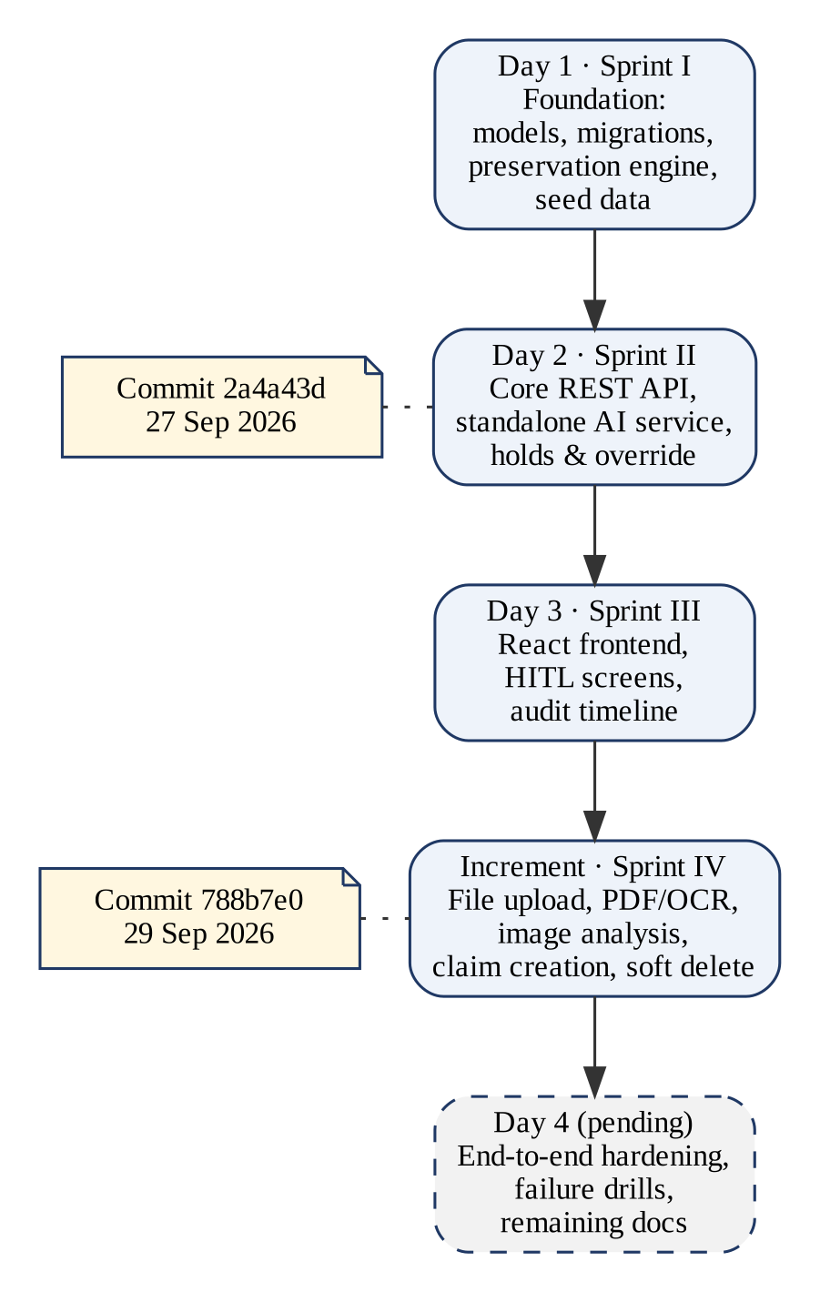
Fig. 2.1: Project Road Map
Table 2.3: Road Map Phases and Deliverables
Stage | Main deliverables | Recorded status
Day 1 / Sprint I | Project structure, PostgreSQL connectivity, SQLAlchemy models, Alembic initial migration, repositories, preservation engine, synthetic seed data, unit tests | Completed
Day 2 / Sprint II | FastAPI core application and schemas, storage abstraction, standalone AI service with deterministic and Ollama providers, fail-open AI client, two-transaction classification flow, hold and override workflow, API tests | Completed
Day 3 / Sprint III | React and Vite interface: claims dashboard, claim detail, document upload and classification, hold confirmation, override form, audit timeline, component tests | Completed (ClaimCenter gap page deferred)
Increment / Sprint IV | Claim creation, real file upload and validation, PDF extraction and OCR fallback, regex findings, image analysis, bulk analysis, soft delete | Committed 29 Sep 2026
Day 4 | Full end-to-end run, AI-service failure drill, larger dataset and performance check, remaining documentation | Not completed

CHAPTER 3
SPRINT PLANNING AND EXECUTION METHODOLOGY
Development followed an incremental, sprint-like methodology in which each increment delivered a working, tested slice of the system. The source of truth for this chapter is the repository: the implementation plan (docs/IMPLEMENTATION_PLAN.md), the locked architecture document (docs/ARCHITECTURE.md), the earlier audit documents and the Git history. The plan's Day 1 to Day 3 stages and the subsequent document-intelligence increment are presented here as Sprints I to IV.
Two qualifications apply. First, sprint dates beyond the two commit dates, meeting minutes, task assignments and formal review outcomes are not recorded in the repository and are therefore not reported. Second, the retrospectives below are written from the technical record, namely design decisions and trade-offs documented in the code comments and documents, rather than from minutes of retrospective meetings. Table 3.1 summarises the four sprints.
Table 3.1: Summary of Sprints
Sprint | Title | Key outcome | Evidence in repository
I | Foundation: data model and preservation engine | Schema, migrations, engine and seed claims; CLM-10042 evaluates to HIGH | IMPLEMENTATION_PLAN Day 1; commit 2a4a43d
II | Core API and standalone AI service | REST API, AI service, fail-open client, two-transaction classification, holds and overrides | IMPLEMENTATION_PLAN Day 2; commit 2a4a43d
III | Frontend and human-in-the-loop workflows | React dashboard, claim detail, hold confirmation, override and timeline screens | IMPLEMENTATION_PLAN Day 3; commit 2a4a43d
IV | Document intelligence | Claim creation, real file upload, PDF/OCR extraction, findings, image analysis, soft delete | Commit 788b7e0 (29 Sep 2026)

3.1 Sprint I - Foundation: Data Model and Preservation Engine

3.1.1 OBJECTIVES WITH USER STORIES OF SPRINT I
The objective of Sprint I was to establish the domain model and the deterministic core on which everything else depends. The user stories addressed were PB-01 (view the evidence checklist) and PB-02 (know which evidence is at risk before the next event). An early audit document had proposed SQLite accessed through Python's sqlite3 module; the locked architecture replaced this with PostgreSQL, SQLAlchemy and Alembic so that the schema would be versioned and the data model could grow. The sprint's acceptance criterion, recorded in the plan, was to migrate, seed and run the analysis on CLM-10042 and obtain HIGH risk with exactly three at-risk items.

3.1.2 FUNCTIONAL DOCUMENT
The functional requirements of Sprint I are FR-01 to FR-04 in Table 4.1. Each claim has an upcoming business event that may be empty. Each evidence item has a type, a required flag, a satisfied flag and an expiry trigger. The evidence taxonomy for PersonalAuto claims, defined once in app/evidence_taxonomy.py and reused by both the seed script and claim creation, is shown in Table 3.2. Five of the six items expire at RepairAuthorization; the police report expires at ClaimClosure.
Table 3.2: PersonalAuto Evidence Taxonomy and Expiry Triggers
Evidence type | Expiry trigger | Rationale
Vehicle Photographs | RepairAuthorization | Pre-repair condition is lost once repairs begin
Police Report | ClaimClosure | Remains obtainable until the claim is closed
Repair Appraisal | RepairAuthorization | Independent appraisal requires the unrepaired vehicle
Vehicle Inspection | RepairAuthorization | Physical inspection requires the unrepaired vehicle
Recorded Statement | RepairAuthorization | Configured to be captured before repair authorisation
Repair Estimate | RepairAuthorization | Estimate should precede authorisation of the repair

3.1.3 ARCHITECTURE DOCUMENT
Sprint I produced the persistence and domain layers shown in Fig. 3.1. SQLAlchemy 2.0 declarative models define the claims, evidence_items, documents, preservation_holds and preservation_logs tables [31], and the initial Alembic migration (revision 98b18e886683) creates them [32]. Enumerated values such as evidence types and triggers are stored as VARCHAR columns (non-native enums), so adding a taxonomy value is a code change rather than a database type alteration. A thin repository module provides data-access functions without business logic.
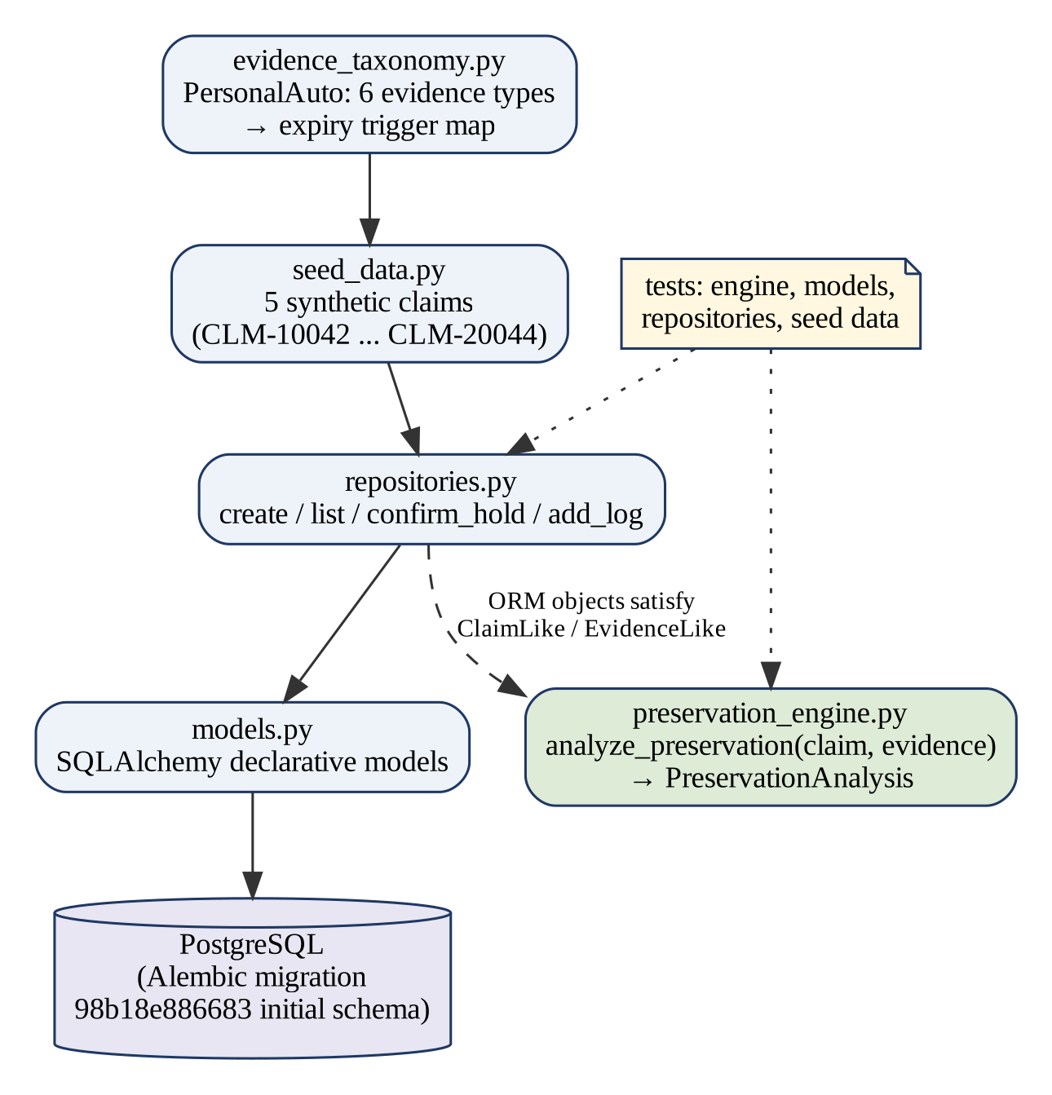
Fig. 3.1: Sprint I Module Structure
The preservation engine is deliberately isolated: it accepts any objects with the required attributes (expressed as typing Protocols) and returns an immutable PreservationAnalysis dataclass. It performs no database access, no network calls and no AI calls, which makes it trivially unit-testable and guarantees that AI availability can never influence the risk result.

3.1.4 OUTCOME OF OBJECTIVES / RESULT ANALYSIS
The synthetic seed script creates five fictional claims designed to cover every risk tier. Running the engine on this data produced the results in Table 3.3 (re-executed during preparation of this report against the repository's engine and seed definitions). CLM-10042 yields HIGH risk with Vehicle Photographs, Repair Appraisal and Recorded Statement at risk, which matches the sprint's acceptance criterion and the engine's unit test for this claim.
Table 3.3: Preservation Engine Results on the Seed Claims
Claim | Upcoming event | Missing | At risk | Risk
CLM-10042 | RepairAuthorization | 3 | 3 (Photographs, Appraisal, Statement) | HIGH
CLM-20011 | None | 0 | 0 | LOW
CLM-20022 | RepairAuthorization | 1 | 1 (Repair Appraisal) | MEDIUM
CLM-20033 | RepairAuthorization | 3 | 3 (Photographs, Appraisal, Inspection) | HIGH
CLM-20044 | ClaimClosure | 0 | 0 (ACTIVE hold seeded) | LOW

3.1.5 SPRINT RETROSPECTIVE
Keeping the engine pure proved valuable: its six unit tests run without a database, and later sprints could not accidentally couple risk calculation to AI. A recorded design decision was that a claim with no upcoming event is always LOW, even if evidence is missing, because nothing is imminently irreversible; missing evidence is still reported separately. The main limitation carried forward is that risk is a count of items rather than a weighted measure, so every item counts equally regardless of its importance to a particular claim.

3.2 Sprint II - Core API and Standalone AI Service

3.2.1 OBJECTIVES WITH USER STORIES OF SPRINT II
Sprint II exposed the domain through a REST API and introduced AI assistance without compromising the deterministic core. It addressed PB-05 (classify documents and match them to evidence), PB-06 (flag uncertain AI results), PB-07 (propose holds from litigation letters), PB-08 (confirm holds), PB-10 (justified overrides) and PB-11 (chronological record).

3.2.2 FUNCTIONAL DOCUMENT
Table 3.4 lists the API endpoints of the core application as they exist in backend/app/api.py at the end of the project; endpoints marked IV were added in Sprint IV. All request and response bodies are Pydantic models [33], so ORM objects are never returned directly, and domain exceptions are translated centrally into HTTP status codes 404, 409, 413 and 415.
Table 3.4: Core REST API Endpoints (prefix /api/claims)
Method | Path | Purpose | Sprint
GET / POST | / | List claims / create a PersonalAuto claim with evidence checklist | II / IV
GET | /{claim_id} | Claim detail | II
GET | /{claim_id}/evidence | Evidence checklist | II
GET / POST | /{claim_id}/analysis | /analyze | Preservation analysis (read-only / audited) | II
GET | /{claim_id}/timeline, /preservation-log | Append-only event log | II
GET / POST | /{claim_id}/documents | List documents / add pasted-text document | II
POST | /{claim_id}/documents/{id}/classify | AI classification and litigation detection | II
GET / POST | /{claim_id}/holds | List holds / propose a manual hold (always PROPOSED) | II
POST | /{claim_id}/holds/{hold_id}/confirm | Only transition to ACTIVE | II
POST | /{claim_id}/override | Justified override of the upcoming event | II
POST | /{claim_id}/documents/upload | Multipart file upload | IV
GET | /{claim_id}/documents/{id}/file | Stream stored file | IV
POST | /{claim_id}/documents/{id}/analyze, /analyze-image | Dispatch analysis by MIME type; vision analysis | IV
POST | /{claim_id}/documents/analyze-all | Sequential bulk analysis with per-item isolation | IV
DELETE | /{claim_id}/documents/{id} | Soft delete with safeguards | IV

The AI service exposes POST /classify-document, POST /detect-litigation-signal, POST /analyze-image (Sprint IV) and GET /health. It owns no claim state and no database; it receives text or an image and returns a label, a confidence and the name of the provider that produced the result.

3.2.3 ARCHITECTURE DOCUMENT
The central architectural rule of Sprint II is that no database transaction is held open while waiting for the AI service. Classification is therefore split into two short transactions around the network call, as shown in Fig. 3.2. The first marks the document PROCESSING, which also acts as a guard against duplicate concurrent requests (HTTP 409). The AI calls then happen with no transaction open. The second transaction applies all consequences atomically: the classification, any evidence satisfaction, any proposed hold and the corresponding log entries either all commit or all roll back.
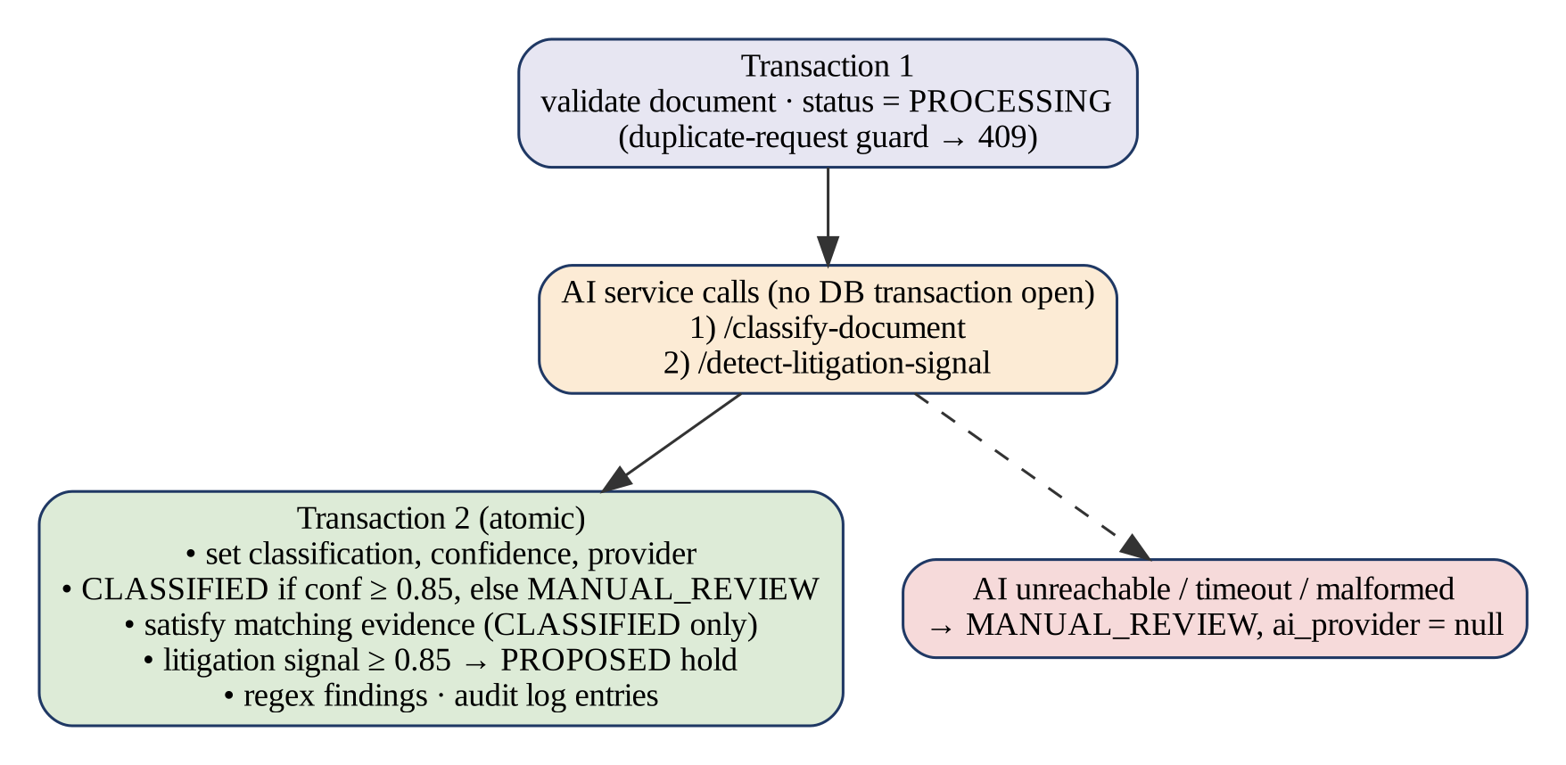
Fig. 3.2: Two-Transaction Document Classification Workflow
The core application's AI client uses a two-second timeout and no retries, and converts every failure class (connection refused, timeout, non-2xx response, malformed or missing JSON fields) into an 'unavailable' result rather than an exception. The asymmetry is intentional and documented in the architecture: AI failures fail open to manual review, while the preservation rules fail closed because they do not depend on AI at all.

3.2.4 OUTCOME OF OBJECTIVES / RESULT ANALYSIS
The plan records that Sprint II was completed with 52 backend and 7 AI-service tests passing against a real PostgreSQL instance, and with a manual demonstration on CLM-10042 covering upload, classification, evidence satisfaction, a litigation letter producing a PROPOSED hold, confirmation to ACTIVE, an override and the resulting audit trail. These figures are the team's own record in the repository; they were not re-executed for this report. The behaviour of the deterministic provider on representative texts is analysed in Section 6.1.

3.2.5 SPRINT RETROSPECTIVE
Running the AI service as a separate process added deployment effort but kept the boundary clean: the service can be replaced, scaled or moved without touching claim state. Recording the provider on every result avoided a subtle honesty problem, namely presenting a keyword match as a model output. A configuration subtlety was identified in the code: the AI service's own Ollama timeout (1 s) must remain below the core client's timeout (2 s), otherwise a fallback that would succeed is reported as unavailable. A limitation is that the code default for the Ollama URL points at a local instance, whereas the example environment file disables it; teams running the service must set this deliberately.

3.3 Sprint III - Frontend and Human-in-the-Loop Workflows

3.3.1 OBJECTIVES WITH USER STORIES OF SPRINT III
Sprint III made the workflow usable by a claim handler. It delivered the user-facing parts of PB-01, PB-02, PB-06, PB-07, PB-08, PB-10 and PB-11: a claims dashboard with risk badges, a claim detail page with risk banner and checklist, document classification results, hold confirmation, the override form and the audit timeline.

3.3.2 FUNCTIONAL DOCUMENT
The frontend is a React 18 single-page application built with Vite [34,35] and React Router. A key functional rule is that the frontend never recalculates risk or evidence status: the risk banner renders the backend's analysis verbatim, and the checklist derives each row's label (SATISFIED, AT RISK or MISSING) only from the satisfied flag and the backend's at-risk list. Validation of overrides (non-blank user and role, justification of at least ten characters) is enforced by the backend and the form simply displays the backend's messages.

3.3.3 ARCHITECTURE DOCUMENT
Fig. 3.3 shows the component hierarchy. All HTTP communication passes through a single module, api/client.js, which wraps fetch, sets JSON headers except for multipart uploads, converts error bodies into an ApiError with a readable message, and reports an unreachable backend explicitly. The claim detail page loads the claim, evidence, analysis, holds, documents and log in parallel and refreshes them after every mutation.
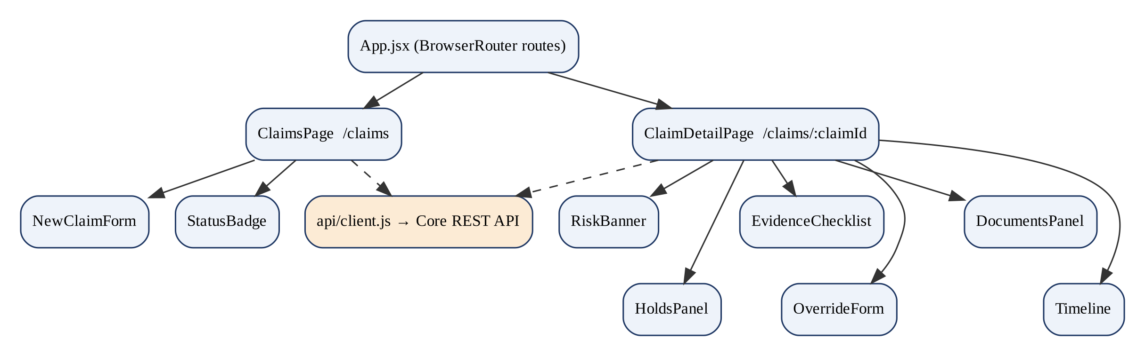
Fig. 3.3: Frontend Component Hierarchy

3.3.4 OUTCOME OF OBJECTIVES / RESULT ANALYSIS
The plan records 19 passing frontend tests (Vitest and Testing Library) at the end of Sprint III and a manual run of the demonstration in a headless browser with screenshots captured at each step; those screenshots are not stored in the repository. The repository now contains 38 frontend test cases across eight test files following later changes. A planned ClaimCenter integration-gap page was deferred and is not present in the code.

3.3.5 SPRINT RETROSPECTIVE
Keeping all business logic on the server simplified the frontend and its tests. The prototype's lack of authentication is visible in the interface: hold confirmation sends a fixed demonstration user name (adjuster.demo) and the override form states that user and role are captured as supplied, not verified. A further gap is that the API supports manual hold proposal but the interface offers no control for it.

3.4 Sprint IV - Document Intelligence

3.4.1 OBJECTIVES WITH USER STORIES OF SPRINT IV
The final increment, committed on 29 September 2026, replaced the text-paste demonstration path with real document handling and broadened the workflow. It addressed PB-03 (create claims), PB-04 (safe upload), PB-12 (photograph description) and PB-13 (safe deletion), and extended PB-05 to PDF and TXT files.

3.4.2 FUNCTIONAL DOCUMENT
Uploaded files are validated by extension and by file signature, limited to 10 MB, hashed with SHA-256 and stored under a generated path. PDF text is extracted with PyMuPDF; if fewer than 20 characters are found, an OCR fallback is attempted when the optional pytesseract package and Tesseract binary are installed, and otherwise the document is marked FAILED for manual review. Regular expressions extract an estimated repair cost and an incident date as findings, each either a genuine match or null. Images can be analysed by an optional vision model, whose findings never satisfy evidence or affect holds. Documents are soft-deleted, and deletion is refused while the document supports a proposed or active hold or satisfies required evidence.

3.4.3 ARCHITECTURE DOCUMENT
Three Alembic migrations extend the schema: file metadata on documents (38755030c7dc), the image_analyses table and image-analysis status (baebeaf3f4be), and document deletion fields, findings and the hold-to-document link (31eb53d6299b). The storage layer is an abstract StorageBackend with one local-filesystem implementation, so object storage could be added as a new class without changing callers. The image-analysis pipeline reuses the same two-transaction pattern as text classification (Fig. 5.2).

3.4.4 OUTCOME OF OBJECTIVES / RESULT ANALYSIS
The increment added test files for claim creation, evidence management, file upload, image analysis, the AI client and vision handling. Signature validation, findings extraction and the deterministic classifier were exercised directly for this report; the results are reported in Chapter 6. The vision path was not exercised because no vision model was configured, which is the shipped default.

3.4.5 SPRINT RETROSPECTIVE
The increment substantially improved realism while preserving the safety rules established earlier: every new AI path fails to manual review and none can change preservation state. Remaining gaps identified from the code are that OCR is only a fallback for scanned PDFs (uploaded images are not OCR-processed), that image files have no deterministic fallback, and that the Day 4 hardening tasks (end-to-end failure drill, larger dataset, performance check and remaining documentation) were not completed.

CHAPTER 4
SYSTEM DESIGN AND ARCHITECTURE

4.1 Functional Document
This section consolidates the functional and non-functional requirements of the system as implemented. Table 4.1 lists the functional requirements together with the module that satisfies each one.
Table 4.1: Functional Requirements
ID | Requirement | Implementation
FR-01 | Store claims with type, status, repair status and upcoming business event | models.Claim, repositories
FR-02 | Generate the evidence checklist from the taxonomy on claim creation | services.create_claim_with_evidence
FR-03 | Compute missing and at-risk evidence and a LOW/MEDIUM/HIGH risk level | preservation_engine.analyze_preservation
FR-04 | Provide read-only and audited analysis | GET /analysis, POST /analyze
FR-05 | Accept pasted text and validated file uploads (<= 10 MB) | file_validation, services.upload_real_file
FR-06 | Extract PDF/TXT text with optional OCR fallback and regex findings | document_extraction
FR-07 | Classify documents into the evidence taxonomy | AI service /classify-document
FR-08 | Detect litigation signals | AI service /detect-litigation-signal
FR-09 | Satisfy evidence only for CLASSIFIED results (confidence >= 0.85) | services._maybe_satisfy_evidence
FR-10 | Propose a hold for litigation signals with confidence >= 0.85 | services._apply_litigation
FR-11 | Confirm holds (PROPOSED to ACTIVE only) | repositories.confirm_hold
FR-12 | Apply justified overrides of the upcoming event | services.apply_override
FR-13 | Soft-delete documents with hold and evidence safeguards | services.delete_document
FR-14 | Record every significant action in an append-only log | repositories.add_log
FR-15 | Optionally analyse vehicle photographs (advisory only) | services.analyze_image, AI /analyze-image

Table 4.2: Non-Functional Requirements
ID | Requirement | How it is addressed
NFR-01 | Explainability | Engine returns at-risk items, explanation and recommendation in plain language
NFR-02 | Determinism and safety | Risk computed by pure functions; AI cannot affect it
NFR-03 | Resilience to AI failure | 2 s timeout, fail-open client, MANUAL_REVIEW status
NFR-04 | Data integrity | Atomic second transaction; no transaction across network calls
NFR-05 | Maintainability | Layered routes/services/repositories; provider and storage abstractions
NFR-06 | Schema evolution | Alembic migrations; non-native enums
NFR-07 | Upload safety | Allow-list, signature check, size limit, sanitised generated paths
NFR-08 | Traceability | Append-only log; provider recorded on AI results
NFR-09 | Security (production) | Not met: authentication, authorisation and log integrity are future work

4.2 Architecture Document
Bona Fide consists of three deployable parts and two storage systems, as shown in Fig. 4.1. The React frontend communicates with the core application over REST. The core application owns the database and the document store and is the only component that changes claim state. The AI service is stateless; it is called by the core application over HTTP and never accesses the database.
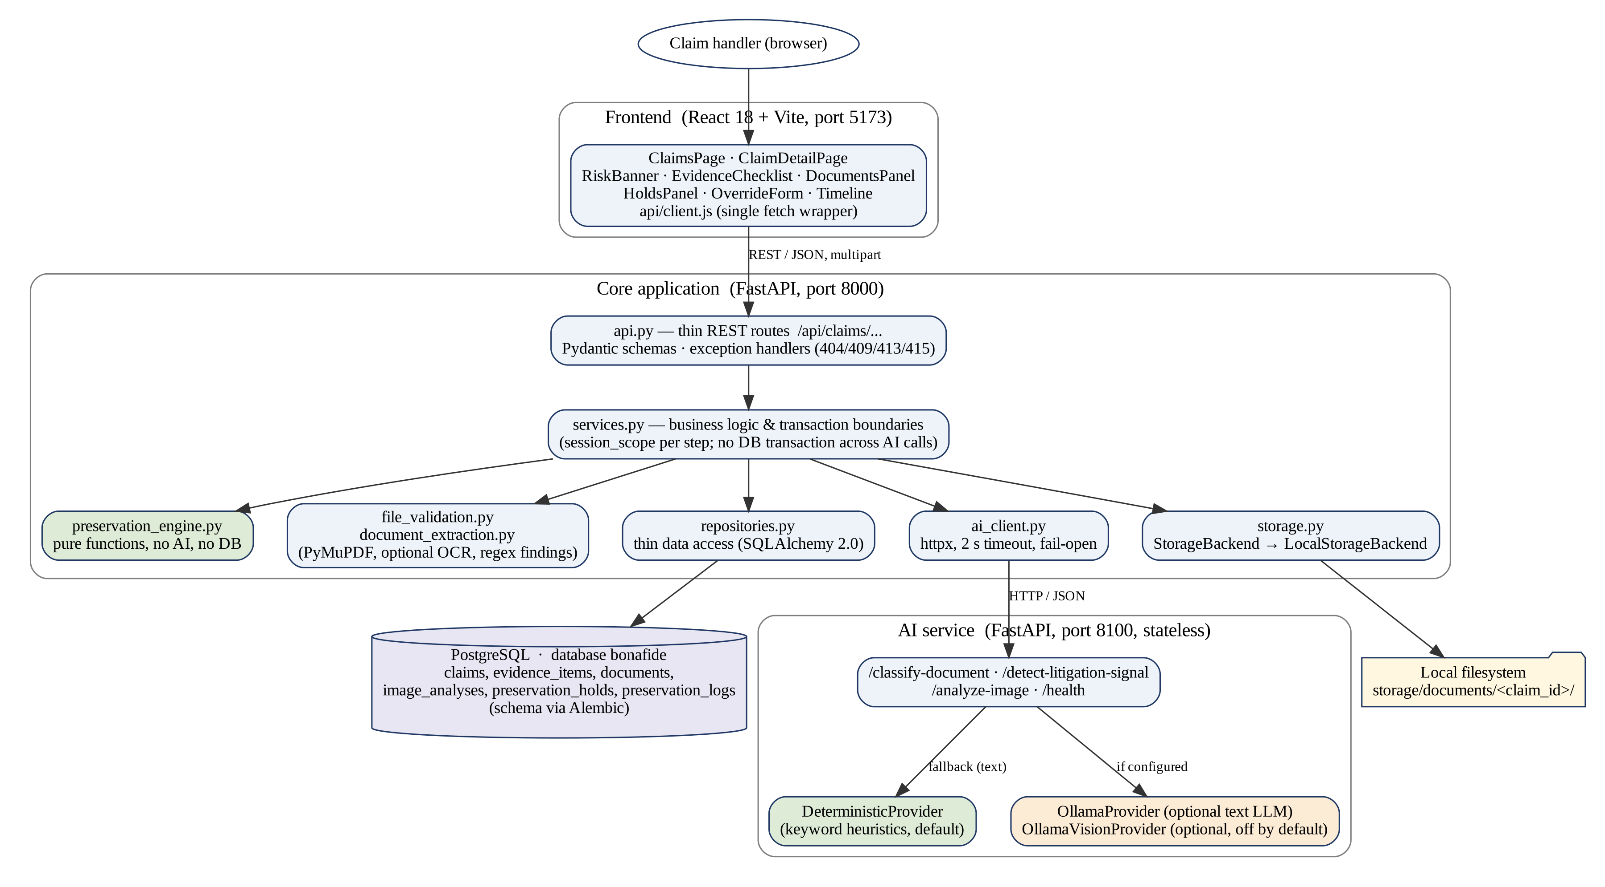
Fig. 4.1: Overall System Architecture of Bona Fide

4.2.1 FRONTEND LAYER
The frontend (React 18, React Router 6, Vite 5) renders two routes, /claims and /claims/:claimId, and delegates all data access to api/client.js. Its base URL is configured through the VITE_API_BASE_URL environment variable.

4.2.2 CORE APPLICATION LAYER
The core application is a FastAPI service [36] organised into thin routes (api.py), a service layer (services.py) that owns transaction boundaries through a session_scope context manager, a repository layer (repositories.py), the pure preservation engine, file validation and extraction modules, the AI client and the storage abstraction. CORS is restricted to configured frontend origins.

4.2.3 AI SERVICE LAYER
The AI service is a second FastAPI application. For text it tries the Ollama provider when an Ollama URL is configured and falls back to the deterministic provider on any failure; every response states which provider produced it. For images there is no deterministic fallback: if no vision provider is configured or it fails, the service returns HTTP 503 with a sanitised reason code such as not_configured or timeout.

4.2.4 DATA AND STORAGE LAYER
PostgreSQL [37] stores structured data, with JSONB used for audit detail, findings and damage regions. Document bytes are never stored in the database; LocalStorageBackend writes them under storage/documents/<claim_id>/ with a random prefix and a sanitised file name. Table 4.3 lists the technology stack with versions taken from the dependency files.
Table 4.3: Technology Stack
Layer | Technology (version) | Purpose
Frontend | React 18.3, React Router 6.28, Vite 5.4 | User interface, routing, build
Frontend tests | Vitest 2.1, Testing Library, jsdom | Component and page tests
Core API | FastAPI 0.115, Uvicorn 0.34, Pydantic 2.10 | REST endpoints and validation
Persistence | PostgreSQL, SQLAlchemy 2.0.36, psycopg 3.2, Alembic 1.14 | Relational storage, ORM, migrations
Document processing | PyMuPDF 1.25; optional pytesseract + Tesseract | PDF text extraction, OCR fallback
AI service | FastAPI 0.115, httpx 0.28 | Classification, litigation and vision endpoints
Optional models | Ollama with qwen2.5:7b (text), llava (vision) | Locally hosted LLM and vision model
Testing | pytest 8.3, pytest-cov 6.0 | Backend and AI-service tests

4.3 Database Design
The schema contains six tables, shown in the entity-relationship diagram of Fig. 4.2 and described in Table 4.4. All tables except claims use integer surrogate keys; claims use the business identifier (for example CLM-10042) as primary key. Deleting a claim cascades to its dependent rows at the ORM level, while documents themselves are only ever soft-deleted by the application.
Table 4.4: Database Tables and Their Purpose
Table | Purpose | Key relationships
claims | Claim header, repair status and upcoming business event | Parent of all other tables
evidence_items | One row per required evidence type with satisfaction state and expiry trigger | claim_id; satisfying_document_id
documents | Metadata, extracted text, classification, litigation signal, statuses, findings, tombstone | claim_id
image_analyses | Structured vision findings (one per image document) | document_id (unique), claim_id
preservation_holds | Hold status, trigger reason and source, confidence, release fields | claim_id; document_id (nullable)
preservation_logs | Append-only audit events with actor, justification and JSON detail | claim_id

The documents table carries two independent status fields: classification_status for text (PENDING, PROCESSING, CLASSIFIED, MANUAL_REVIEW, FAILED) and image_analysis_status for images (NOT_APPLICABLE, PENDING, PROCESSING, ANALYZED, MANUAL_REVIEW, FAILED). The audit table accepts twelve event types: CLAIM_CREATED, ANALYSIS_RUN, DOCUMENT_UPLOADED, DOCUMENT_CLASSIFIED, IMAGE_ANALYZED, EVIDENCE_SATISFIED, LITIGATION_SIGNAL_DETECTED, HOLD_PROPOSED, HOLD_CONFIRMED, HOLD_RELEASED, OVERRIDE_APPLIED and DOCUMENT_DELETED. HOLD_RELEASED is defined but never written, because no release operation exists.
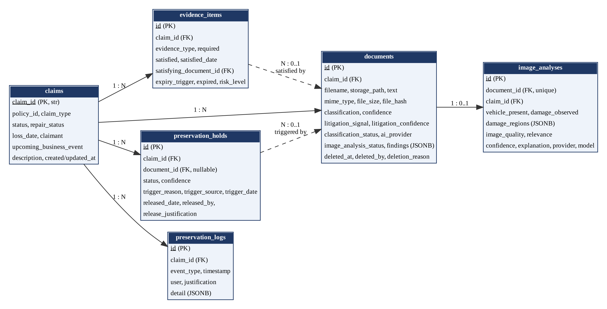
Fig. 4.2: Entity-Relationship Diagram

4.4 Algorithms and Workflow

4.4.1 EVIDENCE-PRESERVATION RISK ASSESSMENT
Let E be the set of evidence items of a claim and t the claim's upcoming business event. The engine first computes the missing set M = {e in E : e.required and not e.satisfied}. If t is empty, the at-risk set A is empty; otherwise A = {e in M : e.expiry_trigger = t}. With N = |A|, the risk level is HIGH if N >= 2, MEDIUM if N = 1 and LOW if N = 0. The thresholds are module constants and are not tunable at runtime. Fig. 4.3 shows the procedure and Table 4.5 the mapping.
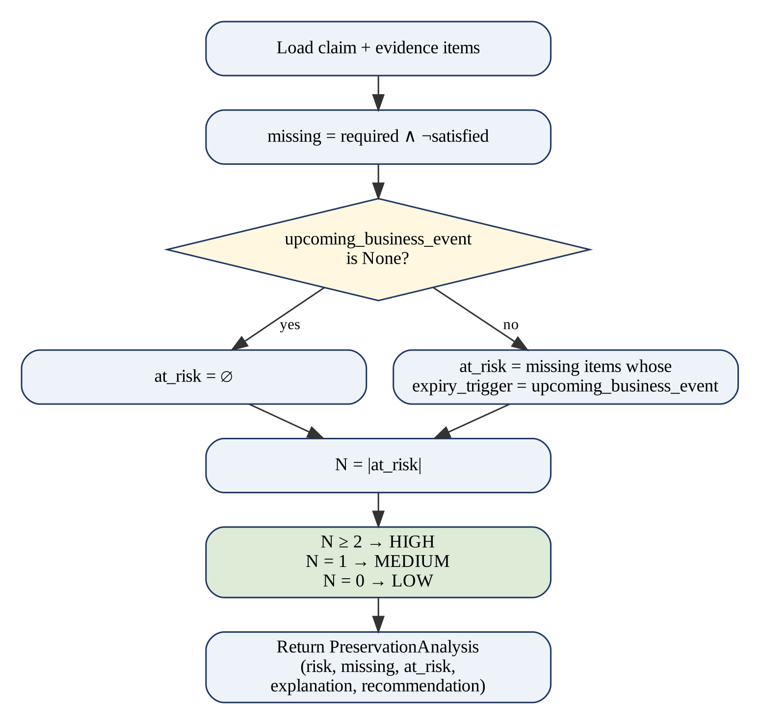
Fig. 4.3: Preservation Risk Assessment Algorithm
Table 4.5: Evidence Risk Classification
At-risk items (N) | Risk level | Recommendation produced
0 | LOW | No preservation action required at this time.
1 | MEDIUM | Preserve the following evidence before <event> occurs: <item>.
2 or more | HIGH | Preserve the following evidence before <event> occurs: <items>.

The result is a business rule, not a probability of loss. Its algorithmic cost is linear in the number of evidence items, which is six for a PersonalAuto claim. For example, with all six items missing and an upcoming ClaimClosure event, only the Police Report matches the trigger, so the risk is MEDIUM; the same evidence state with RepairAuthorization pending would be HIGH.

4.4.2 DOCUMENT UPLOAD AND TEXT EXTRACTION
Fig. 4.4 shows the upload pipeline. The size check precedes validation. Validation accepts only the extensions .jpg, .jpeg, .png, .webp, .pdf and .txt, and checks the leading bytes of binary types (FF D8 FF for JPEG, the eight-byte PNG signature, %PDF for PDF, and RIFF....WEBP for WebP); TXT files must decode as UTF-8 and contain no null bytes. The client-supplied content type is never trusted, following OWASP file-upload guidance [38].
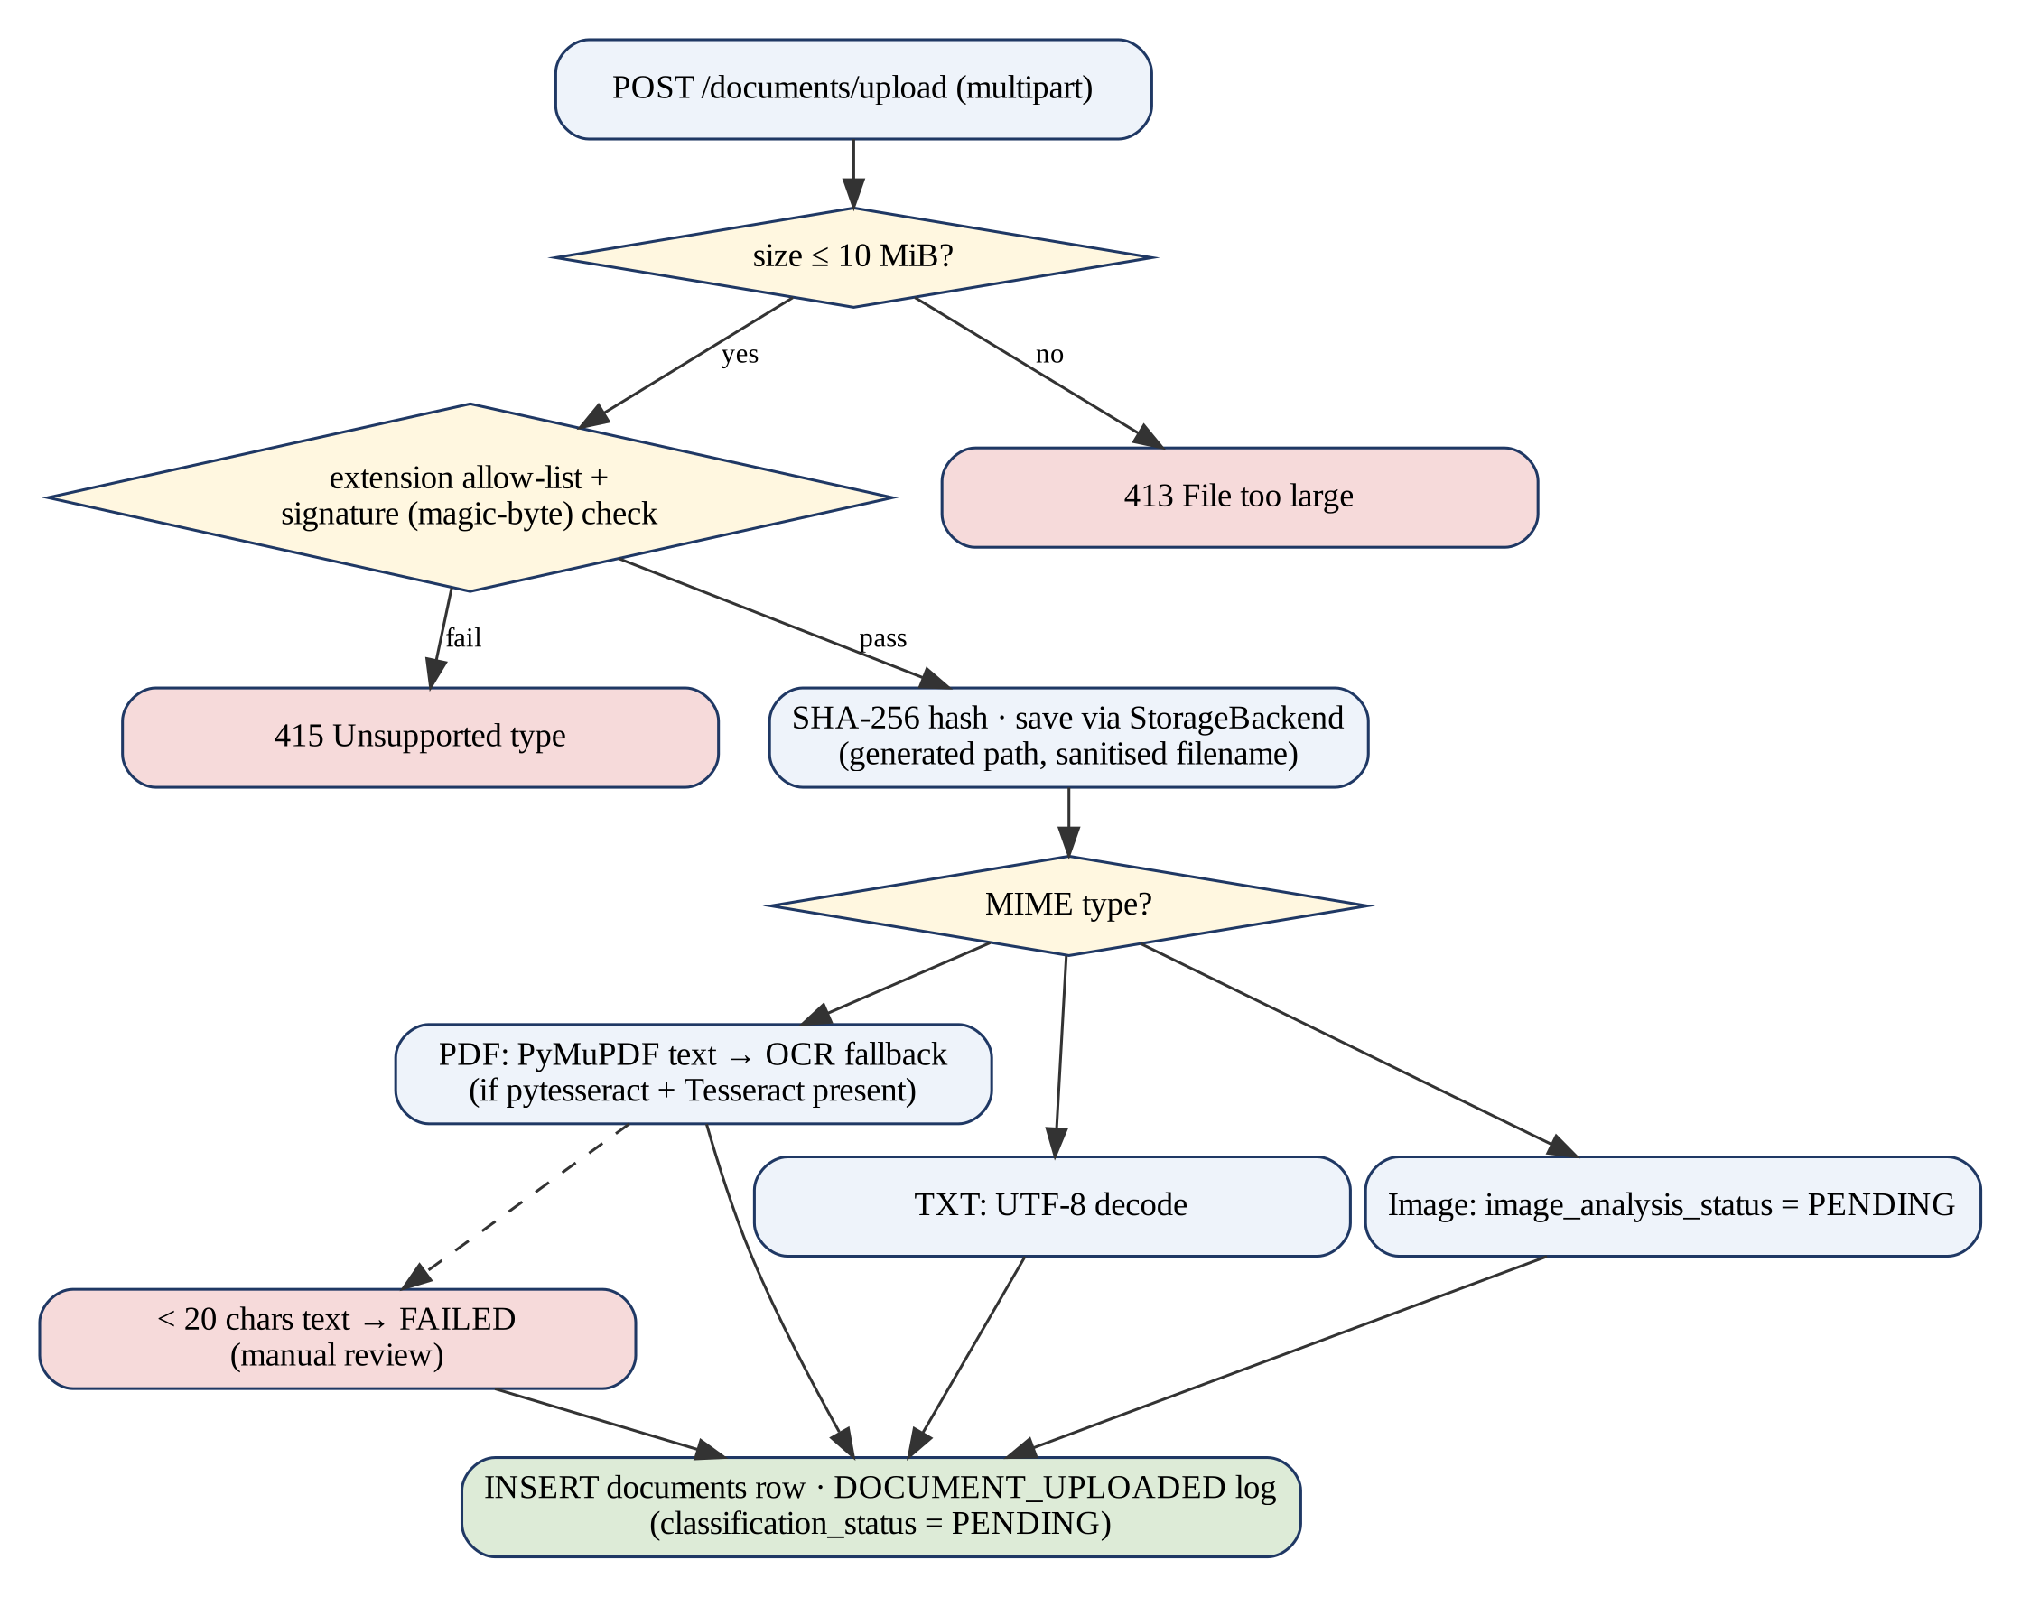
Fig. 4.4: Document Upload and Extraction Pipeline

4.4.3 DOCUMENT CLASSIFICATION AND HUMAN REVIEW
The deterministic provider lower-cases the text and counts, for each class, how many of that class's configured phrases occur in it; the class with the highest positive count wins. With M matching phrases the classification confidence is min(0.55 + 0.15M, 0.97); with no match the result is Other at 0.40. Litigation detection uses the same scheme with min(0.60 + 0.15M, 0.97), returning none at 0.95 when nothing matches, so a single ambiguous phrase (0.75) does not clear the threshold but two corroborating phrases (0.90) do.
These scores are heuristics and are not calibrated probabilities [23]. The core application applies a configurable threshold of 0.85: at or above it a document becomes CLASSIFIED and may satisfy the first matching unsatisfied required evidence item; below it, or when the AI service is unavailable, the document becomes MANUAL_REVIEW and nothing else changes. Fig. 4.5 shows the resulting status lifecycle.
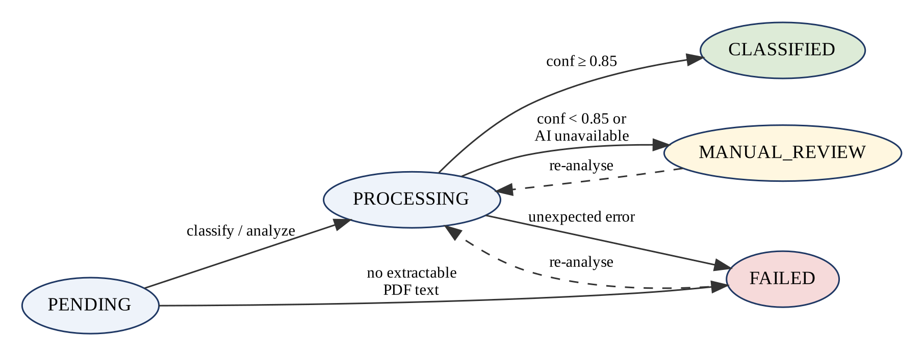
Fig. 4.5: Document Classification Status Lifecycle

4.4.4 LITIGATION-SIGNAL HANDLING
Supported signals are attorney_representation, demand_letter, records_request and none. A signal other than none with confidence at or above 0.85 creates a preservation hold in PROPOSED state linked to the triggering document, unless a proposed or active hold already exists for that document. A litigation signal is an indication that configured phrases were found; it is not a legal determination that litigation is pending.

4.4.5 PRESERVATION-HOLD STATE MACHINE
Fig. 4.6 shows the hold lifecycle. Holds are created only in PROPOSED state, whether by a litigation signal or by the manual POST /holds endpoint, which has no field capable of requesting ACTIVE. The only function that can set ACTIVE is repositories.confirm_hold, and it rejects any starting state other than PROPOSED with HTTP 409. RELEASED, together with released_date, released_by and release_justification, exists in the schema, but no endpoint or service implements the release transition in the current version.
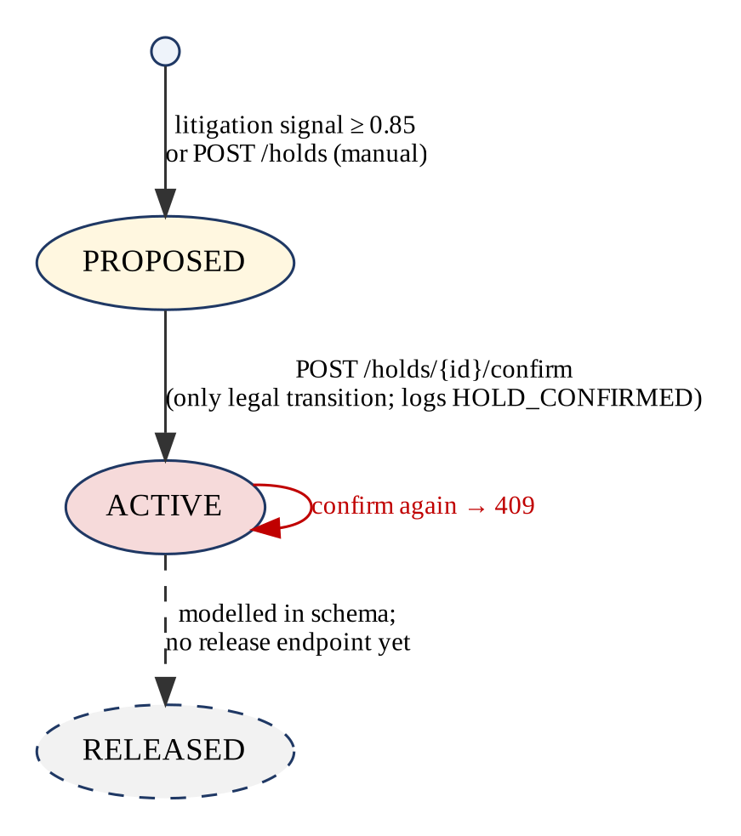
Fig. 4.6: Preservation-Hold State Transitions

4.4.6 OVERRIDE WORKFLOW
An override applies the claim's upcoming business event despite outstanding evidence. The request must contain non-blank user and role values and a justification of at least ten characters, otherwise it is rejected with HTTP 422 before any change. On success, RepairAuthorization sets the repair status to AUTHORIZED, ClaimClosure sets the claim status to CLOSED, the upcoming event is cleared, and an OVERRIDE_APPLIED entry records the role, action, the risk level at the moment of override and the at-risk items that were overridden.

4.4.7 DOCUMENT DELETION SAFEGUARDS
Deletion is a soft delete that sets deleted_at, deleted_by and deletion_reason and removes the stored file on a best-effort basis; the row and its audit history remain. The service refuses deletion with HTTP 409 while the document is linked to a PROPOSED or ACTIVE hold, or while it is the satisfying document of a satisfied evidence item. These checks are enforced on the server regardless of the client.

CHAPTER 5
IMPLEMENTATION
This chapter describes how the design of Chapter 4 is realised in code. File and function names refer to the project repository (github.com/saalini-t/guidewire_bonafide). Short excerpts are used where they clarify a design decision; longer listings are given in Appendix A.

5.1 Frontend Implementation
The frontend is a Vite-built React 18 application. main.jsx mounts the App component inside a BrowserRouter; App renders a header and two routes, with the root path redirecting to /claims. The component hierarchy was shown in Fig. 3.3.

5.1.1 CLAIMS DASHBOARD
ClaimsPage fetches the claim list and then, in parallel, the preservation analysis of each claim, so that every row shows its risk level as a coloured badge (HIGH red, MEDIUM amber, LOW green). The table also shows claim type, status, repair status and upcoming business event. A NewClaimForm above the table submits claimant, policy number, claim type, loss date, description and initial repair status to POST /api/claims and reloads the list on success. Failures show the backend's message with a Retry button rather than a blank page.

5.1.2 CLAIM DETAIL PAGE
ClaimDetailPage loads six resources concurrently with Promise.all and composes six panels. RiskBanner displays the risk level, the engine's explanation, the at-risk items and the recommendation. EvidenceChecklist lists every evidence item with its required flag, a SATISFIED, AT RISK or MISSING badge and its expiry trigger, highlighting triggers that match the upcoming event. DocumentsPanel handles file upload (accepting .jpg, .jpeg, .png, .webp, .pdf and .txt), the pasted-text path, per-document analysis, bulk analysis of pending documents, display of classification, confidence, provider, litigation signal, findings and image-analysis results, and guarded deletion with a reason. HoldsPanel lists holds with status and confidence and offers Confirm Hold for PROPOSED holds. OverrideForm appears only when an upcoming event exists. Timeline renders the preservation log chronologically with actor, justification and JSON detail. A 404 response renders a not-found message with a link back to the list.

5.1.3 API COMMUNICATION
api/client.js is the only module that calls fetch. It sets a JSON content type except for FormData bodies (so the browser can add the multipart boundary), parses error bodies, turns FastAPI validation arrays into readable messages, and raises an ApiError carrying the HTTP status. Components use the status to distinguish, for example, a missing claim (404) from a conflict such as an already-confirmed hold (409).

5.2 Backend Implementation

5.2.1 LAYERING AND TRANSACTIONS
Routes in api.py contain no logic beyond translating request models into service calls. Services open a session_scope per unit of work; the context manager commits on success and rolls back on any exception. Engine settings use expire_on_commit=False so that objects remain readable after the session closes, and relationships needed by responses are eagerly loaded to avoid detached-instance errors. Domain exceptions such as ClaimNotFoundError or InvalidHoldTransitionError are mapped to HTTP responses by handlers registered in main.py.

5.2.2 CLAIM CREATION AND EVIDENCE MANAGEMENT
create_claim_with_evidence validates the claim type against the taxonomy (only PersonalAuto is currently defined; other values are rejected with HTTP 422), generates an identifier in the range CLM-30000 to CLM-99999 that cannot collide with seeded claims, sets RepairAuthorization as the upcoming event when the repair status is PENDING, inserts one unsatisfied evidence item per taxonomy entry and writes a CLAIM_CREATED log entry, all in one transaction. Evidence becomes satisfied only through _maybe_satisfy_evidence, which is called solely for CLASSIFIED documents and links the evidence item to the satisfying document.

5.2.3 PRESERVATION ANALYSIS SERVICE
fetch_analysis loads the claim and its evidence and calls the pure engine; run_analysis does the same and also writes an ANALYSIS_RUN entry containing the risk level and the missing and at-risk lists. The response schema is built directly from the engine's dataclass. The essential selection logic of the engine is the following:
missing = [e.evidence_type for e in evidence_items if e.required and not e.satisfied]
if claim.upcoming_business_event is None:
at_risk = []
else:
at_risk = [e.evidence_type for e in evidence_items
if e.required and not e.satisfied
and e.expiry_trigger == claim.upcoming_business_event]
risk = HIGH if len(at_risk) >= 2 else MEDIUM if len(at_risk) == 1 else LOW

5.2.4 DOCUMENT HANDLING
upload_real_file enforces the size limit, validates the file, computes its SHA-256 hash, saves it through the storage backend and extracts text for PDF and TXT files before opening the database transaction, because these are local operations rather than network calls. analyze_document dispatches by stored MIME type to classify_document for PDF and TXT or to analyze_image for JPEG, PNG and WebP. analyze_all_pending processes eligible documents sequentially, records per-document outcomes (analyzed, skipped or failed) and never lets one failure abort the batch.

5.2.5 HOLDS, OVERRIDES AND AUDIT TRAIL
Holds are created through create_hold with an explicit PROPOSED status and confirmed only through confirm_hold, which writes HOLD_CONFIRMED in the same transaction. apply_override records the override as described in Section 4.4.6. add_log is the only function that writes to preservation_logs, and no update or delete function exists for that table; the API registers only GET routes for /timeline and /preservation-log, which a dedicated test verifies by asserting HTTP 405 for PUT and DELETE. System-generated events are attributed to the actor 'system', seeded events to 'seed_script', and human actions to the user name supplied in the request.

5.3 AI Service Implementation

5.3.1 PROVIDER ABSTRACTION
Text providers implement an abstract AIProvider with classify_document and detect_litigation_signal methods returning a label and a confidence. The selection logic in services/classification.py, shown in Fig. 5.1, tries the Ollama provider only when OLLAMA_BASE_URL is set, and falls back to the deterministic provider on any OllamaUnavailableError. The response's provider field is set by the branch that actually produced the result.
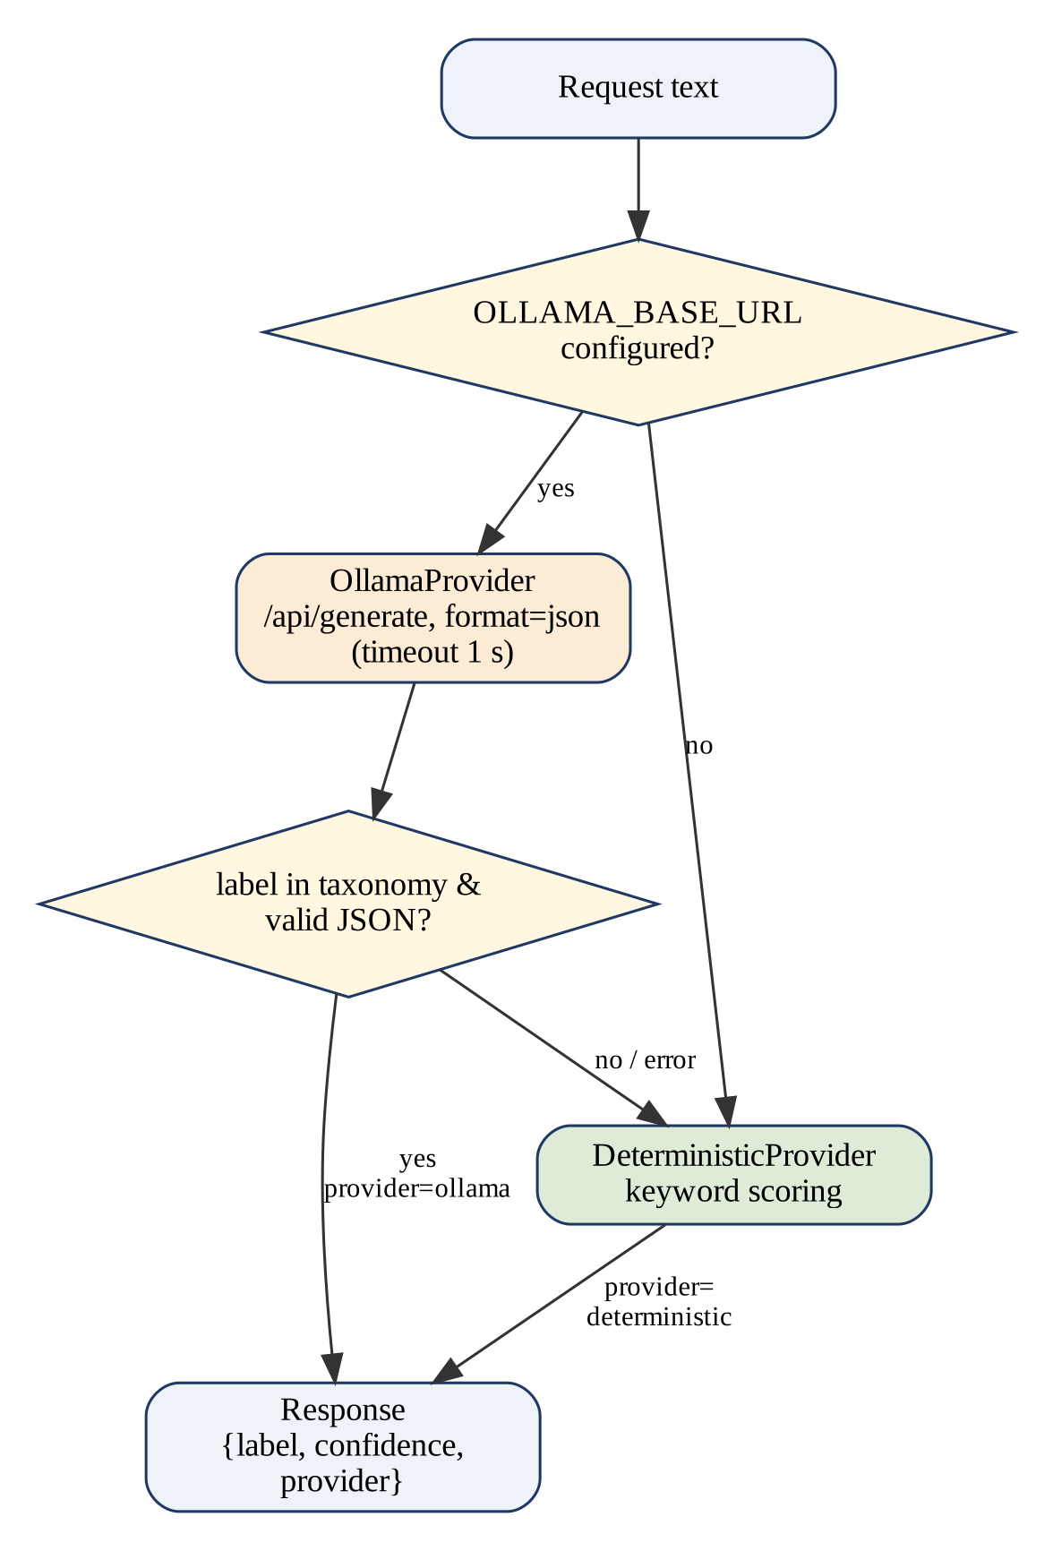
Fig. 5.1: Text Provider Selection and Fallback

5.3.2 DETERMINISTIC PROVIDER
The deterministic provider holds, for each document class and litigation signal, a list of lower-case phrases. Phrases were chosen to limit false positives; for example, the Vehicle Photographs class matches phrases such as 'photos of the vehicle' or 'attached images' rather than the bare word 'photograph', because an attorney letter that lists photographs among categories of records to preserve is not itself a photograph submission. The confidence rules are those of Section 4.4.3. The provider is stateless and produces identical output for identical input.

5.3.3 OPTIONAL LANGUAGE-MODEL PROVIDER
OllamaProvider sends a prompt to Ollama's /api/generate endpoint with format set to json and streaming disabled [20]. The prompt lists the permitted labels and requests a JSON object with a label and a confidence. The response is rejected, triggering fallback, if the request fails, if the JSON is malformed, if fields are missing or if the label is outside the taxonomy, a defence against hallucinated labels [22]. The default model name is qwen2.5:7b [19]. No model is trained or fine-tuned in this project, and no accuracy benchmark of the language-model path has been carried out.

5.3.4 OPTIONAL VISION PROVIDER
Image analysis is disabled by default (VISION_PROVIDER=none), in which case /analyze-image returns HTTP 503 with reason not_configured and the core application marks the image MANUAL_REVIEW. When enabled, OllamaVisionProvider sends the base64 image to a vision model (default llava [21]) with a prompt that restricts the answer to visually observable facts and forbids conclusions about cause, fault, cost or liability. The JSON result (vehicle presence, damage observed, damage regions from a fixed list, image quality, relevance, confidence and a short explanation capped at 300 characters) is validated in the AI service and validated again in the core application before it is stored. Fig. 5.2 summarises the pipeline; by design, its output never satisfies evidence and never creates or confirms a hold.
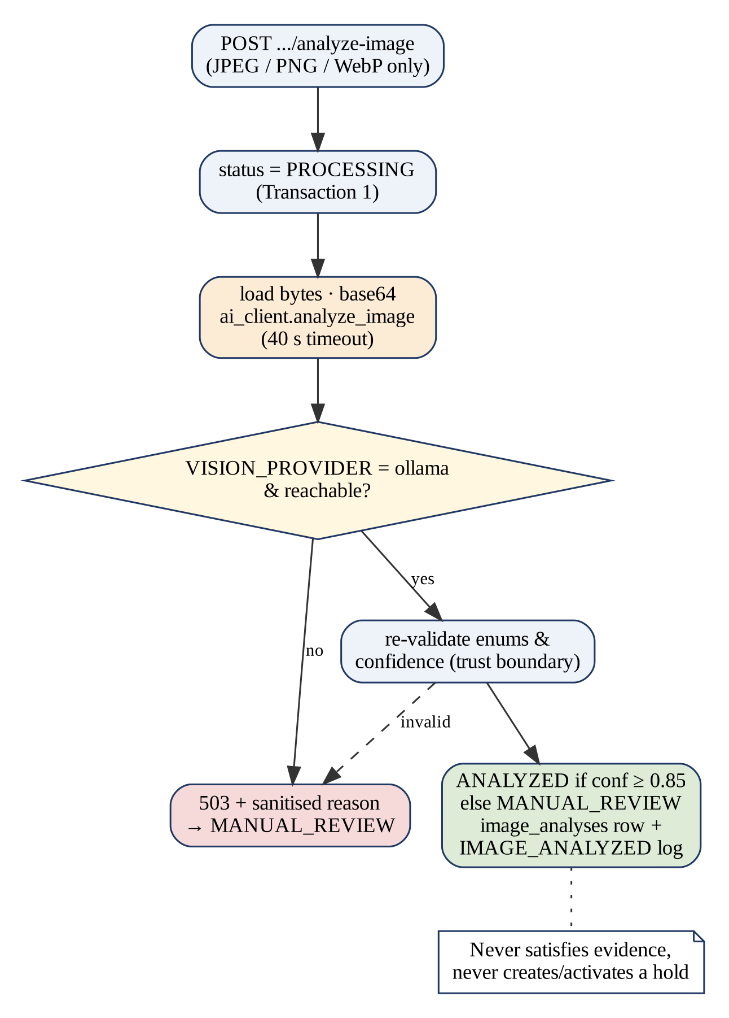
Fig. 5.2: Image Analysis Pipeline

5.4 Security and Validation
Table 5.1 separates the controls that exist in the code from those that a production deployment would require. The distinction matters because insurance documents contain personal and financial information, and several OWASP Top 10 risk categories, notably broken access control and identification and authentication failures, apply directly to such a system [39].
Table 5.1: Implemented Controls and Required Production Controls
Area | Implemented in prototype | Required before production
Authentication | None; user and role are free-text values recorded verbatim | Identity provider integration, sessions or tokens
Authorisation | None; any caller can confirm holds or override | Server-enforced roles for confirm, override, delete
Input validation | Pydantic schemas; claim type and repair status allow-lists; justification length | Same, plus rate limiting
File upload | Extension allow-list, signature check, 10 MB limit, SHA-256, sanitised generated paths | Malware scanning, storage quotas
Data in transit | Plain HTTP on localhost; CORS limited to configured origins | TLS for all services
Data at rest | Local disk and PostgreSQL without encryption | Encrypted storage, backups, retention policy
Audit integrity | Append-only by API design; no update/delete routes | Database-level protection, tamper-evident logging [28]
AI safety | Label validation, thresholds, manual review, no AI-activated holds | Monitoring, evaluation on labelled data [25]
Secrets | Configuration from environment files excluded from Git | Managed secret store

Error handling follows a consistent contract: 404 for unknown claims, documents or holds; 409 for invalid hold transitions, duplicate concurrent analysis and protected deletions; 413 for oversized files; 415 for unsupported or mismatched file types; 422 for schema validation failures; and 503 from the AI service when no vision provider is available. Diagnostic reasons stored in the audit log are sanitised category codes, never raw exception messages or image content.

CHAPTER 6
RESULTS AND DISCUSSIONS

6.1 Project Outcomes
This section reports what the prototype demonstrably does. Evidence is of three kinds, which are kept distinct: (a) features verified by reading the source code, (b) behaviour observed by executing the pure, dependency-free modules (preservation engine, file validation, findings extraction and deterministic provider) during preparation of this report, and (c) results recorded by the team in the repository's implementation plan, which were not re-run for this report. No user study, performance benchmark or accuracy evaluation on real claims has been carried out, and no such figures are claimed.

6.1.1 IMPLEMENTED FEATURE SUMMARY
Table 6.1: Verification Status of Major Features
Feature | Status | Basis
Claim listing, detail and creation (PersonalAuto) | Implemented | api.py, services.py, NewClaimForm
Evidence checklist and satisfaction tracking | Implemented | models.EvidenceItem, _maybe_satisfy_evidence
Missing and at-risk evidence; LOW/MEDIUM/HIGH | Implemented and executed | preservation_engine.py (Table 3.3)
File upload and signature validation | Implemented and executed | file_validation.py (Table 6.3)
PDF text extraction | Implemented | document_extraction.extract_pdf_text
OCR fallback for scanned PDFs | Optional (dependencies not installed by default) | ocr_pdf_text; commented requirements
Regex findings (cost, date) | Implemented and executed | extract_findings
Deterministic classification and litigation detection | Implemented and executed | deterministic.py (Table 6.2)
Ollama text provider | Optional (configuration-dependent) | ollama.py; not exercised
Ollama vision analysis | Optional, disabled by default | ollama_vision.py; not exercised
Manual review routing | Implemented | _apply_classification, thresholds 0.85
Hold proposal and confirmation | Implemented | _apply_litigation, confirm_hold
Hold release | Not implemented (schema fields only) | No endpoint or service
Justified override | Implemented | apply_override, OverrideRequest
Append-only audit timeline | Implemented (application level) | add_log; GET-only routes
Soft delete with safeguards | Implemented | delete_document
Authentication and authorisation | Not implemented | Documented out of scope
Guidewire ClaimCenter integration | Not implemented | Documented out of scope

6.1.2 REPRESENTATIVE WORKFLOW: CLAIM CLM-10042
CLM-10042 is the canonical demonstration claim: a single-vehicle collision whose repair shop has requested authorisation. Its police report, inspection and repair estimate are satisfied, while vehicle photographs, repair appraisal and recorded statement are not. The engine output, reproduced exactly, is: risk HIGH; explanation 'RepairAuthorization is pending. 3 required evidence item(s) have not been preserved and will become materially harder to recover once RepairAuthorization occurs: Vehicle Photographs, Repair Appraisal, Recorded Statement.'; recommendation 'Preserve the following evidence before RepairAuthorization occurs: Vehicle Photographs, Repair Appraisal, Recorded Statement.' Fig. 6.1 compares missing and at-risk counts across all seed claims.
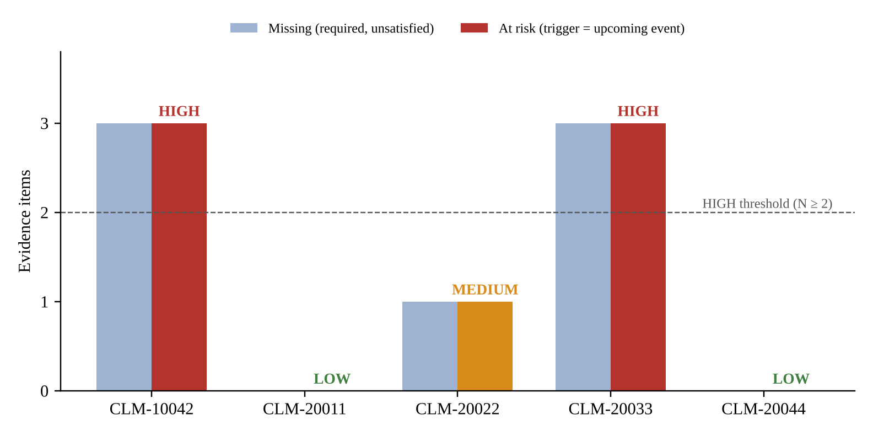
Fig. 6.1: Missing and At-Risk Evidence for the Five Seed Claims
CLM-20044 illustrates why risk alone is not the whole picture: all its evidence is preserved, so the engine reports LOW, yet it carries an ACTIVE hold created from an attorney-representation signal. Hold status and preservation risk are deliberately independent indicators.

6.1.3 CLASSIFICATION EXAMPLES
Table 6.2 shows the deterministic provider's output on eight short texts written for this report, together with the consequence that the core application's rules would apply at the default 0.85 threshold. These examples illustrate the rules; they are not a statistical evaluation and do not establish classification accuracy.
Table 6.2: Deterministic Provider Output on Sample Texts
Sample text (abridged) | Class / conf. | Signal / conf. | Consequence
Police Report. Case number ... responding officer ... | Police Report / 0.97 | none / 0.95 | CLASSIFIED; satisfies Police Report
Body shop estimate: estimated cost of repair ... parts and labor | Repair Estimate / 0.97 | none / 0.95 | CLASSIFIED; satisfies Repair Estimate
Damage appraisal prepared by the appraiser ... | Repair Appraisal / 0.97 | none / 0.95 | CLASSIFIED; satisfies Repair Appraisal
Interview transcript: recorded statement given by ... | Recorded Statement / 0.97 | none / 0.95 | CLASSIFIED; satisfies Recorded Statement
Law Offices of ..., Esq. We represent the claimant ... preserve all relevant records | Other / 0.40 | attorney_representation / 0.97 | MANUAL_REVIEW; PROPOSED hold
This settlement demand is made ... policy limits demand | Other / 0.40 | demand_letter / 0.97 | MANUAL_REVIEW; PROPOSED hold
Thank you for your recent call ... | Other / 0.40 | none / 0.95 | MANUAL_REVIEW; no change
See attached images. | Vehicle Photographs / 0.70 | none / 0.95 | MANUAL_REVIEW (below 0.85); no change

The last row shows the threshold working as intended: a single weak phrase yields a plausible class but insufficient confidence, so no evidence is marked satisfied. The attorney letter shows the separation of the two axes: the document is not an evidence item (Other) but still triggers a proposed hold for human confirmation.

6.2 Testing and Validation

6.2.1 AUTOMATED TEST SUITE
The repository contains 169 automated test functions, summarised in Table 6.4. Backend tests run against a real PostgreSQL database (the architecture explicitly rejects SQLite substitutes) and start the real AI service as a subprocess where a genuine round trip is required. The plan records 52 backend and 7 AI-service tests passing at the end of Sprint II and 19 frontend tests at the end of Sprint III; the suites have since grown. The full suites were not re-executed for this report, so no current pass rate is claimed here; the team should run them and record the results in Table 6.5.
Table 6.3: Executed Validation Checks (File Validation and Findings Extraction)
Input | Expected | Observed
.png with PNG signature | Accepted as image/png | Accepted as image/png
.png containing a GIF header | Rejected (signature) | Rejected: signature check failed
.pdf starting with %PDF | Accepted as application/pdf | Accepted
.txt containing a null byte | Rejected (binary content) | Rejected
.exe file | Rejected (extension) | Rejected: unsupported extension
.webp with RIFF....WEBP header | Accepted as image/webp | Accepted
.jpg containing a PDF header | Rejected (signature) | Rejected
'... dated March 3, 2026 totals $4,521.50 ...' | cost $4,521.50; date March 3, 2026 | As expected
'Loss on 08/12/2026; appraisal $2,300 and supplement $410.00' | last amount; first date | cost $410.00; date 08/12/2026

The final row in Table 6.3 exposes a limitation: the findings extractor reports the last currency amount in the text, which is the supplement rather than the total. This is consistent with the documented rule but would mislead on multi-amount documents, so findings must be reviewed rather than relied upon.
Table 6.4: Automated Test Inventory
Suite / area | Files | Tests | Main behaviours covered
Preservation engine | test_preservation_engine | 6 | No event is LOW; 0/1/2+ thresholds; optional items; CLM-10042 HIGH with 3 items
Models, repositories, seed | test_models, test_repositories, test_seed_data | 16 | Schema, data access, five seeded claims and their risk tiers
Claims API and creation | test_api_claims, test_claim_creation | 15 | Endpoints, validation of claim type and repair status
Documents and evidence | test_document_workflow, test_evidence_management, test_file_upload | 31 | Classification flow, evidence satisfaction, upload validation, path sanitisation
AI client and images | test_ai_client, test_image_analysis | 29 | Fail-open behaviour, timeouts, vision outcomes
Holds, override, audit | test_hold_state_machine, test_override, test_audit_log_immutability | 13 | Only PROPOSED to ACTIVE; justification rules; GET-only log routes
Infrastructure | test_transaction_boundary, test_cors | 2 | No DB connection held during AI call; CORS origins
AI service | test_ai_service, test_vision | 19 | Providers, fallback, taxonomy validation, vision errors
Frontend | 8 *.test.jsx files | 38 | Pages, panels, forms, error and retry states
Total |  | 169

6.2.2 FUNCTIONAL TEST CASES
Table 6.5 maps the main functional requirements to test cases. The expected results follow from the code. The observed column is filled only where the behaviour was executed for this report; the remaining entries must be completed by the team after running the application and test suites.
Table 6.5: Functional Test Cases
ID | Scenario | Expected result | Observed
TC-01 | No at-risk items (CLM-20011) | LOW | LOW (executed)
TC-02 | One at-risk item (CLM-20022) | MEDIUM | MEDIUM (executed)
TC-03 | Three at-risk items (CLM-10042) | HIGH | HIGH (executed)
TC-04 | Missing evidence but no upcoming event | LOW; missing listed | LOW, 6 missing (executed)
TC-05 | Upload with mismatched signature | HTTP 415 | Validator rejects (executed); HTTP to be recorded
TC-06 | Upload larger than 10 MB | HTTP 413 | To be recorded
TC-07 | Classify police report text | CLASSIFIED; evidence satisfied | Provider 0.97 (executed); DB effect to be recorded
TC-08 | Classify with AI service stopped | MANUAL_REVIEW; provider null | To be recorded
TC-09 | Attorney letter | PROPOSED hold, HOLD_PROPOSED log | Signal 0.97 (executed); hold to be recorded
TC-10 | Confirm PROPOSED hold | ACTIVE; HOLD_CONFIRMED | To be recorded
TC-11 | Confirm ACTIVE hold again | HTTP 409 | To be recorded
TC-12 | Override with 5-character justification | HTTP 422; no change | To be recorded
TC-13 | Valid override of RepairAuthorization | AUTHORIZED; event cleared; OVERRIDE_APPLIED | To be recorded
TC-14 | Delete document linked to ACTIVE hold | HTTP 409 | To be recorded
TC-15 | PUT or DELETE on /timeline | HTTP 405 | To be recorded

6.3 Limitations and Discussion
The results support the central design claim: preservation risk is computed deterministically and transparently, and AI assistance is confined to advisory roles with explicit human checkpoints. The executed examples show the engine, validator and deterministic classifier behaving exactly as specified. They do not show that the specification itself is right for real claims, which would require expert review of the taxonomy and trigger map.
Several limitations qualify these results. Risk is a count, not a weighted or probabilistic estimate. The keyword classifier cannot recognise unseen phrasing and its confidences are heuristic. The language-model and vision paths have not been evaluated, and the scores they return are not calibrated [23]. Holds can be confirmed but not released. The audit log is append-only only through the application; a database administrator could still alter it, and nothing would detect the change [27,28]. There is no authentication or authorisation, so recorded user and role values are unverified. Only one claim type exists, all data is synthetic, and no performance, usability or accuracy evaluation has been performed. The Day 4 hardening tasks and several documents referenced in the code (for example API_SPECIFICATION.md and LIMITATIONS.md) are absent from the repository.
Accordingly, Bona Fide should be regarded as a working proof of concept for an evidence-preservation layer, suitable as a basis for further development and evaluation, and not as a production-ready or legally validated system.

CHAPTER 7
CONCLUSION AND FUTURE ENHANCEMENT

7.1 Conclusion
This project addressed the loss of insurance-claim evidence caused by routine business events such as repair authorisation. Bona Fide models each claim's evidence requirements together with the event that expires each one and computes, deterministically, which outstanding items are at risk and how severe that risk is. For the demonstration claim CLM-10042, the engine identifies three items (vehicle photographs, repair appraisal and recorded statement) that would be lost at repair authorisation and classifies the claim as HIGH risk with an actionable recommendation.
The principal technical contributions are a pure, dependency-free preservation engine; a stateless AI service with truthful provider attribution and a deterministic fallback; a two-transaction workflow that never holds a database transaction across a network call; human-in-the-loop controls enforced in code (confidence thresholds, manual review, propose-then-confirm holds and justified overrides); safe document intake with signature validation; and an append-only audit timeline. The system is implemented with React, FastAPI, PostgreSQL, SQLAlchemy and Alembic and is accompanied by 169 automated tests.
The prototype also has clear boundaries. It lacks authentication, hold release and tamper-evident logging, covers one claim type with synthetic data, and has not been evaluated with real claims or users. Within those boundaries, it demonstrates that AI can be introduced into a preservation workflow in a way that adds assistance without weakening accountability.

7.2 Future Enhancements
The following enhancements are proposed; none of them is implemented in the current version.

7.2.1 AUTHENTICATION AND ROLE-BASED AUTHORISATION
Integrate an identity provider and enforce roles on the server so that only authorised users can confirm holds, override rules or delete documents, replacing free-text user and role fields with verified identities.

7.2.2 HOLD RELEASE WORKFLOW
Implement the ACTIVE to RELEASED transition with a mandatory justification, populating the existing released_date, released_by and release_justification fields and writing the already-defined HOLD_RELEASED event.

7.2.3 TAMPER-EVIDENT AUDIT LOGGING
Protect preservation_logs at the database level (restricted privileges or triggers) and add hash chaining or a history-tree structure so that alterations can be detected [28], with retention aligned to log-management guidance [26].

7.2.4 EVALUATION ON LABELLED DATA
Build a labelled, de-identified corpus of claim documents and measure per-class precision, recall and F1-score for the deterministic and model-based providers [11], then calibrate thresholds and confidence scores [23].

7.2.5 RICHER EXTRACTION AND OCR
Apply OCR to uploaded images as well as scanned PDFs, extract claim numbers, parties and amounts with field-level confidence, and consider layout-aware models [13].

7.2.6 CONFIGURABLE EVIDENCE POLICIES
Extend the taxonomy to further claim types and business events, allow weights per evidence item, and support expert-reviewed policy configuration instead of code changes.

7.2.7 INTEGRATION WITH CLAIMS PLATFORMS
Expose the engine and AI service to a platform such as Guidewire ClaimCenter through its supported integration mechanisms, as anticipated in the project's architecture notes [1]; this would be a separate, validated implementation effort.

7.2.8 DEPLOYMENT HARDENING AND MONITORING
Containerise the services, add TLS, encrypted storage, backups, managed secrets, health monitoring and the Day 4 end-to-end failure drills, and complete the missing documentation.

REFERENCES
[1] Guidewire Software, Inc., "ClaimCenter: Claims Management Software," product information. [Online]. Available: https://www.guidewire.com
[2] Federal Rules of Civil Procedure, Rule 37(e), "Failure to Preserve Electronically Stored Information" (as amended 2015). Legal Information Institute, Cornell Law School. [Online]. Available: https://www.law.cornell.edu/rules/frcp/rule_37
[3] The Sedona Conference, "Commentary on Legal Holds, Second Edition: The Trigger & The Process," The Sedona Conference Journal, vol. 20, 2019. [Online]. Available: https://www.thesedonaconference.org/publication/Commentary_on_Legal_Holds
[4] S. Viaene, R. A. Derrig, B. Baesens, and G. Dedene, "A comparison of state-of-the-art classification techniques for expert automobile insurance claim fraud detection," Journal of Risk and Insurance, vol. 69, no. 3, pp. 373-421, 2002.
[5] S. Amershi et al., "Guidelines for human-AI interaction," in Proc. CHI Conference on Human Factors in Computing Systems, Glasgow, UK, 2019, Paper 3, pp. 1-13.
[6] United Nations, Department of Economic and Social Affairs, "Goal 16: Promote peaceful and inclusive societies for sustainable development, provide access to justice for all and build effective, accountable and inclusive institutions at all levels." [Online]. Available: https://sdgs.un.org/goals/goal16
[7] Electronic Discovery Reference Model (EDRM), "EDRM Model," Duke Law / EDRM. [Online]. Available: https://edrm.net
[8] F. Hayes-Roth, "Rule-based systems," Communications of the ACM, vol. 28, no. 9, pp. 921-932, 1985.
[9] B. G. Buchanan and E. H. Shortliffe, Rule-Based Expert Systems: The MYCIN Experiments of the Stanford Heuristic Programming Project. Reading, MA, USA: Addison-Wesley, 1984.
[10] S. Russell and P. Norvig, Artificial Intelligence: A Modern Approach, 4th ed. Hoboken, NJ, USA: Pearson, 2021.
[11] F. Sebastiani, "Machine learning in automated text categorization," ACM Computing Surveys, vol. 34, no. 1, pp. 1-47, 2002.
[12] A. W. Harley, A. Ufkes, and K. G. Derpanis, "Evaluation of deep convolutional nets for document image classification and retrieval," in Proc. 13th International Conference on Document Analysis and Recognition (ICDAR), Tunis, Tunisia, 2015, pp. 991-995.
[13] Y. Xu, M. Li, L. Cui, S. Huang, F. Wei, and M. Zhou, "LayoutLM: Pre-training of text and layout for document image understanding," in Proc. 26th ACM SIGKDD International Conference on Knowledge Discovery and Data Mining, 2020, pp. 1192-1200.
[14] Artifex Software, "PyMuPDF Documentation." [Online]. Available: https://pymupdf.readthedocs.io/
[15] R. Smith, "An overview of the Tesseract OCR engine," in Proc. 9th International Conference on Document Analysis and Recognition (ICDAR), Curitiba, Brazil, 2007, vol. 2, pp. 629-633.
[16] A. Vaswani et al., "Attention is all you need," in Advances in Neural Information Processing Systems 30 (NeurIPS 2017), 2017, pp. 5998-6008.
[17] J. Devlin, M.-W. Chang, K. Lee, and K. Toutanova, "BERT: Pre-training of deep bidirectional transformers for language understanding," in Proc. NAACL-HLT, Minneapolis, MN, USA, 2019, pp. 4171-4186.
[18] T. B. Brown et al., "Language models are few-shot learners," in Advances in Neural Information Processing Systems 33 (NeurIPS 2020), 2020, pp. 1877-1901.
[19] Qwen Team, "Qwen2.5 technical report," arXiv preprint arXiv:2412.15115, 2024.
[20] Ollama, "Ollama API documentation." [Online]. Available: https://github.com/ollama/ollama/blob/main/docs/api.md
[21] H. Liu, C. Li, Q. Wu, and Y. J. Lee, "Visual instruction tuning," in Advances in Neural Information Processing Systems 36 (NeurIPS 2023), 2023.
[22] Z. Ji et al., "Survey of hallucination in natural language generation," ACM Computing Surveys, vol. 55, no. 12, Art. 248, 2023.
[23] C. Guo, G. Pleiss, Y. Sun, and K. Q. Weinberger, "On calibration of modern neural networks," in Proc. 34th International Conference on Machine Learning (ICML), Sydney, Australia, 2017, pp. 1321-1330.
[24] E. Mosqueira-Rey, E. Hernandez-Pereira, D. Alonso-Rios, J. Bobes-Bascaran, and A. Fernandez-Leal, "Human-in-the-loop machine learning: A state of the art," Artificial Intelligence Review, vol. 56, pp. 3005-3054, 2023.
[25] National Institute of Standards and Technology, "Artificial Intelligence Risk Management Framework (AI RMF 1.0)," NIST AI 100-1, Gaithersburg, MD, USA, Jan. 2023, doi: 10.6028/NIST.AI.100-1.
[26] K. Kent and M. Souppaya, "Guide to Computer Security Log Management," NIST Special Publication 800-92, National Institute of Standards and Technology, Gaithersburg, MD, USA, Sep. 2006.
[27] B. Schneier and J. Kelsey, "Secure audit logs to support computer forensics," ACM Transactions on Information and System Security, vol. 2, no. 2, pp. 159-176, 1999.
[28] S. A. Crosby and D. S. Wallach, "Efficient data structures for tamper-evident logging," in Proc. 18th USENIX Security Symposium, Montreal, Canada, 2009, pp. 317-334.
[29] M. Fowler, Patterns of Enterprise Application Architecture. Boston, MA, USA: Addison-Wesley, 2002.
[30] R. T. Fielding, "Architectural styles and the design of network-based software architectures," Ph.D. dissertation, Dept. of Information and Computer Science, University of California, Irvine, CA, USA, 2000.
[31] SQLAlchemy, "SQLAlchemy 2.0 Documentation." [Online]. Available: https://docs.sqlalchemy.org/en/20/
[32] SQLAlchemy, "Alembic Documentation." [Online]. Available: https://alembic.sqlalchemy.org/
[33] Pydantic, "Pydantic Documentation." [Online]. Available: https://docs.pydantic.dev/
[34] Meta Platforms, Inc., "React Documentation." [Online]. Available: https://react.dev/
[35] Vite, "Vite Documentation." [Online]. Available: https://vite.dev/
[36] S. Ramirez, "FastAPI Documentation." [Online]. Available: https://fastapi.tiangolo.com/
[37] The PostgreSQL Global Development Group, "PostgreSQL Documentation." [Online]. Available: https://www.postgresql.org/docs/
[38] OWASP Foundation, "File Upload Cheat Sheet," OWASP Cheat Sheet Series. [Online]. Available: https://cheatsheetseries.owasp.org/cheatsheets/File_Upload_Cheat_Sheet.html
[39] OWASP Foundation, "OWASP Top 10:2021." [Online]. Available: https://owasp.org/Top10/

APPENDIX A
CODING
This appendix reproduces selected source code from the project repository without modification, apart from omitting unrelated functions. Configuration files containing credentials are not reproduced.
A.1 Preservation Engine (backend/app/preservation_engine.py)
from dataclasses import dataclass
from typing import Protocol

from app.enums import EvidenceType, ExpiryTrigger, RiskLevel

HIGH_RISK_AT_RISK_COUNT = 2
MEDIUM_RISK_AT_RISK_COUNT = 1

class EvidenceLike(Protocol):
evidence_type: EvidenceType
required: bool
satisfied: bool
expiry_trigger: ExpiryTrigger

class ClaimLike(Protocol):
claim_id: str
upcoming_business_event: ExpiryTrigger | None

@dataclass(frozen=True)
class PreservationAnalysis:
claim_id: str
risk_level: RiskLevel
upcoming_event: ExpiryTrigger | None
missing_evidence: list[EvidenceType]
at_risk_evidence: list[EvidenceType]
explanation: str
recommendation: str

def analyze_preservation(claim: ClaimLike, evidence_items: list[EvidenceLike]) -> PreservationAnalysis:
missing = [e.evidence_type for e in evidence_items if e.required and not e.satisfied]

if claim.upcoming_business_event is None:
at_risk: list[EvidenceType] = []
else:
at_risk = [
e.evidence_type
for e in evidence_items
if e.required and not e.satisfied and e.expiry_trigger == claim.upcoming_business_event
]

if len(at_risk) >= HIGH_RISK_AT_RISK_COUNT:
risk = RiskLevel.HIGH
elif len(at_risk) == MEDIUM_RISK_AT_RISK_COUNT:
risk = RiskLevel.MEDIUM
else:
risk = RiskLevel.LOW

return PreservationAnalysis(
claim_id=claim.claim_id,
risk_level=risk,
upcoming_event=claim.upcoming_business_event,
missing_evidence=missing,
at_risk_evidence=at_risk,
explanation=_explain(claim, at_risk),
recommendation=_recommend(claim, risk, at_risk),
)

def _explain(claim: ClaimLike, at_risk: list[EvidenceType]) -> str:
if claim.upcoming_business_event is None:
return "No upcoming business event is scheduled, so no evidence is currently at risk."
event = claim.upcoming_business_event.value
if not at_risk:
return f"{event} is pending, but all evidence required before it has already been preserved."
items = ", ".join(e.value for e in at_risk)
return (
f"{event} is pending. {len(at_risk)} required evidence item(s) have not been preserved "
f"and will become materially harder to recover once {event} occurs: {items}."
)

def _recommend(claim: ClaimLike, risk: RiskLevel, at_risk: list[EvidenceType]) -> str:
if risk == RiskLevel.LOW:
return "No preservation action required at this time."
items = ", ".join(e.value for e in at_risk)
event = claim.upcoming_business_event.value if claim.upcoming_business_event else "the upcoming event"
return f"Preserve the following evidence before {event} occurs: {items}."

A.2 Evidence Taxonomy (backend/app/evidence_taxonomy.py)
from app.enums import EvidenceType, ExpiryTrigger

# The only claim type this taxonomy currently covers. Claim creation
# rejects anything else rather than silently generating no evidence
# requirements for a type nobody has defined a taxonomy for.
PERSONAL_AUTO = "PersonalAuto"

# Default expiry-trigger mapping for the six-item Personal Auto evidence
# taxonomy (docs/DATA_MODEL.md documents this as the configurable default).
PERSONAL_AUTO_EVIDENCE_TRIGGER_MAP: dict[EvidenceType, ExpiryTrigger] = {
EvidenceType.VEHICLE_PHOTOGRAPHS: ExpiryTrigger.REPAIR_AUTHORIZATION,
EvidenceType.POLICE_REPORT: ExpiryTrigger.CLAIM_CLOSURE,
EvidenceType.REPAIR_APPRAISAL: ExpiryTrigger.REPAIR_AUTHORIZATION,
EvidenceType.VEHICLE_INSPECTION: ExpiryTrigger.REPAIR_AUTHORIZATION,
EvidenceType.RECORDED_STATEMENT: ExpiryTrigger.REPAIR_AUTHORIZATION,
EvidenceType.REPAIR_ESTIMATE: ExpiryTrigger.REPAIR_AUTHORIZATION,
}

EVIDENCE_TAXONOMY_BY_CLAIM_TYPE: dict[str, dict[EvidenceType, ExpiryTrigger]] = {
PERSONAL_AUTO: PERSONAL_AUTO_EVIDENCE_TRIGGER_MAP,
}

def evidence_taxonomy_for(claim_type: str) -> dict[EvidenceType, ExpiryTrigger]:
return EVIDENCE_TAXONOMY_BY_CLAIM_TYPE[claim_type]

A.3 Upload Validation (backend/app/file_validation.py)
from app.exceptions import UnsupportedFileTypeError

ALLOWED_EXTENSIONS: dict[str, str] = {
".jpg": "image/jpeg",
".jpeg": "image/jpeg",
".png": "image/png",
".webp": "image/webp",
".pdf": "application/pdf",
".txt": "text/plain",
}

_MAGIC_BYTES: dict[str, bytes] = {
".jpg": b"\xff\xd8\xff",
".jpeg": b"\xff\xd8\xff",
".png": b"\x89PNG\r\n\x1a\n",
".pdf": b"%PDF",
}

def extension_of(filename: str) -> str:
if "." not in filename:
return ""
return "." + filename.rsplit(".", 1)[-1].lower()

def validate_upload(filename: str, content: bytes) -> str:
"""Returns the server-determined mime type, or raises
UnsupportedFileTypeError. Never trusts the client's declared
Content-Type — validates extension + (for binary types) actual file
signature instead.
"""
ext = extension_of(filename)
if ext not in ALLOWED_EXTENSIONS:
allowed = ", ".join(sorted(ALLOWED_EXTENSIONS))
raise UnsupportedFileTypeError(f"Unsupported file extension {ext!r}. Allowed: {allowed}")

if ext == ".webp":
# WebP's signature is split ("RIFF" + 4-byte size + "WEBP"), not a
# simple prefix — a plain startswith() check doesn't fit here.
if not (content[:4] == b"RIFF" and content[8:12] == b"WEBP"):
raise UnsupportedFileTypeError("File content does not match a valid .webp file (signature check failed)")
elif ext in _MAGIC_BYTES:
signature = _MAGIC_BYTES[ext]
if not content.startswith(signature):
raise UnsupportedFileTypeError(
f"File content does not match a valid {ext} file (signature check failed)"
)
else:
# .txt: no magic-byte signature exists for plain text. Reject
# anything that isn't valid UTF-8 text or contains null bytes, as a
# basic guard against a disguised binary with a .txt extension.
if b"\x00" in content:
raise UnsupportedFileTypeError("File claims to be .txt but contains binary (null) bytes")
try:
content.decode("utf-8")
except UnicodeDecodeError as exc:
raise UnsupportedFileTypeError("File claims to be .txt but is not valid UTF-8 text") from exc

return ALLOWED_EXTENSIONS[ext]

A.4 Classification, Evidence Satisfaction and Litigation Handling (backend/app/services.py)
def classify_document(claim_id: str, document_id: int) -> ClassifyOutcome:
with session_scope() as session:
_get_claim_or_404(session, claim_id)
document = _get_document_or_404(session, claim_id, document_id)
if document.text is None:
raise UnsupportedFileTypeError(f"Document {document_id} has no extractable text to classify")
if document.classification_status == ClassificationStatus.PROCESSING:
raise DocumentAlreadyProcessingError(document_id)
document.classification_status = ClassificationStatus.PROCESSING
text = document.text

# No DB transaction open across these two AI calls.
try:
classification_result = ai_client.classify_document(text)
litigation_result = ai_client.detect_litigation_signal(text)
except Exception:
logger.exception("unexpected error during classification for document %s", document_id)
with session_scope() as session:
document = _get_document_or_404(session, claim_id, document_id)
document.classification_status = ClassificationStatus.FAILED
return ClassifyOutcome(document=document, hold=None)

with session_scope() as session:
document = get_document(session, document_id)
claim = _get_claim_or_404(session, claim_id)

_apply_classification(session, document, classification_result)
hold = _apply_litigation(session, claim, document, litigation_result)
if document.text:
document.findings = extract_findings(document.text)

return ClassifyOutcome(document=document, hold=hold)

def _apply_classification(session, document: Document, result: AIClassificationResult) -> None:
if not result.available:
document.classification_status = ClassificationStatus.MANUAL_REVIEW
document.ai_provider = None
add_log(
session,
claim_id=document.claim_id,
event_type=PreservationEventType.DOCUMENT_CLASSIFIED,
user=SYSTEM_ACTOR,
detail={
"document_id": document.id,
"outcome": "ai_unavailable",
"status": ClassificationStatus.MANUAL_REVIEW.value,
},
)
return

document.classification = DocumentClass(result.classification)
document.confidence = result.confidence
document.ai_provider = result.provider

if result.confidence >= settings.ai_confidence_threshold:
document.classification_status = ClassificationStatus.CLASSIFIED
_maybe_satisfy_evidence(session, document)
else:
document.classification_status = ClassificationStatus.MANUAL_REVIEW

add_log(
session,
claim_id=document.claim_id,
event_type=PreservationEventType.DOCUMENT_CLASSIFIED,
user=SYSTEM_ACTOR,
detail={
"document_id": document.id,
"classification": result.classification,
"confidence": result.confidence,
"provider": result.provider,
"status": document.classification_status.value,
},
)

def _maybe_satisfy_evidence(session, document: Document) -> None:
"""Only ever called for CLASSIFIED (>= threshold) documents — never for
MANUAL_REVIEW or AI-unavailable outcomes.
"""
candidates = [
item
for item in list_evidence_items(session, document.claim_id)
if item.required and not item.satisfied and item.evidence_type.value == document.classification.value
]
if not candidates:
return
evidence = candidates[0]
evidence.satisfied = True
evidence.satisfied_date = dt.datetime.now(dt.timezone.utc)
evidence.satisfying_document_id = document.id
add_log(
session,
claim_id=document.claim_id,
event_type=PreservationEventType.EVIDENCE_SATISFIED,
user=SYSTEM_ACTOR,
detail={"evidence_type": evidence.evidence_type.value, "document_id": document.id},
)

def _apply_litigation(session, claim: Claim, document: Document, result: AILitigationResult) -> PreservationHold | None:
if not result.available:
return None # leave litigation fields as None rather than fabricate a result

document.litigation_signal = LitigationSignal(result.signal)
document.litigation_confidence = result.confidence

add_log(
session,
claim_id=claim.claim_id,
event_type=PreservationEventType.LITIGATION_SIGNAL_DETECTED,
user=SYSTEM_ACTOR,
detail={
"document_id": document.id,
"signal": result.signal,
"confidence": result.confidence,
"provider": result.provider,
},
)

if result.signal == LitigationSignal.NONE.value or result.confidence < settings.litigation_confidence_threshold:
return None

# Re-analysis (e.g. retrying a document) must not propose a second hold
# for the same document if one is already PROPOSED/ACTIVE — the human
# review step for the existing hold is still the authoritative one.
existing_hold = session.scalars(
select(PreservationHold).where(
PreservationHold.document_id == document.id,
PreservationHold.status.in_([HoldStatus.PROPOSED, HoldStatus.ACTIVE]),
)
).first()
if existing_hold is not None:
return None

hold = create_hold(
session,
claim_id=claim.claim_id,
document_id=document.id,
trigger_reason=f"Litigation signal detected in document {document.id}: {result.signal}",
trigger_source=f"litigation_signal:{result.signal}",
confidence=result.confidence,
status=HoldStatus.PROPOSED,
)
add_log(
session,
claim_id=claim.claim_id,
event_type=PreservationEventType.HOLD_PROPOSED,
user=SYSTEM_ACTOR,
detail={"hold_id": hold.id, "document_id": document.id, "signal": result.signal, "confidence": result.confidence},
)
return hold

A.5 Hold Confirmation and Audit Logging (backend/app/repositories.py)
def confirm_hold(session: Session, hold_id: int, *, user: str) -> PreservationHold:
"""The ONLY function that may transition a hold to ACTIVE. Any starting
status other than PROPOSED is rejected (ACTIVE->ACTIVE, RELEASED->ACTIVE,
etc.) — there is deliberately no general-purpose "set hold status"
function that would let anything else (including AI-driven code) reach
ACTIVE directly.
"""
hold = session.get(PreservationHold, hold_id)
if hold is None:
raise HoldNotFoundError(hold_id)
if hold.status != HoldStatus.PROPOSED:
raise InvalidHoldTransitionError(hold_id, hold.status.value)

hold.status = HoldStatus.ACTIVE
add_log(
session,
claim_id=hold.claim_id,
event_type=PreservationEventType.HOLD_CONFIRMED,
user=user,
detail={"hold_id": hold.id},
)
session.flush()
return hold

def add_log(
session: Session,
*,
claim_id: str,
event_type: PreservationEventType,
user: str,
justification: str | None = None,
detail: dict | None = None,
) -> PreservationLog:
"""Append-only. There is deliberately no update_log or delete_log
function — the API layer must not expose an update/delete endpoint for
preservation_logs.
"""
log = PreservationLog(
claim_id=claim_id,
event_type=event_type,
user=user,
justification=justification,
detail=detail,
)
session.add(log)
session.flush()
return log

A.6 Override Service (backend/app/services.py)
def apply_override(
claim_id: str, *, user: str, role: str, justification: str, action: ExpiryTrigger, detail: dict | None = None
) -> tuple[Claim, PreservationLog]:
with session_scope() as session:
claim = _get_claim_or_404(session, claim_id)
evidence = list_evidence_items(session, claim_id)
analysis = analyze_preservation(claim, evidence)

if action == ExpiryTrigger.REPAIR_AUTHORIZATION:
claim.repair_status = "AUTHORIZED"
elif action == ExpiryTrigger.CLAIM_CLOSURE:
claim.status = "CLOSED"

if claim.upcoming_business_event == action:
claim.upcoming_business_event = None

log_detail = {
"role": role,
"action": action.value,
"risk_level_at_override": analysis.risk_level.value,
"at_risk_evidence": [e.value for e in analysis.at_risk_evidence],
}
if detail:
log_detail["context"] = detail

log = add_log(
session,
claim_id=claim_id,
event_type=PreservationEventType.OVERRIDE_APPLIED,
user=user,
justification=justification,
detail=log_detail,
)
return claim, log

A.7 Deterministic Provider Scoring (ai_service/app/providers/deterministic.py)
# classification: score 0 -> "Other" @ 0.40; score N>=1 -> 0.55 + 0.15*N, capped
_CLASSIFICATION_BASE, _CLASSIFICATION_STEP, _CLASSIFICATION_CAP = 0.55, 0.15, 0.97
_NO_MATCH_CONFIDENCE = 0.40

# litigation: score 0 -> "none" @ 0.95; score N>=1 -> 0.60 + 0.15*N, capped.
# Two corroborating keyword hits (0.90) clears the 0.85 acceptance
# threshold; a single ambiguous hit (0.75) correctly does not.
_LITIGATION_BASE, _LITIGATION_STEP, _LITIGATION_CAP = 0.60, 0.15, 0.97
_NO_SIGNAL_CONFIDENCE = 0.95

def _best_match(lowered_text: str, keyword_map: dict[str, list[str]]) -> tuple[str | None, int]:
best_label, best_score = None, 0
for label, keywords in keyword_map.items():
score = sum(1 for kw in keywords if kw in lowered_text)
if score > best_score:
best_label, best_score = label, score
return best_label, best_score

class DeterministicProvider(AIProvider):
name = "deterministic"

def classify_document(self, text: str) -> ClassificationOutcome:
label, score = _best_match(text.lower(), _CLASSIFICATION_KEYWORDS)
if score == 0:
return ClassificationOutcome(classification="Other", confidence=_NO_MATCH_CONFIDENCE)
confidence = min(_CLASSIFICATION_BASE + _CLASSIFICATION_STEP * score, _CLASSIFICATION_CAP)
return ClassificationOutcome(classification=label, confidence=confidence)

def detect_litigation_signal(self, text: str) -> LitigationOutcome:
label, score = _best_match(text.lower(), _LITIGATION_KEYWORDS)
if score == 0:
return LitigationOutcome(signal="none", confidence=_NO_SIGNAL_CONFIDENCE)
confidence = min(_LITIGATION_BASE + _LITIGATION_STEP * score, _LITIGATION_CAP)
return LitigationOutcome(signal=label, confidence=confidence)

A.8 Provider Selection (ai_service/app/services/classification.py)
from app.config import settings
from app.providers.deterministic import DeterministicProvider
from app.providers.ollama import OllamaProvider, OllamaUnavailableError
from app.schemas import ClassifyResponse, LitigationResponse

_deterministic_provider = DeterministicProvider()

def classify_document(text: str) -> ClassifyResponse:
if settings.ollama_base_url:
try:
outcome = OllamaProvider().classify_document(text)
return ClassifyResponse(classification=outcome.classification, confidence=outcome.confidence, provider="ollama")
except OllamaUnavailableError:
pass
outcome = _deterministic_provider.classify_document(text)
return ClassifyResponse(classification=outcome.classification, confidence=outcome.confidence, provider="deterministic")

def detect_litigation_signal(text: str) -> LitigationResponse:
if settings.ollama_base_url:
try:
outcome = OllamaProvider().detect_litigation_signal(text)
return LitigationResponse(signal=outcome.signal, confidence=outcome.confidence, provider="ollama")
except OllamaUnavailableError:
pass
outcome = _deterministic_provider.detect_litigation_signal(text)
return LitigationResponse(signal=outcome.signal, confidence=outcome.confidence, provider="deterministic")

A.9 Fail-Open AI Client (backend/app/ai_client.py, text methods)
def classify_document(self, text: str) -> AIClassificationResult:
try:
response = self._client.post("/classify-document", json={"text": text}, timeout=self.timeout)
response.raise_for_status()
data = response.json()
return AIClassificationResult(
available=True,
classification=str(data["classification"]),
confidence=float(data["confidence"]),
provider=str(data["provider"]),
)
except (httpx.HTTPError, KeyError, ValueError, TypeError):
return AIClassificationResult(available=False)

def detect_litigation_signal(self, text: str) -> AILitigationResult:
try:
response = self._client.post("/detect-litigation-signal", json={"text": text}, timeout=self.timeout)
response.raise_for_status()
data = response.json()
return AILitigationResult(
available=True,
signal=str(data["signal"]),
confidence=float(data["confidence"]),
provider=str(data["provider"]),
)
except (httpx.HTTPError, KeyError, ValueError, TypeError):
return AILitigationResult(available=False)

APPENDIX B
PROJECT SCREENSHOTS
The repository does not contain application screenshots, and the application was not run while this report was prepared. The placeholders below identify the screenshots the team must capture from the running application (seeded database, AI service with the deterministic provider) and insert in place of each box. Mock-ups must not be substituted for real screenshots.
[Insert screenshot]
/claims after running the seed script
Fig. B.1: Claims dashboard showing the five seed claims with HIGH, MEDIUM and LOW risk badges
[Insert screenshot]
/claims/CLM-10042
Fig. B.2: Claim CLM-10042 detail page with the HIGH risk banner and evidence checklist
[Insert screenshot]
Upload a text-based PDF, click Analyze
Fig. B.3: Documents panel after uploading and analysing a repair estimate PDF
[Insert screenshot]
Paste or upload the letter, classify
Fig. B.4: Attorney-representation letter producing a PROPOSED preservation hold
[Insert screenshot]
Click Confirm Hold, scroll to Timeline
Fig. B.5: Hold confirmed to ACTIVE and the corresponding preservation timeline entries
[Insert screenshot]
Override Preservation Rule panel
Fig. B.6: Override form rejecting a short justification and accepting a valid one
[Insert screenshot]
http://localhost:8000/docs
Fig. B.7: FastAPI interactive documentation of the core API

APPENDIX C
ADDITIONAL DOCUMENTATION
C.1 Repository Information
Repository: https://github.com/saalini-t/guidewire_bonafide. Commits: 2a4a43d 'feat: complete Bona Fide MVP' (27 September 2026) and 788b7e0 'feat: implement document intelligence and preservation hold workflow' (29 September 2026). Top-level folders: ai_service, backend, docs, frontend and storage. Documentation present: ARCHITECTURE.md, ARCHITECTURE_AUDIT.md, IMPLEMENTATION_PLAN.md and PROJECT_AUDIT.md.
C.2 Setup and Execution (derived from the configuration files)
Copy .env.example to backend/.env and ai_service/.env.example to ai_service/.env, and set DATABASE_URL to a PostgreSQL database named bonafide. Then run the commands below from the indicated folders. Ollama and Tesseract are optional and are not needed for the default deterministic configuration.
# backend/
pip install -r requirements.txt
alembic upgrade head
python -m app.seed_data
uvicorn app.main:app --port 8000

# ai_service/
pip install -r requirements.txt
uvicorn app.main:app --port 8100

# frontend/
npm install
npm run dev # http://localhost:5173

# tests
cd backend && pytest
cd ai_service && pytest
cd frontend && npm test

Note: backend/tests/conftest.py starts the AI service using the Windows path ai_service/.venv/Scripts/python.exe; on Linux or macOS this path must be adjusted (for example to .venv/bin/python) before the tests that need the AI service can run.
C.3 Key Configuration Parameters
Table C.1: Configuration Parameters
Parameter | Default | Effect
AI_SERVICE_TIMEOUT_SECONDS | 2.0 | Core client timeout for text AI calls
AI_CONFIDENCE_THRESHOLD | 0.85 | Minimum confidence for CLASSIFIED
LITIGATION_CONFIDENCE_THRESHOLD | 0.85 | Minimum confidence to propose a hold
image_analysis_confidence_threshold | 0.85 | Minimum confidence for ANALYZED
image_analysis_timeout_seconds | 40.0 | Core client timeout for vision calls
max_upload_file_size_bytes | 10 MB | Upload size limit
OLLAMA_BASE_URL | empty in .env.example | Enables the Ollama text provider
OLLAMA_MODEL / VISION_MODEL | qwen2.5:7b / llava | Model names
VISION_PROVIDER | none | Disables image analysis

C.4 Corrections to the Earlier Draft Report
While reconciling the earlier draft report with the source code, the following statements were corrected in this version:
• The draft described hold release as implemented; the code models the RELEASED state but provides no release operation.
• The draft described OCR for image-based text in general; OCR is only an optional fallback for PDFs without a text layer, and its dependencies are not installed by default.
• The draft did not mention claim creation, the separate image-analysis status, soft deletion with safeguards, bulk analysis or regex findings, all of which are implemented.
• The draft listed only a 0.85 classification threshold; separate 0.85 thresholds also apply to litigation signals and image analysis, and the litigation scoring rule is 0.60 + 0.15 per match, capped at 0.97.
• The draft's test table contained only planned cases; this version reports the 169 automated tests present in the repository and distinguishes executed checks from those still to be recorded.
C.5 Publications
No conference or journal publication arising from this project has been made at the time of writing. If a paper is submitted or accepted before final submission, its acceptance notification and first page should be inserted here, in accordance with the department template.

APPENDIX D
PLAGIARISM REPORT
The similarity report must be generated through Turnitin with the assistance of the project guide, as required by the department template, which specifies a similarity index of 10 percent or less. Insert the official report in place of the box below. No similarity score has been estimated or entered in this document.
[Insert official Turnitin similarity report]

