**Inference:**

**The process of “inferring” insights from sample data is called “Inferential Statistics”.**

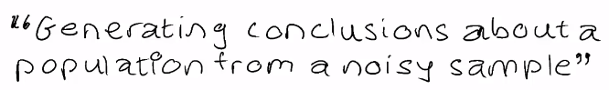

Many a time, you may require a very large amount of data for your analysis which may need too much time and resources to acquire. In such situations, you are forced to work with a **smaller sample of the data**, instead of having the entire data to work with

**[Extrapolation from the sample data to the entire population]**

Note that even after using inferential statistics, you would only be able to estimate the population data from the sample data, but not find the exact values. This is because when you don't have the exact data, you can only make reasonable estimates about it with a limited level of certainty. Therefore, when certainty is limited, we talk in terms of probability

**Prerequisites**

* **Basic definition** of probability
* **Multiplication rule** of probability
* **Addition rule**of probability
* (**Combinatorics**)

## Probability:

## Many events can't be predicted with total certainty. The best we can say is how likely they are to happen, using the idea of probability.

## In general:



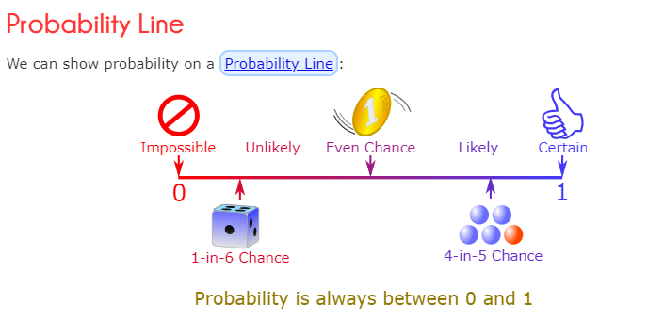

Events can be:

* **Independent** (each event is **not** affected by other events),
* **Dependent** (also called "Conditional", where an event **is** affected by other events)
* **Mutually Exclusive** (events can't happen at the same time)

## Independent Events

Events can be "Independent", meaning each event is **not affected** by any other events.

This is an important idea! A coin does not "know" that it came up heads before ... each toss of a coin is a perfect isolated thing.

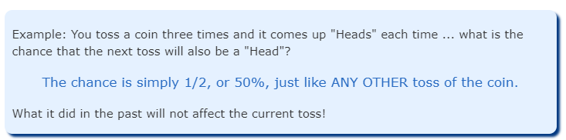

Some people think "it is overdue for a Tail", but *really truly* the next toss of the coin is totally independent of any previous tosses.

Saying "a Tail is due", or "just one more go, my luck is due" is called **The Gambler's Fallacy**

Dependent Events

But some events can be "dependent" ... which means they **can be affected by previous events**.

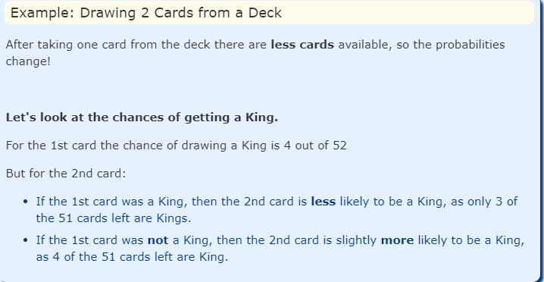

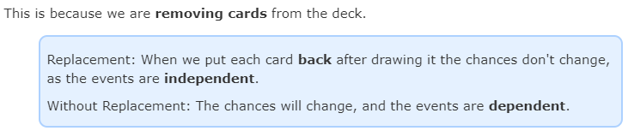

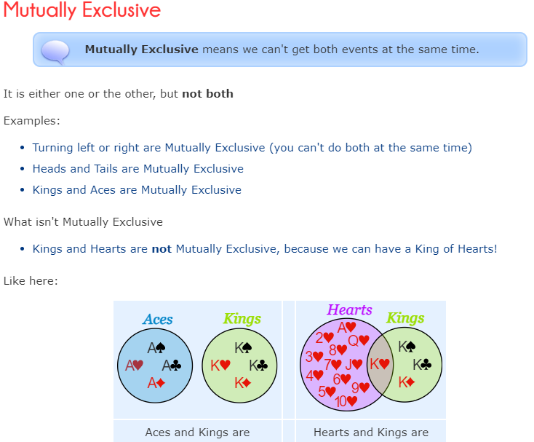

REF: https://www.mathsisfun.com/data/probability-events-types.html