**Basics of Probability:**

1. Random variables

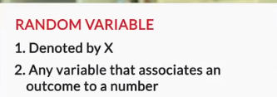

So, the **random variable X** basically converts outcomes of experiments to something measurable.

1. Probability Distribution

**So basically, a probability distribution is ANY form of representation that tells us the probability for all possible values of X. It could be any of the following:**

1. **Table**
2. **Chart [ Probabilities on Y axis and Random variale on X axis ]**
3. **Equation**

**Table form:**

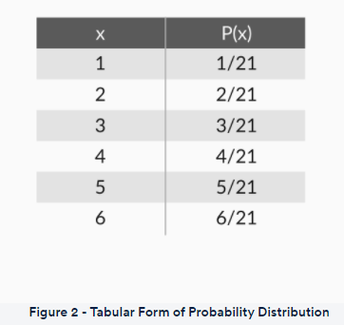

**Chart form:**

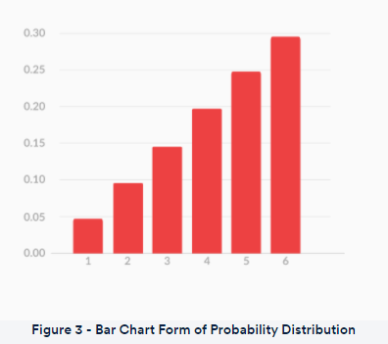

**An Equation Form:**

**P(x) = x/21 (for x = 1, 2, 3, 4, 5 and 6)**

**There are mainly 3 setps involed on solving the problem with probability as stated below:**

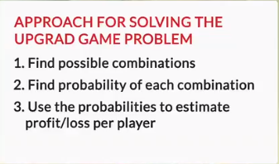

**Step 1. Here X is the random variable, probability of getting red ball**

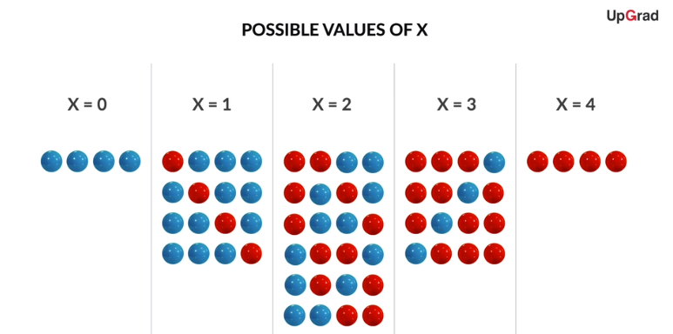

**Step 2. Probability for each combination**

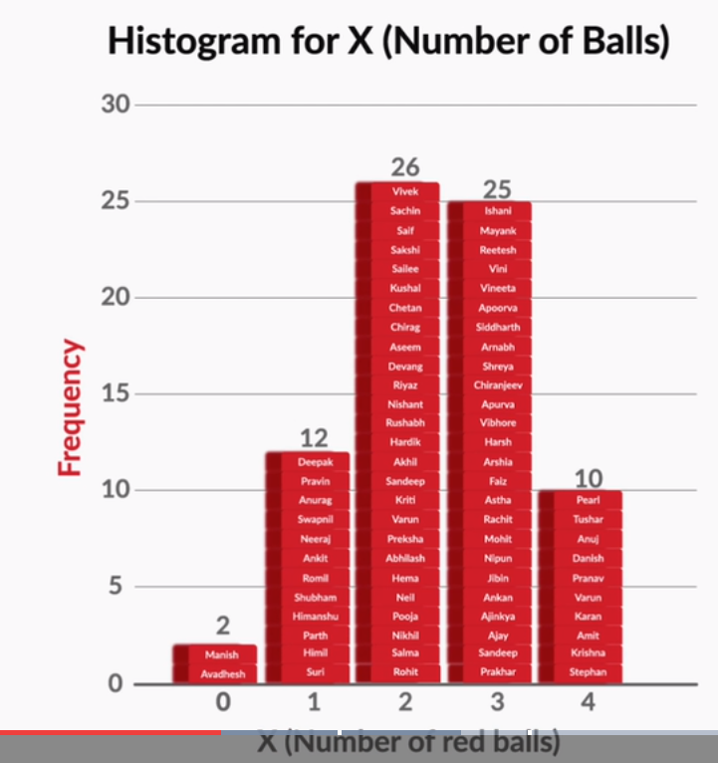

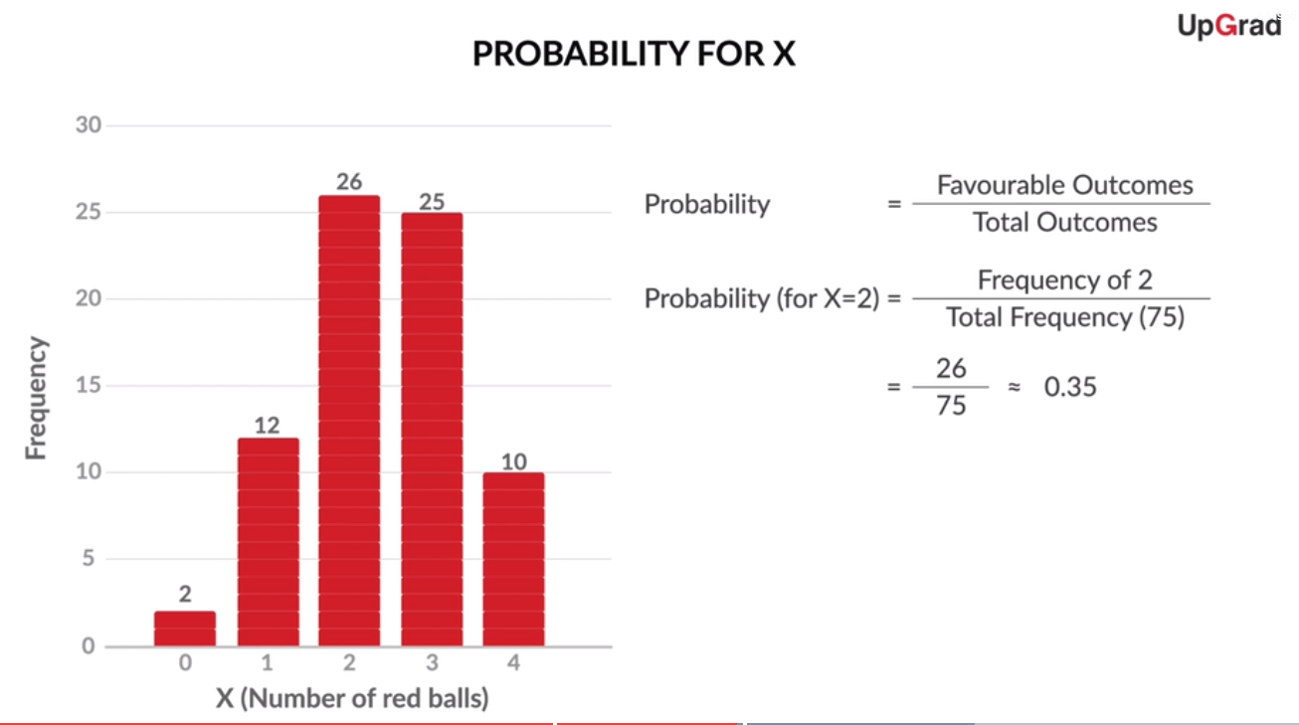

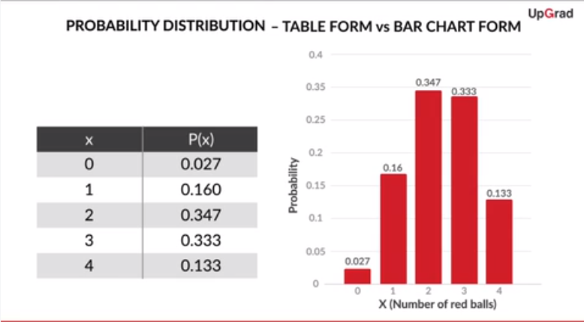

**Step 3: Expected value**

**Let’s say total 1000 people played this game**

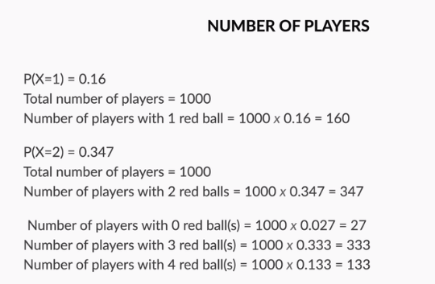

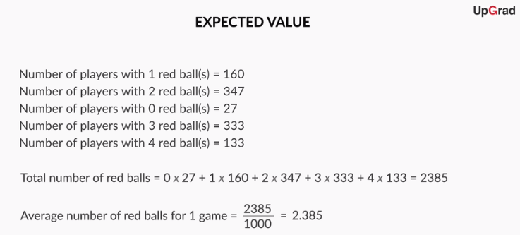

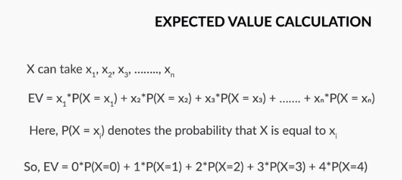

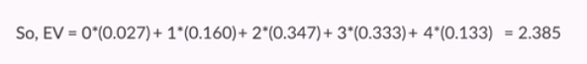

So, the **expected value** for a variable X is the value of X we would “expect” to get after performing the experiment once. It is also called the **expectation**, **average**, and **mean value**. Mathematically speaking, for a random variable X that can take values x1,x2,x3,...........,xn, the expected value (EV) is given by:



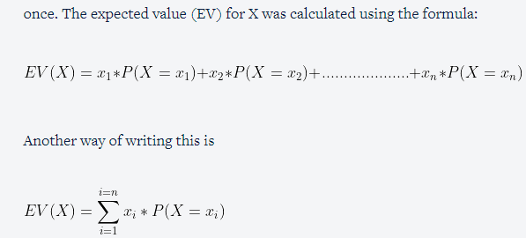

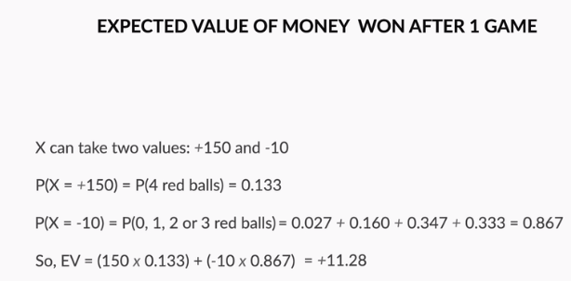

Here Expected value is +11.28 (positive) so if so many people play the game, house will lose lot of money.

Note: Expected value should be –ve, then only hose will make money

So below are the 3 possible options to increase House wining changes

1. Decrease Price money
2. Increase Penalty
3. Reduce the probability of Player winning