Discrete Probability Distributions

Probability distribution for discrete random variables

I. Binomial probability distribution

II. Uniform probability distribution

The concept of cumulative probability which will be very useful on continuous probability distributions

Prerequisites:

1. Multiplication rule
2. Addition rule
3. Combinatorics 

Experiment: A single 6-sided die is rolled. What is the probability of rolling a 2 or a 5?



Top of Form

Bottom of Form

Possibilities:

1. The number rolled can be a 2.

2. The number rolled can be a 5.

Events: These events are mutually exclusive since they cannot occur at the same time.

Probabilities: How do we find the probabilities of these mutually exclusive events? We need a rule to guide us.

**Addition Rule 1:**When two events, A and B, are mutually exclusive, the probability that A or B will occur is the sum of the probability of each event.

P(A or B) = P(A) + P(B)

Let's use this addition rule to find the probability for Experiment 1.

Experiment 1: A single 6-sided die is rolled. What is the probability of rolling a 2 or a 5?

Probabilities:

|  |  |  |
| --- | --- | --- |
| P(2) | = | 1 |
| 6 |
|  | | | | |
| P(5) | = | 1 |  |  |
| 6 |  |  |
|  | | | | |
| P(2 or 5) | = | P(2) | + | P(5) |
|  | | | | |
|  | = | 1 | + | 1 |
| 6 | 6 |
|  | | | | |
| = | 2 |  |  |  |
| 6 |  |  |  |
|  | | | | |
| = | 1 |  |  |  |
| 3 |  |  |  |

**Additional Rule 2:**When two events, A and B, are non-mutually exclusive, the probability that A or B will occur is:

P(A or B) = P(A) + P(B) - P(A and B)

In the rule above, P(A and B) refers to the overlap of the two events. Let's apply this rule to some other experiments.

A single card is chosen at random from a standard deck of 52 playing cards. What is the probability of choosing a king or a club?

Probabilities:

|  |  |  |  |  |  |  |
| --- | --- | --- | --- | --- | --- | --- |
| P(king or club) | = | P(king) | + | P(club) | - | P(king of clubs) |
|  | | | | | | |
|  | = | 4 | + | 13 | - | 1 |
| 52 | 52 | 52 |
|  | | | | | | |
| = | 16 |  |  |  |  |  |
| 52 |  |  |  |  |  |
|  | | | | | | |
| = | 4 |  |  |  |  |  |
| 13 |  |  |  |  |  |

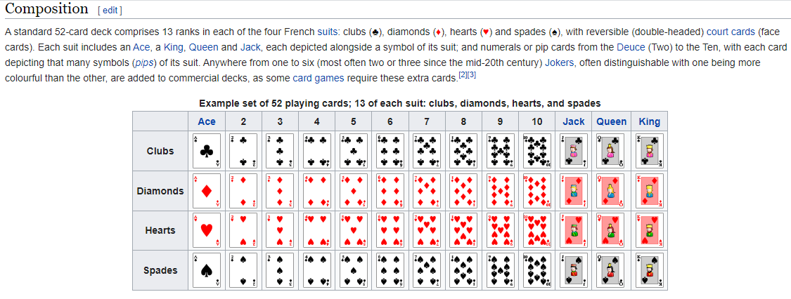

In a math class of 30 students, 17 are boys and 13 are girls. On a unit test, 4 boys and 5 girls made an A grade. If a student is chosen at random from the class, what is the probability of choosing a girl or an A student?

P(G or A Grade) = P(G) + P(A Grade) – P(G and A Grade)

= 13/30 + 9/30 – 5/30

= 17/30

**Multiplication Rule:**

**Definition:**Two events, A and B, are **independent** if the fact that A occurs does not affect the probability of B occurring.

Some other examples of independent events are:

* Landing on heads after tossing a coin **AND** rolling a 5 on a single 6-sided die.
* Choosing a marble from a jar **AND** landing on heads after tossing a coin.
* Choosing a 3 from a deck of cards, replacing it, **AND** then choosing an ace as the second card.
* Rolling a 4 on a single 6-sided die, **AND** then rolling a 1 on a second roll of the die.

To find the probability of two independent events that occur in sequence, find the probability of each event occurring separately, and then multiply the probabilities. This multiplication rule is defined symbolically below. Note that multiplication is represented by AND.

**Multiplication Rule 1:**When two events, A and B, are independent, the probability of both occurring is:

P(A and B) = P(A) **·** P(B)

Experiment 1: A dresser drawer contains one pair of socks with each of the following colors: blue, brown, red, white and black. Each pair is folded together in a matching set. You reach into the sock drawer and choose a pair of socks without looking. You replace this pair and then choose another pair of socks. What is the probability that you will choose the red pair of socks both times?

Probabilities:

|  |  |  |
| --- | --- | --- |
| P(red) | = | 1 |
| 5 |
|  | | | | |
| P(red and red) | = | P(red) | **·** | P(red) |
|  | | | | |
|  | = | 1 | **·** | 1 |
| 5 | 5 |
|  | | | | |
| = | 1 |  |  |  |
| 25 |  |  |  |

A coin is tossed and a single 6-sided die is rolled. Find the probability of landing on the head side of the coin and rolling a 3 on the die.

Probabilities:

|  |  |  |
| --- | --- | --- |
| P(head) | = | 1 |
| 2 |
|  | | | | |
| P(3) | = | 1 |  |  |
| 6 |  |  |
|  | | | | |
| P(head and 3) | = | P(head) | **·** | P(3) |
|  | | | | |
|  | = | 1 | **·** | 1 |
| 2 | 6 |
|  | | | | |
| = | 1 |  |  |  |
| 12 |  |  |  |

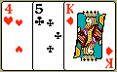Experiment 3: A card is chosen at random from a deck of 52 cards. It is then replaced and a second card is chosen. What is the probability of choosing a jack and then an eight?

Probabilities:

|  |  |  |
| --- | --- | --- |
| P(jack) | = | 4 |
| 52 |
|  | | | | |
| P(8) | = | 4 |  |  |
| 52 |  |  |
|  | | | | |
| P(jack and 8) | = | P(jack) | **·** | P(8) |
|  | | | | |
|  | = | 4 | **·** | 4 |
| 52 | 52 |
|  | | | | |
| = | 16 |  |  |  |
| 2704 |  |  |  |
|  | | | | |
| = | 1 |  |  |  |
| 169 |  |  |  |

Experiment 4: A jar contains 3 red, 5 green, 2 blue and 6 yellow marbles. A marble is chosen at random from the jar. After replacing it, a second marble is chosen. What is the probability of choosing a green and then a yellow marble?

Probabilities:

|  |  |  |
| --- | --- | --- |
| P(green) | = | 5 |
| 16 |
|  | | | | |
| P(yellow) | = | 6 |  |  |
| 16 |  |  |
|  | | | | |
| P(green and yellow) | = | P(green) | **·** | P(yellow) |
|  | | | | |
|  | = | 5 | **·** | 6 |
| 16 | 16 |
|  | | | | |
| = | 30 |  |  |  |
| 256 |  |  |  |
|  | | | | |
| = | 15 |  |  |  |
| 128 |  |  |  |

# Conditional Probability

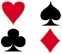

Problem: A math teacher gave her class two tests. 25% of the class passed both tests and 42% of the class passed the first test. What percent of those who passed the first test also passed the second test?

Analysis: This problem describes a [conditional probability](javascript:x1096653463('conditional')) since it asks us to find the probability that the second test was passed given that the first test was passed. In the last lesson, the notation for conditional probability was used in the statement of Multiplication Rule 2.

**Multiplication Rule 2:**When two events, A and B, are dependent, the probability of both occurring is:

multiplication rule

The formula for the Conditional Probability of an event can be derived from Multiplication Rule 2 as follows:

       Start with Multiplication Rule 2.

     Divide both sides of equation by P(A).

     Cancel P(A)s on right-hand side of equation.

               Commute the equation.

                            We have derived the formula for conditional probability.

Now we can use this formula to solve the problem at the top of the page.

Problem: A math teacher gave her class two tests. 25% of the class passed both tests and 42% of the class passed the first test. What percent of those who passed the first test also passed the second test?

Solution:

|  |  |  |  |  |  |  |  |  |
| --- | --- | --- | --- | --- | --- | --- | --- | --- |
| P(Second|First) | = | P(First and Second) | = | 0.25 | = | 0.60 | = | 60% |
| P(First) | 0.42 |

Let's look at some other problems in which we are asked to find a conditional probability.

Example 1: A jar contains black and white marbles. Two marbles are chosen without replacement. The probability of selecting a black marble and then a white marble is 0.34, and the probability of selecting a black marble on the first draw is 0.47. What is the probability of selecting a white marble on the second draw, given that the first marble drawn was black?

Solution:

|  |  |  |  |  |  |  |  |  |
| --- | --- | --- | --- | --- | --- | --- | --- | --- |
| P(White|Black) | = | P(Black and White) | = | 0.34 | = | 0.72 | = | 72% |
| P(Black) | 0.47 |

Example 2: The probability that it is Friday and that a student is absent is 0.03. Since there are 5 school days in a week, the probability that it is Friday is 0.2. What is the probability that a student is absent given that today is Friday?

Solution:

|  |  |  |  |  |  |  |  |  |
| --- | --- | --- | --- | --- | --- | --- | --- | --- |
| P(Absent|Friday) | = | P(Friday and Absent) | = | 0.03 | = | 0.15 | = | 15% |
| P(Friday) | 0.2 |

Example 3: At Kennedy Middle School, the probability that a student takes Technology and Spanish is 0.087. The probability that a student takes Technology is 0.68. What is the probability that a student takes Spanish given that the student is taking Technology?

Solution:

|  |  |  |  |  |  |  |  |  |
| --- | --- | --- | --- | --- | --- | --- | --- | --- |
| P(Spanish|Technology) | = | P(Technology and Spanish) | = | 0.087 | = | 0.13 | = | 13% |
| P(Technology) | 0.68 |

Summary: The conditional probability of an event B in relationship to an event A is the probability that event B occurs given that event A has already occurred. The notation for conditional probability is P(B|A), read as *the probability of B given A*. The formula for conditional probability is:

conditional formula

The Venn Diagram below illustrates P(A), P(B), and P(A and B). What two sections would have to be divided to find P(B|A)?   [Answer](javascript:x1096653463('answer'))

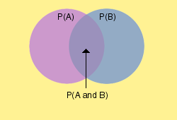

P(White|Black)  =  P(Black and White)  =  0.34  =  0.72  =  72%P(Black)0.47

*Combination*

The number of ways to choose a sample of r elements from a set of n distinct objects where order does not matter and replacements are not allowed

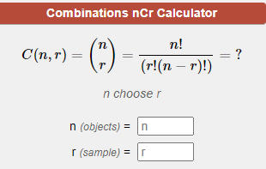

For n ≥ r ≥ 0.

The formula show us the number of ways a sample of “r” elements can be obtained from a larger set of “n” distinguishable objects where order does not matter and repetitions are not allowed. [1] "The number of ways of picking r unordered outcomes from n possibilities." [2]

Also referred to as r-combination or "n choose r" or the **binomial coefficient**.  In some resources the notation uses k instead of r so you may see these referred to as k-combination or "n choose k."

### Combination Problem 1

**Choose 2 Prizes from a Set of 6 Prizes**

You have won first place in a contest and are allowed to choose 2 prizes from a table that has 6 prizes numbered 1 through 6. How many different combinations of 2 prizes could you possibly choose?

In this example, we are taking a subset of 2 prizes (r) from a larger set of 6 prizes (n). Looking at the formula, we must calculate “6 choose 2.”

C (6,2)= 6!/(2! * (6-2)!) = 6!/(2! * 4!) = **15 Possible Prize Combinations**

The 15 potential combinations are {1,2}, {1,3}, {1,4}, {1,5}, {1,6}, {2,3}, {2,4}, {2,5}, {2,6}, {3,4}, {3,5}, {3,6}, {4,5}, {4,6}, {5,6}

### Combination Problem 2

**Choose 3 Students from a Class of 25**

A teacher is going to choose 3 students from her class to compete in the spelling bee. She wants to figure out how many unique teams of 3 can be created from her class of 25.

In this example, we are taking a subset of 3 students (r) from a larger set of 25 students (n). Looking at the formula, we must calculate “25 choose 3.”

C (25,3)= 25!/(3! * (25-3)!)= **2,300 Possible Teams**

### Combination Problem 3

**Choose 4 Menu Items from a Menu of 18 Items**

A restaurant asks some of its frequent customers to choose their favorite 4 items on the menu. If the menu has 18 items to choose from, how many different answers could the customers give?

Here we take a 4 item subset (r) from the larger 18 item menu (n). Therefore, we must simply find “18 choose 4.”

C (18,4)= 18!/(4! * (18-4)!)= **3,060 Possible Answers**

## Handshake Problem

In a group of n people, how many ***different*** handshakes are possible?

First, let's find the ***total*** handshakes that are possible. That is to say, if each person shook hands once with every other person in the group, what is the total number of handshakes that occur?

A way of considering this is that each person in the group will make a total of n-1 handshakes. Since there are n people, there would be n times (n-1) total handshakes. In other words, the total number of people multiplied by the number of handshakes that each can make will be the total handshakes. A group of 3 would make a total of 3(3-1) = 3 * 2 = 6. Each person registers 2 handshakes with the other 2 people in the group; 3 * 2.

Total Handshakes = n(n-1)

However, this includes each handshake twice (1 with 2, 2 with 1, 1 with 3, 3 with 1, 2 with 3 and 3 with 2) and since the orginal question wants to know how many ***different*** handshakes are possible we must divide by 2 to get the correct answer.

Total Different Handshakes = n(n-1)/2

### Handshake Problem as a Combinations Problem

We can also solve this Handshake Problem as a combinations problem as C(n,2).

n *(objects)* = number of people in the group  
r *(sample)* = 2, the number of people involved in each different handshake

The order of the items chosen in the subset does not matter so for a group of 3 it will count 1 with 2, 1 with 3, and 2 with 3 but ignore 2 with 1, 3 with 1, and 3 with 2 because these last 3 are duplicates of the first 3 respectively.

C(n,r)=n!(r!(n−r)!)C(n,r)=n!(r!(n−r)!)

C(n,2)=n!(2!(n−2)!)C(n,2)=n!(2!(n−2)!)

expanding the factorials,

=1×2×3...×(n−2)×(n−1)×(n)(2×1×(1×2×3...×(n−2)))=1×2×3...×(n−2)×(n−1)×(n)(2×1×(1×2×3...×(n−2)))

cancelling and simplifying,

=(n−1)×(n)2=n(n−1)2=(n−1)×(n)2=n(n−1)2

which is the same as the equation above.

<https://www.mathgoodies.com//lessons/vol6/independent_events>

<https://www.mathgoodies.com//lessons/vol6/addition_rules>

<https://www.calculatorsoup.com/calculators/discretemathematics/combinations.php>