# 12.1 - Poisson Distributions

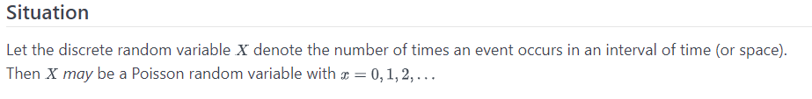

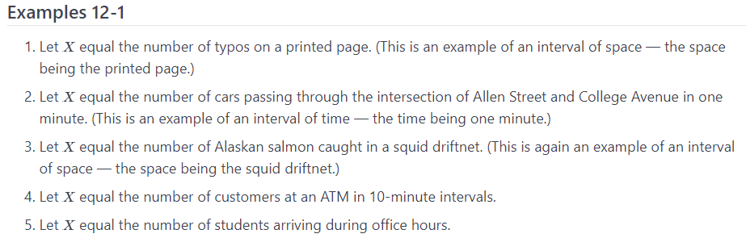

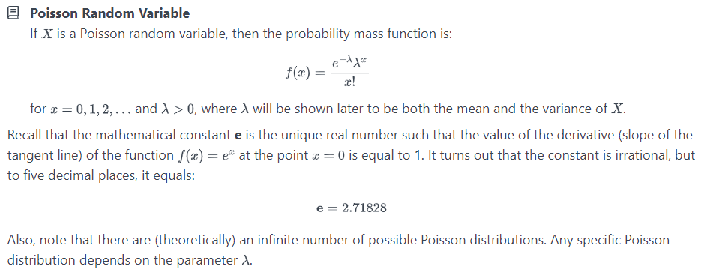

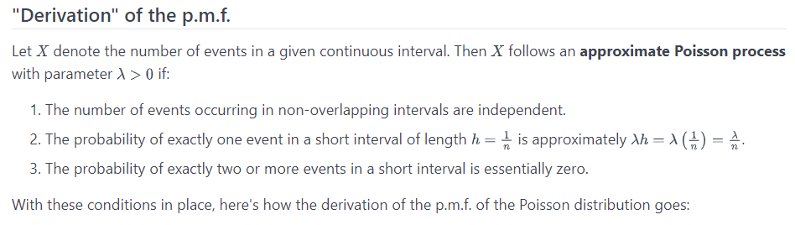

## Example 12-2 [Section](https://online.stat.psu.edu/stat414/lesson/12/12.2#paragraph--254)

### printed page

Question:

Let X equal the number of typos on a printed page with a mean of 3 typos per page. What is the probability that a randomly selected page has **at least one typo** on it?

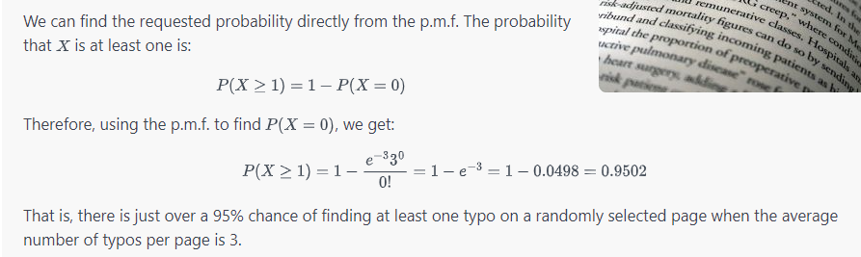

Question:

What is the probability that a randomly selected page has **at most one typo** on it?

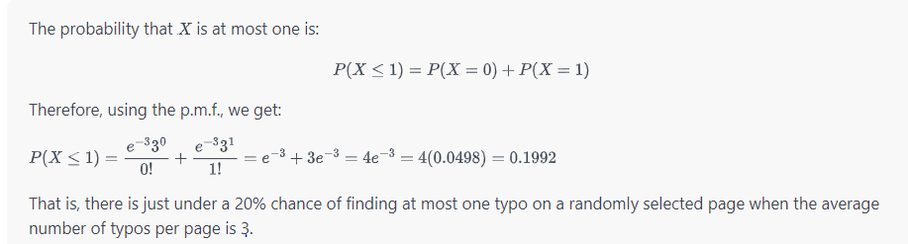

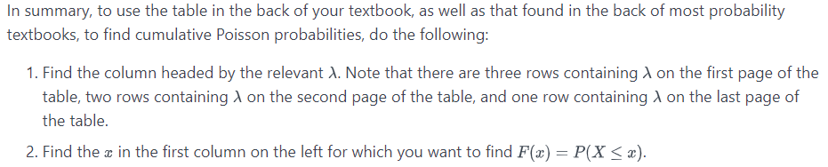

Question:

Let's try it out on an example. If X equals the number of typos on a printed page with a mean of 3 typos per page, what is the probability that a randomly selected page has **four typos** on it?

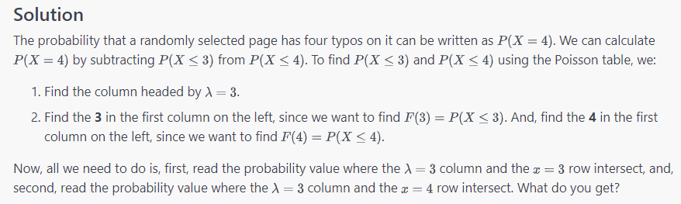

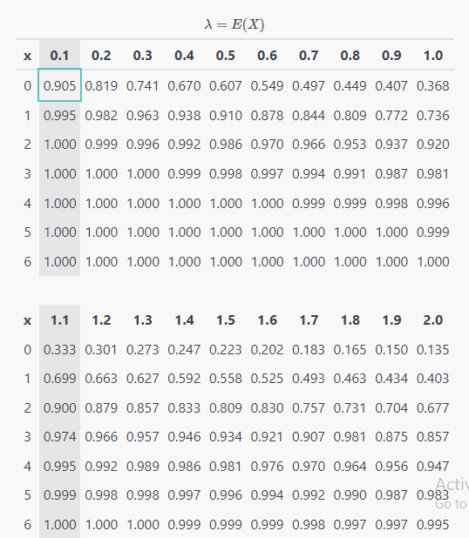

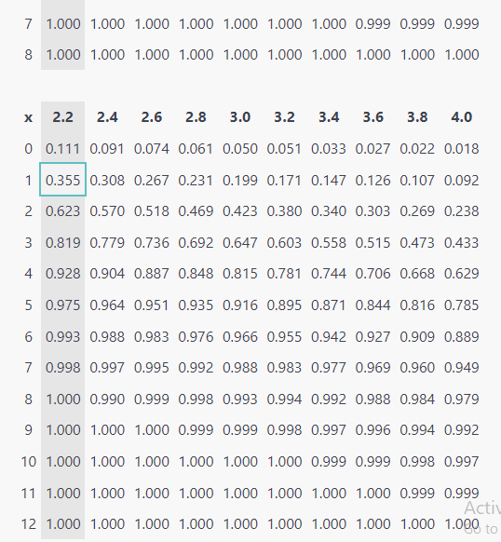

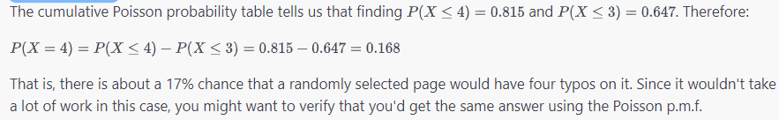

Question:

What is the probability that three randomly selected pages have **more than eight typos** on it?

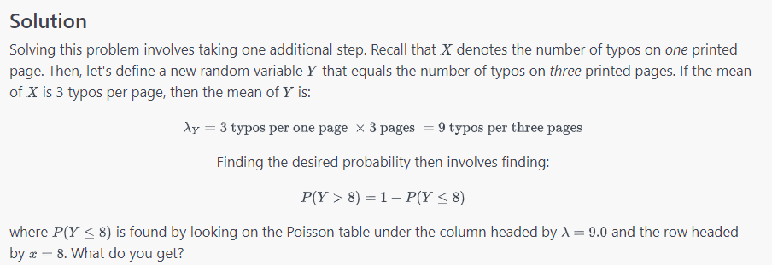

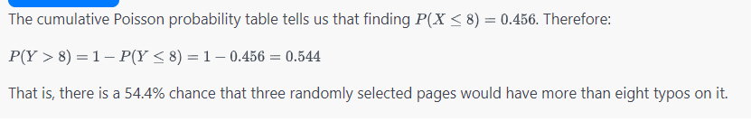

Poison Properties:

