**SRE CHAOS SUMMARY REPORT**

|  |  |
| --- | --- |
| **Application Name** | **SRINU** |
| **Services in Scope** | mytrips-api |
| **Application Members Participated** | Avadhanula, Chandrasekhar |
| **SRE Members Participated** | Anjala Thulasiram, Rajamanickam, Loga |
| **Chaos Test Execution Date** | "02/12/2024" |
| **Chaos Tool Used** | AWS FIS |
| **Disposition** | Modernized |
| **Environment** | SI |

**Chaos Test Results:**

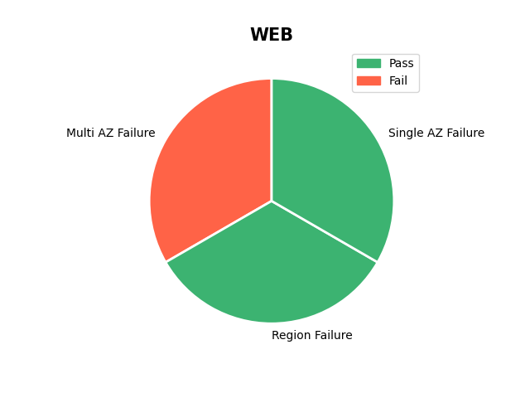

**Reference:**

*https://zap.delta.com/ccoe/docs/operations_process_and_tooling/chaos-engineering/overview/*