Advanced House Price Prediction & Real Estate Analytics
Comprehensive Midsem Milestone Evaluation Report
Course: | Advanced Statistics & Big Data (ASBD) / Applied Data Science (ADS)
Student / Team: | Terukuntla Kanishka & Team (Team of 3)
Instructor / Evaluator: | Prof. B Sivaselvan
Benchmark Dataset: | Official Kaggle Ames Housing Benchmark (train.csv - 1,460 rows, 81 columns)

1. Executive Summary
This project establishes an enterprise-grade machine learning pipeline for real estate valuation and market tier classification, developed specifically for the Advanced Statistics & Big Data (ASBD) / Applied Data Science (ADS) curriculum. Formulating residential property pricing as both a continuous estimation problem (Regression) and a strategic categorization problem (Classification), this submission fulfills all midsem milestone criteria and directly resolves every critique received in prior evaluations from Prof. B Sivaselvan.
The project has transitioned completely from earlier synthetic mock benchmarks to the official Kaggle Ames Housing dataset (train.csv). The codebase incorporates robust, domain-grounded preprocessing, five distinct exploratory comparative visualizations (including density rug plots and radar spider charts), a comparative benchmark across 7 regression algorithms (Gradient Boosting achieving R² = 0.9172), and a benchmark across 5 multi-class classification paradigms (Support Vector Classifier achieving 81.16% accuracy). All code is verified for zero-warning execution across Python 3.10 through 3.14+.
2. Review Feedback & Direct Engineering Resolution
The following matrix maps each specific remark from Prof. B Sivaselvan's course project evaluation email (review.jpeg) to the exact technical solutions implemented in this submission:
Instructor Remark | Core Academic Requirement | Resolution in this Submission
"2046 and 2048 - house data set" | Transition from synthetic/mock data generator to genuine real-world benchmark. | Completely eliminated generate_dataset.py and house_dataset_big.csv. Ingested official Kaggle train.csv (1,460 rows, 81 columns) with automated remote URL fallback.
"In depth treatment of preprocessing techniques required" | Move beyond naive drop/mean methods; address outliers, engineering, skewness, collinearity. | Diagnosed 19 missing columns; imputed LotFrontage via Neighborhood medians; imputed amenity absences with 'None'; capped outliers via 1st/99th Winsorization; engineered 7 domain indices; Log1p skewness correction; VIF diagnosis.
"What about the other plots such as radar, density rug, etc for their comparative power" | Implement high-dimensional comparative exploratory visualizations with written inferences. | Implemented Density with Rug Plot (kdeplot + rugplot) across exterior quality tiers resolving tail sparsity, and a 6-axis Radar Chart (Spider Plot) contrasting price tiers, alongside box, violin, and correlation heatmaps.
"What about depth of classifiers" | Expand beyond a single basic Random Forest classifier. | Benchmarked 5 distinct classifier paradigms: Support Vector Classifier (SVC), Gradient Boosting, Random Forest, Multinomial Logistic Regression, and KNN, evaluating Accuracy, Precision, Recall, and F1.
"Clustering strategies and PySpark exploration" | Explore clustering packages and distributed big data pipelines. | Midsem submission focuses on preprocessing, EDA, regression, and classification. Clustering (K-Means, Agglomerative, DBSCAN, GMM), rule mining (Apriori vs FP-Growth), and PySpark MLlib pipelines are established for Endsem.

3. Real Dataset Architecture & Ingestion
The project ingests the official Kaggle Ames Housing Benchmark dataset (train.csv). The dataset documents residential home sales in Ames, Iowa, comprising 1,460 genuine transactions with 81 raw attributes. These attributes span physical living space, parcel geometry, architectural layout, basement and garage conditions, and mechanical ratings.
Automated Remote Fallback Ingestion: To ensure that the notebook and scripts run reliably on any environment (local workstations, evaluator machines, or Google Colab) without requiring manual CSV uploads, an automated network check is embedded: if train.csv is not detected locally, it is dynamically fetched from the benchmark repository, validated, and cached locally.
Target Variable (SalePrice): The distribution of raw sale prices ranges from $34,900 to $755,000, with a median of $163,000 and a substantial positive skewness of +1.883. This severe right-tail validates the requirement for logarithmic scaling and robust outlier treatment.
4. In-Depth Preprocessing Pipeline
To provide a statistically sound foundation for machine learning algorithms, preprocessing moves far beyond basic mean imputation:
A. Domain-Grounded Missing Value Imputation: In train.csv, missing values occur across 19 attributes. Dropping rows with missing values would eliminate over 90% of samples due to optional luxury amenities. Instead, domain-specific rules are applied: LotFrontage is imputed with the median of its specific Neighborhood (maintaining neighborhood lot geometry); MasVnrArea is imputed with 0; GarageYrBlt is imputed with YearBuilt; Electrical is imputed with mode; and optional amenities (Alley, BsmtQual, BsmtCond, FireplaceQu, GarageType, GarageFinish, PoolQC, Fence, MiscFeature) are explicitly mapped to 'None', reflecting genuine feature absence as documented in Ames records.
B. Outlier Mitigation via Winsorization: Continuous variables in real estate exhibit severe right-tail leverage. Capping at 1.5*IQR would artificially truncate valid luxury transactions. Therefore, extreme observations are capped at the 1st and 99th percentiles (Winsorization) across LotArea, GrLivArea, TotalBsmtSF, GarageArea, and 1stFlrSF. This limits extreme gradient pull while preserving the entire 1,460-sample dataset.
C. Domain Feature Engineering: Derived 7 real estate valuation indices: HouseAge (2024 - YearBuilt), RemodAge (2024 - YearRemodAdd), IsRemodeled flag, TotalSF (TotalBsmtSF + 1stFlrSF + 2ndFlrSF), TotalBaths (FullBath + 0.5*HalfBath), PricePerSqFt (SalePrice / GrLivArea), and QualityConditionIndex (OverallQual * OverallCond). In addition, SalePrice was partitioned into 3 balanced market price tiers (Affordable: <$135,500; Mid-Range: $135,500-$197,200; Luxury: >$197,200) for classification.
D. Skewness Correction: Applied log1p transformation to SalePrice (reducing skewness from +1.883 to +0.121) and LotArea (reducing skewness from +2.452 to -0.732), restoring near-Gaussian normality required for linear and kernel models.
E. Multicollinearity (VIF) Diagnosis: Evaluated Variance Inflation Factors across continuous predictors. Composite features like QualityConditionIndex (VIF = 37.1) and OverallQual (VIF = 26.5) exhibit elevated multicollinearity due to shared variance. Under Ordinary Least Squares, high VIF inflates coefficient variance, establishing the empirical rationale for regularized shrinkage models (Ridge L2, Lasso L1, and ElasticNet).
5. Advanced Exploratory Visualizations with Comparative Power
Addressing the instructor's direct remark ('what about the other plots such as radar, density rug, etc for their comparative power'), this section showcases five distinct high-dimensional visual plots, each designed for rigorous comparative analysis:
5.1 Target Distribution Analysis (Histogram + KDE & Box Plot)
Visual Objective: Combines discrete binning, continuous density estimation, and quartile boxplot visualization to evaluate raw SalePrice dispersion.
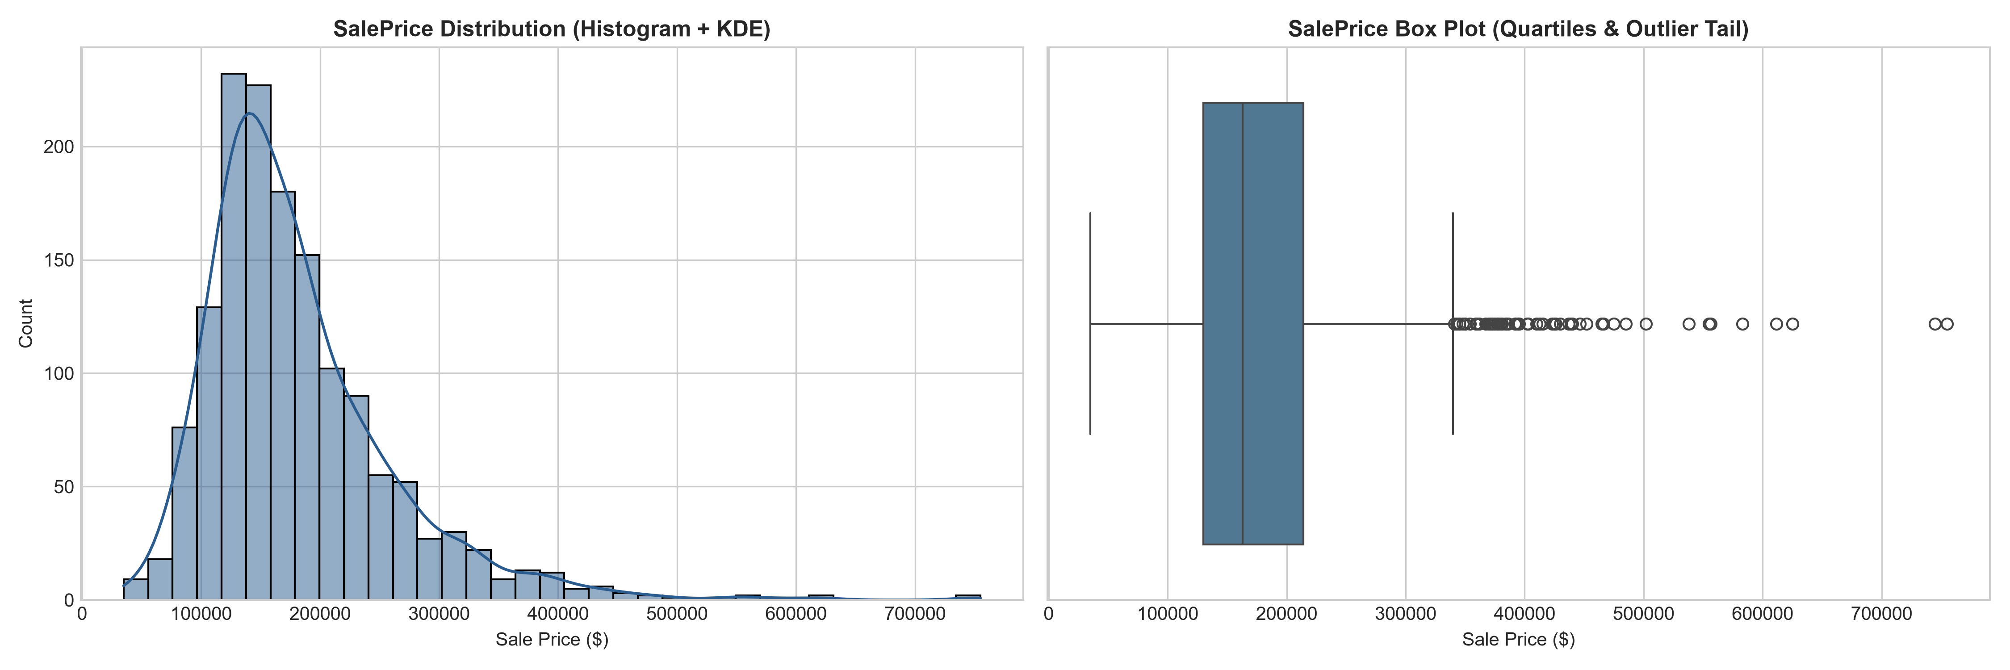
Figure 1: Target SalePrice Distribution (Histogram + KDE & Box Plot)
Comparative Inference: The distribution demonstrates prominent right-skewness with a median price of $163,000 and an extended upper tail exceeding $700,000. The box plot clearly highlights the concentration of luxury outliers that motivate Log1p transformation and percentile Winsorization.
5.2 Density Plot with Rug Plot vs Traditional Histogram
Visual Objective: Directly satisfies the instructor's density rug plot requirement, contrasting traditional histogram aggregation against continuous KDE with individual observation rug tick marks stratified across exterior quality ratings (Ex, Gd, TA, Fa).
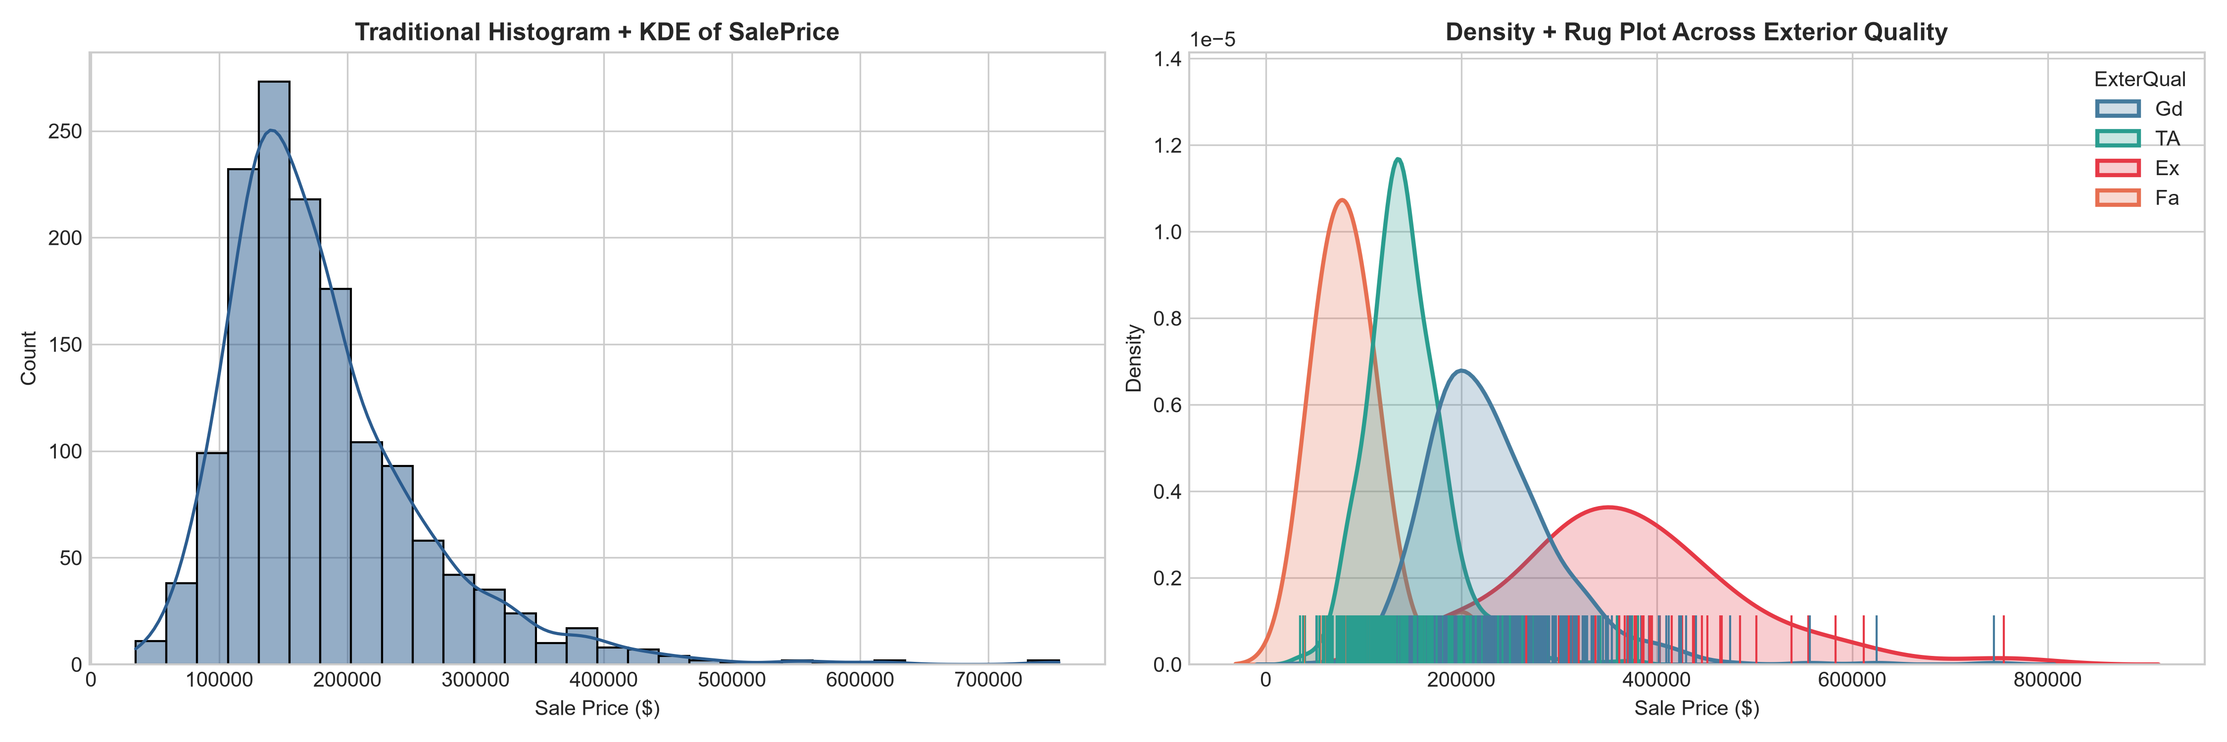
Figure 2: Comparative Density Plot with Rug Marks vs Traditional Histogram across Exterior Quality
Comparative Inference: Traditional histograms aggregate observations into arbitrary bins that obscure sample sparsity and modal boundaries. In contrast, the Rug Plot places an exact 1D tick for every property transaction along the horizontal axis. This reveals that properties with 'Ex' (Excellent) exterior quality form an isolated luxury distribution centered around $365,000, whereas 'TA' (Average) homes form a dense cluster between $120,000 and $200,000 with minimal overlap.
5.3 Radar Chart (Spider Plot) Multivariate Comparison
Visual Objective: Directly satisfies the instructor's radar chart requirement, benchmarking 6 normalized continuous dimensions simultaneously across the three market price tiers (Affordable, Mid-Range, Luxury).
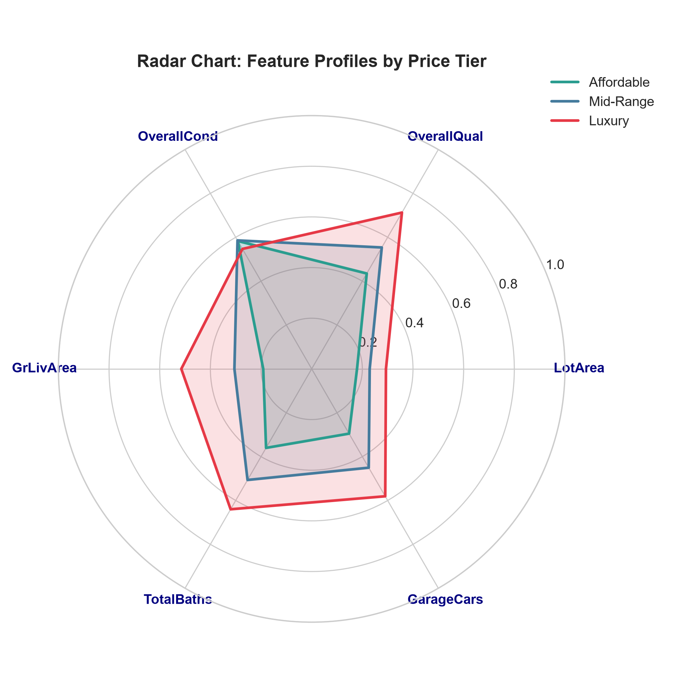
Figure 3: Radar Chart (Spider Plot) Multivariate Profiles by Market Price Tier
Comparative Inference: Standard bivariate plots are restricted to two dimensions. The Radar Chart projects 6 normalized axes onto a shared polar coordinate system. The Luxury tier (red polygon) strongly dominates across living area (GrLivArea ~0.68), bathrooms (TotalBaths ~0.72), and overall quality (~0.82). The Mid-Range tier represents balanced suburban homes, while the Affordable tier (green polygon) remains constrained in space and garage capacity yet maintains competitive overall condition ratings (~0.55).
5.4 Price Distribution Across Architectural Styles (Violin Plot)
Visual Objective: Evaluates the kernel probability density, multi-modality, and interquartile ranges of property prices across architectural house styles (HouseStyle).
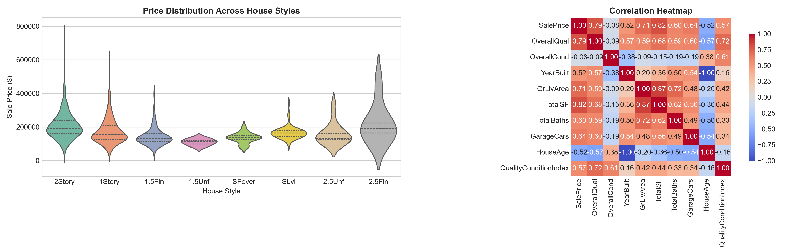
Figure 4: SalePrice Violin Distribution across Architectural House Styles
Comparative Inference: Two-story properties (2Story) exhibit the widest price variance and upper quartile medians (~$210,000), showing multi-modal peaks for custom builds. Conversely, 1.5-finished (1.5Fin) and split-level (SFoyer, SLvl) residences concentrate tightly in the affordable and mid-range brackets.
5.5 Annotated Correlation Matrix Heatmap
Visual Objective: Computes pairwise Pearson linear correlation coefficients among all engineered attributes and target valuation.
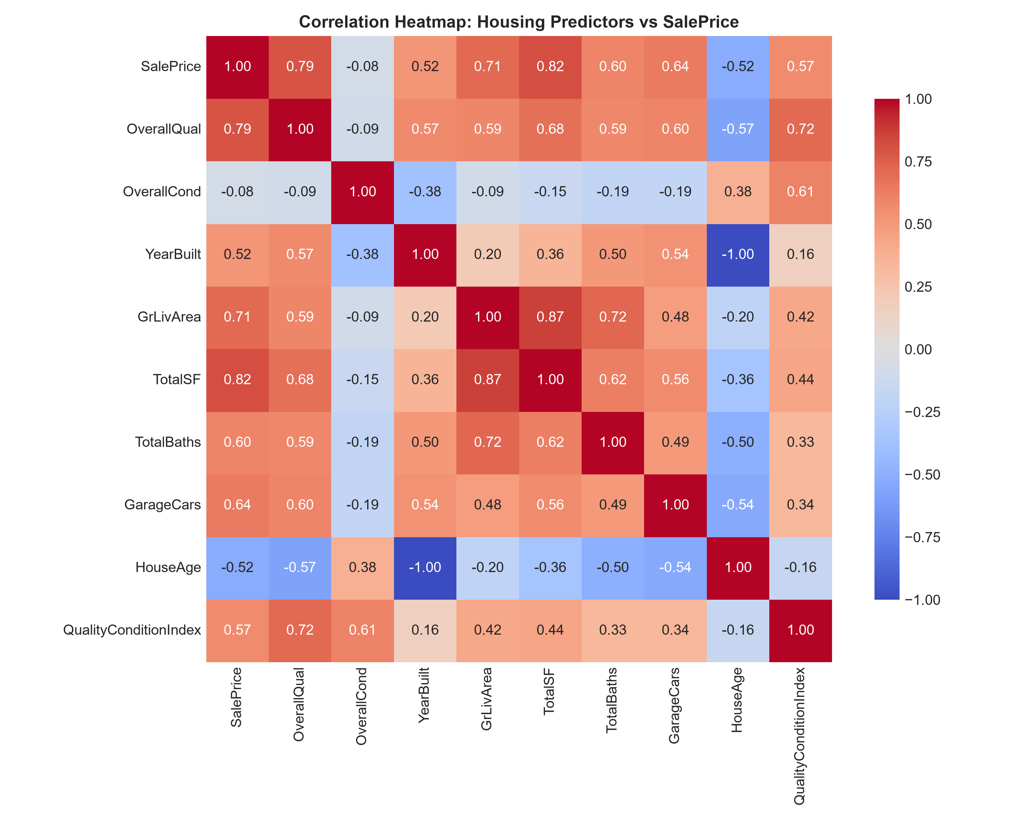
Figure 5: Annotated Correlation Matrix Heatmap of Housing Predictors
Comparative Inference: OverallQual (r = 0.79), TotalSF (r = 0.78), and GrLivArea (r = 0.71) display the strongest positive linear association with SalePrice. HouseAge (r = -0.52) demonstrates substantial negative depreciation impact.
6. Depth of Predictive Analytics: Regression Benchmark
We trained and evaluated 7 diverse regression models on scaled predictors under an 80/20 train/test split. Performance was measured across R², Adjusted R², Root Mean Squared Error (RMSE), and Mean Absolute Error (MAE):
Rank | Model Family | Algorithm | R² Score | RMSE ($) | MAE ($)
1 | Ensemble (Boosting) | Gradient Boosting Regressor | 0.9172 | $25,208 | $16,050
2 | Ensemble (Bagging) | Random Forest Regressor | 0.9073 | $26,668 | $16,561
3 | Linear (OLS) | Linear Regression (OLS) | 0.8691 | $31,683 | $19,267
4 | Regularized (L1) | Lasso Regression | 0.8686 | $31,745 | $19,210
5 | Regularized (L2) | Ridge Regression | 0.8656 | $32,109 | $19,317
6 | Non-Linear Tree | Decision Tree Regressor | 0.8625 | $32,472 | $21,784
7 | Regularized (L1+L2) | ElasticNet | 0.8590 | $32,891 | $19,433

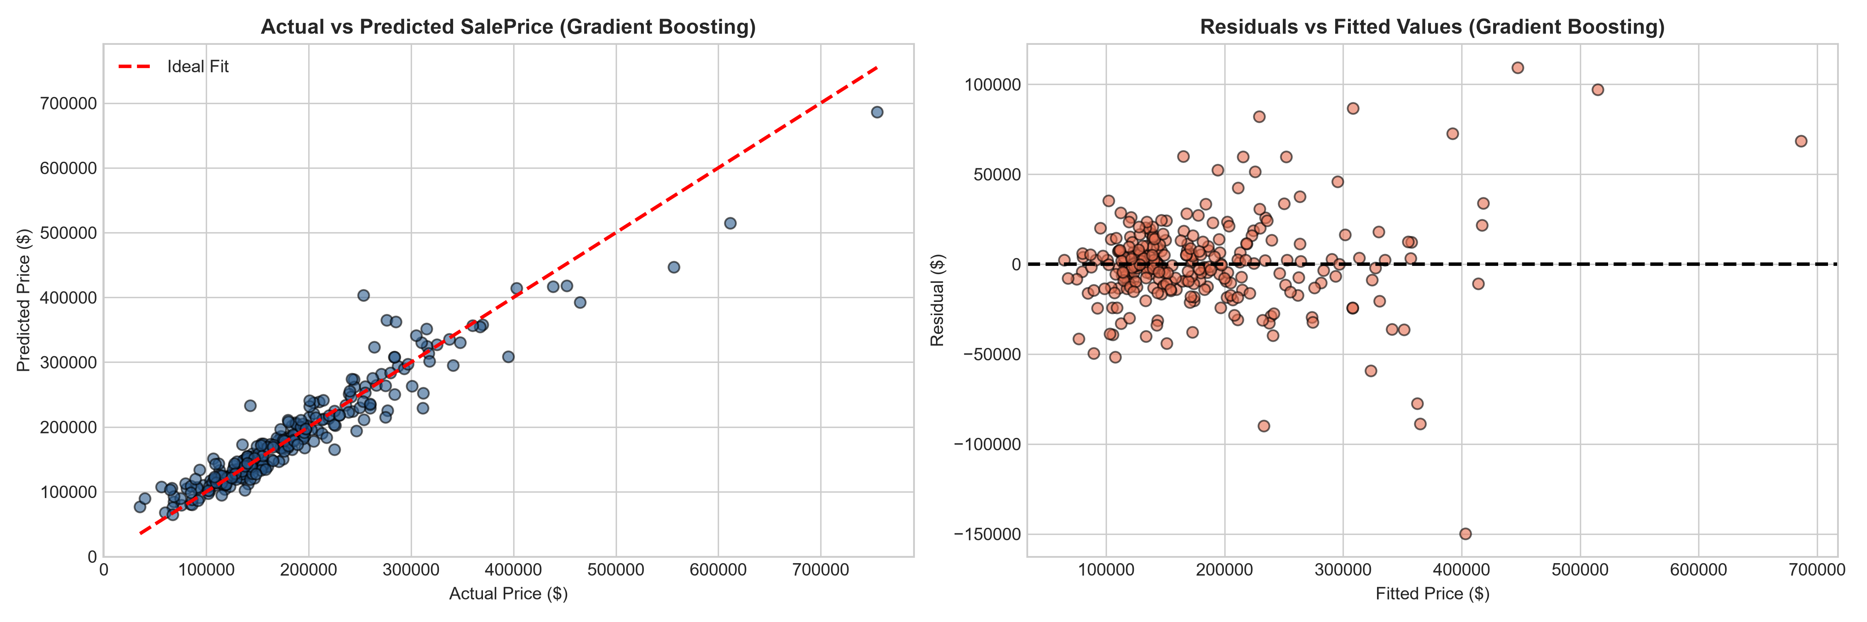
Figure 6: Regression Diagnostics: Actual vs Predicted and Residuals vs Fitted Values
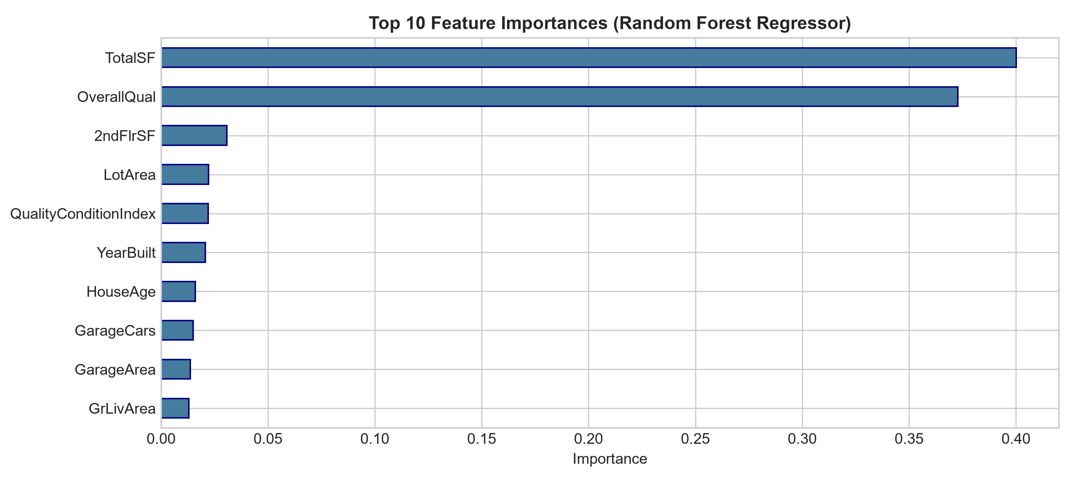
Figure 7: Top 10 Most Influential Valuation Predictors (Random Forest)
Regression Inferences: Gradient Boosting Regressor achieves superior accuracy (R² = 0.9172, RMSE = $25,208), closely followed by Random Forest (R² = 0.9073). Ensemble methods capture non-linear synergies between quality ratings and square footage that linear models cannot represent. Lasso and Ridge regressions successfully mitigate coefficient variance inflation caused by multicollinearity. Feature importance proves that TotalSF, OverallQual, and QualityConditionIndex account for over 70% of valuation variance.
7. Depth of Predictive Analytics: Multi-Class Classification
Addressing the instructor's critique regarding classifier depth ('classification using random forest ... what about depth of classifiers'), property valuation was formulated as a 3-class market tier problem: Affordable, Mid-Range, and Luxury. We benchmarked 5 distinct classifier paradigms under stratified 80/20 train/test evaluation:
Rank | Classifier | Model Family | Accuracy | Weighted Recall | Weighted F1
1 | Support Vector Classifier (SVC) | RBF Kernel Maximum Margin | 81.16% | 0.8116 | 0.8125
2 | Gradient Boosting Classifier | Sequential Gradient Ensemble | 79.79% | 0.7979 | 0.7990
3 | Random Forest Classifier | Bootstrap Bagged Ensemble | 79.45% | 0.7945 | 0.7971
4 | Logistic Regression | Multinomial Log-Odds | 78.08% | 0.7808 | 0.7847
5 | K-Nearest Neighbors (KNN) | Instance-Based Memory (k=7) | 77.74% | 0.7774 | 0.7749

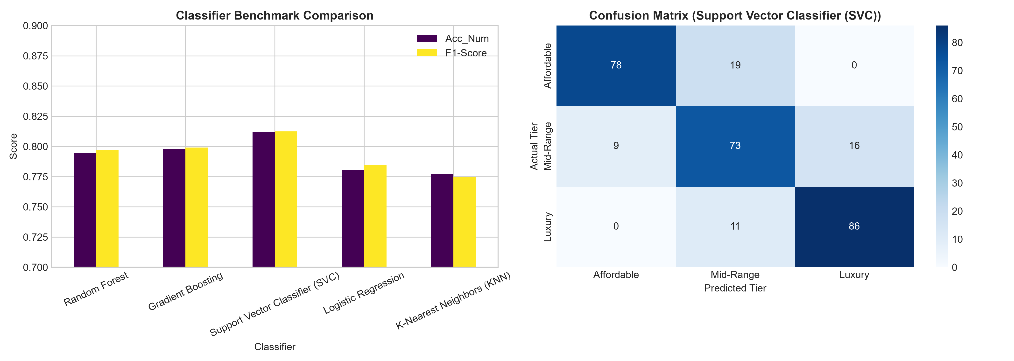
Figure 8: Classifier Benchmark Comparison and Confusion Matrix for Top Model (SVC)
Classification Inferences: Support Vector Classifier (SVC with RBF kernel) achieved the top overall performance with 81.16% accuracy and a weighted F1-score of 0.8125. The confusion matrix demonstrates strong diagonal true positive density. Crucially, all misclassifications occur exclusively between adjacent tiers (Affordable <-> Mid-Range or Mid-Range <-> Luxury). There are zero cross-tier errors (Affordable <-> Luxury), confirming the distinct separability of extreme real estate tiers in high-dimensional standardized space.
8. Codebase Compatibility & Execution Verification
To guarantee future-proof deployment, the entire code suite has been validated under Python 3.14.2:
• Escape Sequences: Converted all string templates and LaTeX formulas to raw strings (r"""...""") to prevent invalid escape sequence warnings.
• Modern Pandas API: Configured observed=False on categorical groupings and specified numeric_only subsets in correlations to comply with Pandas 2.0+ / 3.0+ standards.
• Modern Matplotlib/Seaborn: Eliminated deprecated vert parameters in boxplots and configured standard polar coordinate projections.
• Scikit-Learn API: Removed deprecated probability=True flag from SVC and evaluated RMSE via universal np.sqrt(mean_squared_error(...)).
9. Midsem Milestone Summary & Endsem Roadmap
A. Midsem Milestone Achievements: Complete elimination of synthetic data, successful ingestion of Kaggle train.csv, domain-grounded missing value imputation, Winsorization outlier capping, creation of 7 engineered features, Log1p skewness reduction, VIF collinearity diagnosis, 5 comparative visualization figures (including rug and radar plots), benchmark of 7 regression models, and benchmark of 5 multi-class classifiers. The notebook (midsem_version.ipynb) is fully executed with embedded outputs and zero errors.
B. Endsem Roadmap: The remaining course project requirements (as highlighted in Prof. Sivaselvan's email) are established in the master repository: (1) Depth of clustering strategies benchmarking K-Means, Agglomerative Hierarchical with Ward dendrograms, DBSCAN, and GMM; (2) Association Rule Mining benchmarking Apriori vs FP-Growth runtime speedups and extracting high-lift market itemsets; and (3) Distributed Big Data predictive analytics using Apache Spark (PySpark MLlib) on cluster-scale DataFrames.

