FUTURE_CS_01
Web Application Security Testing

Deverakonda Sri Phani
Phanidatta0406@gmail.com

- Aim:
The aim of this experiment was to perform a vulnerability assessment on the intentionally vulnerable web application bWAPP using OWASP ZAP. The goal was to identify security weaknesses, understand how automated security scanners operate, and document the results along with key insights gained during the process.

- Environment Setup:
Below are the conditions and environment in which the experiment was performed:
- Tested Web Application:
bWAPP (Buggy Web Application) – an intentionally insecure application used for security testing and training.
- Tool Used:
OWASP ZAP (Zed Attack Proxy) – an open-source penetration testing tool for finding vulnerabilities in web apps.
- Operating Environment:
WSL (Windows Subsystem for Linux)
- Deployment Method:
bWAPP was run locally using Docker, following the official setup instructions provided with the application.
- Hosting Details:
bWAPP Web Application running on localhost:8080
OWASP ZAP proxy configured on localhost:8081

- Method:
- Installed and configured WSL on the host system.
- Used Docker within WSL to pull and run the official bWAPP image.
- Confirmed that the bWAPP application was accessible through the browser at http://localhost:8080
- Launched OWASP ZAP and configured the browser to use ZAP as a proxy on port 8081.
- Navigated through the bWAPP web application in the browser to let ZAP capture traffic.
- Performed:
  - Spidering / Crawling of the application
  - Active Scanning for automated vulnerability detection
- Later tested the basic Vulnerability test on the web app. Such as
- SQLi test fuzzer and directly on the site.
- Xss using fuzzer and directly.
- All the images can be seen in my Github provided in the evidence.
- Monitored ZAP alerts and generated a list of vulnerabilities detected during the scan.
- Documented and categorized the identified issues.
- Results:
Analysis using OWASP ZAP.
Vulnerability | CWE ID | Risk Level | Description
SQL Injection | CWE-89 | High | Found injectable parameters in login and search fields.
CSP Header not set | CWE-693 | Medium | Content Security Policy (CSP) is an added layer of security that helps to detect and mitigate certain types of attacks, including Cross Site Scripting (XSS) and data injection attacks.
Cross-Site Scripting (XSS) | CWE-79 | High | Identified reflected XSS vulnerabilities in user input fields.
Absence of Anti-CSRF Tokens (CSRF) | CWE-352 | Medium | No Anti-CSRF tokens were found in a HTML submission form.
Anti-clickjacking header | CWE-1021 | Medium | The response does not protect against 'ClickJacking' attacks.

- Evidence:
For Evidence Regarding the above mentioned attacks These are the following processes I have used.
1. Sql Injection I used following process:
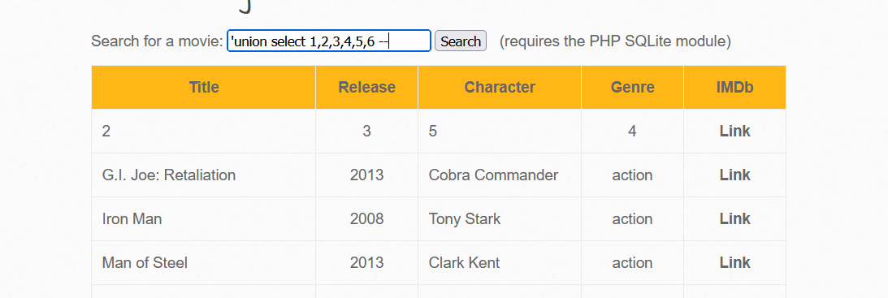
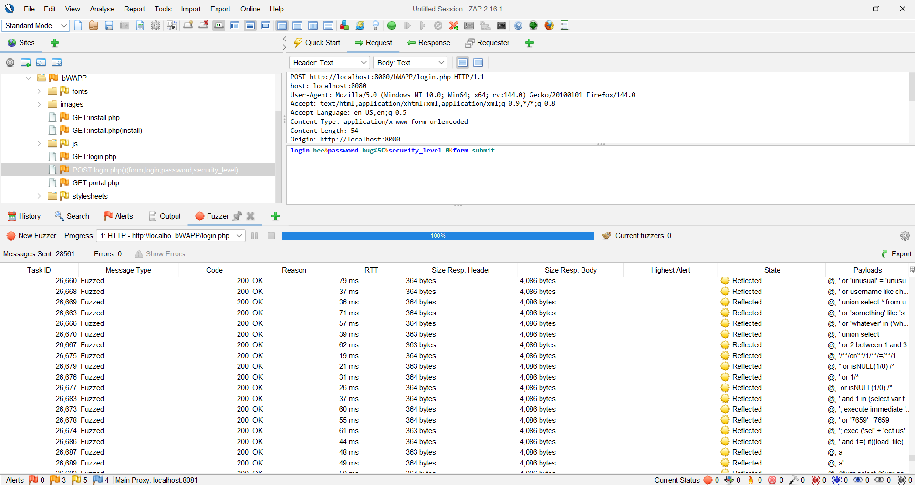
2. For csrf, Csp and Anti-clickjacking header I have used active scan and the image below states the alerts.
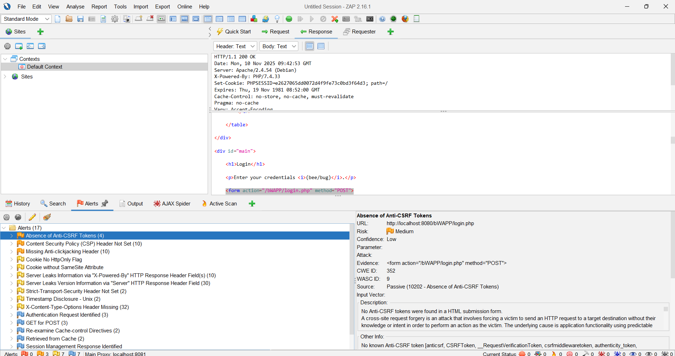
3. For XSS we used this tag “<script>alert(document.cookie)</script>”to stored cookie
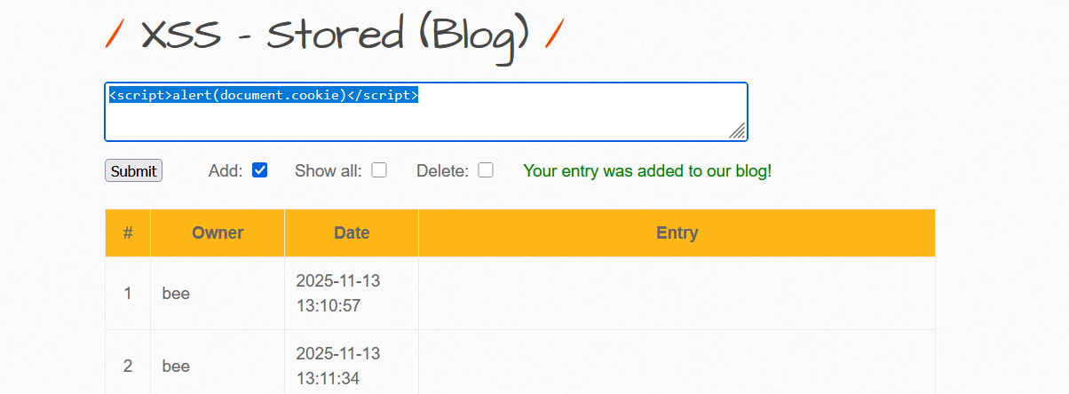

- Possible fixes:
The possblile fixes for the above listed issues are as follows.

- SQL Injection: Implement parameterized queries and validate all user input.
- Cross-Site Scripting (XSS): Sanitize user input and use context-aware output encoding.
- Absence of Anti-CSRF Tokens: Add CSRF tokens to all state-changing forms and validate them server-side.
- Missing Anti-Clickjacking Header: Add X-Frame-Options or Content-Security-Policy: frame-ancestors headers.

