FUTURE_CS_02
Security Alert Monitoring & Incident Response

Deverakonda Sri Phani
Phanidatta0406@gmail.com

- Aim:
The aim of this experiment was to monitor security alerts, analyze potential threats, and simulate incident response — just like a SOC analyst in a real company and document the results along with key insights gained during the process.

- Environment Setup:
Below are the conditions and environment in which the experiment was performed:
- Operating Environment: Windows 11.
- Logs give to experiment: SOC_Task2_sample_logs.txt.
- Tool used for the log analysis is splunk.

- Method:
- Downloaded and installed splunk free trail edition.
- Loaded the sample logs give in assignment into the splunk and started seeing the logs.
- Quires used:
Following queries are used
- For all logs:
  - index =” main”
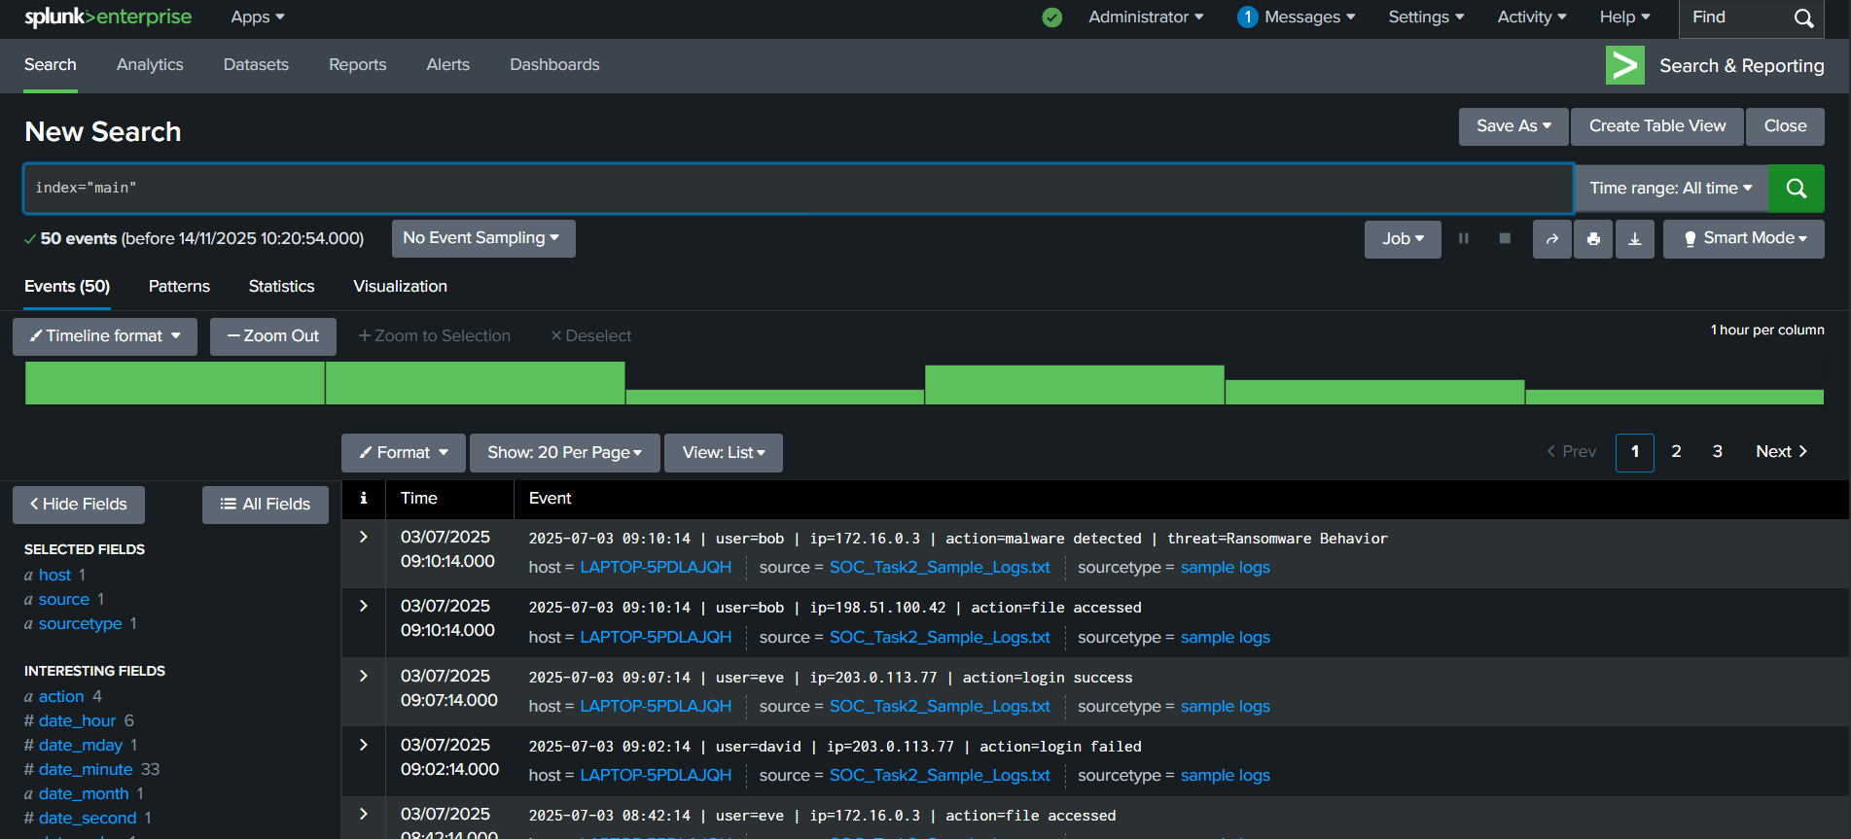
- For all the existing malware and how many of each:
  - index ="main" action="malware detected"
  - | stats count by threat
  - | sort – count
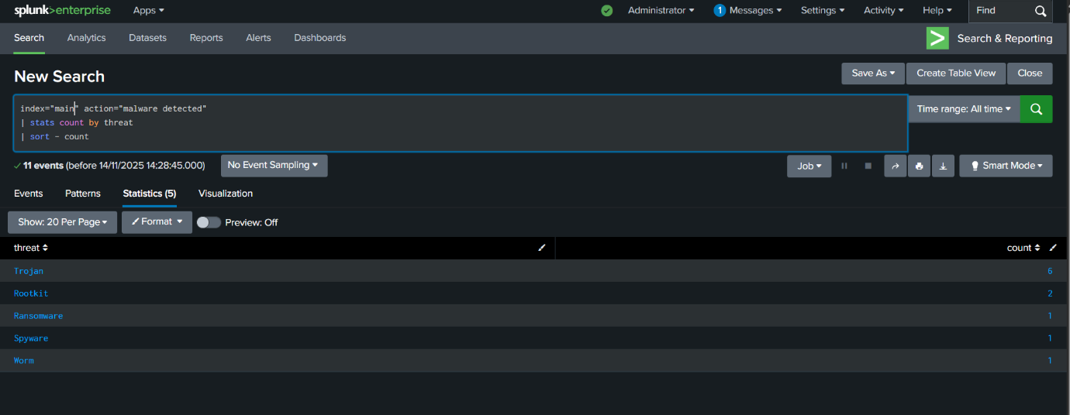
- For all threats and ip and their user:
  - index ="main" action="malware detected"
  - | stats count by threat ip user
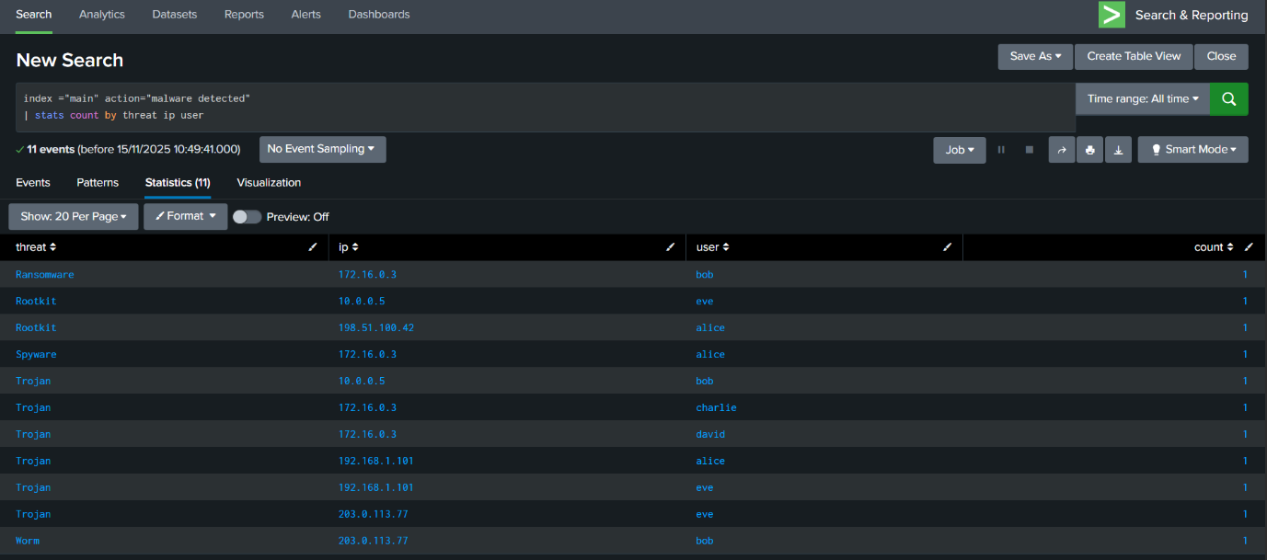
- For all the failed login attempts with their user and their respective ips:
  - index="main" action="login" "failed"
  - | stats count by user ip
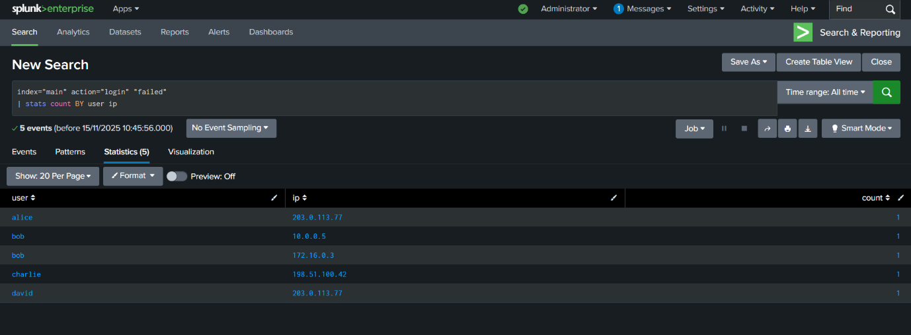

- Results:
Analysis using Splunk.
Incident ID | Host (IP) | Short Description | Priority
INC-1 | 172.16.0.3 | Spyware → Trojan → Ransomware chain (multi-user) | High
INC-2 | 203.0.113.77 | Worm + Trojan + multi-user logins & file access | High
INC-3 | 10.0.0.5 | Trojan + Rootkit + access by multiple users | High
INC-4 | 198.51.100.42 | Rootkit + repeated logins + file access | Medium
INC-5 | 192.168.1.101 | Multiple Trojan detections + repeated connection attempts | Medium

- Identified alerts:
Suspicious alerts identified (3–5 key ones)
Based on the sample logs, these are the main security-relevant alerts / incident candidates:
SOC_Task2_Sample_Logs
- Ransomware on 172.16.0.3 (user=bob)
  - action=malware detected | threat=Ransomware Behavior
  - Comes after spyware and multiple trojans on the same host → looks like the final stage of a serious compromise.
- Worm & Trojan activity on 203.0.113.77 (multi-user)
  - malware detected | threat=Worm Infection Attempt (user=bob)
  - malware detected | threat=Trojan Detected (user=eve)
  - Several users log in and access files afterwards → possible lateral movement and post-exploitation.
- Spyware + Trojan chain on 172.16.0.3 (multi-user)
  - malware detected | threat=Spyware Alert (user=alice)
  - malware detected | threat=Trojan Detected (user=david)
  - Later ransomware on the same host (see #1) → clearly part of the same attack path.
- Rootkit on 10.0.0.5 (plus Trojan & file access)
  - malware detected | threat=Trojan Detected (user=bob)
  - malware detected | threat=Rootkit Signature (user=eve)
  - Followed by file accessed by david → host may be used for stealthy persistence and data access.
- Rootkit & suspicious access on 198.51.100.42
  - malware detected | threat=Rootkit Signature (user=alice)
  - Multiple later login success (alice) and file accessed (bob, david) → likely compromised workstation or server.

- Possible fixes:
The possblile fixes for the above listed issues are as follows.
- Ransomware on 172.16.0.3
Immediately isolate the host and restore from a clean backup to stop encryption spread.

- Worm & Trojan on 203.0.113.77
Block the host’s network traffic and scan all connected systems to stop worm propagation.
- Spyware + Trojan chain on 172.16.0.3
Reset all affected user credentials and remove malware to prevent further credential theft.
- Rootkit on 10.0.0.5
Rebuild the system from a trusted image because rootkits compromise OS integrity.

- Insights Gained:
Key Insights Gained:
- Learned how to analyze logs using Splunk Search & Reporting.
- Understood how malware events connect into multi-stage attack chains.
- Practiced identifying suspicious login attempts and correlating user activity.

