A REPORT ON
A COST-AWARE ADAPTIVE RETRIEVAL: A PARTIALLY OBSERVABLE MARKOV DECISION PROCESS FRAMEWORK FOR AGENTIC RAG ON AWS
BY
M. B. SRI PRANAVYA
ID No. 2024MT03517

AT
Ford Motor Private Limited, Chennai

BITS PILANI
Work Integrated Learning Programmes
(November, 2026)

A REPORT ON
A COST-AWARE ADAPTIVE RETRIEVAL: A PARTIALLY OBSERVABLE MARKOV DECISION PROCESS FRAMEWORK FOR AGENTIC RAG ON AWS
BY
M. B. SRI PRANAVYA
ID No. 2024MT03517
M.Tech - Cloud Computing
Prepared in partial fulfilment of the
WILP Dissertation Course (CCZG628T)
AT
Ford Motor Private Limited, Chennai

BITS Pilani, Pilani Campus, Rajasthan

ACKNOWLEDGEMENTS
I thank the management of Ford Motor Private Limited, Chennai, [Name of Head of Organization, designation], for providing the environment, the cloud access and the time needed to carry out this dissertation.
I am sincerely grateful to my Supervisor, R. Thulasi Priya, Software Engineer, Ford Motor Private Limited, for her continuous guidance and review, and to my Additional Examiner, Dr. M. J. Balachandran, for his valuable suggestions on the formulation, the evaluation and the completion of the database connectivity.
I thank my colleagues at Ford for their technical help with the AWS account and its access policies.
I thank my BITS Pilani faculty mentor, SaiKishor Jangiti, for the direction given at each review stage, and the WILP Division for the structure of the programme.
Finally, I thank my family and friends for their constant encouragement.
M. B. Sri Pranavya

BITS PILANI, WORK INTEGRATED LEARNING PROGRAMMES DIVISION
ABSTRACT SHEET
Field | Details
Organization / Location | Ford Motor Private Limited / Chennai
Duration | 15 weeks (26 July 2026 to 9 November 2026)
Date of Start | 26 July 2026
Date of Submission | 9 November 2026
Title | A Cost-Aware Adaptive Retrieval: A Partially Observable Markov Decision Process Framework for Agentic RAG on AWS
ID No. / Name of Student | 2024MT03517 / M. B. Sri Pranavya
Supervisor | R. Thulasi Priya, Software Engineer, B.E.
Additional Examiner | Dr. M. J. Balachandran, MCA, M.Phil, Ph.D
Faculty Mentor | SaiKishor Jangiti
Key Words | Agentic RAG, POMDP, adaptive retrieval, cost-aware control, AWS Bedrock, OpenSearch
Project Areas | Cloud computing, retrieval-augmented generation, decision-making under uncertainty

Abstract
Retrieval-augmented generation (RAG) systems usually retrieve a fixed number of times, so they pay for retrieval even when the evidence is already sufficient. This dissertation models the decision of what to do next (retrieve, reformulate, validate or stop) as a Partially Observable Markov Decision Process whose belief about evidence sufficiency is updated from relevance, coverage, confidence and latency signals, and whose reward trades answer quality against cost, latency and redundancy. The controller was implemented as a FastAPI service on AWS using Amazon Bedrock (Claude Haiku 4.5, Titan Embeddings v2) and an OpenSearch kNN index, with token-level cost tracking, safeguards and a comparison dashboard. It was benchmarked live against twelve other strategies on HotpotQA and MS MARCO. On HotpotQA (n=80) the POMDP controller matched fixed three-hop retrieval in F1 (0.668 against 0.668) at 30% lower cost and with 2.08 instead of 3.00 hops; at n=200 the saving was 28%. On MS MARCO the saving was about 63%. An ablation shows the cost term causes the saving. Accuracy was not improved, and the stopping depth is nearly fixed in the tuned configuration.
 | Student | Supervisor
Signature
Date

TABLE OF CONTENTS
1. Introduction 1
1.1 Problem and background 1
1.2 Objectives 1
1.3 Scope and limitations 1
1.4 Methodology and value 1
2. Literature Review and Positioning 2
2.1 Related retrieval strategies 2
2.2 The agentic-RAG SoK paper 2
3. POMDP Formulation 3
3.1 State, belief and actions 3
3.2 Observation and belief update 3
3.3 Reward and policy 3
4. System Architecture and Implementation 4
4.1 AWS stack 4
4.2 Provider abstraction 5
4.3 Runtime safeguards 5
4.4 Persistence, security and engineering quality 6
5. Experimental Setup 7
5.1 Data, index and baselines 7
5.2 Evaluation protocol 7
6. Results and Discussion 8
6.1 HotpotQA, test n = 80 8
6.2 Statistical comparison 9
6.3 Larger run and a second dataset 10
6.4 Ablation: the cost term is the cause 10
6.5 Cost sensitivity 11
6.6 Adaptivity audit 11
6.7 Iteration, defects found and reproducibility 12
6.8 Grounding, refusal and conflicting evidence 12
6.9 Live validation on AWS 13
7. Comparison with the SoK Paper and Limitations 18
7.1 Limitations and partially addressed areas 19
8. Conclusions and Recommendations 19
8.1 Conclusions 19
8.2 Recommendations and future work 19
Appendix A: Configuration flags 20
Appendix B: Metrics catalogue 20
Appendix C: Reproduction 20
References 21
Abbreviations 21
Glossary 22

LIST OF FIGURES
Figure 1. POMDP control loop: belief, policy, action, observation and belief update, ending in STOP. 4
Figure 2. Deployed architecture: UI, Cognito, controller and the AWS services it calls. 5
Figure 3. Cost against F1 on HotpotQA (n = 80). The POMDP is in the cheapest group. 8
Figure 4. Mean hops and latency per strategy. 9
Figure 5. Ablation: removing the cost terms raises cost per query. 11
Figure 6. Reasoning trace of a live POMDP query: passages, belief and cost per hop. 13
Figure 7. Comparison dashboard (live AWS): aggregate metrics and radar profile for 13 strategies. 14
Figure 8. Comparison dashboard: per-metric charts. The run used three labelled questions and demonstrates the tooling only. 15
Figure 9. AWS Console: OpenSearch domain active in ap-southeast-2. 15
Figure 10. CloudWatch: Bedrock invocation metrics from the benchmark runs. 16
Figure 11. DynamoDB table agentic-rag-state: a saved episode with query, strategy and trace. 16
Figure 12. S3 object written by the application (reports/ folder). 17
Figure 13. Cognito user pool: user 'demo', status Confirmed. 17
Figure 14. DynamoDB after the Cognito run: the new item is owned by the Cognito subject. 18

LIST OF TABLES
Table 1. Mapping of SoK paper concepts to the implementation 2
Table 2. Runtime safeguards 5
Table 3. Engineering features 6
Table 4. Mid-sem plan against final delivery 6
Table 5. Evaluation protocol 7
Table 6. Main results on HotpotQA (n = 80, live AWS) 8
Table 7. Paired bootstrap, POMDP minus strategy (n = 80) 9
Table 8. Larger HotpotQA run and the MS MARCO dataset 10
Table 9. Ablation with cost, latency and redundancy terms removed 10
Table 10. Cost sensitivity (earlier static-query run, test split) 11
Table 11. Hop-distribution audit 11
Table 12. Iteration history 12
Table 13. Grounding and refusal checks 12
Table 14. Live validation summary 13
Table 15. Side-by-side comparison with the SoK paper 18
Table 16. Key configuration flags 20
Table 17. Metrics catalogue 20
Table 18. List of abbreviations 21
Table 19. Glossary of terms 22

1. Introduction

1.1 Problem and background
A retrieval-augmented generation (RAG) system grounds a language model in retrieved documents [1]. Most deployments retrieve a fixed number of times per question. Easy questions then pay for evidence they do not need, and hard questions may receive too little. Agentic RAG lets the model decide when to retrieve again, but that decision is usually made by prompting and offers no principled way to trade the value of more evidence against its price in tokens, retrieval calls and latency.

1.2 Objectives
- Formulate retrieval control as a POMDP with an explicit belief, typed actions, observations and reward.
- Implement it on real AWS services and measure real token cost, hops and latency.
- Compare it with twelve other strategies under identical conditions, with confidence intervals.
- Show, by ablation, which component is responsible for any saving.

1.3 Scope and limitations
The study uses two datasets (HotpotQA, MS MARCO), one generator model, a small passage index (800 to about 2,000 passages) and one AWS region. The policy is a one-step expected-utility policy, not a learned network. Natural Questions and FEVER were not run. These limits are discussed in Section 7.

1.4 Methodology and value
The work proceeded in three stages: a local mock proof of concept (mid-semester), replacement of every mock component by a live AWS service, and a controlled evaluation with seeded splits, validation-only tuning and paired bootstrap tests. The value is a cheaper RAG controller at equal answer quality, with an auditable trace of every decision.

2. Literature Review and Positioning

2.1 Related retrieval strategies
Self-RAG learns to critique its own retrieval [2]. Adaptive-RAG routes a question to a strategy by estimated complexity [3]. CRAG evaluates retrieval quality and corrects it [4]. FLARE retrieves when the generator is uncertain [5]. HyDE [6], Step-Back prompting [7] and RAG-Fusion [8] change or expand the query. All are implemented here as baselines on one common interface.

2.2 The agentic-RAG SoK paper
A recent systematisation of knowledge (SoK) on agentic RAG [9] formalises the agent as a finite-horizon POMDP and lists open problems, including cost-aware orchestration, adaptive stopping, stable retrieval, consistent evaluation and security. The paper is a survey with no implementation or experiments. This dissertation builds and measures the controller it describes. Table 1 maps each paper concept to the implementation.
Table 1. Mapping of SoK paper concepts to the implementation
Paper concept | Implementation in this work | Code location
Finite-horizon POMDP | Working controller: state, actions, observations, belief, reward, hop-capped horizon | core/pomdp/
Action space (retrieval, reasoning, tool, STOP) | RETRIEVE(source) for local, Wikipedia and arXiv sources, REFORMULATE_QUERY, VALIDATE_EVIDENCE, STOP; pydantic-validated | pomdp/actions.py
Belief state | Explicit belief over evidence sufficiency; linear-pool update for retrieval, Bayes update for the LLM judge; redundancy damping | pomdp/belief.py
Objective: reward minus lambda x cost | U = w_q x gain - w_c x cost - w_l x latency - w_r x redundancy; every weight named and tunable | pomdp/reward.py
Adaptive stopping (open problem) | One-step expected-utility maximiser with STOP always a candidate, plus hop cap, confidence threshold and episode budget | pomdp/policy.py
Planning mechanisms | 13 strategies on one interface: POMDP, POMDP-VI, POMDP-Quality, Fixed-1/2/3, Self-RAG, Adaptive-RAG, CRAG, FLARE, RAG-Fusion, Step-Back, HyDE | core/baselines/
Difficulty prediction (future work in paper) | NumPy query-difficulty and cost predictor | core/ml/predictor.py
Inconsistent evaluation | Single harness: seeded splits, paired bootstrap CIs, Pareto frontier | scripts/
Injection and poisoning risks | Retrieved text scanned, sanitised and fenced before reaching the LLM | security/sanitize.py
Real deployment (not in paper) | Bedrock, OpenSearch, Terraform, LLM cache, $ budget cap and kill switch | backend/app/aws/, infra/

3. POMDP Formulation

3.1 State, belief and actions
The latent state is whether the evidence gathered so far is sufficient to answer the question. The controller keeps a belief b_t over {sufficient, insufficient}, together with the query q, the history h_t and the cost counter c_t, so that s_t = (q, b_t, h_t, c_t). The action set is retrieve(source), reformulate, validate and stop. A RETRIEVE action must carry a source and every other action must not; a validator enforces this so an illegal action cannot be constructed.

3.2 Observation and belief update
After each action the controller observes o_t = (rel, cov, conf, lat): mean relevance of the retrieved passages, coverage of the question's entities, the generator's confidence and the step latency. Retrieval observations update the belief by a linear pool; the LLM judge's verdict updates it by Bayes' rule. Passages already seen are down-weighted so that repeated retrieval cannot inflate the belief.

3.3 Reward and policy
The per-step utility is R = delta-Quality - lambda1 x Cost - lambda2 x Latency - lambda3 x Redundancy, over a finite horizon with gamma = 1. The default policy chooses the action with the highest one-step expected utility under the current belief, with STOP always a candidate. A value-iteration policy (POMDP-VI) and a quality-only policy (all cost terms set to zero) are provided for comparison. The mapping from each symbol to code is documented in docs/POMDP_FORMULATION.md.
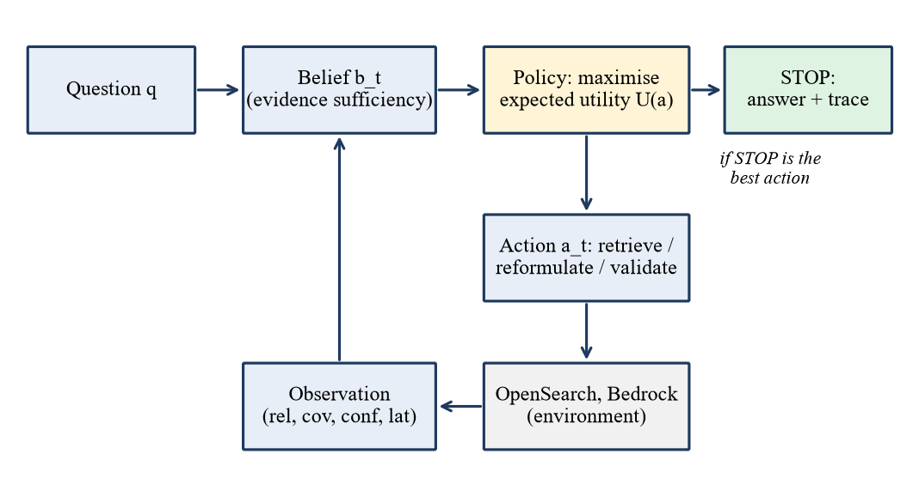
Figure 1. POMDP control loop: belief, policy, action, observation and belief update, ending in STOP.

4. System Architecture and Implementation

4.1 AWS stack
The controller is a FastAPI service. Embeddings come from Amazon Bedrock Titan Embeddings v2 (256 dimensions, normalised); generation uses Claude Haiku 4.5 through the Bedrock Converse API; retrieval uses a dense kNN index on Amazon OpenSearch. Episodes are stored in DynamoDB, reports in S3, and users are authenticated with Amazon Cognito (RS256 JWT verified against the pool's JWKS). Terraform modules describe the network, IAM, data, compute, auth, messaging and observability layers, with a low-budget and a full environment.
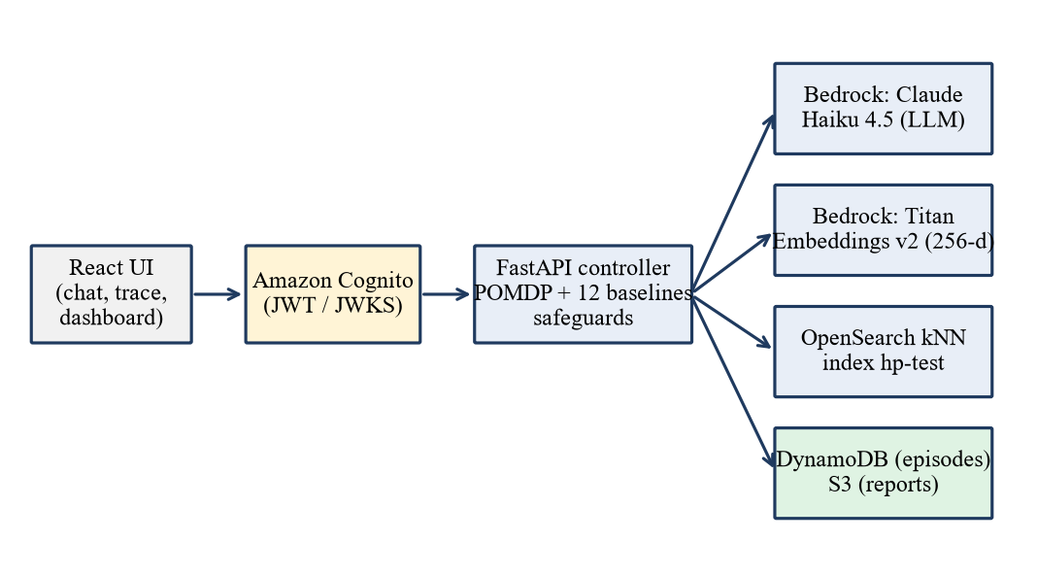
Figure 2. Deployed architecture: UI, Cognito, controller and the AWS services it calls.

4.2 Provider abstraction
Every external capability is a Python Protocol with a mock and a live implementation (LLM, embeddings, vector store, state store, object store, queue), selected by configuration. The same code therefore runs locally for tests and on AWS for measurement.

4.3 Runtime safeguards
The SoK paper lists stable, bounded retrieval as an open problem. Eight configurable safeguards apply identically to every strategy (tests/integration/test_safeguards.py).
Table 2. Runtime safeguards
Safeguard | Purpose
MAX_HOPS hard cap (STOP is the only legal action at the cap) | Guarantees a finite horizon
Confidence threshold stop | Stops once belief in sufficiency is high enough
EPISODE_BUDGET_USD | Per-query spending ceiling
MIN_MARGINAL_GAIN + LOW_GAIN_PATIENCE | Stops when successive retrievals add too little
STALE_PATIENCE | Stops after N retrievals returning no new documents
Duplicate-document accounting | Redundant retrievals cannot raise belief and are penalised
Retrieval timeout and retries | Bounds latency from slow sources
MAX_BUDGET_USD kill switch + on-disk LLM cache | Hard stop on total spend; identical calls are free on re-run

With N = 1, the stale-retrieval stop cut spend on out-of-index questions by about 18% (POMDP 3.75 to 3.0 hops, $0.00402 to $0.00331; Self-RAG 6.0 to 5.0 hops) in a validation run of 30 questions plus 8 out-of-index probes, while all 8 probes were still refused and in-index cost was unchanged.

4.4 Persistence, security and engineering quality
With PERSIST_EPISODES enabled, each answered query is written to DynamoDB on a best-effort basis that never fails the request; this closed the database-connectivity gap raised during the mid-semester review. Table 3 summarises the remaining engineering features.
Table 3. Engineering features
Area | What is implemented
Authentication | JWT on every non-health endpoint; local HS256 signer or Cognito RS256 with JWKS; no endpoint trusts a client-supplied user id
Rate limiting | Per-user and per-IP limits (slowapi) and a concurrency limiter
Prompt-injection defence | Retrieved text sanitised, instruction-like patterns flagged and defanged, content wrapped in a per-request random data fence; Pydantic constraints on all inputs
Infrastructure as code | Terraform modules; least-privilege IAM scoped to specific ARNs; encryption at rest for S3, DynamoDB and OpenSearch
Testing | About 256 test functions in 28 files (unit and integration) covering actions, belief, reward, policy, value iteration, baselines, metrics, sanitisation, rate limiting, auth, cost tracker, LLM cache and persistence
Quality gates | Vitest coverage, Playwright end-to-end tests, SonarQube configuration, pip-audit and npm audit in CI
User interface | React/TypeScript app with login, chat with reasoning trace, and a 13-strategy comparison dashboard (metric tables, radar profile, charts, CSV export)
ML component | Query-difficulty and cost predictor in pure NumPy with its own tests

Table 4. Mid-sem plan against final delivery
Item | Mid-sem plan | Final delivery
Generator | Claude 3 Sonnet | Claude Haiku 4.5
Retrieval | Hybrid BM25 + dense | Dense kNN on OpenSearch
Deployment | Lambda / Fargate / SQS | FastAPI service, tested live
Policy | Learned policy network | One-step expected-utility policy
Datasets | HotpotQA, NQ, FEVER | HotpotQA, MS MARCO
Persistence | Planned | DynamoDB, S3 and Cognito, verified live
Tests | 115 | About 256 test functions in 28 files

5. Experimental Setup

5.1 Data, index and baselines
HotpotQA (distractor setting) [10] was used with a held-out test split of 80 questions, and 200 for a larger confirmation run; MS MARCO [11] used 60 questions. The index held 800 passages (about 2,000 for n=200). The strategies compared were POMDP, POMDP-VI, a quality-only POMDP, Fixed with 1, 2 and 3 hops, Self-RAG, Adaptive-RAG, CRAG, FLARE, RAG-Fusion, Step-Back and HyDE.

5.2 Evaluation protocol
Table 5. Evaluation protocol
Requirement | What was done
Same conditions | One harness, identical model, index, k = 4 retrieval and a seeded 70/15/15 split (seed 13, ids saved in results/splits.json)
No test-set tuning | Cost weight swept on the validation split only (cheapest weight within 0.02 F1 of the best)
Statistics | Paired bootstrap 95% confidence intervals for every pairwise comparison
Cost and quality together | Cost/F1 Pareto frontier and $ per F1
Metrics | Accuracy, exact match, F1, precision, recall, cost ($), tokens, hops, average and p95 latency, success rate, final belief
Honest reporting | A first run in which the POMDP was the most expensive strategy is kept in the record beside the corrected run (Section 6.7)

Cost is the measured Bedrock token charge (Claude Haiku 4.5 at $0.001 per 1K input and $0.005 per 1K output tokens) plus an explicit per-retrieval charge. Answer quality is token F1 against the reference. The saving depends on the retrieval price, which Section 6.5 varies.

6. Results and Discussion

6.1 HotpotQA, test n = 80
Table 6. Main results on HotpotQA (n = 80, live AWS)
Strategy | F1 | Cost ($/query) | Hops | Latency (ms) | On frontier
POMDP | 0.668 | $0.00243 | 2.08 | 5,222 | yes
Step-Back | 0.677 | $0.00252 | 3.00 | 6,820 | yes
HyDE | 0.666 | $0.00245 | 3.73 | 7,291 | no
FLARE | 0.642 | $0.00297 | 3.98 | 10,370 | no
Self-RAG | 0.667 | $0.00302 | 4.08 | 10,555 | no
Adaptive-RAG | 0.622 | $0.00328 | 2.77 | 9,605 | no
Fixed (3 hops) | 0.668 | $0.00348 | 3.00 | 10,416 | no
CRAG | 0.657 | $0.00352 | 5.01 | 15,377 | no
RAG-Fusion | 0.701 | $0.00396 | 6.00 | 17,343 | yes
POMDP-VI | 0.675 | $0.00528 | 4.78 | 16,688 | no

The POMDP reaches F1 0.668 at $0.00243 and 2.08 hops, against Fixed three-hop RAG at the same F1 but $0.00348 and 3.00 hops: about 30% less cost, 31% fewer hops and half the latency. RAG-Fusion has the highest F1 (0.701) but costs 63% more than the POMDP; POMDP-VI is the most expensive, so a more elaborate policy did not help.
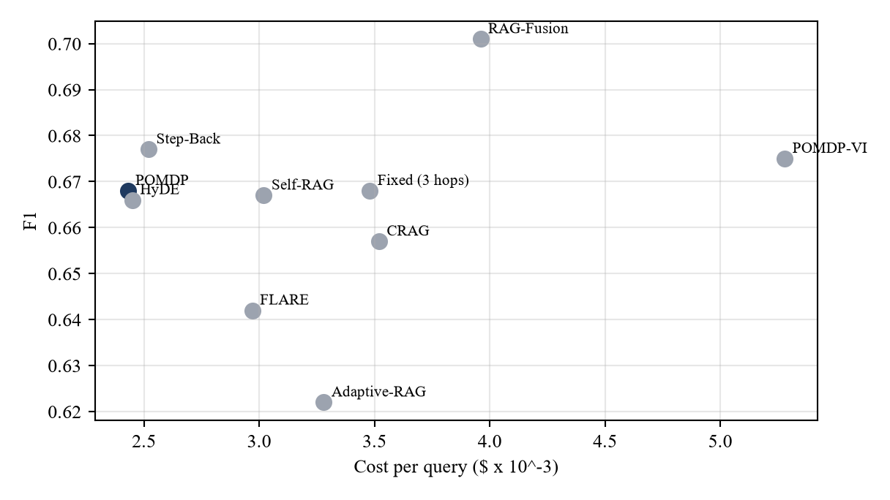
Figure 3. Cost against F1 on HotpotQA (n = 80). The POMDP is in the cheapest group.
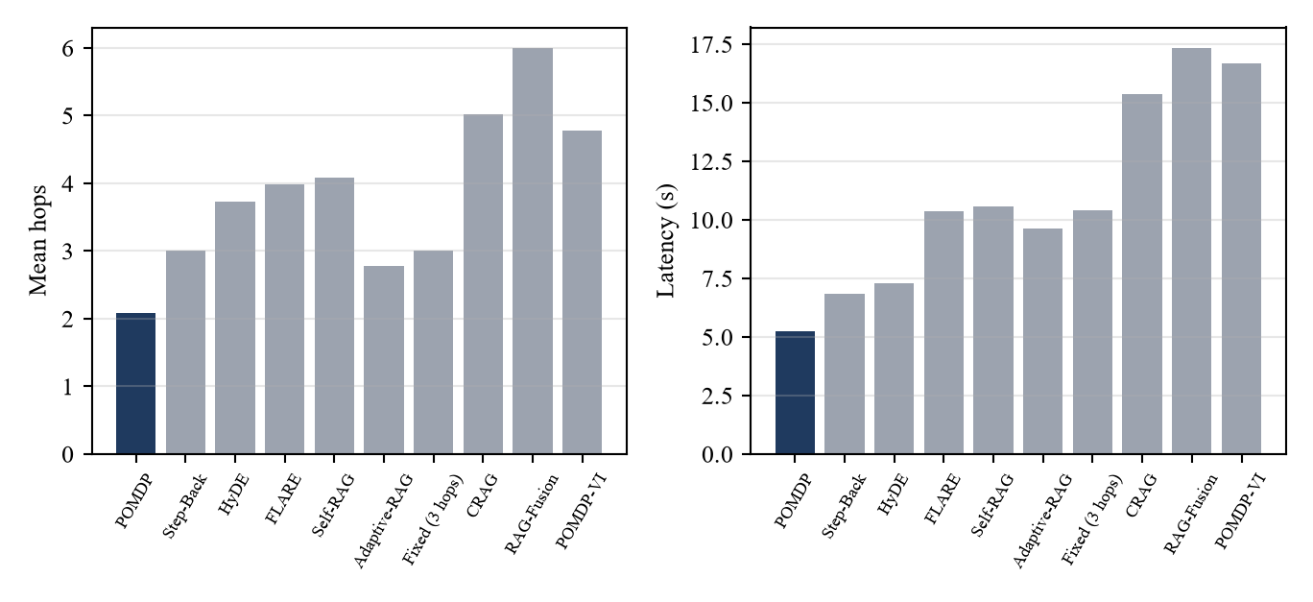
Figure 4. Mean hops and latency per strategy.

6.2 Statistical comparison
Table 7. Paired bootstrap, POMDP minus strategy (n = 80)
Compared with | Cost difference ($/query) | Hops | F1 difference
Fixed (3 hops) | -$0.00104 | -0.93 | -0.000 n.s.
POMDP-VI | -$0.00284 | -2.70 | -0.008 n.s.
CRAG | -$0.00108 | -2.94 | +0.010 n.s.
FLARE | -$0.00054 | -1.90 | +0.026 n.s.
RAG-Fusion | -$0.00153 | -3.93 | -0.034 n.s.
Self-RAG | -$0.00060 | lower | n.s.
Adaptive-RAG | -$0.00087 | lower | +0.045
Step-Back, HyDE | not significant | - | n.s.

The POMDP is significantly cheaper than every strategy in the table except Step-Back and HyDE, whose differences are not significant. Its F1 is never significantly worse and is significantly higher than Adaptive-RAG's.

6.3 Larger run and a second dataset
Table 8. Larger HotpotQA run and the MS MARCO dataset
Run | Strategy | F1 | Cost ($/query) | Hops | Latency (ms)
HotpotQA n=200 | POMDP | 0.692 | $0.00248 | 2.12 | 6,718
HotpotQA n=200 | Fixed (3 hops) | 0.710 | $0.00344 | 3.00 | 10,433
HotpotQA n=200 | Fixed (2 hops) | 0.686 | $0.00237 | 2.00 | 6,866
MS MARCO n=60 | POMDP (weight 60) | 0.323 | $0.00107 | 1.02 | -
MS MARCO n=60 | Fixed (3 hops) | 0.334 | $0.00290 | 3.00 | -
MS MARCO n=60 | Fixed (2 hops) | 0.336 | $0.00200 | 2.00 | -
MS MARCO n=60 | Self-RAG | 0.338 | $0.00191 | 2.57 | -
MS MARCO n=60 | Adaptive-RAG | 0.330 | $0.00120 | 1.07 | -

At n = 200 the POMDP is about 28% cheaper than Fixed three-hop (cost difference -$0.00096, CI [-$0.00103, -$0.00089]; latency 3.7 s lower). Its F1 is 0.018 lower, with an interval of [-0.042, +0.002] that includes zero: the difference is not established, but a small loss cannot be excluded. Fixed two-hop is as cheap as the POMDP, so on HotpotQA the saving over three hops comes from choosing a smaller depth, which the controller did without being told. On the single-hop MS MARCO the controller settles at about one hop, 63% cheaper than Fixed three-hop and 46% cheaper than Fixed two-hop at similar F1.

6.4 Ablation: the cost term is the cause
Table 9. Ablation with cost, latency and redundancy terms removed
Dataset | Variant | F1 | Cost ($/query) | Hops | Latency (ms)
HotpotQA | Cost-aware POMDP | 0.651 | $0.00245 | 2.1 | 4,446
HotpotQA | Quality-only POMDP | 0.667 | $0.00388 | 4.4 | 8,468
MS MARCO | Cost-aware POMDP | 0.325 | $0.00107 | 1.01 | 1,057
MS MARCO | Quality-only POMDP | 0.338 | $0.00264 | 3.33 | 6,889

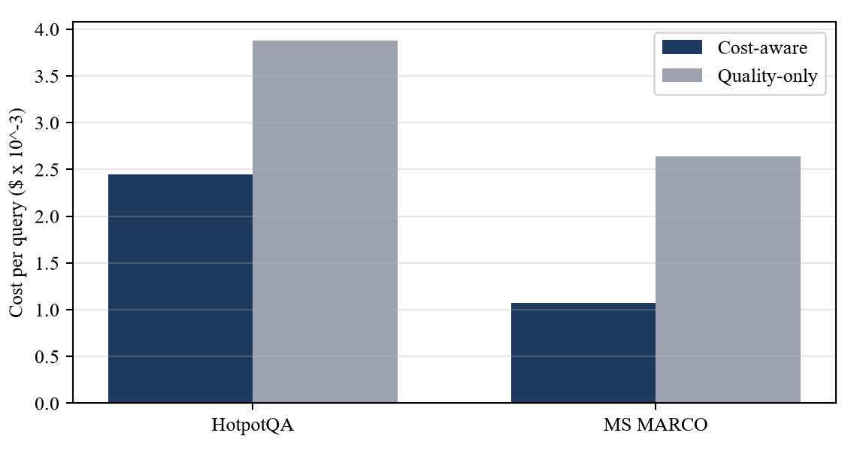
Figure 5. Ablation: removing the cost terms raises cost per query.
Paired 95% intervals (cost-aware minus quality-only): cost -$0.00143 [-$0.00164, -$0.00122] on HotpotQA and -$0.00158 [-$0.00181, -$0.00134] on MS MARCO; F1 -0.016 and -0.014, both not significant. The cost-aware reward therefore produces the saving.

6.5 Cost sensitivity
Table 10. Cost sensitivity (earlier static-query run, test split)
Retrieval price assumption | Saving vs Fixed | vs Self-RAG | vs Adaptive-RAG
$0 per retrieval | 0.46% | not reported | not reported
$0.0005 per retrieval | 41.9% | 64% | 40%
$0.002 per retrieval | 58.1% | 78% | 57%

The advantage depends on retrieval having a price: with free retrieval it is negligible, and it grows with the price of paid search APIs or managed vector queries. Infrastructure cost is also tracked: one t3.small.search OpenSearch node is about $1 per day, and S3, DynamoDB (on demand), Cognito and IAM are near zero when idle. The whole live API campaign cost about $0.07.

6.6 Adaptivity audit
Table 11. Hop-distribution audit
Configuration (test) | Hop distribution | Mean hops | corr(hops, F1)
HotpotQA, weight 40 (n=80) | 2 hops: 77, 4 hops: 3 | 2.08 | +0.12
HotpotQA, weight 60 (n=80) | 1 hop: 67, 2 hops: 13 | 1.16 | -0.07
HotpotQA, weight 20, first run (n=80) | 2 to 6 hops | 3.73 | -0.30
MS MARCO, weight 60 (n=60) | 1 hop: 59, 2 hops: 1 | 1.02 | +0.14
Self-RAG, HotpotQA (n=80) | 2: 32, 4: 13, 6: 35 | 4.08 | -0.33
Adaptive-RAG, HotpotQA (n=80) | 1: 26, 3: 37, 5: 17 | 2.77 | +0.11

At the tuned weight the POMDP uses two hops on 96% of HotpotQA queries. It is adaptive by design but behaves close to a fixed depth in this configuration, which is why the quality-only ablation, rather than per-query depth variation, is the main evidence. Depth does adapt between datasets (about 2 hops on HotpotQA, about 1 on MS MARCO).

6.7 Iteration, defects found and reproducibility
Table 12. Iteration history
Step | Outcome
First run (cost weight 20, two LLM calls per hop) | POMDP was the most expensive strategy (F1 0.679, $0.00385, 3.73 hops against Fixed 0.688, $0.00345, 3.0). Kept in the record.
Diagnosis and fixes | Cost weight raised to 40; unchanged evidence no longer re-judged; the judge proposes the next query in the same call. Six defects were fixed, among them a wrong STOP valuation, baselines retrieving from empty sources, repeated hops reusing the same query, and mock VALIDATE/REFORMULATE actions replaced by real LLM calls.
Final run | POMDP F1 0.667, $0.00242, 2.08 hops: about 30% cheaper than Fixed with no significant F1 loss; confirmed at n = 200.

Runs are reproducible: splits are seeded and stored, tuning uses validation data only, an on-disk LLM cache makes re-runs free, and per-query CSVs allow every interval to be recomputed. Observed run-to-run noise is about 0.01 F1.

6.8 Grounding, refusal and conflicting evidence
Table 13. Grounding and refusal checks
Check | Result
8 out-of-index general-knowledge probes | 8 of 8 refused with 'Insufficient evidence.'; no invented answers
Live question not in the index | POMDP stopped at 4 hops and answered 'Insufficient evidence.' (belief 0.24)
Known-answer live questions | Correct on both gold-labelled questions and across all 13 strategies
Conflicting evidence (earlier static run, one injected contradicting passage, n = 100) | POMDP F1 0.473 against Fixed 0.462, Self-RAG 0.458, Adaptive-RAG 0.481; no significant difference

6.9 Live validation on AWS
Table 14. Live validation summary
Check | Result
API: 6 questions x 13 strategies + /evaluate/batch per strategy | 350 checks passed, 0 failed, 0 warnings
Each response | Real Bedrock tokens, non-zero cost, trace and retrieved documents
/compare with all 13 strategies on one question | Completed in 54 s; all 13 answered correctly
Browser UI test (Playwright), all 13 strategies and dashboard | Passed in 5.0 min
Live persistence | Episode written to DynamoDB and read back; report object written to and read from S3
Cognito: valid / missing / tampered token | 200 / 401 / 401; authenticated query answered 'The Last Lions' (2 hops, $0.002392) and saved under the Cognito subject

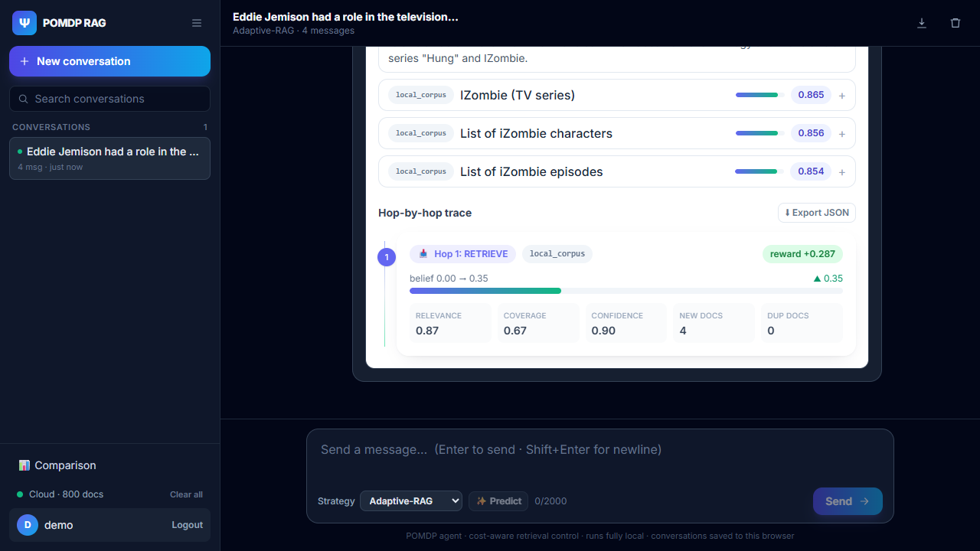
Figure 6. Reasoning trace of a live POMDP query: passages, belief and cost per hop.
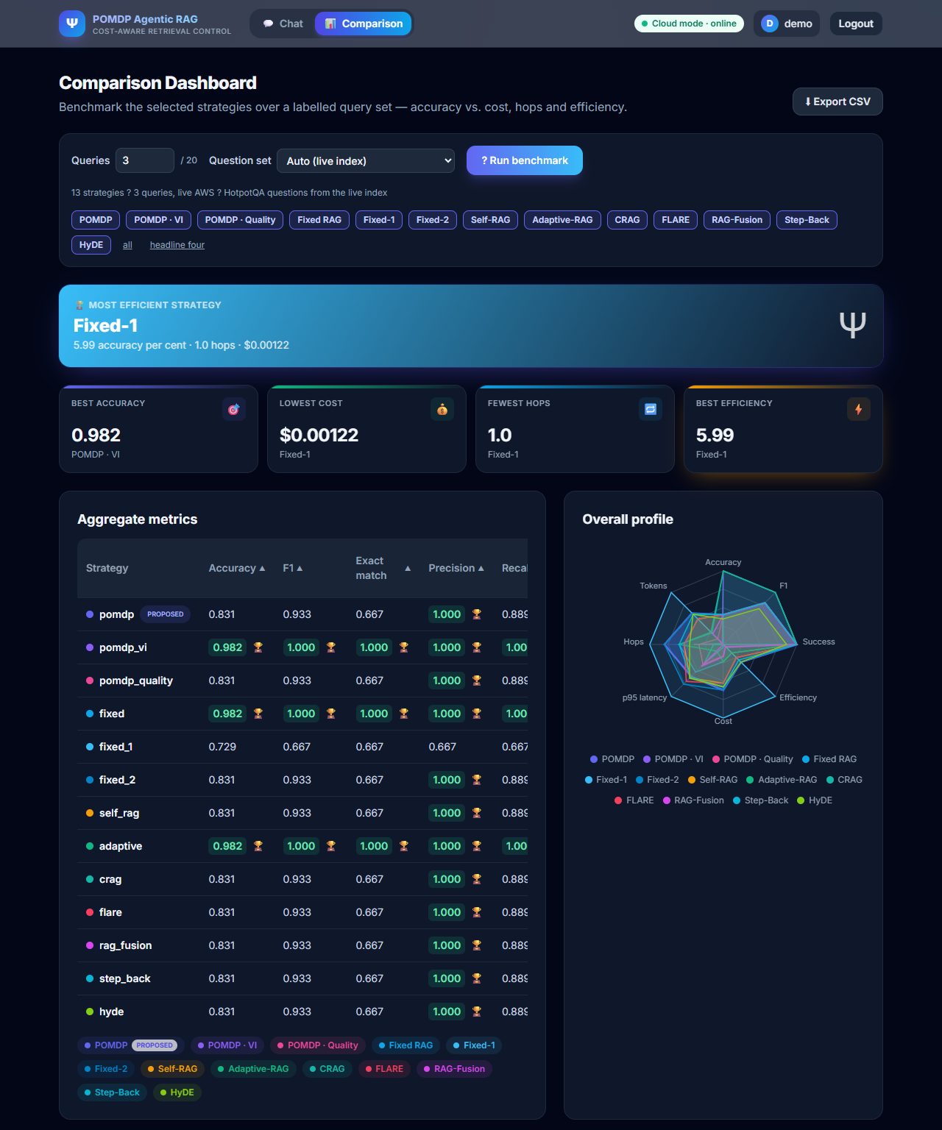
Figure 7. Comparison dashboard (live AWS): aggregate metrics and radar profile for 13 strategies.
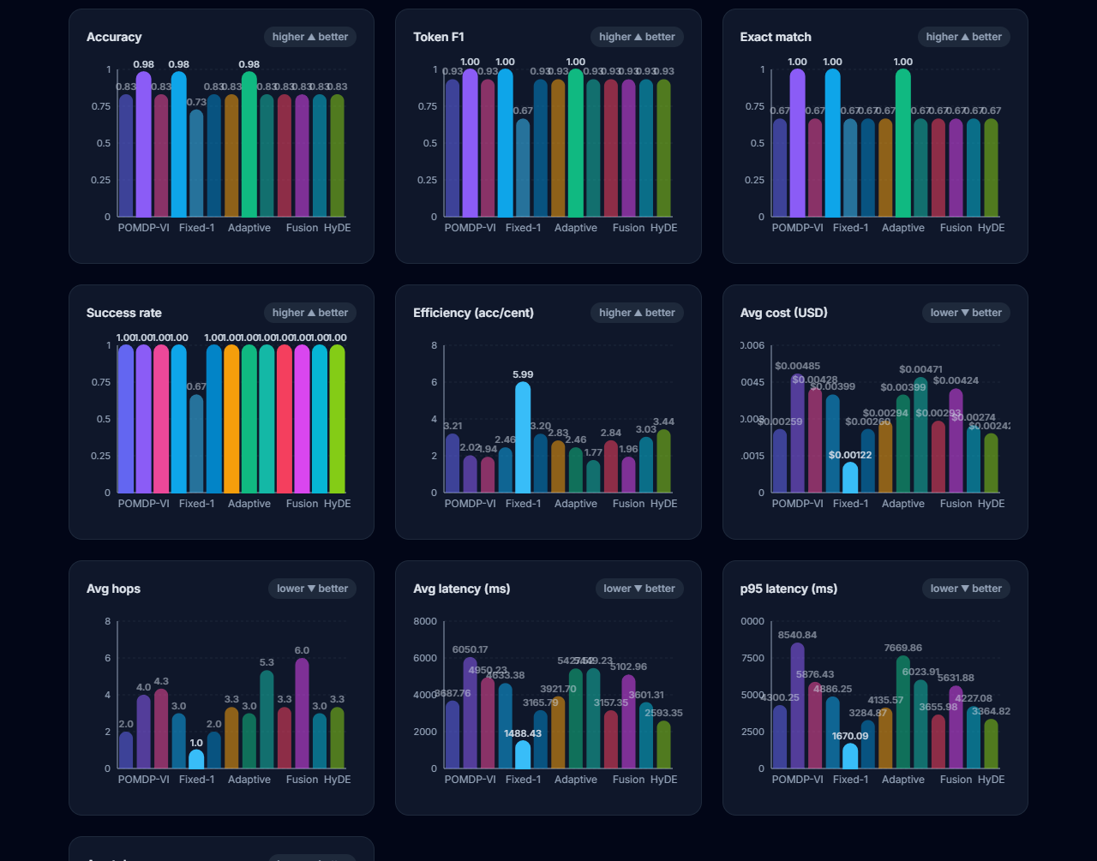
Figure 8. Comparison dashboard: per-metric charts. The run used three labelled questions and demonstrates the tooling only.
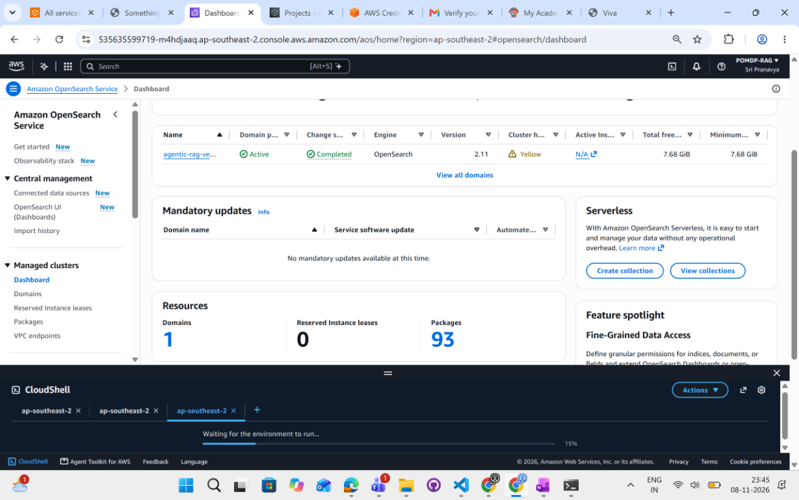
Figure 9. AWS Console: OpenSearch domain active in ap-southeast-2.
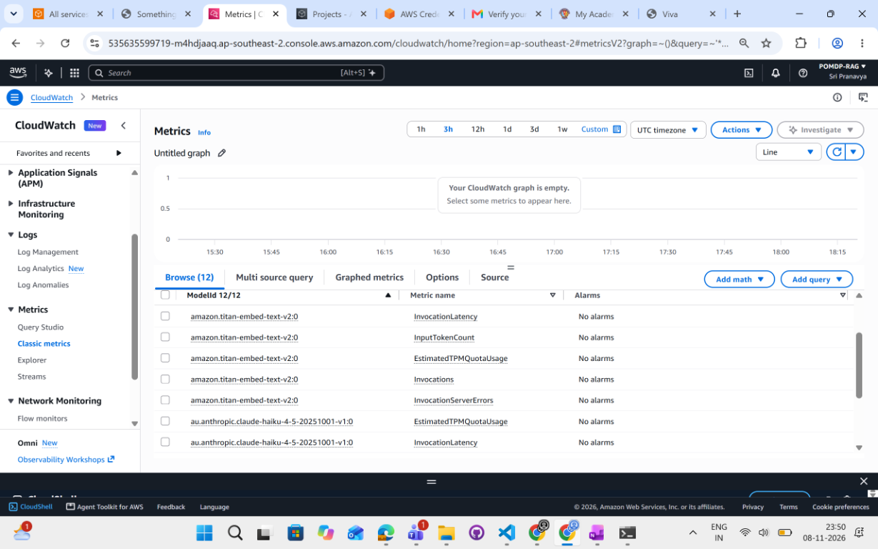
Figure 10. CloudWatch: Bedrock invocation metrics from the benchmark runs.
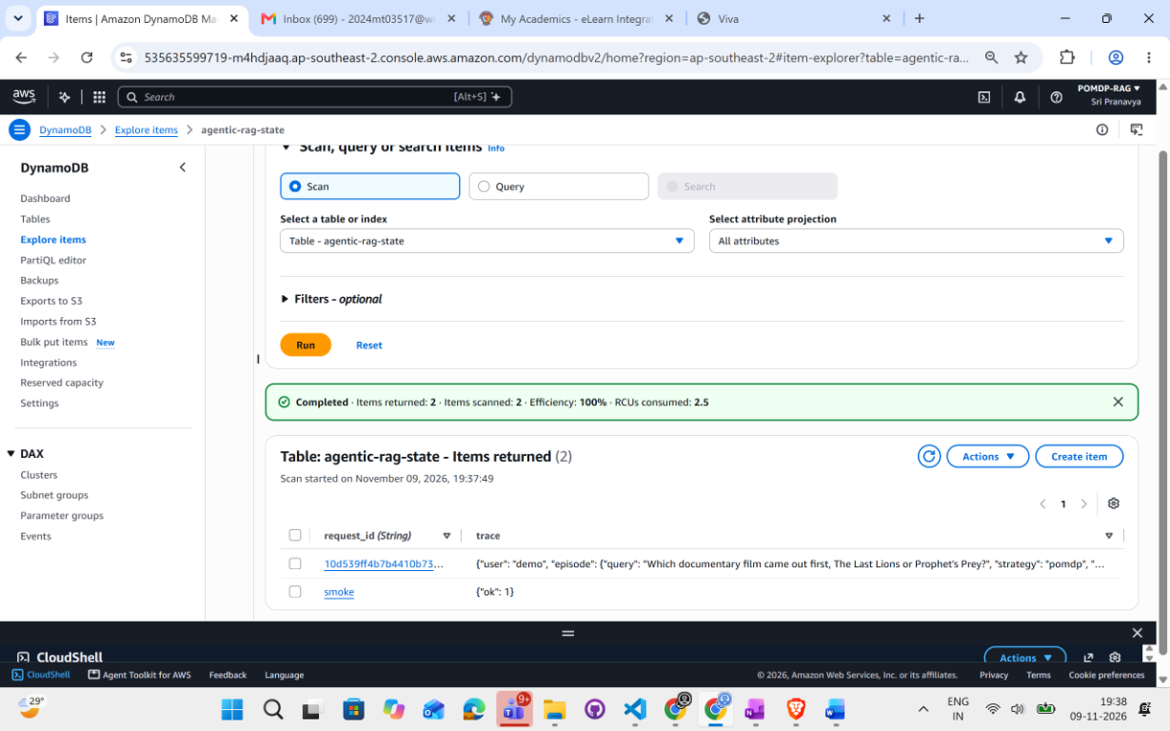
Figure 11. DynamoDB table agentic-rag-state: a saved episode with query, strategy and trace.
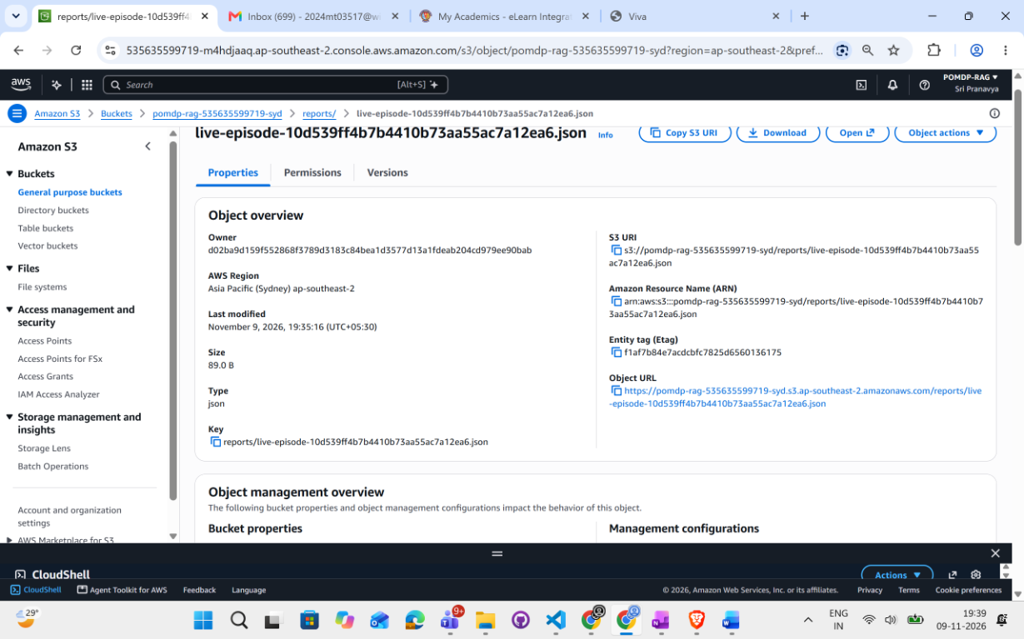
Figure 12. S3 object written by the application (reports/ folder).
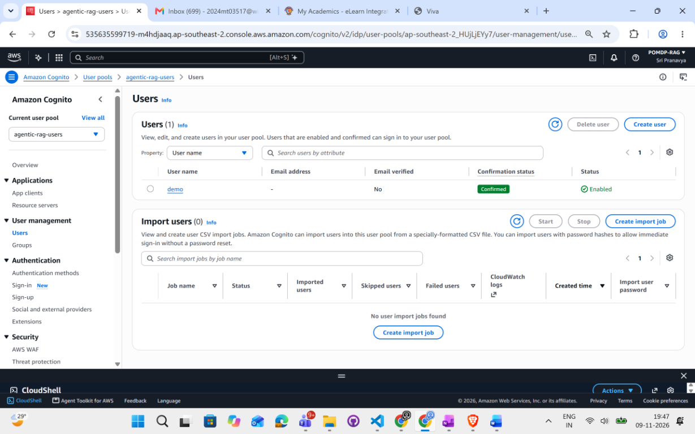
Figure 13. Cognito user pool: user 'demo', status Confirmed.
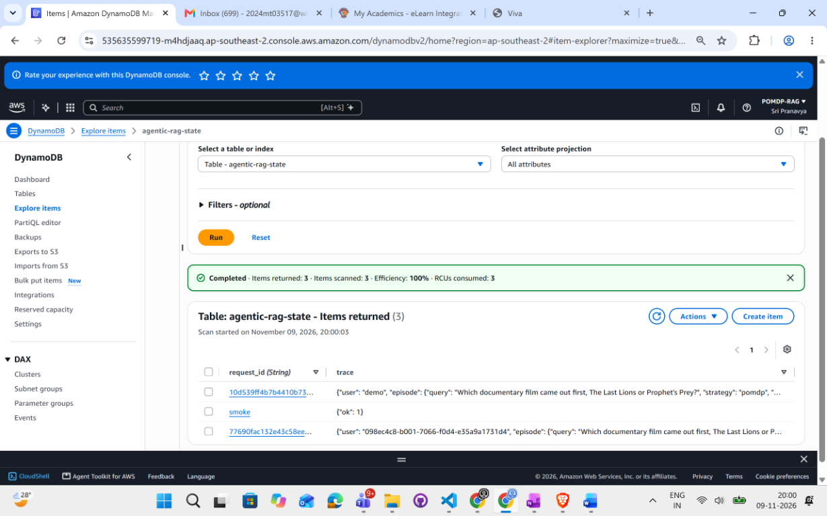
Figure 14. DynamoDB after the Cognito run: the new item is owned by the Cognito subject.

7. Comparison with the SoK Paper and Limitations
Table 15. Side-by-side comparison with the SoK paper
Dimension | SoK paper | This work
Nature | Survey and roadmap | Implemented, deployed and measured system
Experimental results | None | HotpotQA n=80 and n=200, MS MARCO n=60, ablation, all on live AWS
Action space | Abstract, open-ended | 4 typed action kinds, 3 sources, validated
Belief | Memory as stand-in | Explicit, Bayes-style updates, shown in the UI
Cost model | Single lambda x cost term | Separate cost, latency and redundancy weights; real Bedrock token prices
Stopping | Open problem | Expected-utility stop with hop cap, budget cap and confidence threshold
Baselines | Described | 12 baselines implemented and run on one interface
Statistics | Calls for rigorous evaluation | Paired bootstrap CIs, Pareto frontier, validation-only tuning
Cost saving shown | Not measured | About 28 to 30% (HotpotQA), about 63% (MS MARCO) against fixed depth
Bounded retrieval | Open problem | 8 tested safeguards
Grounding | Hallucination listed as risk | 8 of 8 out-of-index refused
Security | Injection listed as risk | JWT/Cognito, rate limiting, injection fencing, least-privilege IAM
Cloud deployment, IaC, UI | Not covered | Bedrock + OpenSearch live, Terraform, 13-strategy dashboard

7.1 Limitations and partially addressed areas
- Adaptive depth: at the tuned weight the depth is nearly fixed (2 hops on 96% of HotpotQA queries); per-query adaptation is limited.
- Benchmark breadth: HotpotQA and MS MARCO only; Natural Questions and FEVER were not run. Indexes are small (800 to about 2,000 passages).
- Quality: the POMDP matches but does not exceed fixed-depth accuracy; at n = 200 a small F1 loss against three hops cannot be excluded.
- Trajectory metrics: Progress Rate, Effective Information Rate and calibration (ECE) are not computed.
- Safety: injection defences are implemented and unit-tested, and conflicting evidence shows no accuracy loss, but injection attacks were not experimentally evaluated.
- Belief: a single scalar over evidence sufficiency rather than a full distribution; the policy is one-step, not a learned network.
- Deployment: hybrid BM25 and Lambda/Fargate deployment were not implemented; the service runs as a FastAPI process.
- Single model and region; cost conclusions depend on the assumed retrieval price (Section 6.5).

8. Conclusions and Recommendations

8.1 Conclusions
- A POMDP controller with a cost-aware reward matched fixed three-hop retrieval in F1 at 28 to 30% lower cost on HotpotQA and about 63% lower on MS MARCO.
- The ablation shows that the cost term, not the belief alone, produces the saving, and the effect holds on two datasets.
- The system ran end to end on AWS with measured cost, 350 passing live checks and persistent, authenticated episodes.
- Accuracy was not improved, and a fixed two-hop baseline is equally cheap on HotpotQA.

8.2 Recommendations and future work
- Run Natural Questions and FEVER on a larger and more varied index.
- Learn the policy from logged episodes and test whether depth adapts across query types.
- Add Progress Rate, Effective Information Rate, calibration and injection-attack experiments.
- Deploy on Lambda or Fargate and add hybrid BM25 retrieval.
- Delete the OpenSearch domain and other billable resources once evaluation is complete.

Appendix A: Configuration flags
Table 16. Key configuration flags
Flag | Meaning
BEDROCK_EMBED_DIMENSION | Titan embedding size (256)
MAX_HOPS / EPISODE_BUDGET_USD | Depth and per-question cost caps
MIN_MARGINAL_GAIN / LOW_GAIN_PATIENCE / STALE_PATIENCE | Stopping rules
MAX_BUDGET_USD / LLM_CACHE_DIR | Global spend kill switch and cache location
PERSIST_EPISODES | Write each episode to DynamoDB

Appendix B: Metrics catalogue
Table 17. Metrics catalogue
Metric | Reported in
Accuracy, exact match, token F1, precision, recall | Sections 6.1 to 6.4, dashboard
Cost per query (real token usage), tokens per query | Sections 6.1 to 6.5
Retrieval hops per query | Sections 6.1 to 6.6
Average and p95 latency | Sections 6.1, 6.4, dashboard
Success rate and efficiency | Dashboard
Final belief per query and per hop | Reasoning trace
Paired bootstrap 95% confidence intervals | Sections 6.2 to 6.4
Cost/F1 Pareto frontier | Section 6.1
Cost sensitivity | Section 6.5
Hop distribution and correlation of hops with F1 | Section 6.6
Refusal rate on out-of-index questions | Section 6.8

Appendix C: Reproduction
Source code, Terraform modules, tests, raw results and evidence screenshots are available in the GitHub repository: https://github.com/Sripranavya/2024mt03517-Cost-Aware-Adaptive-Retrieval-Application . docs/RESULTS.md holds the measured numbers quoted in this report and docs/evidence/ holds the AWS Console and UI screenshots.

References
1. P. Lewis et al., "Retrieval-Augmented Generation for Knowledge-Intensive NLP Tasks", Advances in Neural Information Processing Systems (NeurIPS), 2020.
2. A. Asai et al., "Self-RAG: Learning to Retrieve, Generate, and Critique through Self-Reflection", International Conference on Learning Representations (ICLR), 2024.
3. S. Jeong et al., "Adaptive-RAG: Learning to Adapt Retrieval-Augmented Large Language Models through Question Complexity", NAACL, 2024.
4. S. Yan et al., "Corrective Retrieval Augmented Generation", arXiv:2401.15884, 2024.
5. Z. Jiang et al., "Active Retrieval Augmented Generation", Empirical Methods in Natural Language Processing (EMNLP), 2023.
6. L. Gao et al., "Precise Zero-Shot Dense Retrieval without Relevance Labels", Association for Computational Linguistics (ACL), 2023.
7. H. S. Zheng et al., "Take a Step Back: Evoking Reasoning via Abstraction in Large Language Models", ICLR, 2024.
8. Z. Rackauckas, "RAG-Fusion: a New Take on Retrieval-Augmented Generation", arXiv:2402.03367, 2024.
9. Systematisation of knowledge on agentic retrieval-augmented generation, arXiv:2603.07379, 2026.
10. Z. Yang et al., "HotpotQA: A Dataset for Diverse, Explainable Multi-hop Question Answering", EMNLP, 2018, pp. 2369-2380.
11. T. Nguyen et al., "MS MARCO: A Human Generated MAchine Reading COmprehension Dataset", CoCo@NIPS Workshop, 2016.
12. L. P. Kaelbling, M. L. Littman and A. R. Cassandra, "Planning and acting in partially observable stochastic domains", Artificial Intelligence, Vol. 101, 1998, pp. 99-134.

Abbreviations
Table 18. List of abbreviations
Abbreviation | Expansion
API | Application Programming Interface
AWS | Amazon Web Services
BITS | Birla Institute of Technology and Science
BM25 | Best Matching 25 (keyword ranking function)
CI | Confidence Interval (statistics); Continuous Integration (software), by context
CRAG | Corrective Retrieval-Augmented Generation
CSV | Comma-Separated Values
DB | Database
ECE | Expected Calibration Error
EIR | Effective Information Rate
EM | Exact Match
F1 | F1 score (harmonic mean of precision and recall)
FEVER | Fact Extraction and VERification (dataset)
FLARE | Forward-Looking Active REtrieval augmented generation
HotpotQA | Hotpot Question Answering (multi-hop dataset)
HS256 | HMAC with SHA-256 (symmetric JWT signature)
HyDE | Hypothetical Document Embeddings
IaC | Infrastructure as Code
IAM | Identity and Access Management
ID | Identifier / Identity
JSON | JavaScript Object Notation
JWKS | JSON Web Key Set
JWT | JSON Web Token
kNN | k-Nearest Neighbours
LLM | Large Language Model
MS MARCO | Microsoft MAchine Reading COmprehension (dataset)
NQ | Natural Questions (dataset)
n.s. | Not statistically significant
NumPy | Numerical Python (array library)
p95 | 95th percentile
POC | Proof of Concept
POMDP | Partially Observable Markov Decision Process
POMDP-VI | POMDP policy computed by Value Iteration
PR | Progress Rate
RAG | Retrieval-Augmented Generation
RS256 | RSA Signature with SHA-256 (asymmetric JWT signature)
S3 | Simple Storage Service (Amazon)
SoK | Systematisation of Knowledge
SQS / SNS | Simple Queue Service / Simple Notification Service (Amazon)
UI | User Interface
URI / URL | Uniform Resource Identifier / Locator
USD | United States Dollar
VI | Value Iteration
WILP | Work Integrated Learning Programmes

Glossary
Table 19. Glossary of terms
Term | Meaning
Action | A choice the controller makes at each step: retrieve, reformulate the query, validate the evidence, or stop
Adaptive retrieval | Choosing how much to retrieve per question instead of using a fixed number of retrievals
Agentic RAG | A RAG system in which a model decides its own next step (such as whether to retrieve again) rather than following a fixed pipeline
Ablation | An experiment that removes one component (here the cost terms) to measure its effect
Amazon Bedrock | AWS managed service that provides foundation models (here Claude Haiku 4.5 and Titan Embeddings v2) through an API
Amazon Cognito | AWS service for user sign-up, sign-in and token issuing
Amazon DynamoDB | AWS managed key-value and document database, used here to store episodes
Amazon OpenSearch | AWS managed search service; used here as the vector (kNN) index
Amazon S3 | AWS object storage, used here for report files
Baseline | A comparison method (for example Fixed 3 hops or Self-RAG) run under the same conditions
Belief | The controller's probability that the evidence gathered so far is sufficient to answer
Bootstrap (paired) | Resampling the per-question differences between two strategies to obtain a confidence interval
Confidence interval | A range that is likely to contain the true difference; if it includes zero the difference is not significant
Cost-aware reward | A reward that subtracts cost, latency and redundancy from the quality gain, so spending must be justified
Embedding | A numeric vector that represents the meaning of a text so similar texts lie close together
Episode | One complete question-answering run from the question to the final answer, with all its steps
Evidence sufficiency | Whether the retrieved passages contain enough information to answer correctly
Exact match | Answer counts as correct only if it equals the reference answer after normalisation
Finite horizon | A fixed maximum number of steps, so the loop always ends
Fixed-k RAG | A baseline that always retrieves exactly k times
Foundation model | A large pretrained model (such as Claude) used for many tasks
Hallucination | A fluent answer that is not supported by the evidence
Hop | One retrieval step
Injection (prompt) | Text hidden in a document that tries to give the model instructions
Kill switch | A hard limit on total spend that stops all further model calls
Latency | Time taken to answer a question, in milliseconds
LLM cache | Stored model responses so identical calls are not paid for twice
Multi-hop question | A question that needs facts from more than one document
Observation | The signals the controller receives after an action: relevance, coverage, confidence and latency
Out-of-index question | A question whose answer is not in the indexed passages; the system should refuse it
Pareto frontier | The strategies that no other strategy beats on both cost and F1
Passage | A short chunk of text stored in the index
Policy | The rule that picks the next action from the current belief
Precision / recall | Share of the predicted answer tokens that are correct / share of the reference tokens that are found
Redundancy | Retrieving passages that were already seen, which adds cost but no new information
Reformulation | Rewriting the query to retrieve different evidence
Refusal | Answering 'Insufficient evidence.' instead of guessing
Reward | A numeric score for an action that combines quality gain and penalties
Safeguard | A configured limit (hop cap, budget cap, stop rule) that keeps retrieval bounded
Terraform | A tool that defines cloud infrastructure in code files
Token | A unit of text that a language model reads or writes; Bedrock bills per token
Trace | The recorded step-by-step decisions of one episode (action, belief, reward, cost, passages)
Value iteration | A dynamic-programming method that computes the best action values

