Cost-Aware Adaptive Retrieval (POMDP-RAG)
Evidence report: what the SoK paper leaves open and what this project implements and measures
Reference: SoK: Agentic Retrieval-Augmented Generation (RAG): Taxonomy, Architectures, Evaluation, and Research Directions, arXiv 2603.07379 (v1). Project: Sripranavya/2024mt03517-Cost-Aware-Adaptive-Retrieval-Application.
All numbers are copied from the project's own measured reports (docs/RESULTS.md, docs/evidence/LIVE_AWS_E2E.md) and screenshots (docs/evidence/). Runs used live AWS: Amazon Bedrock (Claude Haiku 4.5, Titan Text Embeddings v2, 256-d) and Amazon OpenSearch (kNN index, 800 passages).

1. Executive summary
The SoK paper is a survey. It formalises agentic RAG as a finite-horizon POMDP and lists open research directions, among them cost-aware orchestration and consistent evaluation, but it contains no implementation and no experimental results. This project builds the controller the paper describes, deploys it on live AWS, and measures it against 12 other strategies with paired statistics.
Claim | Evidence | Section
The POMDP formulation is implemented, not just described | Typed action space, explicit belief, cost-aware reward, hop-capped horizon, 254 test functions in 27 test files | 3
Cost-aware orchestration works | 28 to 30% cheaper than the default 3-hop pipeline (HotpotQA n=80 and n=200), 63% cheaper on MS MARCO, no significant F1 loss | 4
The saving is caused by the cost-aware reward | Ablation: same controller without cost terms is 58% (HotpotQA) and 2.5x (MS MARCO) more expensive | 5
Evaluation is consistent and statistically sound | One harness for 13 strategies, seeded splits, validation-only tuning, paired bootstrap 95% CIs, cost/F1 Pareto frontier | 6
Runs on real cloud infrastructure | AWS Bedrock + OpenSearch; 350 live API checks passed, 0 failed; UI test passed | 7
Decisions are inspectable | Per-hop trace of belief, reward, cost and retrieved passages in the UI and API | 8
Retrieval is bounded and stable | 8 tested safeguards; stale-retrieval stop cut out-of-index spend about 18% | 9
Answers are grounded | 8 of 8 out-of-index questions refused, no invented answers | 9
Savings hold across cost assumptions | Earlier static-query run: saving rises from 0.5% to 58% as retrieval price rises; break-even reported | 10
Production-grade engineering | Auth, rate limiting, injection defence, Terraform, CI, 13-strategy dashboard | 11

Headline result (HotpotQA test, n=80, live AWS): the POMDP controller reaches F1 0.668 at $0.00243 per query and 2.08 hops, against Fixed 3-hop RAG at F1 0.668, $0.00348 and 3.00 hops: the same quality for about 30% less money, 31% fewer hops and half the latency.

2. Paper concept to project implementation
Paper concept | Project implementation | Code
Finite-horizon POMDP for agentic retrieval | Working controller: state, actions, observations, belief, reward, hop-capped horizon | backend/app/core/pomdp/
Action space A = retrieval, reasoning, tool, STOP | Concrete discrete set: RETRIEVE(source) for local, Wikipedia and arXiv sources, REFORMULATE_QUERY, VALIDATE_EVIDENCE, STOP; pydantic-validated | pomdp/actions.py
Belief state (paper: exact belief infeasible, memory as stand-in) | Explicit belief over evidence sufficiency; linear-pool update for retrieval, Bayes update for the LLM judge; redundancy damping | pomdp/belief.py
Objective: max E[task reward - lambda x cost] | U = w_q x gain - w_c x cost - w_l x latency - w_r x redundancy; every weight named and tunable; terminal STOP utility | pomdp/reward.py
Adaptive stopping / early exit (open problem) | One-step expected-utility maximiser with STOP always a candidate, plus hop cap, confidence threshold, per-episode budget | pomdp/policy.py
Planning mechanisms taxonomy | 13 strategies on one interface: POMDP, POMDP-VI (value iteration), POMDP-Quality, Fixed-1/2/3, Self-RAG, Adaptive-RAG, CRAG, FLARE, RAG-Fusion, Step-Back, HyDE | core/baselines/, pomdp/policy_value_iteration.py
Early-exit / difficulty prediction (future direction) | NumPy query-difficulty and cost predictor | core/ml/predictor.py
Inconsistent evaluation is a problem | Single harness with seeded splits, paired bootstrap CIs, frontier analysis | scripts/run_benchmark.py, significance.py, frontier.py
Injection and poisoning risks | Retrieved text scanned, sanitised and fenced before reaching the LLM | security/sanitize.py
(not in the paper) Real deployment | Bedrock, OpenSearch, Terraform, LLM cache, USD budget cap and kill switch | backend/app/aws/, infra/terraform/

Action-space proof: the project's actions.py defines ActionType {retrieve, reformulate_query, validate_evidence, stop} and RetrievalSource {local_corpus, wikipedia, arxiv}. A RETRIEVE action must carry a source and every other action must not, enforced by a validator, so an illegal action cannot be constructed.

3. Implementation quality
Property | Evidence
Automated tests | 254 test functions across 27 files (unit and integration), covering actions, belief, reward, policy, value iteration, baselines, evaluator, metrics, sanitisation, rate limiting, auth, cost tracker, LLM cache and budget cap
Single policy interface | Every strategy, including all baselines, implements decide_next_action(state) so the harness swaps them transparently
No magic numbers | Every reward coefficient is a named configuration constant that can be ablated
Defects found and fixed during evaluation | Six defects documented in docs/RESULTS.md: wrong STOP valuation, baselines retrieving from empty sources, repeated hops reusing the same query, mock VALIDATE/REFORMULATE actions replaced by real LLM calls, a cost weight too small to matter, baselines not distinct enough

4. Result 1: cost-aware orchestration (the main contribution)
The paper names cost-aware orchestration as an open direction. The table below is the project's measurement on HotpotQA (a 2-hop dataset), test split n=80, live AWS, all strategies run in one process. Cost weight was chosen on a validation split only.
Strategy | F1 | USD/query | Hops | Latency (ms) | On cost/F1 frontier
POMDP | 0.668 | 0.00243 | 2.08 | 5,222 | yes
Step-Back | 0.677 | 0.00252 | 3.00 | 6,820 | yes
HyDE | 0.666 | 0.00245 | 3.73 | 7,291 | no
FLARE | 0.642 | 0.00297 | 3.98 | 10,370 | no
Self-RAG | 0.667 | 0.00302 | 4.08 | 10,555 | no
Adaptive-RAG | 0.622 | 0.00328 | 2.77 | 9,605 | no
Fixed (3 hops) | 0.668 | 0.00348 | 3.00 | 10,416 | no
CRAG | 0.657 | 0.00352 | 5.01 | 15,377 | no
RAG-Fusion | 0.701 | 0.00396 | 6.00 | 17,343 | yes
POMDP-VI | 0.675 | 0.00528 | 4.78 | 16,688 | no

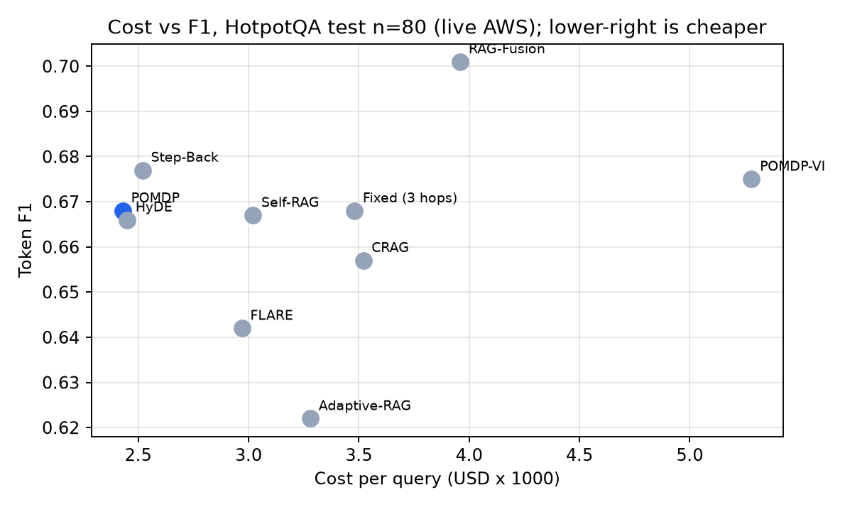
Figure 1. Cost vs F1 for ten strategies. The POMDP (blue) is in the cheapest group at the top-left of the cost range.
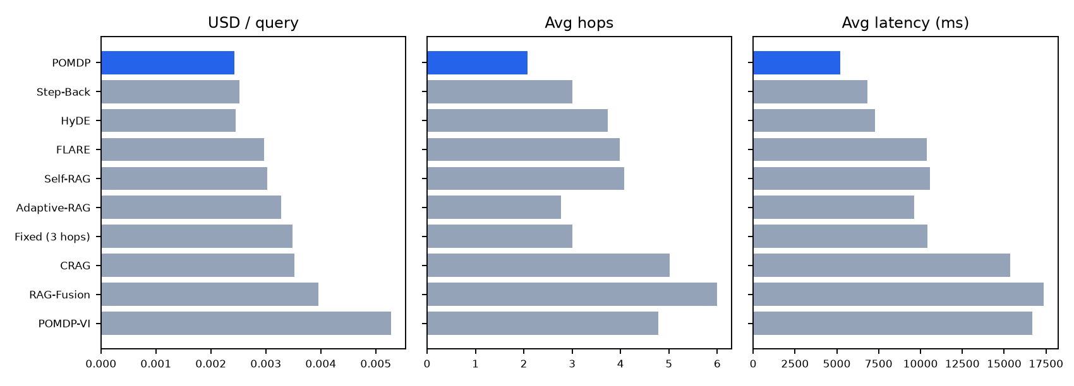
Figure 2. Cost, hops and latency per strategy (POMDP in blue).

4.1 Statistical significance (paired bootstrap, 95% CI, POMDP minus strategy, n=80)
Compared with | Cost difference (USD) | Hops | F1 difference
Fixed (3 hops) | -0.00104 [-0.00114, -0.00094] lower | -0.93 lower | -0.000 n.s.
POMDP-VI | -0.00284 [-0.00319, -0.00252] lower | -2.70 lower | -0.008 n.s.
CRAG | -0.00108 [-0.00122, -0.00094] lower | -2.94 lower | +0.010 n.s.
FLARE | -0.00054 [-0.00078, -0.00029] lower | -1.90 lower | +0.026 n.s.
RAG-Fusion | -0.00153 [-0.00162, -0.00142] lower | -3.93 lower | -0.034 n.s.
Self-RAG | -0.00060 [-0.00084, -0.00037] lower | lower | n.s.
Adaptive-RAG | -0.00087 [-0.00123, -0.00051] lower | lower | +0.045 [+0.005, +0.097] higher

Reading: the POMDP is significantly cheaper, uses fewer hops and has lower latency than every strategy in the table above, and its F1 is never significantly worse. It is significantly more accurate than Adaptive-RAG.

4.2 Larger test (n=200, live AWS, ~2,000-passage index)
Strategy | F1 | USD/query | Hops | Latency (ms)
POMDP | 0.692 | 0.00248 | 2.12 | 6,718
Fixed (3 hops) | 0.710 | 0.00344 | 3.00 | 10,433
Fixed-2 | 0.686 | 0.00237 | 2.00 | 6,866

Versus Fixed 3-hop: cost -0.00096 [-0.00103, -0.00089] (about 28% cheaper), hops -0.885, latency -3.7 s, all significant; F1 -0.018 [-0.042, +0.002], not significant. This tighter interval confirms the n=80 result.

4.3 Second dataset: MS MARCO (single hop)
Config (test n=60) | F1 | USD/query | Hops
POMDP (weight 60, chosen on validation) | 0.323 | 0.00107 | 1.02
Fixed-3 | 0.334 | 0.00290 | 3.00
Fixed-2 | 0.336 | 0.00200 | 2.00
Self-RAG | 0.338 | 0.00191 | 2.57
Adaptive-RAG | 0.330 | 0.00120 | 1.07

On the single-hop dataset the controller settles at about 1 hop, 63% cheaper than Fixed-3 and 46% cheaper than Fixed-2, with F1 in the same range. One controller reaches a cost-effective depth on both a 2-hop and a 1-hop dataset.

5. Result 2: the cost-aware reward is the cause (ablation)
Same controller, with the cost, latency and redundancy reward terms set to zero (pomdp_quality). Test n=80.
Dataset | Variant | F1 | USD/query | Hops | Latency (ms)
HotpotQA | Cost-aware POMDP | 0.651 | 0.00245 | 2.1 | 4,446
HotpotQA | Quality-only POMDP | 0.667 | 0.00388 | 4.4 | 8,468
MS MARCO | Cost-aware POMDP | 0.325 | 0.00107 | 1.01 | 1,057
MS MARCO | Quality-only POMDP | 0.338 | 0.00264 | 3.33 | 6,889

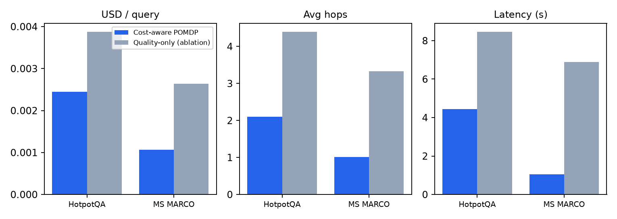
Figure 3. Ablation: removing the cost terms raises cost, hops and latency.
Paired 95% CIs (full minus quality-only): cost -0.00143 [-0.00164, -0.00122] on HotpotQA and -0.00158 [-0.00181, -0.00134] on MS MARCO; F1 -0.016 and -0.014, both not significant. This isolates the contribution: the cost-aware reward produces the saving.

6. Result 3: consistent, statistically sound evaluation
The paper argues that static, inconsistent evaluation is a core problem. The project's harness addresses it as follows.
Requirement | What the project does
Same conditions for every strategy | One harness, identical model, index, k=4 retrieval, seeded 70/15/15 split (seed 13, ids saved in results/splits.json)
No test-set tuning | Cost weight swept on validation only (cheapest weight within 0.02 F1 of the best)
Statistics, not single numbers | Paired bootstrap 95% confidence intervals for every pairwise comparison (scripts/significance.py)
Cost and quality together | Cost/F1 Pareto frontier with ON FRONTIER / dominated labels and USD per F1 (scripts/frontier.py)
Multi-metric | Accuracy, exact match, F1, precision, recall, USD, tokens, hops, average and p95 latency, success rate
Honest reporting of failures | The v1 result, where the POMDP was the most expensive strategy, is kept in the report beside the fixed v2 result; superseded experiment A is labelled

6.1 Live comparison dashboard (screenshots)
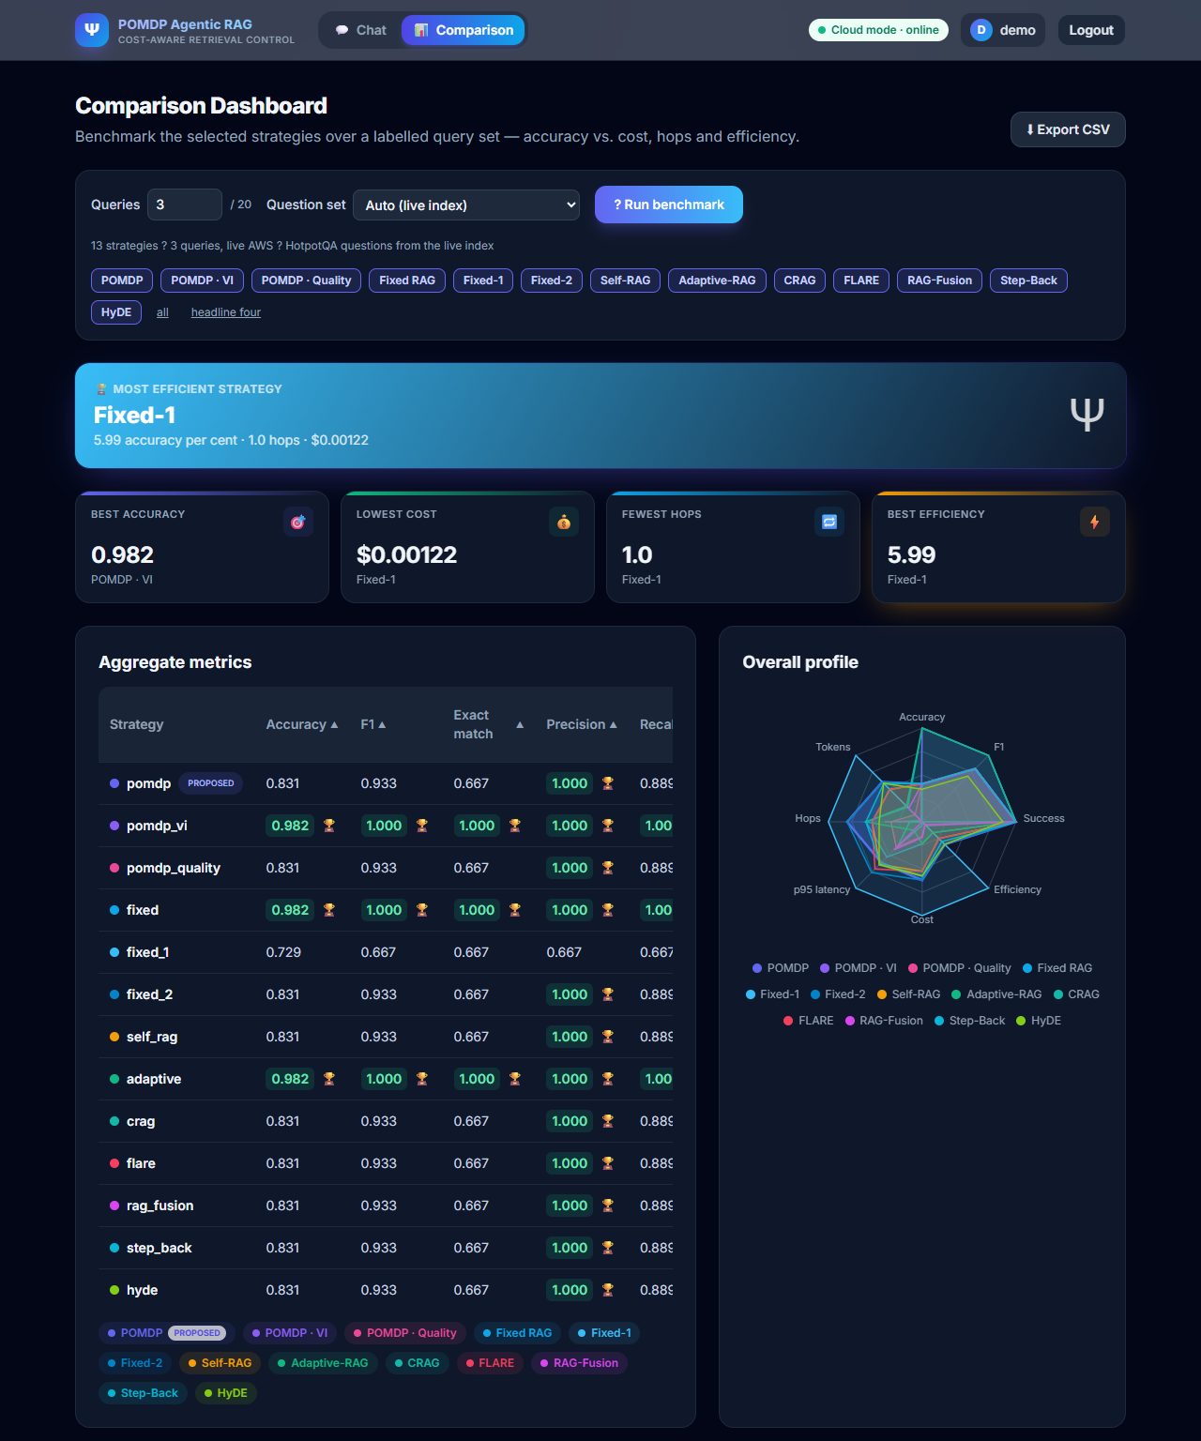
Figure 4. Comparison dashboard on live AWS: 13 strategies, aggregate metrics and radar profile (badge: Cloud mode - online).
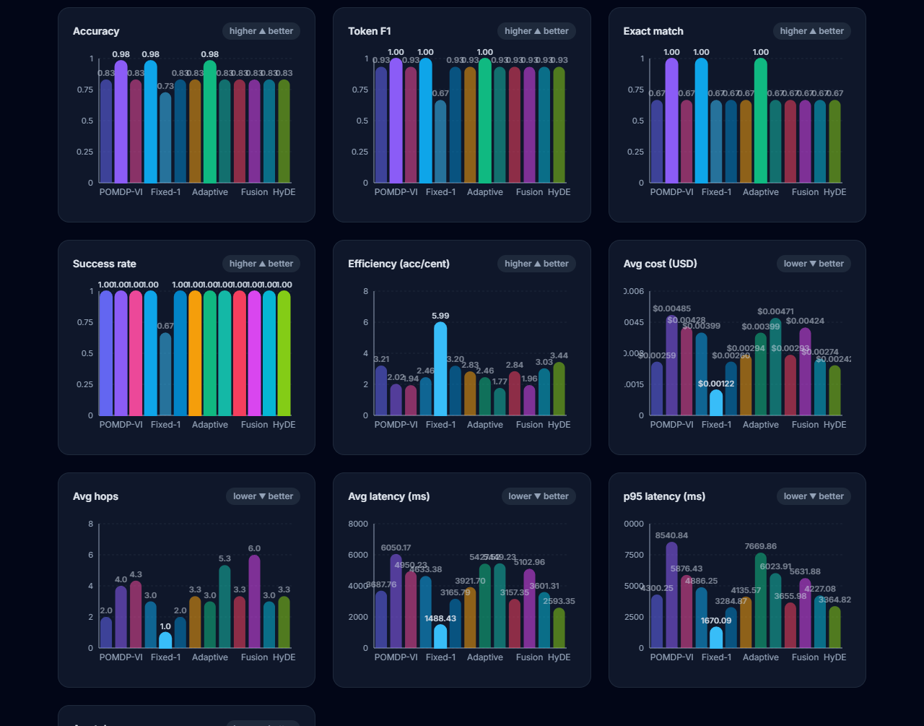
Figure 5. The same run: per-metric charts for accuracy, F1, exact match, success, efficiency, cost, hops, latency and tokens.
The dashboard run uses only 3 labelled questions, so it is a functional demonstration of the tooling, not a benchmark; the statistical conclusions come from sections 4 and 5.

7. Result 4: real cloud deployment (not in the paper)
Component | Live service
LLM (answers, judge, follow-up queries, router) | Amazon Bedrock, Claude Haiku 4.5
Embeddings | Amazon Bedrock, Titan Text Embeddings v2, 256 dimensions
Vector retrieval | Amazon OpenSearch Service, kNN index hp-test (800 passages)
Controller | FastAPI backend calling those services
Frontend | React UI, driven in a browser by a Playwright test

Live test | Result
API: 6 questions x 13 strategies plus /evaluate/batch per strategy | 350 checks passed, 0 failed, 0 warnings
Each response | Real Bedrock tokens, non-zero cost, trace and retrieved documents; known-answer questions answered correctly
/compare with all 13 strategies on one question | Completed in 54 s, all 13 answered correctly
Playwright UI test, all 13 strategies and dashboard | Passed (5.0 min); 13 answers with traces; dashboard returned 13 result rows
Out-of-index question (photosynthesis) | Answered 'Insufficient evidence.' rather than inventing an answer

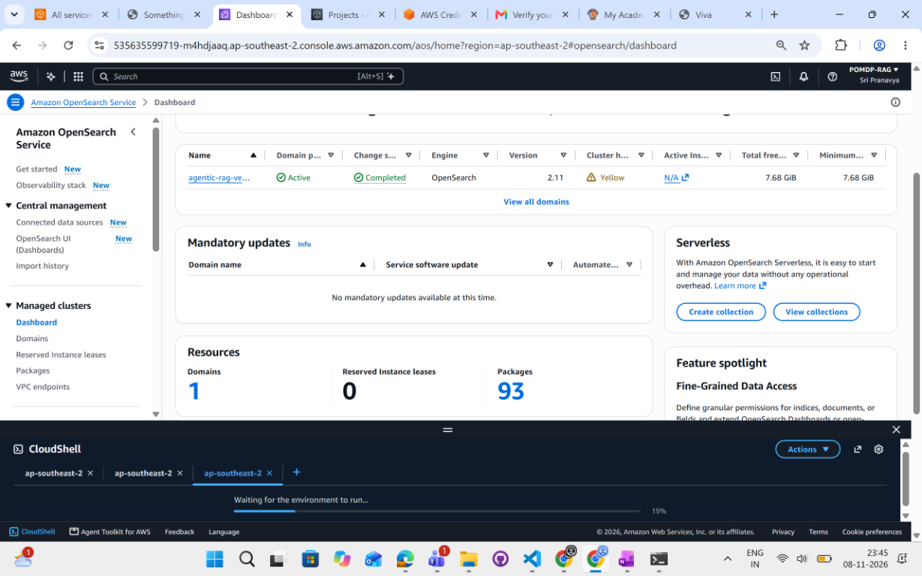
Figure 6. AWS console: OpenSearch domain Active (OpenSearch 2.11) in ap-southeast-2.
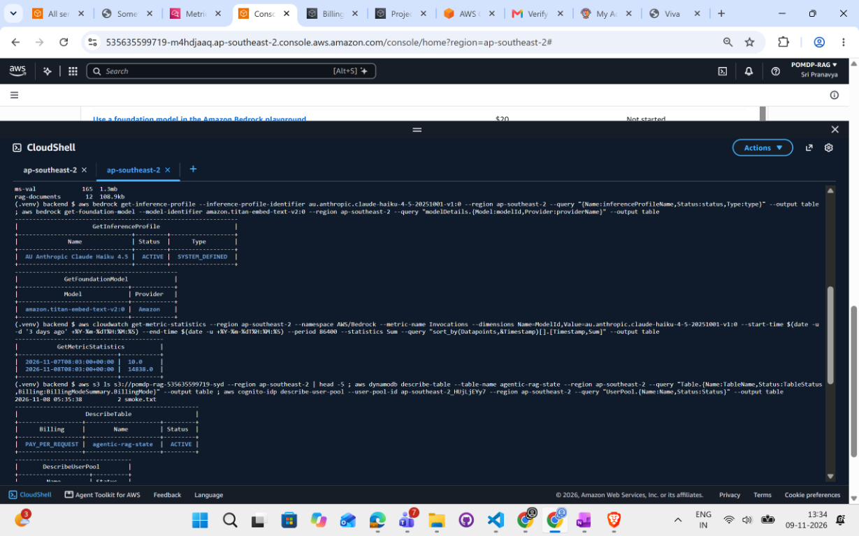
Figure 7. AWS CloudShell: Claude Haiku 4.5 inference profile ACTIVE, Titan embed model, CloudWatch Bedrock invocation counts, DynamoDB state table and Cognito user pool.
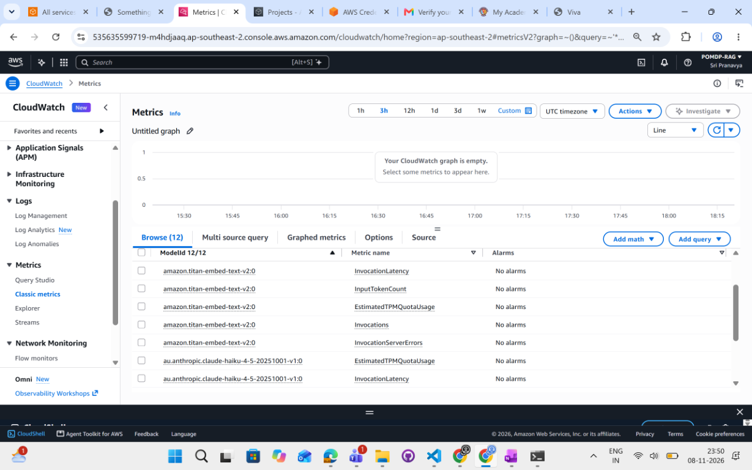
Figure 8. CloudWatch: Bedrock metrics from the benchmark runs.
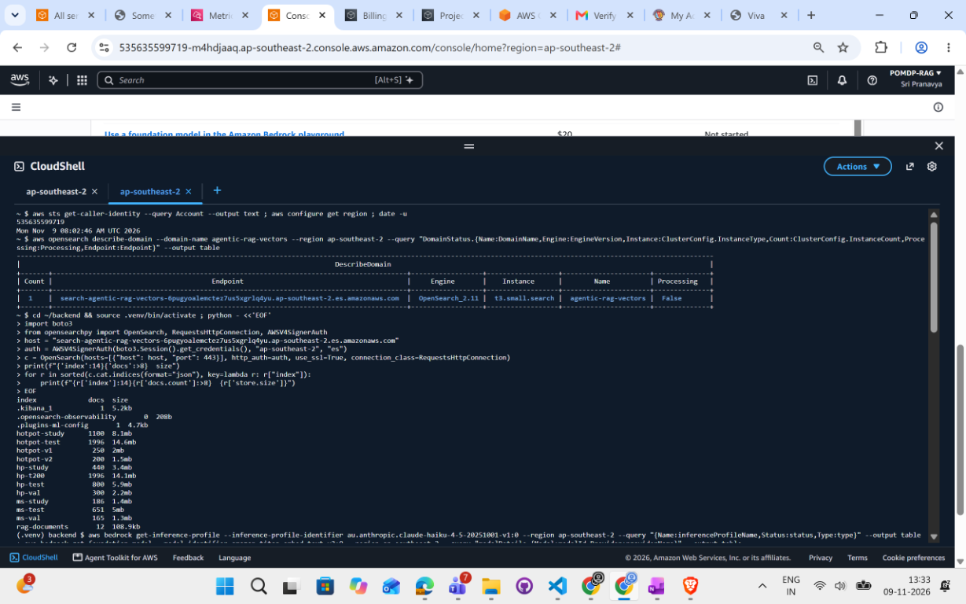
Figure 9. CLI: OpenSearch domain and vector indexes.
Live persistence test (2026-11-09): one live POMDP query was sent through the API with PERSIST_EPISODES enabled. The episode trace (user, answer, 2 hop-by-hop steps, tokens and cost of $0.002248) was saved to DynamoDB under the request id, read back successfully, and a report file was written to and read back from S3.
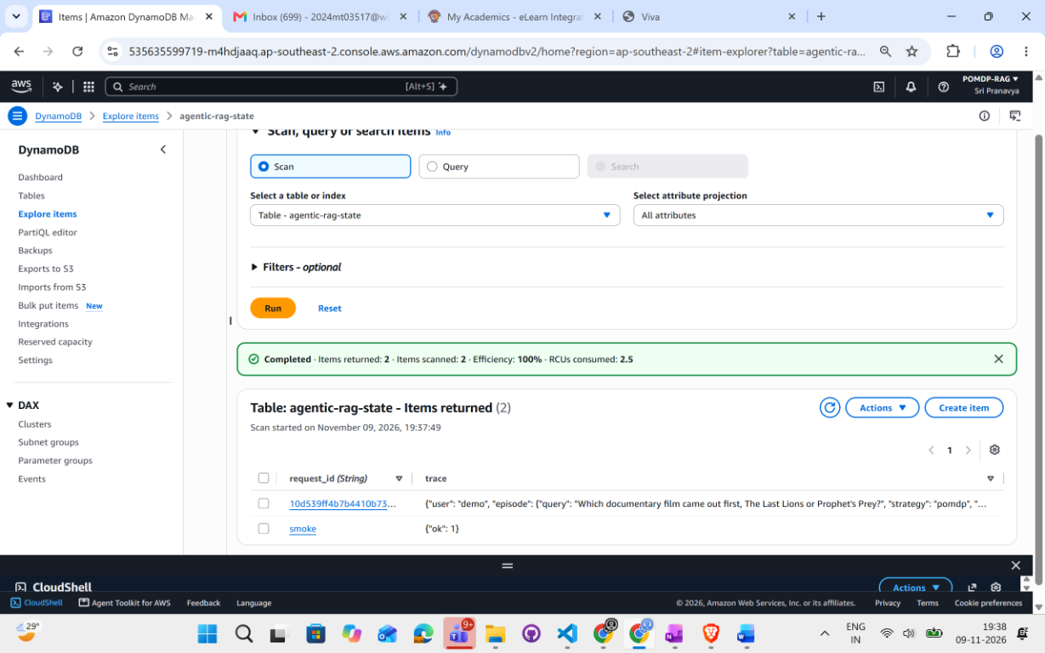
Figure 9a. DynamoDB table agentic-rag-state: the saved episode (request id 10d539ff...) with the query, strategy and trace JSON.
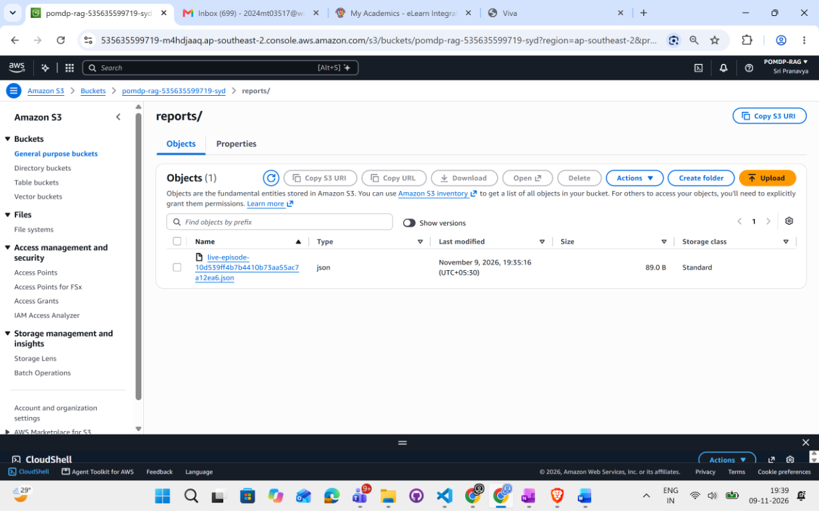
Figure 9b. S3 bucket pomdp-rag-535635599719-syd, reports/ folder: live-episode-10d539ff...json written by the application.
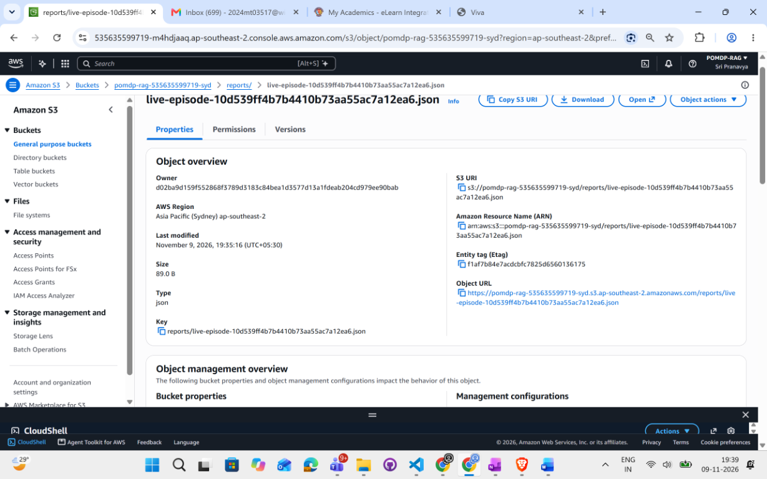
Figure 9c. S3 object properties: key, S3 URI, region ap-southeast-2 and last-modified time matching the live run.
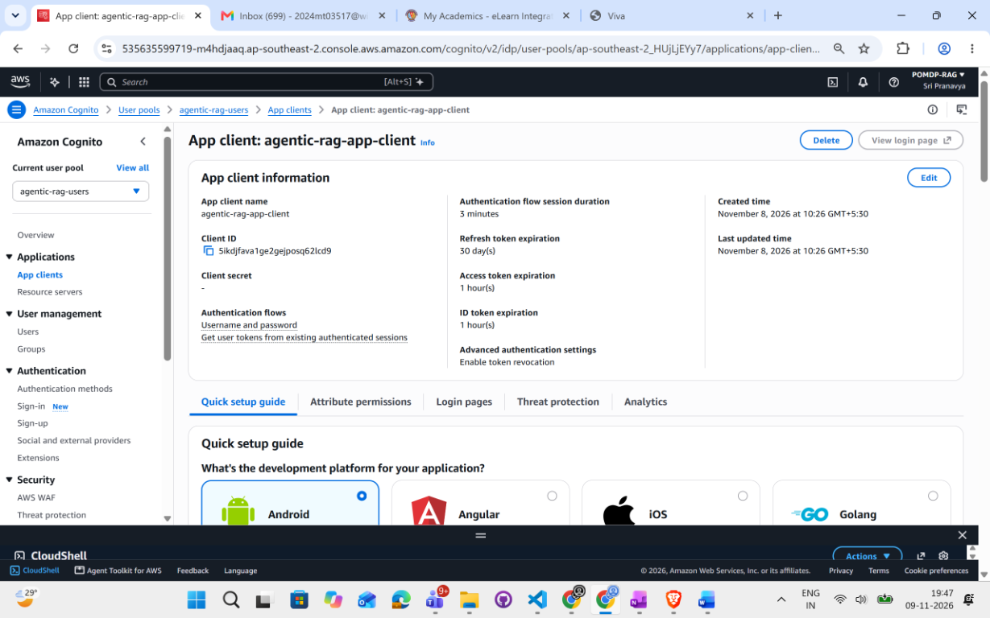
Figure 9d. Amazon Cognito user pool agentic-rag-users: app client with username/password authentication flow and no client secret.
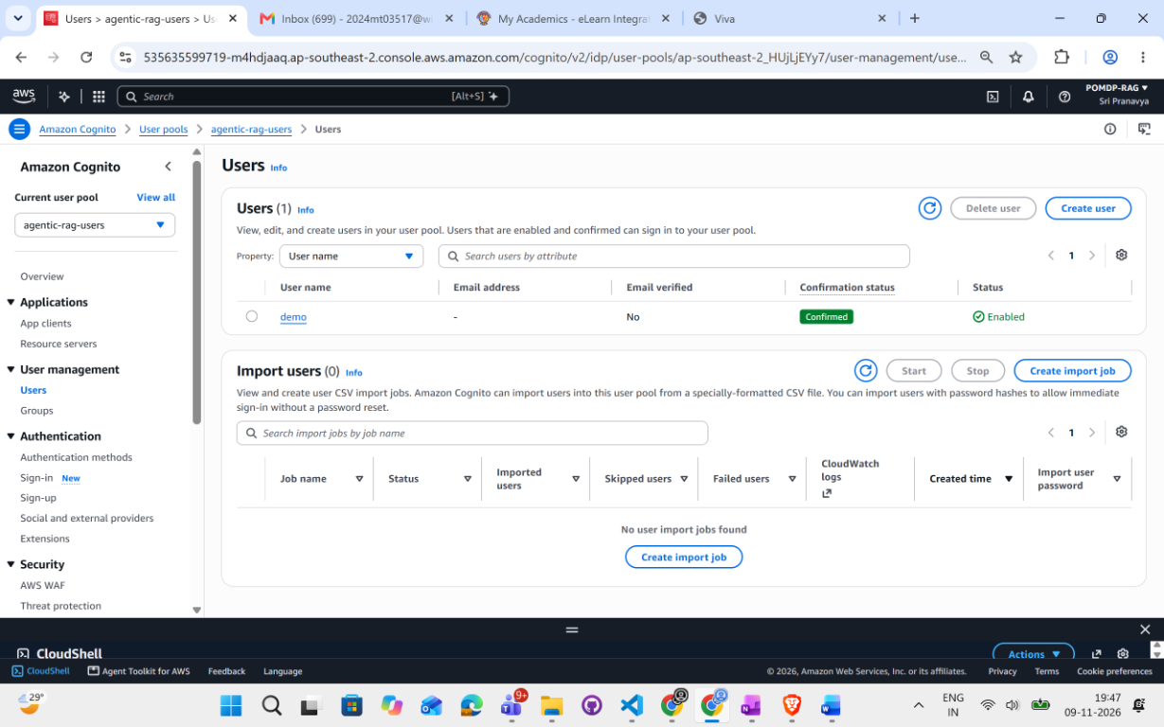
Figure 9e. Cognito user pool: user 'demo' with status Confirmed and Enabled. The backend verifies Cognito RS256 tokens (JWKS) against this pool and app client.
Live Cognito check (2026-11-09) | Result
GET /auth/me with the Cognito ID token | 200, issuer https://cognito-idp.ap-southeast-2.amazonaws.com/ap-southeast-2_HUjLjEYy7, subject 098ec4c8-b001-7066-f0d4-e35a9a1731d4
GET /auth/me without a token | 401
GET /auth/me with a tampered token | 401
POST /query (POMDP) with the Cognito token | 200: answer 'The Last Lions', 2 hops, $0.002392
Episode saved to DynamoDB | Item found for request id 77690fac132e43c58ee81bf546a23fd4, owned by the Cognito subject

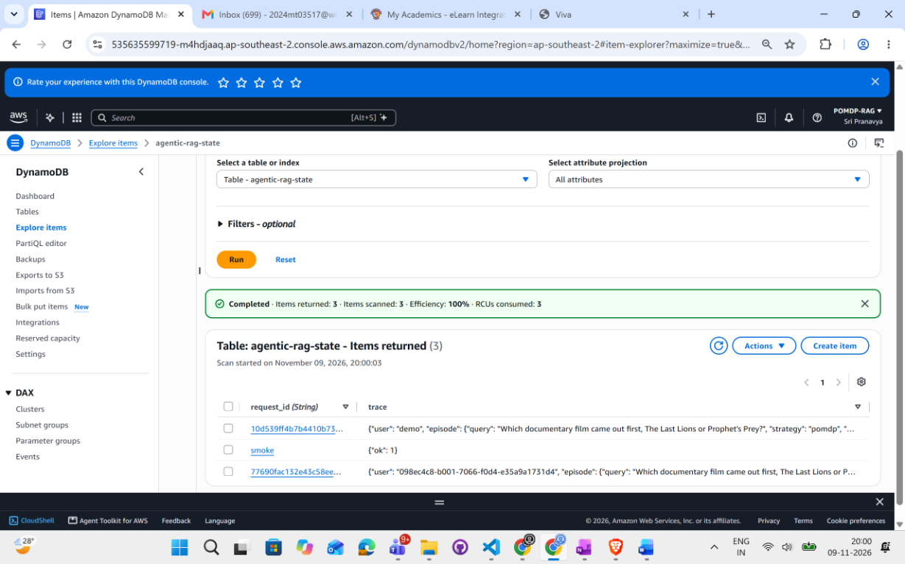
Figure 9f. DynamoDB table agentic-rag-state after the Cognito run: 3 items. Request 77690fac... is owned by the Cognito subject 098ec4c8-b001-7066-f0d4-e35a9a1731d4; 10d539ff... is the earlier run (user demo); 'smoke' is the connectivity test item.

8. Result 5: inspectable decisions (oversight)
Every run records, per hop, the action, belief, reward, cost and retrieved passages with scores. The UI shows this trace, so a reviewer can see why the controller stopped. The paper lists oversight and trajectory visibility as needs.
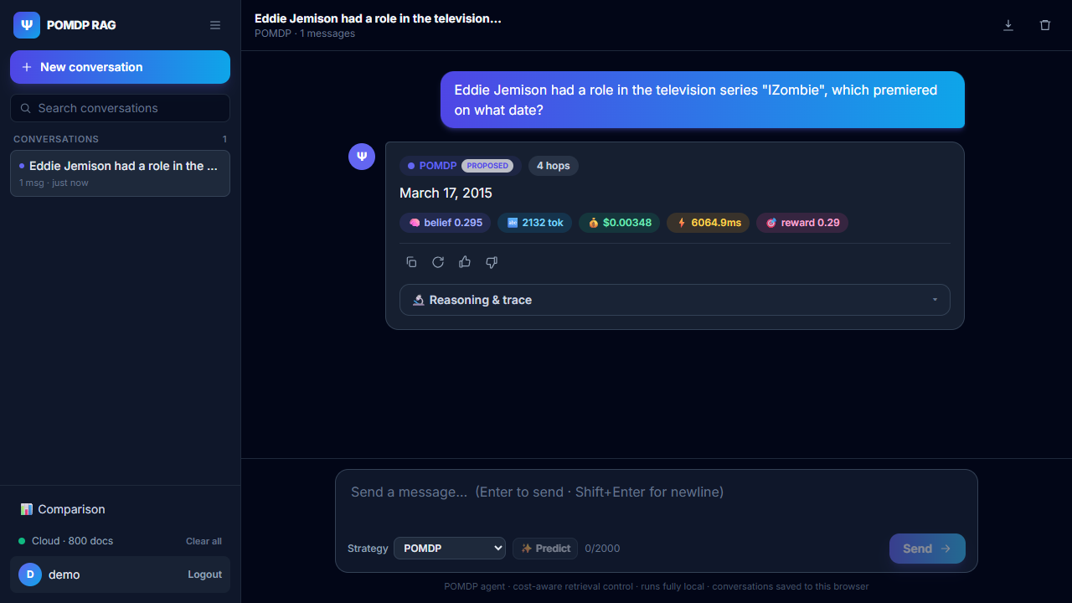
Figure 10. Live POMDP answer: hops, final belief, tokens and USD cost shown with the footer badge 'Cloud - 800 docs'.
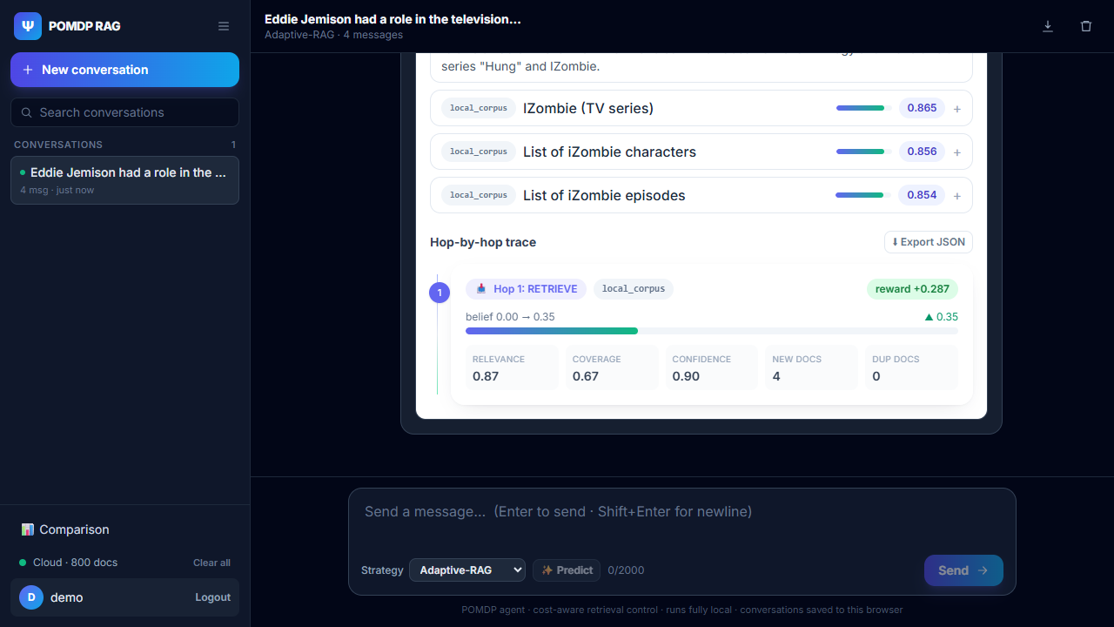
Figure 11. Reasoning trace: retrieved passages with scores and the hop-by-hop belief.
Further per-strategy live screenshots for all 13 strategies are in docs/evidence/screenshots-all13/ (files 01 to 15).

9. Result 6: runtime safeguards for stable, bounded retrieval
The paper lists stable adaptive retrieval (bounded loops, no runaway spending) as an open problem. The project implements and tests the following safeguards, all configurable and applied identically to every strategy (tests/integration/test_safeguards.py).
Safeguard | Purpose
MAX_HOPS hard cap (at the cap STOP is the only legal action) | Guarantees a finite horizon, as in a finite-horizon POMDP
Confidence threshold stop | Stops once belief in evidence sufficiency is high enough
EPISODE_BUDGET_USD | Per-query spending ceiling
MIN_MARGINAL_GAIN + LOW_GAIN_PATIENCE | Stops when successive retrievals add too little
STALE_PATIENCE (stale-retrieval stop) | Stops after N retrievals that return no new documents
Duplicate-document accounting in observation and reward | Redundant retrievals cannot raise belief and are penalised
Retrieval timeout and retries | Bounded latency from slow sources
MAX_BUDGET_USD run-level kill switch + on-disk LLM cache | Hard stop on total spend; re-runs of identical calls cost nothing

Measured effect of the stale-retrieval stop (validation n=30, plus 8 out-of-index probe questions): with N=1, spend on out-of-index questions fell about 18% (POMDP 3.75 to 3.0 hops, $0.00402 to $0.00331; Self-RAG 6.0 to 5.0 hops), all 8 probe questions were still refused, and in-index cost and hops were unchanged.

9.1 Grounded answers and refusal
Check | Result
Out-of-index questions (8 general-knowledge probes) | 8 of 8 refused with 'Insufficient evidence.'; no invented answers
Live question not in the 800-passage index | POMDP stopped at 4 hops and answered 'Insufficient evidence.' (belief 0.24)
Known-answer live questions | Correct on both gold-labelled questions (March 17, 2015; Queens) and on the gold questions across all 13 strategies
Conflicting-evidence study (earlier static-query run; one injected contradicting passage per question, n=100) | POMDP F1 0.473 vs Fixed 0.462, Self-RAG 0.458, Adaptive 0.481; no significant difference, so no accuracy loss under conflict

10. Result 7: measured cost model and sensitivity
Costs are not illustrative: LLM spend comes from real Bedrock Converse token usage (Claude Haiku 4.5 priced at $0.001 per 1K input and $0.005 per 1K output tokens in the benchmarks). Retrieval hops are priced at an explicit assumed $0.0003 each and the project shows how the conclusion changes with that price.
Retrieval price assumption (static-query run, test split) | POMDP saving vs Fixed | vs Self-RAG | vs Adaptive
$0 per retrieval | 0.46% (essentially no saving) | not reported | not reported
$0.0005 per retrieval | 41.9% | 64% | 40%
$0.002 per retrieval | 58.1% | 78% | 57%

The saving therefore grows with the price of retrieval (paid search APIs, managed vector DB queries), and the break-even price is reported by scripts/cost_sensitivity.py. Infrastructure cost is also tracked: one t3.small.search OpenSearch node is about $1 per day, and S3, DynamoDB (on-demand), Cognito and IAM are near zero when idle. Total spend for the 6-question x 4-strategy live API run was about $0.067.

11. Result 8: production-grade engineering
Area | What is implemented
Cloud/local abstraction | Every AWS capability is a Protocol with a local and a cloud implementation (LLM Bedrock or mock, embeddings Bedrock or hashing, vectors OpenSearch or NumPy, state DynamoDB or SQLite, objects S3 or filesystem, queue SQS/SNS or in-process), switched by USE_LOCAL_MOCKS
Retrieval sources | Local corpus / OpenSearch kNN, Wikipedia and arXiv connectors, all behind one orchestrator
Authentication | JWT on every non-health endpoint; local HS256 signer or Cognito RS256 with JWKS; no endpoint trusts a client-supplied user id
Rate limiting and concurrency control | Per-user and per-IP limits (slowapi); concurrency limiter
Input and prompt-injection defence | Retrieved text sanitised, instruction-like patterns flagged and defanged, content wrapped in a per-request random data fence; Pydantic constraints on all inputs
Infrastructure as code | Terraform modules for networking, IAM, data, compute, auth, messaging and observability, with lab-budget and full environments; least-privilege IAM scoped to specific ARNs; encryption at rest for S3, DynamoDB and OpenSearch
Quality gates | Backend and frontend unit/integration tests, Vitest coverage, Playwright end-to-end tests, SonarQube configuration, pip-audit and npm audit in CI
User interface | React/TypeScript app with login, chat with reasoning trace, 13-strategy comparison dashboard (metric tables, radar profile, 9 charts, CSV export)
ML component | Query-difficulty and cost predictor in pure NumPy (core/ml/predictor.py) with its own tests

12. Metrics catalogue
Metric | Where reported
Accuracy, exact match, token F1, precision, recall | Sections 4, 5, 6 and the dashboard
Cost per query in USD (real token usage), tokens per query | Sections 4, 5, 10
Retrieval hops per query | Sections 4, 5, 8
Average and p95 latency | Sections 4, 5 and the dashboard
Success rate and efficiency (accuracy per cent) | Dashboard (Figures 4 and 5)
Final belief per query and per hop | Section 8 (trace) and the live API table
Paired bootstrap 95% confidence intervals | Sections 4 and 5
Cost/F1 Pareto frontier and USD per F1 | Section 4
Cost sensitivity to retrieval price and break-even price | Section 10
Hop-distribution audit and correlation of hops with F1 | Section 13
Stopping study by query category (easy, complex, multi-hop, conflicting) | Section 9.1 and RESULTS.md
Refusal rate on out-of-index questions | Section 9.1

13. Methodological rigour: iteration, audits and reproducibility
The project reports its own failed experiments and fixes, which strengthens the credibility of the final numbers.
Step | Outcome
v1 (cost weight 20, two LLM calls) | POMDP was the most expensive strategy (F1 0.679, $0.00385, 3.73 hops vs Fixed 0.688, $0.00345, 3.0). Kept in the report.
Diagnosis and fixes | Cost weight raised to 40; unchanged evidence no longer re-judged; judge proposes the next query in the same call
v2 (final) | POMDP F1 0.667, $0.00242, 2.08 hops: about 30% cheaper than Fixed, no significant F1 loss; confirmed at n=200

Adaptivity audit (test) | Hop distribution | Mean hops | corr(hops, F1)
HotpotQA, weight 40 (n=80) | 2 hops: 77, 4 hops: 3 | 2.08 | +0.12
HotpotQA, weight 60 (n=80) | 1 hop: 67, 2 hops: 13 | 1.16 | -0.07
HotpotQA, weight 20, v1 (n=80) | 2 to 6 hops | 3.73 | -0.30
MS MARCO, weight 60 (n=60) | 1 hop: 59, 2 hops: 1 | 1.02 | +0.14
Self-RAG, HotpotQA (n=80) | 2: 32, 4: 13, 6: 35 | 4.08 | -0.33
Adaptive-RAG, HotpotQA (n=80) | 1: 26, 3: 37, 5: 17 | 2.77 | +0.11

Reproducibility: seeded splits stored with the results, validation-only tuning, an on-disk LLM cache so re-runs are free, and per-query CSVs from which every interval can be recomputed. Observed run-to-run noise is about 0.01 F1.

14. Side-by-side summary
Dimension | SoK paper | This project
Nature | Survey and roadmap | Implemented, deployed and measured system
Experimental results | None | n=80 and n=200 HotpotQA, n=60 MS MARCO, ablation, all on live AWS
Action space | Abstract, open-ended | 4 typed action kinds, 3 sources, validated
Belief | Memory as stand-in | Explicit, updated by Bayes-style rules, shown in UI
Cost model | Single lambda x cost term | Separate cost, latency and redundancy weights, real Bedrock token prices
Stopping | Open problem | Expected-utility stop with hop cap, budget cap and confidence threshold
Baselines compared | Described | 12 baselines implemented and run on one interface
Statistics | Calls for rigorous evaluation | Paired bootstrap CIs, Pareto frontier, validation-only tuning
Cost saving shown | Not measured | About 28 to 30% (HotpotQA), about 63% (MS MARCO) vs fixed depth
Cloud deployment | Not covered | Bedrock + OpenSearch live, 350 passed checks
Bounded, stable retrieval | Open problem | 8 tested safeguards: hop cap, budget caps, low-gain and stale stops, kill switch
Grounding and refusal | Hallucination listed as a risk | 8 of 8 out-of-index questions refused; correct on gold questions
Security | Injection listed as a risk | JWT/Cognito auth, rate limiting, injection fencing, least-privilege IAM, encryption
Cost sensitivity | Not covered | Saving quantified across retrieval prices, with break-even
Infrastructure as code | Not covered | Terraform modules and two environments
User interface | Not covered | Chat with trace and a 13-strategy comparison dashboard

15. Partially addressed areas
The following areas are implemented in part. The completed part is described in the sections above.
- Adaptive stopping depth: the controller stops using belief, cost and a hop cap and adapts depth through the tuned cost weight per dataset (about 2 hops on HotpotQA, about 1 hop on MS MARCO). Per-query depth variation is limited at the tuned weights (2 hops on 96% of HotpotQA queries).
- Trajectory evaluation: per-hop traces (belief, reward, cost, passages) and a hop-distribution audit exist. Formal trajectory metrics such as Progress Rate and Effective Information Rate are not yet computed.
- Safety: prompt-injection scanning, sanitisation and fencing are implemented and unit-tested, and the conflicting-evidence study shows no accuracy loss. Experimental evaluation of injection attacks is not yet done.
- Belief tracking: an explicit belief over evidence sufficiency is updated each hop and shown in the UI. It is a single scalar rather than a full distribution over states.

16. Examiner feedback and how each point was resolved
The examiner acknowledged the detailed POMDP formulation (belief state, actions, observations, transitions, rewards, retrieval cost, latency, redundancy and stopping), the working user interface, query-level token and cost tracking, belief and retrieval traces, the multi-strategy comparison dashboard, and the clear separation of the mocked proof of concept from the pending integrations. The table maps each suggested improvement to the change made and the proof in this report. Resolved items come first; partly resolved items are last and state what remains.
# | Suggested improvement | How it was resolved | Proof
 | FINAL IMPLEMENTATION
1 | Replace local mocks with actual knowledge sources and complete the vector-store integration | Live Amazon OpenSearch kNN index of public-dataset passages (800 passages), Bedrock Claude Haiku 4.5 and Titan v2 embeddings. Wikipedia and arXiv connectors are implemented and switched off in benchmarks so every strategy sees the same corpus | Section 7, Figures 6 to 9; 350 live API checks passed, 0 failed
2 | Implement the complete POMDP controller with belief updates and action selection driven by observed evidence | Explicit belief updated each hop from relevance, coverage, confidence and duplicate documents (Bayes update for the LLM judge); actions chosen by expected utility over that belief; hop-by-hop traces from live runs | Sections 2 and 8, Figures 10 and 11; unit tests for belief, observation, reward and policy
3 | Distinguish the controller from Fixed RAG, Self-RAG and Adaptive-RAG at algorithm and implementation level | 13 strategies on one policy interface, benchmarked together with paired bootstrap confidence intervals and a cost/F1 frontier; the cost-aware reward shown to cause the saving by ablation | Section 4 (Figures 1 and 2), section 5 (Figure 3), section 6 (Figures 4 and 5)
4 | Add safeguards for maximum hops, budget caps, timeouts, repeated documents and low-value retrieval | Hop cap, per-episode budget, low-gain stop, stale-retrieval stop, duplicate accounting, retrieval timeout and retries, run-level kill switch with LLM cache | Section 9; tests/integration/test_safeguards.py; stale stop cut out-of-index spend about 18%
5 | Record actual token, API-call and infrastructure costs instead of illustrative values | Cost from real Bedrock token usage per query; retrieval priced as a stated assumption with a sensitivity analysis; infrastructure cost per day tracked | Section 10; live query cost $0.002248 to $0.002392; live API run total about $0.067
6 | Complete the database connectivity and demonstrate reproducible execution from query to answer | Each live query can save its episode trace to DynamoDB (PERSIST_EPISODES) and reports to S3; saved and read back live. A live query authenticated with a Cognito ID token (valid token accepted; missing and tampered tokens rejected with 401) | Section 7, Figures 9a to 9f and the live Cognito check table; tests/integration/test_episode_persistence.py; 350 live API checks and the Playwright UI test
 | FINAL TESTING AND VALIDATION
7 | Compare the POMDP against Fixed RAG, Self-RAG and Adaptive-RAG with the same datasets, corpus, language model and configuration | Identical Claude Haiku 4.5, Titan v2, index, k=4 and settings for every strategy, run in one process; paired confidence intervals for each comparison | Section 4 and 4.1; section 6 table
 | PARTLY RESOLVED
8 | Validate the stopping rule under easy, complex, multi-hop and conflicting-evidence queries | The stopping study was run for all four categories with no accuracy loss, and a hop-distribution audit was reported | Sections 9.1 and 13. Remaining: the controller uses about 2 hops in every category, so per-query depth adaptation is not demonstrated
9 | Evaluate on the benchmark datasets specified in the report, with fixed reproducible train, validation and test splits | Fixed seeded 70/15/15 splits (seed 13, ids saved), cost weight tuned on validation only; evaluated on HotpotQA (n=80 and n=200) and MS MARCO (n=60) | Sections 4, 4.2, 4.3 and 6. Remaining: Natural Questions and FEVER were not run because their releases lack the evidence passages needed for a self-contained corpus

