Bluestock Mutual Fund Analytics Capstone Project
MUTUAL FUND ANALYTICS PLATFORM
Submitted By
Devarapalli Sripriya Reddy
Institution
Indian Institute of Information Technology Kottayam (IIIT Kottayam)
Technologies Used
Python, Pandas, NumPy, SQLite, SQLAlchemy, SciPy, Jupyter Notebook, Power BI, GitHub

Executive Summary
The Mutual Fund Analytics Platform is an end-to-end financial analytics solution developed to analyze mutual fund performance, investor behavior, portfolio risk, and market trends. The project combines data engineering, database management, advanced analytics, and business intelligence visualization into a unified platform.
The system processes more than 46,000 NAV records and 32,000 investor transactions. Multiple financial performance metrics including CAGR, Sharpe Ratio, Sortino Ratio, Alpha, Beta, VaR, CVaR, and Maximum Drawdown were calculated to evaluate mutual fund performance.
A Power BI dashboard was developed to provide interactive insights into industry trends, fund performance, investor behavior, and SIP growth patterns. The project demonstrates the complete lifecycle of a financial analytics application from raw data ingestion to business intelligence reporting.

PROBLEM STATEMENT & OBJECTIVES
Problem Statement
Investors often face challenges in selecting suitable mutual funds due to the large number of available schemes, varying risk profiles, and inconsistent performance measures.
Traditional investment analysis often focuses only on returns while ignoring risk-adjusted performance, investor behavior, and portfolio diversification.
This project aims to provide a comprehensive mutual fund analytics platform that enables data-driven investment decision making.
Project Objectives
- Collect and process mutual fund datasets.
- Build an automated ETL pipeline.
- Design a relational database for analytics.
- Analyze fund performance using financial metrics.
- Evaluate portfolio risk using quantitative techniques.
- Study investor transaction behavior.
- Create an interactive business intelligence dashboard.
- Develop a fund recommendation system.

DATASET DESCRIPTION
Datasets Used
The project utilizes ten datasets.
1. Fund Master
Contains scheme details including AMFI code, fund house, category, risk grade, and plan information.
2. NAV History
Daily Net Asset Value history for all schemes.
3. AUM by Fund House
Assets Under Management statistics across mutual fund companies.
4. Monthly SIP Inflows
Monthly SIP contribution data.
5. Category Inflows
Category-wise net inflow and outflow information.
6. Industry Folio Count
Investor account statistics across the industry.
7. Scheme Performance
Fund returns, expense ratios, and risk measures.
8. Investor Transactions
Transaction-level SIP, lump sum, and redemption records.
9. Portfolio Holdings
Fund portfolio allocations and sector weights.
10. Benchmark Indices
Historical benchmark index performance data.
Total Records Processed: More than 85,000 records.

DATA ENGINEERING & ETL PIPELINE
ETL Pipeline
An automated ETL pipeline was created to process mutual fund datasets.
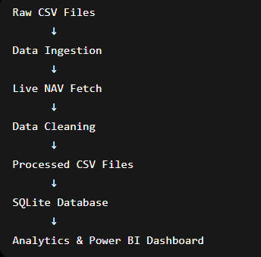
Extraction
- Raw CSV datasets imported.
- Live NAV data fetched using MFAPI.
- Data validation performed.
Transformation
- Missing values handled.
- Duplicate records removed.
- Date formats standardized.
- Transaction categories normalized.
- Risk metrics validated.
Loading
- Cleaned datasets loaded into SQLite database.
- Star schema implemented for analytical processing.
Technologies Used
- Python
- Pandas
- Requests
- SQLAlchemy
- SQLite
The ETL pipeline executes automatically and processes all datasets without manual intervention.

DATABASE DESIGN
Database Architecture
A star schema was designed to support analytical workloads.
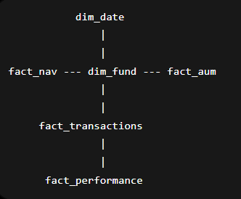
Dimension Tables
dim_fund
Stores scheme metadata.
dim_date
Stores calendar attributes.
Fact Tables
fact_nav
Daily NAV values.
fact_transactions
Investor transaction records.
fact_performance
Performance metrics.
fact_aum
Assets Under Management data.
Benefits
- Faster query execution.
- Improved reporting performance.
- Simplified analytical calculations.
- Better scalability.

EXPLORATORY DATA ANALYSIS
Exploratory Data Analysis
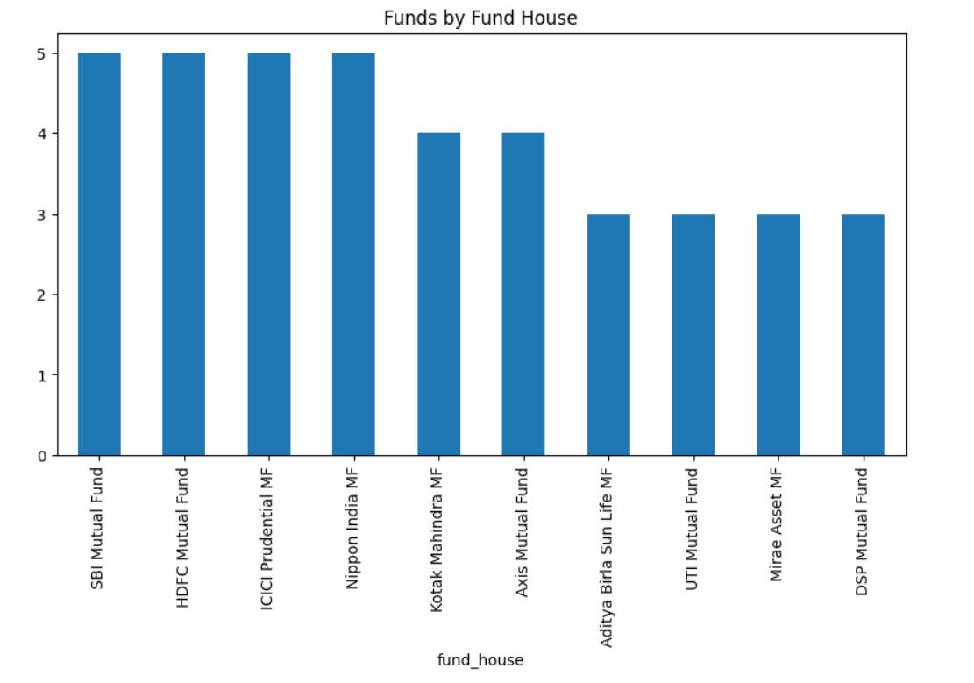
EDA was performed to understand trends and relationships within the data.
Fund House Distribution
Analysis showed concentration among major AMCs including SBI, HDFC, ICICI Prudential, Nippon India, and Kotak.
Risk Category Distribution
Most schemes belonged to Moderate to High risk categories.
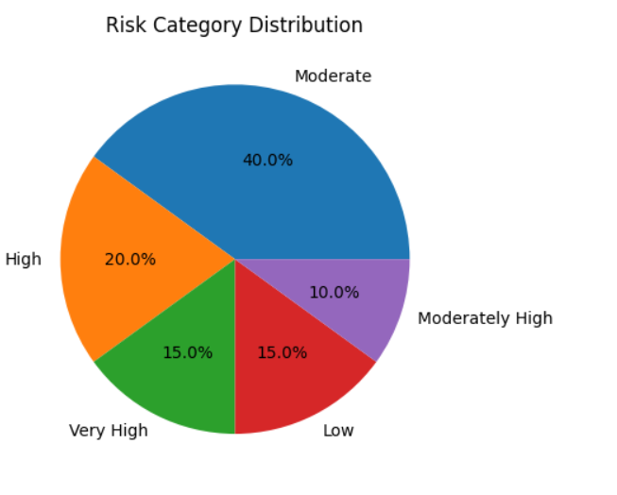
Category Analysis
Large Cap, Flexi Cap, and Small Cap categories dominated the dataset.
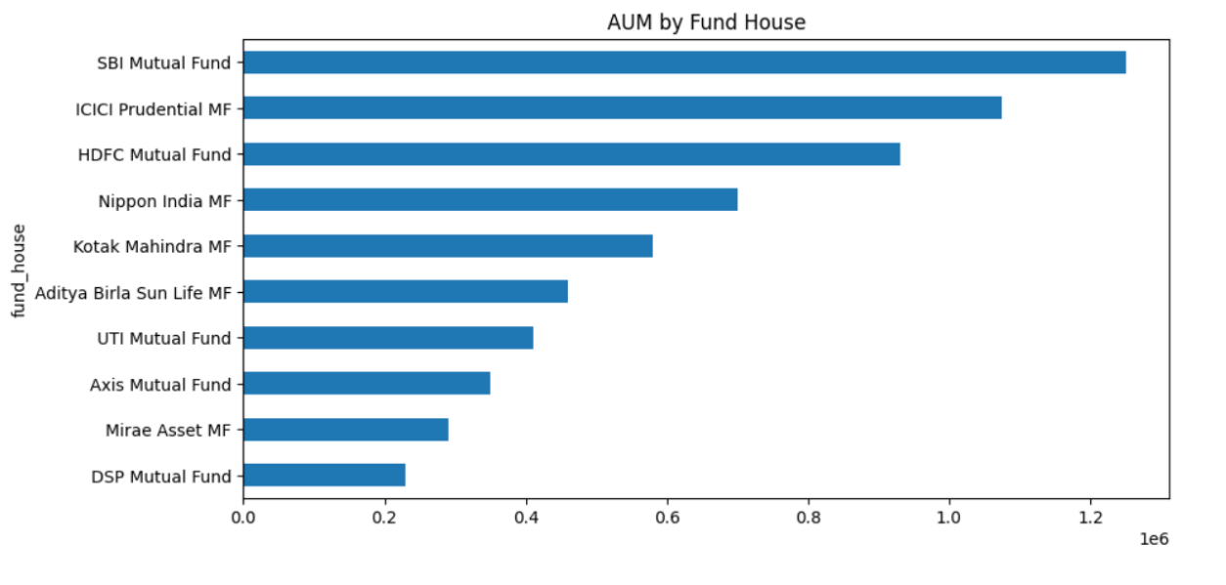
Investor Analysis
Investment activity was concentrated among selected states and metropolitan regions.
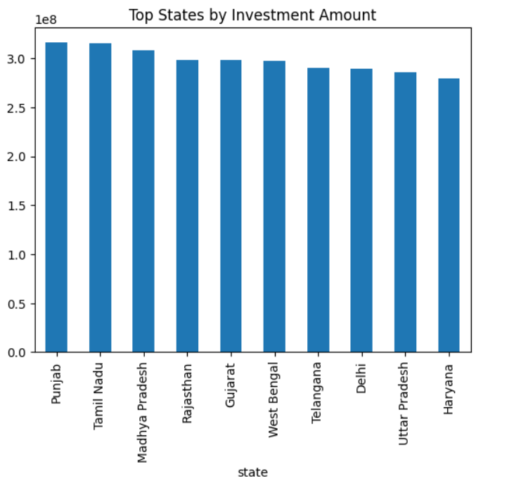
Portfolio Analysis
Financial Services and Technology sectors represented significant portfolio allocations.

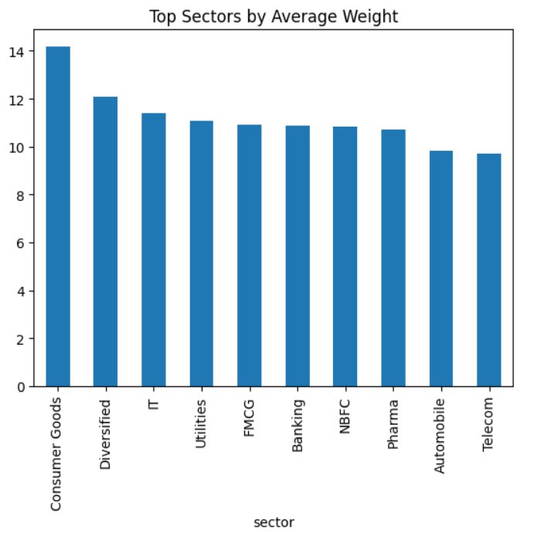
PERFORMANCE ANALYTICS
Performance Metrics
Several quantitative performance measures were calculated.
CAGR
Measures annualized investment growth.
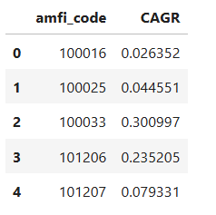
Sharpe Ratio
Measures excess return per unit of total risk.
Sortino Ratio
Measures excess return relative to downside risk.
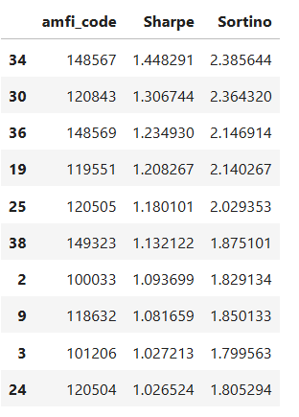
Alpha
Measures risk-adjusted excess return over benchmark.
Beta
Measures market sensitivity.
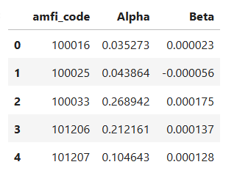
Maximum Drawdown
Measures worst portfolio decline from peak value.
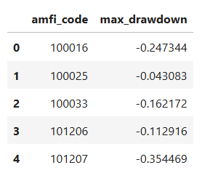
Results
Small Cap and Mid Cap funds generated the highest long-term returns but exhibited higher volatility.
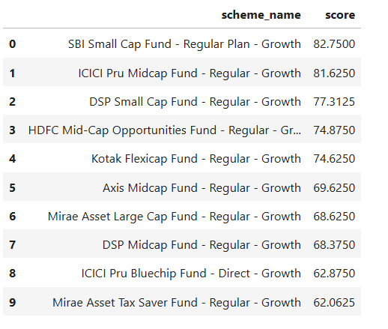
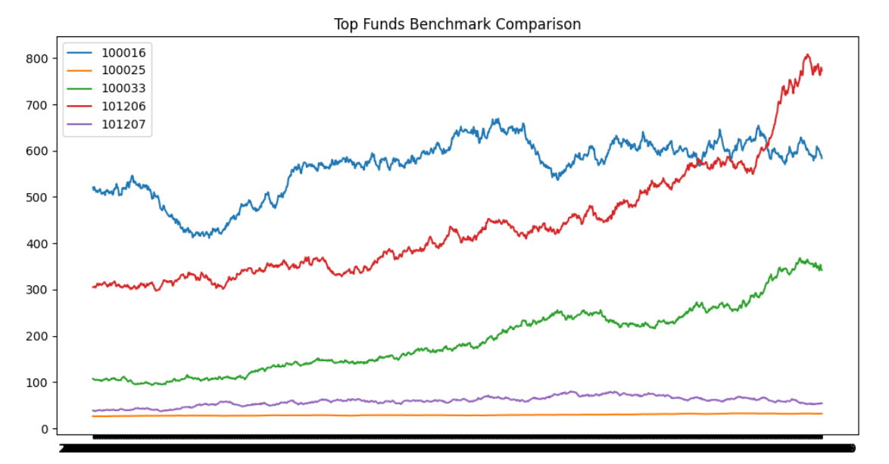

ADVANCED ANALYTICS
Value at Risk (VaR)
Historical VaR at 95% confidence level was computed for all schemes.
VaR estimates the maximum expected loss during adverse market conditions.
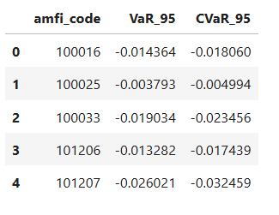
Conditional Value at Risk (CVaR)
CVaR estimates average losses beyond the VaR threshold.
Rolling Sharpe Ratio
A 90-day rolling Sharpe Ratio was calculated to evaluate changing risk-adjusted performance.
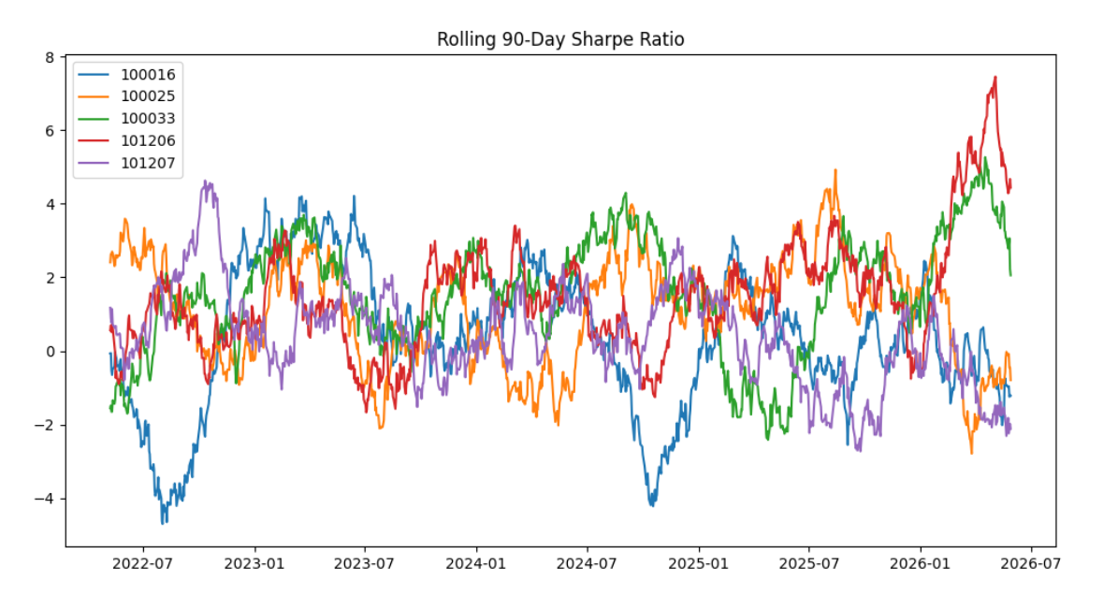
Sector Concentration Analysis
Herfindahl-Hirschman Index (HHI) was used to measure portfolio concentration.
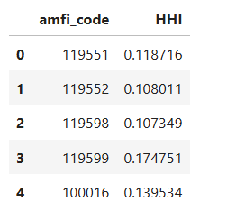
Fund Recommendation System
A recommendation engine was built using:
- Risk Grade
- Sharpe Ratio
- Historical Performance

INVESTOR ANALYTICS
Cohort Analysis
Investors were grouped based on their first investment year.
Metrics analyzed:
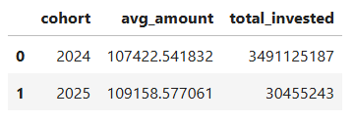
- Average SIP Amount
- Total Invested Amount
- Preferred Mutual Funds
SIP Continuity Analysis
Investors with six or more SIP transactions were analyzed.
Metrics:
- Average Gap Between SIPs
- Continuity Rate
- At-Risk Investors
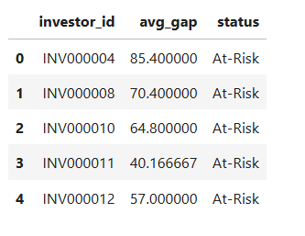
Transaction Analysis
Transactions were segmented by:
- State
- Age Group
- City Tier
- Transaction Type
Key finding: SIP remains the dominant investment mode among retail investors.

POWER BI DASHBOARD
Dashboard Overview
A four-page interactive Power BI dashboard was developed.
Page 1 – Industry Overview
- Total AUM
- SIP Inflows
- Folio Count
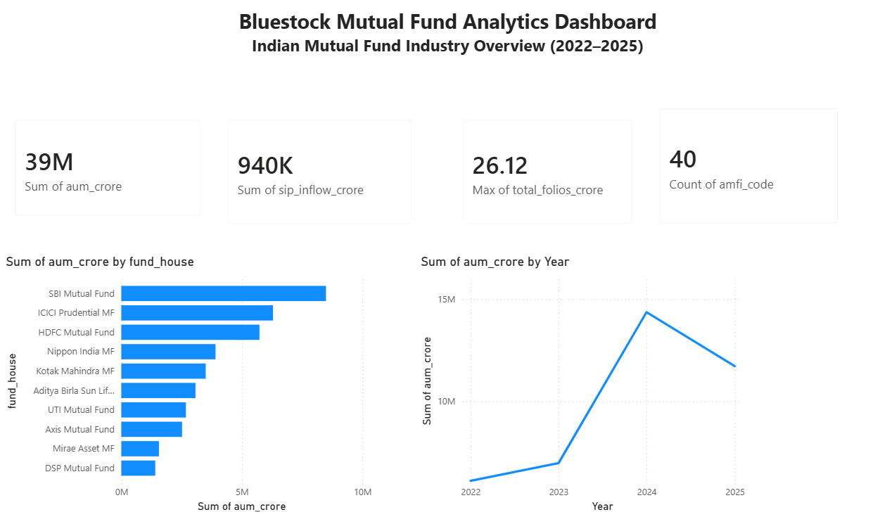
- Industry Trends

Page 2 – Fund Performance
- Risk vs Return Analysis
- NAV Trends
- Fund Scorecard
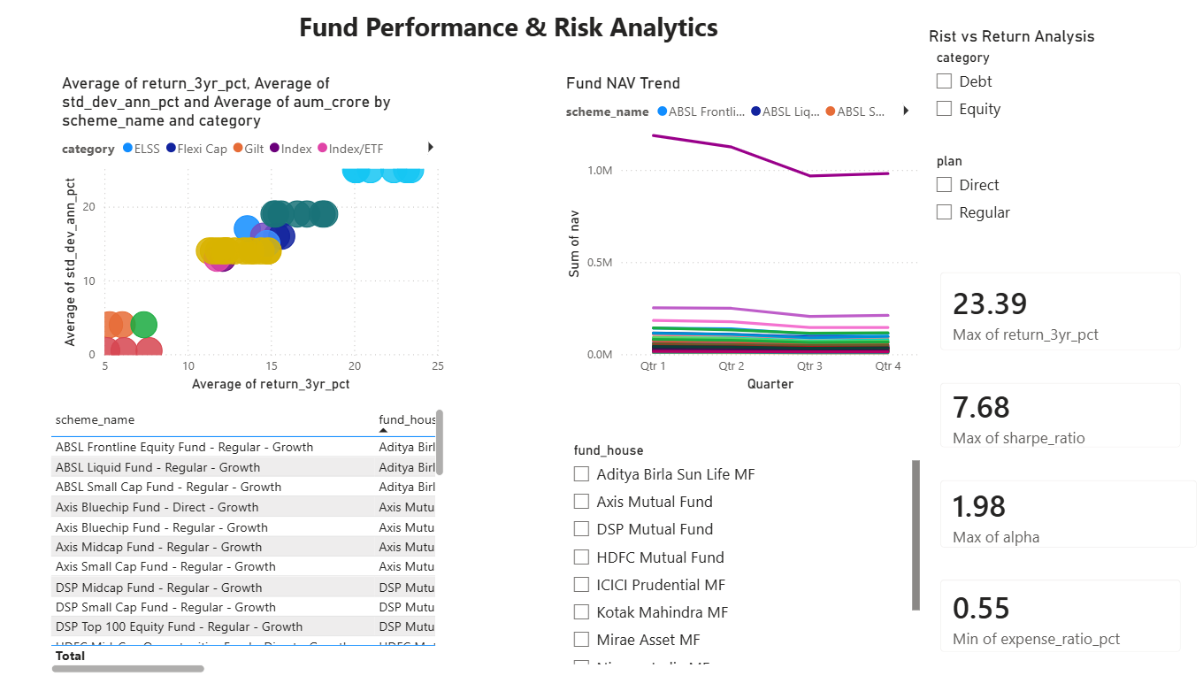

Page 3 – Investor Analytics
- State Analysis
- Transaction Analysis
- Age Group Analysis
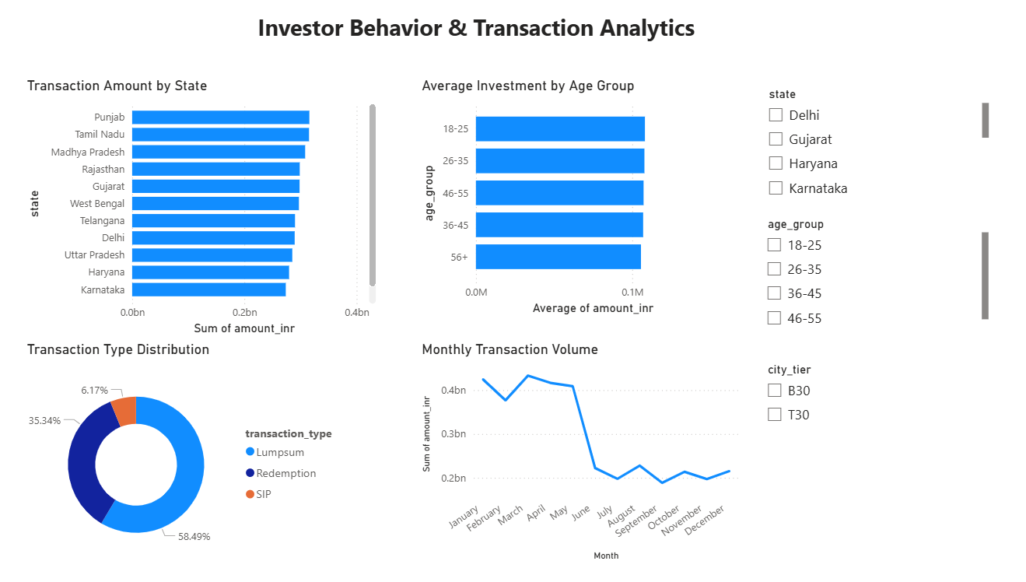
Page 4 – SIP & Market Trends
- SIP Growth
- Category Inflows
- Market Trends
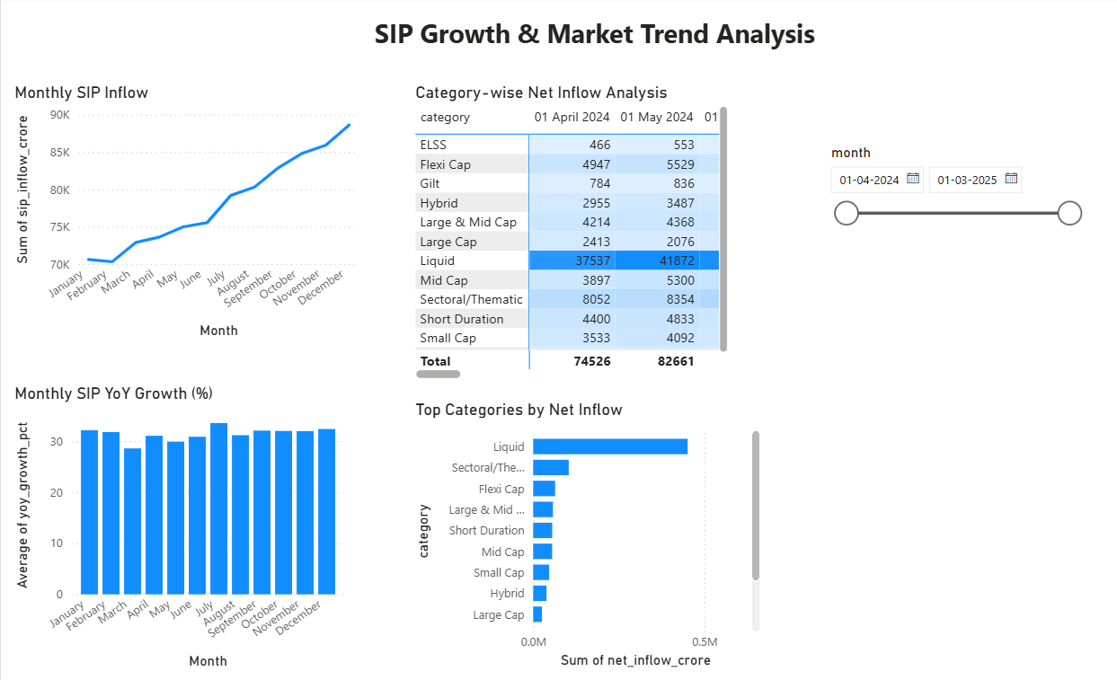

KEY INSIGHTS
Major Findings
- Mutual fund industry AUM has shown strong growth between 2022 and 2025.
- SIP inflows continue to increase steadily, indicating rising retail participation.
- Small Cap funds delivered the highest returns but also carried higher risk.
- Risk-adjusted metrics identified several funds consistently outperforming benchmarks.
- Financial Services and Technology sectors dominate portfolio allocations.
- Investor activity is concentrated in major states and metropolitan areas.
- Equity-oriented funds attracted the highest net inflows.
- Portfolio concentration varies significantly across schemes.
- Rolling Sharpe Ratios revealed changing risk-adjusted performance over time.
- The recommendation system successfully identifies suitable funds based on investor risk preferences.

CONCLUSION & FUTURE WORK
Conclusion
The Mutual Fund Analytics Platform successfully integrates data engineering, financial analytics, and business intelligence into a single solution.
The project demonstrates how modern analytics techniques can support investment decision making through automated data processing, risk assessment, and interactive visualization.
The developed platform enables investors, analysts, and financial institutions to gain deeper insights into mutual fund performance and investor behavior.
Future Enhancements
- Real-time NAV streaming.
- Streamlit web application.
- Monte Carlo portfolio simulation.
- Markowitz portfolio optimization.
- Automated email reporting.
- Machine learning-based return forecasting.
- Cloud deployment and API integration.
References
- AMFI India
- MFAPI
- NSE India
- RBI Publications
- Mutual Fund Industry Reports

Thank You

