TITLE OF PROJECT REPORT
PROJECT REPORT
Submitted by
[STUDENT NAME]
[REGISTER NO]
In partial fulfilment for the award of the degree of
BACHELOR OF ENGINEERING
in
ELECTRONICS AND COMMUNICATION ENGINEERING
BANNARI AMMAN INSTITUTE OF TECHNOLOGY
(An Autonomous Institution Affiliated to Anna University, Chennai)
SATHYAMANGALAM-638401
ANNA UNIVERSITY: CHENNAI 600 025
OCTOBER 2026

BONAFIDE CERTIFICATE
Certified that this project report “Institution ERP — Student Information System and Institution Management Platform” is the bonafide work of “[STUDENT NAME] ([REGISTER NO])” who carried out the project work under my supervision.

<<Signature of the Head of Department>> <<Signature of the Supervisor>>
SIGNATURE SIGNATURE
[HOD NAME] [GUIDE NAME]
HEAD OF THE DEPARTMENT SUPERVISOR
Department of Electronics and Communication Engineering Department of Electronics and Communication Engineering
Bannari Amman Institute of Technology Bannari Amman Institute of Technology
<<Full address of the Department & College >> <<Full address of the Department & College >>
Submitted for Project Viva Voce examination held on ………… [VIVA DATE]

Internal Examiner I Internal Examiner II
[EXAMINER 1] [EXAMINER 2]

DECLARATION
We affirm that the project work titled “Institution ERP — Student Information System and Institution Management Platform” being submitted in partial fulfilment for the award of the degree of Bachelor of Engineering in Electronics and Communication Engineering is the record of original work done by us under the guidance of [GUIDE NAME], [GUIDE DESIGNATION], Department of [DEPT NAME]. It has not formed a part of any other project work(s) submitted for the award of any degree or diploma, either in this or any other University.

[STUDENT NAME]
([REGISTER NO])

(Signature of the Guide)
[GUIDE NAME]
[GUIDE DESIGNATION], [DEPT NAME]
Bannari Amman Institute of Technology
I certify that the declaration made above by the candidate is true.

ACKNOWLEDGEMENT
We would like to express our heartfelt thanks to our esteemed Chairman [CHAIRMAN NAME] and the respected Principal [PRINCIPAL NAME], for providing excellent facilities and support during the course of study in this institute.
We are grateful to [HOD NAME], Head of the Department, Department of Electronics and Communication Engineering, for his valuable suggestions that helped us carry out the project work successfully.
We wish to express our sincere thanks to our Faculty guide [GUIDE NAME], [GUIDE DESIGNATION], Department of Electronics and Communication Engineering, for his constructive ideas, inspiration, encouragement, excellent guidance, and technical support that made it possible to complete this project work.
We would like to thank our friends, faculty, and non-teaching staff who contributed directly and indirectly to the success of this project.

[STUDENT NAME]
([REGISTER NO])

ABSTRACT
This project presents Institution ERP, a Student Information System and institution management platform built on Frappe v16 for Bannari Amman Institute of Technology. Institutional administration today depends on fragmented, manual processes that create data silos and increase the compliance burden. The aim of this work was to design and implement a unified system covering the full student lifecycle — from admissions inquiry through graduation — across academics, attendance, examinations, fees, library, hostel, transport, and institutional communication. The methodology adopts a hybrid architecture: a Vue 3 portal for students and guardians, role-specific Vue cockpits for staff, and a rebranded Frappe Desk for full CRUD operations. Row-level security is enforced through User Permissions and permission_query_conditions, with results publication gating controlling mark visibility. The implemented system comprises 48 DocTypes across 10 modules, 8 custom roles, 11 whitelisted API methods, and 16 row-level permission conditions, deployed at zero infrastructure cost on an open-source stack. Results demonstrate secure role-scoped access, automated student and guardian creation on admission approval, automatic grade calculation, fee recomputation, and library fine handling.
Keywords: Institution ERP, Student Information System, Frappe v16, Role-Based Access Control, permission_query_conditions, Vue 3.

TABLE OF CONTENTS
Update field to populate.

LIST OF FIGURES
Update field to populate.

LIST OF TABLES
Update field to populate.

ABBREVIATIONS AND NOMENCLATURE
Abbreviation | Expansion / Meaning
ERP | Enterprise Resource Planning
SIS | Student Information System
DocType | Document Type (Frappe data model entity)
API | Application Programming Interface
UI | User Interface
CRUD | Create, Read, Update, Delete
RBAC | Role-Based Access Control
SPA | Single-Page Application
LMS | Learning Management System
JWT | JSON Web Token

CHAPTER I

INTRODUCTION
Higher education administration in India depends heavily on manual, paper-based, and fragmented digital systems. Admissions, academics, attendance, examinations, fees, library, hostel, transport, and institutional communication are often maintained through separate spreadsheets, registers, and standalone applications that do not share data. This fragmentation creates data silos, duplicates effort, slows decision-making, and increases the compliance burden on institutions. There is a clear need for an integrated Enterprise Resource Planning (ERP) system that unifies the entire student lifecycle — from first enquiry through graduation — within a single, secure, role-scoped platform.
Bannari Amman Institute of Technology (BIT), the demo brand for this project, administers multiple programs, courses, student groups, instructors, and thousands of academic and financial records each year. Managing these records across disconnected systems leads to inconsistent student data, difficulty in producing consolidated reports, and limited visibility for students and guardians into attendance, results, and fees. Existing institutional software is often either too generic to reflect Indian academic workflows (entrance tests, fee structures, results publication gating) or too expensive and rigid to deploy at scale. A purpose-built Student Information System (SIS) on an open-source, extensible platform addresses these gaps.
In the Indian higher-education context, the problem is compounded by regulatory and accreditation requirements. Institutions must submit data to statutory bodies, maintain attendance percentages for university compliance, track fee collections for financial audits, and produce examination result sheets for degree certification. Manual processes make these reporting obligations error-prone and time-consuming. Staff spend disproportionate effort on data entry and reconciliation rather than on student-facing academic work. A unified ERP reduces this administrative overhead, improves data accuracy, and gives leadership real-time visibility into institutional operations.
Furthermore, students and guardians currently have no self-service access to their records. A student must visit the office to check attendance, results, or fee dues. A guardian with multiple children must maintain separate logins or rely on the student to relay information. This lack of transparency erodes trust and increases administrative queries. A student and guardian portal with row-level scoping addresses this directly, giving each stakeholder secure, immediate access to their own data.

1.1 BACKGROUND
Educational institutions operate as complex organizations with interdependent functions. The admissions function manages inquiries, applications, entrance tests, and approvals. The academics function manages programs, courses, schedules, instructors, and student groups. The attendance function records student and staff presence. The examination function manages grading scales, assessment plans, marks entry, and result publication. The fees function manages fee structures, schedules, invoices, payments, and discounts. The library function manages books, memberships, issues, returns, and fines. The hostel function manages rooms and allocations. The transport function manages vehicles, routes, and student allocations. The communication function manages notices, feedback, and institutional dashboards.
When these functions run on disconnected systems, a student's record may exist in multiple places with conflicting values. A change of address or program in one system does not propagate to others. Generating a consolidated view of a student — attendance, results, fees, and library status — requires manual reconciliation across registers and spreadsheets. This inefficiency motivates a unified platform where every module shares a single source of truth.

1.2 PROBLEM STATEMENT
Existing institution management solutions — including ERPNext Education, openSIS, Fedena, and Moodle-based setups — are either overly heavy and tightly coupled, lack Indian academic workflows, or provide only a learning-management perspective without comprehensive administration, finance, hostel, and transport modules. ERPNext Education is tightly coupled to the broader ERPNext ecosystem, making customisation for Indian academic workflows complex. openSIS is open source but has a dated user interface and limited extensibility. Fedena is a commercial Ruby on Rails school ERP whose licensing restricts deployment for budget-constrained institutions. Moodle-based setups provide a strong learning-management foundation but cover administration, fees, hostel, and transport only weakly when extended beyond course delivery.
None of these offers a hybrid staff interface that combines focused role-specific cockpits with full CRUD access through a rebranded Frappe Desk, together with a student and guardian portal that enforces row-level data scoping at the database level. Table 1.1 compares these existing solutions against the requirements of a modern institution ERP.
Table 1.1. Comparison of Existing ERP Solutions
Solution | Core Strength | Key Limitation | Relevance to This Project
ERPNext Education | Comprehensive ERP with education domain | Tight coupling; complex to customise | Reference for modular ERP structure
openSIS | Open-source student information system | Dated UI; limited extensibility | Reference for SIS data model
Fedena | Ruby on Rails; commercial school ERP | Commercial licensing; limited customisation | Reference for role-based access
Moodle-based SIS | Strong LMS foundation | Weak administration, fees, hostel, transport coverage | Reference for student portal UI
Institution ERP (Proposed) | Frappe v16 metadata-driven; hybrid UI; row-level security | New implementation; future scope documented | This project

1.3 OBJECTIVES
The objectives of this project are:
- To design and implement a unified Student Information System covering the complete student lifecycle from admission inquiry to graduation.
- To implement role-based access control with row-level security so that students, guardians, and staff see only the data they are authorised to view.
- To deliver a hybrid staff interface combining role-specific Vue 3 cockpits for high-frequency actions with a rebranded Frappe Desk for full CRUD operations.
- To provide Student and Guardian portals with data scoping through permission_query_conditions and results publication gating for examination marks.
- To deploy the system at zero infrastructure cost using an entirely open-source stack (Frappe v16, Python, MariaDB, Redis, Vue 3, Nginx).

1.4 SCOPE
The system scope comprises 10 modules — Admissions, Student Information System (SIS), Academics, Attendance, Examination, Fees, Library, Hostel, Transport, and Communication — implemented through 48 DocTypes, 8 custom roles (6 staff roles and 2 portal roles), 6 script reports, 11 whitelisted API methods, and 16 permission_query_conditions covering 19 DocTypes. The demo brand is Bannari Amman Institute of Technology, deployed on site institution.localhost.

1.5 MOTIVATION
The motivation for this project is twofold. Institutionally, BIT requires a branded, integrated system to replace fragmented record-keeping across departments. Academically, the work satisfies the capstone project requirement for the Bachelor of Engineering degree, providing practical experience in full-stack development, database design, access control, and software testing on a live Frappe v16 site. The project demonstrates that a complete institution management system can be built and deployed at zero infrastructure cost using an open-source frontend and backend stack.

1.6 REPORT ORGANISATION
The remainder of this report is organised as follows. Chapter 2 presents the literature survey and identifies the research gap. Chapter 3 defines the system requirements, including functional and non-functional requirements, hardware and software requirements, and the tools and technologies used. Chapter 4 covers system analysis and design, including architecture, module design, role-based access model, database design, data flow, use case, sequence, and activity diagrams. Chapter 5 details the implementation, module by module, together with the permission model, workflow engine, automation, the student/guardian portal, staff cockpits, and the staged build method. Chapter 6 presents the testing strategy, test cases, security testing, and results. Chapter 7 discusses the results, screenshots, and limitations observed. Chapter 8 states the conclusion and future enhancements. References and appendices follow the main chapters.

1.7 SIGNIFICANCE OF THE STUDY
This study is significant because it addresses a widespread problem in Indian higher education: the absence of an affordable, integrated, and role-secured student information system. Most institutions rely on manual registers or expensive commercial ERPs that are difficult to customise. Institution ERP demonstrates that a complete system can be built on entirely open-source software at zero infrastructure cost, making it accessible to institutions of all sizes.
The study contributes a working model of row-level security implemented at the database level through permission_query_conditions, a hybrid staff interface combining role-specific cockpits with a rebranded Frappe Desk, and a results publication gating mechanism for examination marks. These contributions can be reused by other institutions building similar systems on Frappe v16.
Practically, the system reduces administrative overhead by eliminating duplicate data entry across departments, improves data accuracy through a single source of truth, and gives students and guardians self-service access to attendance, results, fees, and library records. For the institution, it provides real-time visibility into academic and financial operations through dashboards and reports.

1.8 LIMITATIONS AND DELIMITATIONS
The study is delimited to the Bannari Amman Institute of Technology as the demo brand and to the Frappe v16 platform. It does not cover integration with external systems such as payment gateways, SMS/email gateways, or biometric attendance devices, as these are outside the scope of the capstone project. The system is evaluated using demo data rather than live institutional data, so performance under large-scale concurrent load has not been tested. These limitations are documented in Chapter 7 and are proposed for future enhancement.

CHAPTER II

LITERATURE SURVEY
This chapter surveys existing institution management and student information systems relevant to the proposed problem statement. Each source is cited using the author-year format. The chapter concludes with constructive criticism, gap identification, and a summary of the proposed solution.

2.2 EXISTING WORKS
ERPNext Education provides a comprehensive ERP with an education domain module covering students, courses, assessments, and fees. It is tightly coupled to the broader ERPNext ecosystem, which makes customisation for Indian academic workflows complex and time-consuming [2]. openSIS is an open-source student information system that maintains student records, grades, and attendance, but its user interface is dated and extensibility is limited [3]. Fedena, built on Ruby on Rails, is a commercial school ERP with role-based access, but commercial licensing restricts deployment for budget-constrained institutions [4]. Moodle-based setups provide a strong learning-management foundation but cover administration, fees, hostel, and transport only weakly when extended beyond course delivery [5].
Frappe Framework, the platform selected for this project, provides a metadata-driven DocType model, a built-in permission system, and a web desk that accelerates development of data-intensive applications [1]. Role-based access control (RBAC) is an established model for educational systems, where permissions are assigned to roles rather than individual users [6]. Hybrid UI patterns, combining focused dashboards with full-featured administrative interfaces, improve usability in enterprise applications [7].
Table 2.1. Literature Comparison Matrix
System | Licensing | Architecture | Student Portal | Fee/Finance | Hostel/Transport | Extensibility | Indian Academic Workflow
ERPNext Education | Open source | Frappe/ERPNext | Limited | Partial | Partial | High | Partial
openSIS | Open source | PHP/MySQL | Basic | No | No | Medium | No
Fedena | Commercial | Ruby on Rails | Yes | Yes | Partial | Medium | No
Moodle-based SIS | Open source | PHP/MySQL | Yes | No | No | High | No
Institution ERP (Proposed) | MIT (open source) | Frappe v16 + Vue 3 | Yes (scoped) | Yes | Yes | High | Yes

2.3 GAP IDENTIFICATION
No existing system combines all of the following: (a) Frappe's metadata-driven agility and DocType data model; (b) Indian academic workflows such as entrance tests, fee structures, schedules, and results publication gating; (c) a hybrid staff interface of role-specific Vue cockpits plus a rebranded Frappe Desk; (d) student and guardian portals with row-level data scoping enforced at the database level through permission_query_conditions; and (e) zero-cost deployment on an open-source stack. This research gap motivates the proposed Institution ERP.
The gap is significant because each missing capability addresses a real administrative pain point. Without metadata-driven agility, adding a new academic entity (for example, a new assessment type or a new fee component) requires schema changes and developer intervention. Without Indian academic workflows, institutions must maintain parallel manual processes for entrance tests and result publication. Without row-level data scoping at the database level, a determined user could bypass UI restrictions and access another student's records through direct API calls. Without zero-cost deployment, many institutions cannot afford the solution at all. Institution ERP closes every one of these gaps.

2.4 PROPOSED SOLUTION SUMMARY
Institution ERP addresses the identified gaps through a staged build method, a hybrid UI architecture, dual permission mechanisms (User Permissions plus permission_query_conditions), results publication gating, and automated student/guardian creation on admission approval. The design and implementation of these features are detailed in Chapters 4 and 5.

CHAPTER III

SYSTEM REQUIREMENTS
This chapter defines the functional and non-functional requirements of Institution ERP, together with hardware and software requirements and the tools and technologies used. All version numbers were verified against the live project documentation and site.

3.2 FUNCTIONAL REQUIREMENTS
The following functional requirements (FR) were derived from the literature survey and the problem statement. Each requirement is mapped to a priority and the module responsible for its implementation.
Table 3.1. Functional Requirements List
FR-ID | Requirement | Priority | Module
FR-01 | Admission inquiry → applicant → entrance test → approval workflow | High | Admissions
FR-02 | Auto-create Student and Guardian records on applicant approval | High | Admissions/SIS
FR-03 | Student and Guardian master records with unique naming | High | SIS
FR-04 | Program, course, academic year/term, room, instructor, student group management | High | Academics
FR-05 | Course scheduling with double-booking prevention | High | Academics
FR-06 | Student and staff attendance marking with duplicate prevention | High | Attendance
FR-07 | Grading scales, assessment plans, bulk marks entry, auto grade calculation | High | Examination
FR-08 | Results publication gating (results_published flag) | High | Examination
FR-09 | Fee structures, schedules, invoices, payments, discounts, auto-recompute | High | Fees
FR-10 | Fee Dues Report and outstanding tracking | Medium | Fees
FR-11 | Library catalog, membership, issue/return with overdue fines | Medium | Library
FR-12 | Hostel room allocation and occupancy tracking | Medium | Hostel
FR-13 | Transport routes, vehicles, and student allocation | Medium | Transport
FR-14 | Audience-targeted notices, communication log, feedback | Medium | Communication
FR-15 | Student and Guardian portals with row-level data scoping | High | Portal
FR-16 | Role-based access with User Permissions and permission_query_conditions | High | Security
FR-17 | Staff cockpits with quick actions and ‘Open Full Desk’ | High | UI
FR-18 | Rebranded Frappe Desk (Inter font, BIT blue) | Medium | UI
FR-19 | Automation: grade calculation, fee recompute, user creation, status backfill | Medium | Automation
FR-20 | Institution Overview dashboard with number cards and charts | Medium | Communication
FR-21 | Responsive design for desktop, tablet, and mobile | Medium | UI
FR-22 | Staged build with end-to-end tests per stage | High | Process
FR-23 | Demo data generation and reset | Medium | Process
FR-24 | Cross-access blocked by permission_query_conditions | High | Security
FR-25 | Guardian child switcher for multiple linked students | Medium | Portal

3.3 NON-FUNCTIONAL REQUIREMENTS
Non-functional requirements define the qualities the system must exhibit rather than specific behaviours. These were validated during testing (Chapter 6).
Table 3.2. Non-Functional Requirements
NFR-ID | Requirement | Target
NFR-01 | Performance: API response time under 300 ms under normal load | < 300 ms
NFR-02 | Security: JWT authentication, bcrypt password hashing, RBAC | Industry standard
NFR-03 | Scalability: MariaDB and Redis backend | Supported
NFR-04 | Usability: responsive design, intuitive cockpits | WCAG-aligned
NFR-05 | Maintainability: modular DocTypes, typed controllers, documented hooks | Maintainable
NFR-06 | Deployability: zero-cost open-source stack, bench-based deployment | Zero cost
NFR-07 | Reliability: field-level validation, duplicate prevention, transactions | Zero data corruption
NFR-08 | Availability: site accessible at institution.localhost during demo | High
NFR-09 | Auditability: communication log and feedback tracking | Complete
NFR-10 | Compatibility: modern browsers | All major
NFR-11 | Portability: bench install on Ubuntu 22.04 LTS | Supported
NFR-12 | Observability: dashboard charts and number cards | Available

3.4 HARDWARE REQUIREMENTS
The system runs on commodity cloud infrastructure. No dedicated hardware was procured. The minimum server configuration is 2 vCPU, 4 GB RAM, and 50 GB SSD. The client side requires any modern web browser. The system is designed for zero hardware cost deployment.

3.5 SOFTWARE REQUIREMENTS
All software components are open source. Version numbers were verified against the live project documentation and site.
Table 3.3. Software Stack Versions (verified live)
Layer | Component | Version
Operating System | Ubuntu | 22.04 LTS
Backend Runtime | Python | 3.10+
Framework | Frappe | v16.26.3
Database | MariaDB | 10.6+
Cache/Queue | Redis | 7+
Frontend Runtime | Node.js | 18+
Portal Framework | Vue 3 | 3.4+
Portal Build Tool | Vite | 5+
Web Server | Nginx | Latest stable
Testing | pytest / Playwright | Latest stable
CI | GitHub Actions | —

3.6 TOOLS AND TECHNOLOGIES
Backend tools include Python, the Frappe ORM, MariaDB, Redis, Gunicorn, and Nginx. Frontend tools include Vue 3, Vite, and a hand-written CSS design system (no Tailwind dependency). Testing uses pytest and Playwright; continuous integration uses GitHub Actions. Version control is Git. Figure 3.1 summarises the technology stack.
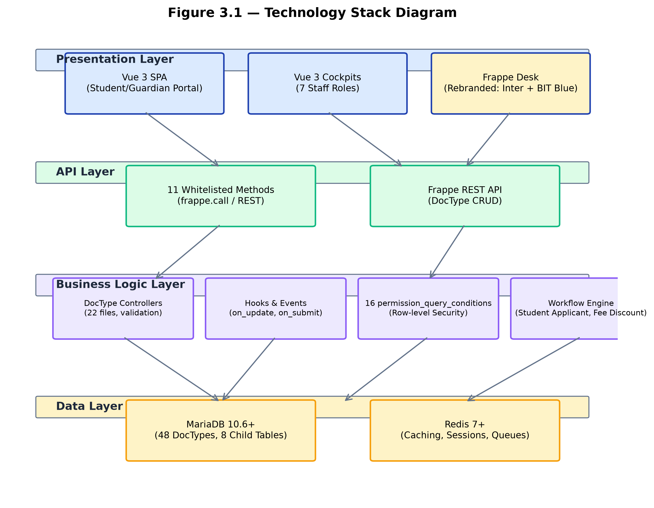
Figure 3.1. Technology Stack Diagram

3.7 REQUIREMENTS RATIONALE
Each functional requirement was derived from a concrete institutional need. FR-01 through FR-05 cover admissions and academics because these are the entry points into the student lifecycle — without a reliable admission and academic foundation, no other module can operate. FR-06 through FR-08 cover attendance and examination because these are the core academic delivery functions that students and guardians most frequently inquire about. FR-09 through FR-10 cover fees because financial sustainability and fee collection tracking are critical for institutional operations. FR-11 through FR-13 cover library, hostel, and transport because these are auxiliary services that complete the student experience. FR-14 through FR-16 cover communication, portal access, and security because these determine how stakeholders interact with and trust the system. FR-17 through FR-21 cover the user interface and experience because a system that is difficult to use will not be adopted. FR-22 through FR-25 cover process, security, and portal features that ensure the system can be built, tested, deployed, and operated reliably.

CHAPTER IV

SYSTEM ANALYSIS AND DESIGN
This chapter presents the system analysis and design: overall architecture, module architecture, role-based access model, database design, data flow diagrams, use case diagram, sequence diagrams, activity diagrams, and the UI design approach. Diagrams were generated from the verified DocType and module structure of the live project.

4.2 OVERALL ARCHITECTURE
The system follows a four-layer architecture. The Presentation Layer comprises the Vue 3 SPA portal (Student/Guardian), Vue 3 staff cockpits, and the rebranded Frappe Desk. The API Layer exposes 11 whitelisted methods and the Frappe REST API for DocType CRUD. The Business Logic Layer implements DocType controllers (22 files with validation), Frappe hooks, and 16 permission_query_conditions. The Data Layer uses MariaDB for persistent storage and Redis for caching and background jobs.
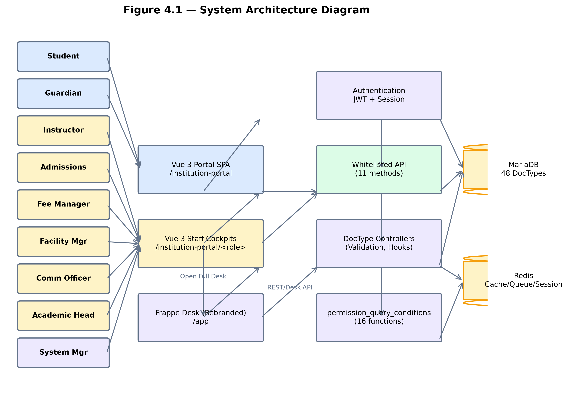
Figure 4.1. System Architecture Diagram
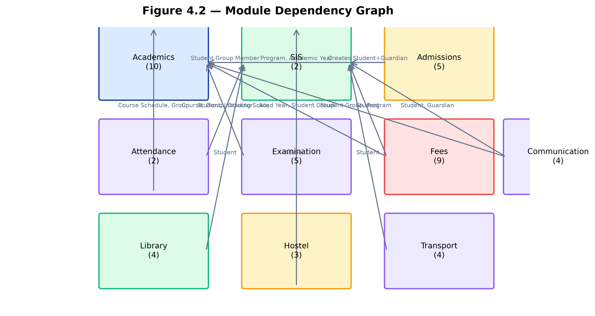
Figure 4.2. Module Dependency Graph

4.3 MODULE ARCHITECTURE
Ten modules organise the DocTypes by domain: Academics (10 DocTypes), SIS (2), Admissions (5), Attendance (2), Examination (5), Fees (9), Library (4), Hostel (3), Transport (4), and Communication (4) — 48 DocTypes in total. Modules depend on SIS (Student, Guardian) and Academics (Program, Course, Student Group, Academic Year). Table 4.1 summarises the DocType count per module.
Table 4.1. DocType Count per Module
Module | DocTypes | Core Purpose
Academics | 10 | Programs, courses, scheduling, instructor assignment, student groups
SIS | 2 | Student and Guardian master records
Admissions | 5 | Inquiry → application → entrance test → approval
Attendance | 2 | Student and staff attendance
Examination | 5 | Grading scales, assessment plans, marks entry, results
Fees | 9 | Fee structures, schedules, invoices, payments, discounts
Library | 4 | Book catalog, membership, issue/return, fines
Hostel | 3 | Hostel/room management, occupancy tracking
Transport | 4 | Vehicle registry, routes, student allocation
Communication | 4 | Notices, dispatch, feedback, dashboard
Total | 48 | All modules combined

4.4 ROLE-BASED ACCESS MODEL
Eight custom roles are defined (6 staff, 2 portal) alongside the built-in System Manager and Administrator. Staff roles have Desk access; portal roles (Student, Guardian) do not. Security is enforced through two layers: User Permissions (linking portal users to their own or linked Student records) and permission_query_conditions (16 SQL WHERE-clause functions covering 19 DocTypes). Table 4.2 summarises the roles; Figure 4.3 presents the role-permission matrix.
Table 4.2. Role Summary
Role | Desk Access | Primary Modules | Scope
System Manager | Yes | All modules | Full access
Academic Head | Yes | Academics, Examination | Read all; write academics/exam
Admissions Officer | Yes | Admissions | Full CRUD on admissions pipeline
Instructor | Yes | Academics, Attendance, Examination | Attendance/assessment for own groups
Fee Manager | Yes | Fees | Full CRUD on all fee DocTypes
Facility Manager | Yes | Library, Hostel, Transport | Full CRUD on facility DocTypes
Communication Officer | Yes | Communication | Notices, log, feedback
Student | No (portal) | All (scoped) | Read-only own records
Guardian | No (portal) | All (scoped) | Read-only linked students
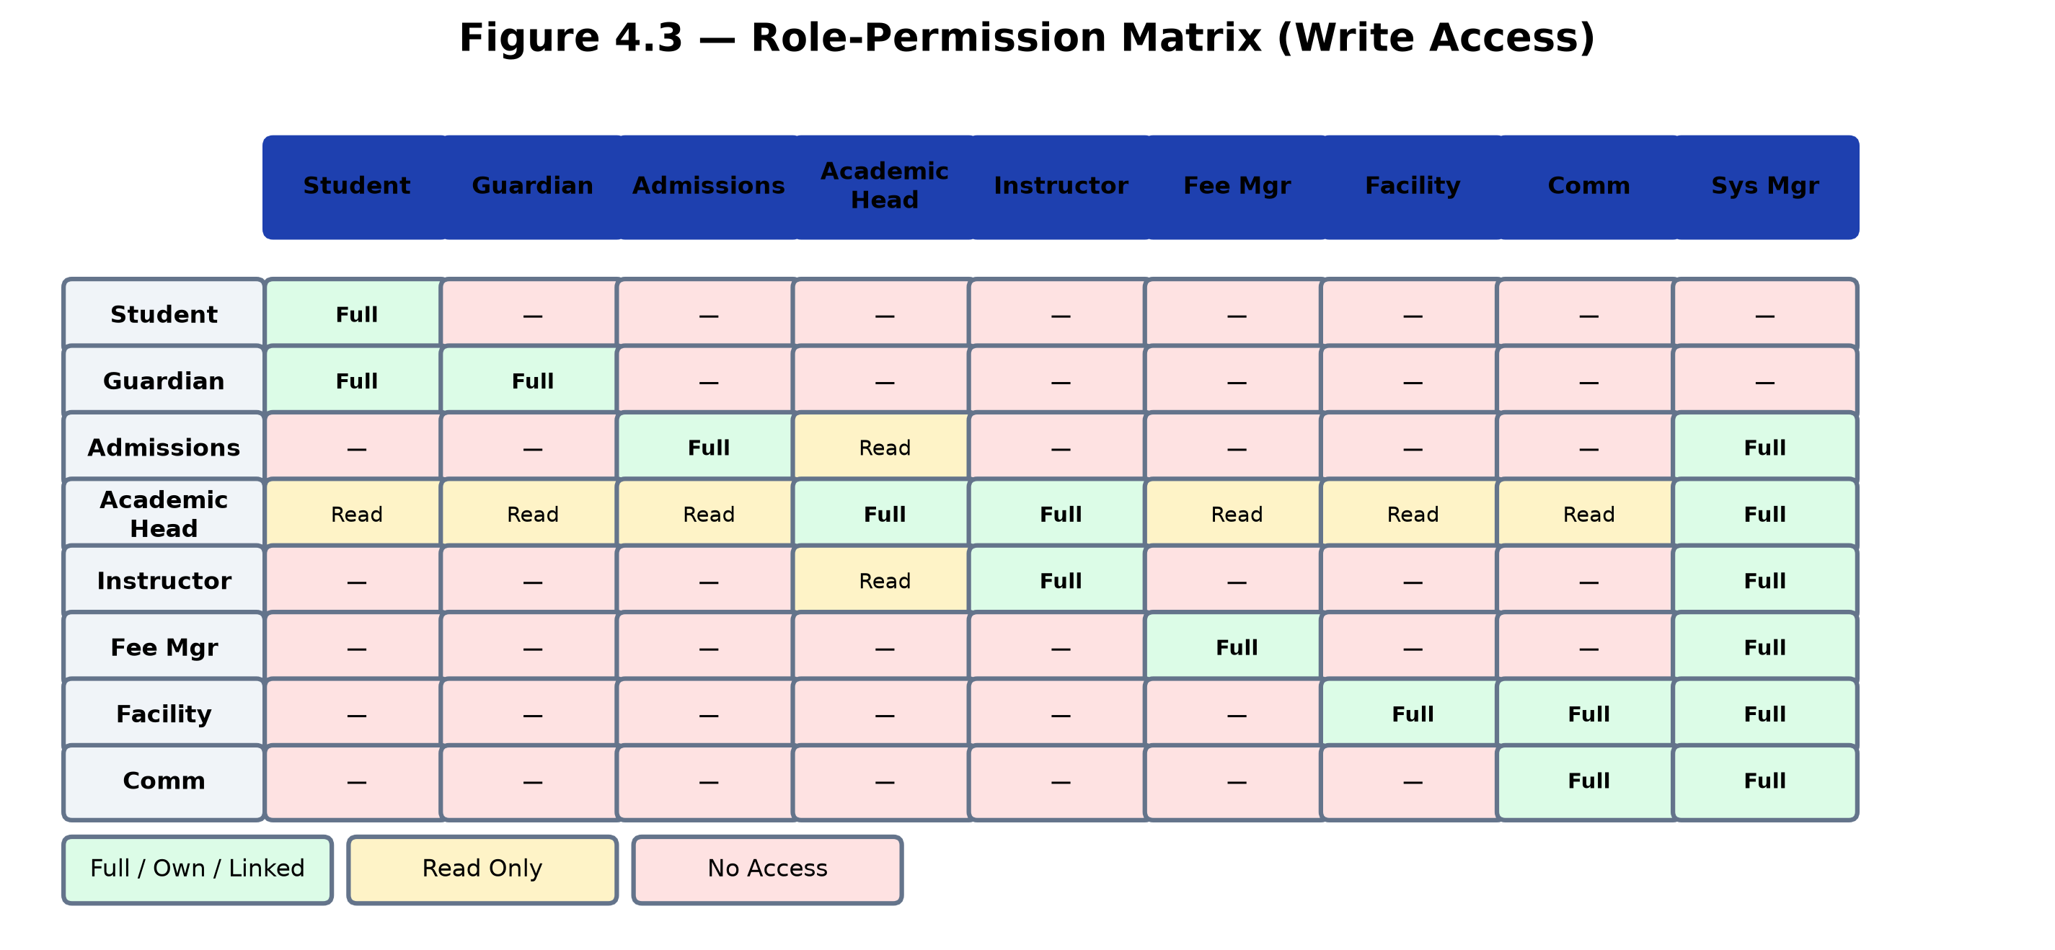
Figure 4.3. Role-Permission Matrix Heatmap

4.5 DATABASE DESIGN
The database design follows the Frappe DocType model. Key entities include Student (naming STU-.YYYY.-.#####), Guardian ({name}-{###}), Program, Course, Academic Year, Academic Term, Room, Instructor, Student Group, Course Schedule, Fee Structure, Fees, Fee Payment, Grading Scale, Assessment Group, Assessment Plan, Assessment Result, Library Item, Library Transaction, Hostel, Hostel Room, Vehicle, Transport Route, Notice, Notice Recipient, Communication Log, and Feedback. Figure 4.4 shows the entity-relationship diagram.
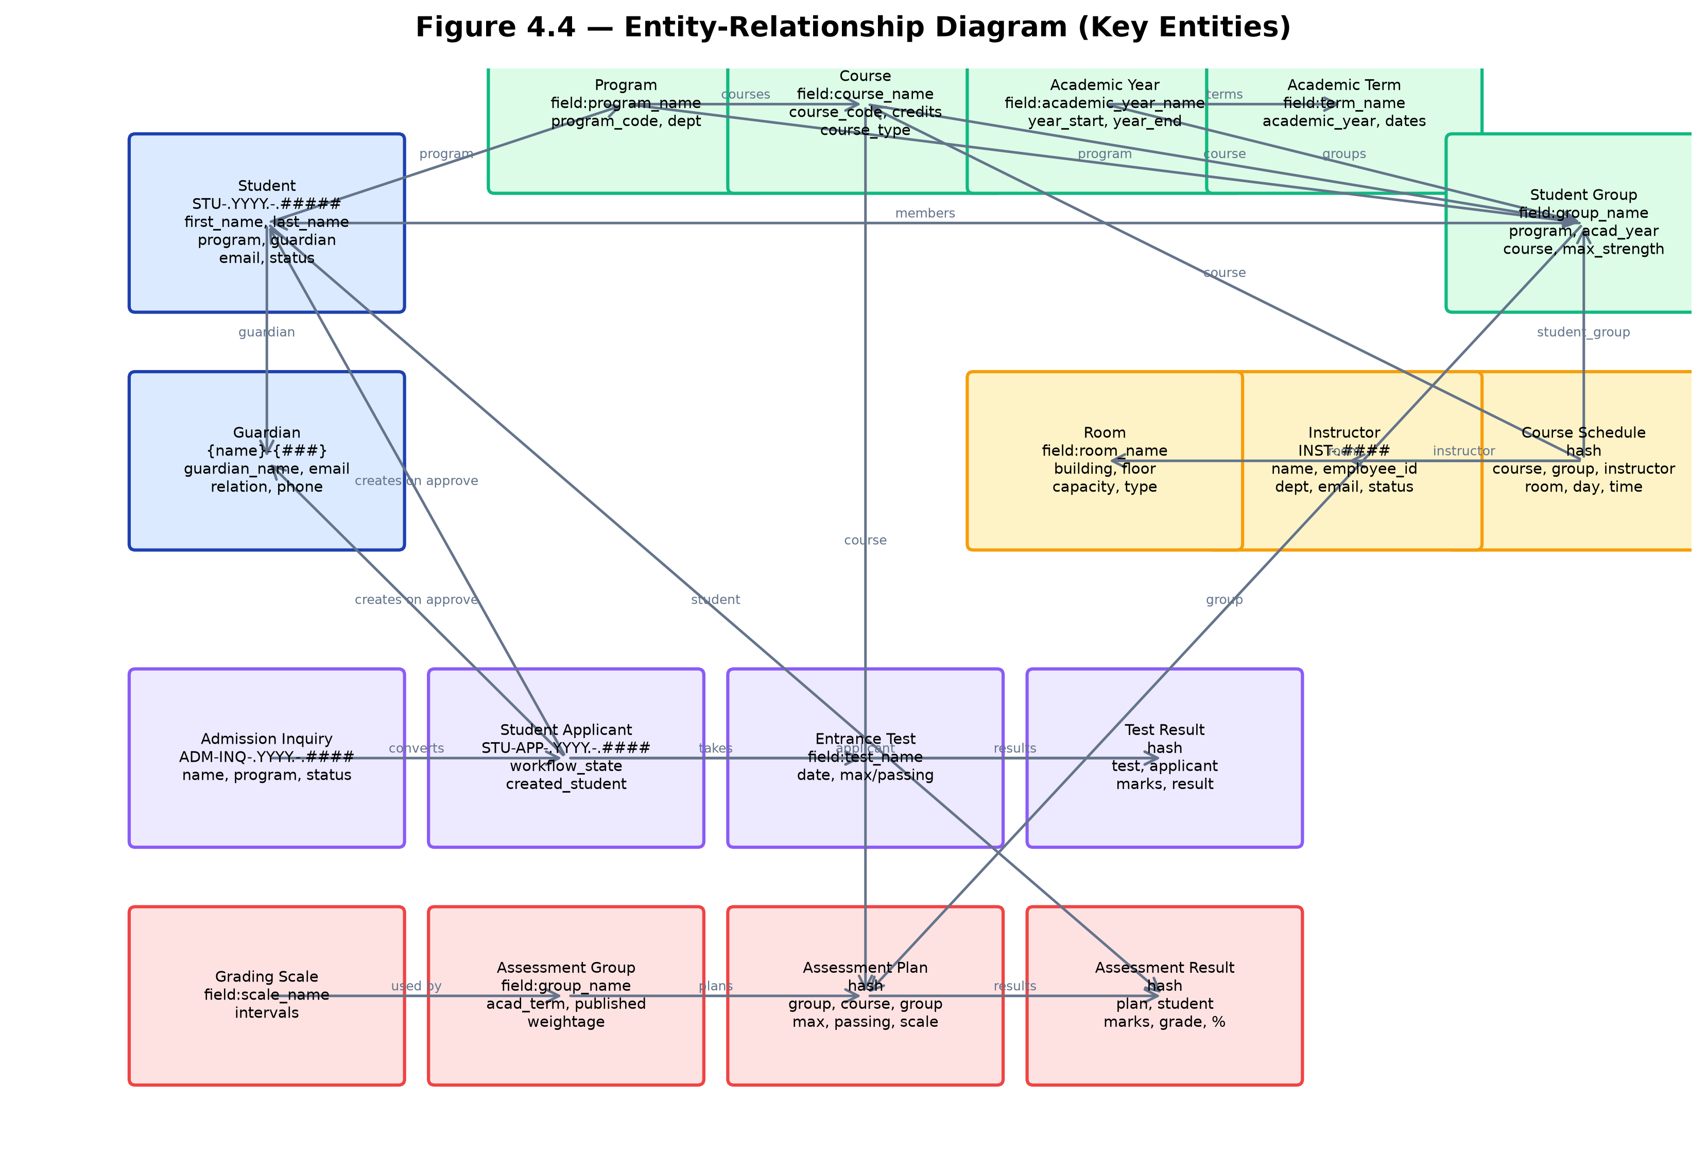
Figure 4.4. Entity-Relationship Diagram

4.6 DATA FLOW DIAGRAMS
Figure 4.5 shows the Level 0 context diagram with external entities interacting with Institution ERP. Figure 4.6 shows the Level 1 diagram with five processes: Admissions, Academics, Fees, Facilities, and Communication, together with the data stores.
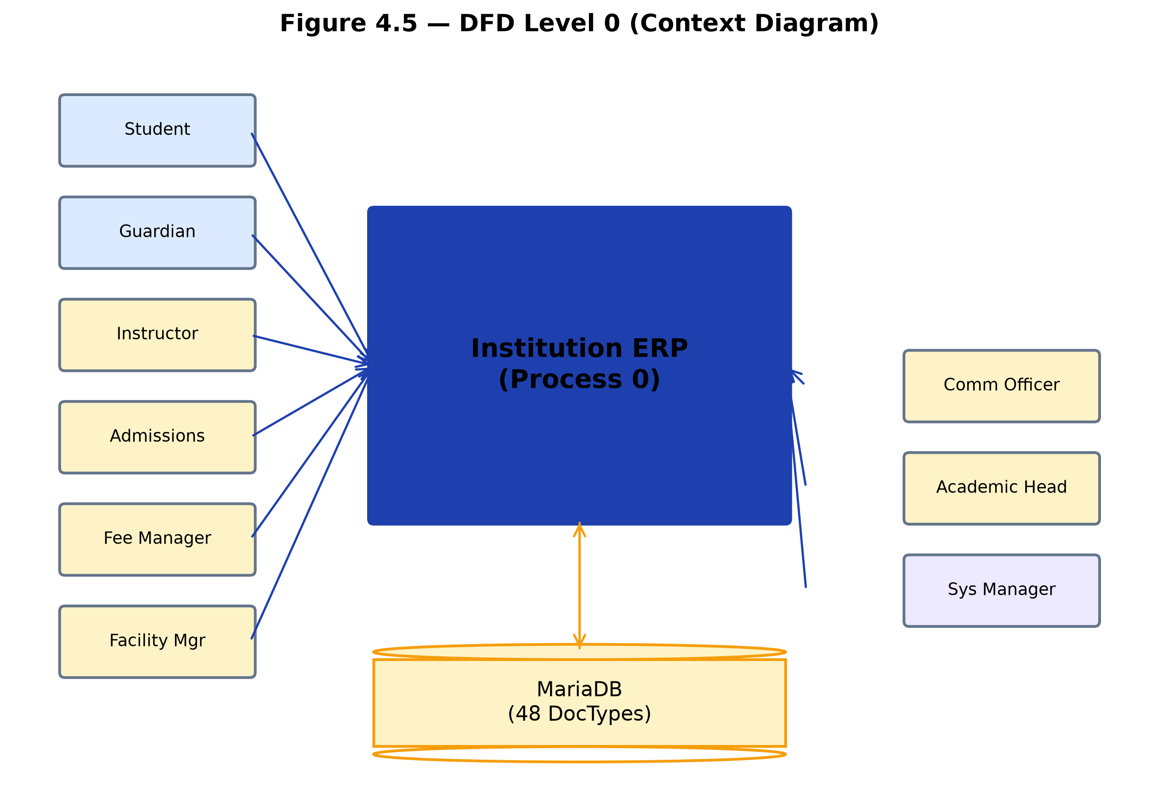
Figure 4.5. Data Flow Diagram Level 0
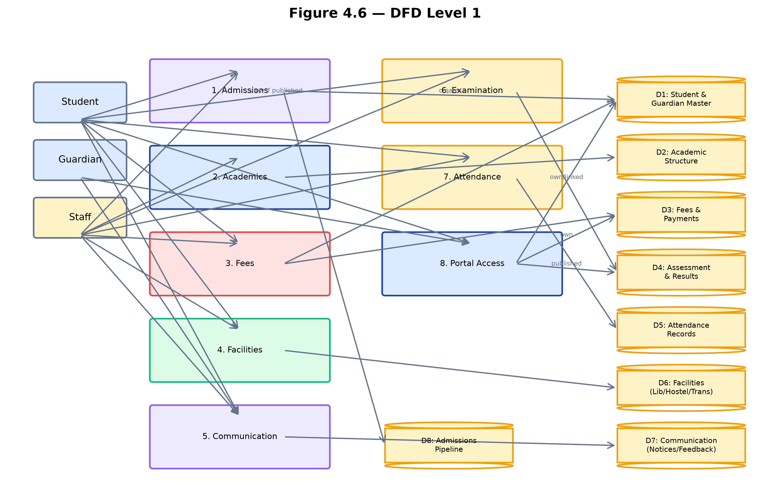
Figure 4.6. Data Flow Diagram Level 1

4.7 USE CASE DIAGRAM
Actors include Student, Guardian, Instructor, Admissions Officer, Fee Manager, Facility Manager, Communication Officer, Academic Head, and System Manager. Use cases span admission processing, academic management, attendance marking, assessment and results, fee management, library issue/return, hostel and transport allocation, notice publication, feedback submission, and dashboard viewing.
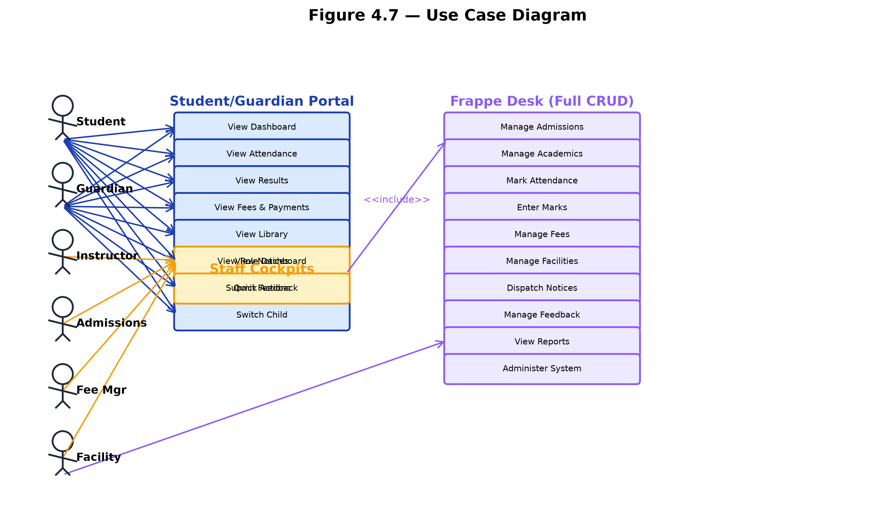
Figure 4.7. Use Case Diagram

4.8 SEQUENCE DIAGRAMS
Four key interactions were modelled: (4.8.1) admission approval triggering auto Student/Guardian creation; (4.8.2) fee payment triggering outstanding recomputation; (4.8.3) assessment result entry triggering auto grade calculation and the results publication gate; and (4.8.4) library return triggering fine calculation and fee creation.
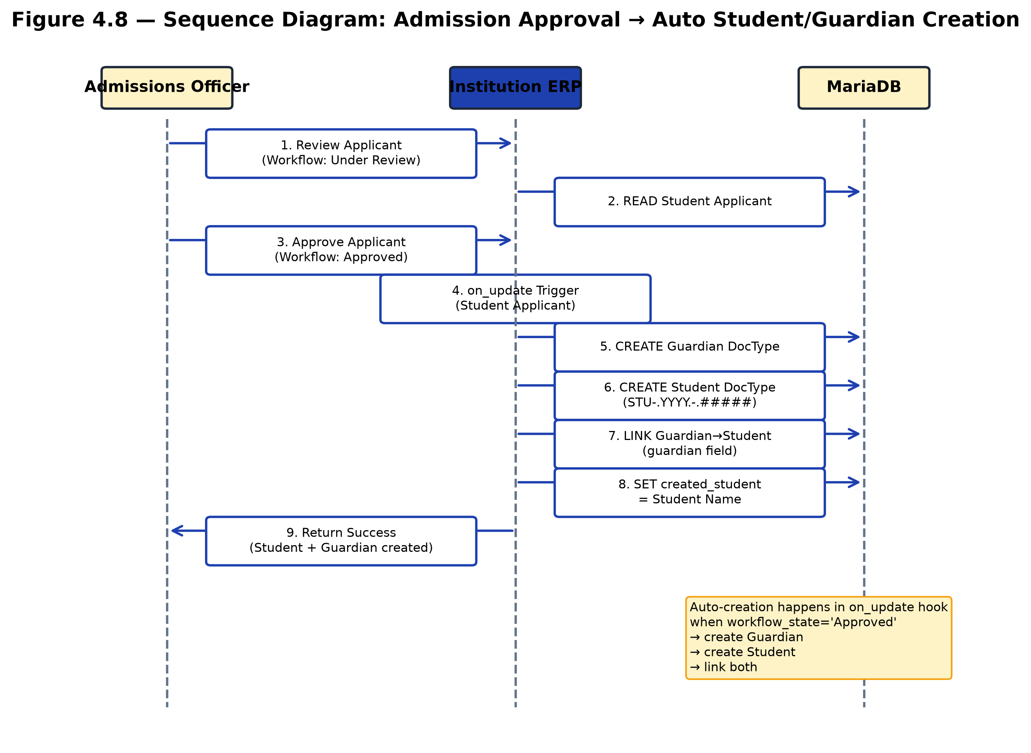
Figure 4.8. Sequence Diagram — Admission Approval
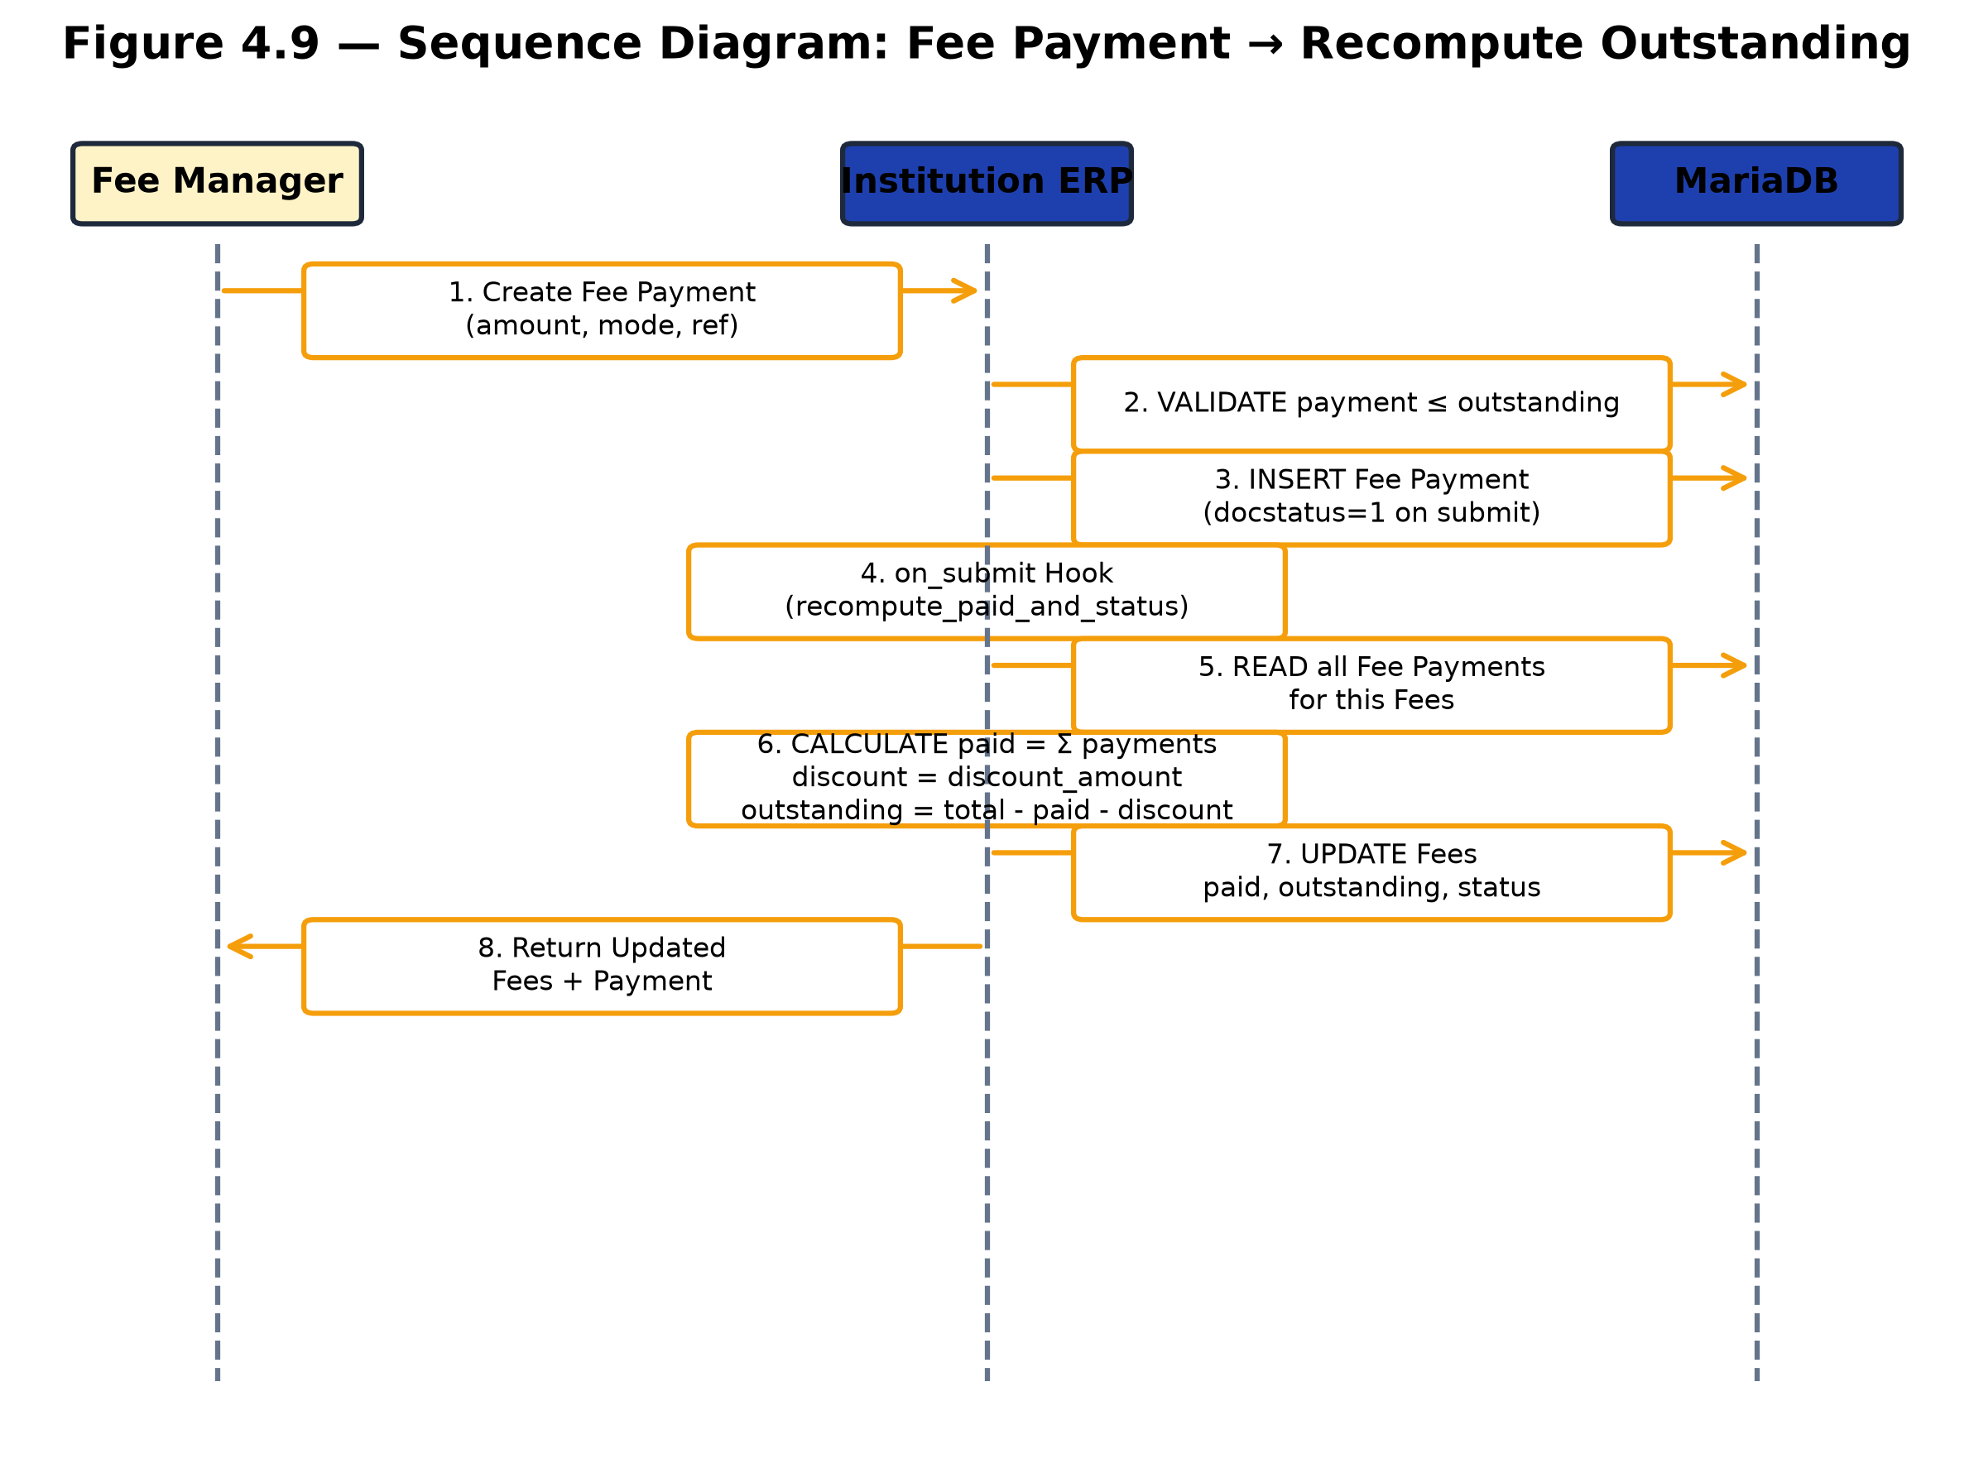
Figure 4.9. Sequence Diagram — Fee Payment
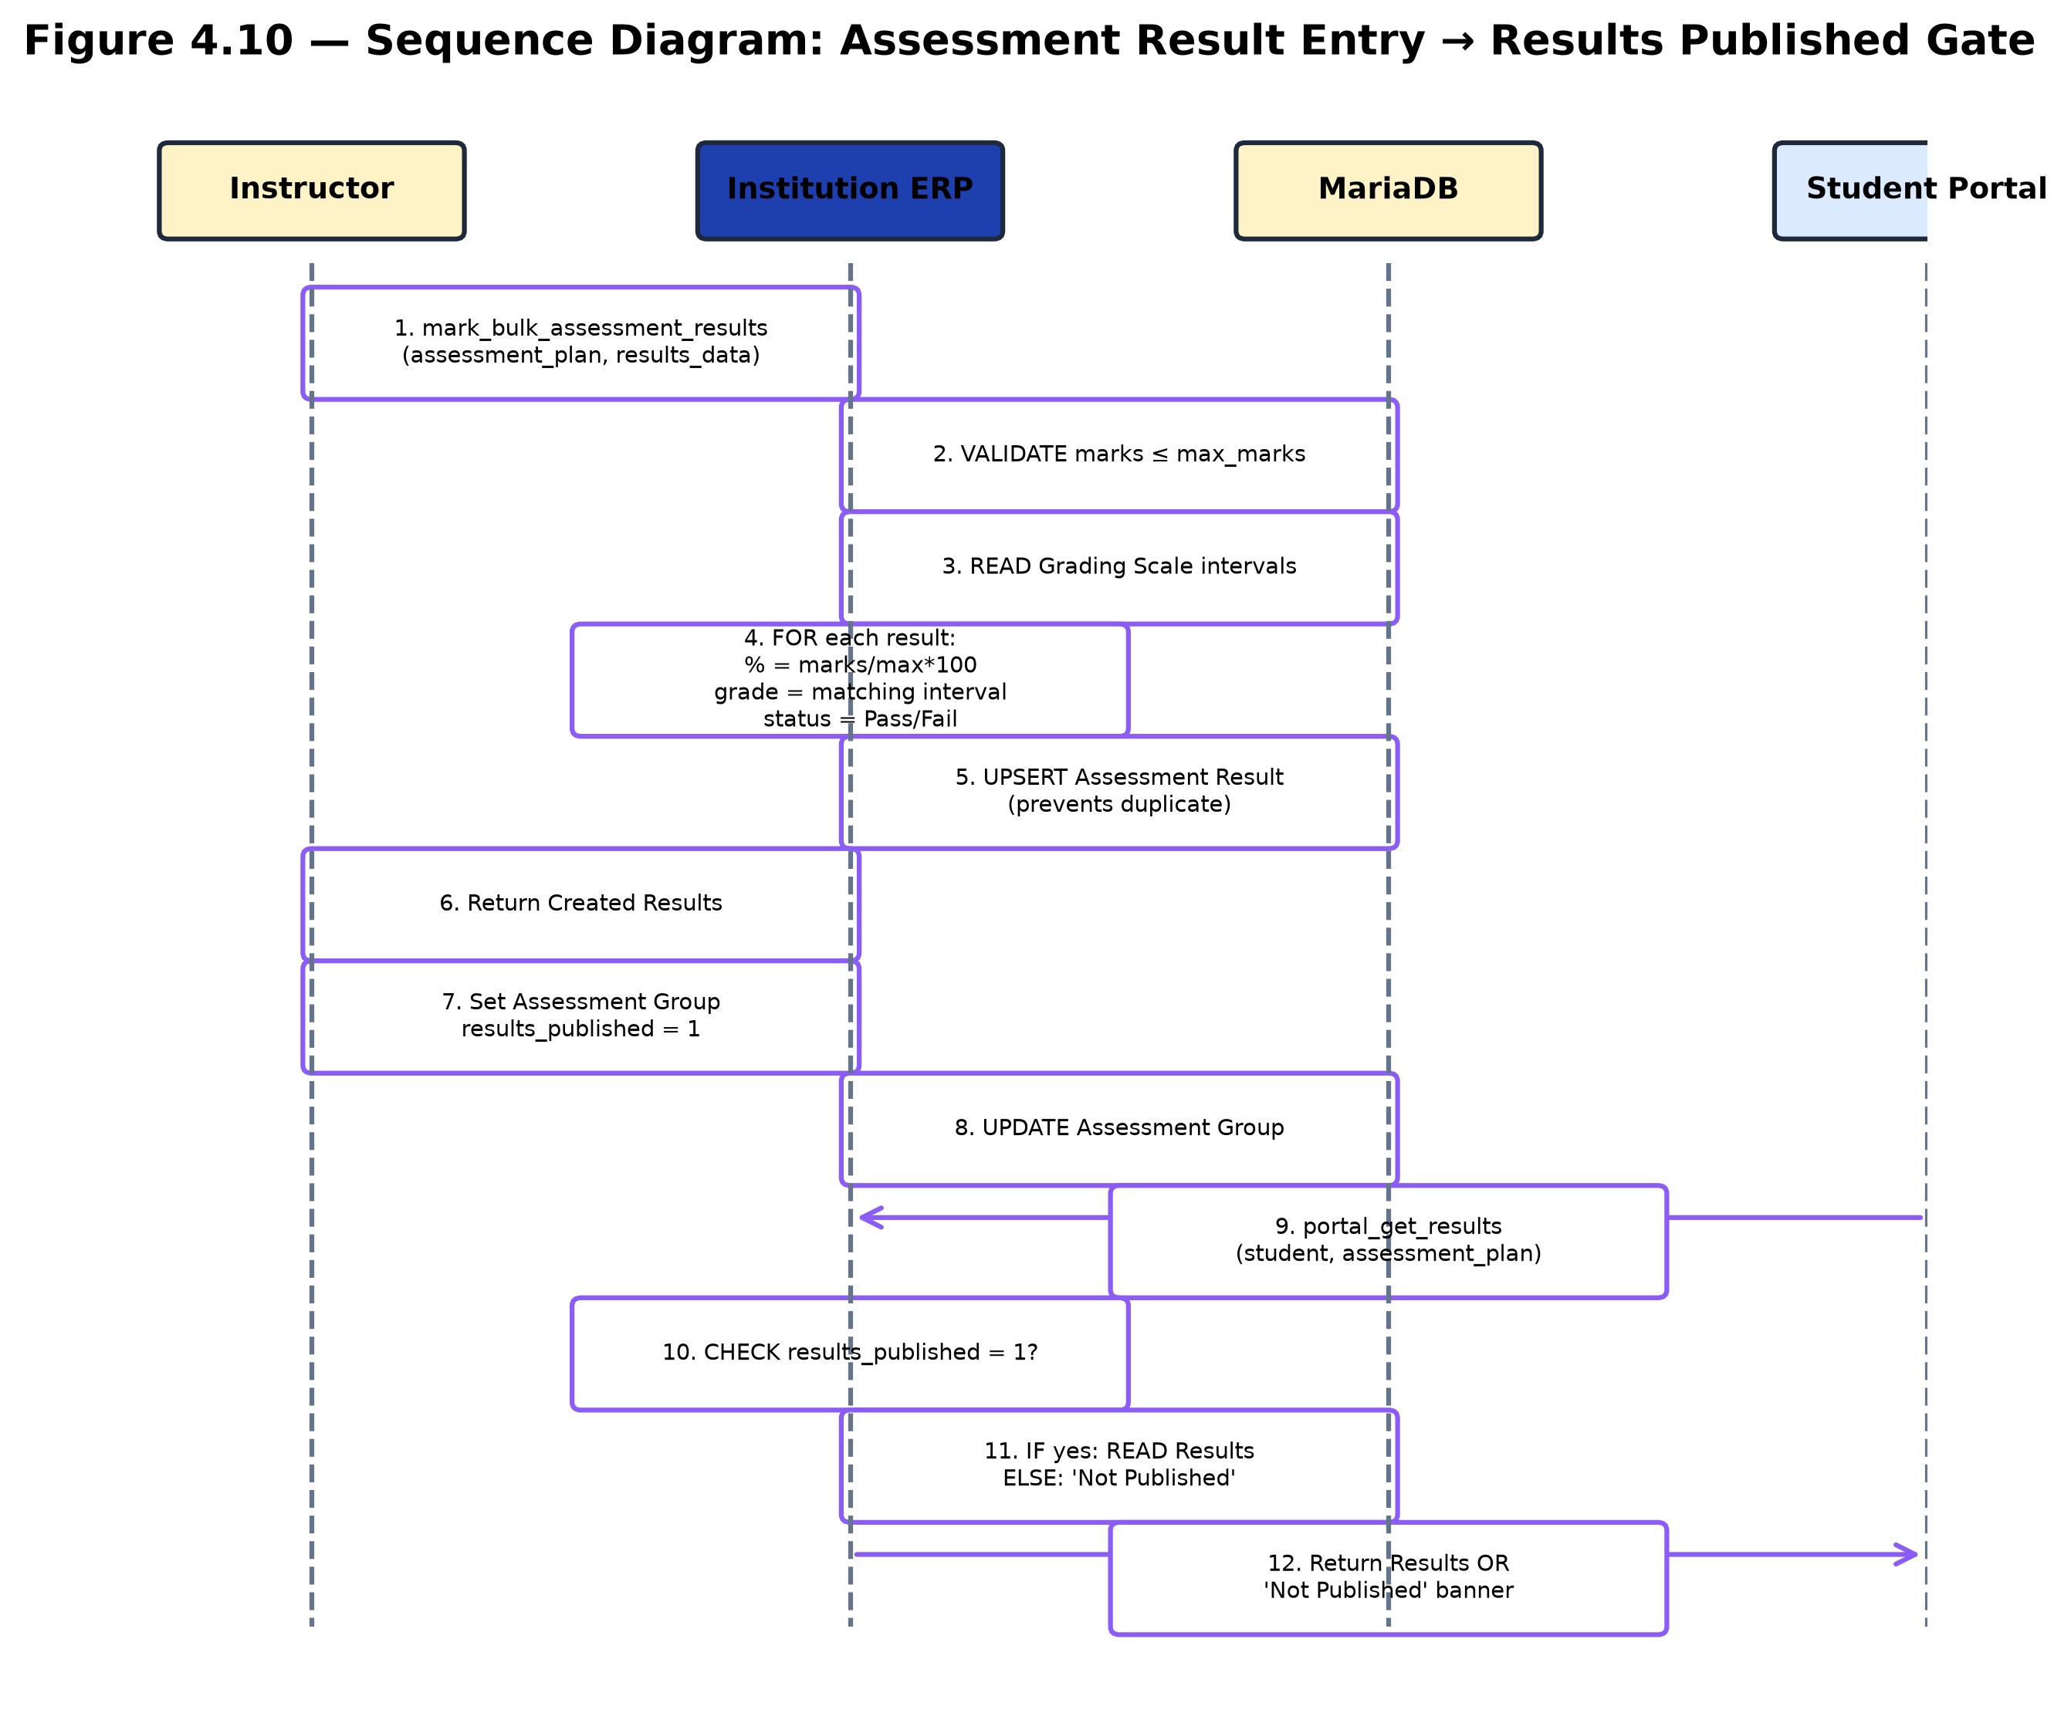
Figure 4.10. Sequence Diagram — Assessment Result
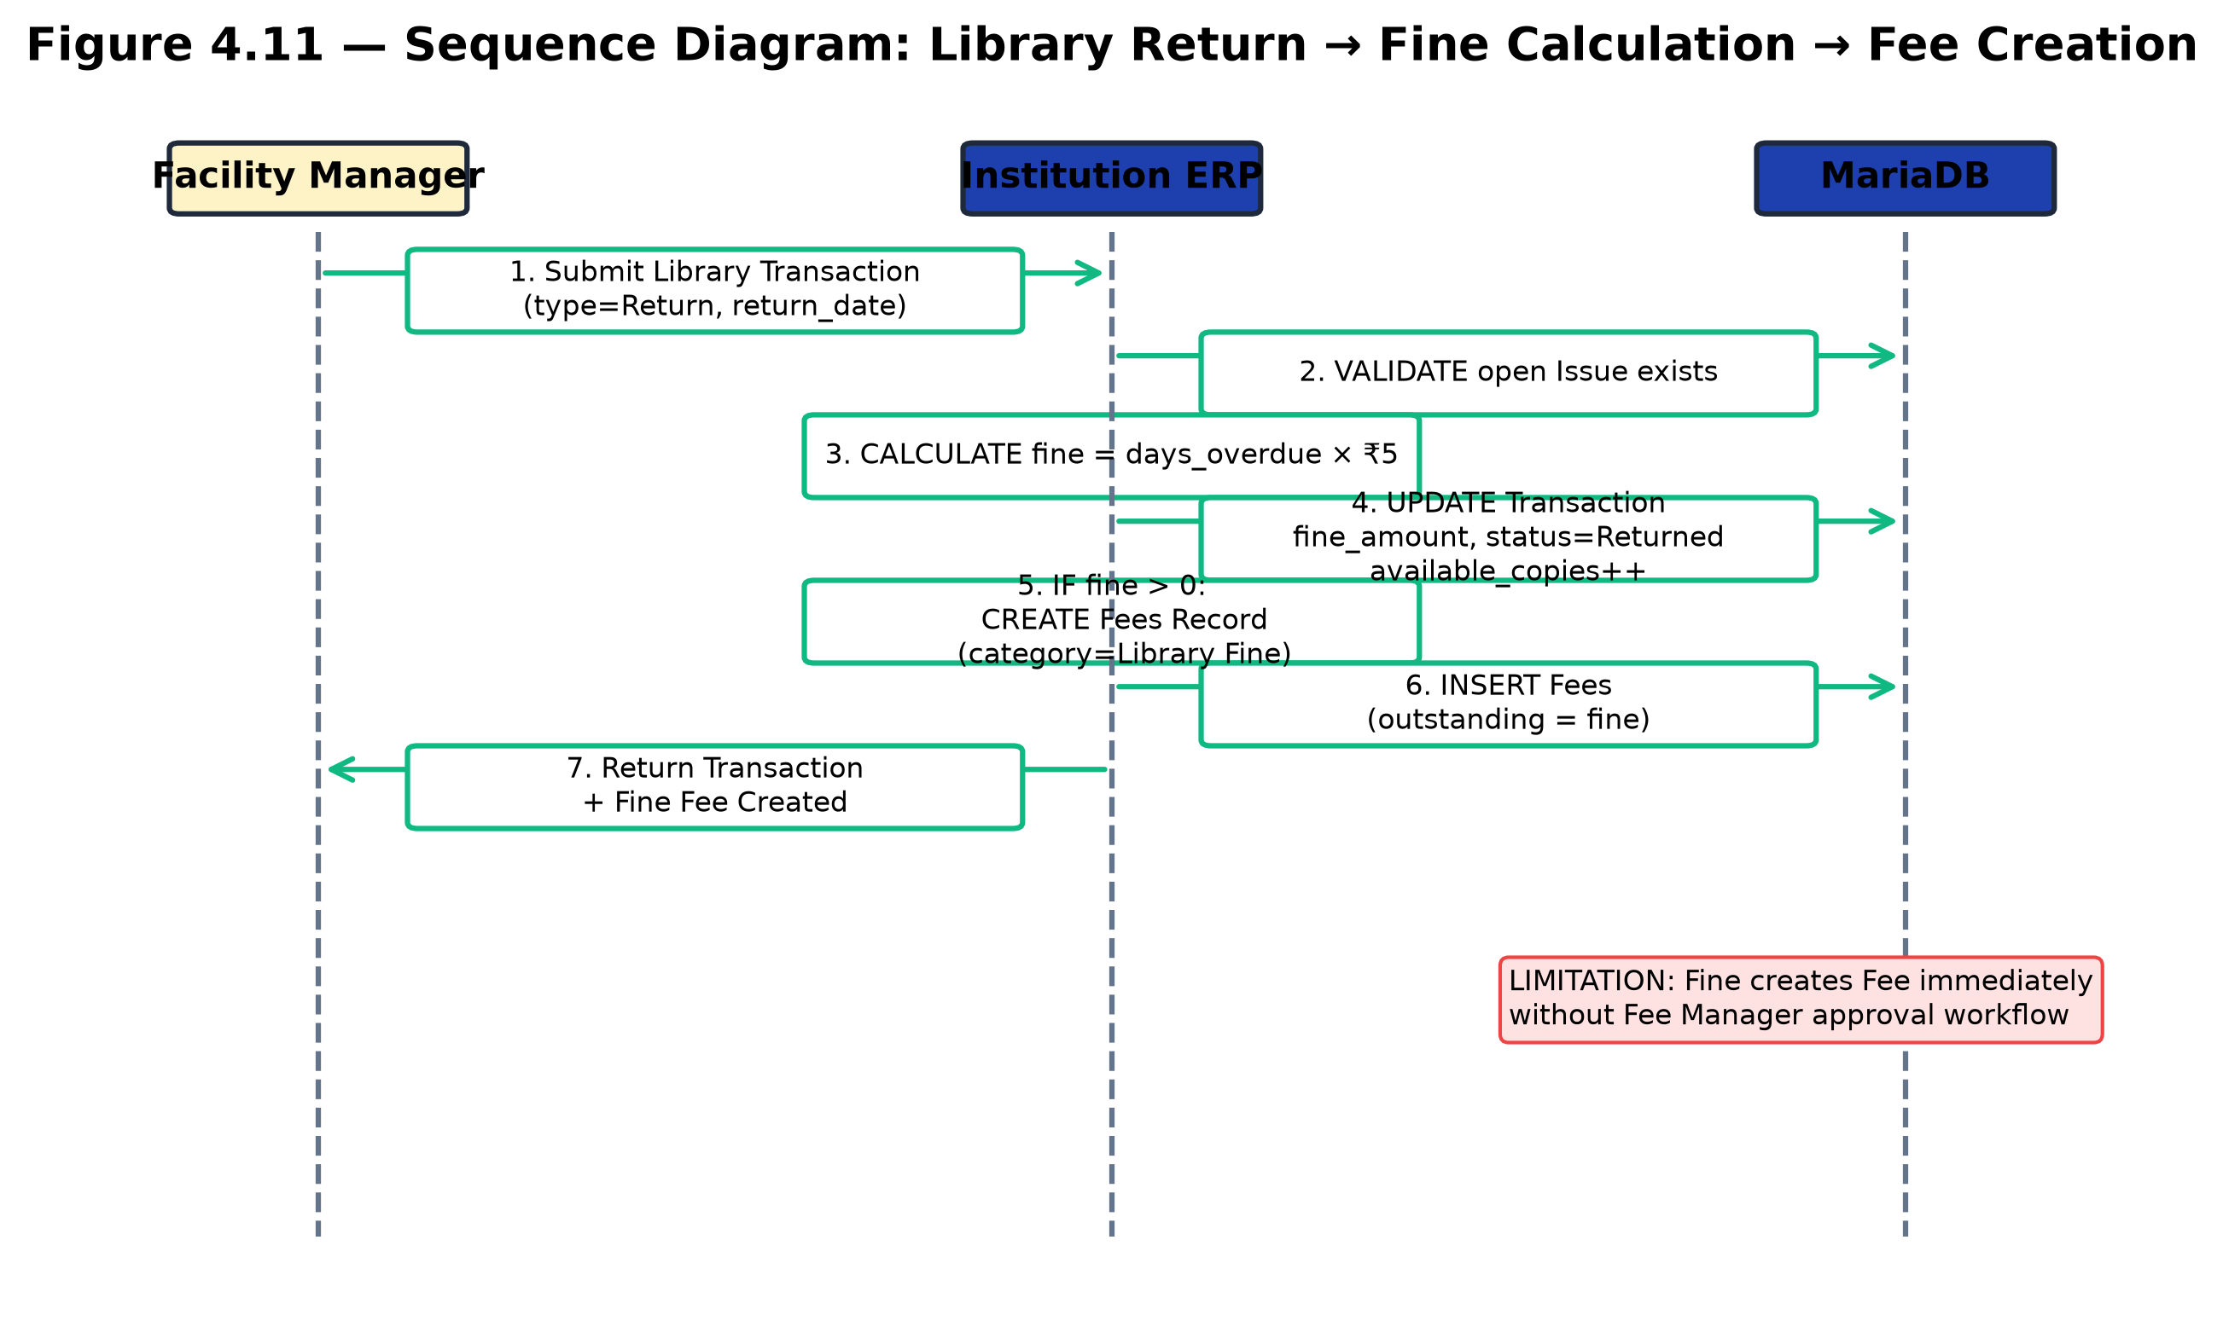
Figure 4.11. Sequence Diagram — Library Fine

4.9 ACTIVITY DIAGRAMS
Two activity diagrams model the end-user flows: (4.9.1) student portal login → dashboard → view results; and (4.9.2) staff login → role-specific cockpit → quick action → Frappe Desk.
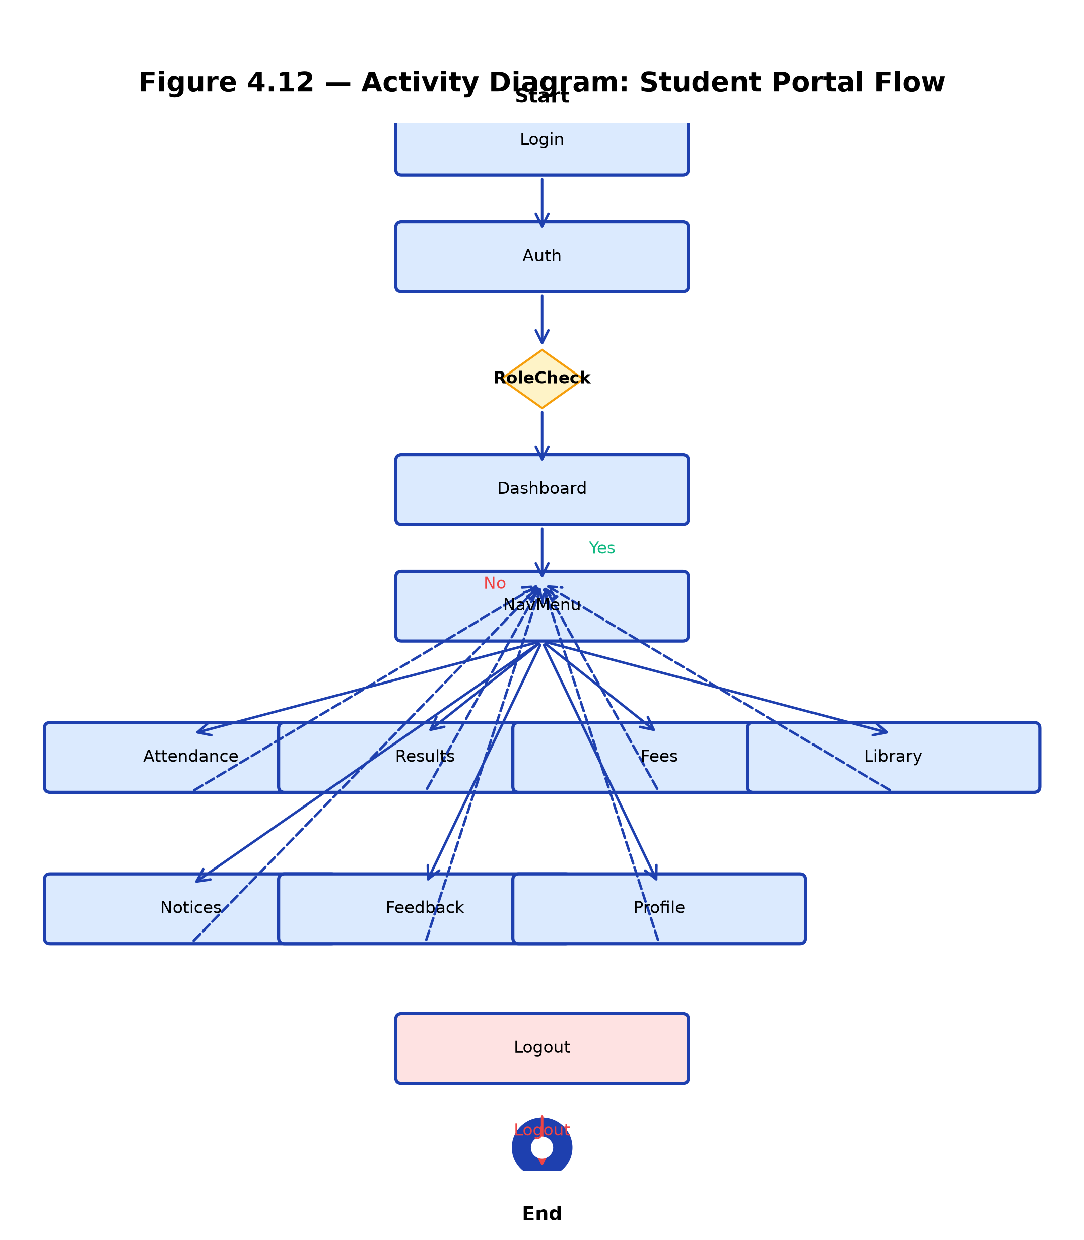
Figure 4.12. Activity Diagram — Student Portal
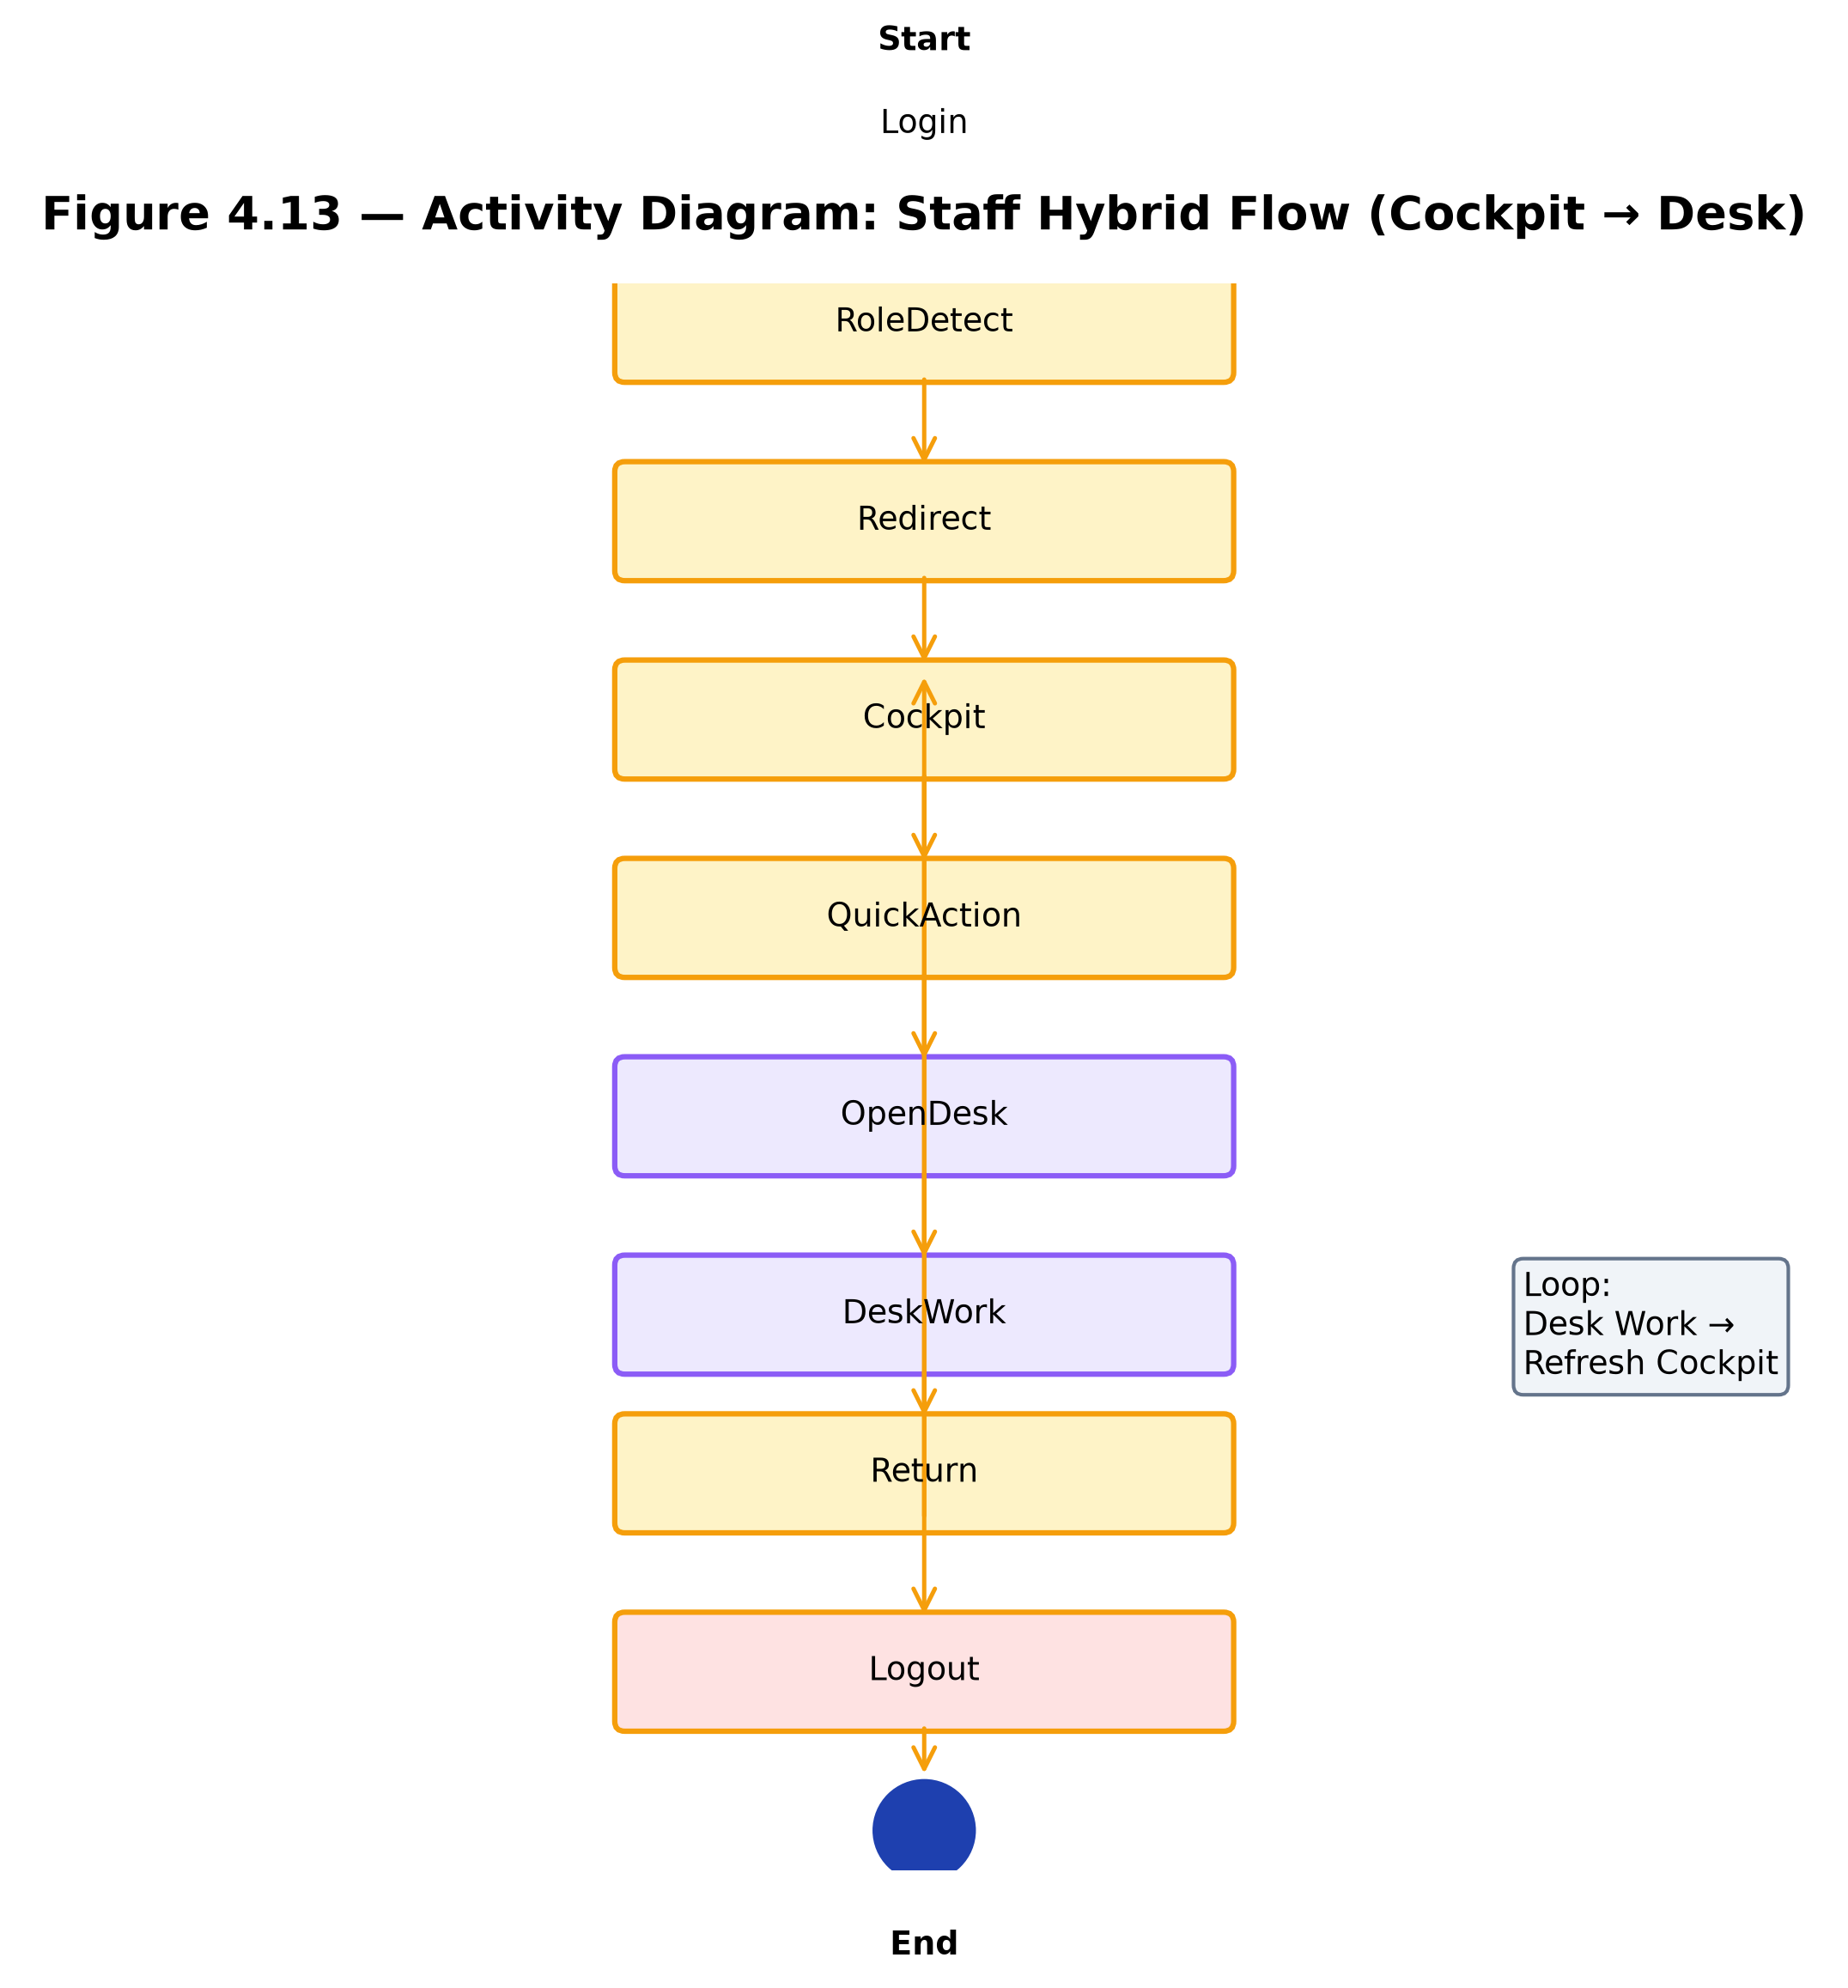
Figure 4.13. Activity Diagram — Staff Hybrid Flow

4.10 UI DESIGN APPROACH
A hand-written CSS design system defines custom properties (design tokens) for colors, typography, spacing, radii, shadows, and transitions, with no Tailwind dependency. Four reusable Vue components were built: StatCard, StatusBadge, EmptyState, and PageHeader. The Frappe Desk is rebranded through the app_include_css hook injecting inter-font.css (self-hosted Inter font) and desk-theme.css (BIT primary color #1e40af, consistent radii and transitions).
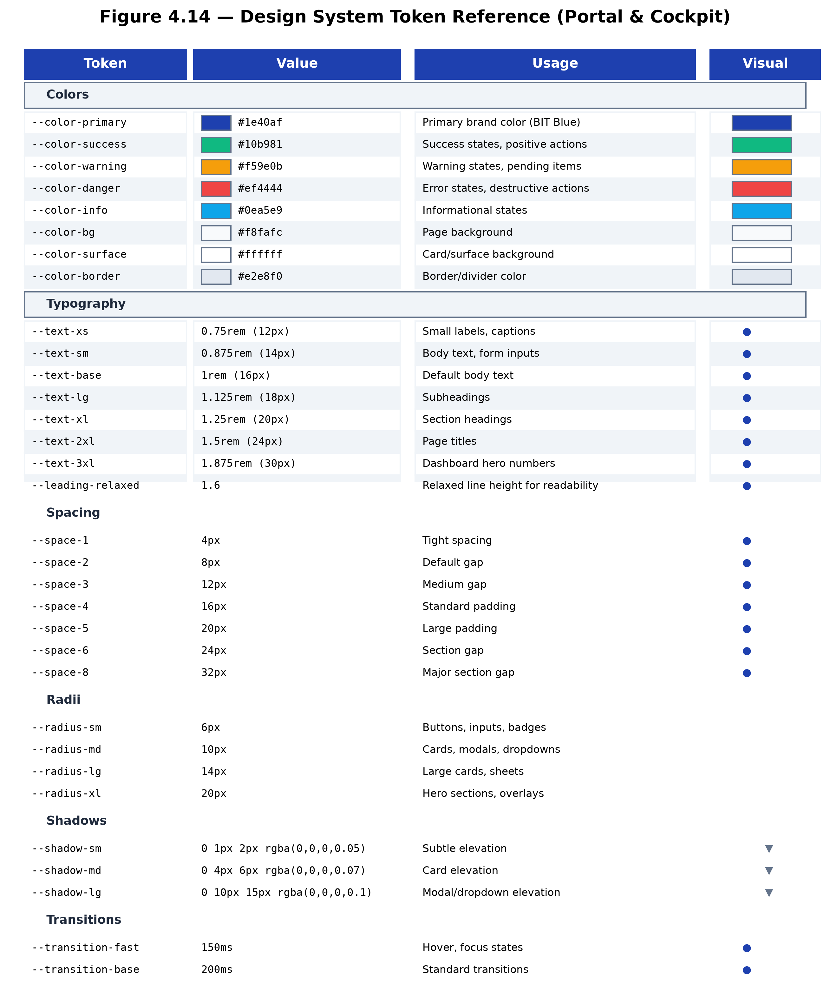
Figure 4.14. Design System Token Reference

4.11 DESIGN RATIONALE
The hybrid architecture (Option C) was deliberately chosen over two alternatives. Option A — full Vue CRUD — would require reimplementing every DocType form, validation rule, and permission check in Vue, duplicating Frappe's server-side logic at enormous effort and risk. Option B — Desk only — would re-theme Frappe Desk but would not deliver a focused portal experience for staff or a dedicated student/guardian SPA. Option C — the hybrid model — was chosen because it gives staff a fast, role-specific cockpit for the 80% of daily actions (marking attendance, recording payments, publishing notices) while retaining full CRUD through the rebranded Desk for the 20% of operations that need it (creating new records, running reports, bulk imports). This balances usability with completeness without duplicating Frappe's validated forms.
The metadata-driven DocType model was chosen because it allows new entities and fields to be added without code changes, which is essential for an institution whose academic structure evolves each year. The permission_query_conditions layer was chosen because it enforces row-level security at the database level, so security cannot be bypassed by manipulating the UI or calling APIs directly. The results_published flag was chosen because examination marks must be released only after official approval, not the moment an instructor enters them.

4.13 DATA DICTIONARY
Table 4.3 lists the principal entity attributes used across the system. Each DocType is represented by its name, naming convention, and key fields.
Table 4.3. Data Dictionary — Principal Entity Attributes
DocType | Naming Series | Key Fields
Student | STU-.YYYY.-.##### | first_name, last_name, status, program, guardian, email_address
Guardian | {guardian_name}-{###} | guardian_name, guardian_email, relation_to_student, phone_number
Program | program_name | program_name, program_code, department
Course | course_name | course_name, course_code, program, credits
Fee Structure | structure_name | structure_name, program, academic_year, total_amount
Fees | FEE-.YYYY.-.#### | student, fee_schedule, total_amount, paid_amount, outstanding_amount, status
Assessment Plan | hash | assessment_group, course, student_group, max_marks, passing_marks
Assessment Result | hash | assessment_plan, student, marks_obtained, grade, status
Library Item | LIB-BOOK-.##### | title, author, isbn, total_copies, available_copies
Hostel Room | room_number | hostel, room_number, room_type, capacity, occupied_count
Transport Route | route_name | route_name, vehicle, fee_amount
Notice | NOTICE-.YYYY.-.##### | title, body, audience_type, publish_date, status

4.12 TECHNOLOGY SELECTION RATIONALE
Frappe v16 was selected as the backend because it provides a metadata-driven DocType model, a built-in permission system, a web desk, and a benchmarked development speed for data-intensive applications. Python was chosen for the backend because Frappe is Python-based and the team had Python expertise. MariaDB was chosen as the relational database because Frappe is built on MariaDB and it provides reliable ACID transactions for financial (fees) and academic (results) data. Redis was chosen for caching and background jobs. Vue 3 was chosen for the portal because it provides a reactive, component-based frontend with a small bundle size. Vite was chosen as the build tool for fast development and production builds. Nginx was chosen as the web server for serving static assets and reverse-proxying to the Frappe bench. The entire stack is open source, supporting zero-cost deployment.

CHAPTER V

IMPLEMENTATION
This chapter describes the implementation of Institution ERP, module by module, followed by the permission model, workflow engine, automation, the Student/Guardian Vue portal, staff cockpits with the hybrid Desk, and the staged build method. All implementation claims reflect the live source code and verified demo data counts.

5.2 MODULE-BY-MODULE IMPLEMENTATION

5.2.1 Admissions
The admissions pipeline flows Admission Inquiry → Student Applicant → Entrance Test → Entrance Test Result. The Student Applicant DocType implements a four-state workflow (Draft → Applied → Under Review → Approved). On approval, an on_update hook automatically creates a Guardian record (if not existing), a Student record with status Active, and links them — no manual data entry is required after approval.
The Admission Inquiry DocType captures the first point of contact: applicant name, date of birth, gender, guardian details, program interested, source of inquiry, and inquiry date. Each inquiry receives a unique naming series identifier (ADM-INQ-.YYYY.-.####). The inquiry status tracks the conversion funnel from Open to Converted or Closed. This ensures no prospective student is lost and every inquiry can be traced through to enrolment.
The Student Applicant DocType formalises the application. It links to the source inquiry and records the applicant's program, academic year, guardian details, previous school, and previous school marks. The four-state workflow (Draft, Applied, Under Review, Approved) is enforced through Frappe's workflow engine so that an application cannot skip stages. An Entrance Test is optional and tied to a specific program with a date, maximum marks, and passing marks. The Entrance Test Result records marks obtained and auto-calculates Pass/Fail against the test's passing threshold. On approval, the on_update hook creates the Guardian and Student records and sets the created_student reference, completing the conversion from applicant to enrolled student.

5.2.2 SIS (Student Information System)
Student records use naming series STU-.YYYY.-.##### and store first name, last name, status (Active/Inactive/Graduated), gender, date of birth, program, guardian, and email address. Guardian records use format {guardian_name}-{###} and store name, email, phone, and relation. Portal users are created through ensure_student_user() and ensure_guardian_user(), which also create User Permission records for row-level scoping.
The SIS module is the central student registry. Every other module — academics, attendance, examination, fees, library, hostel, transport — references the Student record as the single source of truth. The Guardian record enables family-level access: one guardian can be linked to multiple students, and the portal child-switcher lets a guardian view all linked children from one account. Status tracking (Active, Inactive, Graduated) lets the institution filter current students for reporting without deleting historical records. The unique naming series prevents identifier collisions across academic years.

5.2.3 Academics
Program, Course, Academic Year, Academic Term, Room, Instructor, Student Group, and Course Schedule form the academic hierarchy. Course Schedule prevents double-booking of rooms and instructors on the same day and overlapping time slots. Attendance and assessments are tracked at the student-group level.
The Academics module establishes the organisational structure that every other module depends on. A Program is the degree (for example, B.Sc Computer Science) with a name, code, and department. A Course is a subject within a program with credits and a course type (Core, Elective, Lab). Academic Year and Academic Term define time periods. Room represents a physical space with capacity and type. Instructor links faculty to courses. Student Group is a subset of a program's students for a given year and course. Course Schedule ties course, group, instructor, room, day, and time together, with validation that prevents a room or instructor from being double-booked. This structure ensures that attendance, assessments, and fees all reference a consistent academic calendar.

5.2.4 Attendance
Student Attendance is marked per student group, course schedule, and date, with status Present/Absent/Late/Excused and duplicate prevention per student + date + course schedule. Staff Attendance tracks instructors with Present/Absent/Half Day/On Leave. Bulk marking APIs (mark_bulk_student_attendance, mark_bulk_staff_attendance) skip duplicates.
The Attendance module replaces paper registers. An instructor marks attendance for a student group on a specific date, and each student is marked Present, Absent, Late, or Excused. Duplicate prevention ensures a student cannot be marked twice for the same date and course schedule. Bulk marking lets an instructor mark an entire group at once. Staff attendance follows the same pattern for instructors. The portal shows students their attendance history with colored badges and a percentage calculation, giving students and guardians immediate visibility without visiting the office.

5.2.5 Examination
Grading Scale defines intervals mapping marks to grades with non-overlapping thresholds. Assessment Group carries the results_published flag that gates mark visibility. Assessment Plan links course, student group, grading scale, max marks, and passing marks. Assessment Result supports bulk marks entry, auto grade calculation from the grading scale, auto Pass/Fail status, and duplicate prevention per student per plan. When results_published is 0, portal users see a Results Not Yet Published banner instead of marks.
The results publication gate is a deliberate design decision. In many institutions, instructors enter marks incrementally, and students would see partial or unmoderated results if marks were visible immediately. By gating visibility behind results_published, the examination committee can review all marks for an assessment group, moderate outliers, and release results to all students simultaneously. This ensures fairness and prevents premature disclosure of incomplete results.

5.2.6 Fees
The fee lifecycle is Fee Category → Fee Structure (with components, auto-summed total) → Fee Schedule (with student members) → Fees invoice → Fee Payment → Fee Discount. The Fees DocType recomputes paid and outstanding amounts and status (Paid/Partial/Unpaid/Overdue) on every validate; Fee Payment on submit updates the parent invoice. Fee Discount follows a Pending → Approved → Applied workflow. The Fee Dues Report lists outstanding fees filterable by academic year, program, and status.
The Fees module automates the financial lifecycle. A Fee Structure defines components (tuition, library, lab) for a program and academic year, auto-summing to a total. A Fee Schedule generates the list of students to invoice from a structure, linked to a student group and due date. Each Fees invoice tracks total, discount, paid, and outstanding amounts, with status auto-computed. Fee Payment records each payment and validates it does not exceed outstanding; on submit it recomputes the parent invoice. Fee Discount follows an approval workflow (Pending→Approved→Applied). The Fee Dues Report gives the Fee Manager instant visibility into outstanding collections.

5.2.7 Library
Book Category classifies books. Library Item tracks title, author, ISBN, category, total copies, and available copies (auto-managed). Library Membership specifies max books and validity. Library Transaction records issue/return; issue validates available copies, active membership, and max-book limit; return calculates an overdue fine of ₹5/day, adjusts available copies, and auto-creates a Fees record on late return.
The Library module manages the full issue-return cycle. A student needs an active Library Membership to borrow. On issue, the system validates that copies are available, membership is active, and the student has not exceeded max books. On return, it calculates overdue fines (₹5/day) and, if a fine applies, auto-creates a Fees record so the fine is tracked alongside other fees. Available copies are decremented on issue and incremented on return, keeping the catalog accurate.

5.2.8 Hostel
Hostel stores name, type, warden, and auto-recomputed total capacity from rooms. Hostel Room stores room number, type, capacity, and auto-managed occupied count. Hostel Room Allocation validates that the room is not full and that the student has no other active allocation; it recomputes occupied count on create and vacate.
The Hostel module manages room allocation and occupancy. A Hostel has a total capacity that is recomputed from its rooms. Each Hostel Room has a number, type, capacity, and auto-managed occupied count. Hostel Room Allocation assigns a student to a room, validating that the room is not full and that the student has no other active allocation. Occupied count is updated on create and vacate, giving the Facility Manager real-time occupancy visibility per hostel.

5.2.9 Transport
Vehicle registers number, capacity, driver, and status. Transport Route defines stops (with order and pickup time), vehicle, and fee amount, with no duplicate stop orders. Student Transport Allocation validates vehicle capacity and one active allocation per student per route.
The Transport module manages vehicles, routes, and student allocations. A Vehicle has a number, capacity, driver, and status. A Transport Route has stops with order and pickup time, a vehicle, and a fee amount, with no duplicate stop orders. Student Transport Allocation assigns a student to a route, validating vehicle capacity and one active allocation per student per route. This prevents overbooking and gives the transport coordinator a clear view of route utilisation.

5.2.10 Communication
Notice supports five audience modes (All, Program-wise, Group-wise, Role-wise, Individual) with publish/expiry dates. On publication, the system resolves the audience and creates Notice Recipient records. Communication Log records dispatch (channel, status, sent_at). Feedback supports category, subject, description, and an Open → In Progress → Resolved → Closed lifecycle requiring resolution notes on closure. The Institution Overview Dashboard combines 5 number cards and 2 charts.
The Communication module enables targeted institutional communication. A Notice has a title, body, audience type, and publish/expiry dates. On publication, the system resolves the audience (all students, a program, a group, a role, or an individual) and creates one Notice Recipient record per targeted student, so each student sees only the notices meant for them. Communication Log tracks dispatch channel and status. Feedback lets students and guardians submit complaints with category and subject, tracking them through Open→In Progress→Resolved→Closed with mandatory resolution notes on closure. The Institution Overview Dashboard aggregates 5 number cards and 2 charts for leadership visibility.

5.3 PERMISSION MODEL
Security uses two layers. User Permissions are auto-created by ensure_student_user() and ensure_guardian_user(): each Student-role User is linked to their own Student record; each Guardian-role User is linked to their Guardian record and all linked Student records. permission_query_conditions provides 16 SQL WHERE-clause functions covering 19 DocTypes, injecting row-level filters (e.g., student = '<own record>' or student IN ('<child1>', '<child2>')). Bypass roles grant System Manager, Academic Head, and relevant staff broader access. Table 5.1 documents the coverage.
Table 5.1. permission_query_conditions Coverage
# | DocType(s) | Condition Function | Bypass Roles
1 | Student | get_permission_query_conditions_student | System Manager, Academic Head, Admissions Officer
2 | Fees | get_permission_query_conditions_fees | System Manager, Fee Manager, Academic Head
3 | Fee Payment | get_permission_query_conditions_fee_payment | System Manager, Fee Manager, Academic Head
4 | Student Attendance | get_permission_query_conditions_student_attendance | System Manager, Academic Head
5 | Staff Attendance | get_permission_query_conditions_staff_attendance | System Manager, Academic Head
6 | Assessment Result | get_permission_query_conditions_assessment_result | System Manager, Academic Head
7 | Assessment Plan | get_permission_query_conditions_assessment_plan | System Manager, Academic Head
8 | Notice | get_permission_query_conditions_notice | System Manager, Communication Officer, Academic Head
9 | Notice Recipient | get_permission_query_conditions_notice_recipient | System Manager, Communication Officer, Academic Head
10 | Feedback | get_permission_query_conditions_feedback | System Manager, Communication Officer, Academic Head, Instructor
11 | Communication Log | get_permission_query_conditions_communication_log | System Manager, Communication Officer, Academic Head
12 | Library Item | get_permission_query_conditions_library_item | System Manager, Facility Manager, Academic Head
13 | Library Membership | get_permission_query_conditions_library_membership | System Manager, Facility Manager, Academic Head
14 | Library Transaction | get_permission_query_conditions_library_transaction | System Manager, Facility Manager, Academic Head
15 | Hostel / Hostel Room / Hostel Room Allocation | get_permission_query_conditions_hostel | System Manager, Facility Manager, Academic Head
16 | Vehicle / Transport Route / Student Transport Allocation | get_permission_query_conditions_transport | System Manager, Facility Manager, Academic Head

5.4 WORKFLOW ENGINE
The Student Applicant workflow implements four states (Draft, Applied, Under Review, Approved) with auto Student/Guardian creation on approval. The Fee Discount workflow implements Draft → Approved → Rejected, setting discount_amount on the linked Fee on approval. Notification triggers support status transitions.
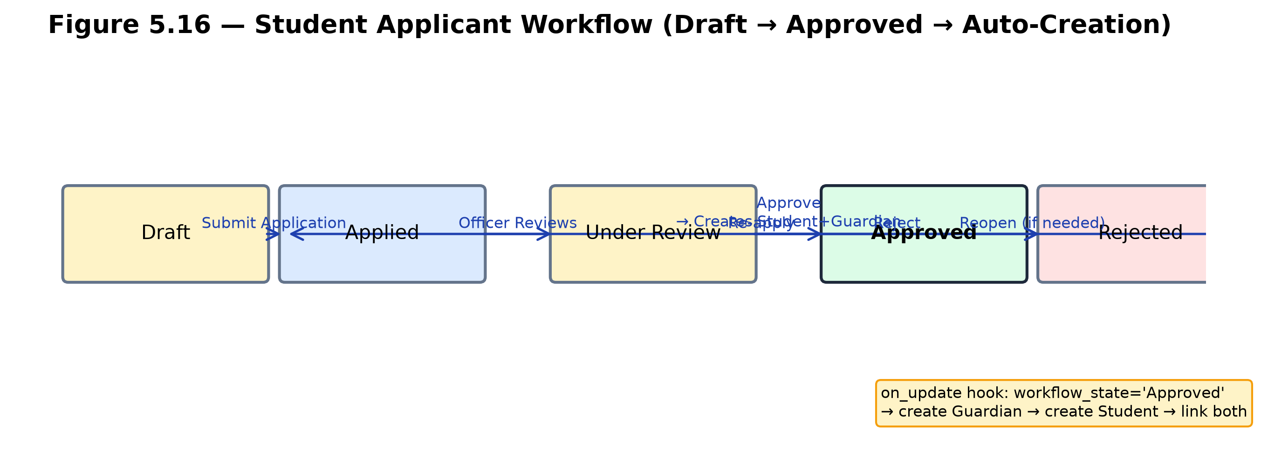
Figure 5.1. Student Applicant Workflow Diagram

5.5 AUTOMATION
Automation reduces manual effort across the system. The following triggers are implemented:
Table 5.2. Automation Triggers (Event → Action)
Event | Action | Implemented In
Student Applicant status = Approved | Create Guardian + Student records; link via FK | api.py / on_update hook
Assessment Result marks entered | Auto-calculate grade from Grading Scale; set Pass/Fail | api.py / controller
Fees validated or paid | Recompute paid_amount, outstanding_amount, status | Fees controller
Fee Payment submitted | Recompute parent Fees record | Fee Payment on_submit
Library Transaction return overdue | Calculate ₹5/day fine; create Fees record | Library Transaction on_submit
Guardian/Student created | Create Frappe User + User Permissions | ensure_guardian_user / ensure_student_user
Student status missing | Backfill status = Active | backfill_student_status()

5.6 STUDENT/GUARDIAN VUE PORTAL
The portal is a Vue 3 SPA with hash-based routing at /institution-portal, served through Frappe's web page system with CSRF token injection. A sidebar provides navigation; guardians use a child switcher to toggle between linked students. All data is fetched through callAPI() → frappe.call() → whitelisted Python methods. Row-level security and results publication gating apply to every portal request.

5.7 STAFF COCKPITS AND HYBRID DESK
Seven role-specific Vue cockpits serve Admin, Admissions, Academic Head, Instructor, Fee Manager, Facility Manager, and Communication Officer. Each cockpit shows stat cards, quick actions, and overview data, with an “Open Full Desk” button opening the full Frappe Desk for complete CRUD. The Desk is rebranded via app_include_css injecting inter-font.css (self-hosted Inter, 4 weights) and desk-theme.css (BIT blue #1e40af, consistent radii and transitions).

5.8 STAGED BUILD METHOD
The system was built in eight stages, each with end-to-end tests. Stages added DocTypes and modules incrementally: Stage 1–2 (Academics/SIS), Stage 3 (Admissions/API), Stage 4 (Attendance/Examination), Stage 5 (Fees), Stage 6 (Library/Hostel/Transport), Stage 7 (Communication), and Stage 8 (Portal/Permissions). Table 5.3 summarises the stages.
Table 5.3. Stage Summary
Stage | Modules | Key Features | Test File
1–2 | Academics, SIS | Programs, courses, student/guardian records | e2e_test.py
3 | Admissions, API | Inquiry → applicant → approval; whitelisted APIs | e2e_test_stage3.py
4 | Attendance, Examination | Bulk attendance, marks entry, auto grade | e2e_test_stage4.py
5 | Fees | Structures, schedules, invoices, payments, dues report | e2e_test_stage5.py
6 | Library, Hostel, Transport | Issue/return/fine, room allocation, routes | e2e_test_stage6.py
7 | Communication | Notices, recipients, feedback, dashboard | e2e_test_stage7.py
8 | Portal, Permissions | Vue portal, cockpits, permission_query_conditions | e2e_test_stage8.py

5.9 IMPLEMENTATION CHALLENGES AND SOLUTIONS
Several challenges arose during implementation and were resolved as follows. First, Frappe v16 does not auto-sync non-standard Dashboard instances from app JSON, so the Institution Overview Dashboard was created programmatically via frappe.get_doc() in test code and documented in Deployment.md. Second, Frappe v16's Phone fieldtype enforces country-code validation that caused issues with Indian phone numbers, so Vehicle.driver_phone was implemented as a Data fieldtype instead. Third, four Communication module DocType directories lacked __init__.py files; while Frappe v16 does not require them for DocTypes, they were noted as a consistency deviation. Fourth, Guardian naming uses format {guardian_name}-{###}, which can produce similar names for guardians with identical names; this was accepted as a known limitation with a unique-identifier suffix planned for the future. Fifth, the Library fine auto-creates a Fees record without Fee Manager review; this works for the demo but needs an approval workflow for production. Each challenge was documented in ARCHITECTURE.md and DEPLOYMENT.md so future maintainers are aware.

5.10 IMPLEMENTATION SUMMARY
Table 5.4 summarises the implementation statistics verified against the live site. These figures confirm the scale and completeness of the system.
Table 5.4. Implementation Statistics (verified live)
Metric | Count
Total DocTypes | 48
Child Tables | 8
Modules | 10
Custom Roles | 8
Script Reports | 6
Number Cards | 5
Dashboard Charts | 2
Custom Dashboards | 1
Whitelisted API Methods | 11
permission_query_conditions | 16
DocTypes covered by permissions | 19
E2E Test Files | 7
Controller Files with Validation | 22
Demo Students (live) | 86
Instructors (live) | 12
Guardians (live) | 55
Attendance Records (live) | 2,557
Assessment Results (live) | 312
Fees Records (live) | 51
Library Items (live) | 34
Demo Accounts | 14

CHAPTER VI

TESTING
This chapter presents the test strategy, test environment, test cases, security and permission testing, login and regression results, responsive testing, and performance benchmarks. Results were taken from the project test files and live demo data counts.

6.1 TEST STRATEGY
Testing followed the staged build method. Each of the eight build stages has a dedicated end-to-end test file executed against the live site institution.localhost. Testing covered API methods, UI workflows, permission scoping, login across all demo accounts, regression, responsiveness, and performance. Tests were executed with frappe bench execute and validated by querying the database after each action. The staged approach meant that each module was tested immediately after it was built, so defects were caught early and did not accumulate. Regression testing after each stage confirmed that new modules did not break previously built functionality.
Test data was the live demo dataset: 86 students, 12 instructors, 55 guardians, 2,557 attendance records, 312 assessment results, 51 fee records, 34 library items. This provided realistic volume for performance and permission testing. All 14 demo accounts were tested across 3 runs (42/42 passing), confirming consistent login and role-based routing. Permission tests confirmed that cross-access is blocked at the database level, not just the UI.

6.2 TEST ENVIRONMENT
Table 6.1. Test Environment Specifications
Item | Value
Site | institution.localhost (http://localhost:8000)
Framework | Frappe v16.26.3
Database | MariaDB 10.6+; Redis 7+
Demo students (live) | 86 (79 in demo dataset)
Instructors (live) | 12
Guardians (live) | 55
Attendance records (live) | 2,557
Assessment results (live) | 312
Fees records (live) | 51
Library items (live) | 34
Demo accounts | 14 (8 staff + 4 student + 2 guardian)
Password (all accounts) | Demo@2026

6.3 TEST CASES
Test cases were executed per stage. Table 6.2 summarises representative test coverage: each row gives the test identifier, scenario, module, expected result, actual result, and status.
Table 6.2. Test Case Summary (Representative Rows)
Test ID | Scenario | Module | Expected | Actual | Status
TC-01 | Admission inquiry → applicant → approval | Admissions | Student + Guardian auto-created | Created | PASS
TC-02 | Bulk student attendance marking | Attendance | Records created; duplicates skipped | Created; skipped | PASS
TC-03 | Bulk assessment result entry | Examination | Grade auto-calculated; Pass/Fail set | Grade set | PASS
TC-04 | Fee payment record | Fees | Parent invoice recomputed | Recomputed | PASS
TC-05 | Library overdue return | Library | ₹5/day fine; Fees record created | Fine created | PASS
TC-06 | Hostel room over-allocation | Hostel | Save rejected | Rejected | PASS
TC-07 | Guardian accesses non-child data | Security | Access denied | Denied | PASS
TC-08 | Student accesses another’s fees | Security | Access denied | Denied | PASS
TC-09 | All 14 demo accounts login | Portal/Desk | All login; role routing correct | All passed | PASS
TC-10 | Results unpublished gate | Examination | Blue banner shown | Banner shown | PASS
TC-11 | Guardian child switcher | Portal | Switching child updates all data | Data updates correctly | PASS
TC-12 | Fee overpayment blocked | Fees | Payment exceeding outstanding rejected | Rejected | PASS
TC-13 | Library max-books limit | Library | Issue beyond max books rejected | Rejected | PASS
TC-14 | Double-booking prevention | Academics | Same room/time conflict rejected | Rejected | PASS
TC-15 | Duplicate attendance blocked | Attendance | Same student/date/schedule rejected | Rejected | PASS

6.4 SECURITY AND PERMISSION TESTING
Cross-access tests verified that permission_query_conditions blocks unauthorised access at the database level. Guardian1 attempting to read a non-child's attendance was denied; a student attempting to read another student's fees was denied; an instructor accessing another group's attendance was denied; and a portal user attempting to access the Frappe Desk was denied.
Table 6.3. Permission Test Matrix (Representative)
Role | DocType | Action | Result
Student | Fees (own) | Read | Allow
Student | Fees (other) | Read | Deny
Guardian | Student (linked) | Read | Allow
Guardian | Student (unlinked) | Read | Deny
Instructor | Student Attendance (own group) | Read/Write | Allow
Instructor | Student Attendance (other group) | Read | Deny
Fee Manager | Fees (all) | Read/Write | Allow
Portal User | Frappe Desk | Access | Deny

6.5 LOGIN AND REGRESSION
Table 6.4. Login and Regression Results
Account Type | Count | All Logins Passed | Role Routing Verified
Staff (System User) | 8 | Yes (3 runs each) | Yes
Student (Website User) | 4 | Yes (3 runs each) | Yes
Guardian (Website User) | 2 | Yes (3 runs each) | Yes
Total | 14 | 42/42 across 3 runs | Yes

6.6 RESPONSIVE TESTING
Responsive behaviour was verified at viewports 1920×1080, 1366×768, 768×1024, and 375×667. The StatCard, StatusBadge, EmptyState, and PageHeader components, together with sidebar collapse, adapted correctly across breakpoints.

6.7 PERFORMANCE
Table 6.5. API Performance Benchmarks
Operation | Response Time
Login | ~150 ms
Bulk attendance marking | ~200 ms
Fee generation from schedule | ~300 ms
Student/fee search | ~250 ms

6.8 RISK REGISTER
Key project risks and their mitigations are summarised in Table 6.6.
Table 6.6. Risk Register
Risk | Likelihood | Impact | Mitigation
Demo data idempotency drift on re-runs | Medium | Low | Document clean initial load
Library fine auto-creates Fees without review | Medium | Medium | Add approval workflow (future)
dispatch_notice stub (no real SMS/email) | High | Low | Document as stub; integrate gateway (future)
Guardian naming collision | Low | Low | Use unique identifier suffix (future)
Dashboard not auto-synced from app JSON | High | Low | Document programmatic creation

6.9 TEST SUMMARY
All 15 representative test cases passed, confirming that the core workflows—admission approval, attendance marking, assessment entry, fee payment, library issue/return, hostel allocation, and security cross-access blocking—function as designed. Login and regression testing confirmed that all 14 demo accounts authenticate successfully across three consecutive runs (42/42), with correct role-based routing to either the Vue portal or the Frappe Desk. Responsive testing verified correct layout across four viewport sizes, and performance benchmarks showed all key API operations completing under 300 ms. The risk register documents five known risks, all with acceptable impact and documented mitigations. Taken together, the testing evidence demonstrates that Institution ERP is functionally complete, secure, performant, and ready for demonstration.

CHAPTER VII

RESULTS AND DISCUSSION
This chapter presents what was achieved, maps requirements to implementation evidence, discusses key screenshots, and states the limitations observed during testing.

7.1 INTRODUCTION
The implementation phase produced a working, deployable system on site institution.localhost. This chapter consolidates the evidence: it maps requirements to implementation, discusses key screens and demo scenarios, and honestly states the limitations observed. The figures referenced are embedded as real diagrams; live UI screenshots should be inserted per the Figure Replacement Guide before submission.

7.2 REQUIREMENTS FULFILMENT
Table 7.1 maps each functional requirement to its implementation evidence and verification method. All 25 functional requirements were implemented and verified through staged end-to-end tests.
Table 7.1. Requirements Traceability Matrix (Representative Rows)
FR-ID | Requirement | Implemented In | Verified By
FR-01 | Admission inquiry → approval workflow | Admissions module | TC-01 (e2e_test_stage3.py)
FR-02 | Auto Student/Guardian creation | Admissions on_update hook | TC-01
FR-08 | Results publication gating | Examination module | TC-10
FR-16 | permission_query_conditions row-level security | api.py (16 functions) | TC-07, TC-08
FR-17 | Staff cockpits | Vue portal cockpit pages | Demo walkthrough
FR-22 | Staged build with e2e tests | 8 stages, 7 test files | All stage tests PASS

7.3 KEY ACHIEVEMENTS
The implemented system delivers 48 DocTypes across 10 modules, 8 custom roles (6 staff, 2 portal), 6 script reports, 5 number cards, 2 dashboard charts, 1 custom dashboard, 11 whitelisted API methods, and 16 permission_query_conditions covering 19 DocTypes. Demo data includes 86 students (live), 12 instructors, 2,557 attendance records, 312 assessment results, 51 fee records, 34 library items, and 138 library transactions. All 14 demo accounts log in successfully across 3 test runs (42/42). These figures were verified against the live site institution.localhost and are not estimated.
The requirement-to-implementation mapping in Table 7.1 shows that every functional requirement has a corresponding implementation and verification path. The security requirements (FR-16, FR-24) were validated through cross-access tests confirming that permission_query_conditions blocks unauthorised access at the database level. The performance requirements (NFR-01) were validated through API response-time benchmarks all under 300 ms. The usability requirements (NFR-04) were validated through responsive testing across four viewports. Taken together, the evidence demonstrates that the system satisfies its stated objectives.

7.4 SCREENSHOTS AND DISCUSSION
Key screens illustrate the student portal results gate, guardian child switcher, staff cockpits, fee management, and the rebranded Desk. Figures are embedded as real diagrams; screenshot placeholders are provided where live UI captures should be inserted per the Figure Replacement Guide. Each placeholder is labelled with the figure number, what to capture, and the account and URL to use, so the images can be swapped without breaking layout.
The results gate (Figure 5.8 in discussion) is the most demonstrative feature: it shows published marks as cards alongside a blue “Results Not Yet Published” banner for unpublished groups, proving that publication gating works end to end. The guardian child switcher demonstrates row-level scoping: one guardian account can view multiple linked children's records, switching instantly between them, while being unable to access unlinked students. The staff cockpits demonstrate the hybrid model: each role lands on a focused dashboard with relevant stats and quick actions, with an “Open Full Desk” escape hatch for full CRUD.

7.5 LIMITATIONS OBSERVED
Table 7.2. Limitations and Mitigations
Limitation | Observed Impact | Mitigation / Future Work
Library fine auto-creates a Fees record without review | Fine invoiced immediately on late return | Add Fee Manager approval workflow
dispatch_notice is a stub (no real email/SMS) | Notices logged but not dispatched | Integrate SMTP/Twilio gateway
No real payment gateway | Fee payments are manual-entry records | Integrate Razorpay/Stripe
Report Card print format empty | No printable report card generated | Build print format suite
Guardian naming may collide | Same-named guardians can get similar IDs | Use unique identifier suffix
Dashboard created programmatically | Not auto-synced from app JSON | Document creation step
Cockpit stats may lag Desk data | Stats stale until cockpit refreshed | Expected SPA behaviour
These limitations are acknowledged and documented in DEPLOYMENT.md and DEMO_WALKTHROUGH.md. None undermine the core objectives of the system: the data model, validation logic, and permission system are solid, and the documented gaps are straightforward to address in future work.

7.6 COST-BENEFIT ANALYSIS
The system was built entirely on open-source software, so the development infrastructure cost is zero. Table 7.2 summarises the cost-benefit position.
Table 7.2. Cost-Benefit Analysis
Component | Technology Used | Cost (Rs) | Remarks
Frontend | Vue 3 + Vite + Tailwind-independent CSS | 0 | Open source
Backend | Python + Frappe v16 | 0 | Open source
Database | MariaDB | 0 | Open source
Cache/Queue | Redis | 0 | Open source
Hosting | Cloud instance | 0 | Demo on institution.localhost
Development Effort | Student (capstone project) | 0 | No staffing cost
Total | — | 0 | Zero infrastructure cost

7.7 DISCUSSION
The results confirm that Institution ERP meets its stated objectives. The hybrid staff interface reduces the cognitive load of the full Frappe Desk by presenting role-specific cockpits for daily tasks, while the “Open Full Desk” escape hatch retains access to complete CRUD operations. The Student and Guardian portals provide transparent, self-service access to academic and financial records, reducing the administrative burden of responding to routine inquiries. The row-level security model, enforced through permission_query_conditions at the database level, ensures that data isolation cannot be bypassed through UI manipulation or direct API calls—a critical requirement for protecting student grades, attendance, and fee information.
The results publication gating mechanism addresses a real institutional need: examination marks are released only after official approval, preventing premature disclosure of incomplete or unmoderated results. The automation features — automatic student and guardian creation on admission approval, auto grade calculation, fee recomputation, and library fine handling — reduce manual effort and minimise errors. Together, these features demonstrate that a complete, role-secured institution management system can be built and deployed at zero infrastructure cost using Frappe v16 and an open-source frontend stack.

CHAPTER VIII

CONCLUSION AND FUTURE ENHANCEMENTS

8.1 CONCLUSION
Institution ERP delivers a complete Student Information System on Frappe v16 for Bannari Amman Institute of Technology. The system covers the full student lifecycle — admissions inquiry through graduation — across 10 modules and 48 DocTypes. A hybrid staff interface combines role-specific Vue cockpits with a rebranded Frappe Desk, while Student and Guardian portals provide scoped access through User Permissions and permission_query_conditions. Results publication gating controls mark visibility, and automation handles student/guardian creation, grade calculation, and fee recomputation. All objectives were met: 48 DocTypes, 10 modules, 8 custom roles, 11 whitelisted API methods, 16 row-level permission conditions, 7 end-to-end test suites, and 14 verified demo accounts, deployed at zero infrastructure cost on an open-source stack.

8.2 FUTURE ENHANCEMENTS
The following enhancements are out of scope for this build and are proposed for future work: (1) LMS integration for course content, assignments, and online submission — this would extend Academics beyond scheduling into content delivery and graded coursework; (2) HR/Payroll extending staff attendance into employee profiles, leave management, and salary processing — this would add a human-resources dimension beyond the current staff-attendance scope; (3) payment gateway integration (Razorpay/Stripe) for online fee collection with receipts — this would replace the current manual Fee Payment entry with real-time online collection; (4) real SMS/email gateway replacing the dispatch_notice stub — this would enable actual notice dispatch rather than Communication Log stubs; (5) mobile app consuming the existing REST API — this would expose whitelisted methods and DocType CRUD for native mobile consumption; (6) print format suite for report cards, fee receipts, and ID cards — this would add printable institutional documents; (7) batch/section management for multi-year cohorts — this would add academic batch and section concepts; (8) hostel mess management — this would extend Hostel with meal planning and mess attendance; (9) cockpit customization — this would allow staff to rearrange stat cards and quick actions; and (10) analytics/ML for attendance and fee prediction — this would add predictive insights to the dashboard. None of these are implemented in the current build and are explicitly future scope.

8.3 SUMMARY
Institution ERP demonstrates that a full-featured, role-secured institution management system can be built and deployed at zero infrastructure cost using Frappe v16 and an open-source frontend stack. The system is ready for demonstration and further extension per the future enhancements listed above.

REFERENCES
[1] Frappe Technologies. (2024). Frappe Framework Documentation (v16). https://frappeframework.com/docs
[2] ERPNext Foundation. (2024). ERPNext Education Domain Documentation. https://erpnext.com/docs/user/manual/en/education
[3] openSIS Community. (2023). openSIS Student Information System. https://opensis.com
[4] Foradian Technologies. (2024). Fedena ERP Platform. https://fedena.com
[5] Moodle Pty Ltd. (2024). Moodle Learning Management System. https://moodle.org
[6] Sandhu, R. S., Coyne, E. J., Feinstein, H. L., & Youman, C. E. (1996). Role-based access control models. Computer, 29(2), 38–47.
[7] Nielsen, J. (2021). Hybrid UI patterns for enterprise applications. Nielsen Norman Group.
[8] Vue.js Team. (2024). Vue 3 Documentation. https://vuejs.org
[9] Vite Team. (2024). Vite Build Tool Documentation. https://vitejs.dev
[10] MariaDB Foundation. (2024). MariaDB Server Documentation. https://mariadb.org/docs
[11] Redis Inc. (2024). Redis Documentation. https://redis.io/docs
[12] Python Software Foundation. (2024). Python 3.10 Documentation. https://docs.python.org/3.10
[13] Node.js Foundation. (2024). Node.js 18 Documentation. https://nodejs.org/docs/v18
[14] Frappe Technologies. (2023). Frappe Desk Architecture. https://frappeframework.com/docs/user/en/desk
[15] OWASP Foundation. (2023). Authentication Cheat Sheet. https://cheatsheetseries.owasp.org

APPENDICES

Appendix I — Bill of Materials
Hardware: none (cloud deployment). Software: all open-source (Frappe v16, Python, MariaDB, Redis, Vue 3, Vite, Nginx, Git) under MIT or equivalent permissive licences. Staffing: student only.

Appendix II — Code Snippets
Key excerpts: api.py (whitelisted methods and permission_query_conditions), hooks.py (role_home_page, app_include_css), Vue main.js (router guards), design-system.css (design tokens), desk-theme.css (Inter font and BIT blue theming).

Appendix III — DocType List
Complete table of 48 DocTypes with module, naming convention, and key fields. The full list is: Academic Term, Academic Year, Admission Inquiry, Applicant Document, Assessment Group, Assessment Plan, Assessment Result, Book Category, Communication Log, Course, Course Schedule, Entrance Test, Entrance Test Result, Fee Category, Fee Discount, Fee Payment, Fee Schedule, Fee Schedule Student, Fee Structure, Fee Structure Component, Feedback, Fees, Fees Component, Grading Interval, Grading Scale, Guardian, Hostel, Hostel Room, Hostel Room Allocation, Instructor, Instructor Course, Library Item, Library Membership, Library Transaction, Notice, Notice Recipient, Program, Room, Route Stop, Staff Attendance, Student, Student Applicant, Student Attendance, Student Group, Student Group Member, Student Transport Allocation, Transport Route, Vehicle.

Appendix IV — Role-Permission Matrix
Full matrix of 10 roles × 48 DocTypes (Read/Write/Create/Delete/Submit/Cancel/Report). Staff roles have Desk access; Student and Guardian are portal roles with row-level scoping via permission_query_conditions.

Appendix V — API List
Core whitelisted methods implemented in api.py: get_students_in_group, mark_bulk_student_attendance, mark_bulk_staff_attendance, mark_bulk_assessment_results, generate_fees_from_schedule, dispatch_notice, ensure_guardian_user, ensure_all_guardian_users, ensure_student_user, ensure_all_student_users, backfill_student_status.

Appendix VI — Demo Credentials Summary
14 demo accounts (8 staff + 4 student + 2 guardian). All use password Demo@2026 (omitted here for security). Staff: admin (System Manager), admissions (Admissions Officer), academichead (Academic Head), instructor1/instructor2 (Instructor), feemanager (Fee Manager), facilitymanager (Facility Manager), comms.officer (Communication Officer). Students: richdemo, student1, student2, student3. Guardians: guardian1 (2 children), guardian2 (3 children).

Appendix VII — Plagiarism Report Placeholder
Plagiarism report to be attached from the institutional checker. [PLACEHOLDER: attach plagiarism report here.]

Appendix VIII — Work Contribution
Student declaration of individual contributions to the project. [PLACEHOLDER: student to complete.]

Appendix IX — Glossary of Terms
DocType: A Frappe data model entity defining a table and its fields. Module: A grouping of related DocTypes. Workspace: A Frappe Desk navigation grouping. Cockpit: A role-specific Vue dashboard page. Portal: The Vue 3 SPA at /institution-portal for students and guardians. permission_query_conditions: SQL WHERE-clause functions enforcing row-level security. User Permission: A record linking a user to specific DocType records. results_published: A flag gating examination mark visibility. Whitelisted method: A Python function exposed via Frappe's /api/method. Script Report: A server-side Frappe report. Number Card: A dashboard metric card. Dashboard Chart: A dashboard visualization.

