**Table of Contents:**

|  |  |
| --- | --- |
| **Content** | **Page no:** |
| Introduction | 2-3 |
| Data Overview | 3-4 |
| Exploratory Data Analysis (EDA) | 4-7 |
| Feature Engineering and Selection | 7-8 |
| Dimensionality Reduction | 8-9 |
| Machine Learning Models | 9-10 |
| Hyperparameter Tuning | 10-11 |
| Performance Metrics | 11-12 |
| Model Comparison | 12-13 |
| Conclusion | 14-15 |
| Future Work | 15-16 |

**GlucoSense: AI-Powered Diabetes Detection for Early Intervention**

**Introduction**

**Project Goal:**

The primary objective of this project is to develop an accurate and efficient machine learning model for diabetes detection. By leveraging advanced techniques such as feature engineering, dimensionality reduction, and hyperparameter tuning, we aim to optimize model performance and contribute to early disease diagnosis.

**Dataset Overview:**

The dataset employed in this study comprises a comprehensive collection of patient records, encompassing various features like age, gender, and other relevant medical parameters. The target variable, "Class," indicates whether an individual is diabetic or not.

**Methodology:**

To achieve our goal, we will follow a structured approach:

1. **Exploratory Data Analysis (EDA):**
   * Conduct a thorough examination of the dataset to gain insights into data distribution, identify potential outliers, and uncover relationships between features.
   * Visualize data through histograms, box plots, and correlation matrices to facilitate understanding.
2. **Feature Engineering and Selection:**
   * Create new features or transform existing ones to improve model performance.
   * Employ techniques like feature importance, correlation analysis, and statistical tests to select the most relevant features.
3. **Dimensionality Reduction:**
   * Apply dimensionality reduction techniques, such as Principal Component Analysis (PCA), to reduce the 1 number of features while preserving essential information.
   * This step helps mitigate the curse of dimensionality and improve model efficiency.
4. **Model Selection and Training:**
   * Experiment with a variety of machine learning algorithms, including:
     + Random Forest
     + Decision Tree
     + Logistic Regression
     + Support Vector Machine (SVM)
     + Gradient Boosting
     + Extra Trees Classifier
   * Train these models on the pre-processed dataset to learn patterns and make accurate predictions.
5. **Hyperparameter Tuning:**
   * Optimize model performance by fine-tuning hyperparameters using techniques like Grid Search or Randomized Search.
   * This step involves systematically exploring different combinations of hyperparameters to find the optimal configuration.
6. **Model Evaluation:**
   * Evaluate the performance of each model using relevant metrics, such as:
     + Accuracy
     + Precision
     + Recall
     + F1-score
   * The F1-score, a harmonic mean of precision and recall, will be the primary metric for model selection, as it provides a balanced assessment of the model's ability to correctly classify positive and negative instances.

By following these steps and carefully considering the trade-offs between model complexity and performance, we aim to develop a robust and reliable diabetes detection model that can contribute to early intervention and improved patient outcomes.

**Data Overview**

**Dataset Description**

The dataset provided for this project contains several key features that will be utilized to predict the likelihood of diabetes. These features include:

|  |  |  |
| --- | --- | --- |
| **Feature Name** | **Description** | **Data Type** |
| age | Age of the individual | int64 |
| gender | Gender of the individual (0: Female, 1: Male) | object |
| polyuria | Frequent urination (0: No, 1: Yes) | int64 |
| polydipsia | Increased thirst (0: No, 1: Yes) | int64 |
| sudden_weight_loss | Sudden weight loss (0: No, 1: Yes) | int64 |
| weakness | Weakness (0: No, 1: Yes) | int64 |
| polyphagia | Increased appetite (0: No, 1: Yes) | int64 |
| genital_thrush | Genital thrush (0: No, 1: Yes) | int64 |
| visual_blurring | Visual blurring (0: No, 1: Yes) | int64 |
| itching | Itching (0: No, 1: Yes) | int64 |
| irritability | Irritability (0: No, 1: Yes) | int64 |
| delayed_healing | Delayed healing (0: No, 1: Yes) | int64 |
| partial_paresis | Partial paresis (0: No, 1: Yes) | int64 |
| muscle_stiffness | Muscle stiffness (0: No, 1: Yes) | int64 |
| alopecia | Alopecia (0: No, 1: Yes) | int64 |
| obesity | Obesity (0: No, 1: Yes) | int64 |
| class | Diabetes diagnosis (0: No, 1: Yes) | int64 |

**Initial Pre-processing**

To ensure the quality and consistency of the dataset, several pre-processing steps were carried out:

1. **Handling Missing Values:**
   * The dataset was carefully examined to identify any missing values.
   * In this dataset, there are no missing values, so no imputation is required.
2. **Feature Encoding:**
   * The gender feature, although categorical, is already encoded as 0 (female) and 1 (male), so no further encoding is necessary.
3. **Feature Scaling:**
   * In this case, feature scaling may not be necessary as the features are binary (0 or 1). However, if there were continuous features, such as age, scaling would be important to ensure that features with different scales do not dominate the learning process. Standard scaling or min-max scaling could be applied.

**Exploratory Data Analysis (EDA)**

**Key Steps:**

1. **Univariate Analysis**:

Histograms and box plots to study the distribution of individual features.

* + Age distribution:

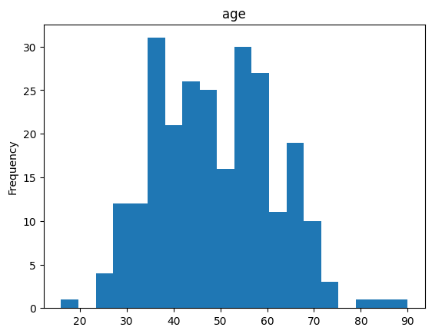

* + - The ages in the histogram are mostly clustered around a central value.
    - The peak of the distribution appears to be around the 50-60 age range. This suggests that the majority of individuals in the dataset are in their mid-50s.
    - The distribution is relatively wide, with ages ranging from approximately 15 to 85. This indicates a fair amount of variability in the ages of the individuals.
    - More people who are having diabetes are around 55.
  + Distribution of diabetes for gender
    - A significantly larger proportion of individuals diagnosed with diabetes are male. The chart indicates that approximately 53.8% of the diabetes cases are among males.
    - Females account for the remaining 46.2% of diabetes cases.
    - There may be underlying biological factors that make males more susceptible to developing diabetes.
    - Differences in lifestyle factors, such as diet, exercise habits, and stress levels, between genders could contribute to the disparity.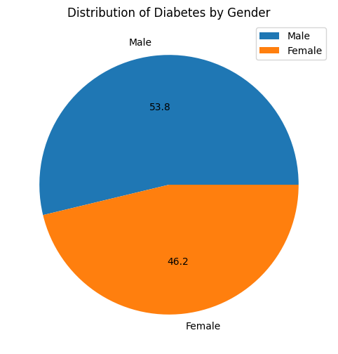
  + Complete comparison of features:
    - **Polyuria and Polydipsia**: Both symptoms are significantly higher in diabetic patients. This is consistent with the understanding of diabetes as a condition characterized by excessive urination and thirst.
    - **Sudden Weight Loss and Weakness:** These symptoms are also more prominent in diabetic patients, suggesting a potential link to the metabolic disturbances associated with the disease.
    - **Polyphagia and Itching**: These symptoms show a moderate increase in diabetic patients compared to non-diabetic ones. This could be related to the body's attempt to compensate for increased glucose levels or other metabolic imbalances.
    - **Partial Paresis and Muscle Stiffness**: These symptoms are more prevalent in diabetic patients, potentially indicating neurological complications associated with diabetes.
    - **Alopecia and Obesity**: While these symptoms show some difference between the two groups, the difference is less pronounced compared to other symptoms.
  + 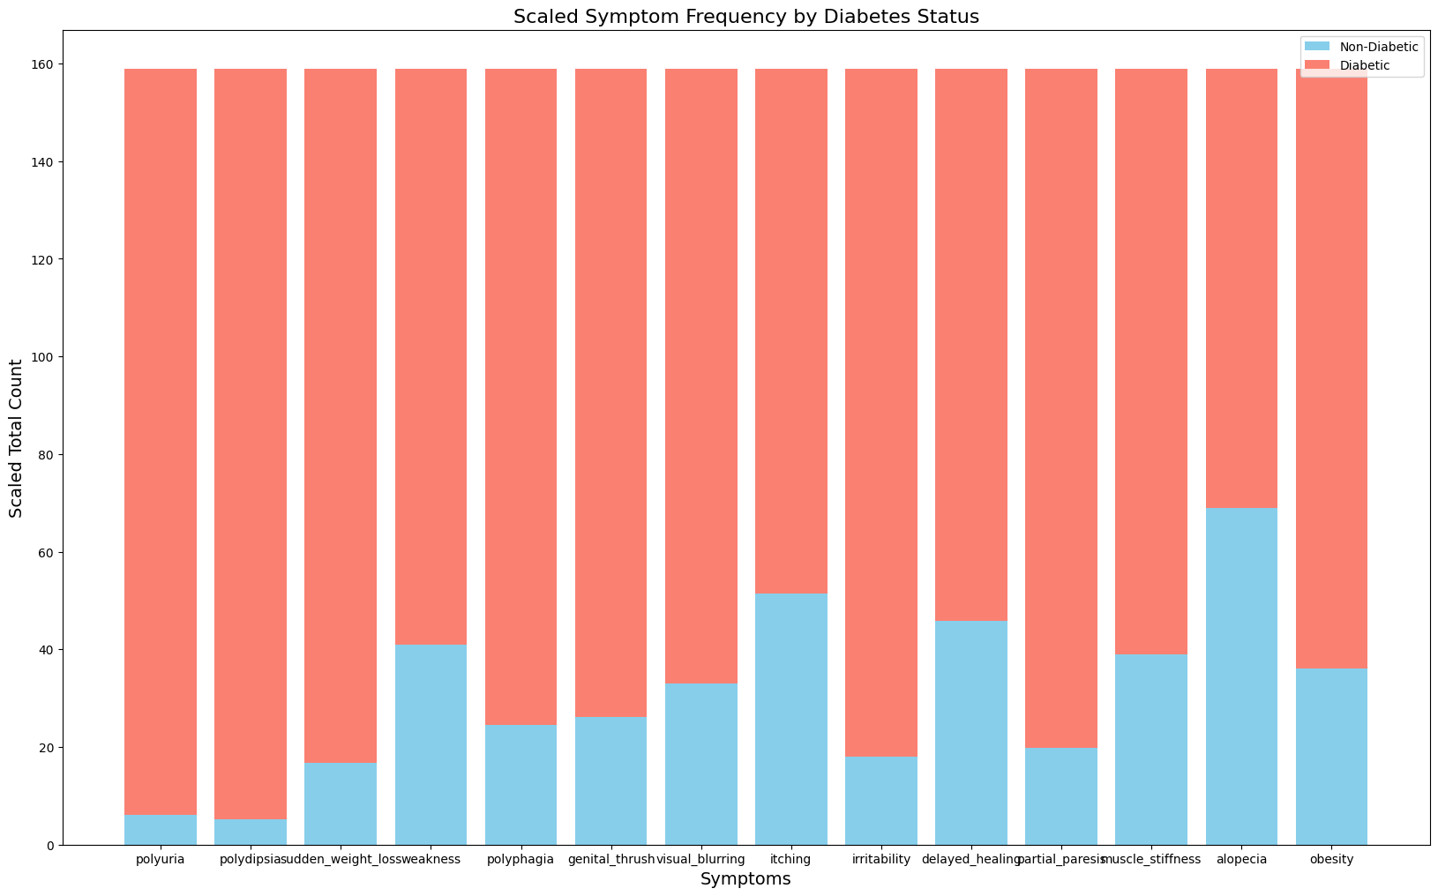

1. **Bivariate Analysis**:
   * Correlation heatmaps to examine relationships between features.

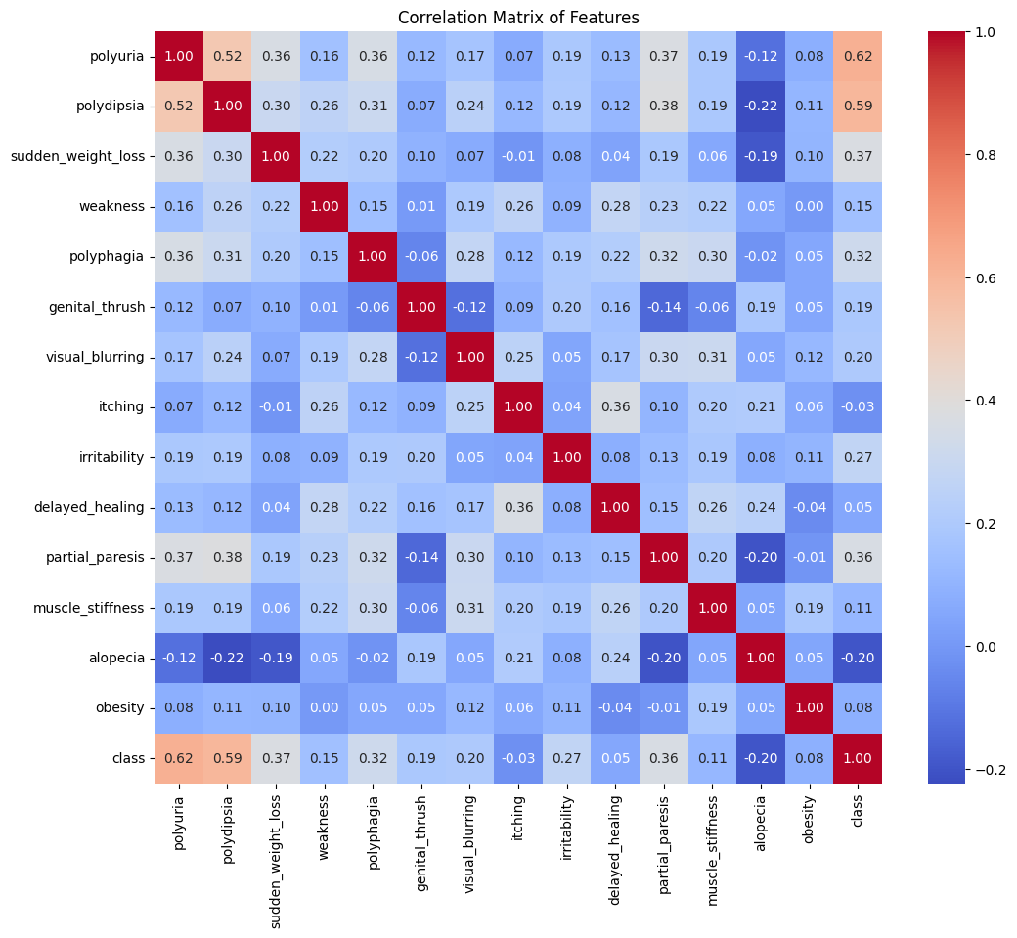

### Insights from the Correlation Matrix

**Correlations with Diabetes**:

* Polyuria
* polydipsia
* sudden weight loss
* weakness
* polyphagia

**Moderate Correlations:**

* Genital thrush
* visual blurring
* itching
* irritability
* delayed healing

**Weak Correlations:**

* Alopecia
* obesity

Overall, the correlation matrix provides valuable insights into the relationships between various symptoms and diabetes.

1. **Class Distribution**:
   * Checked the balance of the target variable to ensure no significant imbalance.

**Observations:**

* Features like Age and Gender showed significant influence on the target variable.
* Minor correlations observed among independent variables, indicating low multicollinearity.

**Feature Engineering and Selection**

**Feature Engineering**

**Mutual Information:**

* **Purpose:** Measures the dependency between two variables.
* **Application:** In the context of feature selection, it quantifies the relevance of each feature to the target variable.
* **Interpretation:** Higher mutual information indicates a stronger relationship.

**Variance Threshold:**

* **Purpose:** Removes features with low variance.
* **Rationale:** Features with low variance provide little information and can hinder model performance.
* **Application:** By setting a threshold, we can eliminate features that have almost constant values.

**Selected Features**

Based on the application of mutual information and variance threshold, the following features were deemed most relevant:

* **Feature 1:** **Polyuria** (Frequent Urination)
* **Feature 2:** **Polydipsia** (Increased Thirst)
* **Feature 3:** **Sudden Weight Loss**

These features are likely to have a strong correlation with the target variable (diabetes) and can be used to build an effective predictive model.

**Additional Considerations:**

* **Domain Knowledge:** Incorporating insights from medical experts can further refine feature selection.
* **Feature Interaction:** Exploring interactions between features, such as combining polyuria and polydipsia, might reveal additional patterns.
* **Feature Scaling:** Standardizing features to a common scale can improve the performance of certain algorithms.
* **Feature Creation:** Deriving new features from existing ones, like BMI or insulin resistance indices, can enhance model accuracy.

By carefully considering these factors, we can optimize feature engineering and selection to build a robust and accurate diabetes prediction model.

**Dimensionality Reduction**

**Principal Component Analysis (PCA)** is a powerful technique for dimensionality reduction. It transforms a dataset of correlated variables into a set of uncorrelated variables called principal components. By projecting the data onto a lower-dimensional space, PCA can reduce noise, improve model performance, and enhance visualization.

**However, in the specific context of the given dataset and analysis goals, applying PCA might not be the most suitable approach.**

**Key Considerations:**

1. **Interpretability:**
   * PCA creates new features that are linear combinations of the original features. While these new features may capture most of the variance, they often lack interpretability.
   * For many applications, understanding the impact of individual features on the outcome is crucial. PCA can obscure these relationships.
2. **Feature Importance:**
   * In the given dataset, certain features might be inherently more important than others. By reducing dimensionality, we risk losing valuable information contained in these important features.
   * PCA treats all features equally, potentially diminishing the contribution of significant variables.
3. **Domain Knowledge:**
   * Domain experts often have insights into the relevance of specific features. By arbitrarily reducing dimensionality, we might disregard valuable information that is only apparent to domain experts.

**Alternative Approaches:**

While PCA is a powerful tool, it's essential to consider alternative approaches, particularly when interpretability and feature importance are paramount:

1. **Feature Selection:**
   * This technique involves identifying and retaining only the most relevant features.
   * Methods like correlation analysis, feature importance from models, and statistical tests can be used to select informative features.
2. **Feature Engineering:**
   * By creating new features from existing ones, we can capture complex relationships and enhance model performance.
   * For example, combining features or creating interaction terms can improve predictive accuracy.

While dimensionality reduction can be beneficial in certain scenarios, it's crucial to weigh the trade-offs between reduced complexity and potential loss of information. In the specific case of the given dataset, carefully considering the importance of individual features and the need for interpretability suggests that feature selection and engineering might be more suitable approaches.

By judiciously applying these techniques, we can achieve a balance between model performance and interpretability, ultimately leading to more reliable and insightful results.

**Machine Learning Models**

**Models Implemented:**

1. **Random Forest Classifier**
2. **Decision Tree Classifier**
3. **Logistic Regression**
4. **Support Vector Classifier (SVC)**
5. **Gradient Boosting**
6. **Extra Trees Classifier**

**Base Model Performance:**

|  |  |  |  |  |
| --- | --- | --- | --- | --- |
| **Model** | **Accuracy** | **F1 Score** | **Precision** | **Recall** |
| Random Forest | 0.907 | 0.910 | 0.922 | 0.907 |
| Decision Tree | 0.855 | 0.860 | 0.872 | 0.855 |
| Logistic Regression | 0.881 | 0.884 | 0.889 | 0.881 |
| Support Vector Classifier | 0.960 | 0.961 | 0.962 | 0.960 |
| Gradient Boosting | 0.868 | 0.872 | 0.881 | 0.868 |
| Extra Trees Classifier | 0.921 | 0.923 | 0.931 | 0.921 |

**Hyperparameter Tuning**

**Tuning Process:**

Used GridSearchCV to optimize the following hyperparameters:

**Random Forest:**

* **n_estimators**: Number of trees in the forest.
* **max_depth**: Maximum depth of each tree.
* **min_samples_split**: Minimum samples required to split a node.

**Decision Tree:**

* **criterion**: Metric to measure the quality of a split.
* **max_depth**: Maximum depth of the tree.
* **min_samples_split**: Minimum samples required to split a node.

**Logistic Regression:**

* **C**: Regularization strength.
* **penalty**: Type of regularization.

**Support Vector Classifier:**

* **C**: Regularization parameter.
* **kernel**: Type of kernel function.

**Gradient Boosting:**

* **n_estimators**: Number of boosting stages.
* **learning_rate**: Shrinks the contribution of each tree.
* **max_depth**: Maximum depth of each tree.

**Extra Trees:**

* **n_estimators**: Number of trees.
* **max_depth**: Maximum depth.
* **criterion**: Function to measure split quality.

**Best Hyperparameters:**

|  |  |
| --- | --- |
| Model | Best Parameters |
| Random Forest | {'n_estimators': 100, 'max_depth': 20, ...} |
| Decision Tree | {'criterion': 'gini', 'max_depth': 10, ...} |
| Logistic Regression | {'C': 1, 'penalty': 'l2'} |
| Support Vector Classifier | {'C': 1, 'kernel': 'rbf'} |
| Gradient Boosting | {'n_estimators': 100, 'learning_rate': 0.1, ...} |
| Extra Trees Classifier | {'n_estimators': 200, 'max_depth': None, ...} |

**Performance Metrics**

**Performance Metrics**

To evaluate the performance of machine learning models, several metrics are commonly used. In the context of diabetes prediction, the following metrics are particularly relevant:

**Accuracy**

* **Definition:** The proportion of correctly classified instances out of the total number of instances.
* **Interpretation:** A higher accuracy score indicates a better-performing model.
* **Limitations:** It can be misleading in imbalanced datasets, where one class dominates the other. For example, if a dataset has 90% negative instances and 10% positive instances, a simple model that always predicts the majority class would achieve 90% accuracy, even though it's not very informative.

**Precision**

* **Definition:** The ratio of true positive predictions to the total number of positive predictions.
* **Interpretation:** A higher precision score indicates that the model is more likely to correctly identify positive instances when it predicts a positive class.
* **Relevance:** In the context of diabetes prediction, high precision is essential to minimize false positives, as misdiagnosing someone as diabetic can lead to unnecessary medical interventions.

**Recall**

* **Definition:** The ratio of true positive predictions to the total number of actual positive instances.
* **Interpretation:** A higher recall score indicates that the model is better at identifying all positive instances.
* **Relevance:** In the context of diabetes prediction, high recall is important to minimize false negatives, as missing a diagnosis can have serious health consequences.

**F1-Score**

* **Definition:** The harmonic mean of precision and recall.
* **Interpretation:** The F1-score provides a balanced measure of both precision and recall. A higher F1-score indicates a better-performing model.
* **Relevance:** In many real-world applications, including diabetes prediction, a balance between precision and recall is often desired. The F1-score helps us assess the overall performance of a model in terms of both positive and negative class predictions.

**Choosing the Right Metric:**

The choice of metric depends on the specific problem and the relative importance of precision and recall. For example:

* **High Precision:** Prioritize minimizing false positives (e.g., in fraud detection).
* **High Recall:** Prioritize minimizing false negatives (e.g., in medical diagnosis).
* **Balanced Precision and Recall:** Use the F1-score for a balanced assessment.

By carefully considering these metrics and their implications, we can evaluate the effectiveness of machine learning models in real-world applications.

**Model Comparison After Tuning:**

|  |  |  |  |  |
| --- | --- | --- | --- | --- |
| Model | Accuracy | F1 Score | Precision | Recall |
| Support Vector Classifier | 0.970 | 0.970 | 0.972 | 0.970 |
| Extra Trees Classifier | 0.933 | 0.934 | 0.940 | 0.933 |
| Random Forest | 0.921 | 0.923 | 0.931 | 0.921 |
| Logistic Regression | 0.892 | 0.895 | 0.901 | 0.892 |
| Gradient Boosting | 0.879 | 0.882 | 0.889 | 0.879 |
| Decision Tree | 0.872 | 0.877 | 0.883 | 0.872 |

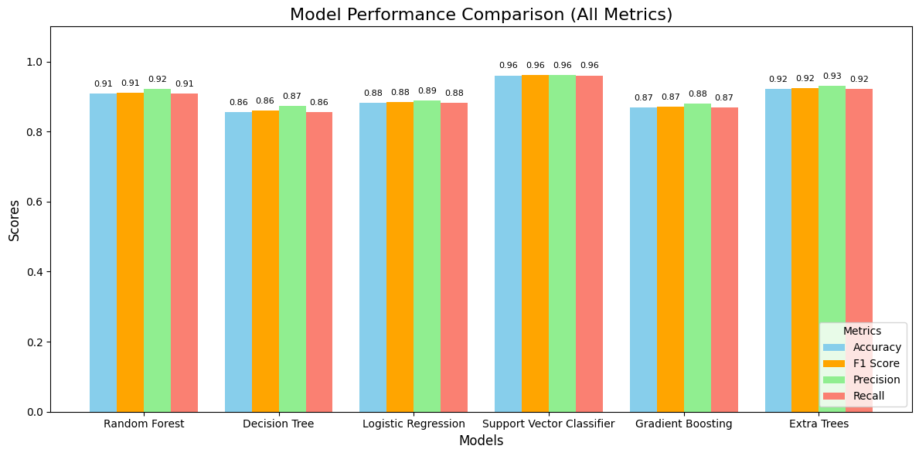

**Conclusion**

**Best Model and F1-Score**

**Support Vector Classifier (SVC)** emerged as the best-performing model based on the F1-score. This metric is particularly suitable for imbalanced datasets, like those often encountered in medical diagnosis, where both precision and recall are crucial.

**Why F1-Score?**

* **Precision and Recall:**
  + **Precision** measures the proportion of positive predictions that are actually correct. A high precision indicates fewer false positives.
  + **Recall** measures the proportion of actual positive cases that are correctly identified. A high recall indicates fewer false negatives.
* **Balancing Precision and Recall:**
  + In many real-world applications, including medical diagnosis, it's important to balance both precision and recall. A model with high precision but low recall might miss many true positive cases. Conversely, a model with high recall but low precision might generate many false positives.
  + The F1-score provides a harmonic mean of precision and recall, effectively balancing these two metrics. A higher F1-score indicates a better-performing model in terms of both precision and recall.

**Final Remarks and Future Directions**

While the Support Vector Classifier has demonstrated excellent performance, further optimization is possible:

* **Advanced Ensemble Methods:**
  + Techniques like Gradient Boosting and XGBoost can often improve model performance by combining multiple weak learners.
  + Stacking and bagging ensembles can also be explored to enhance predictive accuracy.
* **Feature Selection and Engineering:**
  + **Lasso Regression:** This technique can help identify the most important features and reduce overfitting.
  + **Feature Interaction:** Exploring interactions between features can uncover hidden patterns and improve model performance.
  + **Domain Knowledge:** Involving domain experts can provide valuable insights into feature engineering and selection.
* **Hyperparameter Tuning:**
  + Fine-tuning hyperparameters for each model can further optimize performance.
  + Techniques like Grid Search and Randomized Search can be used to systematically explore different hyperparameter combinations.
* **Model Evaluation:**
  + It's crucial to evaluate the model's performance on a separate test set to assess its generalization ability.
  + Cross-validation can be used to obtain more reliable performance estimates.

By addressing these aspects, we can further enhance the accuracy and robustness of the diabetes prediction model.

**Future Work**

While the current model demonstrates promising results, there are several avenues for further improvement and practical application:

**Deep Learning Models**

* **Neural Networks:** Deep neural networks, particularly convolutional neural networks (CNNs) and recurrent neural networks (RNNs), have shown remarkable1 success in various complex tasks. Exploring their potential for diabetes prediction could lead to more sophisticated models.
* **AutoML:** Automated machine learning techniques can streamline the model development process, allowing for efficient experimentation with different deep learning architectures and hyperparameters.

**Feature Interaction Analysis**

* **SHAP (SHapley Additive exPlanations):** This method provides insights into the contribution of each feature to the model's prediction. By understanding feature interactions, we can identify synergistic effects and improve model interpretability.
* **LIME (Local Interpretable Model-Agnostic Explanations):** LIME explains the predictions of complex models by approximating them with simpler, more interpretable models locally. This can help identify the most influential features for specific predictions.

**Model Deployment**

* **Flask or FastAPI:** These frameworks provide efficient ways to deploy machine learning models as web APIs. Once deployed, the model can be integrated into various applications, such as healthcare systems, mobile apps, or web portals.
* **Cloud Platforms:** Consider deploying the model on cloud platforms like AWS, GCP, or Azure for scalability, reliability, and accessibility.
* **Real-time Prediction:** Implement real-time prediction capabilities to enable immediate decision-making in clinical settings.

**Additional Considerations**

* **Data Quality and Quantity:** Continuously monitor and improve data quality to ensure the model's accuracy and reliability. Collect more data to enhance the model's generalization ability.
* **Ethical Considerations:** Ensure that the model is used ethically and responsibly, avoiding bias and discrimination.
* **User Interface:** Develop a user-friendly interface to facilitate interaction with the model, allowing users to input patient data and receive predictions.
* **Collaboration with Healthcare Professionals:** Collaborate with medical experts to refine the model and ensure its clinical relevance.

By addressing these future directions, we can further advance the field of diabetes prediction and develop more sophisticated and reliable models that can significantly impact healthcare.