Generative Modeling for Inclusive Facial Image Creation

Course: CPS584 Advanced Intelligent Systems and Deep Learning

Team Members:
Name: Sriraj Guptha Batchu
ID: 1017499100
Name: Vinitha Uppunuru
ID: 1017928230

- Introduction
Generative models have become crucial in creating hyper-realistic digital content, such as virtual avatars and movie characters, especially as technology increasingly shapes how we interact with one another. However, a critical question remains: how accurately do these models capture the full diversity of human identities?
To address this, this project blends the features of three distinct ethnic groups—Orientals, Indians, and White Europeans—while exploring synthetic face generation. Our aim is to balance the unique characteristics of each ethnic group with seamless, composite imagery, using diffusion models, a cutting-edge generative technique inspired by natural diffusion processes.
Beyond the technical aspects, this project also emphasizes the importance of diversity in digital imagery. By focusing on fair representation, it ensures that AI-generated content reflects the inclusiveness of our world. Ultimately, it’s a step toward ensuring that the digital faces of tomorrow genuinely represent the broad spectrum of human identity.

2. Project Description
The project is structured into three key phases, each contributing to the successful implementation of a generative system designed to create diverse and inclusive synthetic facial imagery.

1. Data Preparation
The first step was to collect and process a dataset of facial images representing three ethnic groups: Orientals, Indians, and White Europeans. Here's how it was done:
- Collecting Data: We sourced facial images from publicly available repositories, like the Fairface Dataset, to ensure a broad and representative collection of features.
- Preparing the Images: To ensure consistency, all images were resized to a standard resolution, normalized for quality, and categorized into the three demographic groups.
- Enhancing Diversity: We applied techniques like flipping, rotating, and cropping the images to increase variety and ensure that the dataset was balanced and fair.
This thorough preparation created a strong and reliable dataset, setting the stage for effective model training and ensuring fair representation of all groups.

2. Model Development
The core of the project involved building an advanced generative model using a class-conditioned U-Net architecture. Key aspects of this phase included:
- Class Conditioning: By integrating class embeddings, the model was able to generate images specifically tailored to individual ethnic groups or combinations of groups. This gave the system precise control over the features being generated.
- Learning Patterns: The model effectively learned detailed patterns unique to each demographic group, making it possible to blend features from multiple groups seamlessly and realistically.
- Generating High-Quality Images: Thanks to the U-Net’s innovative design, the model produced lifelike and visually accurate images, consistently achieving impressive results.
This phase demonstrated the model’s ability to handle complex generative tasks while maintaining high-quality outputs.

3. Image Generation
In the final phase, the trained model was put to work, creating synthetic facial images that highlighted its generative capabilities:
- Creating the Images: The model generated ten facial images for each combination of the selected ethnic groups, including blends of two groups (e.g., Orientals + Indians) and all three groups combined.
- Blending Features: By interpolating between class embeddings, the model created smooth, realistic blends of facial features from the different groups.
- Deliverables:
  - A full collection of synthetic images for all group combinations, showcasing the diversity and accuracy of the model.
  - A detailed report explaining the process, findings, and results.
  - A video demonstration highlighting the model’s ability to create high-quality synthetic images.
This phase showcased the creative potential of generative AI, pushing the boundaries of what diffusion models can achieve in terms of diversity and precision.

3. Tasks Overview
The project was systematically divided into four primary tasks, each focusing on a critical aspect of the development and implementation process:

Task 1: Preparing the Dataset
The first step was all about building a reliable and balanced dataset to train the model. This involved:
- Collecting Images: We gathered facial images from three ethnic groups: Orientals, Indians, and White Europeans.
- Standardizing and Cleaning: All images were resized to a consistent size and normalized for uniform quality, ensuring everything was ready for training.
- Organizing the Dataset: The images were sorted into categories based on ethnicity, making the training process smoother and more efficient.
This step was crucial in setting a strong foundation for the model by providing a diverse and well-structured dataset.

Task 2: Building and Training the Model
This phase focused on designing and teaching the generative model how to create synthetic images. Here's what we did:
- Developing the Model: We built a diffusion-based generative model using a U-Net architecture enhanced with class embeddings. This allowed the model to generate images tailored to specific ethnic groups or combinations of groups.
- Training the Model: Using the prepared dataset, we trained the model to understand the unique features of each group and how to blend them seamlessly.
This phase brought the model to life, equipping it with the ability to create diverse and realistic facial images.

Task 3: Generating Images
With the trained model ready, we moved on to creating synthetic images. Here’s what happened:
- Image Creation: The model generated facial images for various group combinations, such as:
  - Orientals + Indians
  - Orientals + Europeans
  - Indians + Europeans
  - Orientals + Indians + Europeans
- Blending Features: By blending class embeddings, the model was able to create smooth and realistic combinations of facial features from different groups.
This step demonstrated the model’s ability to produce lifelike and diverse facial images, reflecting its creative and technical potential.

Task 4: Documenting and Presenting Results
The final task was all about showcasing what the model achieved:
- Writing a Report: We documented the project’s process, findings, and results, complete with examples of the generated images and data on the model’s performance.
- Creating a Video: A video was made to visually demonstrate the model’s capabilities and the quality of its synthetic images.
This task ensured that the project outcomes were easy to understand and share, highlighting the success of the model.

4. Data Collection
For this project, we used the Fairface Dataset, a diverse and comprehensive collection of facial images that includes individuals from various ethnic backgrounds. This dataset played a critical role in ensuring the project had a wide and inclusive representation of human features, forming the foundation for training the generative model.
One of the standout features of the Fairface Dataset is its diversity. It includes facial images from numerous ethnic groups, making it a balanced and inclusive resource. For this project, we specifically focused on three key demographic groups: Indian, Oriental, and White European. These groups were selected to highlight a variety of distinct facial characteristics while exploring how they could be blended seamlessly through generative modeling.
The dataset was instrumental in helping the model achieve its objectives. Its high-quality and reliable images provided the consistency needed for effective training, ensuring that the model could generate realistic and accurate outputs. Furthermore, the dataset allowed the model to analyze and combine unique features from each group, enabling it to create both individual and harmonized synthetic facial images.
By carefully curating the dataset, we ensured that the diffusion model had the tools it needed to succeed. This step was foundational to the project’s success, providing a strong basis for generating lifelike images that celebrate human diversity.

5. Proposed Method
To create diverse and realistic synthetic facial images, we used a combination of detailed dataset preparation and an advanced diffusion model built on an enhanced U-Net architecture. This approach allowed us to tailor the generated images to specific demographic groups and their combinations.

A. Preparing the Dataset
The first step was to prepare a robust and well-balanced dataset. Here’s how we approached it:
- Image Collection: We gathered more than 600 facial images for each of the three demographic groups—Oriental, Indian, and European.
- Preprocessing:
  - All images were resized to a uniform resolution of 28x28 pixels for consistency.
  - Normalization was applied to make the data easier for the model to work with, ensuring it was evenly distributed with a zero mean and unit variance.
- Data Augmentation: To increase diversity and help the model generalize better, we applied techniques like flipping the images horizontally and rotating them slightly.
- Class Embeddings: We added labels to the dataset that the model could use to generate images specific to each group or blends of multiple groups.

B. Building the Diffusion Model
The backbone of the project was the enhanced U-Net architecture, specifically designed to handle the complexity of blending facial features. Here’s what makes it unique:
- Down Blocks: These layers break down the input image into smaller pieces, using ResNet layers for detailed feature extraction and attention layers to focus on the most important patterns.
- Mid Block (Bottleneck): This is where the model condenses all the information into a compact form, capturing the abstract features without reducing the image size further.
- Up Blocks: These layers rebuild the image, using transpose convolutions to scale it back up. Skip connections from the Down Blocks ensure that fine details are preserved in the final image.
The architecture was repeated twice, allowing the model to learn and recreate even the most intricate patterns from the dataset.

C. Training the Model
Training the model was a step-by-step process that ensured it learned how to generate high-quality images:
- Optimizer: We used the Adam optimizer, a powerful tool that helps the model adjust its parameters efficiently during training.
- Learning Rate Scheduler: A cosine scheduler was used to gradually adjust the learning rate, helping the model learn more effectively and converge faster.
- Training: The model was trained over several cycles, or epochs, to ensure it fully understood the data and could produce accurate outputs.

D. Generating Images
Once the model was trained, we used it to create synthetic facial images. Here’s how the process worked:
- Class Conditioning: The model used the class labels (embeddings) to guide the generation process, producing images that reflected specific ethnic groups or combinations of features.
- Outputs: For each combination of demographic groups, the model generated 10 unique synthetic images. These combinations included:
  - Orientals + Indians
  - Orientals + Europeans
  - Indians + Europeans
  - Orientals + Indians + Europeans
By blending features seamlessly, the model created realistic, lifelike images that captured the distinct traits of each group while showcasing how they could be harmoniously combined.

6. Details of Implementation (at every step!) and problems you encountered?
A. Data Preparation
Getting the dataset ready for training was the first step, but it came with some challenges:
- Resizing the Images: To make the dataset uniform and compatible with the model, all images were resized to 28x28 pixels. However, this smaller resolution caused a noticeable loss of detail, as it couldn’t capture the finer facial features.
- Trying Higher Resolutions: We attempted to work with larger image sizes to preserve more detail, but the system couldn’t handle the increased memory demands. This led to frequent crashes, interrupting the preprocessing phase.
- Making a Compromise: Given the resource limitations, we had to stick with the 28x28 resolution. While this ensured the system could run smoothly, it meant sacrificing some level of detail in the images, which affected the overall quality of the generated outputs.

B. Training the Model
Training the model turned out to be a time-consuming process, with several roadblocks:
- Tuning the Learning Rate: To find the best settings for the model, we tested multiple learning rates. Each configuration required a lot of training time, which slowed down progress significantly.
- Long Training Periods: We trained the model for about 50 epochs for each configuration. This was necessary for thorough testing but added to the already lengthy training cycles.
- Limited Experimentation: Because each training cycle took so long, we didn’t have enough time to test alternative approaches or fine-tune the model’s hyperparameters as much as we wanted. This left room for potential improvements that we couldn’t explore.
- Impact on Efficiency: The lengthy training times made the overall process less efficient, slowing down the optimization and refinement of the model.

7. Program

Libraries
import os
import shutil
import pandas as pd
import torch
import pandas as pd
import numpy as np
from peft import LoraConfig, TaskType, get_peft_model

from torch.optim import Adam
import kagglehub
import shutil
import matplotlib.pyplot as plt
from PIL import Image
import torch.nn as nn
import torchvision
import random
from tqdm import tqdm
from torchvision import datasets, transforms
import os
from torchvision.utils import make_grid
from diffusers import DDPMPipeline,DDPMScheduler
device = torch.device('cuda' if torch.cuda.is_available() else 'cpu')
Setting up the path

Ind_dest="/content/train/Indian/"
white_dest='/content/train/White/'
ori_dest='/content/train/Oriental/'
train_dir='/content/train/'
import shutil
import os

# Remove directories if they exist
if os.path.exists('C:\\content\\train'):
shutil.rmtree('C:\\content\\train')
if os.path.exists('C:\\Users\\rajgu\\.cache\\kagglehub'):
shutil.rmtree('C:\\Users\\rajgu\\.cache\\kagglehub')

# Create directories
os.makedirs(Ind_dest, exist_ok=True)
os.makedirs(white_dest, exist_ok=True)
os.makedirs(ori_dest, exist_ok=True)

path = kagglehub.dataset_download("aibloy/fairface")
path+='/FairFace/'
train=pd.read_csv(path+"/train_labels.csv")
val=pd.read_csv(path+"/val_labels.csv")
category_dataframes = {}
for category, group in train.groupby('race'):
category_dataframes[category] = group.reset_index(drop=True)
ind=category_dataframes['Indian']
ori=category_dataframes['East Asian']
white=category_dataframes['White']

for root, dirs, files in os.walk("C:\\Users\\rajgu\\.cache\\kagglehub\\datasets\\aibloy\\fairface\\versions\\1"):
print(f"Root: {root}")
print(f"Directories: {dirs}")
print(f"Files: {files}")

def collect_Images(dest, df):
for file in df['file'][:600]:
# Adjust the source path to match the actual structure
src = os.path.join(path, file.replace('/', os.sep)) # Replace '/' with '\' on Windows
if os.path.exists(src):
shutil.move(src, dest)
else:
print(f"File not found: {src}")

collect_Images(Ind_dest,ind)
collect_Images(white_dest,white)
collect_Images(ori_dest,ori)

Training and Generating the image

train_dir='/content/train/'
transform = transforms.Compose([
transforms.Resize((28, 28)),
transforms.ToTensor(),
])

for b,(x,y) in enumerate(data_loader):
print("Input shape:", x.shape)
print("Labels:", y)
plt.imshow(x[5].permute(1,2,0))
break
class ClassConditionedUnet(nn.Module):
def __init__(self, num_classes=3, class_emb_size=4):
super().__init__()

# The embedding layer will map the class label to a vector of size class_emb_size
self.class_emb = nn.Embedding(num_classes, class_emb_size)

# Self.model is an unconditional UNet with extra input channels to accept the conditioning information (the class embedding)
self.model = UNet2DModel(
sample_size=28, # the target image resolution
in_channels=3 + class_emb_size, # Additional input channels for class cond.
out_channels=3, # the number of output channels
layers_per_block=2, # how many ResNet layers to use per UNet block
block_out_channels=(32, 64, 64),
down_block_types=(
"DownBlock2D", # a regular ResNet downsampling block
"AttnDownBlock2D", # a ResNet downsampling block with spatial self-attention
"AttnDownBlock2D",
),
up_block_types=(
"AttnUpBlock2D",
"AttnUpBlock2D", # a ResNet upsampling block with spatial self-attention
"UpBlock2D", # a regular ResNet upsampling block
),
)

def get_class_embed(self,class_label):
return self.class_emb(class_label)

# Our forward method now takes the class labels as an additional argument
def forward(self, x, t, class_cond):
# Shape of x:
bs, ch, w, h = x.shape

# class conditioning in right shape to add as additional input channels
# class_cond = self.class_emb(class_labels) # Map to embedding dimension
class_cond = class_cond.view(bs, class_cond.shape[1], 1, 1).expand(bs, class_cond.shape[1], w, h)
# x is shape (bs, 1, 28, 28) and class_cond is now (bs, 4, 28, 28)

# Net input is now x and class cond concatenated together along dimension 1
net_input = torch.cat((x, class_cond), 1) # (bs, 5, 28, 28)

# Feed this to the UNet alongside the timestep and return the prediction
return self.model(net_input, t).sample # (bs, 1, 28, 28)
# Create a scheduler
noise_scheduler = DDPMScheduler(num_train_timesteps=1000, beta_schedule="squaredcos_cap_v2")
net = ClassConditionedUnet().to(device)
n_epochs = 10
#
loss_fn = nn.MSELoss()
opt = torch.optim.Adam(net.parameters(), lr=5e-4)
losses = []

# The training loop
for epoch in range(n_epochs):
for x, y in tqdm(data_loader):

# Get some data and prepare the corrupted version
x = x.to(device) * 2 - 1 # Data on the GPU (mapped to (-1, 1))
y = y.to(device)
noise = torch.randn_like(x)
timesteps = torch.randint(0, 999, (x.shape[0],)).long().to(device)
noisy_x = noise_scheduler.add_noise(x, noise, timesteps)

# Get the model prediction
pred = net(noisy_x, timesteps, net.get_class_embed(y)) # Note that we pass in the labels y

# Calculate the loss
loss = loss_fn(pred, noise) # How close is the output to the noise

# Backprop and update the params:
opt.zero_grad()
loss.backward()
opt.step()

# Store the loss for later
losses.append(loss.item())

# Print out the average of the last 100 loss values to get an idea of progress:
avg_loss = sum(losses[-100:]) / 100
print(f"Finished epoch {epoch}. Average of the last 100 loss values: {avg_loss:05f}")

# View the loss curve
plt.plot(losses)
zero=net.get_class_embed(torch.tensor([1]).to(device))
one=net.get_class_embed(torch.tensor([0]).to(device))
mix=(0.4*zero+0.6*one)
x = torch.randn(1, 3, 28, 28).to(device)
for i, t in tqdm(enumerate(noise_scheduler.timesteps)):

# Get model pred
with torch.no_grad():
residual = net(x, t, mix) # Again, note that we pass in our labels y

# Update sample with step
x = noise_scheduler.step(residual, t, x).prev_sample
# plt.imshow(x.squeeze(0).permute(1,2,0).detach().cpu())
plt.imshow(x.squeeze(0).permute(1, 2, 0).cpu().clip(-1, 1) * 0.5 + 0.5);

#check 1

# Prepare random x to start from, plus some desired labels y
x = torch.randn(12, 3, 28, 28).to(device)
y = torch.tensor([[i] * 4 for i in range(3)]).flatten().to(device)

# Sampling loop
for i, t in tqdm(enumerate(noise_scheduler.timesteps)):

# Get model pred
with torch.no_grad():
residual = net(x, t, net.get_class_embed(y)) # Again, note that we pass in our labels y

# Update sample with step
x = noise_scheduler.step(residual, t, x).prev_sample

grid = torchvision.utils.make_grid(x, nrow=6)
plt.imshow(grid.permute(1, 2, 0).cpu().clip(-1, 1) * 0.5 + 0.5);
# Show the results
# fig, ax = plt.subplots(1, 1, figsize=(3, 3))
# ax.imshow(torchvision.utils.make_grid(x.detach().cpu().clip(-1, 1), nrow=3)[0])

import os
print("Current Working Directory:", os.getcwd())
torch.save(net.state_dict(),"/content/head_diff.pth")
dir_path = "C:/content"
print("Files in directory:", os.listdir(dir_path))

#check 2 for the combination

# Prepare random x to start from, plus some desired labels y
x = torch.randn(12, 3, 28, 28).to(device)
c1 = net.get_class_embed(torch.tensor([[0] * 12 ]).flatten().to(device))
c2 = net.get_class_embed(torch.tensor([[1] * 12 ]).flatten().to(device))
c3 = net.get_class_embed(torch.tensor([[2] * 12 ]).flatten().to(device))
cc=0.3*c1+0.3*c2+0.4*c2

# Sampling loop
for i, t in tqdm(enumerate(noise_scheduler.timesteps)):

# Get model pred
with torch.no_grad():
residual = net(x, t, cc) # Again, note that we pass in our labels y

# Update sample with step
x = noise_scheduler.step(residual, t, x).prev_sample

grid = torchvision.utils.make_grid(x, nrow=6)
plt.imshow(grid.permute(1, 2, 0).cpu().clip(-1, 1) * 0.5 + 0.5);
# Show the results
# fig, ax = plt.subplots(1, 1, figsize=(3, 3))
# ax.imshow(torchvision.utils.make_grid(x.detach().cpu().clip(-1, 1), nrow=3)[0])

#Final image generation of the combinations

# Import save_image
from torchvision.utils import save_image

# Image generation function
def generate_images(class_combinations, num_images=10, img_size=(28, 28)):
os.makedirs("./generated_images", exist_ok=True)
for combo_name, weights in class_combinations.items():
print(f"Generating images for combination: {combo_name}")
os.makedirs(f"./generated_images/{combo_name}", exist_ok=True)
for i in range(num_images):
x = torch.randn(1, 3, *img_size).to(device) # Random noise
cc = sum(weight * emb for weight, emb in weights)
for t in noise_scheduler.timesteps:
with torch.no_grad():
residual = net(x, t, cc)
x = noise_scheduler.step(residual, t, x).prev_sample
save_image(x.clip(-1, 1) * 0.5 + 0.5, f"./generated_images/{combo_name}/image_{i+1}.png")

# Class combinations
c1 = net.get_class_embed(torch.tensor([0]).to(device)) # Oriental
c2 = net.get_class_embed(torch.tensor([1]).to(device)) # Indian
c3 = net.get_class_embed(torch.tensor([2]).to(device)) # White

class_combinations = {
"Orientals_Indians": [(0.5, c1), (0.5, c2)],
"Orientals_White": [(0.5, c1), (0.5, c3)],
"Indian_White": [(0.5, c2), (0.5, c3)],
"Orientals_Indian_White": [(0.33, c1), (0.33, c2), (0.34, c3)],
}

generate_images(class_combinations)

# Visualize generated images
def visualize_images(combo_name):
folder = f"./generated_images/{combo_name}/"
images = [transforms.ToTensor()(Image.open(folder + f"image_{i+1}.png")) for i in range(10)]
grid = make_grid(images, nrow=5)
plt.figure(figsize=(10, 5))
plt.imshow(grid.permute(1, 2, 0))
plt.axis("off")
plt.title(f"Generated Images: {combo_name}")
plt.show()

# Example visualization
visualize_images("Orientals_Indians")
visualize_images("Orientals_White")
visualize_images("Indian_White")
visualize_images("Orientals_Indian_White")

8. Results
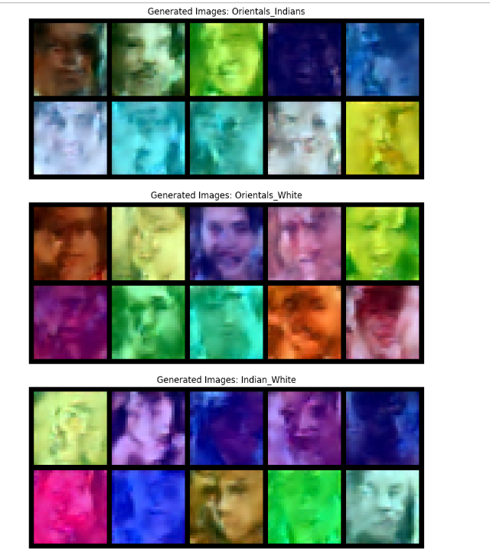
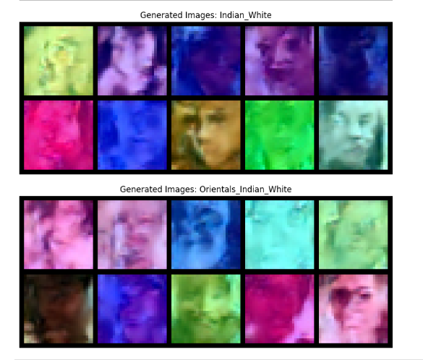

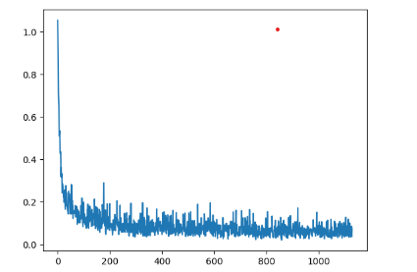

9. Conclusion
This project showed how powerful diffusion-based generative models can be in creating diverse facial images by blending features from European, Indian, and Oriental ethnic groups. Even though we faced challenges like limited batch sizes, low image resolution, and computing constraints, the model was still able to produce images that captured the key facial traits of each group.
While these limitations did affect the overall quality of the images, the results proved that diffusion models can still generate high-quality, controlled images that reflect specific ethnic features. The project demonstrated the effectiveness of these models in handling complex tasks, creating diverse and realistic synthetic faces.
In the end, this project is an important step toward using AI for more inclusive and representative content. There’s still room for improvement, and with further refinement, these models have the potential to generate even more accurate and diverse outputs in the future.

