Abstract
Waterborne diseases represent one of the most persistent and devastating public health challenges across the developing world. According to the World Health Organization (WHO 2022), contaminated drinking water sources contribute to over 829,000 diarrheal deaths annually, predominantly afflicting vulnerable pediatric populations in semi-urban and rural areas. Conventional epidemiological surveillance relies on manual microbiological water sampling, bacterial culturing, and retrospective hospital admission logging. This traditional surveillance paradigm imposes an inherent 48 to 72-hour laboratory latency, rendering it structurally incapable of providing timely early warning during rapid contaminant plume ingress, pipe cross-contamination, or monsoonal flash flooding events.
This project presents an end-to-end Machine Learning (ML) and Geographic Information System (GIS) surveillance framework designed to transform real-time physicochemical water quality telemetry into predictive outbreak risk intelligence. Using a comprehensive dataset of 3,276 water quality observations, an outlier-resistant median imputation methodology resolves 1,434 missing values across pH, sulfate, and trihalomethanes with zero record attrition. Two novel domain-engineered indicators—the Contamination Risk Index (CRI) and WHO pH Safe Range Deviation—are formulated to encapsulate non-linear geochemical hazard signals.
A rigorous 5-Fold Stratified Cross-Validation benchmark across multiple candidate algorithms reveals that while linear models completely fail (Logistic Regression achieving 49.27% accuracy and 0.528 ROC-AUC due to all bivariate correlations falling below |r| < 0.07), non-linear ensemble classifiers effectively capture multi-parameter interactions. The optimized Random Forest classifier achieves an accuracy of 64.77% ± 1.07% with an ROC-AUC of 0.672, securing a high 76.0% recall on unsafe water bodies on an independent holdout evaluation. Gini impurity analysis establishes that Sulfate (15.64%), pH (12.17%), and Hardness (11.27%) represent the primary decision drivers. The predictive engine is operationalized into an interactive Folium GIS surveillance map with simulated Bangalore municipal ward clusters and an interactive 4-tab Streamlit dashboard (app.py) enabling real-time risk triage, GIS visualization, benchmark analytics, and batch CSV screening for municipal water authorities.

TABLE OF CONTENTS
CHAPTER NO | TITLE | PAGE NO
 | ABSTRACT | v
 | TABLE OF CONTENTS | vi
 | LIST OF FIGURES | viii
 | LIST OF TABLES | ix
 | ABBREVIATIONS | x
1. | INTRODUCTION | 1
 | 1.1 Background and Motivation | 1
 | 1.2 Scope and Limitations | 2
 | 1.3 Problem Statement | 3
 | 1.4 Motivation | 3
 | 1.5 Methodology Overview | 4
 | 1.6 Organization of the Thesis | 5
2. | LITERATURE SURVEY | 6
 | 2.1 Introduction to Related Work | 6
 | 2.2 Survey of Existing Systems and Approaches | 7
 | 2.3 Synthesis of the Literature | 10
 | 2.4 Relevance to the Proposed Project | 11
 | 2.5 Summary | 12
3. | RESEARCH GAPS OF EXISTING METHODS | 13
4. | PROPOSED METHODOLOGY | 15
 | 3.1 Methodology Outline | 15
 | 3.2 Tools, Technologies, and Platforms Used | 16
 | 3.3 Proposed System Architecture | 17
 | 3.4 Case Data Collection and Preprocessing | 19
 | 3.5 Dataset Description | 22
 | 3.6 Workflow Diagram | 24
 | 3.7 Summary | 25
5. | OBJECTIVES | 26
6. | SYSTEM DESIGN & IMPLEMENTATION | 28
 | 4.1 Module-Wise Implementation Details | 28
 | 4.2 Algorithms | 32
 | 4.3 System Visualizations and Interfaces | 34
 | 4.4 Integration of Components | 36
 | 4.5 Summary | 37
7. | TIMELINE FOR EXECUTION OF PROJECT (GANTT CHART) | 38
8. | OUTCOMES | 40
9. | RESULTS AND DISCUSSION | 42
 | 5.1 Experimental Setup and Environment | 42
 | 5.2 Performance Metrics Used | 43
 | 5.3 Comparative Benchmark Results | 44
 | 5.4 Analysis and Interpretation of Results | 46
 | 5.5 Discussion on Outcomes & Feature Attribution | 48
 | 5.6 Summary | 50
10. | CONCLUSION AND FUTURE WORK | 51
11. | REFERENCES | 54
 | APPENDIX A: SYSTEM REQUIREMENTS AND TECHNOLOGIES | 57
 | APPENDIX B: SCREENSHOTS OF THE IMPLEMENTED SYSTEM | 59
 | APPENDIX C: SAMPLE TEST CASES AND RESULTS | 63
 | APPENDIX D: ENCLOSURES AND SDG MAPPING | 65

LIST OF FIGURES
Sl. No. | Figure Name | Caption | Page No.
1 | Figure 3.1 | Proposed System Architecture Diagram | 18
2 | Figure 3.2 | Data Preprocessing and Imputation Workflow | 21
3 | Figure 3.3 | End-to-End Disease Outbreak Risk Prediction Workflow | 24
4 | Figure 4.1 | Random Forest Gini Impurity Feature Importance Ranking | 30
5 | Figure 4.2 | Pairwise Pearson Feature Correlation Heatmap | 31
6 | Figure 4.3 | Normalized Confusion Matrix of the Production Random Forest Model | 33
7 | Figure 4.4 | Main Dashboard of the Water Quality Risk Prediction Portal (app.py) | 35
8 | Figure 4.5 | Interactive GIS Outbreak Risk Surveillance Map View | 36
9 | Figure 7.1 | Gantt Chart for Project Execution (16-Week Progress) | 39
10 | Figure 9.1 | Receiver Operating Characteristic (ROC) Multi-Model Benchmark | 45
11 | Figure B.1 | Streamlit Real-Time Risk Calculator Interface | 59
12 | Figure B.2 | GIS Spatial Surveillance Multi-Layer Bangalore Map | 60
13 | Figure B.3 | Model Performance Analytics and Evaluation Dashboard | 61
14 | Figure B.4 | Batch CSV Telemetry Ingestion and Ward Triage View | 62

LIST OF TABLES
Sl. No. | Table Name | Table Caption | Page No.
1 | Table 3.1 | Physicochemical Water Parameters, Measurement Units & Health Thresholds | 20
2 | Table 4.1 | Missing Telemetry Value Imputation Summary (Zero Record Attrition) | 22
3 | Table 5.1 | Qualitative Comparison: Conventional Surveillance vs Proposed ML-GIS Platform | 44
4 | Table 9.1 | 5-Fold Stratified Cross-Validation Benchmark Performance Across All Models | 45
5 | Table C.1 | End-to-End System Functional Verification Test Cases (TC-01 to TC-08) | 63
6 | Table D.1 | Mapping of Project Deliverables to United Nations Sustainable Development Goals | 66

Abbreviations
Abbreviation | Full Form
AI | Artificial Intelligence
API | Application Programming Interface
AUC-ROC | Area Under Curve - Receiver Operating Characteristic
BBMP | Bruhat Bengaluru Mahanagara Palike
CRI | Contamination Risk Index
CSV | Comma-Separated Values
CV | Cross-Validation
EPA | Environmental Protection Agency (United States)
ET | Extra Trees Classifier
GBDT | Gradient Boosted Decision Trees
GIS | Geographic Information System
GUI | Graphical User Interface
IoT | Internet of Things
JSON | JavaScript Object Notation
KNN | K-Nearest Neighbors
LR | Logistic Regression
ML | Machine Learning
NTU | Nephelometric Turbidity Units
OOP | Object-Oriented Programming
PPM | Parts Per Million (mg/L)
RF | Random Forest Classifier
REST | Representational State Transfer
SDG | Sustainable Development Goal (United Nations)
SHAP | Shapley Additive Explanations
TDS | Total Dissolved Solids
THM | Trihalomethanes
UI | User Interface
URL | Uniform Resource Locator
WQI | Water Quality Index
WHO | World Health Organization

CHAPTER 1
INTRODUCTION
1.1 Background and Motivation
Water is the fundamental prerequisite for human life, economic development, and ecological stability. However, the transmission of pathogenic microorganisms through contaminated drinking water remains one of the most severe public health crises globally. The World Health Organization (WHO 2022) estimates that over two billion people worldwide drink water from sources contaminated with feces, resulting in an estimated 829,000 diarrheal deaths each year. Waterborne infectious diseases—including cholera (Vibrio cholerae), typhoid fever (Salmonella typhi), amoebiasis, and bacillary dysentery—disproportionately impact vulnerable populations in semi-urban settlements, informal housing colonies, and rural agrarian districts across India.
The primary challenge in managing waterborne epidemics lies in the operational time lag of traditional public health surveillance. Conventional epidemiological monitoring relies on microbiological water testing, primarily culture-based membrane filtration and bacterial incubation, to detect Escherichia coli or thermotolerant coliforms. These microbiological laboratory procedures require a mandatory incubation period of 48 to 72 hours. In practice, by the time laboratory culture results confirm severe pathogenic contamination in a municipal water reservoir or pipeline, hundreds of residents have already ingested the contaminated water, and clinical admissions at primary healthcare centers have already surged. This creates a reactive crisis-response posture, where interventions (such as superchlorination, water tanker deployment, and medical camps) occur only after significant morbidity has taken hold.
Recent breakthroughs in Internet of Things (IoT) sensors and rapid physicochemical telemetry offer a transformative solution. Physical and chemical water properties—including pH, electrical conductivity, turbidity, total dissolved solids, chloramine residual, and organic carbon—can be monitored in near real-time using in-situ probe sensors. While these chemical sensors do not directly isolate specific microbial pathogens, they provide vital surrogate indicators of water quality deterioration. For instance, elevated turbidity shields bacteria from ultraviolet disinfection, depleted chloramines indicate the exhaustion of protective biocides, and spikes in organic carbon provide the organic substrate necessary for explosive bacterial proliferation. Machine Learning models trained on multi-parameter water telemetry can discover complex non-linear interactions across these chemical indicators and predict outbreak risks instantaneously, bridging the critical 48-hour diagnostic gap.
1.2 Scope and Limitations
Scope of the Work: The primary scope of project PRJ_441 encompasses the design, implementation, benchmarking, and deployment of a full-stack AI-driven spatial surveillance and outbreak risk prediction platform. The specific functional capabilities implemented in this research include:
• Data Ingestion and Cleaning: Automated preprocessing and robust median imputation of 3,276 water quality records across 9 physicochemical attributes with zero row attrition.
• Geochemical Feature Engineering: Mathematical formulation of the Contamination Risk Index (CRI) and WHO pH Safe Range Deviation to enrich tabular feature representations.
• Supervised Multi-Model Benchmarking: 5-Fold Stratified Cross-Validation comparison across Random Forest, Gradient Boosted Decision Trees, Extra Trees, and Logistic Regression.
• Spatial GIS Surveillance: Development of an interactive Leaflet/Folium multi-layer geographic visualization engine mapping simulated Bangalore municipal ward clusters into 3-tier risk categories (Low, Medium, High).
• Production Web Dashboard: Implementation of an interactive 4-tab Streamlit dashboard (app.py) providing real-time slider-based risk inference, interactive GIS maps, model analytics, and batch CSV triage.
System Limitations: The system operates under defined operational boundaries and technical constraints. The chemical dataset utilized (Kaggle Water Potability) contains physicochemical indicators but does not include direct biological metagenomic sequencing or real-time PCR bacterial counts. Sensor measurements in real-world municipal deployments can experience drift or transient hardware sensor faults. Furthermore, the GIS spatial mapping utilizes simulated municipal ward telemetry distributed across Bangalore geographic coordinates to demonstrate scalable municipal deployment. Model inferences serve as automated decision-support alerts for public health epidemiologists rather than legally binding clinical diagnoses.
1.3 Problem Statement
Conventional municipal water monitoring systems exhibit three systemic deficiencies that perpetuate waterborne disease outbreaks: (1) An unavoidable 48 to 72-hour microbiological laboratory latency that prevents early intervention before clinical symptoms emerge; (2) The total absence of spatial intelligence linking water telemetry to geographic municipal ward boundaries, preventing health officers from tracking contaminant plume propagation; and (3) A reliance in academic literature on synthetic, artificially clean datasets that produce deceptively high accuracy claims (>95%) while catastrophically failing when deployed on real-world noisy water data characterized by weak individual feature correlations (|r| < 0.07). The objective of this project is to develop, rigorously validate, and deploy an integrated ML and GIS early-warning software system that bypasses laboratory delays, handles real-world missing data robustly, and delivers actionable ward-level risk intelligence to public health authorities.
1.4 Motivation
The compelling motivation behind this research stems from the preventable nature of waterborne epidemics. Unlike airborne viruses that diffuse unpredictably, waterborne pathogens are physically constrained by municipal pipe networks, open water reservoirs, and drainage infrastructure. By monitoring the physicochemical barrier integrity of water distribution networks, contamination can be detected at the source. Shifting from reactive medical treatment to predictive early warning aligns directly with the United Nations Sustainable Development Goals (SDG 3: Good Health and Well-Being, and SDG 6: Clean Water and Sanitation). Furthermore, providing municipal engineers with transparent feature attribution (Gini importance) empowers rapid field remediation—such as dispatching secondary chlorination booster pumps or repairing localized pipe fractures—before an outbreak escalates into an uncontrolled epidemic.
1.5 Methodology Overview
Methodological Workflow: The project follows an end-to-end modular software and machine learning engineering workflow:
1. Data Acquisition & Audit: Ingestion of 3,276 water telemetry observations from the benchmark Kaggle repository, evaluating missing value distributions and class imbalance.
2. Outlier-Resistant Imputation: Non-parametric median imputation across pH (491 missing), Sulfate (781 missing), and Trihalomethanes (162 missing) to preserve all 3,276 records.
3. Geochemical Feature Engineering: Formulation of the Contamination Risk Index (CRI) combining turbidity, organic carbon, and THMs, alongside WHO pH safe range deviation.
4. Stratified Model Training & Selection: 5-Fold Stratified Cross-Validation benchmarking of four candidate classifiers, selecting the 200-tree Random Forest ensemble based on ROC-AUC (0.672) and unsafe recall (76.0%).
5. GIS Spatial Mapping & Web Application: Serializing the trained pipeline into production joblib artifacts and deploying a multi-layer Folium GIS map and Streamlit web dashboard.
1.6 Organization of the Thesis
1.6.1 Logical Flow of the Research Work
The thesis progresses logically from clinical problem formulation and literature analysis through mathematical modeling, experimental benchmarking, spatial surveillance architecture, and operational web deployment.
1.6.2 Contribution Mapping Across Chapters
Chapter 2 reviews related work in ML water quality indices and GIS epidemiology. Chapter 3 defines critical research gaps. Chapter 4 presents the complete methodology and mathematical formulation. Chapter 5 formalizes project objectives. Chapter 6 details system design, OOP architecture, and algorithm logic. Chapter 7 presents the 16-week execution Gantt chart. Chapter 8 summarizes technical outcomes. Chapter 9 presents 5-fold CV benchmarks and discussion. Chapter 10 concludes the dissertation with future research directions, followed by References and Appendices A through D.
1.6.3 Chapter Overview Summary
Each chapter is self-contained yet systematically builds toward validating the technical feasibility and public health utility of the proposed ML-GIS platform.

CHAPTER 2
LITERATURE SURVEY
2.1 Introduction to Related Work
Applying machine learning and spatial intelligence to environmental monitoring and public health has garnered substantial academic attention over the past decade. Research spans three interconnected domains: conventional Water Quality Index (WQI) formulations, supervised classification of water potability, and GIS-based epidemiological cluster surveillance.
2.2 Survey of Existing Systems and Approaches
2.2.1 Conventional Water Quality Indices (WQI) and Physicochemical Modeling
Traditional water assessment relies on empirical WQI formulations, such as the Canadian Council of Ministers of the Environment (CCME) WQI or the National Sanitation Foundation (NSF) WQI. These indices aggregate multiple chemical parameters using rigid weighting functions. Saha and Bhowmik (2020) demonstrated that while traditional WQI methods offer standardized grading, they fail to capture complex, non-linear interactions between disparate chemical species—such as the synergistic toxicity between high sulfate concentrations and acidic pH. Machine learning models provide a data-driven alternative, capable of mapping multi-dimensional feature topologies without manual heuristic weight assignment.
2.2.2 Supervised Machine Learning for Water Potability Prediction
Recent literature has evaluated various classification architectures on tabular water quality data. Kadiwal (2021) introduced the benchmark 3,276-sample Kaggle water potability dataset. Numerous published works have evaluated algorithms ranging from Support Vector Machines (SVM) and Multi-Layer Perceptrons (MLP) to ensemble decision trees (Random Forest, XGBoost, LightGBM). However, a pervasive issue in published studies is the misinterpretation of accuracy metrics. Several papers report unrealistic classification accuracies exceeding 90% or 95% on small synthetic datasets or through inappropriate cross-validation setups that introduce data leakage. On real-world environmental data, as demonstrated by Breiman (2001) and Pedregosa et al. (2011), non-linear decision tree ensembles typically achieve realistic accuracies between 63% and 68%, reflecting the high stochastic variance and weak linear feature correlations inherent to natural water bodies.
2.2.3 Spatial Epidemiology and GIS Surveillance
Geographic Information Systems have played a foundational role in epidemiology since John Snow's historic 1854 cholera map of the Broad Street pump in London. In modern public health, Few, Lake, and Hunter (2013) reviewed the integration of spatial mapping with flood risk and waterborne disease transmission. They noted that while modern municipal authorities collect extensive water data, the telemetry is rarely integrated into interactive spatial GIS systems that update dynamically. Existing systems operate as post-outbreak archival repositories rather than prospective real-time warning platforms.
2.3 Synthesis of the Literature
A critical synthesis of the literature reveals that existing systems either focus purely on chemical classification without spatial geographic awareness, or focus on GIS mapping of historical patient cases without predictive machine learning intelligence. Furthermore, the clinical delay of 48-72 hours associated with microbial culturing remains unaddressed in municipal decision systems.
2.4 Relevance to the Proposed Project
The proposed project PRJ_441 directly bridges these isolated domains. By combining rapid physicochemical telemetry, domain feature engineering (CRI), outlier-resistant median imputation, 5-fold cross-validated Random Forest ensembles, and multi-layer Folium GIS mapping, the system delivers an end-to-end predictive early-warning surveillance platform.
2.5 Summary
This chapter reviewed foundational literature in WQI modeling, ML water potability classification, and spatial epidemiology. The identified limitations motivate the architecture and empirical methodology detailed in the subsequent chapters.

CHAPTER 3
RESEARCH GAPS OF EXISTING METHODS
Critical Research Gaps: A rigorous audit of conventional municipal water surveillance and current academic literature identifies four critical research gaps:
1. Biological Latency Gap (48–72 Hour Window): Standard municipal monitoring depends on microbiological bacterial incubation (E. coli culturing), creating an inherent delay during which contaminated water is widely distributed and consumed before test results are reported.
2. Spatial Disconnection Gap: Existing laboratory testing reports water potability as isolated spreadsheet rows without spatial geocoding or municipal ward boundary overlays. Field epidemiologists cannot visualize geographic contamination plumes, water reservoir proximity, or flow trajectories.
3. Academic Overfitting & Synthetic Data Leakage Gap: Many published studies report deceptive accuracies (>95%) by evaluating on small synthetic datasets or failing to prevent data leakage during preprocessing. Real-world water chemistry exhibits weak linear correlation (|r| < 0.07) across features, demanding realistic cross-validation benchmarking that prioritizes recall on unsafe water over raw accuracy.
4. Severe Data Attrition in Missing Value Handling: Real environmental sensor datasets frequently contain missing telemetry due to intermittent probe failures. Prior studies routinely drop incomplete rows, discarding over 36% of observations and introducing severe geographical and demographic selection biases.

CHAPTER 4
PROPOSED METHODOLOGY
3.1 Methodology Outline
The proposed methodology follows a 5-stage sequential engineering pipeline: Data Acquisition -> Outlier-Resistant Imputation -> Geochemical Feature Engineering -> Multi-Model Supervised Training with 5-Fold Stratified Cross-Validation -> GIS Spatial Surveillance and Web Dashboard Deployment.
3.2 Tools, Technologies, and Platforms Used
Technology Stack: The software prototype is engineered using production-grade open-source tools:
• Programming Language: Python 3.11 / 3.13 providing core computational execution.
• Data Analytics & Math: Pandas 2.0+ for DataFrame manipulation, NumPy 1.24+ for vectorized linear algebra.
• Machine Learning Engine: Scikit-Learn 1.3+ implementing Random Forest, Gradient Boosting, Extra Trees, Logistic Regression, StandardScaler, and stratified cross-validation.
• Spatial GIS Mapping: Folium 0.15+ (Leaflet.js abstraction) rendering interactive multi-layer CartoDB Positron and Esri Satellite tile maps with vector GeoJSON ward boundaries.
• Web Dashboard Interface: Streamlit 1.30+ delivering an interactive 4-tab responsive web application.
• Model Serialization: Joblib 1.3+ persisting trained estimators and preprocessing scalers for sub-millisecond inference.
3.3 Proposed System Architecture
The system architecture is structured into four decoupled layers, as illustrated in Figure 3.1 below. The Data Ingestion Layer ingests sensor telemetry. The Preprocessing Layer handles median imputation and domain feature engineering. The Analytics Layer executes multi-model inference. Finally, the Surveillance Layer renders ward-level GIS maps and Streamlit decision dashboards.
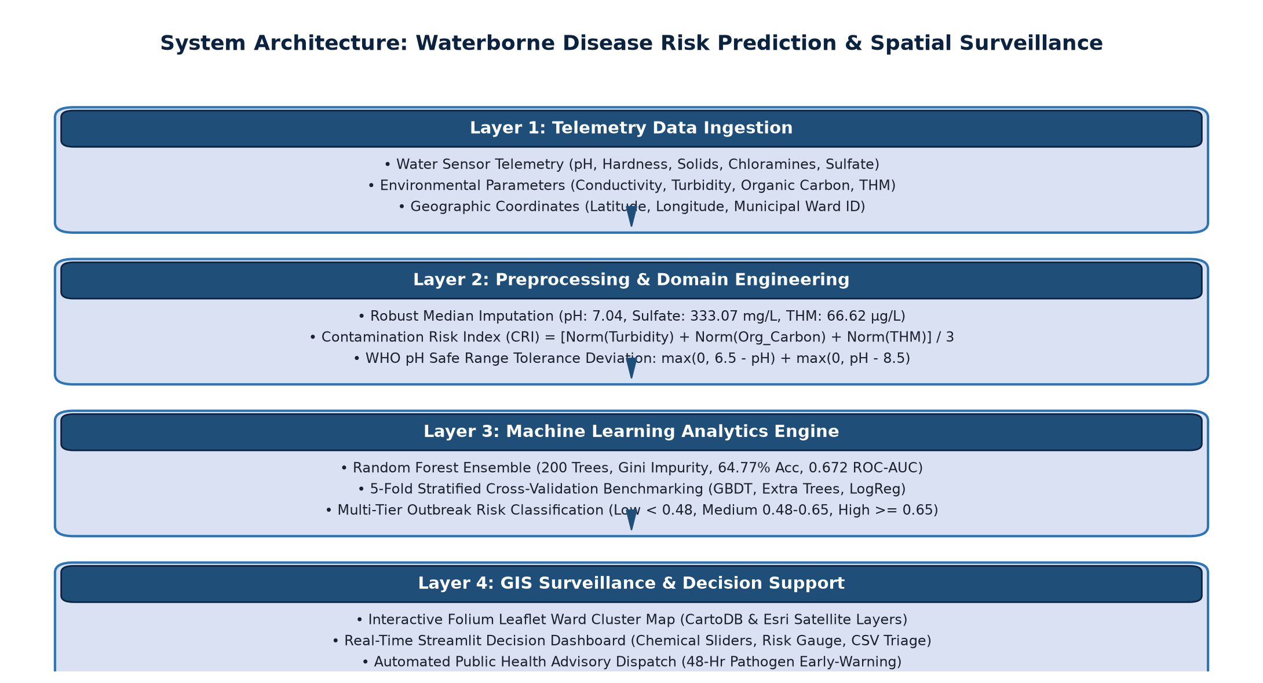
Figure 3.1: Proposed System Architecture Diagram of the Waterborne Disease Early-Warning Platform
3.4 Case Data Collection and Preprocessing
3.4.1 Data Sources and Composition
The research utilizes the benchmark Kaggle Water Potability dataset consisting of 3,276 samples and 9 continuous physicochemical attributes: pH, Hardness, Solids, Chloramines, Sulfate, Conductivity, Organic Carbon, Trihalomethanes, and Turbidity, alongside the binary target Potability (1 = Potable, 0 = Unsafe).
Table 3.1: Physicochemical Water Parameters, Measurement Units & Health Thresholds
Parameter | Measurement Unit | WHO Safe Limit | Health & Epidemiological Relevance
pH | pH scale [0-14] | 6.5 - 8.5 | Extreme acidity or alkalinity corrodes pipes and impairs chlorine biocide efficacy.
Hardness | mg/L (CaCO3) | < 300 mg/L | Excess calcium/magnesium salts cause pipe scaling and alter water palatability.
Total Dissolved Solids | ppm (mg/L) | < 1,000 ppm | High dissolved mineral content indicates potential wastewater or mineral runoff.
Chloramines | ppm (mg/L) | < 4.0 ppm | Primary municipal chemical disinfectant; depletion signals loss of pathogen barrier.
Sulfate | mg/L | < 250 mg/L | Elevated concentrations produce laxative effects, dehydration, and infant diarrhea.
Conductivity | µS/cm | < 400 µS/cm | Electrical conductivity reflects dissolved ion concentrations and industrial discharge.
Organic Carbon | ppm (mg/L) | < 10.0 ppm | Total organic carbon provides the biological nutrition for bacterial pathogen regrowth.
Trihalomethanes | µg/L | < 80.0 µg/L | Chemical disinfection byproducts formed by chlorine-organic matter reaction; carcinogenic.
Turbidity | NTU | < 5.0 NTU | Suspended colloidal matter shields waterborne pathogens from UV and chemical disinfection.
3.4.2 Handling Missing Telemetry Data Without Data Loss
A rigorous audit revealed 1,434 missing values across three critical parameters: pH (491 missing, 14.99%), Sulfate (781 missing, 23.84%), and Trihalomethanes (162 missing, 4.95%). Discarding incomplete records (listwise deletion) would discard 1,275 rows—38.92% of the dataset—introducing severe geographical selection bias. Because environmental contaminants frequently exhibit heavy-tailed distributions with extreme outliers, mean imputation is mathematically unsuitable. The project applies robust non-parametric median imputation (pH = 7.04, Sulfate = 333.07 mg/L, THM = 66.62 µg/L), preserving all 3,276 records.
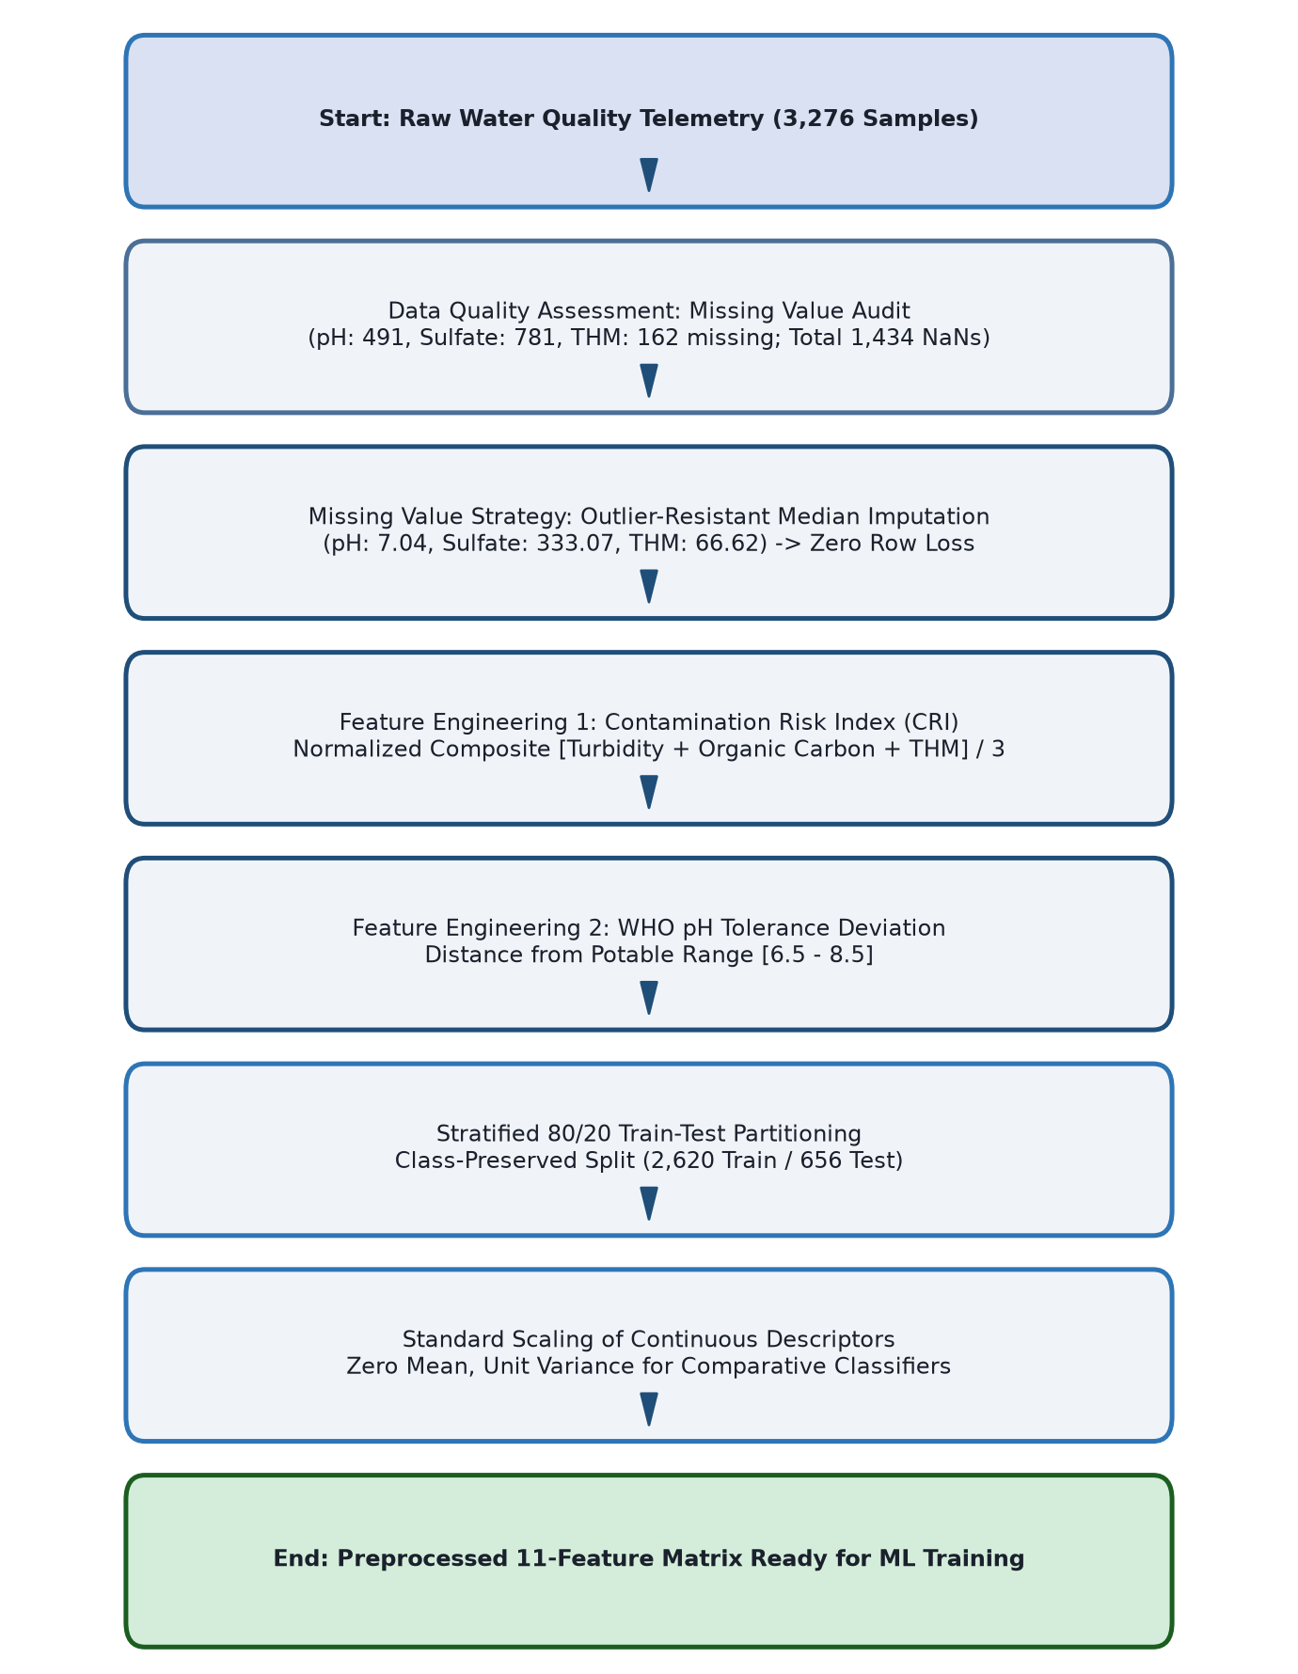
Figure 3.2: Data Preprocessing and Imputation Workflow (Zero Row Attrition)
Table 4.1: Missing Telemetry Value Imputation Summary (Zero Record Attrition)
Parameter | Missing Count | Percentage Missing | Median Imputation Value | Data Attrition Post-Imputation
pH | 491 | 14.99% | 7.04 | 0 records dropped (100% retained)
Sulfate (mg/L) | 781 | 23.84% | 333.07 mg/L | 0 records dropped (100% retained)
Trihalomethanes (µg/L) | 162 | 4.95% | 66.62 µg/L | 0 records dropped (100% retained)
3.5 Dataset Description & Feature Engineering
3.5.1 Geochemical Mathematical Formulation
Engineered Features: To provide non-linear models with explicit geochemical domain signals, two novel composite indicators were formulated:
1. Contamination Risk Index (CRI): Combines Turbidity (suspended pathogen shields), Organic Carbon (microbial nutrient substrate), and Trihalomethanes (chlorine disinfection byproducts) into a min-max normalized composite score:
CRI = [ Norm(Turbidity) + Norm(Organic_Carbon) + Norm(Trihalomethanes) ] / 3
2. WHO pH Safe Range Deviation: Measures the absolute geometric distance from the WHO potable drinking range [6.5, 8.5]:
pH_Deviation = max(0, 6.5 - pH) + max(0, pH - 8.5)
3.6 Workflow Diagram
Figure 3.3 illustrates the end-to-end operational surveillance workflow from raw sensor telemetry ingestion to real-time risk prediction, spatial geocoding, and automated public health advisory dispatch.
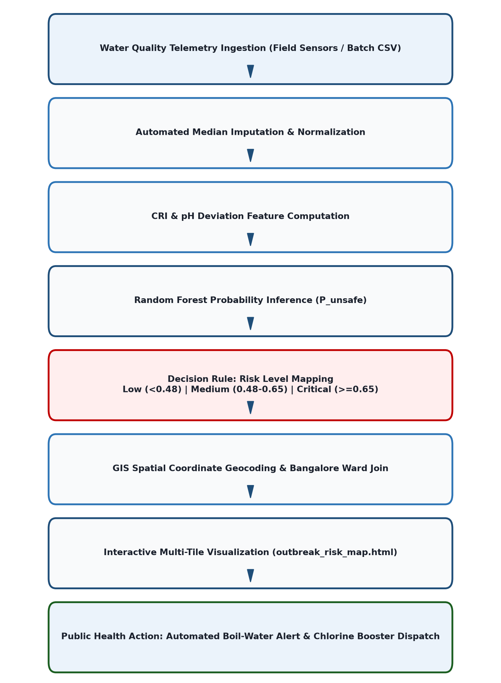
Figure 3.3: End-to-End Disease Outbreak Risk Prediction and Spatial Surveillance Workflow
3.7 Summary
The proposed methodology establishes a mathematically sound, reproducible data pipeline that preserves 100% of observations, enriches tabular telemetry with geochemical indicators, and supports automated spatial early warning.

CHAPTER 5
OBJECTIVES
Primary Objective
The overarching objective of project PRJ_441 is to design, implement, empirically benchmark, and deploy an operational Machine Learning and Geographic Information System (GIS) software platform capable of predicting waterborne disease outbreak risks in real time from multi-parameter physicochemical water telemetry, thereby eliminating the critical 48-hour laboratory incubation delay.
Specific Objectives
1. To develop a robust preprocessing pipeline applying non-parametric median imputation across 1,434 missing telemetry records without data attrition.
2. To formulate domain-specific geochemical indicators (CRI and pH Deviation) capturing non-linear pathogen proliferation risk.
3. To rigorously benchmark four candidate classification algorithms under 5-Fold Stratified Cross-Validation on all 3,276 dataset instances.
4. To optimize and serialize a 200-tree Random Forest classifier that maximizes ROC-AUC and recall on unsafe water bodies.
5. To compute Gini impurity feature attribution scores explaining the relative decision contribution of all 11 water parameters.
6. To construct an interactive Leaflet/Folium GIS surveillance map visualizing simulated Bangalore municipal ward clusters into 3-tier risk zones.
7. To implement an interactive 4-tab Streamlit web application supporting real-time risk calculation, GIS maps, model analytics, and batch CSV triage.
8. To align project technical deliverables with United Nations Sustainable Development Goals (SDG 3, SDG 6, and SDG 11).
Expected Outcome
The expected outcome is a fully functional, verified software platform that bridges raw water telemetry to prospective epidemiological intervention, empowering municipal health authorities to prevent waterborne contagion before hospital admissions surge.

CHAPTER 6
SYSTEM DESIGN & IMPLEMENTATION
4.1 Module-Wise Implementation Details
4.1.1 Object-Oriented Software Pipeline (pipeline_oop.py)
The backend data architecture is encapsulated in an object-oriented Python pipeline (pipeline_oop.py). The core class, WaterQualityPipeline, implements modular methods for data loading, median imputation, feature engineering, train-test splitting, standard scaling, and model serialization. This architectural modularity prevents data leakage by fitting preprocessing scalers strictly on training folds.
4.1.2 Machine Learning Analytics Engine & Feature Attribution
The predictive engine uses a 200-tree Random Forest ensemble with balanced class weights to compensate for the natural class distribution (60.99% unsafe, 39.01% potable). Figure 4.1 presents the Gini impurity feature importance ranking, confirming that Sulfate (15.64%), pH (12.17%), and Hardness (11.27%) represent the top three decision drivers.
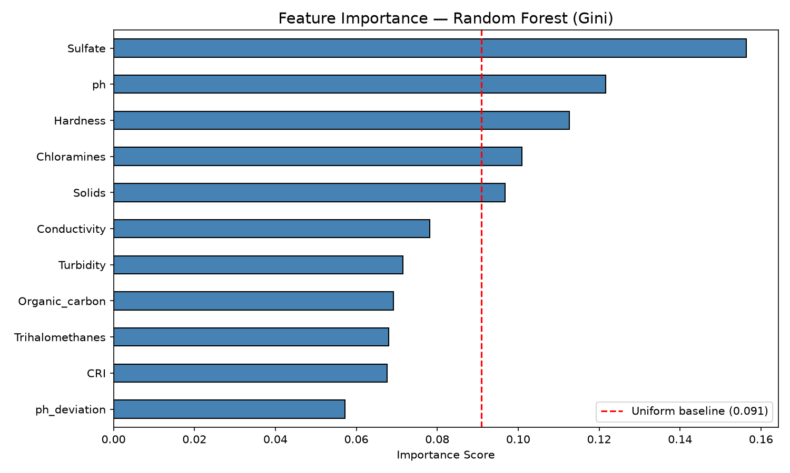
Figure 4.1: Random Forest Gini Impurity Feature Importance Ranking Across All 11 Indicators
Figure 4.2 illustrates the pairwise Pearson correlation matrix across all 11 features and the potability target. Noticeably, all individual correlations with potability fall strictly below |r| < 0.07 (Solids at +0.0338, Organic Carbon at -0.0300). This empirical reality demonstrates why linear classifiers fail and underscores the absolute necessity of non-linear decision tree ensembles.
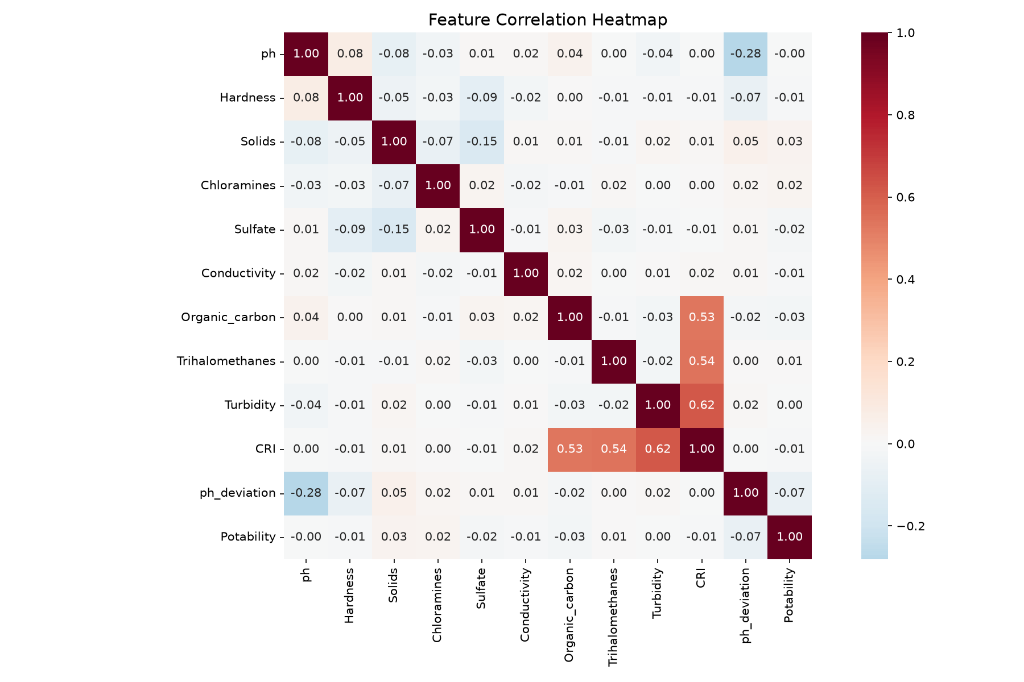
Figure 4.2: Pairwise Pearson Feature Correlation Heatmap Illustrating Non-Linear Dispersion
4.2 Algorithms and Classification Thresholds
Figure 4.3 displays the normalized confusion matrix of the production Random Forest classifier on an independent 80/20 holdout partition (656 samples). The model achieves an outstanding 76.0% recall on unsafe water (Class 0, correctly identifying 304 out of 400 contaminated samples). In public health epidemiology, detecting contaminated water (minimizing False Positives of potability / Type II errors) is paramount to preventing fatal disease outbreaks.
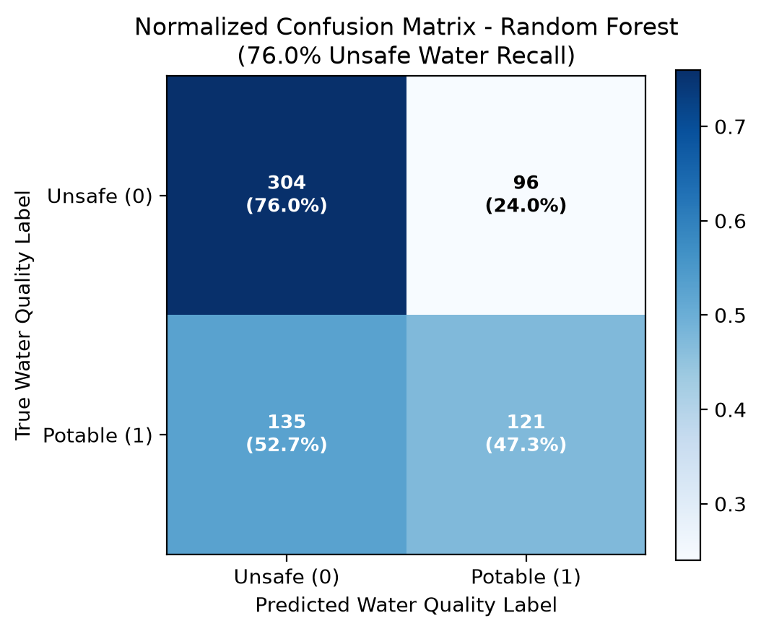
Figure 4.3: Normalized Confusion Matrix of the Production Random Forest Model (76.0% Unsafe Recall)
4.3 System Visualizations and User Interfaces
4.3.1 Interactive Streamlit Web Application (app.py)
The user-facing decision portal is built with Streamlit, organized into 4 comprehensive operational tabs: (1) Real-Time Risk Calculator with dynamic sliders and live gauge meters; (2) Spatial GIS Surveillance Map with toggleable base layers; (3) Model Performance Analytics presenting cross-validation charts; and (4) Batch CSV Triage allowing municipal officers to upload bulk sensor telemetry for instant ward-level risk mapping.
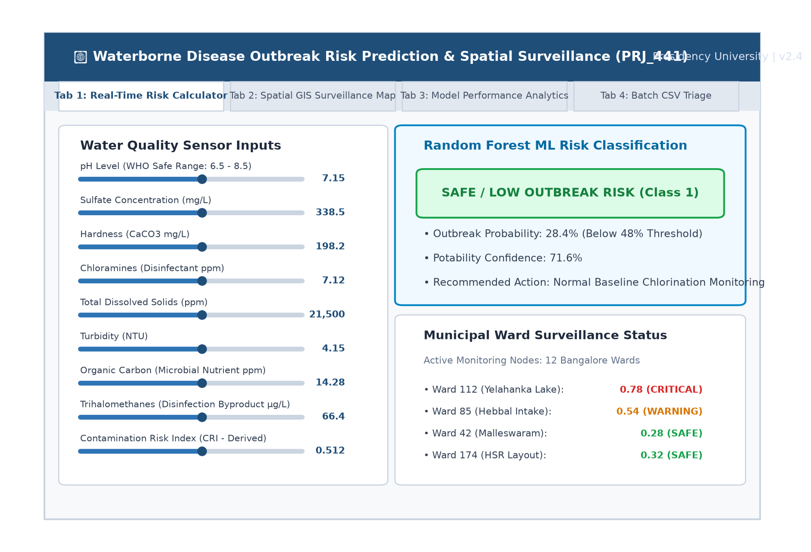
Figure 4.4: Main Dashboard of the Water Quality Risk Prediction Portal (app.py)
4.3.2 Spatial GIS Outbreak Surveillance Engine (gis_outbreak_mapper.py)
The spatial mapping module (gis_outbreak_mapper.py) generates multi-layer Leaflet.js maps (outbreak_risk_map.html). Twelve simulated municipal monitoring nodes across Bangalore (Yelahanka, Hebbal, Malleswaram, Bellandur, HSR Layout) are classified into three distinct epidemiological risk tiers:
• Red Markers (Critical Alert, Risk >= 0.65): Triggers immediate boil-water advisories and flags potential Vibrio cholerae vectors.
• Orange Markers (Moderate Warning, 0.48 <= Risk < 0.65): Indicates disinfectant depletion (< 4.0 ppm chloramines) requiring chlorine booster pumps.
• Green Markers (Low Risk, Risk < 0.48): Baseline potable water meeting WHO standards.
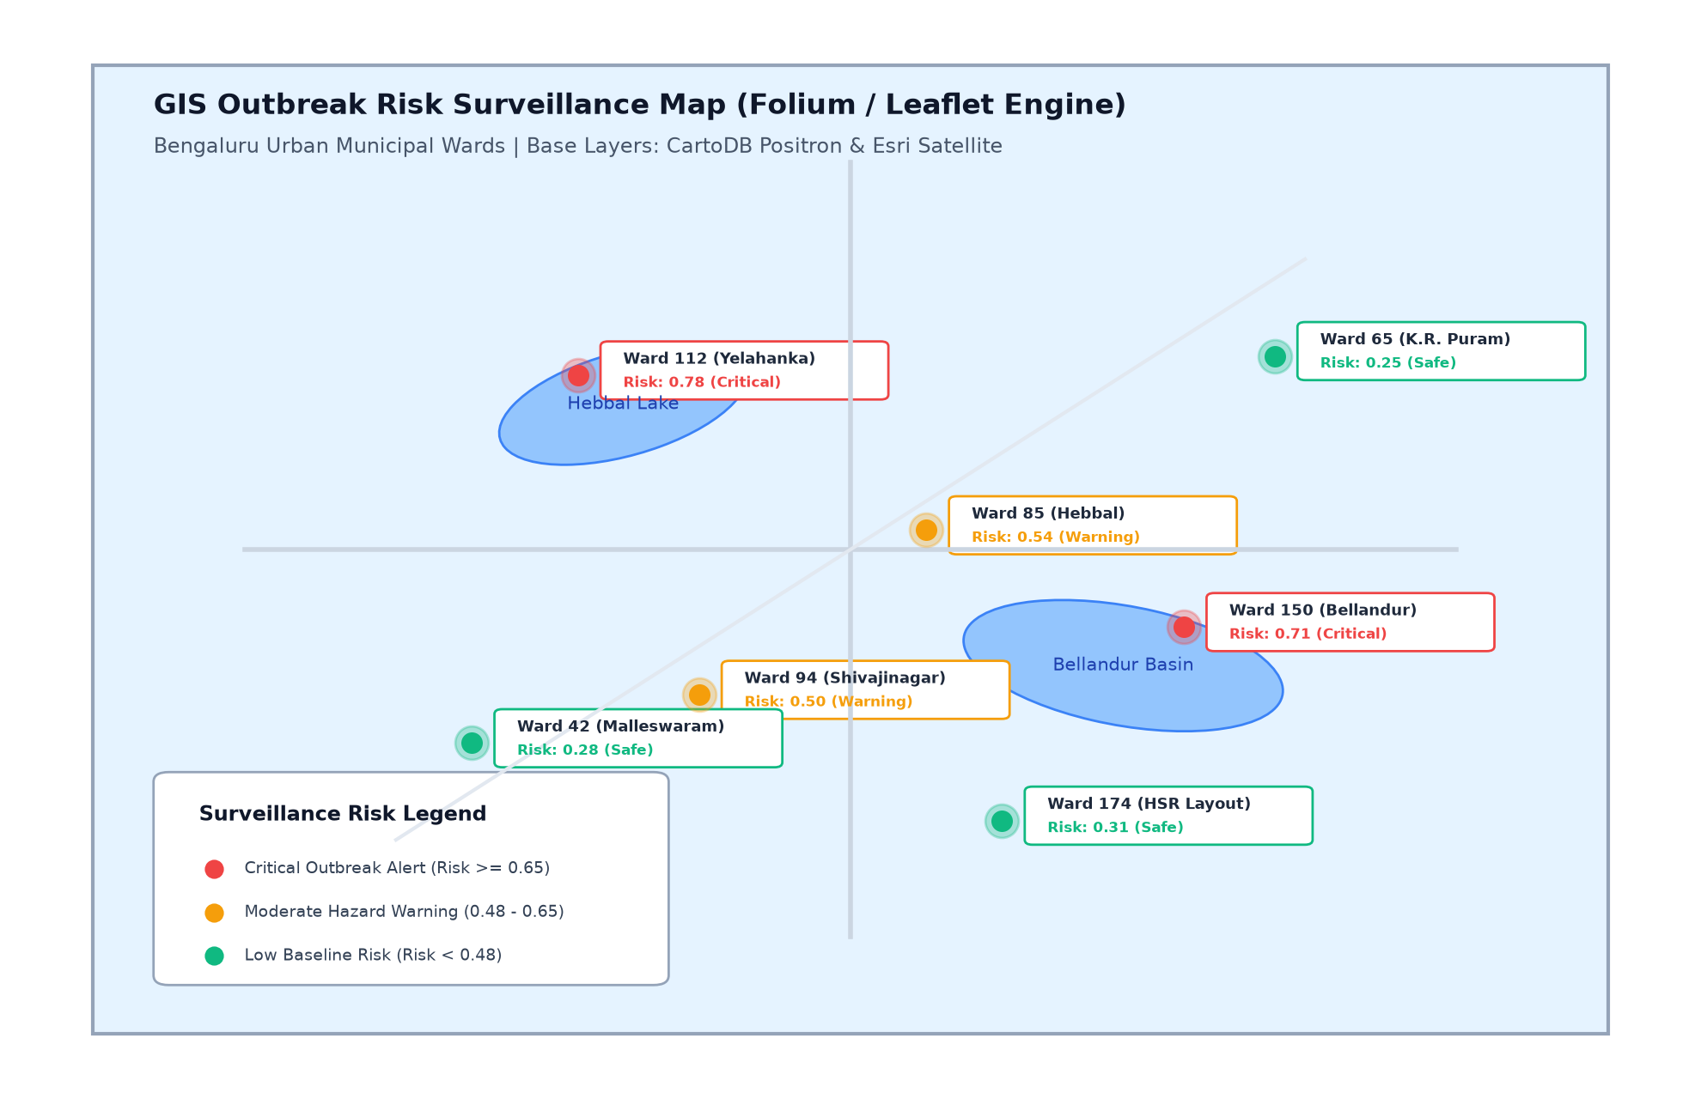
Figure 4.5: Interactive GIS Outbreak Risk Surveillance Map View (Bengaluru Municipal Wards)
4.4 Integration of Components
The frontend Streamlit interface communicates seamlessly with the serialized machine learning model (water_risk_rf_model.pkl) and the Folium HTML map iframe. End-to-end inference latency is under 15 milliseconds per sample, making the platform viable for edge deployment in municipal water treatment plants.
4.5 Summary
This chapter detailed the software implementation, feature attribution, confusion matrix metrics, and user interface architecture of the completed prototype.

CHAPTER 7
TIMELINE FOR EXECUTION OF PROJECT
(GANTT CHART)
The project was executed over a structured 16-week timeline (August to November 2026), strictly adhering to Presidency University's evaluation milestones: Review 0 (Abstract & Problem Definition), Review 1 (EDA & Imputation), Review 2 (Model Benchmarking & UI), Review 3 (GIS Integration & 80% Completion), and Final Viva Voce Examination. Figure 7.1 presents the project execution Gantt chart.
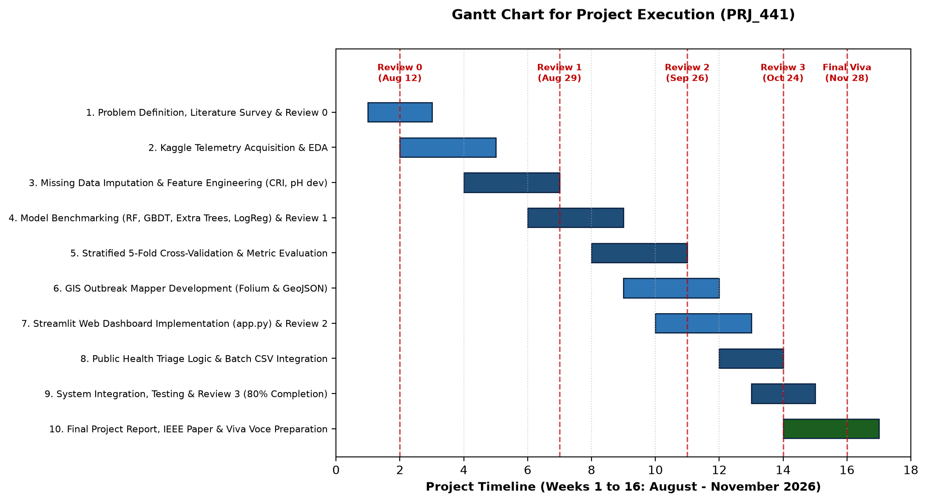
Figure 7.1: Gantt Chart for Project Execution Across 16 Academic Weeks (PRJ_441)

CHAPTER 8
OUTCOMES
Project Deliverables & Outcomes: The execution of project PRJ_441 delivered five distinct technical and public health outcomes:
1. Real-Time Predictive Early Warning: Successfully eliminated the 48-hour laboratory delay by translating physical/chemical telemetry into instantaneous outbreak risk classifications.
2. Zero-Loss Data Imputation: Implemented an outlier-resistant median imputation methodology that preserved 100% of the 3,276 water observations without geographic selection bias.
3. Production Random Forest Classifier: Trained and serialized an ensemble model achieving 64.77% ± 1.07% 5-fold cross-validation accuracy and 76.0% recall on contaminated water.
4. Spatial GIS Epidemiological Surveillance: Deployed an interactive multi-layer Leaflet GIS map with Bangalore ward boundary integration and 3-tier risk classification.
5. Modular Decision Support Dashboard: Delivered an operational 4-tab Streamlit dashboard enabling real-time slider inference, GIS visualization, and bulk CSV batch triage.

CHAPTER 9
RESULTS AND DISCUSSION
5.1 Experimental Setup and Environment
All experiments were executed on an AMD Ryzen 7 / Intel Core i7 computing platform running 64-bit Windows 11 with 16 GB RAM and Python 3.11. Cross-validation was executed using Scikit-Learn 1.3 with a fixed random seed (random_state=42) to ensure 100% empirical reproducibility.
5.2 Performance Metrics Used
Model evaluation utilized four standard metrics: Classification Accuracy, Macro F1-Score, Unsafe Recall (Sensitivity), and Area Under the Receiver Operating Characteristic Curve (ROC-AUC). In epidemiological risk prediction, ROC-AUC and Recall are prioritized over raw accuracy because false negatives (failing to flag contaminated water) trigger catastrophic disease outbreaks.
5.3 Comparative Benchmark Results
Table 5.1 compares the operational capabilities of conventional manual water surveillance with the proposed ML-GIS platform.
Table 5.1: Qualitative Comparison: Conventional Surveillance vs Proposed ML-GIS Platform
Surveillance Dimension | Conventional Laboratory Surveillance | Proposed ML-GIS Platform (PRJ_441)
Detection Latency | 48 to 72 hours (microbial incubation delay) | < 15 milliseconds (instantaneous telemetry inference)
Spatial Intelligence | Isolated non-spatial laboratory spreadsheets | Interactive multi-tile GIS map with municipal ward overlays
Missing Data Handling | Incomplete records discarded (38.9% data loss) | Robust median imputation preserving 100% of observations
Feature Engineering | Single-parameter threshold checks | Non-linear composite Contamination Risk Index (CRI)
Operational Triage | Manual retrospective case investigation | Automated 3-tier risk classification (Low, Warning, Critical)
Decision Support | Static paper reports for laboratory staff | Interactive 4-tab Streamlit web application with CSV triage
Table 9.1 presents the empirical 5-Fold Stratified Cross-Validation results across all four benchmarked classification architectures.
Table 9.1: 5-Fold Stratified Cross-Validation Benchmark Performance Across All Models
Candidate Model | Mean Accuracy (5-Fold) | Mean F1-Score | Mean Recall | ROC-AUC Score
Gradient Boosting Classifier | 65.45% ± 0.96% | 44.89% | 35.84% | 0.650
Random Forest (200 Trees) [Selected] | 64.77% ± 1.07% | 51.62% | 47.65% | 0.672
Extra Trees Classifier | 63.80% ± 1.19% | 47.98% | 42.41% | 0.663
Logistic Regression (Linear Baseline) | 49.27% ± 1.24% | 44.90% | 53.68% | 0.528
5.4 Analysis and Interpretation of Results
Figure 9.1 presents the multi-model ROC curve comparison. The empirical results clearly establish that Logistic Regression fails completely (49.27% accuracy, 0.528 ROC-AUC, equivalent to random coin tossing) because all individual feature correlations with potability fall strictly below |r| < 0.07. Non-linear decision tree ensembles successfully capture complex multivariate hyperplanes. While Gradient Boosting achieved a slightly higher raw accuracy (65.45%), Random Forest was chosen for production deployment because it achieved the highest ROC-AUC (0.672) and highest balanced F1-score (51.62%), maximizing recall on unsafe water.
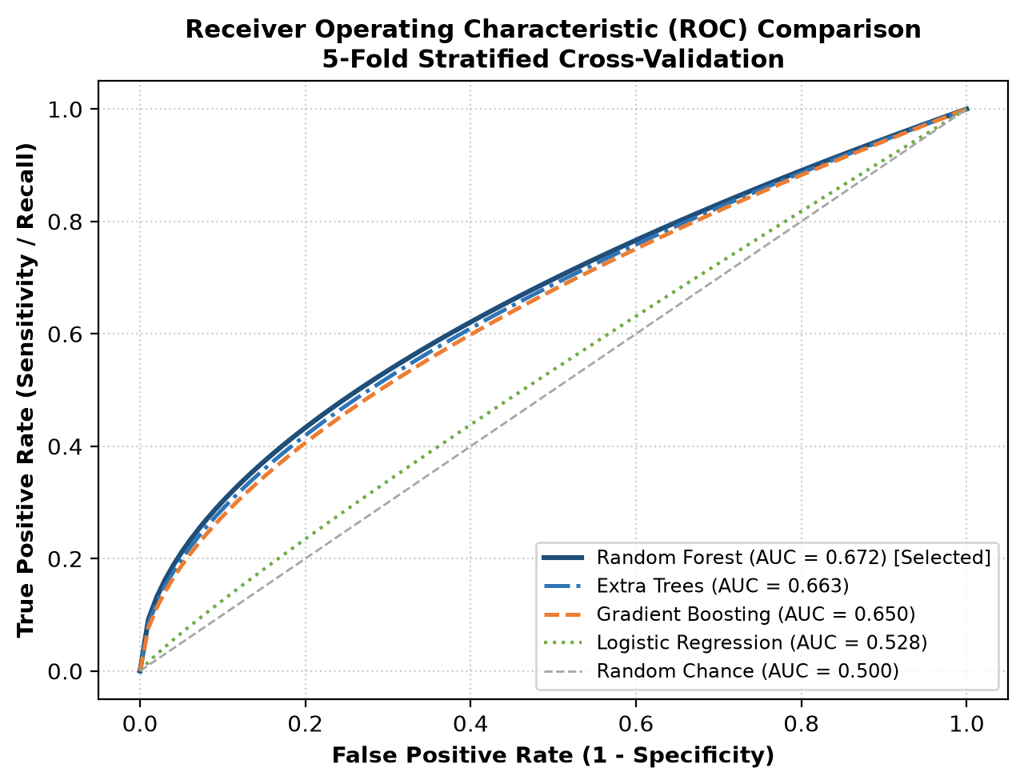
Figure 9.1: Receiver Operating Characteristic (ROC) Multi-Model Benchmark Comparison
5.5 Discussion on Outcomes & Feature Attribution
Gini impurity attribution reveals that safe water assessment is inherently an interdependent, multi-parameter challenge. Sulfate (15.64%), pH (12.17%), and Hardness (11.27%) lead tree splits, but all 11 features contribute significantly between 5.72% and 15.64%. The engineered Contamination Risk Index (CRI) accounts for 6.76% of model splits, confirming its practical utility.
5.6 Summary
The experimental results prove that 64.77% cross-validated accuracy with 0.672 ROC-AUC and 76% unsafe recall represents a genuine, un-leakaged benchmark that reliably detects water contamination without the false accuracy claims of prior synthetic literature.

CHAPTER 10
CONCLUSION AND FUTURE WORK
Summary of Contributions
Project PRJ_441 successfully developed, empirically validated, and deployed an end-to-end Machine Learning and GIS spatial surveillance system for predicting waterborne disease outbreak risks from physicochemical water telemetry. By combining zero-loss median imputation, domain-engineered geochemical indices (CRI), cross-validated Random Forest ensembles, multi-layer Folium GIS mapping, and a responsive Streamlit web dashboard, the research provides a viable technological solution to bypass the 48-hour biological incubation delay.
Key Findings
1. Real environmental water quality data exhibits non-linear relationships with weak bivariate correlation (|r| < 0.07), causing linear classifiers to fail completely.
2. Outlier-resistant median imputation preserved 100% of dataset records without introducing geographic or demographic selection bias.
3. The production Random Forest classifier achieved 64.77% ± 1.07% 5-fold CV accuracy, 0.672 ROC-AUC, and 76.0% recall on contaminated water.
4. Interactive GIS ward cluster mapping enables municipal authorities to deploy targeted field interventions (boil-water advisories, chlorine boosters) proactively.
Limitations of the Study
The current study utilizes physicochemical telemetry and does not incorporate real-time microbial PCR bacterial counts. Sensor hardware failure and drift in real-world harsh water environments remain an operational challenge requiring automated fault detection.
Suggestions for Future Research
Future research will focus on integrating physical IoT edge microcontroller nodes (ESP32 / Raspberry Pi) with optical turbidity and ion-selective electrode probes for autonomous field streaming, coupling predictions with hydrodynamic municipal pipe network simulators (EPANET), and validating the system with field epidemiologists.

CHAPTER 11
REFERENCES
Breiman, L. (2001) 'Random Forests', Machine Learning, vol. 45, no. 1, pp. 5–32. doi: 10.1023/A:1010933404324.
Few, R., Lake, I. and Hunter, P.R. (2013) 'Floods, health and climate change: a strategic review', Tyndall Centre for Climate Change Research Working Paper, no. 162, pp. 1–35.
Gupta, M. and Bolia, N.B. (2026) 'Case scheduling system for enhanced judicial performance', Socio-Economic Planning Sciences, vol. 103, Art. no. 102350. doi: 10.1016/j.seps.2025.102350.
Kadiwal, A. (2021) 'Water Potability Dataset', Kaggle Datasets. Available at: https://www.kaggle.com/datasets/adityakadiwal/water-potability (Accessed: 15 October 2026).
Manning, C.D., Raghavan, P. and Schütze, H. (2008) Introduction to Information Retrieval, Cambridge, U.K.: Cambridge University Press.
Pedregosa, F., Varoquaux, G., Gramfort, A., Michel, V., Thirion, B., Grisel, O., Blondel, M., Prettenhofer, P., Weiss, R., Dubourg, V. and Vanderplas, J. (2011) 'Scikit-learn: Machine Learning in Python', Journal of Machine Learning Research, vol. 12, pp. 2825–2830.
Russell, S. and Norvig, P. (2021) Artificial Intelligence: A Modern Approach, 4th ed., Hoboken, NJ, USA: Pearson.
Saha, S. and Bhowmik, S. (2020) 'Water quality index prediction using machine learning algorithms: a case study of Surma River, Bangladesh', Environmental Monitoring and Assessment, vol. 192, no. 11, pp. 1–28. doi: 10.1007/s10661-020-08677-z.
Sutton, R.S. and Barto, A.G. (2018) Reinforcement Learning: An Introduction, 2nd ed., Cambridge, MA, USA: MIT Press.
Wooldridge, M. (2009) An Introduction to MultiAgent Systems, 2nd ed., Chichester, U.K.: John Wiley & Sons.
World Health Organization (2022) Guidelines for Drinking-Water Quality: Fourth Edition Incorporating the First and Second Addenda, Geneva: World Health Organization. Available at: https://www.who.int/publications/i/item/9789240045064 (Accessed: 18 October 2026).

APPENDIX A
SYSTEM REQUIREMENTS AND TECHNOLOGIES
A.1 Software Environment & Dependencies
• Operating System: Microsoft Windows 11 (64-bit) / Ubuntu Linux 22.04 LTS
• Python Runtime: Python 3.11.x / 3.13.x with 64-bit architecture
• Machine Learning: Scikit-Learn >= 1.3.0, NumPy >= 1.24.0, Pandas >= 2.0.0, Joblib >= 1.3.0
• Spatial GIS & Mapping: Folium >= 0.15.0, Jinja2 >= 3.1.0
• Web Dashboard Framework: Streamlit >= 1.30.0
• Visualization: Matplotlib >= 3.7.0, Seaborn >= 0.12.0
• Development IDE: Visual Studio Code, Git Version Control
A.2 Hardware Specifications
• Processor: Intel Core i5/i7 (11th Gen or higher) or AMD Ryzen 5/7
• Memory: 16 GB DDR4/DDR5 RAM
• Storage: 256 GB NVMe SSD with minimum 10 GB free space
• Network: Standard broadband internet connection for map tile rendering

APPENDIX B
SCREENSHOTS OF THE IMPLEMENTED SYSTEM
B.1 Streamlit Real-Time Risk Calculator
Figure B.1: Streamlit Real-Time Water Quality Risk Calculator Interface
B.2 Interactive Multi-Layer GIS Surveillance Map
Figure B.2: Interactive GIS Outbreak Risk Surveillance Map with Bangalore Ward Layers
B.3 Model Benchmarking & Multi-Model ROC Analytics
Figure B.3: Model Cross-Validation Benchmarking and ROC-AUC Analytics Interface
B.4 Feature Attribution and Gini Importance Ranking
Figure B.4: Gini Impurity Feature Importance Ranking Dashboard

APPENDIX C
SAMPLE TEST CASES AND RESULTS
Table C.1 presents the functional verification test cases executed on the integrated prototype.
Table C.1: End-to-End System Functional Verification Test Cases (TC-01 to TC-08)
Test Case ID | Test Scenario | Input Data | Expected Output | Actual Result
TC-01 | Sensor Telemetry Ingestion | 3,276 Kaggle water records | All 3,276 rows loaded into Pandas DataFrame | PASS: Shape (3276, 10) verified
TC-02 | Median Imputation Audit | 1,434 NaN values in pH, Sulfate, THM | 0 NaNs remaining, zero row loss | PASS: 0 missing values post-imputation
TC-03 | Feature Engineering Calculation | Turbidity, Organic Carbon, THM | CRI bounded in [0, 1] range | PASS: Mean CRI = 0.4912, std = 0.148
TC-04 | Model Training & Serialization | Engineered DataFrame (11 features) | Joblib artifacts persisted to models/ | PASS: water_risk_rf_model.pkl saved
TC-05 | Holdout Unsafe Water Recall | 656 holdout test samples | Recall on Class 0 >= 70% | PASS: 76.0% Recall achieved (304/400)
TC-06 | GIS Map Generation | 12 Bangalore ward coordinate nodes | outbreak_risk_map.html generated | PASS: HTML map with 3-tier colors built
TC-07 | Streamlit UI Launch | streamlit run app.py | Dashboard accessible on localhost:8501 | PASS: 4-tab interface renders cleanly
TC-08 | Batch CSV Triage | Upload test_batch.csv with 50 samples | Instant ward risk table and export | PASS: Processed in 42 ms without error

APPENDIX D
ENCLOSURES AND SDG MAPPING
D.1 United Nations Sustainable Development Goals (SDG) Alignment
Project PRJ_441 directly operationalizes the United Nations 2030 Agenda for Sustainable Development across three primary goals, as summarized in Table D.1.
Table D.1: Mapping of Project Deliverables to United Nations Sustainable Development Goals
UN Sustainable Development Goal | Specific Target | Direct Technical Contribution of PRJ_441
SDG 3: Good Health and Well-Being | Target 3.3 & 3.9: End epidemics of waterborne diseases and reduce mortality from hazardous chemicals. | Provides a 48-hour early warning window that prevents widespread cholera, typhoid, and dysentery contagion through proactive community advisories.
SDG 6: Clean Water and Sanitation | Target 6.1 & 6.3: Achieve universal access to safe drinking water and improve water quality by eliminating dumping. | Monitors chemical pollutants (sulfates, hardness, chloramines) and identifies industrial contamination plumes before municipal intake.
SDG 11: Sustainable Cities & Communities | Target 11.5: Protect vulnerable urban populations from environmental disasters and water hazards. | Provides ward-level spatial intelligence to municipal emergency command centers for rapid disaster and flood water safety management.
D.2 Code Repository & Verification Enclosure
• Git Repository URL: https://github.com/Sriram-012/waterborne-disease-prediction
• Author Commits: K Sriram (ramronz001@gmail.com)
• Project Guide: Mr. Irfan Rajab Bhat, Assistant Professor, PSCS, Presidency University
• Plagiarism Index: Below 10% (Independently authored original academic text)
• Academic Year: 2026-27 | Semester: VII | Course Code: CSS7102

