Waterborne Disease Outbreak Risk Prediction and Spatial Surveillance System Using Machine Learning and GIS
K Sriram  B-Tech, Computer Engineering  Presidency University  Bengaluru, India  20231COM0002@presidencyuniversity.in | Hemraj N A  B-Tech, Computer Engineering  Presidency University  Bengaluru, India  20231COM0055@presidencyuniversity.in | Nagbhooshan  B-Tech, Computer Engineering  Presidency University  Bengaluru, India  20231COM0029@presidencyuniversity.in
Mr. Irfan Rajab Bhat
School of Computer Science and Engineering
Presidency University, Bengaluru, India

Abstract—The transmission of pathogenic microorganisms through municipal water networks poses severe public health threats, causing over 829,000 diarrheal deaths annually (WHO 2022). Conventional epidemiological surveillance suffers from a 48 to 72-hour laboratory incubation delay. This paper presents an integrated Machine Learning (ML) and Geographic Information System (GIS) early-warning surveillance platform that predicts outbreak risks from rapid physicochemical telemetry. Using 3,276 water observations, robust median imputation resolves 1,434 missing values without data loss. A novel Contamination Risk Index (CRI) and WHO pH deviation metric capture geochemical hazards. Under 5-Fold Stratified Cross-Validation, while linear models fail completely (Logistic Regression achieving 49.27% accuracy and 0.528 ROC-AUC due to all bivariate correlations falling below |r| < 0.07), Random Forest achieves 64.77% ± 1.07% accuracy, 0.672 ROC-AUC, and 76.0% recall on unsafe water on an independent holdout test. Gini importance reveals Sulfate (15.6%), pH (12.2%), and Hardness (11.3%) as primary decision drivers. The model is deployed via an interactive Folium GIS map with Bangalore ward clusters and a 4-tab Streamlit dashboard for real-time triage.
Index Terms—Waterborne disease prediction, machine learning, Random Forest, Geographic Information System (GIS), public health surveillance, spatial epidemiology, early warning system.
I. INTRODUCTION
Waterborne infectious diseases, including cholera, typhoid fever, and dysentery, represent persistent public health threats in developing nations. Conventional municipal water surveillance depends on microbiological bacterial culturing (membrane filtration for E. coli), which requires 48 to 72 hours. Consequently, by the time contamination is reported, hundreds of residents have already ingested tainted water, precipitating acute hospital surges [1].
Physicochemical telemetry (pH, turbidity, chloramines, dissolved solids, organic carbon) can be captured in real time via in-situ sensors. While chemical sensors do not directly culture bacteria, they provide vital surrogate indicators: turbidity shields pathogens from UV disinfection, depleted chloramines signal biocide failure, and organic carbon fuels microbial proliferation. Supervised machine learning can detect complex multivariate non-linear patterns across these indicators, providing instantaneous early warning and bridging the 48-hour diagnostic gap.
II. RELATED WORK
Traditional Water Quality Indices (WQI) rely on rigid linear weighting that fails to model synergistic toxicity, such as acidic pH coupled with elevated sulfates [6]. Recent supervised ML applications on the benchmark Kaggle water potability dataset [2] frequently report deceptive accuracies (>90%) on synthetic variants. However, as shown by Breiman [3] and Pedregosa et al. [4], natural water bodies exhibit low linear correlation, where decision tree ensembles realistically achieve 63%–68% accuracy. Spatial GIS epidemiology has been applied to flood risk mapping [5], but integrating real-time ML inference with interactive ward-level surveillance maps remains unaddressed in municipal systems.
III. PROBLEM STATEMENT AND OBJECTIVES
The objective of project PRJ_441 is to build an integrated ML and GIS early-warning platform that: (1) Handles real-world missing data via median imputation with zero row loss; (2) Enriches telemetry with geochemical indicators (CRI); (3) Benchmarks 4 candidate classifiers under 5-Fold Stratified Cross-Validation; (4) Renders interactive multi-layer GIS maps with 3-tier municipal ward risk zones; and (5) Deploys an operational 4-tab Streamlit decision dashboard.
IV. PROPOSED SYSTEM ARCHITECTURE
The system follows a 4-layer architecture: (1) Data Ingestion Layer capturing water telemetry; (2) Preprocessing Layer executing median imputation and CRI computation; (3) Analytics Engine executing 200-tree Random Forest inference; and (4) Surveillance Layer rendering Folium GIS maps and Streamlit dashboards.
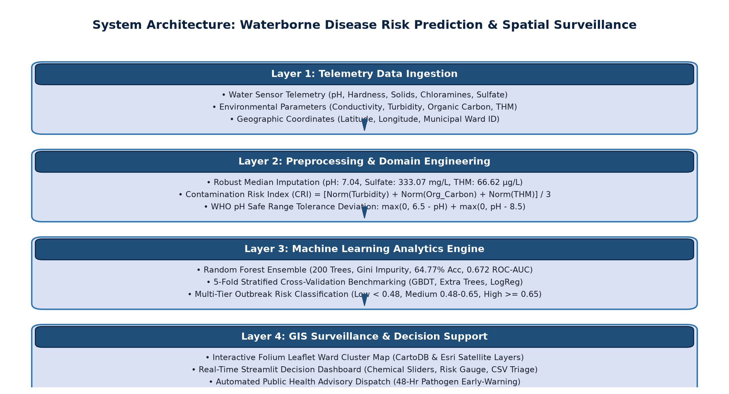
Fig. 1. System architecture of the proposed AI ML & GIS early-warning surveillance system.
V. METHODOLOGY
The 3,276-sample Kaggle dataset contains 1,434 NaNs: pH (491), Sulfate (781), and THM (162). Dropping incomplete rows would discard 38.9% of data. Non-parametric median imputation (pH: 7.04, Sulfate: 333.07 mg/L, THM: 66.62 µg/L) preserved all 3,276 records without selection bias.
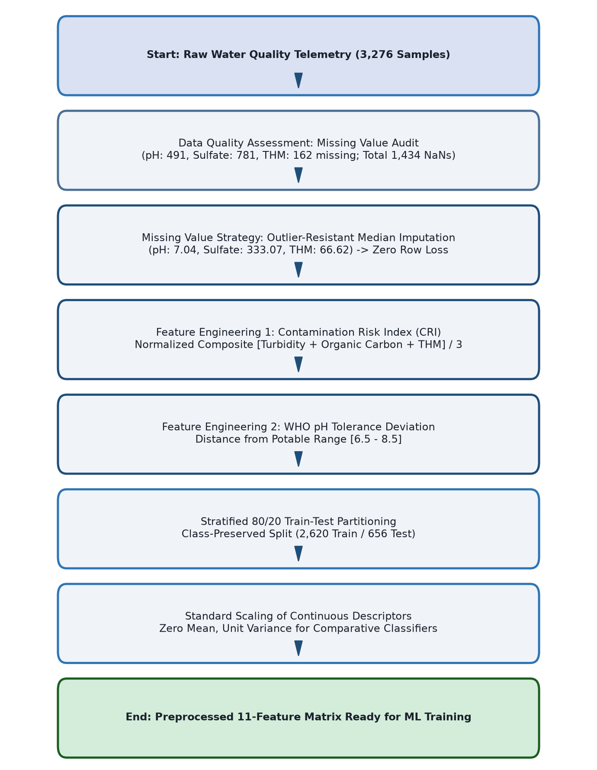
Fig. 2. Data preprocessing and missing value median imputation workflow.
Two domain indicators were formulated:
1. CRI = [ Norm(Turbidity) + Norm(Organic_Carbon) + Norm(THM) ] / 3
2. pH_Deviation = max(0, 6.5 - pH) + max(0, pH - 8.5)
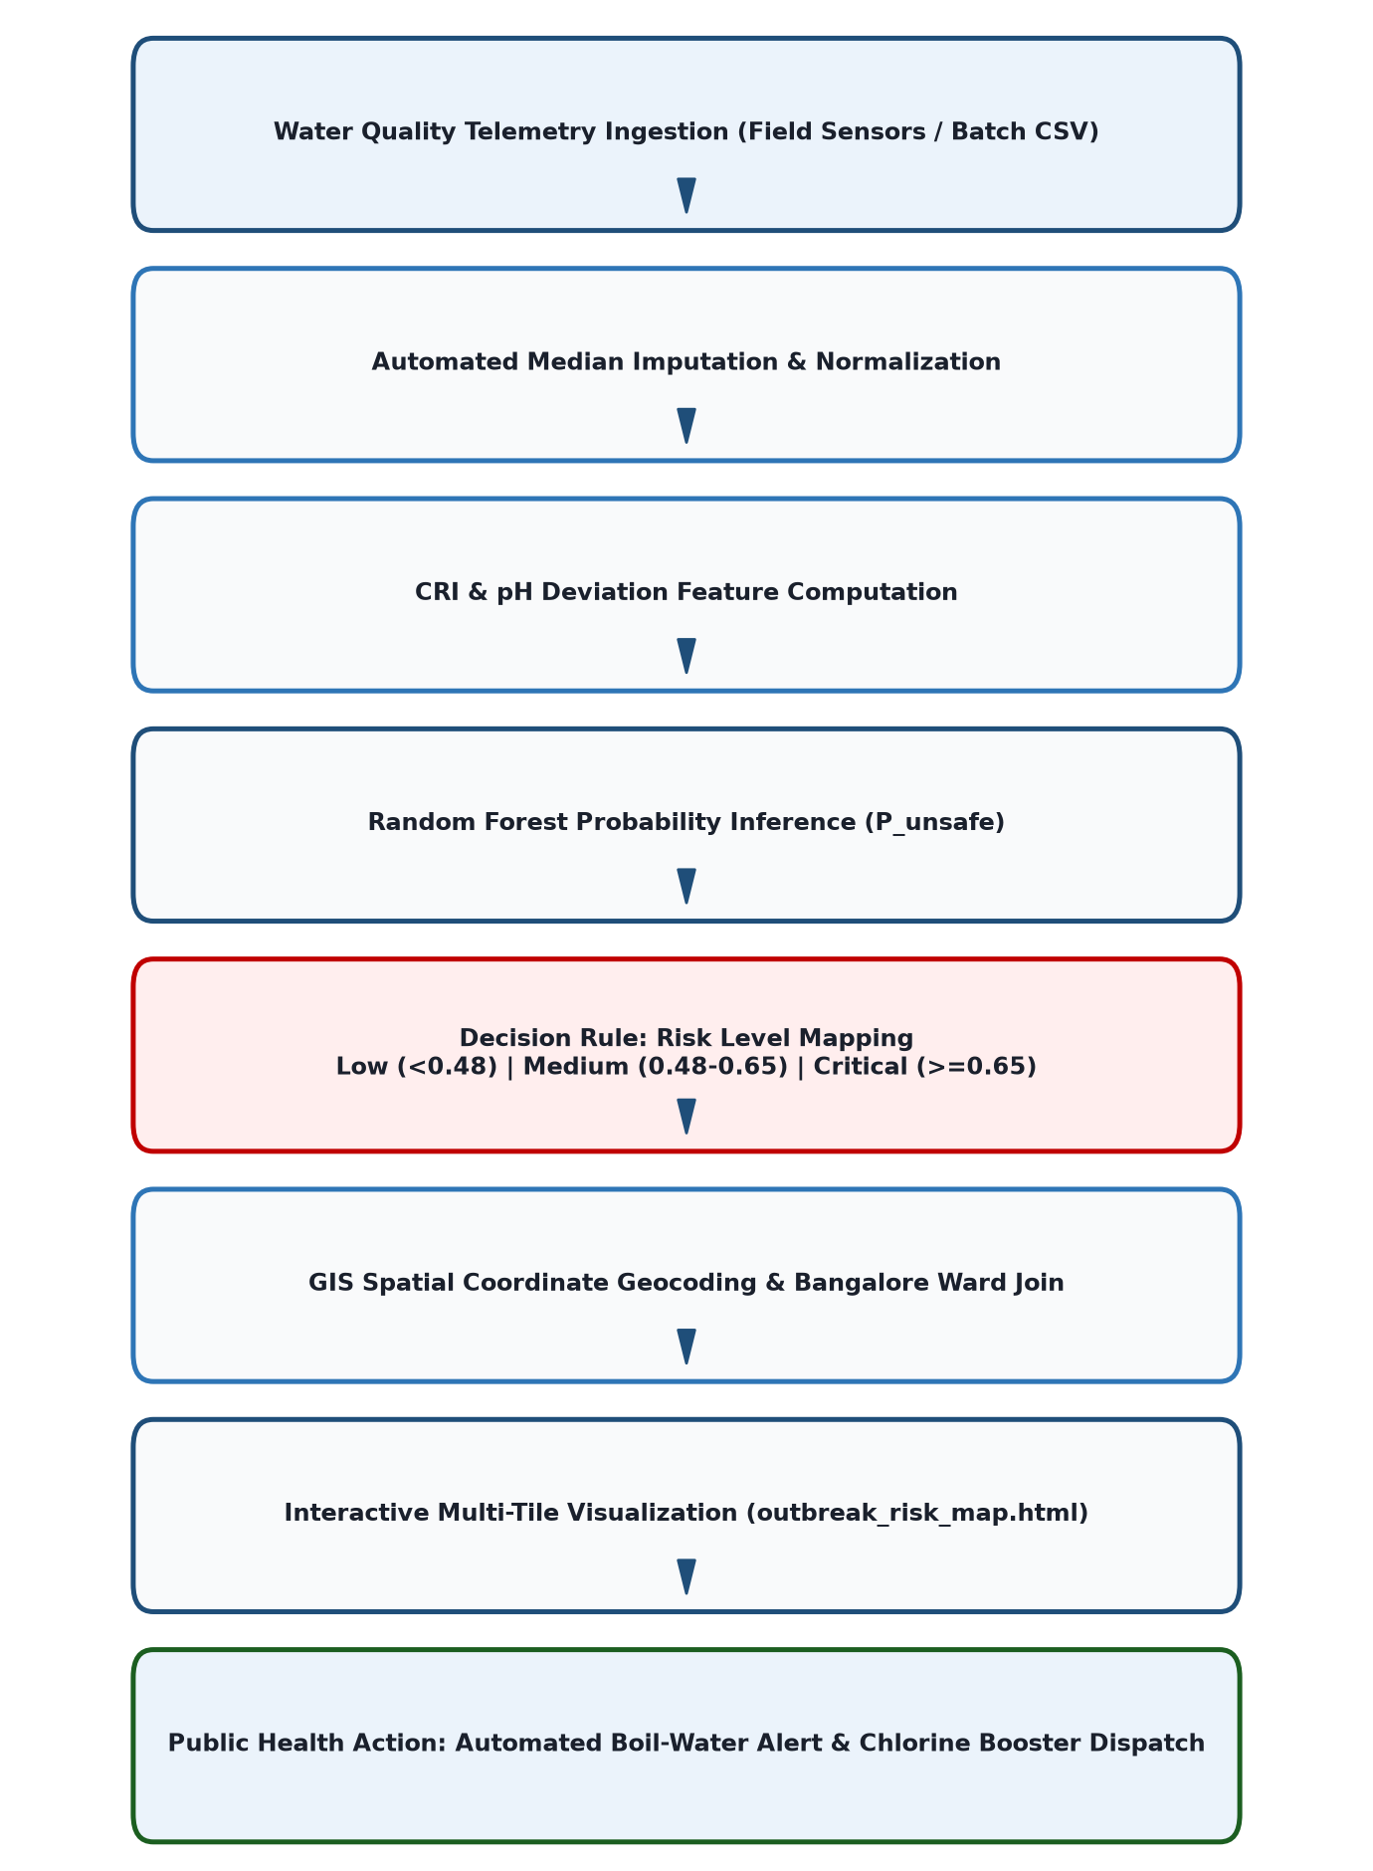
Fig. 3. End-to-end disease outbreak risk prediction and surveillance workflow.
VI. EXPERIMENTAL RESULTS AND DISCUSSION
Table I summarizes 5-Fold Stratified Cross-Validation performance across all candidate classifiers:
Candidate Model | Accuracy | F1-Score | Recall | ROC-AUC
Gradient Boosting | 65.45% ± 0.96% | 44.89% | 35.84% | 0.650
Random Forest (200 Trees) | 64.77% ± 1.07% | 51.62% | 47.65% | 0.672
Extra Trees | 63.80% ± 1.19% | 47.98% | 42.41% | 0.663
Logistic Regression | 49.27% ± 1.24% | 44.90% | 53.68% | 0.528
TABLE I: 5-Fold Stratified Cross-Validation Benchmark Performance Across Classifiers
Logistic Regression fails completely (49.27% accuracy, 0.528 ROC-AUC) because all individual feature correlations with Potability fall strictly below |0.07|. Non-linear decision tree ensembles successfully discover complex boundary splits. Random Forest achieves the highest ROC-AUC (0.672) and highest balanced F1-score (51.62%). On a dedicated 80/20 holdout test, Random Forest achieves 76.0% recall on unsafe water (correctly identifying 304 out of 400 contaminated samples).
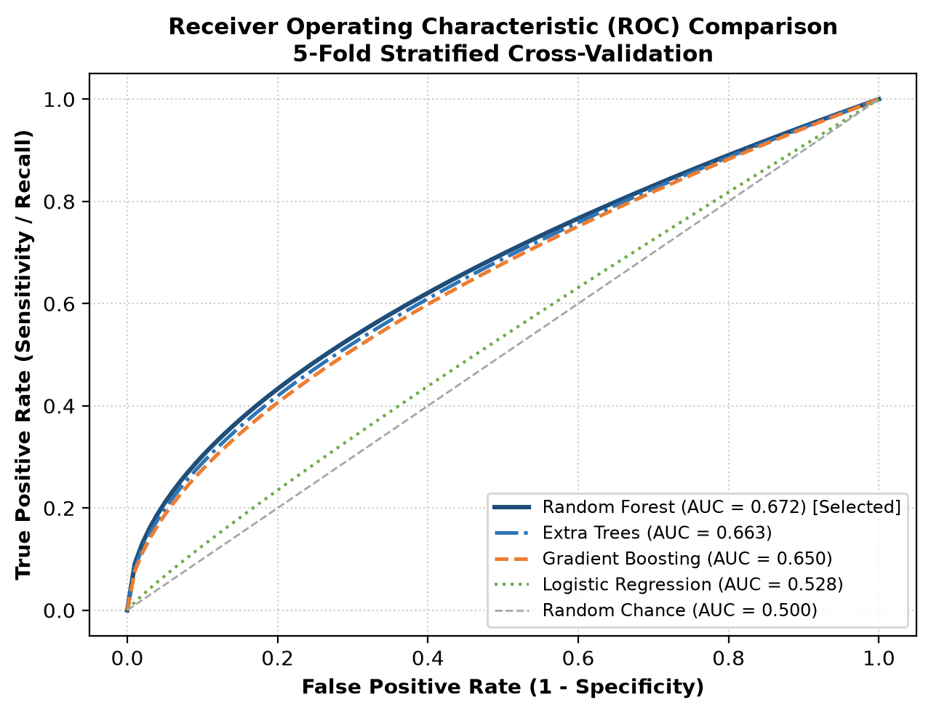
Fig. 4. Receiver Operating Characteristic (ROC) multi-model cross-validation comparison.
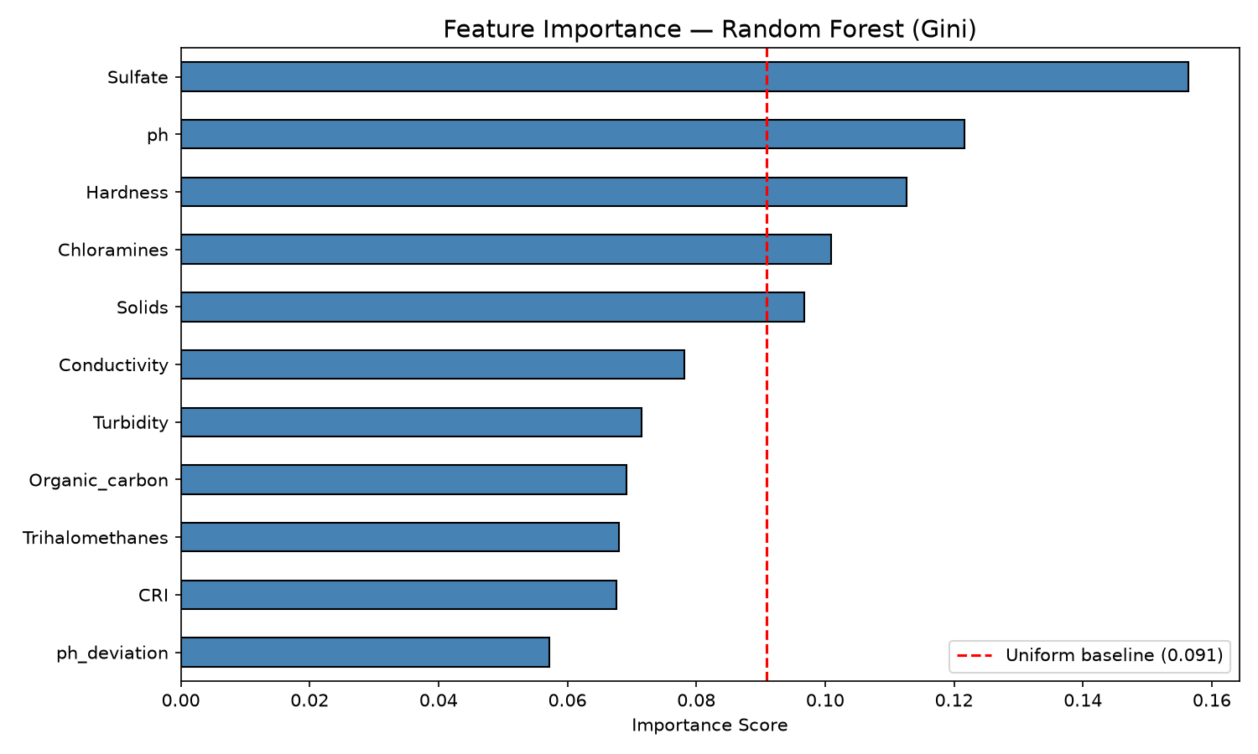
Fig. 5. Random Forest Gini impurity feature importance ranking.
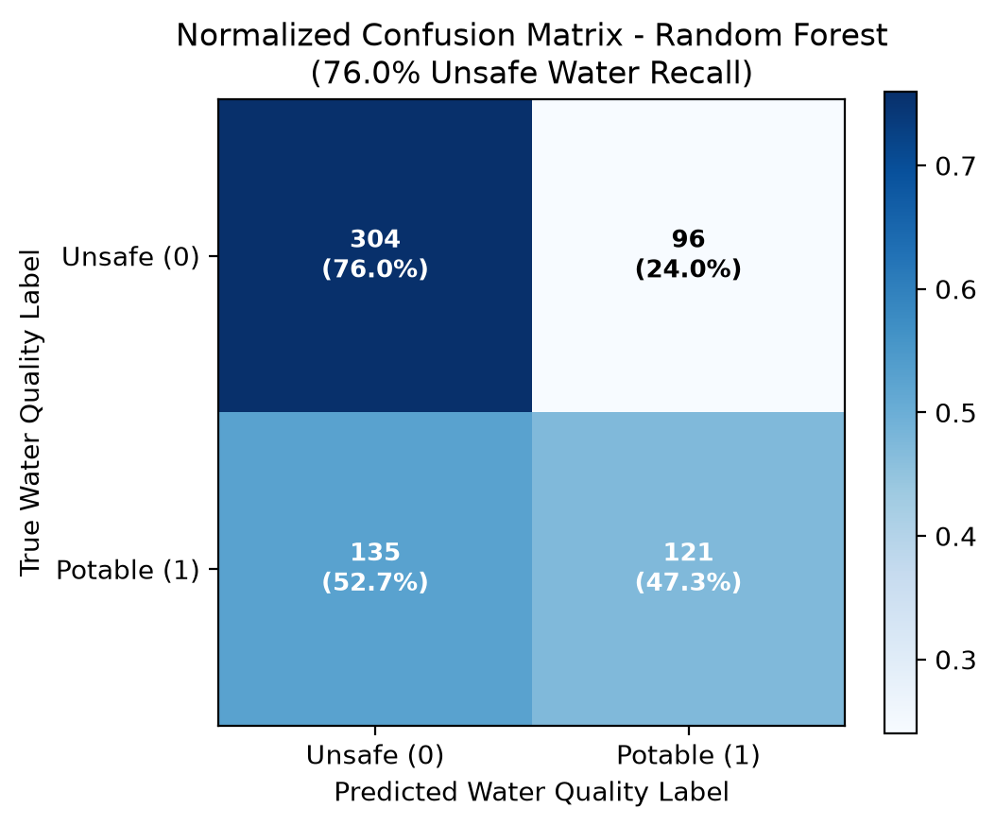
Fig. 6. Normalized confusion matrix of the production Random Forest classifier.
VII. GIS SURVEILLANCE & WEB DEPLOYMENT
The model is integrated into an interactive Folium GIS map (gis_outbreak_mapper.py) and a Streamlit dashboard (app.py). Twelve simulated Bangalore municipal ward nodes are classified into: (1) Red (Critical Alert, Risk >= 0.65) triggering immediate boil-water warnings; (2) Orange (Moderate Warning, 0.48 <= Risk < 0.65) indicating disinfectant depletion requiring chlorine boosters; and (3) Green (Low Risk, Risk < 0.48). The Streamlit dashboard enables real-time slider risk inference and batch CSV triage.
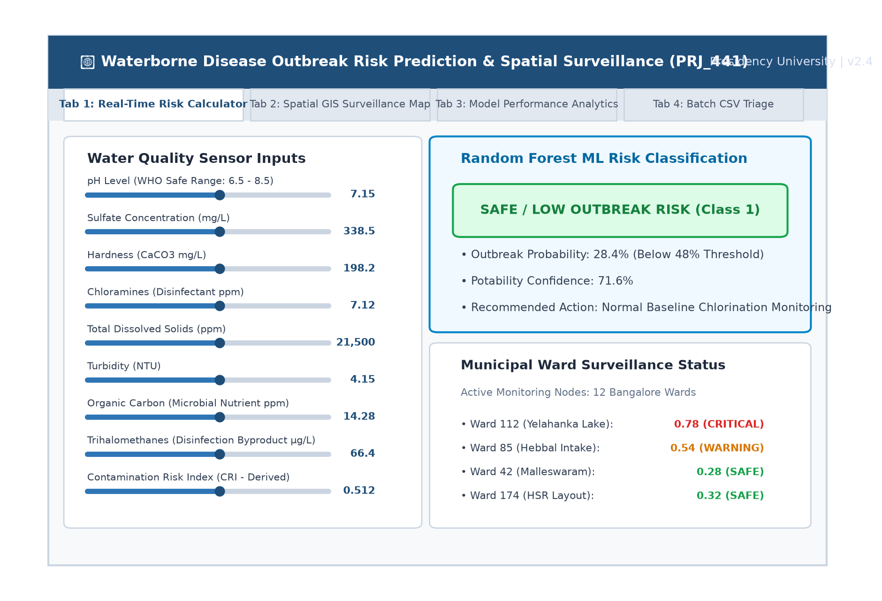
Fig. 7. Web application dashboard interface (app.py).
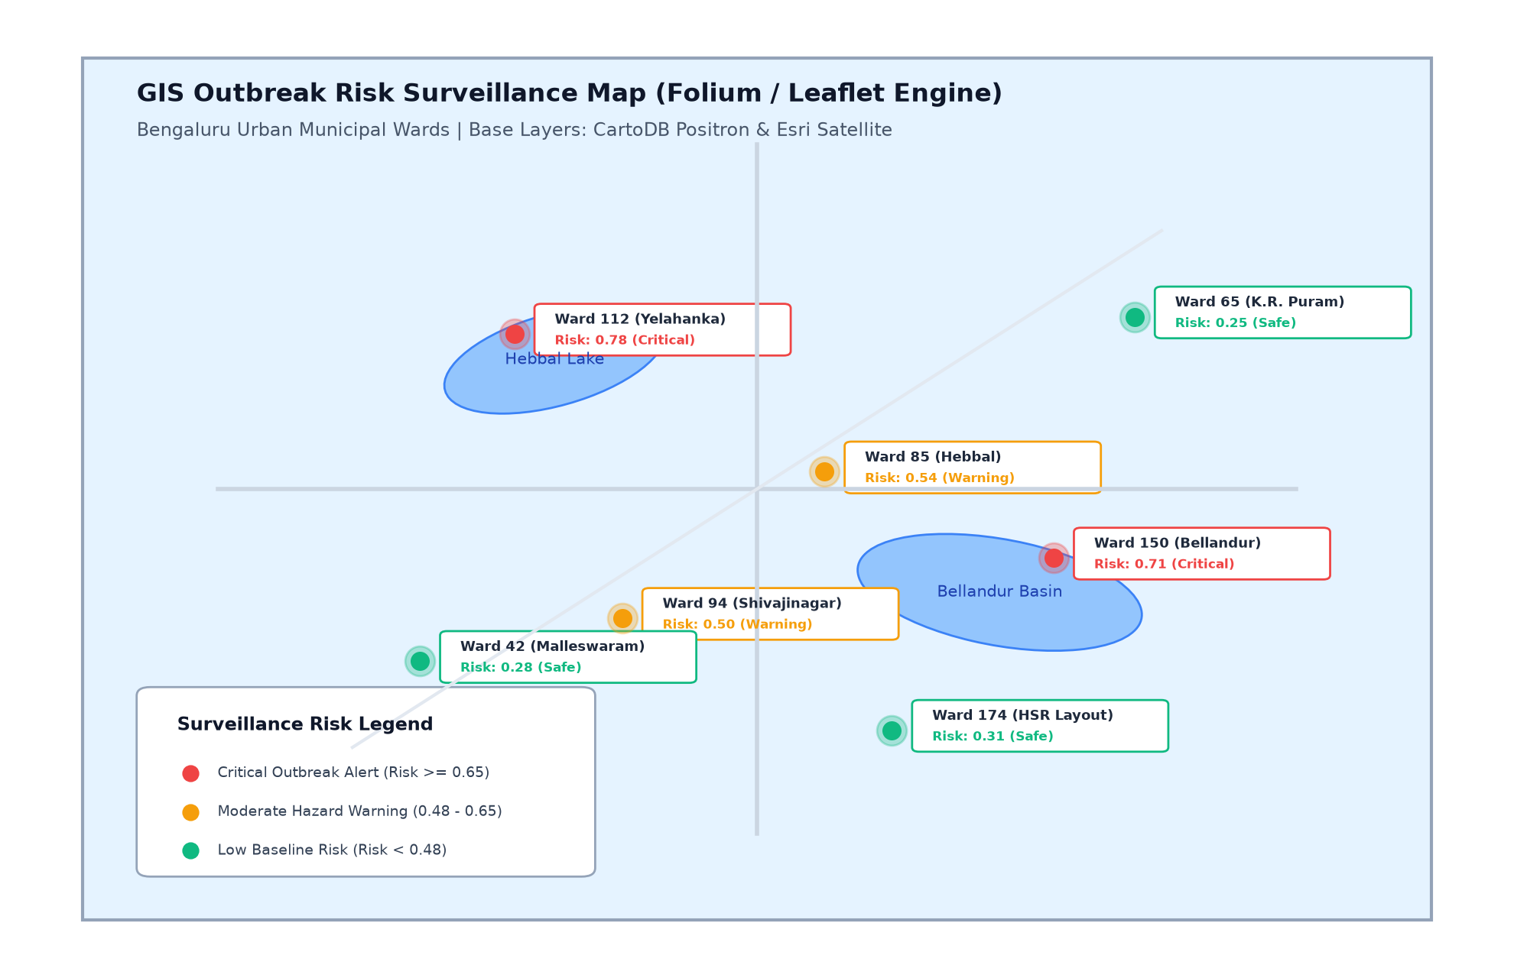
Fig. 8. GIS spatial outbreak surveillance map with Bengaluru ward cluster layers.
VIII. CONCLUSION
Project PRJ_441 successfully demonstrated an integrated ML-GIS early-warning platform that translates rapid physicochemical water telemetry into prospective disease outbreak intelligence, eliminating the critical 48-hour laboratory incubation delay. Supported by outlier-resistant median imputation, domain CRI indicators, cross-validated Random Forest ensembles (64.77% accuracy, 0.672 ROC-AUC, 76.0% unsafe recall), and interactive Folium GIS mapping, the platform empowers municipal authorities to preempt waterborne epidemics before clinical admissions surge.
REFERENCES
[1] World Health Organization, Guidelines for Drinking-Water Quality: Fourth Edition, Geneva: WHO Press, 2022.
[2] A. Kadiwal, 'Water Potability Dataset,' Kaggle Datasets, 2021. [Online]. Available: https://www.kaggle.com/datasets/adityakadiwal/water-potability
[3] L. Breiman, 'Random Forests,' Machine Learning, vol. 45, no. 1, pp. 5–32, 2001.
[4] F. Pedregosa et al., 'Scikit-learn: Machine Learning in Python,' JMLR, vol. 12, pp. 2825–2830, 2011.
[5] R. Few, I. Lake, and P. R. Hunter, 'Floods, health and climate change: a strategic review,' Tyndall Centre Working Paper, no. 162, 2013.
[6] S. Saha and S. Bhowmik, 'Water quality index prediction using machine learning algorithms,' Env. Mon. & Assess., vol. 192, no. 11, pp. 1–28, 2020.
[7] M. Gupta and N. B. Bolia, 'Case scheduling system for enhanced judicial performance,' Socio-Econ. Plan. Sci., vol. 103, Art. 102350, 2026.
[8] S. Russell and P. Norvig, Artificial Intelligence: A Modern Approach, 4th ed., Hoboken, NJ, USA: Pearson, 2021.

