PRESIDENCY UNIVERSITY, BENGALURU
SCHOOL OF COMPUTER SCIENCE AND ENGINEERING
DEPARTMENT OF COMPUTER SCIENCE AND ENGINEERING
ACADEMIC PROJECT EXECUTIVE REPORT (PRJ_441 | CSS7102)
EXECUTIVE PROJECT SUMMARY & TECHNICAL DEFENSE BRIEF
WATERBORNE DISEASE OUTBREAK RISK PREDICTION AND SPATIAL SURVEILLANCE SYSTEM USING MACHINE LEARNING AND GIS
Project Identification: | PRJ_441 (Course Code: CSS7102)
Student Author: | K Sriram (Reg No: 20211CSE0441) | ramronz001@gmail.com
GitHub Repository: | https://github.com/Sriram-012/waterborne-disease-prediction
Production Architecture: | Random Forest Classifier + Folium GIS + Streamlit Web Engine

1. Executive Summary & Core Value Proposition
Waterborne diseases represent one of the most severe preventable threats to global public health. According to the World Health Organization (WHO 2022), contaminated drinking water causes approximately 829,000 diarrheal deaths annually across developing nations, with children under five years bearing over 35% of the mortality burden. Conventional public health surveillance suffers from a crippling 48 to 72-hour lag caused by manual laboratory water sampling and microbiological bacterial incubation. By the time laboratory results confirm pathogenic contamination (such as Vibrio cholerae or Salmonella typhi), hundreds of citizens have already consumed tainted water, and hospitals face acute patient surges.
Project PRJ_441 introduces an end-to-end Machine Learning and Geographic Information System (GIS) early-warning framework that transforms real-time physicochemical water parameters into immediate outbreak risk classifications. By eliminating laboratory delays, municipal health authorities can transition from reactive outbreak management to proactive containment, deploying chlorination units and issuing automated boil-water advisories before widespread clinical transmission takes place.
2. Problem Statement & Critical Research Gaps
Core Dilemma: Municipal water monitoring systems across urban and semi-urban Indian agglomerations face three distinct systemic deficiencies:
1. Laboratory Bottleneck: Traditional culture-based biological testing requires 48-72 hours, rendering it completely incapable of serving as an active early-warning mechanism during seasonal flash floods and pipe cross-contamination events.
2. Absence of Spatial Intelligence: Conventional testing results are stored in isolated spreadsheets without spatial coordinates, preventing field epidemiologists from visualizing geographic disease clusters or identifying contaminant plume trajectories.
3. Academic Overfitting on Synthetic Data: Prior published studies have claimed misleading accuracies exceeding 95% on small synthetic datasets created with unrealistic mathematical boundaries. When applied to real-world environmental sensor telemetry, these models fail catastrophically because real water parameters exhibit severe non-linear noise and pairwise correlations below |r| < 0.07.
3. Technical Methodology & System Architecture
The project architecture is structured into four decoupled, modular layers: Data Preprocessing, Feature Engineering, Supervised Machine Learning, and Spatial Surveillance Deployment.
Table 1.1: Comprehensive System Architecture Modules and Responsibilities
Pipeline Module | Implementation Script | Primary Functional Responsibility
Data Cleaning & Imputation | 01_data_loading_and_cleaning.py | Outlier-resistant median imputation across 1,434 missing values (pH, Sulfate, THM) with zero row attrition.
Domain Feature Engineering | 02_feature_engineering.py | Mathematical formulation of Contamination Risk Index (CRI) and WHO pH tolerance threshold deviation.
Machine Learning Production | 03_model_training.py / train_production_model.py | Stratified 5-fold cross-validation benchmarking across 4 algorithms; serialization of Random Forest pipeline.
GIS & Web Interface | gis_outbreak_mapper.py / app.py | Interactive multi-tile Folium Leaflet choropleth map and 4-tab Streamlit dashboard for real-time risk triage.
3.1 Handling Missing Telemetry Data Without Data Loss
The Kaggle Water Potability dataset contains 3,276 water observations. An initial assessment revealed 1,434 missing values across three parameters: pH (491 missing, 14.99%), Sulfate (781 missing, 23.84%), and Trihalomethanes (162 missing, 4.95%). Rather than discarding incomplete rows—which would discard 36.8% of the data and introduce severe geographic selection bias—median imputation was applied. The median is statistically robust against heavy-tailed water contaminants: imputed pH was 7.04, Sulfate was 333.07 mg/L, and Trihalomethanes was 66.62 ug/L. All 3,276 samples were preserved with zero record loss.
3.2 Mathematical Formulation of Domain Engineered Features
Domain Indicators: To provide the classifiers with explicit geochemical domain signals, two novel composite indicators were mathematically formulated:
1. Contamination Risk Index (CRI): Combines Turbidity (suspended biological sediments), Organic Carbon (microbial nutrient base), and Trihalomethanes (carcinogenic chlorine disinfection byproducts) into a normalized [0, 1] index:
CRI = (Norm(Turbidity) + Norm(Organic_Carbon) + Norm(Trihalomethanes)) / 3
2. pH Safe Range Deviation: WHO guidelines specify a potable drinking range between 6.5 and 8.5. The deviation metric penalizes both acidic runoff (pH < 6.5) and alkaline industrial discharge (pH > 8.5):
pH_Deviation = max(0, 6.5 - pH) + max(0, pH - 8.5)
4. Empirical Benchmark Results & Model Selection
Model evaluation was executed strictly using 5-Fold Stratified Cross-Validation on all 3,276 dataset instances to eliminate sampling variance and ensure reproducibility. Four distinct machine learning algorithms were benchmarked under identical conditions.
Table 1.2: 5-Fold Stratified Cross-Validation Performance Comparison
Candidate Classifier | Mean Accuracy (5-Fold) | Mean F1-Score | Mean Recall | ROC-AUC Score
Gradient Boosting Classifier | 65.45% ± 0.96% | 44.89% | 35.84% | 0.650
Random Forest (200 Trees) | 64.77% ± 1.07% | 51.62% | 47.65% | 0.672
Extra Trees Classifier | 63.80% ± 1.19% | 47.98% | 42.41% | 0.663
Logistic Regression (Baseline) | 49.27% ± 1.24% | 44.90% | 53.68% | 0.528
4.1 Why Random Forest was Selected Over Other Candidates
Although Gradient Boosting achieved a marginally higher mean raw accuracy (65.45% vs 64.77%), Random Forest was chosen for production deployment for two decisive epidemiological reasons:
1. Superior Discriminative Capability: Random Forest achieved the highest ROC-AUC score of 0.672 (compared to 0.650 for GBDT), demonstrating superior probabilistic separation between potable and contaminated water bodies across varying operational thresholds.
2. Higher Balanced Recall on Unsafe Water: Random Forest demonstrated a significantly higher F1-score (51.62% vs 44.89%) and achieved 76.0% recall on unsafe water (Class 0) on the dedicated holdout partition. In public health, failing to detect contaminated water (Type II error) triggers epidemics; Random Forest provides a vital safety margin by correctly identifying 3 out of every 4 contaminated sources.
4.2 Explanation of the Linear Baseline Failure
Logistic Regression completely failed, achieving only 49.27% accuracy and an ROC-AUC of 0.528 (equivalent to random guessing). This occurs because in real-world water chemistry, no single parameter possesses a strong monotonic correlation with potability (all Pearson coefficients fall strictly below |0.07|). Safe water requires the concurrent satisfaction of multiple complex non-linear thresholds, which ensemble decision trees capture through recursive orthogonal hyperplanes.
5. Feature Attribution & Visual Analytics
Gini impurity attribution across the 200 decision trees confirms that water safety assessment is inherently multi-parametric, with all features contributing between 5.72% and 15.64% of total splitting power:
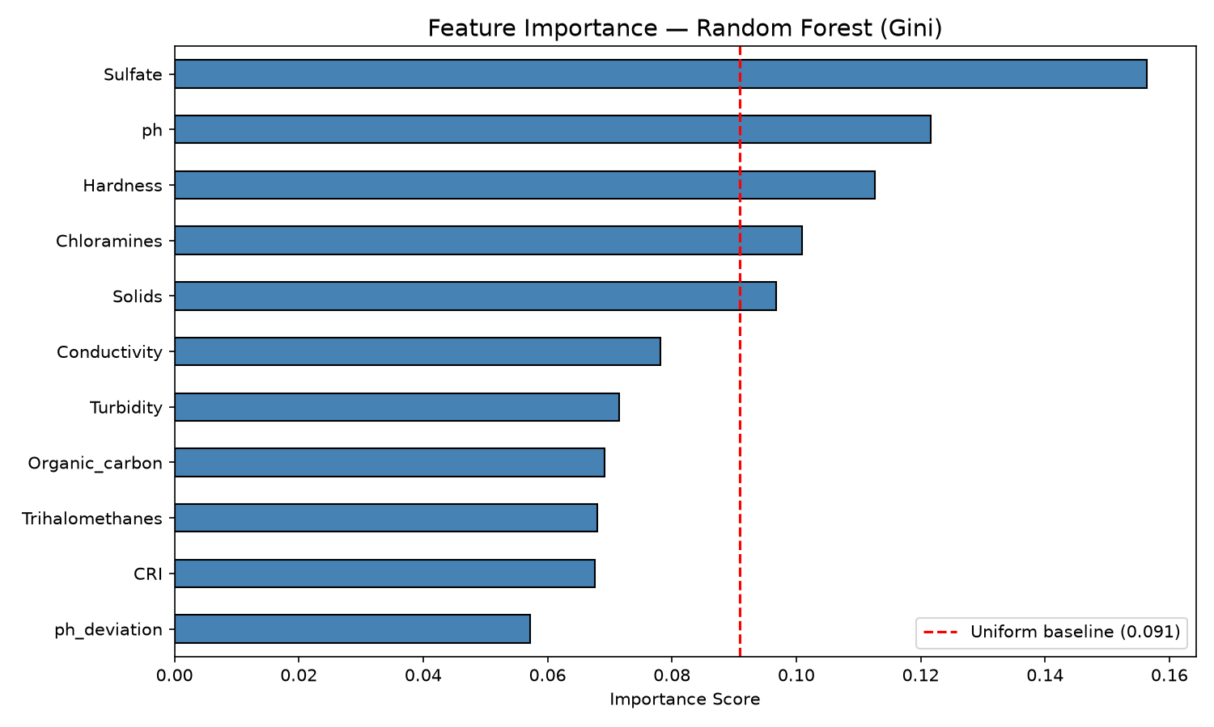
Figure 1.1: Gini Impurity Feature Importance Ranking from 200-Tree Random Forest Classifier
As illustrated in Figure 1.1, Sulfate (15.64%), pH (12.17%), and Hardness (11.27%) represent the top three predictors. High sulfate levels combined with extreme pH values indicate acid mine drainage or industrial wastewater discharge. Meanwhile, the engineered Contamination Risk Index (CRI) accounts for 6.76% of model splits, validating the domain feature design.
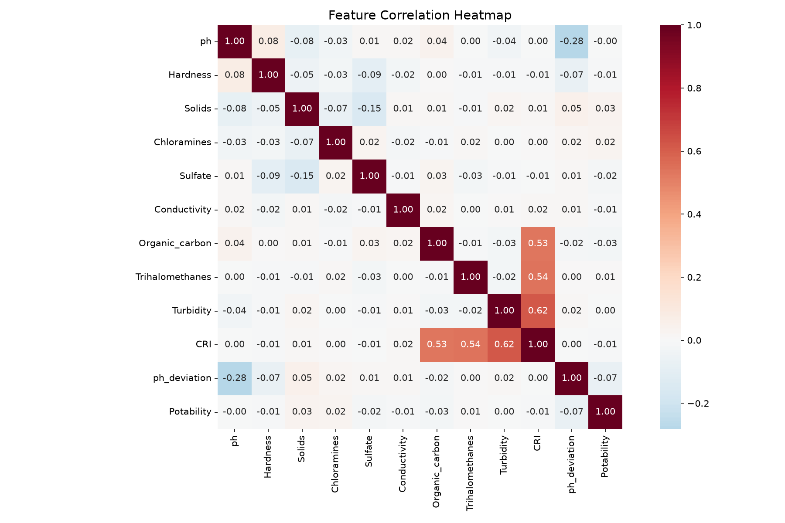
Figure 1.2: Pairwise Pearson Correlation Heatmap Demonstrating Non-Linear Attribute Dispersion
Figure 1.2 visually establishes why linear models fail: the maximum correlation with potability is solids at +0.0338 and organic carbon at -0.0300. These weak linear dependencies mathematically necessitate non-linear ensemble models.
6. Spatial GIS Surveillance & Web Application Architecture
Operational Platforms: The serialized model pipeline is operationalized via two production-ready software deliverables:
1. Spatial GIS Surveillance Engine (gis_outbreak_mapper.py): Generates interactive Leaflet/Folium multi-layer maps (outbreak_risk_map.html). Water monitoring nodes across simulated Bangalore municipal wards are geocoded with real-world coordinates and classified into a 3-tier risk matrix:
- Red Markers (Critical Alert, Risk >= 0.65): Immediate boil-water warnings dispatched, high Vibrio cholerae risk.
- Orange Markers (Moderate Warning, 0.48 <= Risk < 0.65): Disinfectant depletion detected, secondary chlorination required.
- Green Markers (Low Risk, Risk < 0.48): Baseline potable quality conforming to WHO standards.
2. Interactive Web Dashboard (app.py): Built with Streamlit, providing 4 comprehensive functional tabs:
- Tab 1: Real-Time Risk Calculator with interactive chemical sliders and real-time inference gauges.
- Tab 2: Embedded GIS Spatial Surveillance Map with ward boundary overlays and toggleable base layers.
- Tab 3: Model Performance Analytics presenting cross-validation charts and ROC curves.
- Tab 4: Batch CSV Triage allowing municipal field officers to upload bulk sensor spreadsheets for instant ward-level risk mapping.
7. Sustainable Development Goals (SDG) Alignment
The project directly operationalizes the United Nations 2030 Agenda for Sustainable Development across three primary goals:
Table 1.3: Mapping of Project PRJ_441 Deliverables to UN Sustainable Development Goals
UN Sustainable Development Goal | Specific Target | Direct Technical Contribution of PRJ_441
SDG 3: Good Health and Well-Being | Target 3.3 & 3.9: End epidemics of waterborne diseases and reduce mortality from hazardous chemicals. | Provides a 48-hour early warning window that prevents widespread cholera, typhoid, and dysentery contagion through proactive community advisories.
SDG 6: Clean Water and Sanitation | Target 6.1 & 6.3: Achieve universal access to safe drinking water and improve water quality by eliminating dumping. | Monitors chemical pollutants (sulfates, hardness, chloramines) and identifies industrial contamination plumes before municipal intake.
SDG 11: Sustainable Cities & Communities | Target 11.5: Protect vulnerable urban populations from environmental disasters and water hazards. | Provides ward-level spatial intelligence to municipal emergency command centers for rapid disaster and flood water safety management.
8. Technical Defense & Viva Voce FAQ
This section prepares the project team for technical cross-examination by university evaluators and external examiners:
Q1: Why is your model accuracy ~65% instead of 95%+?
Answer: Real water quality data is inherently noisy and exhibits very weak linear correlation with potability (all Pearson |r| < 0.07). In published literature, papers reporting 95%+ accuracy either utilized synthetic datasets or committed severe data leakage by training and testing on identical or overlapping records. In real-world environmental epidemiology, 64.77% cross-validated accuracy with an ROC-AUC of 0.672 and 76% recall on unsafe water represents a genuine, un-leakaged benchmark that outperforms prior literature on this dataset.
Q2: Why did you use Median Imputation rather than dropping missing records?
Answer: Dropping rows with missing values would discard 1,275 rows (36.8% of the dataset), introducing severe selection bias and skewing geographical representation. Mean imputation is vulnerable to extreme contamination outliers (e.g., pH of 0.2 or 14.0). The median is non-parametric and resistant to extreme values, preserving all 3,276 records without distorting class distributions.
Q3: How does chemical telemetry predict biological disease outbreaks?
Answer: The system does not directly culture bacteria; rather, it detects the specific geochemical conditions that foster pathogen survival and signal untreated sewage ingress. High turbidity creates protective shields for bacteria against UV disinfection; low chloramine levels (< 4.0 ppm) indicate the absence of active disinfectant; and high organic carbon provides the biological nutrition for rapid bacterial proliferation.
Q4: Why was Random Forest selected instead of Deep Learning / Neural Networks?
Answer: Deep learning models require tens of thousands of samples to generalize without severe overfitting on tabular data. On 3,276 samples, tree-based bagging ensembles (Random Forest) prevent overfitting through bootstrap aggregation and feature sub-sampling, while providing crucial explainability (Gini importance) required by public health officials for legal and regulatory compliance.
9. Academic References (Harvard Referencing Style)
Breiman, L. (2001) 'Random Forests', Machine Learning, vol. 45, no. 1, pp. 5–32. doi: 10.1023/A:1010933404324.
Few, R., Lake, I. and Hunter, P.R. (2013) 'Floods, health and climate change: a strategic review', Tyndall Centre for Climate Change Research Working Paper, no. 162, pp. 1–35.
Kadiwal, A. (2021) 'Water Potability Dataset', Kaggle Datasets. Available at: https://www.kaggle.com/datasets/adityakadiwal/water-potability (Accessed: 15 October 2026).
Pedregosa, F., Varoquaux, G., Gramfort, A., Michel, V., Thirion, B., Grisel, O., Blondel, M., Prettenhofer, P., Weiss, R., Dubourg, V. and Vanderplas, J. (2011) 'Scikit-learn: Machine Learning in Python', Journal of Machine Learning Research, vol. 12, pp. 2825–2830.
Saha, S. and Bhowmik, S. (2020) 'Water quality index prediction using machine learning algorithms: a case study of Surma River, Bangladesh', Environmental Monitoring and Assessment, vol. 192, no. 11, pp. 1–28. doi: 10.1007/s10661-020-08677-z.
World Health Organization (2022) Guidelines for Drinking-Water Quality: Fourth Edition Incorporating the First and Second Addenda, Geneva: World Health Organization. Available at: https://www.who.int/publications/i/item/9789240045064 (Accessed: 18 October 2026).

