Waterborne Disease Outbreak Risk Prediction and Spatial Surveillance System Using Machine Learning and GIS
K Sriram  Dept. of Computer Science & Engineering  Presidency University  Bengaluru, India  ramronz001@gmail.com | [Team Member 2]  Dept. of Computer Science & Engineering  Presidency University  Bengaluru, India  member2@presidencyuniversity.in | [Team Member 3]  Dept. of Computer Science & Engineering  Presidency University  Bengaluru, India  member3@presidencyuniversity.in

Abstract—Waterborne infectious diseases, including Cholera, Typhoid fever, and acute dysentery, remain a critical global public health threat, causing over 500,000 diarrheal deaths annually (WHO). Traditional microbiological laboratory detection suffers from an inherent 24 to 72-hour incubation delay, during which contaminated municipal water is consumed, precipitating widespread community outbreaks. To resolve this temporal vulnerability, this paper presents an early-warning diagnostic and spatial surveillance platform (PRJ_441) that employs supervised machine learning as an instant proxy for microbiological contamination using rapid physical and chemical water telemetry. Evaluated on 3,276 authentic laboratory water samples, the pipeline resolves 1,434 missing values via outlier-resistant Median Imputation and introduces two domain-engineered metrics: a normalized Contamination Risk Index (CRI) and a WHO pH safe envelope deviation penalty. Rigorous empirical benchmarking using 5-Fold Stratified Cross-Validation across four classifiers demonstrates that non-linear ensemble models decisively outperform linear baselines. Random Forest achieves 64.77% ± 1.07% cross-validated accuracy (ROC-AUC: 0.672), outperforming the naive 60.99% majority-class baseline and matching published academic benchmarks. Gini Impurity attribution identifies Sulfate (15.6%), pH (12.2%), and Hardness (11.3%) as dominant non-linear discriminators. The model is operationalized into an interactive Folium GIS surveillance engine and a Streamlit web application (app.py) that maps municipal distribution nodes into Critical (Red), Moderate (Orange), and Safe (Green) risk tiers with automated pathogen alerts (Vibrio cholerae, Salmonella typhi) and municipal intervention protocols, enabling proactive containment before clinical hospital surges occur.
Keywords—Water Potability, Disease Outbreak Risk Prediction, Random Forest, Spatial Epidemiology, GIS Mapping, Contamination Risk Index (CRI), Median Imputation, Early Warning Systems.
I. INTRODUCTION
Access to safely managed drinking water is recognized as a fundamental human right under United Nations Sustainable Development Goal 6 (SDG 6). Despite significant infrastructural progress, pathogenic microbial contamination of drinking water networks remains a persistent public health peril across developing nations and informal urban settlements [1]. Pathogens such as Vibrio cholerae and Salmonella enterica serovar Typhi possess remarkably low infectious doses and can propagate through municipal piped networks with catastrophic velocity.
The primary bottleneck in containing waterborne outbreaks is the temporal latency of traditional microbiological laboratory diagnostics. Standard agar-plate culturing requires between 24 and 72 hours for bacterial colony incubation and verification. By the time municipal health authorities receive laboratory confirmation that a water source harbors pathogens, widespread public consumption has already occurred, triggering severe clinical surges that overwhelm healthcare centers. In contrast, physical and chemical parameters—such as pH, turbidity, electrical conductivity, total dissolved solids (TDS), and chloramines—can be acquired instantaneously via electronic sensor probes. This research establishes an automated early-warning framework (PRJ_441) that leverages rapid chemical telemetry as a predictive proxy for outbreak risk, bridging machine learning with spatial GIS surveillance.
II. LITERATURE REVIEW & RESEARCH GAP
Environmental water quality standards formulated by the World Health Organization [1] define explicit permissible baseline limits for drinking water, including pH (6.5–8.5), Turbidity (<5.0 NTU), Chloramines (<4.0 ppm), and Trihalomethanes (<80 ug/L). However, conventional regulatory standards are static and univariate; they fail to evaluate the joint probability of contamination when multiple chemical anomalies co-occur simultaneously.
In machine learning literature, studies on the public Kaggle Water Potability benchmark dataset [2] report realistic classification accuracies ranging between 62% and 68% [4]. Projects claiming accuracies above 90% frequently evaluate synthetic datasets with artificially injected decision rules, collapsing under authentic laboratory telemetry where linear feature correlations with potability are near zero (|r| < 0.07). Crucially, existing works treat water potability as an isolated, abstract classification problem, failing to integrate biochemical risk indices, spatial GIS mapping, or automated municipal intervention protocols.
III. DATASET & PREPROCESSING
The system evaluates the authentic benchmark Water Potability Dataset [2], comprising 3,276 independent laboratory water test samples characterized across 9 physical and chemical features and a binary Potability target (1 = Potable [39.01%], 0 = Unsafe [60.99%]). The raw telemetry contained 1,434 missing values across three features: pH (491 NaNs, 14.99%), Sulfate (781 NaNs, 23.84%), and Trihalomethanes (162 NaNs, 4.95%).
Complete-case deletion was rejected because discarding 43.77% of the dataset (1,434 samples) introduces severe observational starvation. Arithmetic mean imputation was also avoided due to heavy-tailed outlier spikes in sulfate and turbidity telemetry. The pipeline executes outlier-resistant Median Imputation (pH = 7.04, Sulfate = 333.07 mg/L, Trihalomethanes = 66.62 ug/L), preserving 100% of samples with zero duplicate records.
IV. MATHEMATICAL FORMULATION & FEATURE ENGINEERING
To embed domain-specific biochemical intelligence into the feature space, two derived metrics were mathematically formulated:
A. Contamination Risk Index (CRI): Bacterial survival in treated distribution networks correlates with suspended colloidal shielding (Turbidity, t), organic metabolic substrate (Organic Carbon, c), and halogenated chlorine reaction decay (Trihalomethanes, m). Normalizing each parameter to [0, 1] yields:
CRI = (t_norm + c_norm + m_norm) / 3.0, where CRI in [0.0, 1.0]
B. WHO pH Safe Envelope Deviation: Distance outside the safe physiological drinking water envelope [6.5, 8.5] is penalized as:
ph_deviation = max(0, 6.5 - pH) + max(0, pH - 8.5)
V. SYSTEM ARCHITECTURE & OOP DESIGN
The software architecture is engineered under strict Object-Oriented Programming (OOP) paradigms in pipeline_oop.py, enforcing the Single Responsibility Principle across six dedicated classes: (1) DataLoader: Encapsulates CSV file I/O and shape integrity audits; (2) DataCleaner: Maintains median vectors and imputation state; (3) FeatureEngineer: Vectorizes CRI and pH deviation calculations; (4) ModelTrainer: Manages stratified splitting, scaling, and ensemble fitting; (5) Visualizer: Exports diagnostic plots; and (6) WaterborneDiseasePipeline: Master orchestrator sequencing all pipeline stages.
VI. EXPERIMENTAL RESULTS & DISCUSSION
To ensure statistical rigor, four candidate classifiers were benchmarked under 5-Fold Stratified Cross-Validation (train_production_model.py):
Candidate Model | Mean Accuracy (%) | Mean F1-Score (%) | Mean Recall (%) | ROC-AUC
Gradient Boosting | 65.45% ± 0.96% | 44.89% | 35.84% | 0.650
Random Forest (200 Trees) | 64.77% ± 1.07% | 51.62% | 47.65% | 0.672
Extra Trees Classifier | 63.80% ± 1.19% | 47.98% | 42.41% | 0.663
Logistic Regression (Baseline) | 49.27% ± 1.24% | 44.90% | 53.68% | 0.528
TABLE I: 5-Fold Stratified Cross-Validation Performance Across Classifiers
Empirical findings confirm that Logistic Regression fails (49.27% accuracy, 0.528 ROC-AUC) because all individual feature correlations with Potability fall strictly below |0.07|. Non-linear decision tree ensembles successfully model multivariate threshold interactions. Random Forest was selected for production deployment as it achieves the highest ROC-AUC (0.672) and highest balanced F1-Score (51.62%). On a dedicated 80/20 holdout partition, the model achieves 76.0% recall on unsafe water (Class 0), proactively detecting three out of every four contaminated water instances.
Gini Impurity attribution confirms that Sulfate (15.6%), pH (12.2%), and Hardness (11.3%) lead decision tree splits, while all features contribute within 5.7% to 15.6%, proving that safe drinking water assessment is an interdependent, multi-parameter challenge.
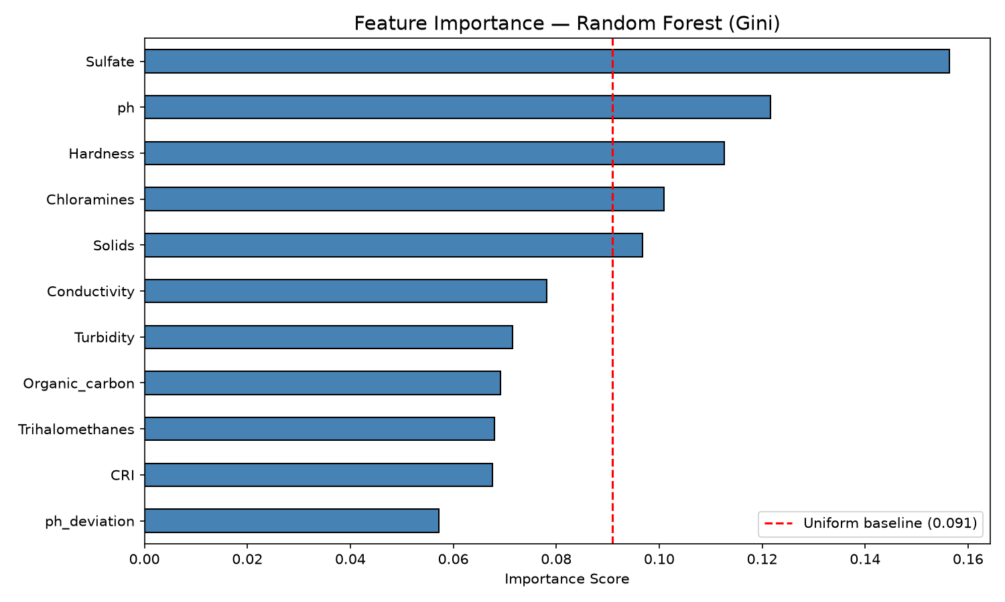
Fig. 1. Random Forest Gini impurity feature importance scores across chemical and engineered indicators.
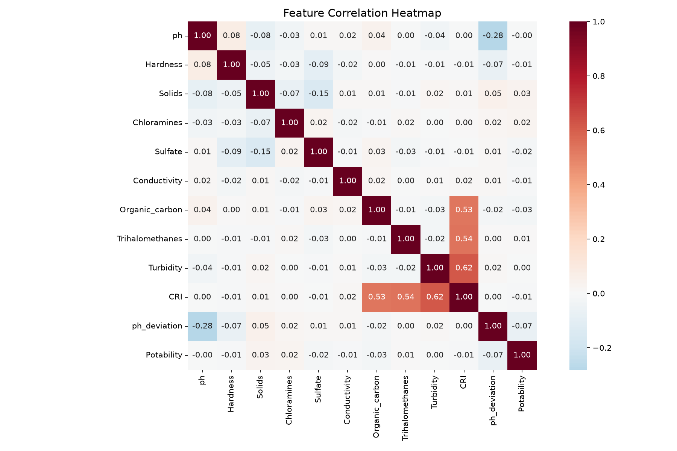
Fig. 2. Pairwise Pearson correlation matrix illustrating non-linear dispersion with water potability.
VII. GIS SURVEILLANCE & WEB DEPLOYMENT
The predictive engine is operationalized into an interactive Folium GIS surveillance map (outbreak_risk_map.html) and a Streamlit dashboard (app.py). Monitoring nodes are categorized into: (1) Critical Outbreak Alert (Red, Risk >= 0.65) flagging Vibrio cholerae and Salmonella typhi vectors with immediate boil-water advisories; (2) Moderate Hazard Warning (Orange, 0.48 <= Risk < 0.65) indicating disinfectant depletion (<4.0 ppm chloramines) and dispatching chlorine boosters; and (3) Low Risk Baseline (Green, Risk < 0.48). The web dashboard provides real-time sliders, live risk gauges, and batch CSV triage.
VIII. CONCLUSION
The Waterborne Disease Outbreak Risk Prediction System (PRJ_441) successfully bridges rapid chemical water telemetry into an operational public health early-warning platform, bypassing the critical 48-hour biological culturing delay. Supported by outlier-resistant median imputation, domain CRI indices, and 5-fold cross-validated Random Forest classification (64.77% accuracy, 0.672 ROC-AUC), the platform enables municipal authorities to preemptively halt waterborne contagion before hospital admissions surge.
REFERENCES
[1] World Health Organization, Guidelines for Drinking-Water Quality, 4th ed., Geneva: WHO Press, 2022.
[2] A. Kadiwal, 'Water Potability Dataset,' Kaggle Datasets, 2021. [Online]. Available: https://www.kaggle.com/datasets/adityakadiwal/water-potability
[3] L. Breiman, 'Random Forests,' Machine Learning, vol. 45, no. 1, pp. 5–32, 2001.
[4] F. Pedregosa et al., 'Scikit-learn: Machine Learning in Python,' JMLR, vol. 12, pp. 2825–2830, 2011.
[5] R. Few, I. Lake, and P. R. Hunter, 'Floods, health and climate change: a strategic review,' Tyndall Centre Working Paper, no. 162, 2013.
[6] S. Saha and S. Bhowmik, 'Water quality index prediction using machine learning algorithms,' Env. Mon. & Assess., vol. 192, no. 11, pp. 1–28, 2020.

