1. PROJECT OVERVIEW

Project/ App Name

Creators Studio

Project Description
This project is a mobile-responsive expense management application developed for a small fabric business owner. The application is intended to help the user record, manage, and track expenses related to purchasing fabrics and accessories used in garment production.
The application focuses mainly on maintaining purchasing records in a simple, fast, and organized manner.
The current version of the application includes:
- User authentication
- Fabric purchasing bill entry
- Accessory purchasing bill entry
- Dynamic form handling
- Automatic total price calculation
The application is planned to be scalable so that future modules such as payment bills, expense history tables, reports, and analytics can be added later without major structural changes.

Main Objective
The main objective of this application is to replace manual expense tracking with a structured digital system that allows the business owner to:
- Enter purchasing expenses quickly
- Organize fabric and accessory purchase data
- Reduce manual calculation work
- Maintain records digitally
- Prepare the application for future reporting and analytics features

Target User
The application is designed for:
- A single business owner
- Internal business usage only
- No multi-user management currently required

2. Core Features Implemented in Current Design

1. User Authentication
The application starts with a login page.

Login Flow
- Existing users can log in using username and password.
- New users can register using:
  - Username
  - Password
  - Confirm Password
After successful login, the user is redirected to the dashboard.

2. Dashboard
The dashboard currently contains two main modules:
- Purchasing Bills
- Payment Bills
Currently, only the Purchasing Bills module is fully designed and implemented in the requirement phase.
The Payment Bills module is reserved for future development.

Purchasing Bills Module
Inside the Purchasing Bills module, the user must select one of the following categories:
- Fabrics
- Accessories

Fabric Purchasing Module
The Fabric Purchasing module is used to store expenses related to fabric purchases.
The user must enter:
- Fabric Name
- Fabric Type
- Colour
- GSM
- Weight
- Rib
- Price Per Kg

Dynamic Dropdown Behaviour

Fabric Name
The Fabric Name field is a dropdown selection field.
If the user selects:
- “Others”
then the application must allow manual text input for entering a custom fabric name.

Fabric Type
The Fabric Type field also behaves similarly:
- Dropdown selection
- “Others” option enables manual entry

Dynamic Multiple Entry Feature
The Fabric module supports adding multiple colour entries for the same fabric purchase.
An Add button is provided that dynamically creates additional rows containing:
- Colour
- GSM
- Weight
- Rib
- Price Per Kg
This allows the user to enter multiple colour variations under the same fabric purchase entry.

Automatic Calculation
The application must automatically calculate Total Price using:
- Weight
- Price Per Kg
The calculated total should update dynamically whenever values are changed.

Fixed Units
The following units are fixed and cannot be modified by the user:
- Weight → KG
- Rib → g
- Price → ₹ symbol
These units are displayed automatically in the UI.

Submission Flow
After entering all required data:
- User clicks Submit
- Data is stored in the database
- User is redirected back to Dashboard

Accessories Purchasing Module
The Accessories module is used to store accessory purchase expenses.
The user first selects an Accessory Name from a dropdown.
Depending on the selected accessory type, different input fields are displayed dynamically.

Cone Accessory
If the user selects:
- Cone
the following fields must be displayed:
- Colour Name
- Colour Code
- Unit
- Price Per Unit

Multiple Dynamic Entries
The Cone module also supports dynamic multiple entries using an Add button.
The Add button creates new rows containing:
- Colour Name
- Colour Code
- Unit
- Price Per Unit
This allows multiple cone colour entries within the same purchase.

Automatic Calculation
Total Price is automatically calculated using:
- Unit
- Price Per Unit

Size Pattern Accessory
If the user selects:
- Size Pattern
the following fields must be displayed:
- Brand Name
- Style Number
- Style Name
- Price

Others Accessory
If the user selects:
- Others
the following fields must be displayed:
- Name
- Unit / Kg / Gross
- Price

Current Project Scope
The current project scope includes:
- Authentication system
- Dashboard navigation
- Fabric purchasing entry system
- Accessory purchasing entry system
- Dynamic forms
- Automatic price calculations
- Database storage

Future Enhancements
The following modules are planned for future implementation:
- Payment Bills Module
- Expense Table View
- Search and Filter Features
- Reports Module
- PDF Export
- Expense Analytics Dashboard
- Monthly Expense Summary
- Edit/Delete Records
- Supplier Management
- Inventory Tracking

Technical Architecture
The application will follow:
- REST API architecture
- Layered backend architecture
- MVC design pattern

3. Planned Technology Stack

Frontend
- HTML
- CSS
- JavaScript

Backend
- Core Java
- JDBC
- Spring Framework
- Spring Boot
- Spring MVC
- Spring Data JPA

Database
- MySQL

Development Goal
The goal of this project is to create a scalable, maintainable, and user-friendly expense management application that simplifies purchase recording operations for a fabric business while also serving as a strong full-stack development project using Java and Spring Boot technologies.

4. Screen flow
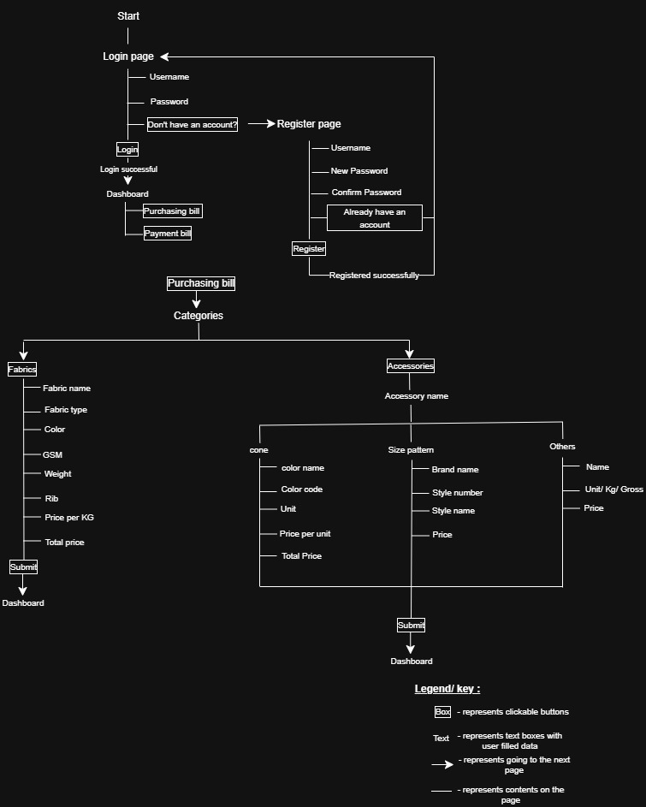
5. UI Wireframes
i. Login Page
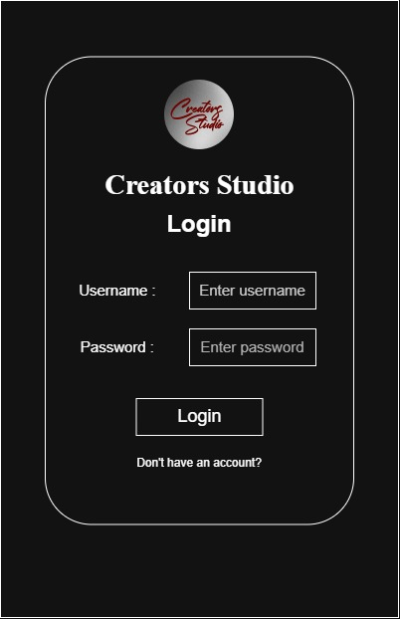
This page is for login-in into the app.

ii. Register page
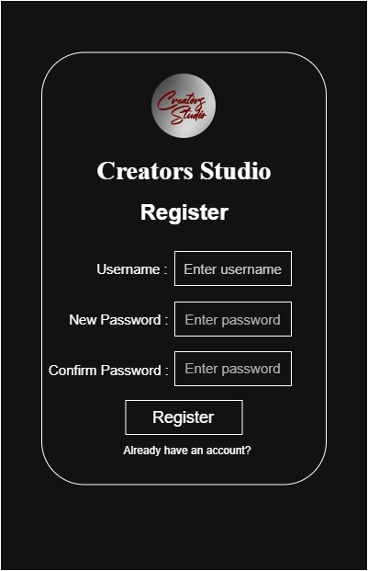
This page is for registering into app.

iii. Dashboard
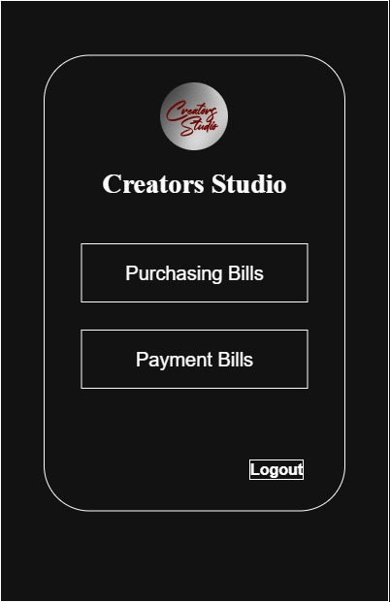
This page is the dashboard page of the app.

iv. Purchasing bills page
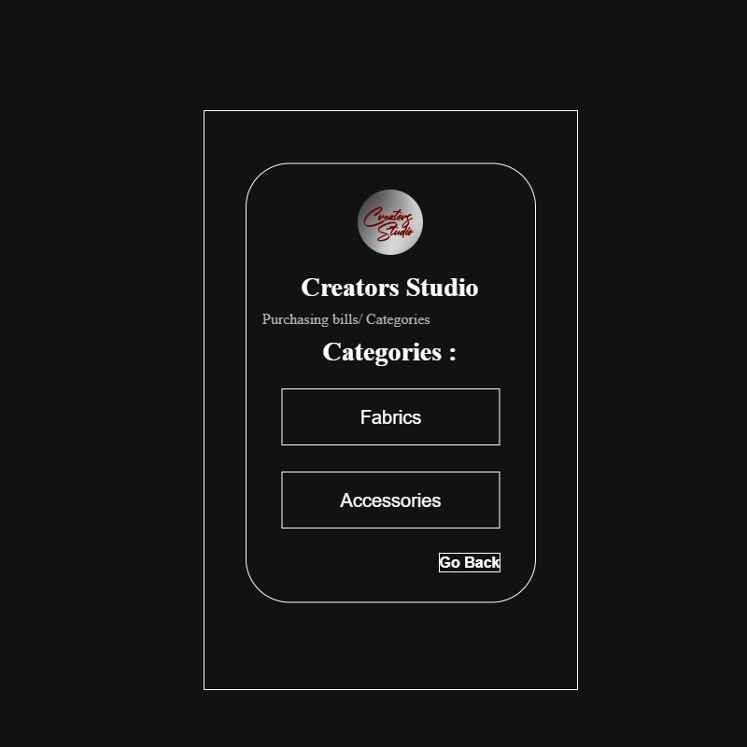
This page is used to know whether the user purchased fabric or accessory.
v. Fabrics page 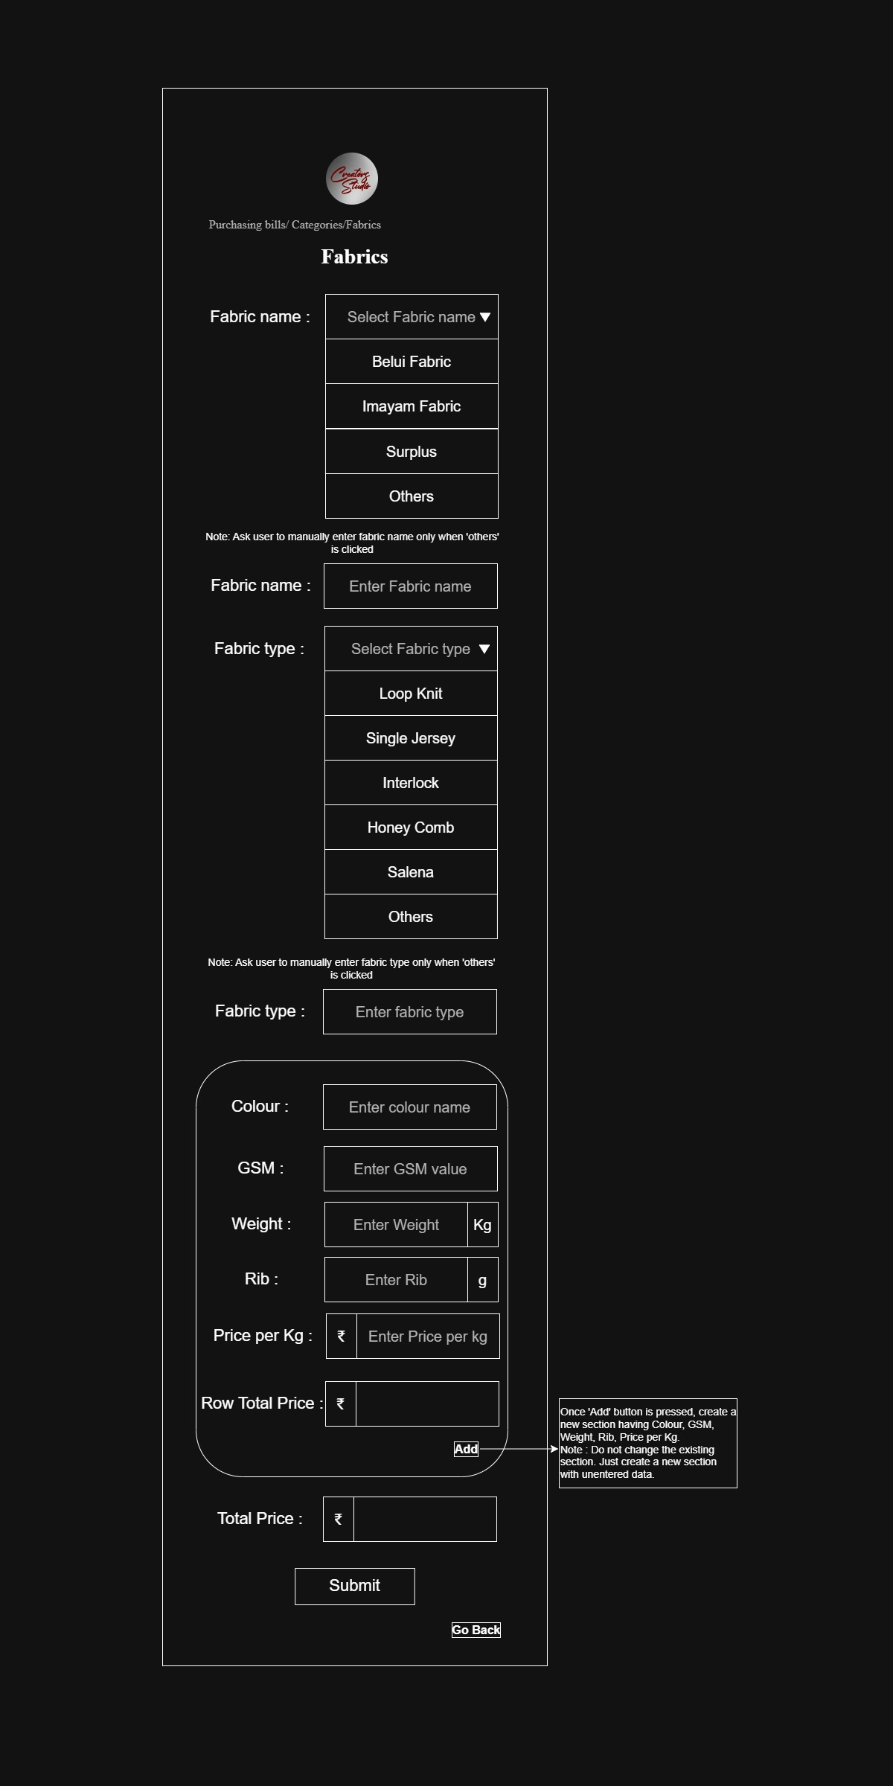
This page allows the user to get fabric details and add multiple fabric colour entries dynamically.
vi. Accessories page
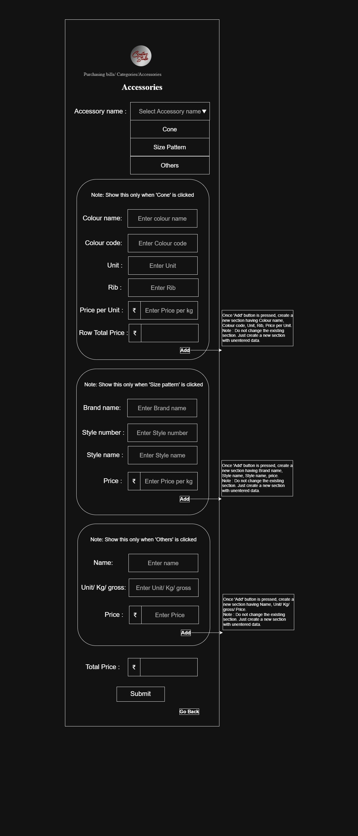
This page allows the user to add accessory details and add multiple cone accessory colour and other entries dynamically.

6. Database Blueprint
Table 1 - user:
Column | Data type | Constraints | Purpose
Id | bigint | Primary key, AUTO_INCREMENT | Unique user ID
Username | varchar(50) | Unique, NOT NULL | Unique username
Password | varchar(255) | NOT NULL | Encrypted password

Table 2 – Fabric
Column | Data type | Constraints | Purpose
id | bigint | Primary key, AUTO_INCREMENT | Unique fabric ID
Fabric_name | Varchar(100) | NOT NULL
Fabric_type | Varchar(100) | NOT NULL
Total_price | decimal | NOT NULL
Purchase_date | Datetime | NOT NULL | Records the purchased date
Created_at | timestamp | NOT NULL | Records the purchased time

Table 3 – Fabric_items
Column | Data type | Constraints | Purpose
id | bigint | Primary key, AUTO_INCREMENT | Unique fabric ID
Fabric_id | bigint | Foreign key
colour | Varchar(100) | NOT NULL
GSM | int | NOT NULL
Weight | decimal | NOT NULL
Rib | decimal | NOT NULL
Price_per_kg | decimal | NOT NULL
Row_total | decimal | NOT NULL

Table 4 – Accessory
Column | Data type | Constraints | Purpose
id | bigint | Primary key, AUTO_INCREMENT | Unique accessory ID
Accessory_name | Varchar(100) | NOT NULL
Total_price | decimal | NOT NULL | Combined final total
Purchase_date | Datetime | NOT NULL | Records the purchased date
Created_at | timestamp | NOT NULL | Records the purchased time

Table 5 – Cone
Column | Data type | Constraints | Purpose
id | bigint | Primary key, AUTO_INCREMENT | Unique cone ID
Accessory_id | bigint | Foreign key -> accessory.id | Linked accessory

Table 6 – Cone_items
Column | Data type | Constraints | Purpose
id | bigint | Primary key, AUTO_INCREMENT | Unique cone ID
Cone_id | bigint | Foreign key
colour_name | Varchar(100) | NOT NULL
Colour_code | Varchar(100) | NOT NULL
unit | decimal | NOT NULL
Price_per_unit | decimal | NOT NULL
Row_total | decimal | NOT NULL | Row subtotal

Table 7 – Size_pattern
Column | Data type | Constraints | Purpose
Id | bigint | Primary key, AUTO_INCREMENT | Unique size pattern ID
Accessory_id | bigint | Foreign key -> accessory.id | Linked accessory
brand_name | Varchar(100) | NOT NULL
style_number | Int | NOT NULL
Style_name | Varchar(100) | NOT NULL
price | decimal | NOT NULL

Table 8 – others
Column | Data type | Constraints | Purpose
id | bigint | Primary key, AUTO_INCREMENT | Unique cone ID
Accessory_id | bigint | Foreign key -> accessory.id | Linked accessory
Items_name | Varchar(100) | NOT NULL
unit | decimal | NOT NULL
price | decimal | NOT NULL

7. API BLUEPRINT

Base URL
/api

AUTH MODULE APIs

Register User
POST /api/auth/register

Purpose
Create new account

Login User
POST /api/auth/login

Purpose
Login existing user

DASHBOARD MODULE APIs

Get Dashboard Data
GET /api/dashboard

Purpose
Load dashboard modules

FABRIC PURCHASE MODULE APIs

Create Fabric Purchase
POST /api/purchases/fabrics

Purpose
Save new fabric purchasing bill

Get All Fabric Purchases
GET /api/purchases/fabrics

Purpose
Get all fabric purchase records

Get Fabric Purchase By ID
GET /api/purchases/fabrics/{id}

Purpose
Get single fabric purchase details

Update Fabric Purchase
PUT /api/purchases/fabrics/{id}

Purpose
Update fabric purchase details

Delete Fabric Purchase
DELETE /api/purchases/fabrics/{id}

Purpose
Delete fabric purchase entry

ACCESSORY PURCHASE MODULE APIs

Create Accessory Purchase
POST /api/purchases/accessories

Purpose
Save new accessory purchasing bill

Get All Accessory Purchases
GET /api/purchases/accessories

Purpose
Get all accessory purchase records

Get Accessory Purchase By ID
GET /api/purchases/accessories/{id}

Purpose
Get single accessory purchase details

Update Accessory Purchase
PUT /api/purchases/accessories/{id}

Purpose
Update accessory purchase details

Delete Accessory Purchase
DELETE /api/purchases/accessories/{id}

Purpose
Delete accessory purchase entry

CONE ACCESSORY APIs

Create Cone Entry
POST /api/accessories/cone

Purpose
Save cone accessory details

Get All Cone Entries
GET /api/accessories/cone

Purpose
Get all cone entries

Get Cone Entry By ID
GET /api/accessories/cone/{id}

Purpose
Get single cone entry

Update Cone Entry
PUT /api/accessories/cone/{id}

Purpose
Update cone details

Delete Cone Entry
DELETE /api/accessories/cone/{id}

Purpose
Delete cone entry

SIZE PATTERN APIs

Create Size Pattern Entry
POST /api/accessories/size-pattern

Purpose
Save size pattern details

Get All Size Pattern Entries
GET /api/accessories/size-pattern

Purpose
Get all size pattern entries

Get Size Pattern Entry By ID
GET /api/accessories/size-pattern/{id}

Purpose
Get single size pattern entry

Update Size Pattern Entry
PUT /api/accessories/size-pattern/{id}

Purpose
Update size pattern details

Delete Size Pattern Entry
DELETE /api/accessories/size-pattern/{id}

Purpose
Delete size pattern entry

OTHER ACCESSORY APIs

Create Other Accessory Entry
POST /api/accessories/others

Purpose
Save other accessory details

Get All Other Accessory Entries
GET /api/accessories/others

Purpose
Get all other accessory entries

Get Other Accessory Entry By ID
GET /api/accessories/others/{id}

Purpose
Get single other accessory entry

Update Other Accessory Entry
PUT /api/accessories/others/{id}

Purpose
Update other accessory details

Delete Other Accessory Entry
DELETE /api/accessories/others/{id}

Purpose
Delete other accessory entry

RECOMMENDED CONTROLLER STRUCTURE
AuthController
DashboardController
FabricPurchaseController
AccessoryPurchaseController
ConeController
SizePatternController
OthersController

RECOMMENDED SERVICE STRUCTURE
AuthService
DashboardService
FabricPurchaseService
AccessoryPurchaseService
ConeService
SizePatternService
OthersService

REQUEST METHODS USED
GET -> Fetch data
POST -> Create data
PUT -> Update data
DELETE -> Delete data

FUTURE MODULE PLACEHOLDER
Payment Bills Module
Expense Table Module
Reports Module
Search Module
Filter Module
Export PDF Module

8. BUSINESS RULES

Authentication Rules

User Registration
- Each username must be unique.
- Username cannot be empty.
- Password cannot be empty.
- Confirm Password must exactly match Password.
- Password must be stored in encrypted format in the database.
- Duplicate usernames are not allowed.

User Login
- Only registered users can log in.
- Username and password must match stored credentials.
- Invalid username or password must display an error message.
- After successful login, user must be redirected to Dashboard.

Dashboard Rules
- Dashboard is displayed only after successful login.
- Dashboard currently contains:
  - Purchasing Bills
  - Payment Bills
- Payment Bills module is reserved for future implementation.
- User must be able to navigate to Purchasing Bills module from Dashboard.

Purchasing Bills Rules
- User must select one category before entering purchase details.
- Available categories:
  - Fabrics
  - Accessories
- Data must not be saved until Submit button is clicked.

Fabric Module Rules

Fabric Name Rules
- Fabric Name must be selected from dropdown.
- Dropdown must contain predefined fabric names.
- Dropdown must include “Others” option.
- If “Others” is selected, user must be allowed to manually enter fabric name.
- Fabric Name field is mandatory.

Fabric Type Rules
- Fabric Type must be selected from dropdown.
- Dropdown must contain predefined fabric types.
- Dropdown must include “Others” option.
- If “Others” is selected, user must be allowed to manually enter fabric type.
- Fabric Type field is mandatory.

Colour Rules
- Colour field is manual entry.
- Colour field cannot be empty.

GSM Rules
- GSM must be numeric.
- GSM cannot be negative.
- GSM field is mandatory.

Weight Rules
- Weight must be numeric.
- Weight cannot be negative or zero.
- Weight unit must always remain “KG”.
- User must not be allowed to edit or remove “KG”.
- Weight field is mandatory.

Rib Rules
- Rib must be numeric.
- Rib cannot be negative or zero.
- Rib unit must always remain “g”.
- User must not be allowed to edit or remove “g”.
- Rib field is mandatory.

Price Per Kg Rules
- Price Per Kg must be numeric.
- Price cannot be negative or zero.
- Currency symbol ₹ must always be displayed.
- User must not be allowed to edit or remove currency symbol.
- Price Per Kg field is mandatory.

Dynamic Row Rules — Fabric Module
- User can dynamically add multiple rows using Add button.
- Newly added rows must contain:
  - Colour
  - GSM
  - Weight
  - Rib
  - Price Per Kg
- Multiple rows belong to same fabric purchase entry.
- Each row must independently calculate its own Row Total using:
Row Total = Weight × Price Per Kg
- A Total Price must be calculated by adding all Row Totals together.
- Empty rows must not be saved.

Fabric Price Calculation Rules

Row Total Rules
- Each row must automatically calculate its own Row Total.
- Row Total field must be read-only.
- User must not manually edit Row Total.
- Row Total must dynamically update whenever:
  - Weight changes
  - Price Per Kg changes

Total Price Rules
- Total Price must automatically calculate by adding all Row Totals.
- Formula:
Total Price = Sum of All Row Totals
- Total Price field must be read-only.
- User must not manually edit Total Price.
- Total Price must dynamically update whenever any row value changes.

Fabric Submission Rules
- Fabric purchase data must be stored only after clicking Submit button.
- After successful save:
  - success message must be displayed
  - user must be redirected to Dashboard
- Failed save operation must display proper error message.

Accessories Module Rules

Accessory Selection Rules
- User must first select Accessory Name from dropdown.
- Different accessory types must dynamically display different input fields.
- Accessory Name field is mandatory.

Cone Accessory Rules

Cone Fields
Cone accessory must contain:
- Colour Name
- Colour Code
- Unit
- Price Per Unit

Colour Name Rules
- Colour Name is mandatory.
- Colour Name cannot be empty.

Colour Code Rules
- Colour Code is mandatory.
- Colour Code cannot be empty.

Unit Rules
- Unit must be numeric.
- Unit cannot be negative or zero.
- Unit field is mandatory.

Price Per Unit Rules
- Price Per Unit must be numeric.
- Price cannot be negative or zero.
- Currency symbol ₹ must always be displayed.
- User must not be allowed to edit or remove currency symbol.

Dynamic Row Rules — Cone Module
- User can dynamically add multiple rows using Add button.
- Newly added rows must contain:
  - Colour Name
  - Colour Code
  - Unit
  - Price Per Unit
- Multiple rows belong to same cone purchase entry.
- Each row must independently calculate its own Row Total using:
  - Unit × Price Per Unit
- A Total Price must be displayed at the bottom.
- Total Price must be calculated by adding all Row Totals together.
- Empty rows must not be saved.

Cone Total Price Rules
- Row Total must automatically calculate for each row.
- Formula:
Row Total = Unit × Price Per Unit
- Total Price must automatically calculate by adding all Row Totals.
- Formula:
Total Price = Sum of All Row Totals
- Row Total fields must be read-only.
- Total Price field must be read-only.
- User must not manually edit Row Total or Total Price.
- Total Price must dynamically update whenever any row value changes.

Size Pattern Rules

Required Fields
Size Pattern accessory must contain:
- Brand Name
- Style Number
- Style Name
- Price

Brand Name Rules
- Brand Name is mandatory.
- Brand Name cannot be empty.

Style Number Rules
- Style Number must be numeric.
- Style Number is mandatory.

Style Name Rules
- Style Name is mandatory.
- Style Name cannot be empty.

Price Rules
- Price must be numeric.
- Price cannot be negative or zero.
- Currency symbol ₹ must always be displayed.
- User must not be allowed to edit or remove currency symbol.

Others Accessory Rules

Required Fields
Others accessory must contain:
- Name
- Unit / Kg / Gross
- Price

Name Rules
- Name field is mandatory.
- Name cannot be empty.

Unit / Kg / Gross Rules
- Value must be numeric.
- Value cannot be negative or zero.
- Field is mandatory.

Price Rules
- Price must be numeric.
- Price cannot be negative or zero.
- Currency symbol ₹ must always be displayed.
- User must not be allowed to edit or remove currency symbol.

Submission Rules — Accessories
- Accessory purchase data must be stored only after clicking Submit button.
- After successful save:
  - success message must be displayed
  - user must be redirected to Dashboard
- Failed save operation must display proper error message.

Database Rules
- All IDs must be auto-generated.
- Primary keys must be unique.
- Foreign key relationships must be maintained properly.
- Null values must not be allowed in mandatory fields.
- Data types must strictly follow database blueprint.

API Rules
- Application must use REST API architecture.
- GET APIs must only retrieve data.
- POST APIs must create new data.
- PUT APIs must update existing data.
- DELETE APIs must remove data.

UI Rules
- Application must be mobile responsive.
- Forms must be user-friendly and simple.
- Validation messages must be clearly visible.
- Required fields must be properly indicated.
- Submit buttons must remain disabled if mandatory fields are empty.
- Dynamic rows must visually align properly.
- Read-only calculated fields must be visually distinguishable.

Error Handling Rules
- Invalid input must display proper validation message.
- System errors must display user-friendly messages.
- Application must prevent saving incomplete or invalid data.
- Empty dynamic rows must be ignored or removed automatically.

Future Scope Rules
The architecture must support future implementation of:
- Payment Bills Module
- Expense Table View
- Search and Filters
- Reports
- PDF Export
- Analytics Dashboard
- Edit/Delete Operations
- Supplier Management
- Inventory Management
- Monthly Expense Tracking

9. FOLDER STRUCTURE REQUIREMENT

Project Architecture
The application must follow:
- Layered Architecture
- MVC Pattern
- REST API Architecture
- Clean Code Structure
- Separation of Concerns Principle
The backend and frontend must be organized properly for scalability, maintainability, and future feature expansion.

Recommended Project Structure
project-root/
│
├── src/
│ ├── main/
│ │ ├── java/
│ │ │ └── com/example/fabricexpensemanagement/
│ │ │
│ │ │ ├── controller/
│ │ │ │
│ │ │ │ ├── AuthController.java
│ │ │ │ ├── DashboardController.java
│ │ │ │ ├── FabricPurchaseController.java
│ │ │ │ ├── AccessoryPurchaseController.java
│ │ │ │ ├── ConeController.java
│ │ │ │ ├── SizePatternController.java
│ │ │ │ └── OthersController.java
│ │ │
│ │ │ ├── service/
│ │ │ │
│ │ │ │ ├── AuthService.java
│ │ │ │ ├── DashboardService.java
│ │ │ │ ├── FabricPurchaseService.java
│ │ │ │ ├── AccessoryPurchaseService.java
│ │ │ │ ├── ConeService.java
│ │ │ │ ├── SizePatternService.java
│ │ │ │ └── OthersService.java
│ │ │
│ │ │ ├── repository/
│ │ │ │
│ │ │ │ ├── UserRepository.java
│ │ │ │ ├── FabricRepository.java
│ │ │ │ ├── AccessoryRepository.java
│ │ │ │ ├── ConeRepository.java
│ │ │ │ ├── SizePatternRepository.java
│ │ │ │ └── OthersRepository.java
│ │ │
│ │ │ ├── entity/
│ │ │ │
│ │ │ │ ├── User.java
│ │ │ │ ├── Fabric.java
│ │ │ │ ├── Accessory.java
│ │ │ │ ├── Cone.java
│ │ │ │ ├── SizePattern.java
│ │ │ │ └── Others.java
│ │ │
│ │ │ ├── dto/
│ │ │ │
│ │ │ │ ├── LoginRequestDTO.java
│ │ │ │ ├── RegisterRequestDTO.java
│ │ │ │ ├── FabricRequestDTO.java
│ │ │ │ ├── FabricResponseDTO.java
│ │ │ │ ├── AccessoryRequestDTO.java
│ │ │ │ └── AccessoryResponseDTO.java
│ │ │
│ │ │ ├── config/
│ │ │ │
│ │ │ │ ├── SecurityConfig.java
│ │ │ │ ├── SwaggerConfig.java
│ │ │ │ └── AppConfig.java
│ │ │
│ │ │ ├── exception/
│ │ │ │
│ │ │ │ ├── GlobalExceptionHandler.java
│ │ │ │ ├── ResourceNotFoundException.java
│ │ │ │ ├── ValidationException.java
│ │ │ │ └── AuthenticationException.java
│ │ │
│ │ │ ├── util/
│ │ │ │
│ │ │ │ ├── PriceCalculatorUtil.java
│ │ │ │ ├── ValidationUtil.java
│ │ │ │ └── ResponseUtil.java
│ │ │
│ │ │ ├── constant/
│ │ │ │
│ │ │ │ ├── AppConstants.java
│ │ │ │ └── ApiConstants.java
│ │ │
│ │ │ └── FabricExpenseManagementApplication.java
│ │
│ │ ├── resources/
│ │ │
│ │ │ ├── application.properties
│ │ │ ├── static/
│ │ │ ├── templates/
│ │ │ └── data.sql
│ │
│ │ └── webapp/
│ │ │
│ │ ├── css/
│ │ ├── js/
│ │ ├── images/
│ │ └── pages/
│ │ ├── login.html
│ │ ├── register.html
│ │ ├── dashboard.html
│ │ ├── fabric-purchase.html
│ │ └── accessory-purchase.html
│
├── pom.xml
├── README.md
└── .gitignore

Folder Responsibilities

controller/
Responsible for:
- Handling API requests
- Receiving frontend requests
- Returning API responses
Controllers should:
- Contain only request handling logic
- Not contain business logic
- Call service layer methods

service/
Responsible for:
- Business logic
- Calculations
- Data processing
- Validation coordination
Services should:
- Process application logic
- Interact with repositories
- Return processed results

repository/
Responsible for:
- Database operations
- CRUD operations
- Query execution
Repositories should:
- Use Spring Data JPA
- Extend JpaRepository
- Contain database query methods

entity/
Responsible for:
- Database table mapping
- JPA entity definitions
Entities should:
- Represent database tables
- Use proper annotations
- Maintain relationships

dto/
Responsible for:
- Request body objects
- Response body objects
- API data transfer
DTOs should:
- Prevent direct entity exposure
- Improve security
- Separate API structure from database structure

config/
Responsible for:
- Application configurations
- Security setup
- Swagger configuration
- Bean configurations

exception/
Responsible for:
- Global exception handling
- Custom exception classes
- API error responses

util/
Responsible for:
- Helper methods
- Common reusable logic
- Calculation utilities

constant/
Responsible for:
- Static constant values
- API constants
- Application-wide constants

resources/
Responsible for:
- Configuration files
- Static resources
- SQL scripts
- Application properties

webapp/
Responsible for:
- Frontend files
- HTML pages
- CSS styles
- JavaScript files
- Images

Frontend Folder Structure
webapp/
│
├── css/
│ ├── login.css
│ ├── dashboard.css
│ ├── fabric.css
│ └── accessory.css
│
├── js/
│ ├── login.js
│ ├── dashboard.js
│ ├── fabric.js
│ └── accessory.js
│
├── images/
│
└── pages/
├── login.html
├── register.html
├── dashboard.html
├── fabric-purchase.html
└── accessory-purchase.html

Architecture Rules
- Controllers must not directly access repositories.
- Business logic must only exist inside service layer.
- Database operations must only happen through repositories.
- Entities must only represent database structure.
- DTOs must be used for API communication.
- Exception handling must be centralized.
- Utility functions must be reusable.
- Folder structure must remain modular and scalable.

Naming Convention Rules

Class Naming
- Use PascalCase for class names.
Example:
FabricPurchaseController
AccessoryService
UserRepository

Method Naming
- Use camelCase for method names.
Example:
saveFabricPurchase()
getAllAccessories()
calculateTotalPrice()

Variable Naming
- Use meaningful variable names.
Example:
totalPrice
fabricName
pricePerKg

Future Scalability Requirement
The folder structure must support future modules including:
- Payment Bills
- Reports
- Expense Tables
- Analytics Dashboard
- Supplier Management
- Inventory Management
- Export Features
without major restructuring of the application architecture.

10. FUTURE FEATURES

Future Scope Overview
The application architecture must be designed in a scalable and modular manner so that additional business modules and advanced features can be added in future versions without requiring major restructuring of the existing system.
The current version of the application mainly focuses on entering and storing purchasing expense data. Future versions will extend the application into a complete expense tracking and payment management system.

1. Payment Bills Module

Purpose
The Payment Bills module will be used to manage and track payment-related details for all purchasing expenses.
This module will help the user:
- Track paid amounts
- Track pending amounts
- Maintain payment history
- Generate expense reports with payment information

Planned Features

Payment Entry
User will be able to:
- Add payment details for purchases
- Enter paid amount
- Enter payment date
- Enter payment method
- Track remaining balance

Payment Status Tracking
The application should support:
- Fully Paid
- Partially Paid
- Pending Payment
statuses for each purchase record.

Linked Purchase Details
Each payment record should be linked with:
- Fabric purchase details
- Accessory purchase details
so that complete expense history can be maintained.

2. Expense History Table

Purpose
The application will include a complete expense table screen where the user can view all stored purchasing and payment records.

Planned Features
The expense table should display:
- Fabric Name
- Fabric Type
- Colour
- GSM
- Weight
- Rib
- Price Per Kg
- Total Price
- Accessory Details
- Payment Status
- Paid Amount
- Pending Amount
- Purchase Date

Table Features
The expense table should support:
- Search functionality
- Filter functionality
- Sorting
- Pagination
- Date-wise filtering
- Expense category filtering

3. PDF Report Generation

Purpose
The application must support generating expense reports in PDF format.
This feature will allow the user to:
- Download expense history
- Share expense reports
- Maintain offline records
- Print reports if needed

Planned PDF Content
The generated PDF should contain:
- Purchase details
- Fabric details
- Accessory details
- Payment details
- Total expense summary
- Pending payment summary
- Date-wise expense data

PDF Data Fields
The PDF report may include:
- Fabric Name
- Fabric Type
- Colour
- GSM
- Weight
- Rib
- Price Per Kg
- Accessory Name
- Accessory Details
- Total Price
- Paid Amount
- Pending Amount
- Payment Status
- Purchase Date
- Payment Date

PDF Export Features
The application should support:
- Download PDF
- Print PDF
- Generate monthly reports
- Generate date-range reports

4. Expense Analytics Dashboard

Purpose
The application may later include graphical expense analytics.

Planned Analytics
The dashboard may display:
- Monthly expense summary
- Fabric expense analysis
- Accessory expense analysis
- Pending payment analysis
- Expense trends

5. Search and Filter Module

Planned Search Features
User should be able to search by:
- Fabric Name
- Fabric Type
- Colour
- Accessory Name
- Brand Name
- Style Number

Planned Filter Features
User should be able to filter by:
- Date
- Expense category
- Payment status
- Price range
- Fabric type

6. Edit and Delete Features

Planned Features
User should be able to:
- Edit purchase entries
- Delete incorrect entries
- Update payment records

7. Supplier Management Module

Purpose
Future versions may include supplier management.

Planned Features
The user may later:
- Store supplier details
- Link purchases with suppliers
- Track supplier-wise expenses

8. Inventory Management Module

Purpose
The application may later expand into inventory management.

Planned Features
Possible future features:
- Fabric stock tracking
- Accessory stock tracking
- Low stock alerts
- Stock usage history

9. Date and Time Tracking

Planned Features
The application should later support:
- Purchase timestamps
- Payment timestamps
- Monthly expense history
- Daily expense summaries

10. Advanced Reporting

Planned Features
Future reports may include:
- Monthly expense report
- Fabric-wise expense report
- Accessory-wise expense report
- Pending payment report
- Payment summary report

11. Mobile Optimization Enhancements

Planned Improvements
Future versions may improve:
- Mobile responsiveness
- UI performance
- Faster loading
- Better user experience

12. Security Enhancements

Planned Features
Future versions may include:
- JWT Authentication
- Session management
- Password reset functionality
- Better security configuration

Future Architecture Requirement
The application architecture must remain:
- modular
- scalable
- maintainable
So future modules can be added without rewriting the existing application structure.
The backend, database structure, APIs, and frontend design should all support future expansion of:
- payment management
- reporting
- analytics
- PDF generation
- inventory tracking
- expense monitoring systems.

Project logo:


