1. select a.account_number,c.customer_number,c.FIRSTNAME,c.lastname ,a.account_opening_date from account_master a join customer_master c ON a.customer_number=c.customer_number order by a.account_number asc;

2. select count(*) as Cust_Count from customer_master where CUSTOMER_CITY="Delhi";

3. select a.customer_number,c.FIRSTNAME,a.account_number from account_master a join customer_master c on a.customer_number=c.CUSTOMER_NUMBER where day(a.account_opening_date) > 15 order by a.customer_number asc, a.account_number asc;

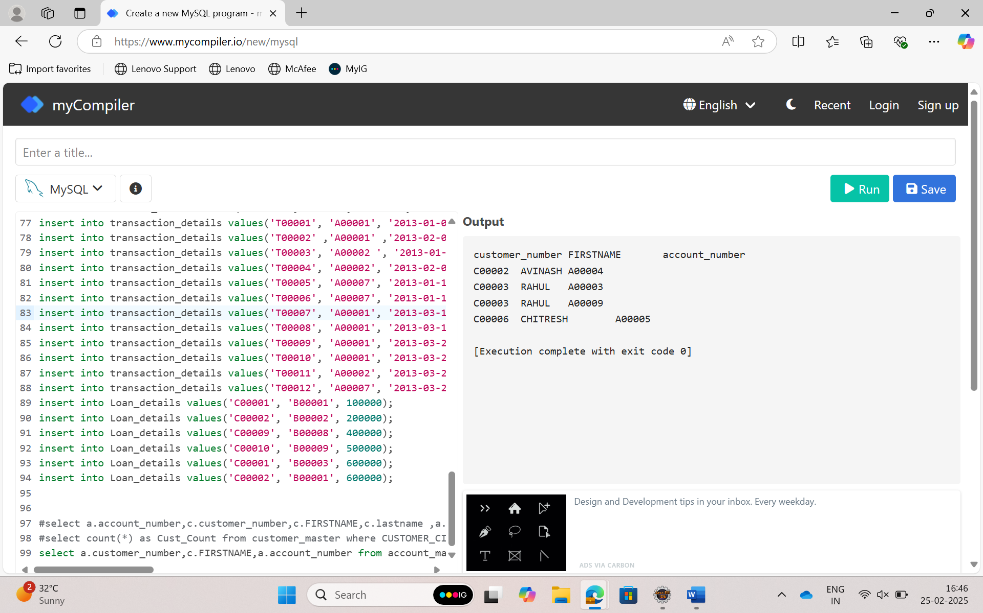

4.select count(*) as Count_Customer from customer_master c left join account_master a on c.CUSTOMER_NUMBER=a.customer_number where a.account_number IS NUll;

5. SELECT t.transaction_type, COUNT(*) AS Trans_Count FROM transaction_details t JOIN account_master a ON t.account_number = a.account_number WHERE a.customer_number LIKE '%001' AND (t.transaction_type = 'WITHDRAWAL' OR t.transaction_type = 'DEPOSIT') GROUP BY t.transaction_type ORDER BY t.transaction_type ASC;

