# BONAFIDE CERTIFICATE

Certified that the project report titled “**PREDICTION OF STOCK PRICE USING REGRESSION MODEL**” is the bonafide work of **Mr. SRIRAM V** who carried out the work under my supervision. Certified further that to the best of my knowledge the work reported herein does not form part of any other project report or dissertation on the basis of which a degree or award was conferred on an earlier occasion on this or any other candidate.

Signature of Student Signature of Guide

# SRIRAM V DR. GEETHA P

Roll No: 2130MCS0054 Associate Professor

Register No: 75721200058 IST Department

Anna university

Chennai 600 025

# CERTIFICATE OF VIVA-VOCE EXAMINATION

This is to certify that **Mr. SRIRAM V (Roll No:** 2231MCA0011**; Register No:** 67222100056**)** has been subjected to Viva-voce-Examination on…………… at the Study Centre **Centre for Distance Education, Anna University**.

Internal Examiner External Examiner

Name : Name :

Designation : Designation :

Address : Address :

# Coordinator Study Centre

**ACKNOWLEDGEMENT**

First and foremost, I would like to thank Dr. P. NIRMAL KUMAR, Professor and Additional Director, Centre for Distance Education, Anna University, Chennai for his constant motivation throughout the course.

I am most grateful to Dr. S. PRADEEP, Assistant Professor, Centre for Distance Education, Anna University, Chennai for his guidance and constant supervision as well as for providing necessary information throughout the completion of this project. I also thank my review committee member Mrs. N. SARASWATHI, Assistant Professor, Centre for Distance Education, Anna University, Chennai for her moral support.

I am also grateful to my parents, friends and colleagues for their timely support and constant words of encouragement. Last but not the least; I extend my thanks to The Almighty.

(Mr. SRIRAM V)

# ABSTRACT

Food Bridge combats the twin problems of food waste and hunger by creating a seamless connection between hotels with excess food and orphanages struggling with food insecurity. This innovative project hinges on a user-friendly web application that acts as a communication bridge. Hotels can leverage this platform to post real-time alerts about their surplus food, specifying details like type, quantity, and preferred pick-up times. Orphanages and other authorized recipients benefit from a notification system tailored to their location and preferences, ensuring they're promptly alerted to available food before it spoils.

The impact of Food Bridge extends far beyond simply connecting donors and recipients. By diverting edible food from landfills, the project plays a crucial role in promoting environmental sustainability. Reduced food waste translates to less methane emissions from decomposition, while also conserving valuable resources used in food production. Furthermore, Food Bridge directly addresses food insecurity by providing orphanages and other vulnerable communities with access to nutritious meals, a critical factor for overall well-being, especially for children.

This platform goes beyond efficiency by fostering collaboration and social responsibility within the community. Hotels play a vital role by donating surplus food, while orphanages and other recipients benefit from this generosity. Food Bridge strengthens the social fabric by encouraging businesses to give back and participate in a more sustainable and equitable food system. This innovative approach has the potential to create a positive ripple effect, promoting environmental responsibility, enhancing food security, and fostering stronger communities.

# CHAPTER 1 INTRODUCTION

* 1. **OVERVIEW OF THE PROJECT**

Predicting stock prices is a complex and crucial endeavour in the world of finance and investment. This introduction will provide an overview of using regression models to forecast the stock prices of two prominent Indian companies, Tata and Reliance. Tata and Reliance are among the largest conglomerates in India, with diversified business interests, making their stock prices sensitive to a myriad of factors, including market conditions, company performance, industry trends, and macroeconomic indicators.

# LITERATURE SURVEY:

A literature review is a body of text that aims to review the critical points of current knowledge on and/or methodological approaches to a particular topic. It is secondary sources and discuss published information in a particular subject area and sometimes information in a particular subject area within a certain time period. Its ultimate goal is to bring the reader up to date with current literature on a topic and forms the basis for another goal, such as future research

may be needed in the area and precedes a research proposal and may be just a simple summary of sources. Usually, it has an organizational pattern and combines both summary and synthesis.

# EXISTING SYSTEM:

Stock trend prediction is a hot issue in the Fintech field. Effective stock profiling is challenging due to highly non-stationary dynamics and complex interplays. Existing methods usually regard each stock independently or detect simplistic homogeneous structures. Practically, stock correlation originates from diverse aspects and underlying relationship signals are implicit in comprehensive graphs.

# DEMERITS:

* + - Possible lack of comparative analysis
    - Complexity and usability.
    - They did not do a deployment.
    - Limited scalability.

# PROPOSED SYSTEM:

The proposed system aims to predict the stock prices of Tata and Reliance using regression models. The system utilizes historical stock price data and relevant factors to build regression models that can forecast future stock prices. The following components are included in the proposed system. Historical stock price data for Tata and Reliance, along with other relevant factors such as market indices, news sentiment, and economic indicators, will be collected.

# MERITS

* + - We compared more than two algorithms to get a better accuracy level.
    - We build a user-friendly web application.
    - We improved the accuracy level and performance level.
    - We implemented Machine Learning properly.

# OBJECTIVE AND SCOPE

Food Bridge's primary objective is to establish a seamless connection between hotels with surplus food and orphanages facing food insecurity. This web-based platform aims to achieve the following:

* **Reduce food waste:** By diverting edible food from landfills, Food Bridge promotes environmental sustainability.
* **Enhance food security:** Orphanages and other authorized recipients gain access to nutritious meals, improving their well-being.
* **Foster community connections:** The platform facilitates collaboration and social responsibility within the community by connecting donors with recipients in need.

The scope of Food Bridge encompasses the development and implementation of a user-friendly web application. This application will cater to both hotels and orphanages, offering the following functionalities:

* **Registration and account management:** Hotels and orphanages can register and manage their accounts, including specifying preferences and updating relevant information.
* **Real-time notification system:** Hotels can post alerts about available surplus food, including details like type, quantity, and preferred pick-up time. Orphanages and other recipients will receive instant notifications based on their location and preferences.
* **Communication and coordination tools:** The platform facilitates communication between donors and recipients, ensuring smooth scheduling and coordination for food pick-up and delivery.

# CHAPTER 2

**SOFTWARE REQUIREMENT SPECIFICATION**

# OVERVIEW DESCRIPTION

The main purpose of Requirement Specifications is to describe in a precise manner all the capabilities that will be provided by the Software Application “PREDICTION OF STOCK PRICE USING REGRESSION MODEL” which deals with Linear algorithm, Random Forest algorithm and ARD algorithm for predicting the future stock price. The data collection and preprocessing describe the data sources and methods for collecting and preprocessing the data for the prediction task using data cleaning.

# PRODUCT PERSPECTIVE

The system or the project will use regression models, which are statistical techniques that analyse the relationship between a dependent variable (stock price) and one or more independent variables (such as market trends, company performance, economic indicators, etc). The system or the project will find a mathematical function that best fits the data and can be used to estimate the stock price for any given value of the independent variables.

# PRODUCT FUNCTION

The system functions can be described as follows:

**User Interface Design:**

Orphanage and Hotel User should be able to login into application with their Gmail account. New user should get login access after Admin approval.

**Admin Verification:**

Admin is responsible for verifying registration requests received from Orphanage and Hotels users. Admin needs to verify and approves the request for valid users. And should rejects the request for not valid users.

**Create Food Request:**

Orphanage User creates a Food request with food count. Request sends to nearby Hotels.

**Accepts Food Request:**

Hotel user having enough food can accept the request. When Hotel does not have enough food for the request, they can accept by providing food count they have.

**Declines Food Request:**

In case Hotel users do not have enough food for a request they can Decline it. Declined requests stilled be visible as open request for other hotel users to accept.

**Food Delivery:**

Once food request is accepted for required count, their contacts are shared to each other. Both users can contact each other and plan food delivery accordingly.

**Cancel Request:**

Orphanage user can cancel the raised request in case they got food from other source, they can be able to Cancel the request.

# USER CHARACTERISTICS:

**Admin user:**

Admin user is responsible for verifying and approving new user requests. Should be able to view open and closed requests. Admin can be able to access other user’s data and Food request details. But Admin won’t be able to update any data.

**Orphanage User:**

Orphanage user is responsible for creating food requests in the application. Only orphanage user can be able to create, accept, Close or Cancel the request.

**Hotel User:**

Hotel user is responsible for providing food for the requests by accepting it. They can also decline the request when not having enough foods.

# OPERATING ENVIRONMENT:

System requirements are the required specifications a device must have in order to use certain hardware or software. The hardware and software specification required for the application are listed below.

# Hardware requirements:

The software specifications used for the development of the application:

Processor: AMD Ryzen 5 5600H with Radeon Graphics, 3301 MHz

RAM: 8 GB

Hard Disk: 500 GB (SSD)

# Software Requirements:

The software specifications used for the development of the application:

Front-End Framework: Angular 17, Ionic

Development Environment: Visual Studio Code

Database Management: Firestore

Hosting: Firebase

Login Management: Google OAuth

# CONSTRAINS:

The system or the project will only use the closing price of the stock as the dependent variable for the prediction task, which may not reflect the intraday fluctuations or volatility of the stock price.

# SPECIFIC REQUIREMENTS

The following subsections of Requirement Specifications should facilitate in providing the entire overview of the “PREDICTION OF STOCK PRICE USING REGRESSION MODEL” under development. This document aims at defining the overall software requirements for developers. Efforts have been made to define the requirements of the prediction system exhaustively and accurately.

# EXTERNAL INTERFACE REQUIREMENTS:

**Google Chrome**

Google Chrome is a cross-platform web browser developed by Google. It was first released in 2008 for Microsoft Windows built with free software components from Apple Web Kit and Mozilla Firefox. It was later ported to Linux, macOS, iOS, and Android where it is the default browser built into the OS. The browser is also the main component of Chrome OS, where it serves as the platform for web applications.

# SYSTEM FEATURES

This system needs to have certain features to enable its round the clock use by multiple stakeholders with similar but not the same requirements. Hence, the set system is designed to

have the following elements: - High availability, Security, Usability, Reliability.

# UML:

# USE CASE DIAGRAM

# Class Diagram:

# SEQUENCE DIAGRAM

# WORKFLOW DIAGRAM

# ENTITY RELATIONSHIP DIAGRAM

# ACTIVITY DIAGRAM

# DATA FLOW DIAGRAM

# SOFTWARE QUALITY ATTRIBUTES

**Reliability** – Reliability is the probability and percentage of the software performing without failure for a specific number of uses or amount of time.

**Availability** - This feature defines the amount of time the system is running, the time it takes to repair a fault, and the time between lapses. We plan a system to be available 24x7.

**Maintainability** - This feature indicates the average time and ease and rapidity with which a system can be restored after a failure.

**Security** - Security measures ensure your software’s safety against espionage or sabotage. As prediction system contains lot of sensitivity data especially personal records of clients.

**Data integrity** - Data integrity refers to maintaining and assuring data accuracy and consistency over its entire lifecycle. If this factor is corrupted, data is lost due to a database error.

**Usability** - This feature concerns the users; it indicates how effectively they can learn and use a system.

# CHAPTER 3

**SYSTEM DESIGN AND TEST PLAN**

# SYSTEM DESIGN

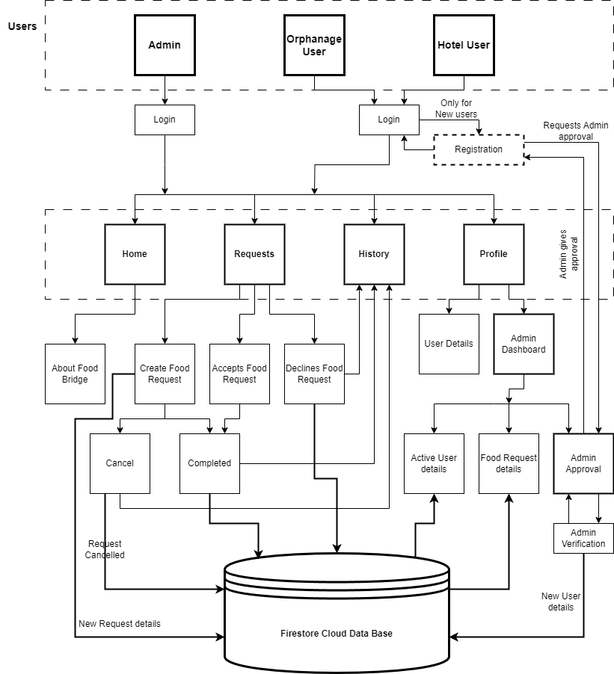

3.1 FIGURE SYSTEM ARCHITECTURE

# DATABASE DESIGN

Below are some of the sample database designs exists in the prediction application acting as an input.

# Table 3.2 Tata Dataset

**TATA DATASET:**

# Table 3.3 Reliance Dataset

# 3.3. SYSTEM TESTING

The purpose of testing is to discover errors. Testing is the process of trying to discover every conceivable fault or weakness in a work product. It provides a way to check the functionality of components, sub-assemblies, assemblies and/or a finished product It is the process of exercising software with the intent of ensuring that the Software system meets its requirements and user expectations and does not fail in an unacceptable manner. There are various types of tests. Each test type addresses a specific testing requirement.

# TYPES OF TESTS UNIT TESTING

Unit testing involves the design of test cases that validate that the internal program logic is functioning properly, and that program inputs produce valid outputs. All decision branches and internal code flow should be validated. It is the testing of individual software units of the application .it is done after the completion of an individual unit before integration. This is a structural testing, that relies on knowledge of its construction and invasive. Unit tests perform basic tests at component level and test a specific business process, application, and/or system configuration. Unit tests ensure that each unique path of a business process performs accurately to the documented specifications and contains clearly defined inputs and expected results.

# INTEGRATION TESTING

Integration tests are designed to test integrated software components to determine if they actually run as one program. Testing is event driven and is more concerned with the basic outcome of screens or fields. Integration tests demonstrate that although the components were individually satisfaction, as shown by successfully unit testing, the combination of components is correct and consistent. Integration testing is specifically aimed at exposing the problems that arise from the combination of components.

# FUNCTIONAL TEST

Functional tests provide systematic demonstrations that functions tested are available as specified by the business and technical requirements, system documentation, and user manuals.

Functional testing is centred on the following items:

Valid Input: identified classes of valid input must be accepted. Invalid Input: identified classes of invalid input must be rejected. Functions: identified functions must be exercised.

Output: identified classes of application outputs must be exercised.

Systems/Procedures: interfacing systems or procedures must be invoked. Organization and preparation of functional tests is focused on requirements, key functions, or special test cases. In addition, systematic coverage pertaining to identify

Business process flows; data fields, predefined processes, and successive processes must be considered for testing. Before functional testing is complete, additional tests are identified and the effective value of current tests is determined.

# Table 3.1 Test Case register

|  |  |  |  |  |  |
| --- | --- | --- | --- | --- | --- |
| **TEST CASE NO** | **MODULE** | **TEST CASE SUMMARY** | **EXPECTED OUTCOME** | **ACTUAL OUTCOME** | **RESULT** |
| **1** | **Register** | To verify | User should | User is able |  |
|  |  | that the user  can | be able to  register their details in the application. | to register to  the system | **PASS** |
|  |  | register the |  | successfully |  |
|  |  | details in the application. |  |  |  |

# Table 3.2 Test Case login

|  |  |  |  |  |  |
| --- | --- | --- | --- | --- | --- |
| **TEST CASE NO** | **MODULE** | **TEST CASE SUMMARY** | **EXPECTED OUTCOME** | **ACTUAL OUTCOME** | **RESULT** |
| **1** | **Login** | To verify | User should | User is able |  |
|  |  | that the user  is able to | be able to  login to the | to login to  the system | **PASS** |
|  |  | login to the | system | successfully |  |
|  |  | system | successfully. |  |  |
|  |  | successfully. |  |  |  |

# CHAPTER 4 IMPLEMENTATION AND RESULTS

# IMPLEMENTATION

# RESULTS

Post implementation and deployment, we carried out testing with the end users and found that the features where very suitable for the purpose of Prediction of stock price using regression model. Tests are conducted and all the results are evaluated. That is test results are compared with expected results. When erroneous data are uncovered, an error is implied and debugging commences. It met the testing and authentication workflow as set out by various authorities and any changes in the workflow was quickly adopted through making changes to configurable items in the system. This system was successfully used by User during the field testing.

Working of the system has captured in screenshot during its run demonstrates the successfully implemented as elaborated in the requirements specification. The features covered are listed below:

# HOME PAGE

Figure 4.1 Home Page

# LOGIN PAGE

Figure 4.2 Login Page

# REQUEST PAGE

Figure 4.3 Request Page

# HISTORY PAGE

Figure 4.4 History Page

# PROFILE PAGE

Figure 4.5 Profile Page

# ADMIN DASHBOARD PAGE

Figure 4.6 Admin Dashboard Page

# ALGORITHM LAYOUT PAGE

Figure 4.7 Algorithm Layout Page

# CHAPTER 5

**CONCLUSION AND FUTURE WORK**

# CONCLUSION

The analytical process started from data cleaning and processing, missing value, exploratory analysis and finally model building and evaluation. The Best accuracy on public test set is higher accuracy score will be found out. This application can help out to find the Tata and Reliance Stock Price.

# FUTURE WORK:

* **Network Expansion:** We envision a world where Food Bridge connects even more communities. We'll be actively expanding our network to encompass a wider range of locations, ensuring our platform reaches those who need it most.
* **Enhanced Services:** We're dedicated to providing a robust suite of services to our growing network. This includes the introduction of features like:
  + **Monetary Donations:** Empowering individuals to directly contribute financially to the fight against hunger.
  + **Individual Food Donations:** Providing a platform for anyone with surplus food to seamlessly donate to those in need.
* **Raising Awareness:** Food Bridge understands the importance of public education. We plan to organize impactful awareness programs and activities focused on food waste reduction and food security. These initiatives will target both local communities and children, fostering a culture of responsibility and sustainability.
* **Streamlined User Experience:** We're constantly striving to improve user experience. User-friendly request notification and tracking methods are on the horizon, ensuring smooth communication and efficient food retrieval.

# REFERENCE

1. Thirunavukkarasu Anbalagan a, S. Uma Maheswari b, Classification and Prediction of Stock Market Index Based on Fuzzy Meta graph, Elsevier B.V, 1877-0509 © 2015, DOI: 10.1016/j.procs.2015.03.200
2. Devanshu Upadhyay1, Soumya Sharma2, Stock Price Prediction Using Concept of Long- Short Term Memory, International Journal of Scientific Engineering and Research (IJSER),

Volume 9 Issue 12, December 2021

1. Dr. P. K. Sahoo, Mr. Krishna charlapally, Stock Price Prediction Using Regression Analysis, International Journal of Scientific & Engineering Research, Volume 6, Issue 3,

March-2015 ISSN 2229-5518

1. *Kathika Sai Krishna, Mettupalli Hari Naveen Reddy, Appidi Koushik Reddy, Mukkamalla Naveen Reddy,* Stock price prediction using machine learning models in python, *International Journal of Advance Research, Ideas and Innovations in Technology,* Volume 7, Issue 2 - V7I2- 1525 *© 2021*