# BONAFIDE CERTIFICATE

Certified that the project report titled “**FOOD BRIDGE – BRIDGING THE GAP BETWEEN FOOD SOURCE AND PEOPLE IN NEED**” is the bonafide work of **Mr. SRIRAM V** who carried out the work under my supervision. Certified further that to the best of my knowledge the work reported herein does not form part of any other project report or dissertation on the basis of which a degree or award was conferred on an earlier occasion on this or any other candidate.

Signature of Student Signature of Guide

# Mr. SRIRAM V DR. GEETHA P

Roll No: 2231MCA0011 Associate Professor

Register No: 67222100056 IST Department

Anna university

Chennai 600 025

# CERTIFICATE OF VIVA-VOCE EXAMINATION

This is to certify that **Mr. SRIRAM V (Roll No:** 2231MCA0011**; Register No:** 67222100056**)** has been subjected to Viva-voce-Examination on…………… at the Study Centre **Centre for Distance Education, Anna University**.

Internal Examiner External Examiner

Name : Name :

Designation : Designation :

Address : Address :

# Coordinator Study Centre

**ACKNOWLEDGEMENT**

First and foremost, I would like to thank Dr. P. NIRMAL KUMAR, Professor and Additional Director, Centre for Distance Education, Anna University, Chennai for his constant motivation throughout the course.

I am most grateful to Dr. GEETHA P, Associate Professor, IST Department, Anna University, Chennai for his guidance and constant supervision as well as for providing necessary information throughout the completion of this project. I also thank my review committee member Mrs. N. SARASWATHI, Assistant Professor, Centre for Distance Education, Anna University, Chennai for her moral support.

I am also grateful to my parents, friends and colleagues for their timely support and constant words of encouragement. Last but not the least; I extend my thanks to The Almighty.

(Mr. SRIRAM V)

# ABSTRACT

Food Bridge combats the twin problems of food waste and hunger by creating a seamless connection between hotels with excess food and orphanages struggling with food insecurity. This innovative project hinges on a user-friendly web application that acts as a communication bridge. Hotels can leverage this platform to post real-time alerts about their surplus food, specifying details like type, quantity, and preferred pick-up times. Orphanages and other authorized recipients benefit from a notification system tailored to their location and preferences, ensuring they're promptly alerted to available food before it spoils.

The impact of Food Bridge extends far beyond simply connecting donors and recipients. By diverting edible food from landfills, the project plays a crucial role in promoting environmental sustainability. Reduced food waste translates to less methane emissions from decomposition, while also conserving valuable resources used in food production. Furthermore, Food Bridge directly addresses food insecurity by providing orphanages and other vulnerable communities with access to nutritious meals, a critical factor for overall well-being, especially for children.

This platform goes beyond efficiency by fostering collaboration and social responsibility within the community. Hotels play a vital role by donating surplus food, while orphanages and other recipients benefit from this generosity. Food Bridge strengthens the social fabric by encouraging businesses to give back and participate in a more sustainable and equitable food system. This innovative approach has the potential to create a positive ripple effect, promoting environmental responsibility, enhancing food security, and fostering stronger communities.

சுருக்கம்

|  |  |  |
| --- | --- | --- |
|  | **TABLE OF CONTENT** |  |
| **CHAPTER** | **TITLE** | **PAGE NO** |
| **NO** |  |  |
|  | **ABSTRACT (ENGLISH)** | iv |
|  | **ABSTRACT (TAMIL)** | v |
|  | **LIST OF TABLES** | viii |
|  | **LIST OF FIGURES** | viii |
|  | **LIST OF ABBREVIATIONS** | ix |
| **1** | **INTRODUCTION** |  |
|  | 1.1 OVERVIEW OF PROJECT | 1 |
|  | 1.2. LITERATURE SURVEY | 1 |
|  | 1.3. EXISTING SYSTEM | 3 |
|  | 1.4. PROPOSED SYSTEM | 4 |
|  | 1.5 OBJECTIVE AND SCOPE | 4 |
|  | 1.6 ORGANIZATION OF THE REPORT | 5 |
| **2** | **REQUIREMENT SPECIFICATION** |  |
|  | 2.1. OVERALL DESCRIPTION | 6 |
|  | 2.1.1. PRODUCT PERSPECTIVE | 6 |
|  | 2.1.2. PRODUCT FUNCTIONS | 6 |
|  | 2.1.3. USER CHARACTERISTICS | 7 |
|  | 2.1.4. OPERATING ENVIRONMENT | 7 |
|  | 2.1.5. CONSTRAINTS | 7 |
|  | 2.2. SPECIFIC REQUIREMENTS | 8 |
|  | 2.2.1. EXTERNAL INTERFACE REQUIREMENTS | 8 |
|  | 2.2.2. SYSTEM FEATURE | 9 |
|  | 2.2.3. UML | 9 |
|  | 2.2.3.1 USE CASE DIAGRAM | 10 |
|  | 2.2.3.2 CLASS DIAGRAM | 10 |
|  | 2.2.3.3 SEQUENCE DIAGRAM | 11 |
|  | 2.2.3.4 WORK FLOW DIAGRAM | 12 |
|  | 2.2.3.5 ENTITY RELATIONSHIP DIAGRAM | 13 |
|  | 2.2.3.6 ACTIVITY DIAGRAM | 14 |
|  | 2.2.3.7 DATA FLOW DIAGRAM | 15 |

2.2.4 SOFTWARE QUALITY ATTRIBUTES 16

1. SYSTEM DESIGN AND TEST PLAN
   1. DECOMPOSITION DESCRIPTION 18
      1. DATA PREPROCESSING 18
      2. DATA ANALYSIS OF VISUALIZATION 18
      3. ARD REGRESSION 19
      4. RANDOM FOREST REGRESSION 19
      5. LINEAR REGRESSION 20
   2. DEPENDENCY DESCRIPTION 20
      1. SYSTEM DESIGN 21
      2. DATABASE DESIGN 21

3.3. SYSTEM TESTING 22

1. IMPLEMENTATION AND RESULTS
   1. IMPLEMENTATION 27
   2. RESULTS 28
      1. HOME PAGE 28
      2. LOGIN PAGE 29
      3. REQUEST PAGE 29
      4. HISTORY PAGE 30
      5. PROFILE PAGE 30
      6. ADMIN DASHBOARD PAGE 31
2. CONCLUSION AND FUTURE WORK
   1. CONCLUSION 33
   2. FUTURE WORK 33

REFERENCE 34

# LIST OF TABLES

|  |  |  |  |
| --- | --- | --- | --- |
| **TABLE NO** |  | **TITLE** | **PAGE.NO** |
| 3.1 | TEST CASE |  | 25 |
| 3.2 | LOGIN |  | 25 |
| **FIGURE.NO** | **TITLE** | | **PAGE NO** |
| 2.1 | USECASE DIAGRAM | | 10 |
| 2.2 | CLASS DIAGRAM | | 10 |
| 2.3 | SEQUENCE DIAGRAM | | 11 |
| 2.4 | WORKFLOW DIAGRAM | | 12 |
| 2.5 | ER – DIAGRAM | | 13 |
| 2.6 | ACTIVITY DIAGRAM | | 14 |
| 2.7 | DATA FLOW DIAGRAM | | 15 |
| 3.1 | SYSTEM ARCHITECTURE | | 21 |
| 3.2 | ORPHANAGE USER DB | | 22 |
| 3.3 | HOTEL USER DB | | 22 |
| 3.4 | FOOD REQUEST DB | | 28 |
| 3.5 | HISTORY DB | | 29 |
| 4.1 | HOME PAGE | | 29 |
| 4.2 | LOGIN PAGE | | 30 |
| 4.3 | REQUEST PAGE | | 30 |
| 4.4 | HISTORY PAGE | | 31 |
| 4.5 | PROFILE PAGE | | 31 |
| 4.6 | ADMIN DASHBOARD PAGE | | 32 |

**LIST OF ABBREVATION**

ARD - AUTOMATIC RELEVANCE DETERMINATION ER - ENTITY RELATIONSHIP

LSTMS- LONG-SHORT TERM MEMORY

GAN - GENERATIVE ADVERSARIAL NETWORK DJIA - DOW JONES INDUSTRIAL AVERAGE

# CHAPTER 1 INTRODUCTION

* 1. **OVERVIEW OF THE PROJECT**

The Food Bridge tackles food waste and food insecurity by connecting hotels with excess food to orphanages in need. A web application allows hotels to list their surplus food, while notifying nearby orphanages about the available donations. This approach not only helps feed people but also reduces environmental impact by diverting food from landfills and promoting sustainability. Food Bridge fosters a collaborative community where businesses can give back and contribute to a more equitable food system.

# LITERATURE SURVEY:

A literature review is a body of text that aims to review the critical points of current knowledge on and/or methodological approaches to a particular topic. It is secondary sources and discuss published information in a particular subject area and sometimes information in a particular subject area within a certain time period. Its ultimate goal is to bring the reader up to date with current literature on a topic and forms the basis for another goal, such as future research that

may be needed in the area and precedes a research proposal and may be just a simple summary of sources. Usually, it has an organizational pattern and combines both summary and synthesis. A summary is a recap of important information about the source, but a synthesis is a re- organization or reshuffling of information. It might give a new interpretation of old material or combine new with old interpretations or it might trace the intellectual progression of the field, including major debates. Depending on the situation, the literature review may evaluate the sources and advise the reader on the most pertinent or relevant of them.

**Title:** *Research on Amazon’s stock price forecasting based on arbitrage pricing model based on big data*

**Author:** *Haocheng Du*

**Year:***2022*

The generation of big data is based on the network data generated when people use Internet information systems to interact. Big data can reflect the general laws of specific fields and industries, provide more accurate references for decision makers and managers, and provide people with better Data services.

# EXISTING SYSTEM:

Stock trend prediction is a hot issue in the Fintech field. Effective stock profiling is challenging due to highly non-stationary dynamics and complex interplays. Existing methods usually regard each stock independently or detect simplistic homogeneous structures. Practically, stock correlation originates from diverse aspects and underlying relationship signals are implicit in comprehensive graphs. Besides, RNNs are extensively used to simulate stock volatility while inadequate in capturing fine-granular patterns across local time snippets. To this end, in this paper we propose HATR-I, a Hierarchical Adaptive Temporal-Relational Interaction model to characterize and predict stock evolutions. Specifically, we grasp short- and long-term transition regularities of stock dynamics based on cascaded dilated convolutions and gating paths. By formulating different views of domain adjacency graphs into a unified multiplex network with edge attributes, we inject node- and semantic level dual attention to refine the propagation of inter-stock collaborative information. Particularly, the stock pair matching is proceeding along each time-stage rather than until final compressed representations, meanwhile significant feature points and scales are identified considering the effect of time attenuation.

# DEMERITS:

* + - Possible lack of comparative analysis
    - Complexity and usability.
    - They did not do a deployment.
    - Limited scalability.

# PROPOSED SYSTEM:

The proposed system aims to predict the stock prices of Tata and Reliance using regression models. The system utilizes historical stock price data and relevant factors to build regression models that can forecast future stock prices. The following components are included in the proposed system. Historical stock price data for Tata and Reliance, along with other relevant factors such as market indices, news sentiment, and economic indicators, will be collected. This data serves as the input for training and testing the regression models. The collected data may undergo pre-processing steps to handle outliers, missing values, and inconsistencies. Techniques such as outlier detection, imputation methods, and data normalization will be applied to ensure the quality and consistency of the dataset. Various regression models, including linear regression, polynomial regression, and support vector regression, will be implemented to predict the stock prices of Tata and Reliance. These models will utilize the pre- processed data and selected features to learn the underlying relationships between the input variables and stock prices. The proposed system provides a reliable and automated approach for predicting the stock prices of Tata and Reliance using regression models.

# MERITS

* + - We compared more than two algorithms to get a better accuracy level.
    - We build a user-friendly web application.
    - We improved the accuracy level and performance level.
    - We implemented Machine Learning properly.

# OBJECTIVE AND SCOPE

Food Bridge's primary objective is to establish a seamless connection between hotels with surplus food and orphanages facing food insecurity. This web-based platform aims to achieve the following:

* **Reduce food waste:** By diverting edible food from landfills, Food Bridge promotes environmental sustainability.
* **Enhance food security:** Orphanages and other authorized recipients gain access to nutritious meals, improving their well-being.
* **Foster community connections:** The platform facilitates collaboration and social responsibility within the community by connecting donors with recipients in need.

The scope of Food Bridge encompasses the development and implementation of a user-friendly web application. This application will cater to both hotels and orphanages, offering the following functionalities:

* **Registration and account management:** Hotels and orphanages can register and manage their accounts, including specifying preferences and updating relevant information.
* **Real-time notification system:** Hotels can post alerts about available surplus food, including details like type, quantity, and preferred pick-up time. Orphanages and other recipients will receive instant notifications based on their location and preferences.
* **Communication and coordination tools:** The platform facilitates communication between donors and recipients, ensuring smooth scheduling and coordination for food pick-up and delivery.

# ORGANIZATION OF THE REPORT

Chapter 1 - This chapter gives a brief introduction about the overview of the entire project, literature survey, existing & proposed system and the objective & scope of the project.

Chapter 2 - This chapter gives a brief introduction about the overall description, product perspective, product functions, user characteristics, operating environment, constraints and system requirements and the tools and technologies involved in the development of the project.

Chapter 3 - This chapter explains the overall system architecture. It explains how a user interacts with the system, how intercommunication happens between various services within the system and the various testing methods used for testing the platform.

Chapter 4 - This chapter gives a detailed explanation of how each module was developed and the various demonstrated images captured of the project.

Chapter 5 - This chapter summarizes the whole project, and talks about the future enhancements that can be done in the platform.

# CHAPTER 2

**SOFTWARE REQUIREMENT SPECIFICATION**

# OVERVIEW DESCRIPTION

The main purpose of Requirement Specifications is to describe in a precise manner all the capabilities that will be provided by the Software Application “PREDICTION OF STOCK PRICE USING REGRESSION MODEL” which deals with Linear algorithm, Random Forest algorithm and ARD algorithm for predicting the future stock price. The data collection and preprocessing describe the data sources and methods for collecting and preprocessing the data for the prediction task using data cleaning and transformation techniques, such as handling missing values, outliers, or scaling the data. It also utilizes the graphical tools, such as line plots, scatter plots, histograms, etc., to visualize the data. It also defines the metrics, such as mean squared error, mean absolute error etc., that would be used to evaluate the accuracy and performance of each model on the testing set.

# PRODUCT PERSPECTIVE

The system or the project will use regression models, which are statistical techniques that analyse the relationship between a dependent variable (stock price) and one or more independent variables (such as market trends, company performance, economic indicators, etc). The system or the project will find a mathematical function that best fits the data and can be used to estimate the stock price for any given value of the independent variables.

# PRODUCT FUNCTION

The system functions can be described as follows

**User Interface Design:**

Orphanage and Hotel User should be able to login into application with their Gmail account. New user should get login access after Admin approval.

**Admin Verification:**

Admin is responsible for verifying registration requests received from Orphanage and Hotels users. Admin needs to verify and approves the request for valid users. And should rejects the request for not valid users.

**Create Food Request:**

Orphanage User creates a Food request with food count. Request sends to nearby Hotels.

**Accepts Food Request:**

Hotel user having enough food can accept the request. When Hotel does not have enough food for the request, they can accept by providing food count they have.

**Declines Food Request:**

In case Hotel users do not have enough food for a request they can Decline it. Declined requests stilled be visible as open request for other hotel users to accept.

**Food Delivery:**

Once food request is accepted for required count, their contacts are shared to each other. Both users can contact each other and plan food delivery accordingly.

**Cancel Request:**

Orphanage user can cancel the raised request in case they got food from other source, they can be able to Cancel the request.

# USER CHARACTERISTICS:

**Admin user:**

Admin user is responsible for verifying and approving new user requests. Should be able to view open and closed requests. Admin can be able to access other user’s data and Food request details. But Admin won’t be able to update any data.

**Orphanage User:**

Orphanage user is responsible for creating food requests in the application. Only orphanage user can be able to create, accept, Close or Cancel the request.

**Hotel User:**

Hotel user is responsible for providing food for the requests by accepting it. They can also decline the request when not having enough foods.

# OPERATING ENVIRONMENT:

System requirements are the required specifications a device must have in order to use certain hardware or software. The hardware and software specification required for the application are listed below.

# Hardware requirements:

The software specifications used for the development of the application:

**Processor:** AMD Ryzen 5 5600H with Radeon Graphics, 3301 MHz

**RAM:** 8 GB

**Hard Disk:** 500 GB (SSD)

# Software Requirements:

The software specifications used for the development of the application:

**Front-End Framework:** Angular 17, Ionic

**Development Environment:** Visual Studio Code

**Database Management:** Firestore

**Hosting:** Firebase

**Login Management:** Google OAuth

# CONSTRAINS:

The system or the project will only use the closing price of the stock as the dependent variable for the prediction task, which may not reflect the intraday fluctuations or volatility of the stock price.

# SPECIFIC REQUIREMENTS

The following subsections of Requirement Specifications should facilitate in providing the entire overview of the “PREDICTION OF STOCK PRICE USING REGRESSION MODEL” under development. This document aims at defining the overall software requirements for developers. Efforts have been made to define the requirements of the prediction system exhaustively and accurately.

# EXTERNAL INTERFACE REQUIREMENTS:

**Google Chrome**

Google Chrome is a cross-platform web browser developed by Google. It was first released in 2008 for Microsoft Windows built with free software components from Apple Web Kit and Mozilla Firefox. It was later ported to Linux, macOS, iOS, and Android where it is the default browser built into the OS. The browser is also the main component of Chrome OS, where it serves as the platform for web applications.

Most of Chrome’s source code comes from Google’s free and open-source software project Chromium, but Chrome is licensed as proprietary freeware. Web Kit was the original rendering engine, but Google eventually forked it to create the Blink engine; all Chrome variants except iOS now use Blink.

As of July 2021, Stat Counter estimates that Chrome has a 65% worldwide browser market share (after peaking at 72.38% in November 2018) on personal computers (PC), is most used on tablets (has surpassed Safari), and is also dominant on smartphones, and at 63.59% across all platforms combined. Because of this success, Google has expanded the Chrome brand name to other products: Chrome OS, Chromecast, Chromebook, Chromebit, Chromebox, and Chromebase.

# SYSTEM FEATURES

This system needs to have certain features to enable its round the clock use by multiple stakeholders with similar but not the same requirements. Hence, the set system is designed to have the following elements:

**High availability** - The system should be available under 24x7 with an acceptable down- time.

**Security** - Only authorized member should be able to access the system as deals with personal and medical data of the patients.

**Usability** - Its user interface should be highly responsive, easy to learn and operate and require less-time to onboard health workers and diagnostic staff.

**Reliability** - As this system deals with life and emergencies of the patients, it is critical that every component of the system functions as expected all the time. This will be proper testing and continuous monitoring post deployment to achieve the goal.

# UML:

UML, short for Unified Modelling Language, is a standardized modelling language consisting of an integrated set of diagrams, developed to help system and software developers for specifying, visualizing, constructing, and documenting the artifacts of software systems, as well as for business modelling and other non-software systems. The UML represents a collection of best engineering practices that have proven successful in the modelling of large and complex systems. The UML is a very important part in the software development process and uses mostly graphical notations to express the design of software projects. Using the UML helps project teams communicate, explore potential designs, and validate the architectural design of the software.

# USE CASE DIAGRAM

Use case diagrams are considered for high level requirement analysis of a system. So when the requirements of a system are analysed the functionalities are captured in use cases. So, it can say that uses cases are nothing but the system functionalities written in an organized manner.

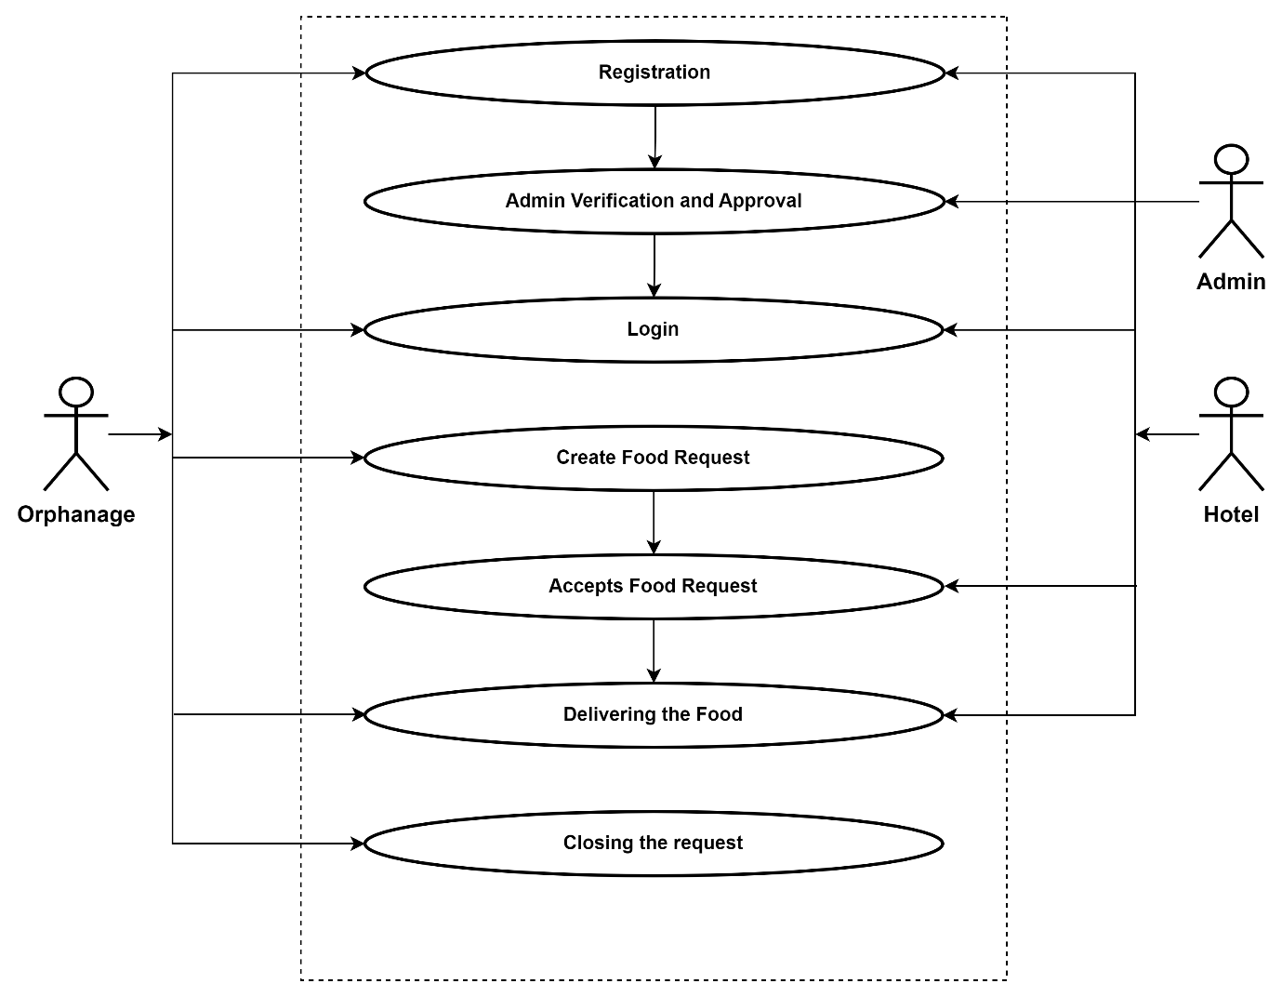

Figure 2.1 Use Case Diagram

# Class Diagram:

Class diagram is basically a graphical representation of the static view of the system and represents different aspects of the application. So a collection of class diagrams represent the whole system. The name of the class diagram should be meaningful to describe the aspect of the system. Each element and their relationships should be identified in advance Responsibility (attributes and methods) of each class should be clearly identified for each class minimum number of properties should be specified and because, unnecessary properties will make the diagram complicated. Use notes whenever required to describe some aspect of the diagram and at the end of the drawing it should be understandable to the developer/coder. Finally, before making the final version, the diagram should be drawn on plain paper and rework as many times as possible to make it correct.

Figure 2.2 Class Diagram

# SEQUENCE DIAGRAM

Sequence diagrams model the flow of logic within your system in a visual manner, enabling you both to document and validate your logic, and are commonly used for both analysis and design purposes. Sequence diagrams are the most popular UML artifact for dynamic modelling, which focuses on identifying the behaviour within your system. Other dynamic modelling techniques include [activity diagramming](http://agilemodeling.com/artifacts/activityDiagram.htm), [communication diagramming](http://agilemodeling.com/artifacts/communicationDiagram.htm), [timing diagramming](http://agilemodeling.com/artifacts/timingDiagram.htm), and [interaction overview diagramming.](http://agilemodeling.com/artifacts/interactionOverviewDiagram.htm) Sequence diagrams, along with [class](http://agilemodeling.com/artifacts/classDiagram.htm) [diagrams](http://agilemodeling.com/artifacts/classDiagram.htm) and [physical data models](http://agiledata.org/essays/dataModeling101.html) are in my opinion the most important design-level models for modern business application development.

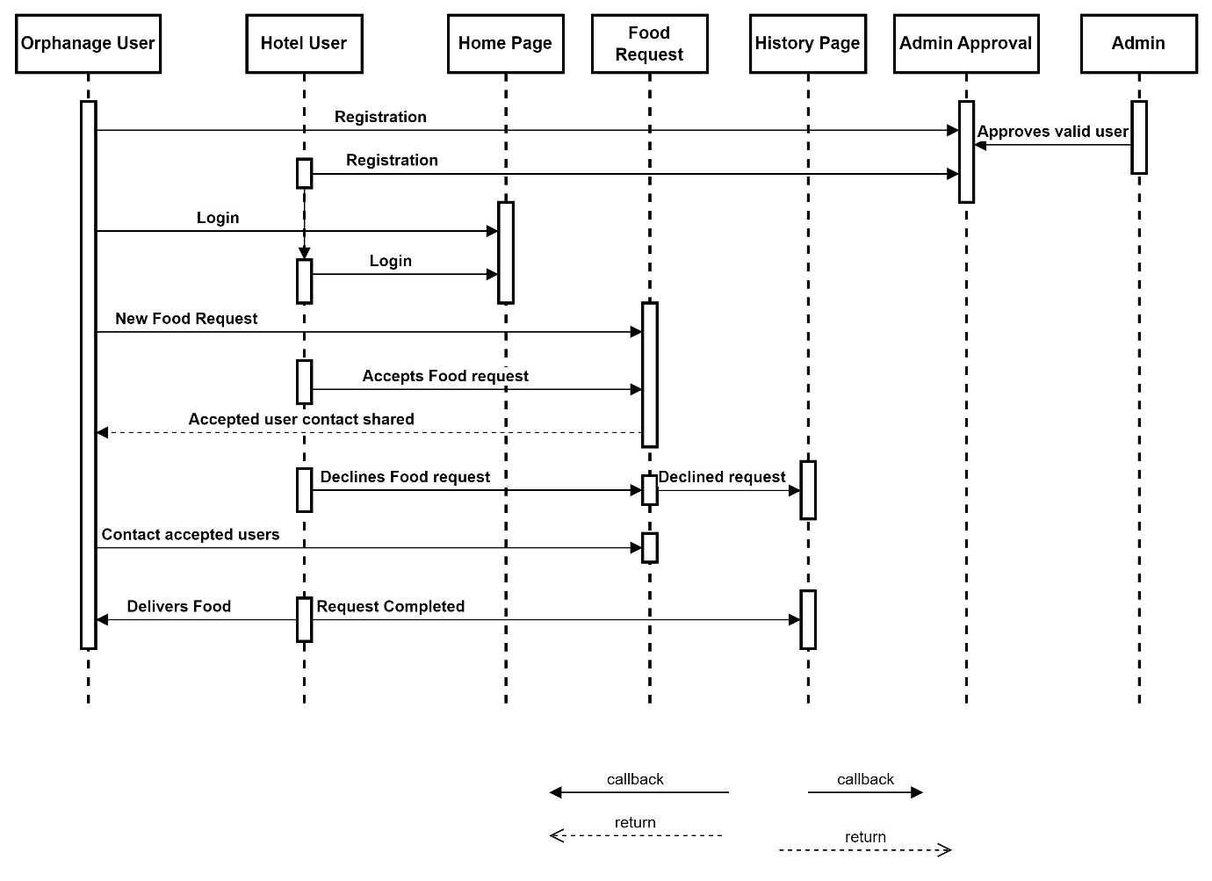

Figure 2.3 Sequence Diagram

# WORK FLOW DIAGRAM

A workflow diagram (also known as a workflow) provides a graphic overview of the business process. Using standardized symbols and shapes, the workflow shows step by step how your work is completed from start to finish.

Figure 2.4 Work Flow Diagram

# ENTITY RELATIONSHIP DIAGRAM

An entity relationship diagram (ERD), also known as an entity relationship model, is a graphical representation of an information system that depicts the relationships among people, objects, places, concepts or events within that system. An ERD is a [data modeling](https://searchdatamanagement.techtarget.com/definition/data-modeling) technique that can help define business processes and be used as the foundation for a [relational database](https://searchdatamanagement.techtarget.com/definition/relational-database). Entity relationship diagrams provide a visual starting point for database design that can also be used to help determine information system requirements throughout an organization. After a relational database is rolled out, an ERD can still serve as a referral point, should any debugging or business process re-engineering be needed later.

Figure 2.5 Entity Relationship Diagram

# ACTIVITY DIAGRAM

Activity is a particular operation of the system. Activity diagrams are not only used for visualizing dynamic nature of a system but they are also used to construct the executable system by using forward and reverse engineering techniques. The only missing thing in activity diagram is the message part. It does not show any message flow from one activity to another. Activity diagram is some time considered as the flow chart. Although the diagrams looks like a flow chart but it is not. It shows different flow like parallel, branched, concurrent.

Figure 2.6 Activity Diagram

# DATA FLOW DIAGRAM

Machine learning needs data gathering have lot of past data. Data gathering have sufficient historical data and raw data. Before data pre-processing, raw data can’t be used directly. It’s used to pre-process then, what kind of algorithm with model. Training and testing this model working and predicting correctly with minimum errors. Tuned model involved by tuned time to time with improving the accuracy.

Figure 2.7 Process of dataflow diagram

# SOFTWARE QUALITY ATTRIBUTES

**Reliability** – Reliability is the probability and percentage of the software performing without failure for a specific number of uses or amount of time.

**Availability** - This feature defines the amount of time the system is running, the time it takes to repair a fault, and the time between lapses. We plan a system to be available 24x7.

**Maintainability** - This feature indicates the average time and ease and rapidity with which a system can be restored after a failure.

**Security** - Security measures ensure your software’s safety against espionage or sabotage. As prediction system contains lot of sensitivity data especially personal records of clients.

**Data integrity** - Data integrity refers to maintaining and assuring data accuracy and consistency over its entire lifecycle. If this factor is corrupted, data is lost due to a database error.

**Usability** - This feature concerns the users; it indicates how effectively they can learn and use a system.

# CHAPTER 3

**SYSTEM DESIGN AND TEST PLAN**

# DECOMPOSITION DESCRIPTION

The data set is pre processed by undergoing certain data cleaning techniques to remove the errors from dataset. Data visualization can be helpful when exploring and getting to know a dataset and can help with identifying patterns, corrupt data, outliers, and much more. The algorithms are implemented to create a machine learning “model”. The deployment of the required model can be implemented for prediction of future stock price using a new data.

# DATA PREPROCESSING

Importing the library packages with loading given dataset. To analysing the variable identification by data shape, data type and evaluating the missing values, duplicate values. A validation dataset is a sample of data held back from training your model that is used to give an estimate of model skill while tuning models and procedures that you can use to make the best use of validation and test datasets when evaluating your models. Data cleaning / preparing by rename the given dataset and drop the column etc. to analyse the uni- variate, bi-variate and multi-variate process. The steps and techniques for data cleaning will vary from dataset to dataset. The primary goal of data cleaning is to detect and remove errors and anomalies to increase the value of data in analytics and decision making.

# DATA ANALYSIS OF VISUALIZATION

Data visualization is an important skill in applied statistics and machine learning. Statistics does indeed focus on quantitative descriptions and estimations of data. Data visualization provides an important suite of tools for gaining a qualitative understanding. This can be helpful when exploring and getting to know a dataset and can help with identifying patterns, corrupt data, outliers, and much more. With a little domain knowledge, data visualizations can be used to express and demonstrate key relationships in plots and charts that are more visceral and stakeholders than measures of association or significance.

Sometimes data does not make sense until it can look at in a visual form, such as with charts and plots. Being able to quickly visualize of data samples and others is an important skill both in applied statistics and in applied machine learning. It will discover the many types of plots

that you will need to know when visualizing data in Python and how to use them to better understand your own data.

* + - * How to chart time series data with line plots and categorical quantities with bar charts.
      * How to summarize data distributions with histograms and box plots.

# AUTOMATIC RELEVANCE DETERMINATION

Automatic Relevance Determination (ARD) is a Bayesian regression algorithm designed to automate the process of feature selection in regression models. With a focus on handling datasets with numerous input features, ARD operates within the framework of Bayesian linear regression. It introduces the concept of feature relevance by associating each input feature with a binary variable, signifying its importance in the model. The ARD algorithm is particularly notable for its ability to automatically estimate hyperparameters, including precision terms for feature relevance and coefficients, typically using methods like Expectation-Maximization or Variational Inference. By analyzing the Bernoulli parameters for feature relevance, ARD effectively prunes irrelevant features, streamlining the model and reducing overfitting. As a result, ARD not only simplifies the model but also provides a posterior distribution over coefficients, accounting for uncertainty and aiding in feature selection for improved predictive accuracy and interpretability. While ARD offers benefits like automated feature selection and uncertainty quantification, it can be computationally intensive, and the choice of prior distributions can influence its performance. In summary, ARD is a powerful tool for enhancing the robustness and interpretability of regression models, particularly in scenarios with high- dimensional data.

# IMPLEMENTING RANDOM FOREST REGRESSION

Random Forest is a powerful ensemble machine learning algorithm that combines the predictive strength of multiple decision trees to make accurate and robust predictions. At its core, it uses decision trees as building blocks, but the ensemble approach sets it apart. The "Random" aspect comes from the introduction of randomness in two key ways: bootstrapping and feature selection. When constructing each decision tree in the forest, a random sample of the training data, with replacement, is drawn. This diversity among trees helps mitigate overfitting. Additionally, for each tree, a random subset of input features is considered at each

node to determine the best split, ensuring that no single feature dominates the model. The final prediction is made by aggregating the individual tree predictions through majority voting (in classification tasks) or averaging (in regression tasks). Notably, Random Forest provides a robust estimate of its own performance through the out-of-bag (OOB) error, making it an appealing choice for practitioners. This method tests data points that were not included in the training set for each tree, offering an unbiased estimate of model accuracy. Random Forest is renowned for its high accuracy, robustness, feature importance measurement, and ability to handle missing data, making it a widely used and trusted tool in various domains, from finance to healthcare, where accuracy, resilience, and interpretability are paramount. Nevertheless, its challenge lies in model interpretability and the computational resources required when working with numerous features or trees. In summary, Random Forest excels in enhancing predictive performance and reducing the risk of overfitting, making it a valuable asset in the machine learning toolkit for a wide array of applications.

# IMPLEMENTING LINEAR REGRESSION

Linear regression is a statistical technique that tries to find a linear relationship between a dependent variable (such as stock price) and one or more independent variables (such as time, volume, indicators, etc.). It can be used to forecast future stock prices based on historical data and patterns. However, linear regression has some limitations and assumptions that may not hold true in the real world, such as linearity, normality, homoscedasticity, and independence of errors. [Therefore, linear regression may not be able to capture the complexity and](https://www.alpharithms.com/predicting-stock-prices-with-linear-regression-214618/) [uncertainty of the stock market.](https://www.alpharithms.com/predicting-stock-prices-with-linear-regression-214618/)

# DEPENDENCY DESCRIPTION

The successful implementation of the prediction system is highly dependent on effective and accurate requirements gatherings. Moreover, the continuously evolving scenario of predicting requires that the design is kept up-to-date and implemented as soon as possible. This system can be installed in the client environment and this will help in the maintenance of the system in future. People are inherently resistant to change, and computers have been known to facilitate change. The success of prediction system also depends on easy-to-use user interface that can enable fast learning and adoption of the system by its end users.

# SYSTEM DESIGN

A system design for prediction of stock price project is a way of describing the architecture and components of a system that can perform the task of predicting the future prices of stocks based on historical and current data. A system design can help to plan, develop, test, and deploy the system, as well as to communicate the system’s functionality and requirements to the stakeholders.

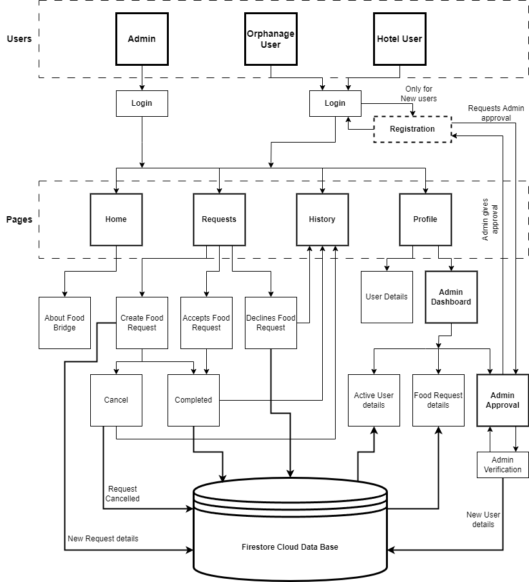

3.1 FIGURE SYSTEM ARCHITECTURE

# DATABASE DESIGN

Below are some of the sample database designs exists in the prediction application acting as an input.

**RESTAURANT USER DB:**

3.2 FIGURE RESTAURANT USER DB

**ORPHANAGE USER DB:**

3.2 FIGURE ORPHANAGE USER DB

**FOOD REQUEST DB:**

3.2 FIGURE FOOD REQUEST DB

**HISTORY DB:**

3.2 FIGURE HISTORY DB

# 3.3. SYSTEM TESTING

The purpose of testing is to discover errors. Testing is the process of trying to discover every conceivable fault or weakness in a work product. It provides a way to check the functionality of components, sub-assemblies, assemblies and/or a finished product It is the process of exercising software with the intent of ensuring that the Software system meets its requirements and user expectations and does not fail in an unacceptable manner. There are various types of tests. Each test type addresses a specific testing requirement.

# TYPES OF TESTS UNIT TESTING

Unit testing involves the design of test cases that validate that the internal program logic is functioning properly, and that program inputs produce valid outputs. All decision branches and internal code flow should be validated. It is the testing of individual software units of the application .it is done after the completion of an individual unit before integration. This is a structural testing, that relies on knowledge of its construction and invasive. Unit tests perform basic tests at component level and test a specific business process, application, and/or system configuration. Unit tests ensure that each unique path of a business process performs accurately to the documented specifications and contains clearly defined inputs and expected results.

# INTEGRATION TESTING

Integration tests are designed to test integrated software components to determine if they actually run as one program. Testing is event driven and is more concerned with the basic outcome of screens or fields. Integration tests demonstrate that although the components were individually satisfaction, as shown by successfully unit testing, the combination of components is correct and consistent. Integration testing is specifically aimed at exposing the problems that arise from the combination of components.

# FUNCTIONAL TEST

Functional tests provide systematic demonstrations that functions tested are available as specified by the business and technical requirements, system documentation, and user manuals.

Functional testing is centred on the following items:

Valid Input: identified classes of valid input must be accepted. Invalid Input: identified classes of invalid input must be rejected. Functions: identified functions must be exercised.

Output: identified classes of application outputs must be exercised.

Systems/Procedures: interfacing systems or procedures must be invoked. Organization and preparation of functional tests is focused on requirements, key functions, or special test cases. In addition, systematic coverage pertaining to identify

Business process flows; data fields, predefined processes, and successive processes must be considered for testing. Before functional testing is complete, additional tests are identified and the effective value of current tests is determined.

# Table 3.1 Test Case register

|  |  |  |  |  |  |
| --- | --- | --- | --- | --- | --- |
| **TEST CASE NO** | **MODULE** | **TEST CASE SUMMARY** | **EXPECTED OUTCOME** | **ACTUAL OUTCOME** | **RESULT** |
| **1** | **Register** | To verify | User should | User is able |  |
|  |  | that the user  id able to | be able to  register to | to register to  the system | **PASS** |
|  |  | register the |  | successfully |  |
|  |  | details in the |  |  |  |

|  |  |  |  |  |  |
| --- | --- | --- | --- | --- | --- |
|  |  | system successfully. | the system successfully. |  |  |

**Table 3.2 Test Case login**

|  |  |  |  |  |  |
| --- | --- | --- | --- | --- | --- |
| **TEST CASE NO** | **MODULE** | **TEST CASE SUMMARY** | **EXPECTED OUTCOME** | **ACTUAL OUTCOME** | **RESULT** |
| **1** | **Login** | To verify | User should | User is able |  |
|  |  | that the user  id able to | be able to  login to the | to login to  the system | **PASS** |
|  |  | login to the | system | successfully |  |
|  |  | system | successfully. |  |  |
|  |  | successfully. |  |  |  |

# CHAPTER 4 IMPLEMENTATION AND RESULTS

# IMPLEMENTATION

System Implementation uses the structure created during system design and the results of system analysis to construct system elements that meet the stakeholder requirements and system requirements developed in the early life cycle phases. Also, this is crucial phase in the system development life cycle is successful implementation of the system design. Implementation describes covering the system design into operation; which includes all those activities that take place to convert from the old system to new system. The new system may be totally new, replacing an existing manual or automated system or it may be a major modification to an existing system. Proper implementation is essential to provide a reliable system to meet the organization requirements. Successful implementation may not guarantee improvement in the organization using the new system, but improper installation will prevent it.

The implementation stage involves the following tasks:

* Careful planning; Investigation of system and constraints.
* Design of methods to achieve the changeover phase.
* Training of staff in the changeover phase.
* Evaluation of the changeover method

The method of implementation and the time scale to be adopted are found out initially. Next, the system is tested properly and the system is tested and the same time users are trained in the new procedures.

# RESULTS

Post implementation and deployment, we carried out testing with the end users and found that the features where very suitable for the purpose of Prediction of stock price using regression model. Tests are conducted and all the results are evaluated. That is test results are compared with expected results. When erroneous data are uncovered, an error is implied and debugging commences. It met the testing and authentication workflow as set out by various authorities and any changes in the workflow was quickly adopted through making changes to configurable items in the system. This system was successfully used by User during the field testing.

Working of the system has captured in screenshot during its run demonstrates the successfully implemented as elaborated in the requirements specification. The features covered are listed below:

# HOMEPAGE

Figure4.1 Home Page

# LOGINPAGE

Figure4.2 Login Page

# REQUESTPAGE

Figure4.3 Request Page

# HISTORYPAGE

Figure4.4 History Page

# PROFILEPAGE

Figure4.5 Profile Page

# ADMIN DASHBOARD PAGE

Figure4.6 Admin Dashboard Page

# CHAPTER 5

**CONCLUSION AND FUTURE WORK**

# CONCLUSION

Food Bridge presents a promising solution to simultaneously address food waste andhunger. By connecting those with surplus food to those in need, the project contributes to a more sustainable and equitable food system. This innovative approach has the potential to create a positive ripple effect, promoting environmental responsibility, enhancing food security, and fostering stronger communities.

# FUTUREWORK:

* **Network Expansion:** We envision a world where Food Bridge connects even more communities. We will be actively expanding our network to encompass a wider range of locations, ensuring our platform reaches those who need it most.
* **Enhanced Services:**We are dedicated to providing a robust suite of services to our growing network. This includes the introduction of features like:
  + **Monetary Donations:** Empowering individuals to directly contribute financially to the fight against hunger.
  + **Individual Food Donations:** Providing a platform for anyone with surplus food to seamlessly donate to those in need.
* **Raising Awareness:** Food Bridge understands the importance of public education. We plan to organize impactful awareness programs and activities focused on food waste reduction and food security. These initiatives will target both local communities and children, fostering a culture of responsibility and sustainability.
* **Streamlined User Experience:** We're constantly striving to improve user experience. User-friendly request notification and tracking methods are on the horizon, ensuring smooth communication and efficient food retrieval.

# REFERENCE

1. Thirunavukkarasu Anbalagan a, S. Uma Maheswari b, Classification and Prediction of Stock Market Index Based on Fuzzy Meta graph, Elsevier B.V, 1877-0509 © 2015, DOI: 10.1016/j.procs.2015.03.200
2. Devanshu Upadhyay1, Soumya Sharma2, Stock Price Prediction Using Concept of Long- Short Term Memory, International Journal of Scientific Engineering and Research (IJSER),

Volume 9 Issue 12, December 2021

1. Dr. P. K. Sahoo, Mr. Krishna charlapally, Stock Price Prediction Using Regression Analysis, International Journal of Scientific & Engineering Research, Volume 6, Issue 3,

March-2015 ISSN 2229-5518

1. *Kathika Sai Krishna, Mettupalli Hari Naveen Reddy, Appidi Koushik Reddy, Mukkamalla Naveen Reddy,* Stock price prediction using machine learning models in python, *International Journal of Advance Research, Ideas and Innovations in Technology,* Volume 7, Issue 2 - V7I2- 1525 *© 2021*