# CHAPTER 3

**SYSTEM DESIGN AND TEST PLAN**

# DECOMPOSITION DESCRIPTION

The data set is pre processed by undergoing certain data cleaning techniques to remove the errors from dataset.

# DATA PREPROCESSING

Importing the library packages with loading given dataset. To analysing the variable identification by data shape, data type and evaluating the missing values, duplicate values.

# DATA ANALYSIS OF VISUALIZATION

Data visualization is an important skill in applied statistics and machine learning. Statistics does indeed focus on quantitative descriptions and estimations of data.

# AUTOMATIC RELEVANCE DETERMINATION

Automatic Relevance Determination (ARD) is a Bayesian regression algorithm designed to automate the process of feature selection in regression models. With a focus on handling datasets with numerous input features, ARD operates within the framework of Bayesian linear regression.

# IMPLEMENTING RANDOM FOREST REGRESSION

Random Forest is a powerful ensemble machine learning algorithm that combines the predictive strength of multiple decision trees to make accurate and robust predictions. At its core, it uses decision trees as building blocks, but the ensemble approach sets it apart.

# IMPLEMENTING LINEAR REGRESSION

Linear regression is a statistical technique that tries to find a linear relationship between a dependent variable (such as stock price) and one or more independent variables (such as time, volume, indicators, etc.). It can be used to forecast future stock prices based on historical data and patterns. However, linear regression has some limitations and assumptions that may not hold true in the real world, such as linearity, normality, homoscedasticity, and independence of errors. [Therefore, linear regression may not be able to capture the complexity and](https://www.alpharithms.com/predicting-stock-prices-with-linear-regression-214618/) [uncertainty of the stock market.](https://www.alpharithms.com/predicting-stock-prices-with-linear-regression-214618/)

# DEPENDENCY DESCRIPTION

The successful implementation of the prediction system is highly dependent on effective and accurate requirements gatherings. Moreover, the continuously evolving scenario of predicting requires that the design is kept up-to-date and implemented as soon as possible. This system can be installed in the client environment and this will help in the maintenance of the system in future. People are inherently resistant to change, and computers have been known to facilitate change. The success of prediction system also depends on easy-to-use user interface that can enable fast learning and adoption of the system by its end users.

# SYSTEM DESIGN

A system design for prediction of stock price project is a way of describing the architecture and components of a system that can perform the task of predicting the future prices of stocks based on historical and current data. A system design can help to plan, develop, test, and deploy the system, as well as to communicate the system’s functionality and requirements to the stakeholders.

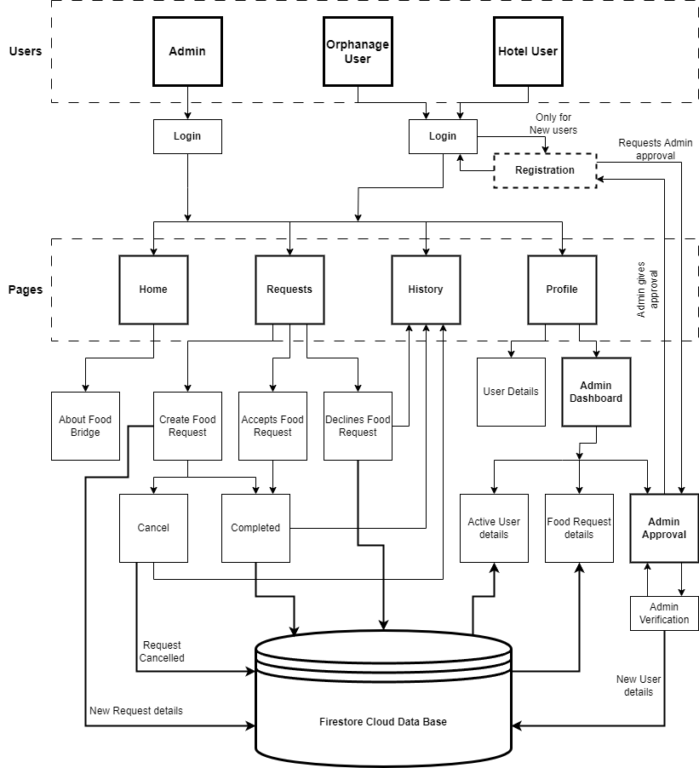

3.1 FIGURE SYSTEM ARCHITECTURE

# DATABASE DESIGN

Below are some of the sample database designs exists in the prediction application acting as an input.

# Table 3.2 Tata Dataset

**TATA DATASET:**

# Table 3.3 Reliance Dataset

# 3.3. SYSTEM TESTING

The purpose of testing is to discover errors. Testing is the process of trying to discover every conceivable fault or weakness in a work product. It provides a way to check the functionality of components, sub-assemblies, assemblies and/or a finished product It is the process of exercising software with the intent of ensuring that the Software system meets its requirements and user expectations and does not fail in an unacceptable manner. There are various types of tests. Each test type addresses a specific testing requirement.

# TYPES OF TESTS

# UNIT TESTING

Unit testing involves the design of test cases that validate that the internal program logic is functioning properly, and that program inputs produce valid outputs. All decision branches and internal code flow should be validated. It is the testing of individual software units of the application .it is done after the completion of an individual unit before integration. This is a structural testing, that relies on knowledge of its construction and invasive. Unit tests perform basic tests at component level and test a specific business process, application, and/or system configuration. Unit tests ensure that each unique path of a business process performs accurately to the documented specifications and contains clearly defined inputs and expected results.

# INTEGRATION TESTING

Integration tests are designed to test integrated software components to determine if they actually run as one program. Testing is event driven and is more concerned with the basic outcome of screens or fields. Integration tests demonstrate that although the components were individually satisfaction, as shown by successfully unit testing, the combination of components is correct and consistent. Integration testing is specifically aimed at exposing the problems that arise from the combination of components.

# FUNCTIONAL TEST

Functional tests provide systematic demonstrations that functions tested are available as specified by the business and technical requirements, system documentation, and user manuals.

Functional testing is centered on the following items:

Valid Input: identified classes of valid input must be accepted. Invalid Input: identified classes of invalid input must be rejected. Functions: identified functions must be exercised.

Output: identified classes of application outputs must be exercised.

Systems/Procedures: interfacing systems or procedures must be invoked. Organization and preparation of functional tests is focused on requirements, key functions, or special test cases. In addition, systematic coverage pertaining to identify.

Business process flows: data fields, predefined processes, and successive processes must be considered for testing. Before functional testing is complete, additional tests are identified and the effective value of current tests is determined.

# Table 3.1 Test Case register

|  |  |  |  |  |  |
| --- | --- | --- | --- | --- | --- |
| **TEST CASE NO** | **MODULE** | **TEST CASE SUMMARY** | **EXPECTED OUTCOME** | **ACTUAL OUTCOME** | **RESULT** |
| **1** | **Register** | To verify | User should | User is able |  |
|  |  | that the user  can | be able to  register their details in the application. | to register to  the system | **PASS** |
|  |  | register the |  | successfully |  |
|  |  | details in the application. |  |  |  |

# Table 3.2 Test Case login

|  |  |  |  |  |  |
| --- | --- | --- | --- | --- | --- |
| **TEST CASE NO** | **MODULE** | **TEST CASE SUMMARY** | **EXPECTED OUTCOME** | **ACTUAL OUTCOME** | **RESULT** |
| **1** | **Login** | To verify | User should | User is able |  |
|  |  | that the user  is able to | be able to  login to the | to login to  the system | **PASS** |
|  |  | login to the | system | successfully |  |
|  |  | system | successfully. |  |  |
|  |  | successfully. |  |  |  |

# Table 3.3 Test Case deployment

|  |  |  |  |  |  |
| --- | --- | --- | --- | --- | --- |
| **TEST CASE NO** | **MODULE** | **TEST CASE SUMMARY** | **EXPECTED OUTCOME** | **ACTUAL OUTCOME** | **RESULT** |
| **1** | **Deployment** | To verify | User should | User is able |  |
|  |  | that the user  is able to get | be able to get  the predicted | to get the  predicted | **PASS** |
|  |  | the predicted | closing price | closing price |  |
|  |  | closing price |  |  |  |

# Table 3.4 Test Case deployment

|  |  |  |  |  |  |
| --- | --- | --- | --- | --- | --- |
| **TEST CASE NO** | **MODULE** | **TEST CASE SUMMARY** | **EXPECTED OUTCOME** | **ACTUAL OUTCOME** | **RESULT** |
| **1** | **Deployment** | To verify | User should | User is able |  |
|  |  | that the user  id able to | be able to  login to the | to login to  the system | **PASS** |
|  |  | login to the | system | successfully |  |
|  |  | system | successfully. |  |  |
|  |  | successfully. |  |  |  |

# CHAPTER 4

# IMPLEMENTATION AND RESULTS

# IMPLEMENTATION

System Implementation uses the structure created during system design and the results of system analysis to construct system elements that meet the stakeholder requirements and system requirements developed in the early life cycle phases. Also, this is crucial phase in the system development life cycle is successful implementation of the system design. Implementation describes covering the system design into operation; which includes all those activities that take place to convert from the old system to new system. The new system may be totally new, replacing an existing manual or automated system or it may be a major modification to an existing system. Proper implementation is essential to provide a reliable system to meet the organization requirements. Successful implementation may not guarantee improvement in the organization using the new system, but improper installation will prevent it.

The implementation stage involves the following tasks:

* Careful planning; Investigation of system and constraints.
* Design of methods to achieve the changeover phase.
* Training of staff in the changeover phase.
* Evaluation of the changeover method

The method of implementation and the time scale to be adopted are found out initially. Next, the system is tested properly and the system is tested and the same time users are trained in the new procedures.

# RESULTS

Post implementation and deployment, we carried out testing with the end users and found that the features where very suitable for the purpose of Prediction of stock price using regression model. Tests are conducted and all the results are evaluated. That is test results are compared with expected results. When erroneous data are uncovered, an error is implied and debugging commences. It met the testing and authentication workflow as set out by various authorities and any changes in the workflow was quickly adopted through making changes to configurable items in the system. This system was successfully used by User during the field testing.

Working of the system has captured in screenshot during its run demonstrates the successfully implemented as elaborated in the requirements specification. The features covered are listed below:

# HOME PAGE

Figure 4.1 Home Page

# LOGIN PAGE

Figure 4.2 Login Page

# REQUEST PAGE

Figure 4.3 Request Page

# HISTORY PAGE

Figure 4.4 History Page

# PROFILE PAGE

Figure 4.5 Profile Page

# ADMIN DASHBOARD PAGE

Figure 4.6 Admin Dashboard Page

# ALGORITHM LAYOUT PAGE

Figure 4.7 Algorithm Layout Page

# CHAPTER 5

**CONCLUSION AND FUTURE WORK**

# CONCLUSION

Food Bridge presents a promising solution to simultaneously address food waste and hunger. By connecting those with surplus food to those in need, the project contributes to a more sustainable and equitable food system. This innovative approach has the potential to create a positive ripple effect, promoting environmental responsibility, enhancing food security, and fostering stronger communities.

# FUTURE WORK:

* **Network Expansion:** We envision a world where Food Bridge connects even more communities. We will be actively expanding our network to encompass a wider range of locations, ensuring our platform reaches those who need it most.
* **Enhanced Services:** We are dedicated to providing a robust suite of services to our growing network. This includes the introduction of features like:
  + **Monetary Donations:** Empowering individuals to directly contribute financially to the fight against hunger.
  + **Individual Food Donations:** Providing a platform for anyone with surplus food to seamlessly donate to those in need.
* **Raising Awareness:** Food Bridge understands the importance of public education. We plan to organize impactful awareness programs and activities focused on food waste reduction and food security. These initiatives will target both local communities and children, fostering a culture of responsibility and sustainability.
* **Streamlined User Experience:** We're constantly striving to improve user experience. User-friendly request notification and tracking methods are on the horizon, ensuring smooth communication and efficient food retrieval.

# REFERENCE

1. Thirunavukkarasu Anbalagan a, S. Uma Maheswari b, Classification and Prediction of Stock Market Index Based on Fuzzy Meta graph, Elsevier B.V, 1877-0509 © 2015, DOI: 10.1016/j.procs.2015.03.200
2. Devanshu Upadhyay1, Soumya Sharma2, Stock Price Prediction Using Concept of Long- Short Term Memory, International Journal of Scientific Engineering and Research (IJSER),

Volume 9 Issue 12, December 2021

1. Dr. P. K. Sahoo, Mr. Krishna charlapally, Stock Price Prediction Using Regression Analysis, International Journal of Scientific & Engineering Research, Volume 6, Issue 3,

March-2015 ISSN 2229-5518

1. *Kathika Sai Krishna, Mettupalli Hari Naveen Reddy, Appidi Koushik Reddy, Mukkamalla Naveen Reddy,* Stock price prediction using machine learning models in python, *International Journal of Advance Research, Ideas and Innovations in Technology,* Volume 7, Issue 2 - V7I2- 1525 *© 2021*