**Food Bridge - Bridging the Gap Between Food Sources and People in Need**

# ABSTRACT

Food Bridge combats the twin problems of food waste and hunger by creating a seamless connection between hotels with excess food and orphanages struggling with food insecurity. This innovative project hinges on a user-friendly web application that acts as a communication bridge. Hotels can leverage this platform to post real-time alerts about their surplus food, specifying details like type, quantity, and preferred pick-up times. Orphanages and other authorized recipients benefit from a notification system tailored to their location and preferences, ensuring they're promptly alerted to available food before it spoils.

The impact of Food Bridge extends far beyond simply connecting donors and recipients. By diverting edible food from landfills, the project plays a crucial role in promoting environmental sustainability. Reduced food waste translates to less methane emissions from decomposition, while also conserving valuable resources used in food production. Furthermore, Food Bridge directly addresses food insecurity by providing orphanages and other vulnerable communities with access to nutritious meals, a critical factor for overall well-being, especially for children.

This platform goes beyond efficiency by fostering collaboration and social responsibility within the community. Hotels play a vital role by donating surplus food, while orphanages and other recipients benefit from this generosity. Food Bridge strengthens the social fabric by encouraging businesses to give back and participate in a more sustainable and equitable food system. This innovative approach has the potential to create a positive ripple effect, promoting environmental responsibility, enhancing food security, and fostering stronger communities.

# CHAPTER 1

## INTRODUCTION

### 1.1 OBJECTIVE:

Food Bridge's primary objective is to establish a seamless connection between hotels with surplus food and orphanages facing food insecurity. This web-based platform aims to achieve the following:

* **Reduce food waste:** By diverting edible food from landfills, Food Bridge promotes environmental sustainability.
* **Enhance food security:** Orphanages and other authorized recipients gain access to nutritious meals, improving their well-being.
* **Foster community connections:** The platform facilitates collaboration and social responsibility within the community by connecting donors with recipients in need.

### 1.2 PROBLEM STATEMENT:

Food Bridge addresses two critical issues: food waste and hunger. Here's a breakdown of the problem statement:

* **Excessive food waste:** Hotels discard a significant amount of edible food every year. This wasted food represents not only a financial loss but also a missed opportunity to nourish those in need.
* **Food insecurity:** Many orphanages and other organizations struggle to provide adequate and nutritious meals due to limited resources. This lack of access to food can negatively impact the health and well-being of individuals, especially children.

Food Bridge aims to bridge this gap by creating a system that efficiently connects those with surplus food to those facing hunger.

### 1.3 SCOPE OF THE PROJECT:

The scope of Food Bridge encompasses the development and implementation of a user-friendly web application. This application will cater to both hotels and orphanages, offering the following functionalities:

* **Registration and account management:** Hotels and orphanages can register and manage their accounts, including specifying preferences and updating relevant information.
* **Real-time notification system:** Hotels can post alerts about available surplus food, including details like type, quantity, and preferred pick-up time. Orphanages and other recipients will receive instant notifications based on their location and preferences.
* **Communication and coordination tools:** The platform facilitates communication between donors and recipients, ensuring smooth scheduling and coordination for food pick-up and delivery.

It's important to note that the current scope focuses on connecting hotels with orphanages. The project might consider expanding its reach in the future to include other establishments with surplus food and a wider range of recipient organizations.

### 1.4 ACHIEVEMENT

Food Bridge anticipates achieving positive outcomes in several areas:

* **Reduced environmental impact:** By minimizing food waste, Food Bridge helps conserve resources and reduce methane emissions from decomposing food in landfills.
* **Improved food security:** Orphanages and other recipients gain access to a reliable source of nutritious meals, contributing to better health and well-being.
* **Strengthened communities:** The platform fosters collaboration between businesses and social organizations, promoting social responsibility and a more connected community.

The success of Food Bridge will be measured by the amount of food redistributed, the number of users actively participating on the platform, and the positive feedback received from donors and recipients.

# CHAPTER 2

## Literature Survey

# CHAPTER 3

## SYSTEM SPECIFICATION

### 3.1 HARDWARE REQUIREMENTS

The application has been developed with the system having the following requirements:

* Processor: AMD Ryzen 5 5600H with Radeon Graphics, 3301 MHz
* RAM: 8 GB
* Hard Disk: 500 GB (SSD)

### 3.2 SOFTWARE REQUIREMENTS

The application has been developed with the system having the following requirements:

* Front-End Framework: Angular 17, Ionic
* Development Environment: Visual Studio Code
* Database Management: Firestore
* Hosting: Firebase
* Login Management: Google OAuth

### 3.3 DOMAIN KNOWLEDGE

Food Bridge utilizes a combination of powerful technologies to achieve its goal of connecting food donors with recipients. Here's a closer look at each element:

**Ionic:**

Food Bridge leverages Ionic for its user interface (UI) development. Ionic is a popular framework for building hybrid mobile applications. It allows developers to create native-looking apps using web technologies like HTML, CSS, and JavaScript. This approach offers several advantages:

* **Cross-platform development:** With Ionic, a single codebase can be used to create apps for both Android and iOS, saving time and resources.
* **Native-like feel:** Ionic apps provide a smooth and responsive user experience that closely resembles native apps.
* **Rich UI components:** Ionic offers a comprehensive set of pre-built UI components that streamline the development process.

**Angular:**

The project utilizes Angular to handle the application's logic and functionality. Angular is a powerful JavaScript framework well-suited for building complex single-page web applications (SPAs). Here's how Angular contributes to Food Bridge:

* **Structured development:** Angular enforces a well-defined architecture, making the code maintainable and scalable as the application grows.
* **Data binding:** Angular's two-way data binding simplifies the process of keeping the UI and application logic in sync.
* **Reusable components:** Similar to Ionic, Angular promotes component-based development, allowing for code reuse and faster development cycles.

**Firebase:**

Food Bridge employs Firebase, a suite of tools and services from Google, to build the backend functionality of the Android application. Here's what Firebase offers:

* **Backend as a Service (BaaS):** Firebase provides pre-built backend functionalities such as authentication, database management, and cloud storage, eliminating the need for developers to set up and manage their own servers.
* **Real-time features:** Firebase offers real-time capabilities, which are crucial for Food Bridge's core functionality. Real-time notifications ensure that orphanages are promptly alerted about available surplus food.

**Firestore:**

Within Firebase, Food Bridge utilizes Firestore, a flexible and scalable cloud NoSQL database. Firestore allows for storing and managing the application's data, including details about hotels, orphanages, surplus food items, and user information. Firestore offers several benefits for Food Bridge:

* **Scalability:** Firestore automatically scales to accommodate the application's growing needs.
* **Offline support:** Firestore enables offline data access, ensuring smooth operation even if internet connectivity is limited.
* **Real-time updates:** Firestore integrates seamlessly with Firebase's real-time features, enabling instant updates for both donors and recipients.

**Google OAuth:**

Food Bridge implements Google OAuth, an authentication service developed by Google, to manage user logins. Google OAuth streamlines the login process by allowing users to sign in with their existing Google accounts. This offers several advantages:

* **Simplified registration:** Users don't need to create separate accounts for Food Bridge, reducing friction and encouraging participation.
* **Enhanced security:** Google OAuth leverages Google's robust security infrastructure, ensuring user data is protected.
* **Scalability:** Google OAuth can handle a large number of users efficiently.

By combining these technologies, Food Bridge creates a robust and user-friendly platform that tackles the issues of food waste and hunger effectively.

# CHAPTER 4

## SYSTEM DESIGN

**4.1 SYSTEM ARCHITECTURE:**

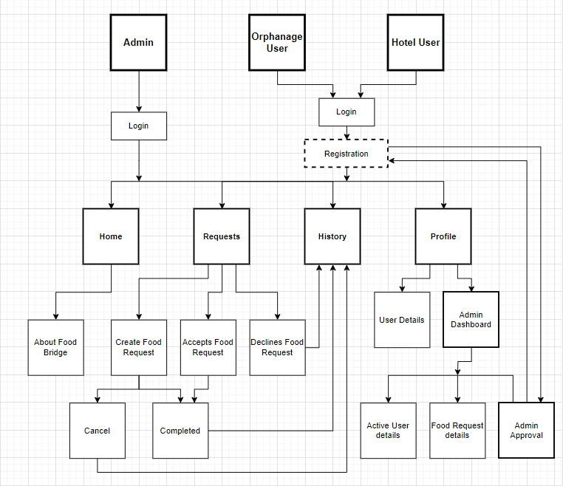

**4.2 MODEL OVERVIEW:**

**4.2.1 Admin**

**4.2.2 Orphanage User**

**4.2.3 Hotel User**

**4.2.4 Login**

**4.2.5 Registration**

**4.2.6 Home**

**User Registration:**

* Appropriate Hotel/Orphanage member are required to fill the respected details and request the Admin for application login access.

**Admin Verification:**

* Admin verifies all the received requests and provide them an appropriate Login access only for valid requests.
* Admin rejects the received access requests with invalid details.

**User Login:**

* Appropriate Hotel/Orphanage member, who received access from Admin can access the Application.

**User Profile:**

* Admin user can be a Hotel/Orphanage user. Admin will have Dashboard option for Admin Verification process.
* Logged user (Admin/Hotel/Orphanage) details will be prepopulated in the User Profile.

**Home Page:**

About Food bridge and points.

**Food Requests:**

* Orphanage member can raise Food request from Requests page by just giving food count.
* Raised Food request is sent to all nearby Hotel members.
* Orphanage member could Cancel the request if they wanted to.

**Accept Requests:**

* When a Hotel Accepts the Request, then their contacts are shared to each other.
* Accepted request should not be displayed for other Hotel users.
* And Food delivered successfully.

**Decline Requests:**

* If the Hotel is not having enough food for the request, they can Decline the request.
* Food request can be still viewed by other nearby hotels.

**Requests Completed:**

* When requested food is delivered, then that request is marked as Completed.
* When request is Declined by a Hotel, that request is marked Closed for that particular Hotel only.

**History:**

* Completed, Cancelled and Closed requests are moved to History page.
* By clicking Delete button, user can delete the Requests in History page.

# CHAPTER 5

# CHAPTER 6

## RESULTS AND DISCUSSION

# CHAPTER 7

## CONCLUSION

PROJECT ACHIEVEMENT

CHALLENGES FACED

OVERCOMING CHALLENGES

FUTURE WORK