Parkinson Disease Detection Using Deep Neural Networks

In this project we are using various machine learning algorithms such as SVM, XGBOOST and MLP (multilayer perceptron) to predict Parkinson disease from SPEECH file but this algorithms prediction accuracy is not accurate so we are implementing advance Convolution Neural Network (CNN2D) and then compare its performance with machine learning algorithms.

To train all algorithms we have used speech files which contains spontaneous dialogs and TEXT READING and it contains two different folder called HC (healthy) and PD (Parkinson disease). Features are extracted from speech file by using python SOUND API. Below screen showing dataset audio files used in this project

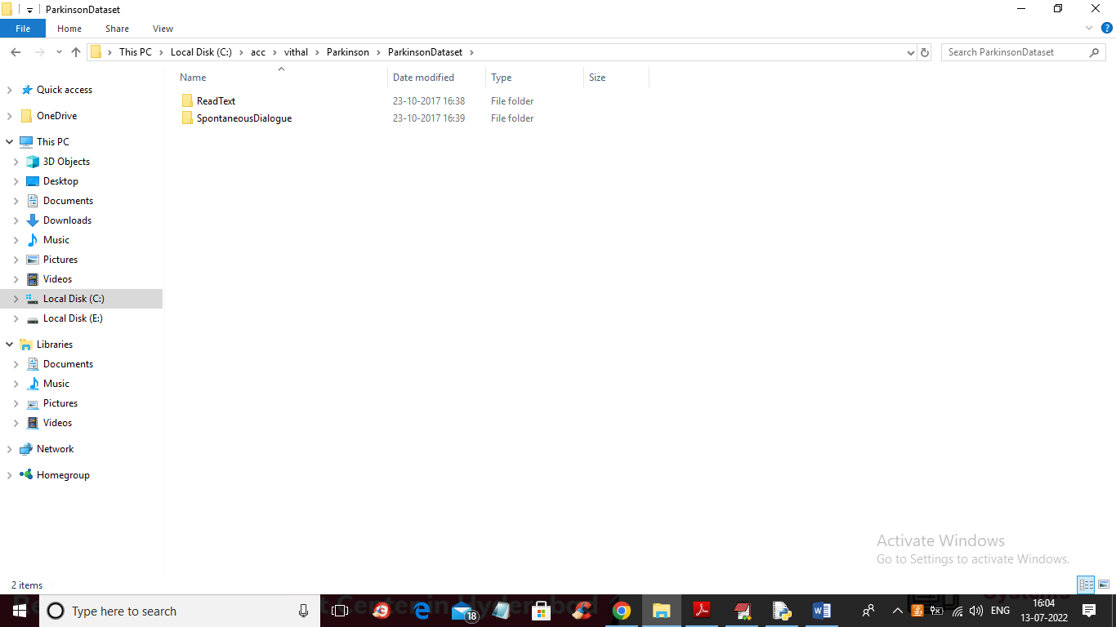

In above screen we have two different speech files with TEXT READING and dialogues and just go inside any folder to view speech file in healthy and Parkinson disease folders

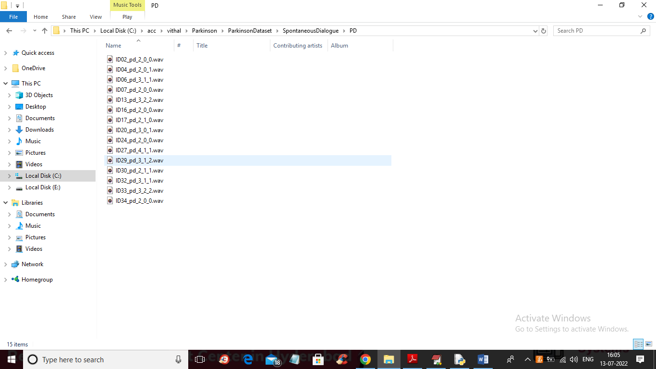

In above screen we can see wav file with Parkinson disease and we are using above files to extract features and then train with machine and deep learning algorithms.

To implement this project we have designed following modules

1. Upload Parkinson Speech Dataset: using this module we will upload all audio files folder to application and then application read all audio files and then extract features from it.
2. Preprocess Dataset: using this module we will replace missing values with mean value and then normalize all extracted features using MINMAX scaling and then split dataset into train and test where application used 80% dataset for training and 20% for testing
3. Train SVM Algorithm: using this module we will train SVM with processed train data and then apply trained model on 20% test data to calculate prediction accuracy.
4. Train XGBoost Algorithm: using this module we will train XGBoost with processed train data and then apply trained model on 20% test data to calculate prediction accuracy.
5. Train MLP Algorithm: using this module we will train MLP with processed train data and then apply trained model on 20% test data to calculate prediction accuracy.
6. Train CNN Algorithm: using this module we will train CNN with processed train data and then apply trained model on 20% test data to calculate prediction accuracy.
7. Predict Parkinson from Test Speech: using this module we will upload TEST audio speech file and then extract features and then apply trained model on extracted features to predict whether speech file is healthy or contains Parkinson disease
8. Comparison Graph: using this module we will plot comparison graph between all modules

SCREEN SHOTS

To run project double click on ‘run.bat’ file to get below screen

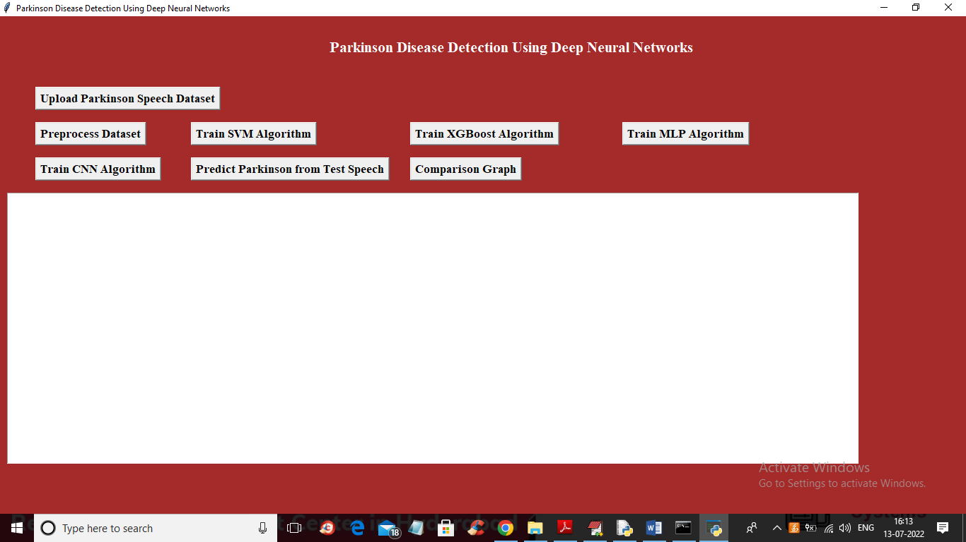

In above screen click on ‘Upload Parkinson Speech Dataset’ button to upload dataset folder and then will get below screen

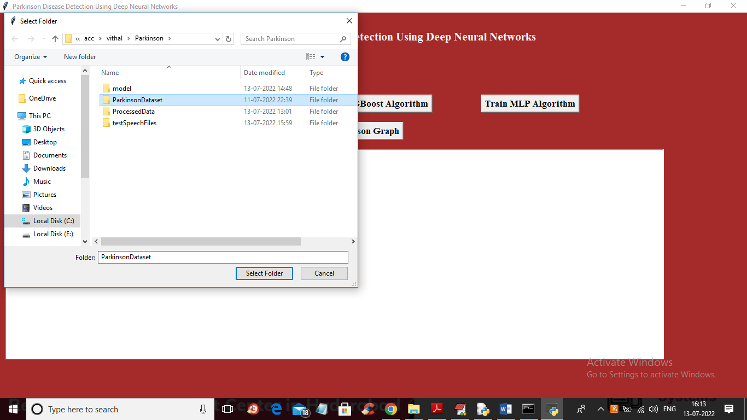

In above screen selecting and uploading ‘Parkinson Dataset’ folder and then click on ‘Select Folder’ button to load dataset and get below output

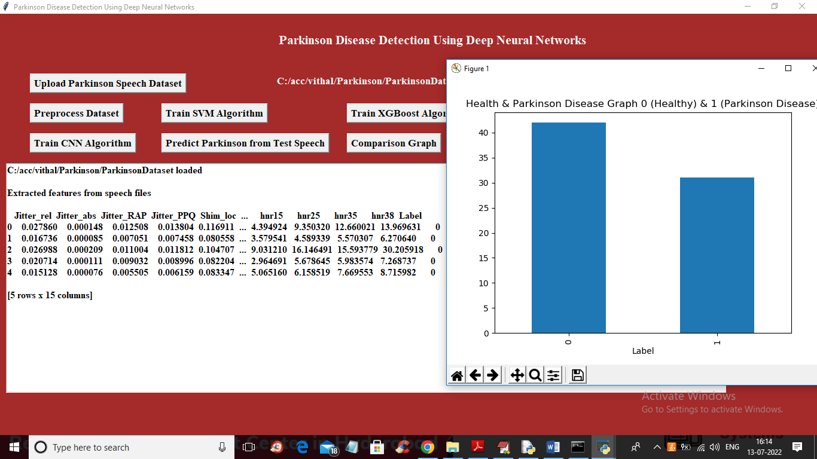

In above screen from all audio files features are extracted and then in graph we are displaying total healthy and Parkinson disease found in dataset. In above dataset 0 mean healthy and 1 means Parkinson disease and now close above graph and then click on “Preprocess Dataset” to replace missing values and then normalize values and then split dataset into train and test and will get below output

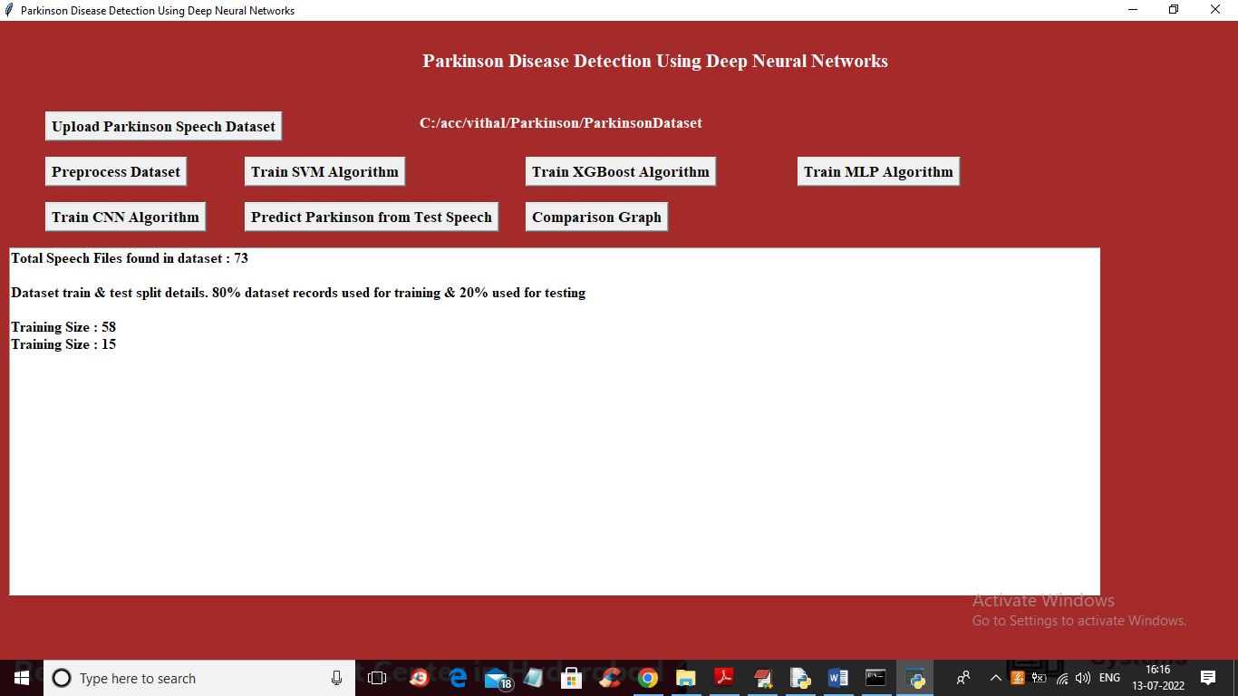

In above screen we can see dataset contains total 73 audio file and then application using 80% (58 records) for training and 20% for testing and now dataset is ready and now click on ‘Train SVM Algorithm’ button to train SVM and get below output

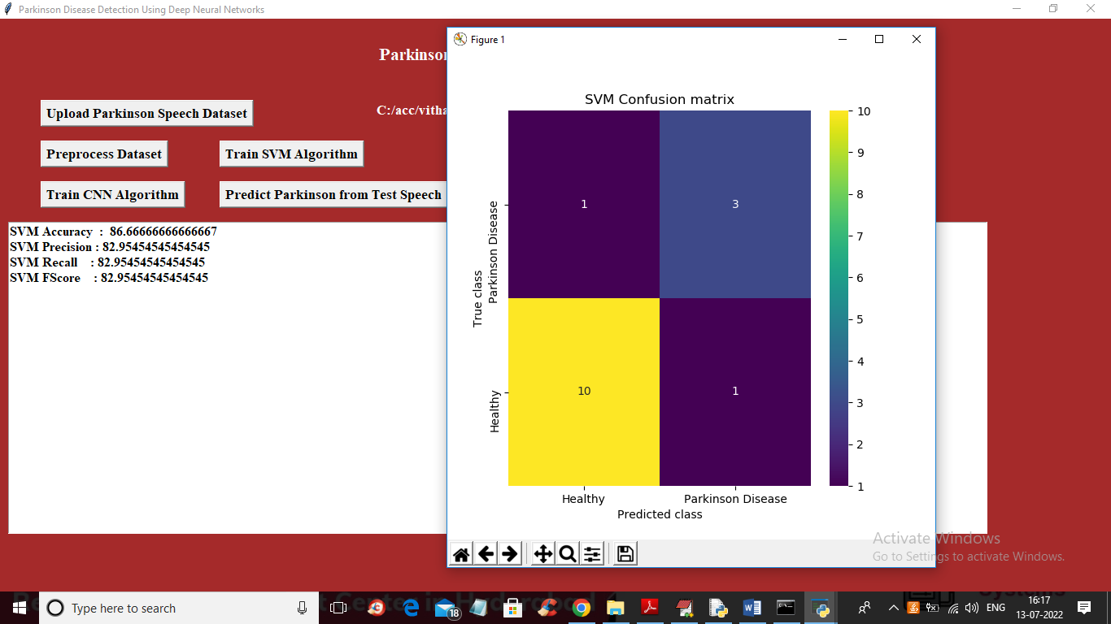

In above screen with SVM we got 86% accuracy and in confusion matrix graph x-axis represents Predicted classes and y-axis represents TEST classes and in above graph we can see only 1 record is incorrectly predicted in both Healthy and Parkinson disease classes. Now close above graph and then click on ‘Run XGBoost Algorithm’ button to get below output

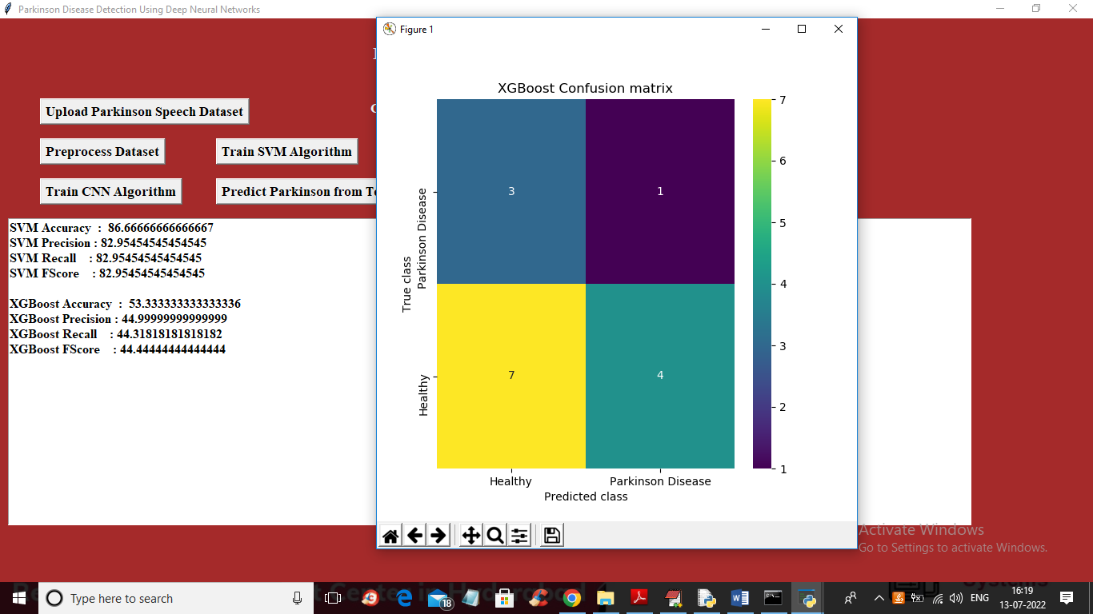

In above screen with XGBoost we got 53% accuracy and in confusion matrix we can see 3 and 4 records are wrongly predicted so total 7 are incorrect prediction so its performance is not good and now close above graph and then click on ‘Train MLP Algorithm’ button to get below output

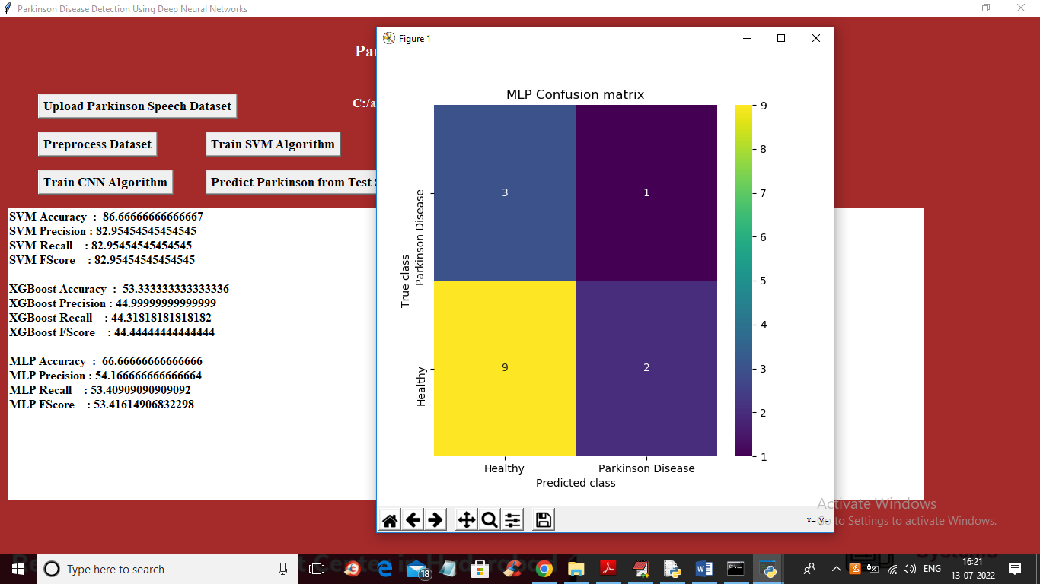

In above screen with MLP we got 66% accuracy and 3 and 2 records are wrongly predicted so its performance also not good and now close above graph and then click on ‘Train CNN Algorithm’ button to get below output

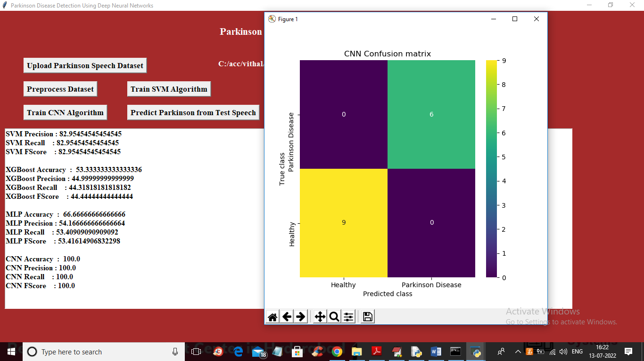

In above screen with CNN we got 100% accuracy and in graph we can see 0 records are wrongly predicted so its performance is good. CNN test on randomly split test data so its accuracy may vary for 86 to 100% for each run. Now close above graph and then click on ‘Predict Parkinson from Test Speech’ button to upload test audio file and then CNN will predict weather its healthy speech file or not.

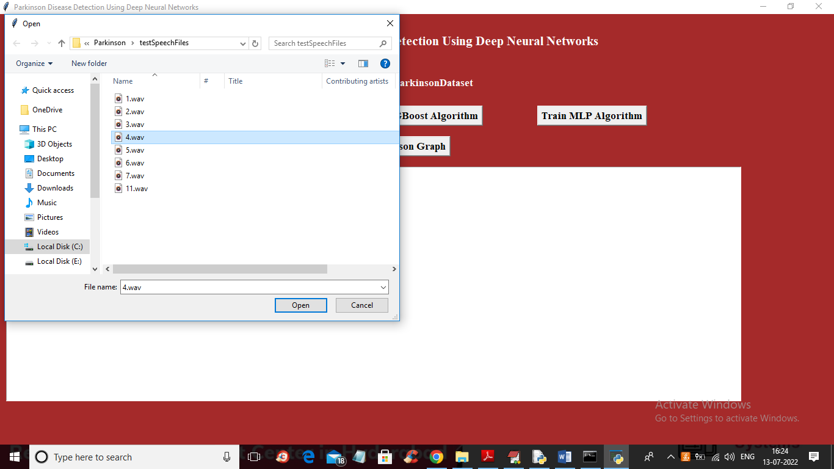

In above screen selecting and uploading ‘4.wav’ file and then click on ‘Open’ button so application will extract features and then perform prediction using CNN and will get below output

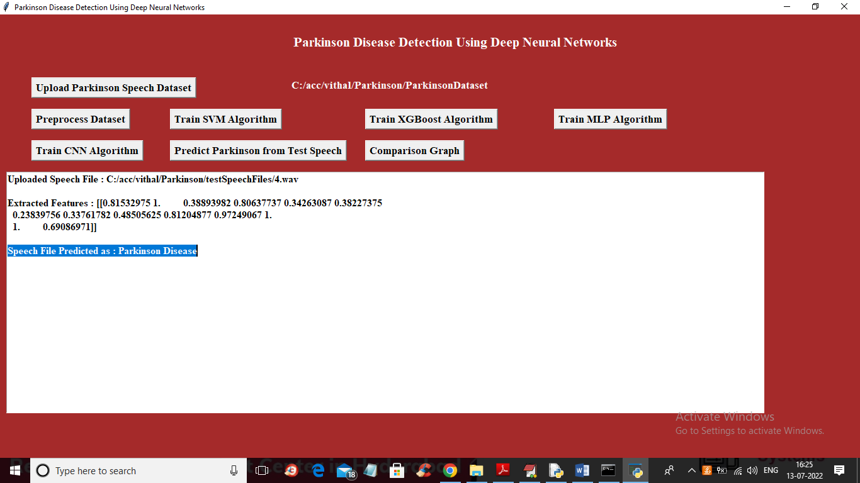

In above screen in text area we can see features are extracted from uploaded audio file and then in blue colour we can see audio features predicted as ‘Parkinson Disease’ and now test other audio file

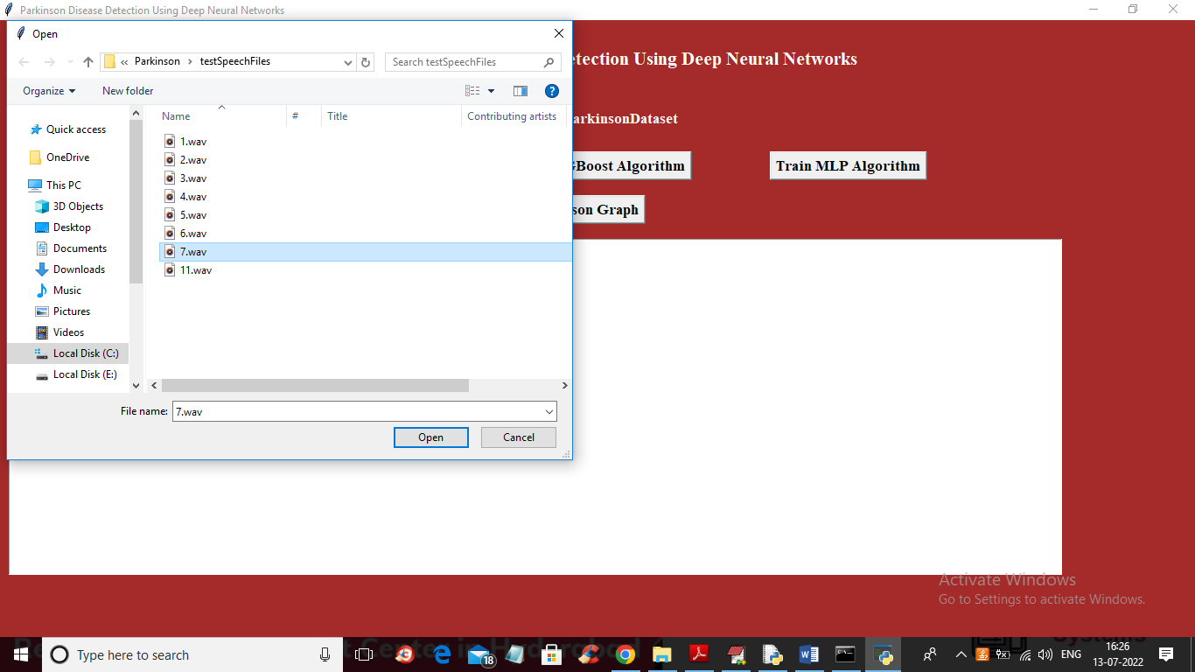

In above screen selecting and uploading 7.wav file and then click on ‘Open’ button to get below output

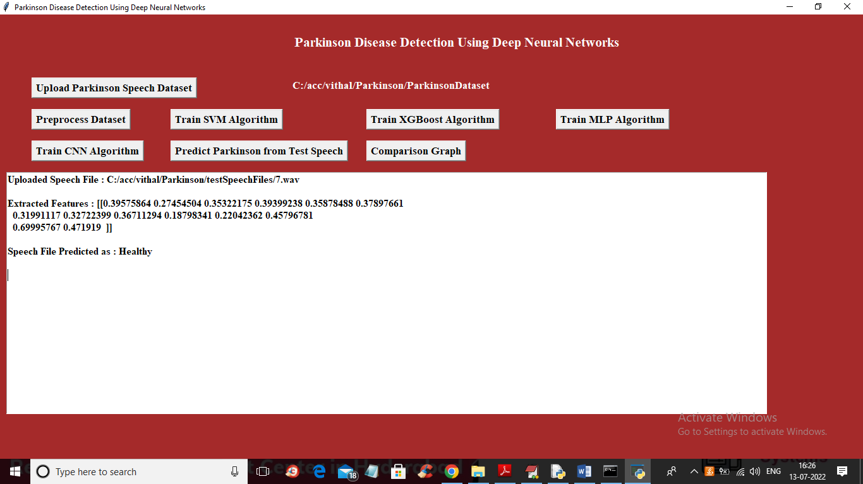

In above screen uploaded speech filed predicted as ‘Healthy’ and similarly you can upload and test other audio files. Now click on ‘Comparison Graph’ button to get below graph

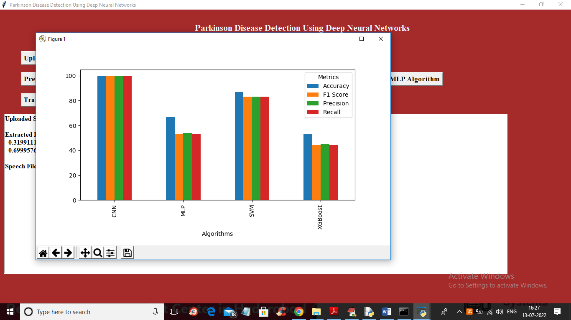

In above graph x-axis represents algorithm names and y-axis represents accuracy, precision, recall and FSCORE in different colour bars and in all algorithms CNN has got high performance