

IE6600: Computation and Visualization for Analytics

Project 2: Traffic Accident Analysis of Tempe

Group 17 Ashna Arora
Dheeraj Kumar Goli Siyuan Gao

- Introduction
Traffic accidents are a major public health issue globally, leading to significant loss of life, injuries, and economic costs. Understanding the factors contributing to road accidents is crucial for developing effective prevention strategies. This report delves into the "Crash Data" dataset from Tempe, a comprehensive collection of 43,242 traffic accident records, through exploring the influence of various factors on traffic accidents, this report puts forward some suggestions to reduce the traffic accident rate effectively.
- Problem Statement
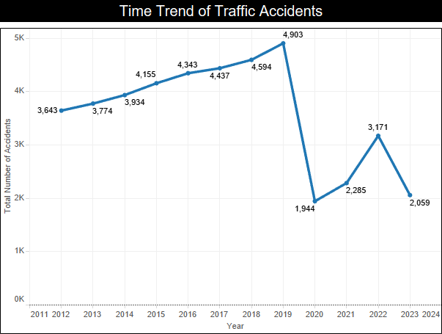
From the time trend chart, we can find that the traffic accident rate was relatively high before 2020, and the traffic accident rate decreased after 2020 because of the novel coronavirus. In order to prevent the traffic accident rate from returning to the previous high level, what specific measures can we take to reduce the traffic accident rate? What are the external and internal factors that cause traffic accidents?

- Data Description

Data Source:
Dataset from data.gov

Data Description

  - Data Processing:
We selected the key columns and dropped the null value. To ensure the integrity of the data, we filtered the outliers in the Tableau platform using the filter function.
- Methodology and Design Process

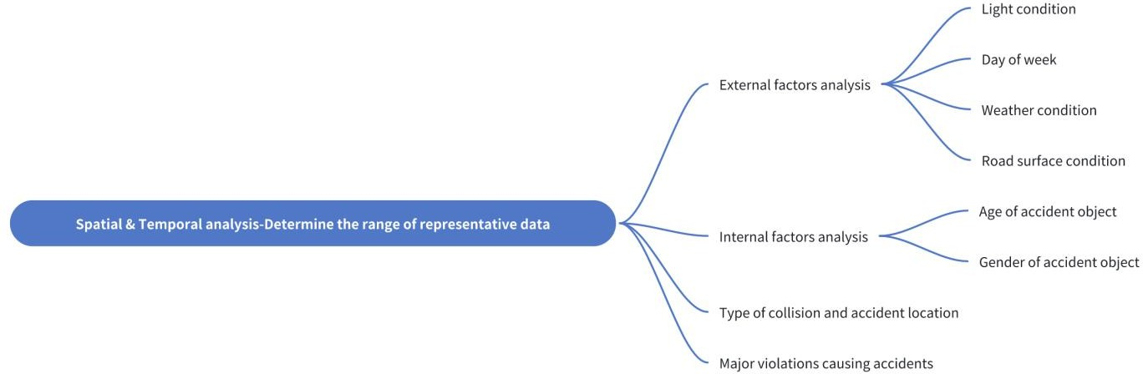

Determine the range of representative data
Before 2020, the number of traffic accidents is on the rise year by year, and 2015-2019 is the five years with the largest number of traffic accidents, so we choose the data of these five years as the basis for subsequent analysis. Then to identify key locations, we filtered the number of accidents down to at least 150, and we got the eight worst streets, and all the streets that intersect them.
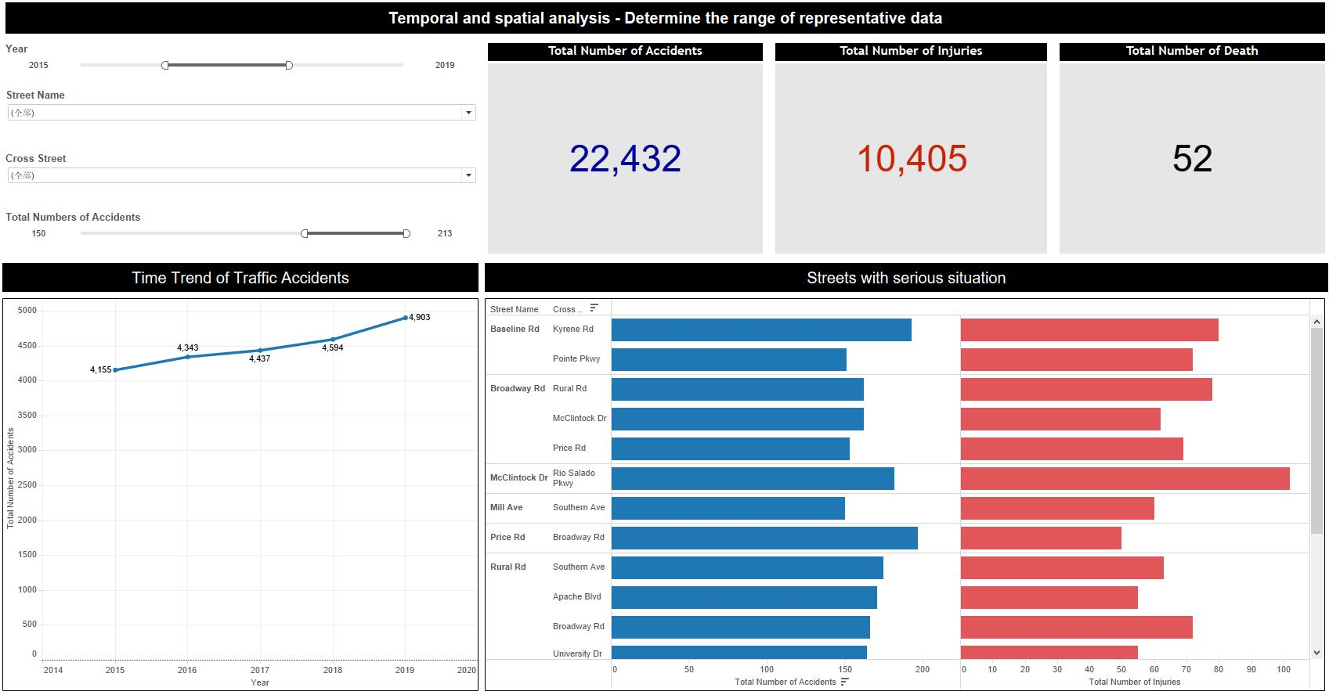

Geographical Visualization
Here we present all the filtered data in the real map, so that you can have a more intuitive sense of the location and frequency of traffic accidents.

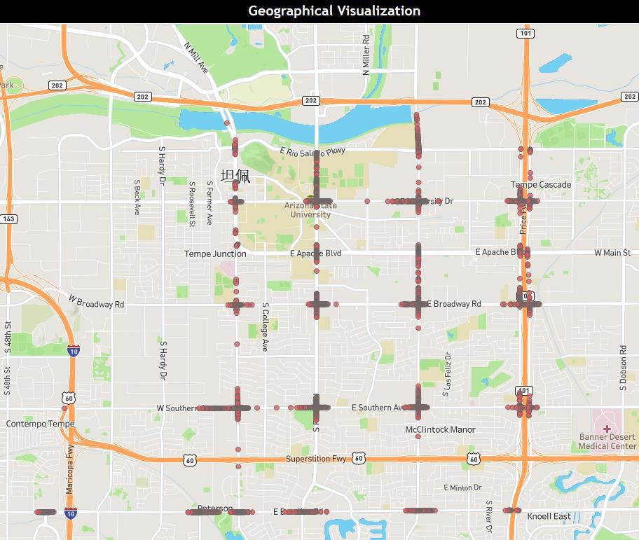

External factors analysis
In the external factor analysis dashboard, we can see that the traffic accident rate increases significantly between 7pm and 4am, which means that the traffic accident rate is higher under poor lighting conditions, and there is a higher accident rate on weekdays than on weekends, mainly because there is a higher travel demand on weekdays. In addition, we can see that the traffic accident rate is not significantly related to weather and road conditions, and most traffic accidents occur on clear and dry roads.
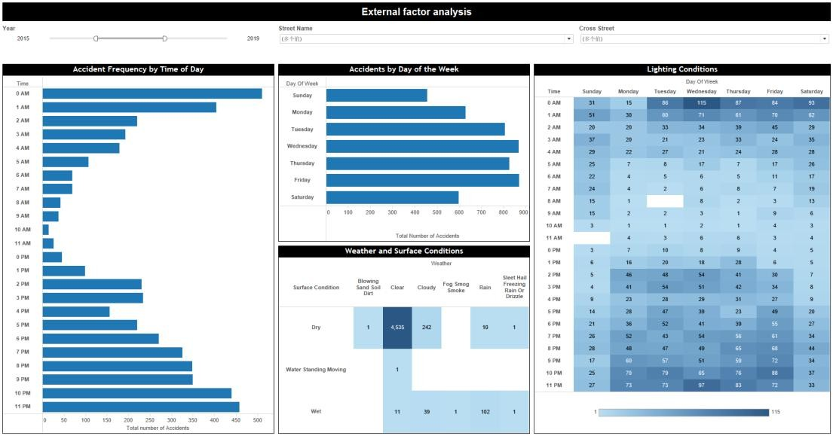

Internal factors analysis-Age

In the age analysis of the accident objects, we can see that most of the accidents are caused by young people between 18 and 25 years old, mainly because of speeding and refusing to yield the right of way. Most of the passive victims of accidents are also young people aged 20-28, mainly due to speeding and unsafe lane changes.
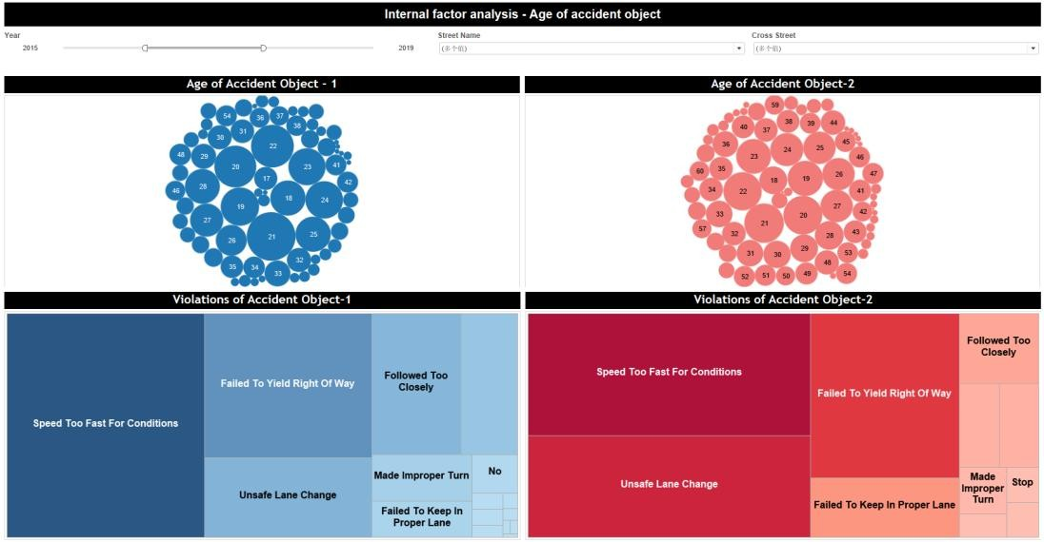

Internal factors analysis-Gender
In the gender analysis of the accident objects, we can see that the traffic accident rate of men is about 33% higher than that of women. No matter what kind of violation, the accident rate of men is higher than that of women, indicating that male drivers tend to have more impulsive driving behaviors.
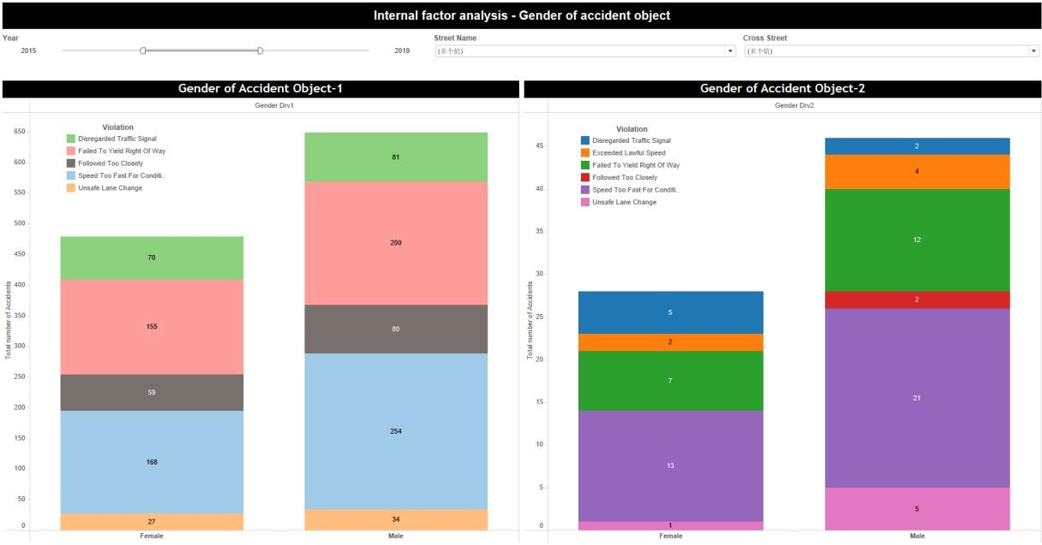

Type of collision and accident location

In the collision type analysis table, we can see that most traffic accidents are vehicles, and in the following location analysis thermal map, we can get a specific location distribution. For example, the intersection of University Dr and Rural Rd is the most dangerous, with 213 traffic accidents occurring in 5 years.
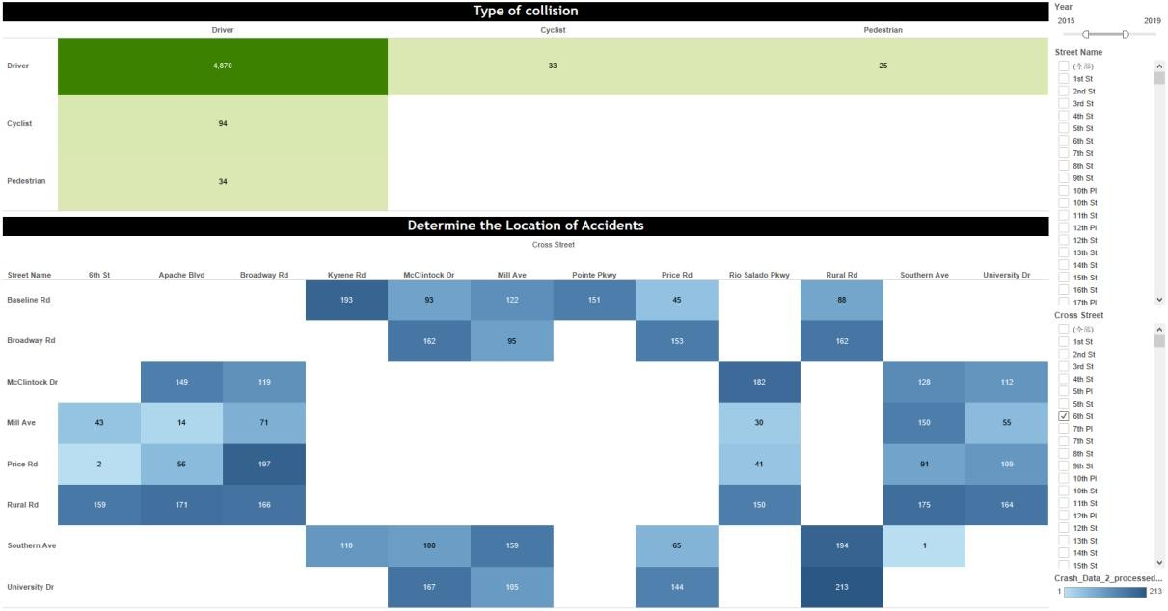

Major violations causing accidents
From this word cloud map, we can see that speeding accounts for the largest proportion of all accident types, followed by refusal to yield the right of way, and unsafe lane changes. If the subsequent traffic management is to be carried out, then these three reasons are the worthiest of attention.
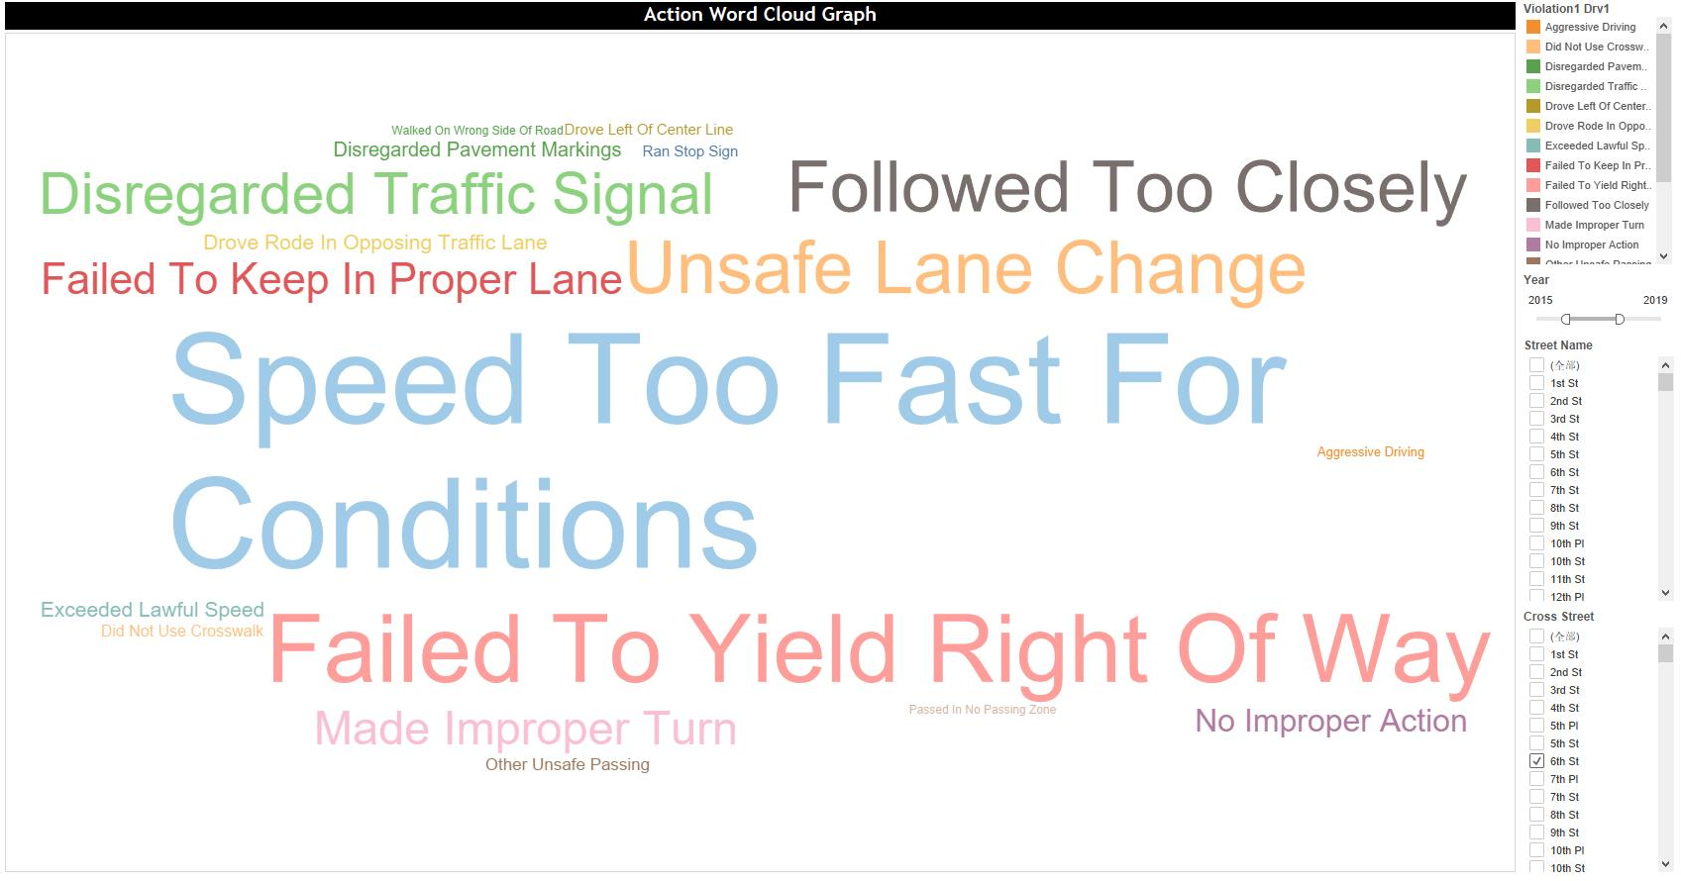

- Key Insights
There are 18 intersections with the highest traffic accident rates and most noteworthy:

Street Name | Cross Street Name | Total Accidents | Total Injuries
Baseline Rd | Kyrene Rd | 193 | 80
 | Pointe Pkwy | 151 | 72
Broadway Rd | Rural Rd | 162 | 78
 | McClintock Dr | 162 | 62
 | Price Rd | 153 | 69
McClintock Dr | Rio Salado Pkwy | 182 | 102
Mill Ave | Southern Ave | 150 | 60
Price Rd | Broadway Rd | 197 | 50
Rural Rd | Southern Ave | 175 | 63
 | Apache Blvd | 171 | 55
 | Broadway Rd | 166 | 72
 | University Dr | 164 | 55
 | 6th St | 159 | 81
 | Rio Salado Pkwy | 150 | 69
Southern Ave | Rural Rd | 194 | 85
 | Mill Ave | 159 | 65
University Dr | Rural Rd | 213 | 78
 | McClintock Dr | 167 | 54
The traffic accident rate is higher under poor lighting conditions, and there is a higher accident rate on weekdays than on weekends.
Most of the accidents are caused by young people between 18 and 25 years old, mainly violations are speeding and refusing to yield the right of way. Most of the passive victims of accidents are also young people aged 20-28, mainly due to speeding and unsafe lane changes.
The traffic accident rate of men is about 33% higher than that of women. For car-car collisions, we should pay more attention to 4 intersections:
Price Rd - Broadway Rd Baseline Rd - Kyrene Rd Southern Ave - Rural Rd University Dr - Rural Rd
Speeding too fast and refusing to yield the right of way are the most frequent violations in traffic accidents.

