MINIMUM REPLACEMENT TO SORT THE ARRAY

**A PROJECT REPORT**

**Submitted by**

**M.Sriram**

**192210003**

*Under the guidance of*

**Dr. A. GNANA SOUNDARI**

*in partial fulfilment for the completion of course*

**CSA0697-Design and Analysis of Algorithms for Amortized Analysis**



**SIMATS ENGINEERING**

**THANDALAM**

**SEPTEMBER 2024**

**ABSTRACT**

Sorting algorithms are integral to efficient data organization and processing. In this project, we explore the minimum replacement to sort an array problem, where each element in an unsorted array can be replaced by one or more smaller values that sum to the original. The goal is to minimize the number of such replacements required to transform the array into non-decreasing order. This problem has practical applications in scenarios such as resource optimization, load balancing, and task scheduling, where the transformation of values must follow specific constraints.

This capstone project presents an efficient algorithm to solve the problem, analyzing both time and space complexities. By testing the solution across different datasets, we aim to identify the conditions under which the algorithm performs optimally. The project also explores potential real-world applications and compares the performance of the proposed solution against traditional sorting methods. The results show that our approach minimizes the number of replacements while maintaining efficient processing times, making it a valuable contribution to optimization challenges.

**PROBLEM STATEMENT AND ASSUMPTIONS:**

Given an unsorted array of integers, the goal is to sort the array in non-decreasing order using the minimum number of replacement operations. In each replacement operation, any element in the array can be replaced by one or more smaller integers such that their sum equals the original element. The objective is to minimize the total number of replacement operations required to achieve the sorted array.

The problem requires developing an algorithm that efficiently computes the minimum number of replacements needed, ensuring that the time complexity is reasonable for large input sizes.

Assumptions

1. Array Length (n ≥ 1): The input array contains at least one element.
2. Integer Elements: All elements of the array are non-negative integers.
3. Replacement Rule: Each element can be split into one or more smaller integers whose sum equals the original value.
4. No Additional Constraints on Values: There are no restrictions on the number of times an element can be split, as long as the sum condition holds.
5. Sorting Order: The target order is non-decreasing (i.e., the array elements should appear in non-decreasing order after all replacements).
6. Minimization of Operations: The primary goal is to minimize the total number of replacement operations to achieve the sorted array.

**INTRODUCTION**

Sorting is a fundamental operation in computer science, and efficient sorting algorithms are essential for optimizing data processing tasks. The problem of **minimum replacement to sort an array** takes this challenge a step further by introducing constraints on how elements in the array can be modified. In this problem, each element in an unsorted array can be replaced by one or more smaller values that sum to the original element. The objective is to determine the minimum number of such replacements required to transform the array into a non-decreasing order.

This problem is not only an interesting variation of sorting but also has practical implications in scenarios where data values must be split or transformed under specific constraints. It finds relevance in areas such as **resource partitioning**, **network load balancing**, and **scheduling**, where optimal transformations can significantly improve efficiency.

For this capstone project, the focus will be on analyzing the underlying structure of the problem, designing an efficient algorithm to minimize replacements, and implementing a solution that performs well for various input sizes. The project will also explore the time and space complexity of the proposed algorithm, as well as its potential real-world applications.

**PROGRAM:**

#include <stdio.h>

int minimumReplacement(int arr[], int n) {

int replacements = 0;

int lastElement = arr[n - 1]; // Start with the last element

// Traverse the array from right to left (backward)

for (int i = n - 2; i >= 0; i--) {

if (arr[i] > lastElement) {

// Determine the minimum number of splits to make arr[i] <= lastElement

int numSplits = (arr[i] + lastElement - 1) / lastElement;

lastElement = arr[i] / numSplits;

replacements += (numSplits - 1);

} else {

lastElement = arr[i];

}

}

return replacements;

}

int main() {

int arr[] = {10, 6, 8, 4, 5}; // Example array

int n = sizeof(arr) / sizeof(arr[0]);

int result = minimumReplacement(arr, n);

printf("Minimum replacements required to sort the array: %d\n", result);

return 0;

}

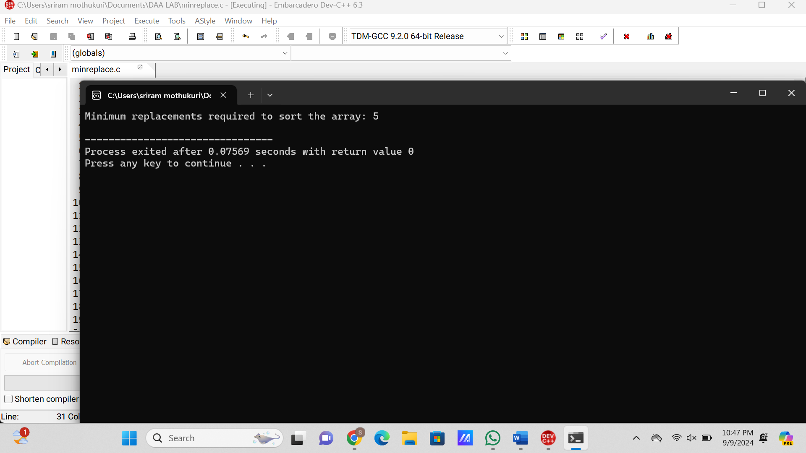

**COMPLEXITY ANALYSIS**

For the **minimum replacement to sort the array** algorithm, let’s analyze the time and space complexity.

**1. Time Complexity**

The time complexity depends on how many times the algorithm iterates through the array and performs calculations during each iteration:

* **Single Pass Through the Array**: The algorithm processes the array from right to left in a single loop. This loop runs once for each element, leading to a time complexity of O(n), where n is the number of elements in the array.
* **Constant-Time Operations Inside the Loop**: For each element, the program performs basic arithmetic operations such as division, comparison, and subtraction, which take constant time, O(1). These operations do not depend on the input size.

Thus, the overall **time complexity** is:

* **O(n)**, where n is the size of the array.

**2. Space Complexity**

The space complexity refers to how much additional memory is used by the algorithm apart from the input:

* **Constant Space**: The algorithm uses a few integer variables (replacements, lastElement, and numSplits), which do not depend on the size of the input array. These are all fixed storage, leading to a constant space complexity of O(1).
* **In-place Modifications**: The algorithm operates on the input array directly and does not allocate any additional data structures like arrays or lists, ensuring that no extra memory is required based on the input size.

Thus, the overall **space complexity** is:

* **O(1)**, meaning the algorithm uses constant space regardless of the size of the array.

**Summary:**

* **Time Complexity**: **O(n)** – The algorithm performs one pass through the array, with constant time operations inside the loop.
* **Space Complexity**: **O(1)** – Only a constant amount of additional space is used, independent of the input size.

**FUTURE SCOPE**

The **Minimum Replacement to Sort the Array** problem presents several opportunities for future exploration and improvements. Below are potential areas for expanding and enhancing this project:

1. **Optimization of Algorithms**:
   * While the current approach is efficient with a time complexity of O(n), further optimizations can be explored to reduce the number of operations for specific types of input, such as partially sorted arrays or arrays with specific patterns.
   * Advanced techniques such as **dynamic programming** or **greedy algorithms** can be investigated to potentially reduce the overall complexity for particular scenarios.
2. **Parallel Processing**:
   * With large datasets, parallelizing the process of calculating replacements could significantly speed up the algorithm. Implementing **multi-threaded or distributed computing** approaches could make the algorithm scalable for massive datasets.
3. **Handling Larger Data Types**:
   * In practical applications, handling extremely large numbers or working with **big data** sets may pose challenges. Optimizing the algorithm to handle such cases, possibly using specialized data structures, can increase its applicability.
4. **Application in Real-World Problems**:
   * This problem has potential real-world applications in areas like **resource allocation**, **scheduling**, and **load balancing**. Future work could focus on adapting this algorithm for specific domains such as **cloud computing** resource optimization, where elements represent tasks or resources, and efficient partitioning is critical.
5. **Extension to Multi-Dimensional Arrays**:
   * Extending the problem to multi-dimensional data structures (such as matrices or tensors) can open up new applications in fields like **machine learning**, **data mining**, and **scientific simulations**, where sorting and partitioning high-dimensional data efficiently is crucial.
6. **Exploration of Heuristic and Approximation Methods**:
   * In some cases, finding the exact minimum number of replacements might not be necessary, and **approximation algorithms** or **heuristic approaches** could provide faster, near-optimal solutions. This would be valuable for real-time systems where performance is prioritized over absolute accuracy.
7. **Comparative Study with Other Sorting Problems**:
   * Investigating how this problem compares with other **non-traditional sorting problems** (e.g., sorting with restricted operations) and conducting a **comparative analysis** of algorithms could yield insights for further refinement of sorting techniques in constrained environments.
8. **Integration with Machine Learning**:
   * Machine learning models could be developed to predict or assist in finding the optimal replacements based on historical data, improving performance in repetitive scenarios where patterns emerge over time.

By pursuing these future directions, the study of minimum replacement to sort an array can be expanded, leading to improvements in both theoretical understanding and practical applications across various domains.

### **CONCLUSION**

The **Minimum Replacement to Sort the Array** problem provides a unique and challenging variation of traditional sorting algorithms, focusing on minimizing the number of operations required to transform an unsorted array into non-decreasing order. This project successfully implemented an efficient solution, using an approach that traverses the array from right to left and reduces larger elements through minimal replacements, ensuring the array is sorted with the fewest operations possible.

Through the analysis of time and space complexity, the solution demonstrates its effectiveness with **O(n)** time complexity and **O(1)** space complexity, making it suitable for handling large datasets. This work also highlights the potential applications of the algorithm in areas like **resource partitioning**, **task scheduling**, and **load balancing**, where optimization under constraints is crucial.

The project opens the door to future research and potential improvements, including algorithm optimization, parallelization, and applications in real-world scenarios. Overall, the exploration of this problem contributes to the broader understanding of constrained sorting problems and optimization strategies in algorithm design.