BANKING ONBOARDING · KYC · KYB · AML · RISK

From Intent to Active Customer
One onboarding story, told twice: what the customer experiences, and what the bank does behind the scenes.
Part 1: Retail | Akash Sharma opens a savings account
Part 2: Commercial | Rahul Sharma opens a current account for ABC Solutions Pvt. Ltd.

All persons, entities and details in this scenario are fictional.

How to read this document
Each stage follows one pattern: the persona acts, the bank or system responds, a banking concept is applied, and a result follows. Financial terms are introduced inside the story, at the point where they are needed.
- Customer view: what the customer is trying to do, provides and experiences.
- Bank view: the KYC, KYB, CDD, AML, PEP, sanctions, risk, decisioning and human review behind it.

Part 1: Retail Customer Onboarding

Akash wants to open a savings account
“I want to open a savings account, ideally from my phone.”
Persona | Akash Sharma, 24, Software Engineer
Customer type | Retail / Individual
Status | NTB: New-to-Bank (no existing relationship with the bank)
Goal | Open a digital savings account

The journey in eleven steps: Intent, Registration, Customer data capture, KYC, Document verification, Identity and liveness, AML / PEP / Sanctions, Risk assessment, Decision, Activation, Ongoing KYC and monitoring.

Retail flow chart: Akash in pictures
The next two pages show the same journey as a flow chart in everyday words. Each box has a plain-English line and a coloured line naming the banking term.
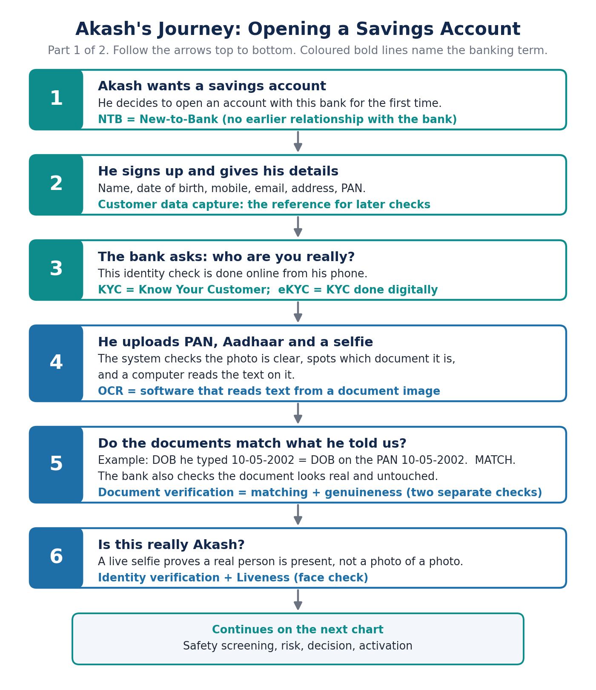
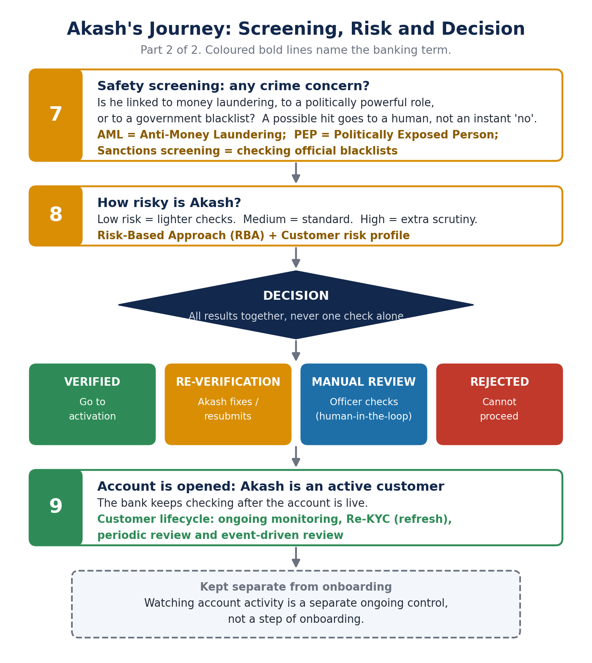

1. Akash starts the journey
Akash registers and tells the bank who he is: name, date of birth, mobile, email, address and PAN or basic details. The bank captures this core information and creates an onboarding application. What Akash declares here becomes the reference point for every later comparison.
Who / what | What happens
Akash does | Registers and enters personal details
Bank / system | Captures customer data and creates the onboarding application
Concept | NTB (New-to-Bank). ETB (Existing-to-Bank) customers are not an automatic skip of KYC.
Result | Declared data becomes the reference for verification

Note: “CDE”, “TV” and “NTV” are not defined in the source decks, so they are not expanded here. They are marked as terms to be confirmed with the mentor.

2. Akash shares his proof
Akash submits his PAN, Aadhaar and a selfie. The system collects the files, checks their quality, identifies the document type so the right checks apply, and reads the details using OCR (optical character recognition). A blurry or dark upload simply prompts Akash to upload again.
Akash entered DOB | 10-05-2002
PAN / Aadhaar shows | 10-05-2002
Result | MATCH

3. Can the bank trust the information?
Three separate questions are asked, followed by a live check.
- Information matching: does the document match what Akash declared?
- Document authenticity: does it look genuine and acceptable, with nothing altered?
- Identity verification: can the identity be linked to the person applying?
Matching and genuineness are separate: a matching document can still be suspicious. Akash then takes a live selfie (liveness / face verification, part of eKYC). The system checks that a real person is present and that the face result is acceptable. A pass lets him continue; failure or doubt leads to retry, re-verification or review.

4. What is Akash’s risk?
The bank screens Akash for AML (money-laundering concern), PEP (politically exposed person) and sanctions matches. Clear results continue. A possible match goes to a human reviewer; it is not proof of wrongdoing. The results combine into a customer risk profile.
Under the Risk-Based Approach (RBA), not every customer gets the same scrutiny. The depth of checks follows the risk profile.
Risk | What it means
LOW | Simple checks, minimum paperwork
MEDIUM | Standard checks, regular reviews
HIGH | Extra scrutiny, closer watch

5. The decision
The final decision rests on the combined results of verification, screening and risk assessment, never on a single check.
Outcome | What happens next
VERIFIED | Continue to activation
RE-VERIFICATION | Akash corrects or resubmits information
MANUAL REVIEW | A KYC / compliance officer investigates (human-in-the-loop) and records the reason
REJECTED | The application cannot proceed

6. Akash becomes an active customer
KYC is complete, the application is approved, the account is activated and Akash is an active customer. KYC does not stop there. Across the customer lifecycle the bank continues ongoing monitoring, Re-KYC, periodic review and event-driven review (for example changed details or expired documents).
Re-KYC frequency follows risk: High every 2 years, Medium every 8, Low every 10. This is taken from the retail source deck, which attributes it to RBI KYC rules; confirm with the compliance team.

Part 2: Commercial Customer Onboarding

Rahul is not onboarding just himself
Rahul is onboarding a legal entity.
Persona | Rahul Sharma, Founder & Director
Customer | ABC Solutions Pvt. Ltd., Technology Services
Status | NTB: New-to-Bank
Goal | Open a current account
Supporting people | Priya Mehta (Authorized Signatory); KYC officer on the bank side

Why commercial onboarding is different
 | Retail | Commercial
Customer | Individual | Legal entity
Verification | KYC | KYC + KYB + UBO + risk
Typical evidence | PAN / Aadhaar / identity documents | Business registration, tax documents, relevant individuals
Decision on | Individual risk | Entity + ownership + control + risk

The complexity comes from the bank needing to understand both the business and the people behind it.

Commercial flow charts: Rahul and ABC in pictures
The next pages show the commercial journey as three flow charts in everyday words, with the banking terms in colour.
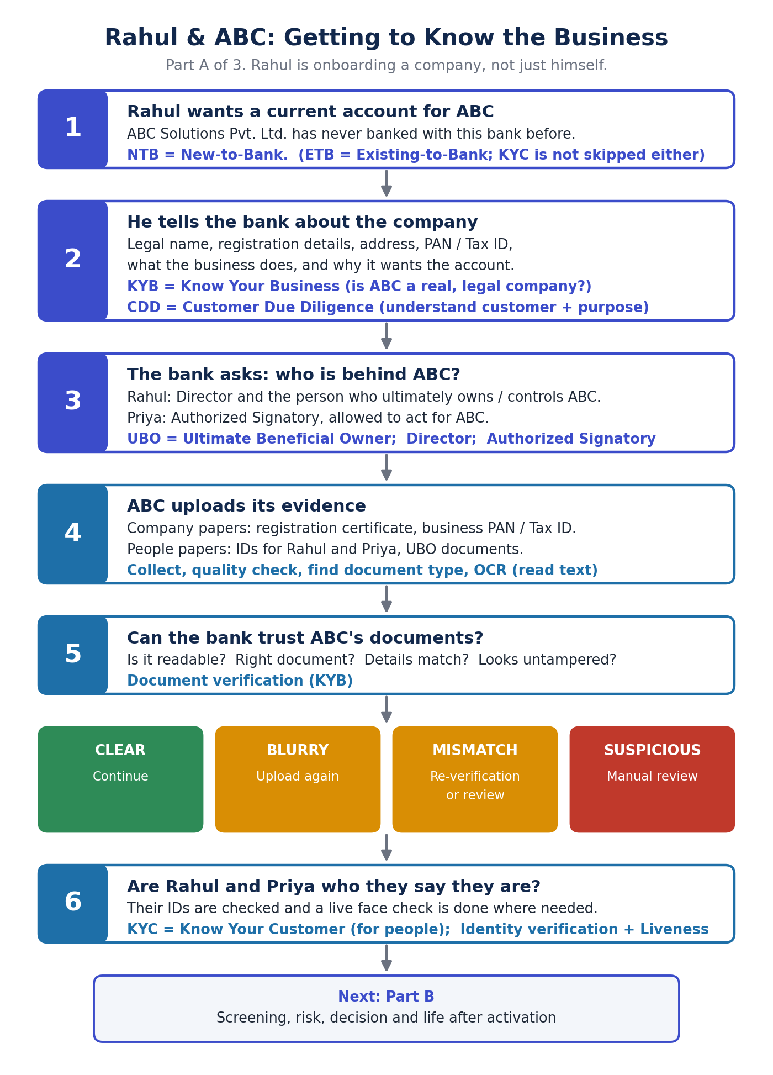
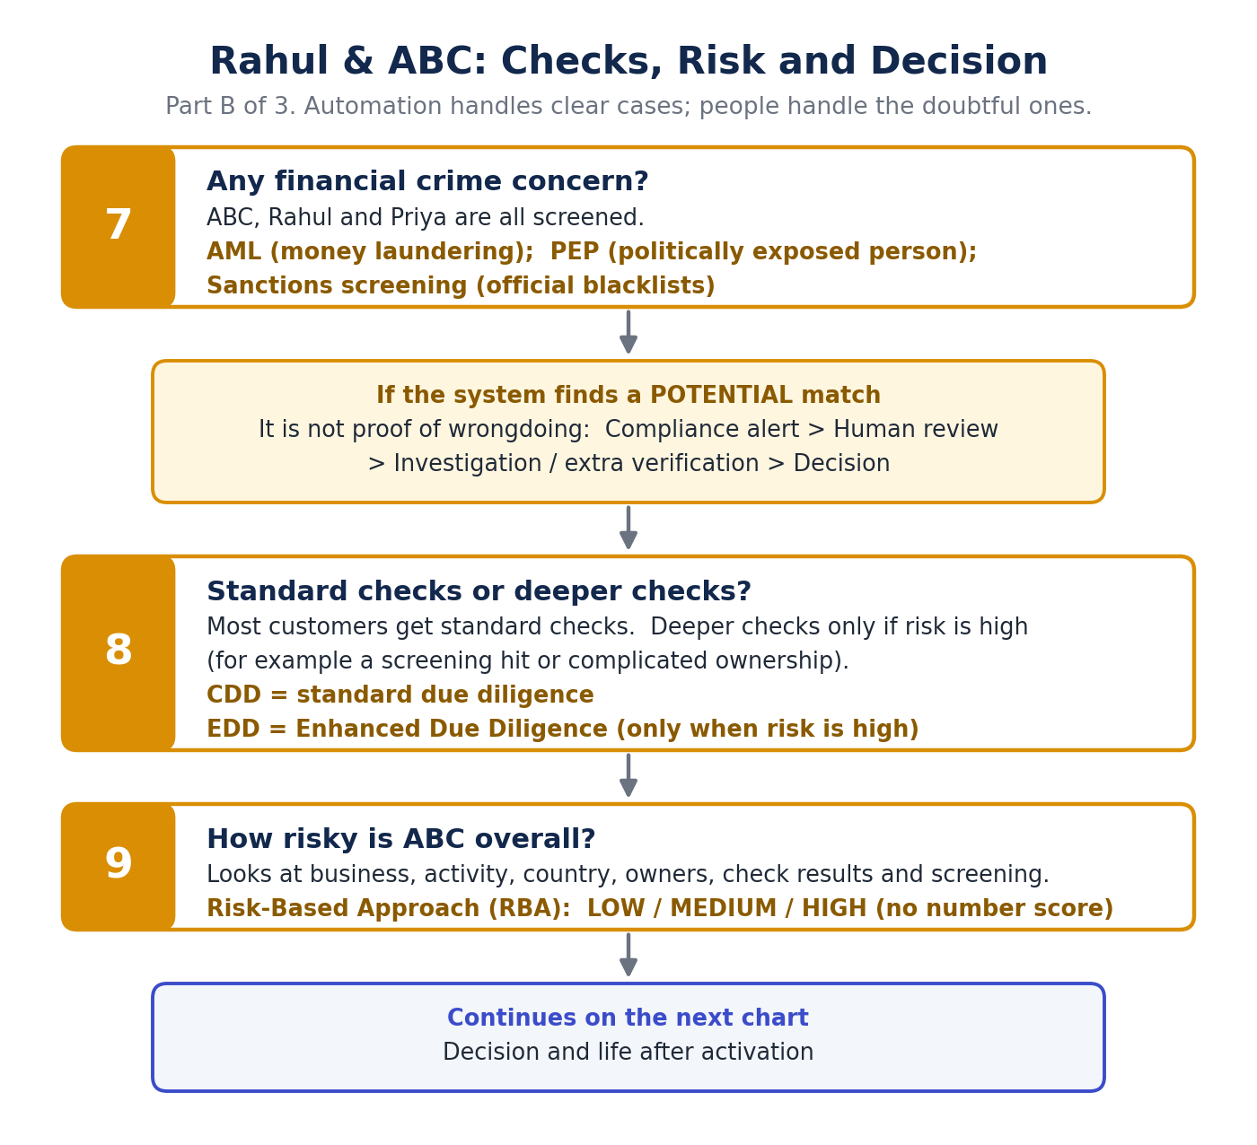
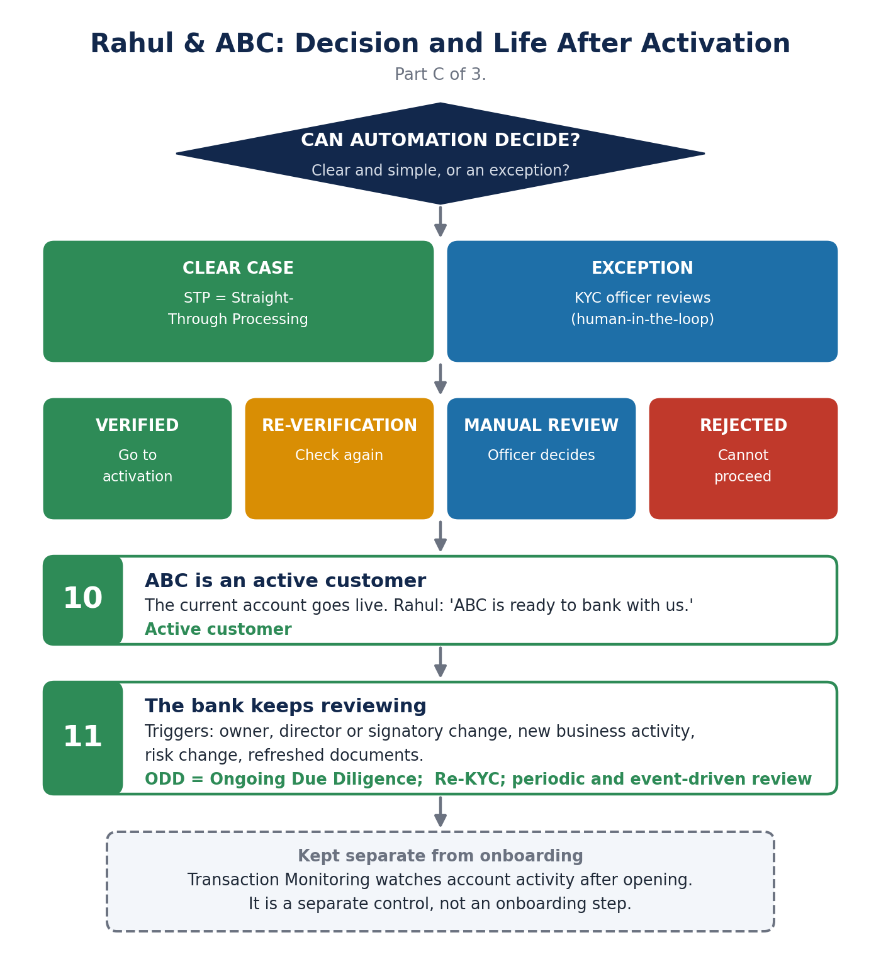

1. Rahul tells the bank about ABC
Rahul provides ABC’s legal business name, registration details, business address, PAN / Tax ID, nature of business and the purpose of the relationship.
- KYB (Know Your Business): KYC verifies the people; KYB verifies and understands the business entity.
- CDD (Customer Due Diligence): helps the bank understand who the customer is and the nature and purpose of the relationship.
What Rahul declares becomes the reference for later document checks.

2. Who is behind ABC?
Person | Role
Rahul Sharma | Director and UBO (Ultimate Beneficial Owner): identified as the person who ultimately owns or controls ABC
Priya Mehta | Authorized Signatory: permitted to act on behalf of ABC

Rahul holds two roles but is one person, verified once. The UBO matters because it establishes ownership and control, shows whom the bank must screen for AML (not only the company), and can influence the risk assessment.

3. ABC provides its evidence
- Business documents: Business Registration Certificate, Business PAN / Tax ID, relevant company documents.
- Individual documents: Rahul’s identification, Priya’s identification, UBO documentation.
The system collects the documents, checks quality, identifies type, extracts data (OCR) and validates. From the Business Registration Certificate it reads the business name, registration number, address and tax ID.

4. Can the bank verify ABC?
Four questions are asked of each document: is it readable, is it the correct document, do the details match, and does it look acceptable and untampered?
Result | Next step
CLEAR | Continue
BLURRY | Re-upload
MISMATCH | Re-verification / review
SUSPICIOUS | Manual review

5. Can the bank verify the people?
The bank must verify not only ABC, but also the relevant people connected to it: Rahul (Director + UBO) and Priya (Authorized Signatory). This uses identity verification, plus liveness / face verification where applicable. Possible outcomes are PASS, RETRY, RE-VERIFICATION or HUMAN REVIEW. Human-in-the-loop applies only where automation cannot safely conclude, such as repeated failure or unresolved doubt.

6. Is there a financial crime concern?
ABC, Rahul and Priya are all screened for AML, PEP and sanctions. A potential match is not automatically proof of wrongdoing. The path is:
Potential match → Compliance alert → Human review → Investigation / additional verification → Decision
The case is reviewed, not automatically rejected.

7. CDD or EDD?
- CDD (Customer Due Diligence): standard due diligence for a customer of acceptable risk.
- EDD (Enhanced Due Diligence): additional information and investigation where risk is elevated, for example a screening hit, complex ownership or high-risk activity.
EDD is risk-triggered. It does not apply to every customer.

8. Customer risk profile
Under the Risk-Based Approach, the bank considers business profile, business activity, geography, ownership / UBO, verification results and AML / PEP / sanctions results. These produce a qualitative profile of LOW, MEDIUM or HIGH. No numerical score is used. The depth of controls follows the risk, and HIGH may lead to EDD.

9. When automation cannot decide
Clear, low-complexity cases move through standard automated processing (STP, Straight-Through Processing). A mismatch, screening hit, UBO complexity or elevated risk is an exception, routed to human review. This is human-in-the-loop: a KYC / compliance officer reviews customer information, documents, ownership / UBO, screening and risk, then approves, requests re-verification or rejects. Commercial onboarding is not fully automated.

10. Final decision
Check | Status
Business verification | PASS
Director verification | PASS
Signatory verification | PASS
UBO | IDENTIFIED
Documents | ACCEPTABLE
AML / PEP / Sanctions | CLEAR / RESOLVED
Risk profile | ACCEPTABLE
FINAL KYC / KYB DECISION | VERIFIED

Alternatives: RE-VERIFICATION, MANUAL REVIEW, REJECTED.

11. ABC becomes an active customer
KYC / KYB complete, approval, current account activation, active customer. Rahul: “ABC Solutions is now ready to operate its banking relationship.”

12. The relationship continues
After activation the bank performs Ongoing Due Diligence (ODD). Events that can trigger a review include ownership change, director change, signatory change, business activity change, risk profile change and document refresh. These lead to KYC refresh / Re-KYC, periodic review and event-driven review.
Transaction monitoring is a separate ongoing control that watches account activity. It is not an onboarding step and is not part of the onboarding decision.

Retail vs Commercial: Same Objective, Different Journey
 | Retail: Akash | Commercial: Rahul / ABC
Customer | Individual | Legal entity
Relationship | Personal banking | Business banking
Verification | KYC | KYC + KYB + UBO
Evidence | PAN / Aadhaar / selfie | Business documents + relevant individuals
Risk | Individual identity / AML risk | Entity + ownership + financial-crime risk
Journey | Fast, standardised, digital-first | More evidence, several stakeholders, possible human review

Good onboarding does not mean removing controls. It means applying the right controls to the right customer.

Plain-English key to every term
Term | In everyday words
NTB / ETB | New-to-Bank: first time with this bank / Existing-to-Bank: already a customer
KYC | Know Your Customer: checking who a person really is
eKYC | KYC done digitally, for example from a phone
KYB | Know Your Business: checking a company is real and legal, and what it does
OCR | Software that reads the text on an uploaded document
Document verification | Checking a document matches the details given and looks genuine
Identity verification | Linking the documents to the real person applying
Liveness | A live selfie check that a real person is present
UBO | Ultimate Beneficial Owner: the real person who ultimately owns or controls a company
AML | Anti-Money Laundering: the rules and checks that prevent and detect financial crime
PEP | Politically Exposed Person: someone in a prominent public position, screened with extra care
Sanctions screening | Checking names against official blacklists
CDD | Customer Due Diligence: understanding the customer and the purpose of the relationship
EDD | Enhanced Due Diligence: extra checks, only when risk is higher
RBA / risk profile | Risk-Based Approach: Low, Medium or High risk decides how deep the checks go
STP | Straight-Through Processing: clear cases pass automatically
Human-in-the-loop / manual review | A KYC or compliance officer decides when automation cannot safely do so
Exception handling / re-verification | Unclear cases are routed to a person, or the customer checks and resubmits
Re-KYC | Refreshing KYC information when due
ODD | Ongoing Due Diligence: keeping the customer profile current after activation
Customer lifecycle | Everything that happens after the account opens: monitoring, Re-KYC, periodic and event-driven review
Transaction Monitoring | A separate control that watches account activity after onboarding

Terms to be confirmed
CDE, TV and NTV are not defined in the uploaded material, so no expansion is given. Please confirm their intended meaning with the mentor before using them.

