# **ONC YouTube Channel Performance Analysis Report**

**Aadi Sriram Kumar**

**Data Analytics - Intern.**

**ONC**

**01-11-2024**

This report presents a comprehensive data-driven analysis of the ONC YouTube channel's performance. Based on recent data, **the analysis highlights trends in daily views, viewer retention, and click-through rate (CTR) performance.** The goal is to provide actionable insights to enhance the channel's engagement, optimize content strategy, and foster a loyal subscriber base.

## 1. Daily Views Trend by Video

The chart below illustrates the fluctuation of daily views over time for individual videos, showcasing the ebb and flow of viewer interest. Each line represents a unique video, highlighting how some videos attract attention rapidly while others maintain a more consistent engagement.

**Key Insights:**  
1. Videos that address trending topics, such as "Trump’s support GROWING among GEN Z says NEW POLL," show immediate high viewership spikes. However, these spikes often fade quickly as viewer interest in trending topics diminishes.  
2. Content that sustains viewership over a longer period could potentially build more loyalty and consistent engagement.

**Recommendation:**To sustain viewership, consider balancing trending topics with evergreen content to maintain consistent engagement across videos. Developing a series or follow-up content on high-interest topics may also keep audiences returning.

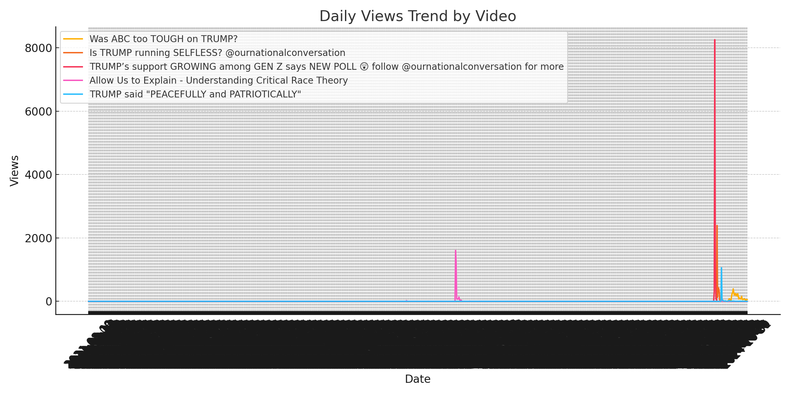

## 2. Views vs Watch Time by Video

The scatter plot below compares the number of views to total watch time per video. This visualization helps identify whether viewers are watching videos thoroughly or disengaging early. Videos with high watch time and moderate views often indicate stronger engagement from the audience.

**Key Insights:** - Most videos tend to have a trade-off between high viewership and watch time. High views with low watch time suggest that viewers may not be watching these videos entirely, indicating potential drop-off points.  
 - Videos with lower views but high watch time show that a smaller audience is more deeply engaged.

**Recommendation:**  
Consider adjusting the pacing and content structure to retain viewers. Engaging hooks at the start and covering main points quickly can improve retention. Replicating the style of high-retention videos could also boost watch time across the channel.

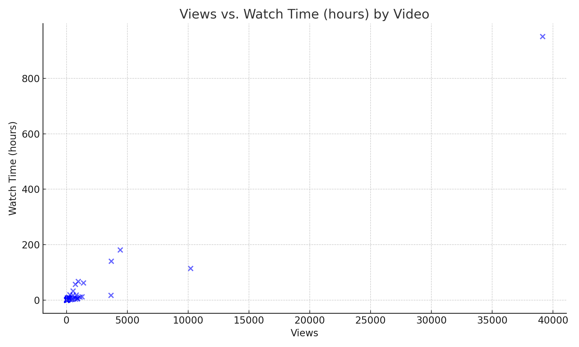

## 3. Click-Through Rate (CTR) by Video

The bar chart below shows the click-through rate (CTR) for individual videos, highlighting the effectiveness of thumbnails and titles in drawing viewer attention. Higher CTR generally indicates that the video’s title and thumbnail resonated with viewers and encouraged clicks.

Key Insights:  
 - Videos with a strong CTR suggest that the thumbnail and title were effective in capturing viewers’ interest. This emphasizes the importance of visual appeal and compelling language.  
 - Underperforming videos with low CTR may require better alignment between the thumbnail, title, and video content.

**Recommendation:**  
Utilize high-CTR videos as templates for future thumbnails and titles. Experiment with styles and use A/B testing to identify the most engaging formats. Incorporating clear messaging, questions, or bold statements could increase CTR.

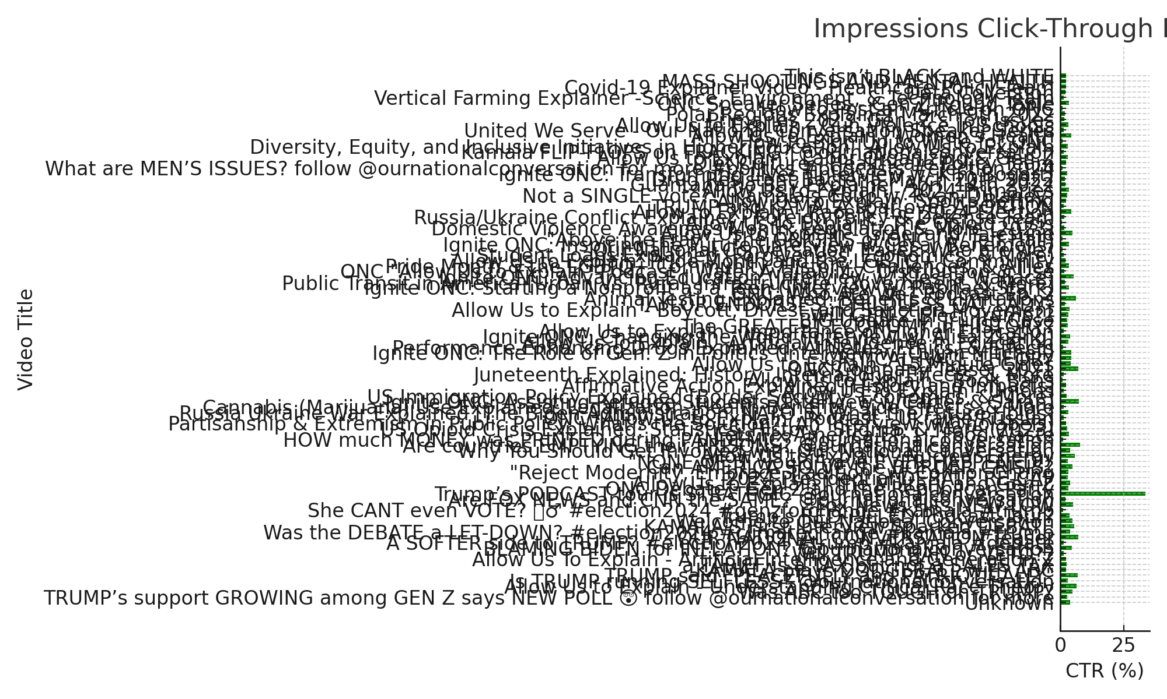

## Conclusion

The ONC YouTube channel exhibits strong potential, especially when leveraging trending topics. However, for sustained growth and engagement, a focus on optimizing content structure, improving retention, and experimenting with thumbnail and title formats is essential.

**Summary Recommendations:  
 1. Content Strategy Adjustments :** Create a balance between trending and evergreen content to maintain both quick engagement and sustained interest.  
**2. Optimize Viewer Retention :** Use engaging hooks, shorten intros, and replicate high-retention styles to keep viewers engaged throughout the videos.  
**3. A/B Testing for Thumbnails and Titles :** Identify high-performing styles and test variations to increase CTR and overall engagement.