**User Management Project Info**

Technologies:-

|  |  |
| --- | --- |
|  | **Technologies** |
| Front End | Angular, primeng, type scripts |
| Back End | Wer ApI, EF DB fist approach |
| Database | Sql Server |
| Logging | Log4net |
| Dependency Injection | Unity(IOC)- Constructor Injection |

**Project Architecture**

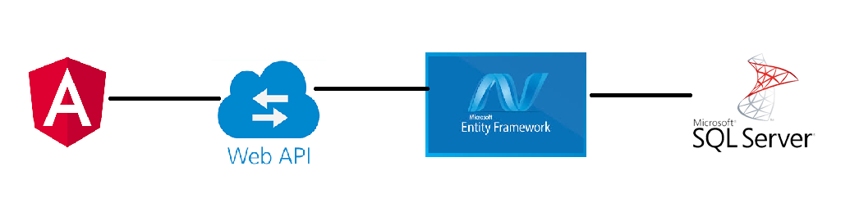

**Project Layers**



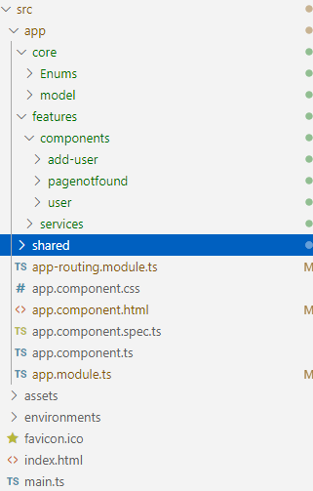

Back End: -

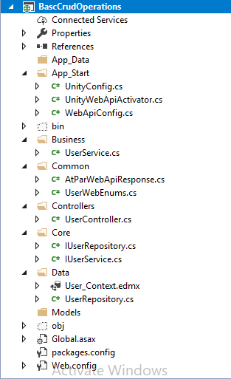

Flow : -

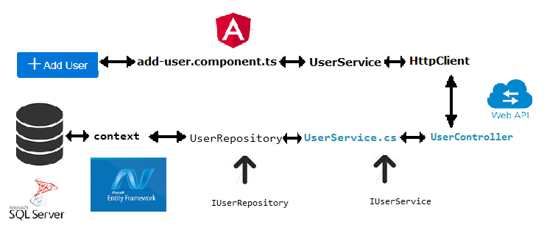

**Screenshots**

**Default –**

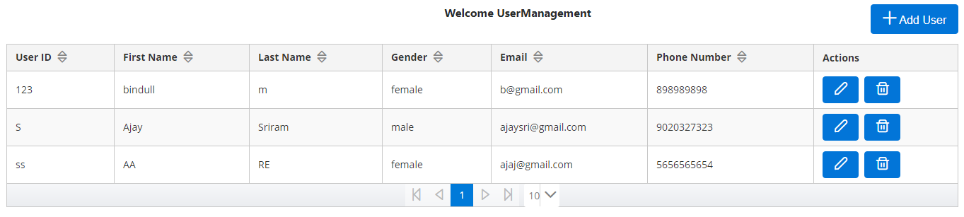

**Add User: -**

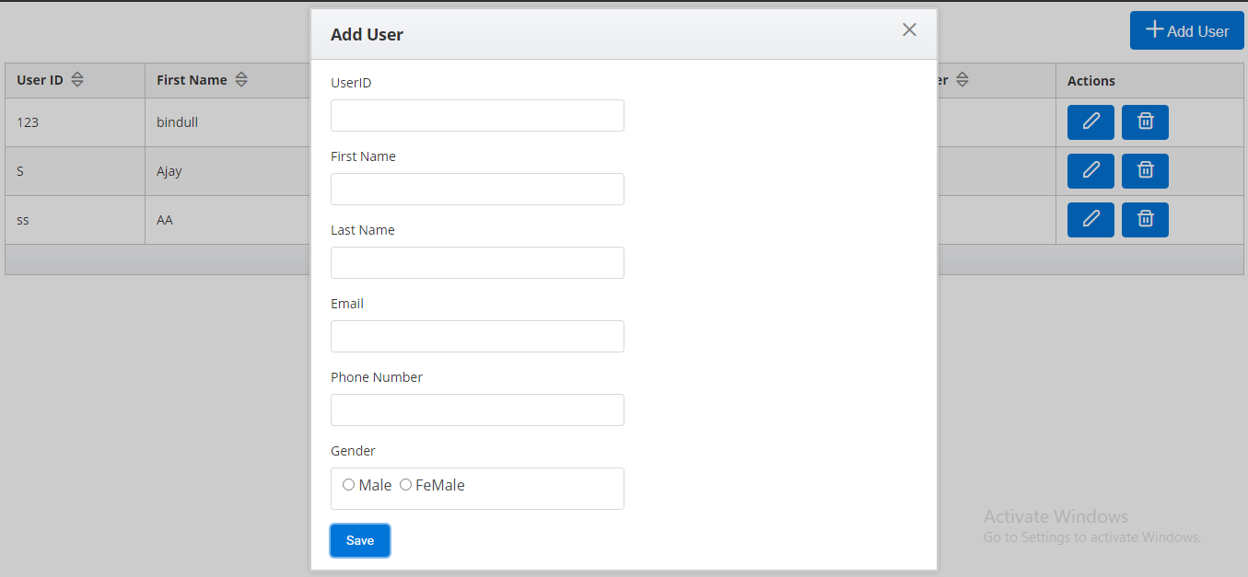

**Edit User: -**

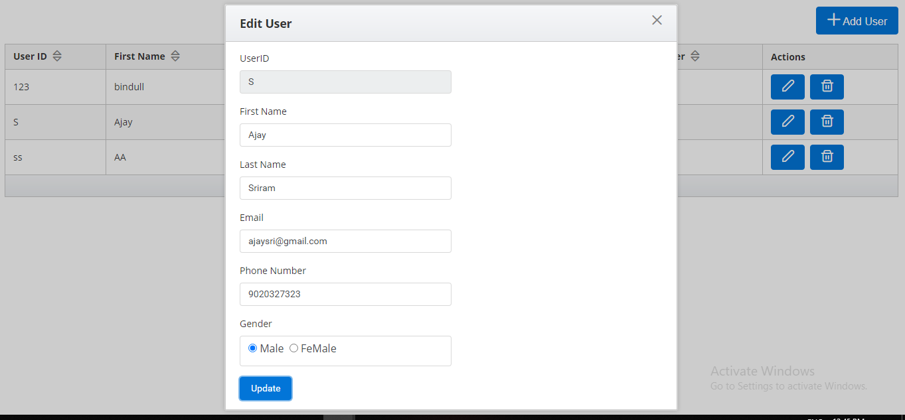

**Delete User: -**

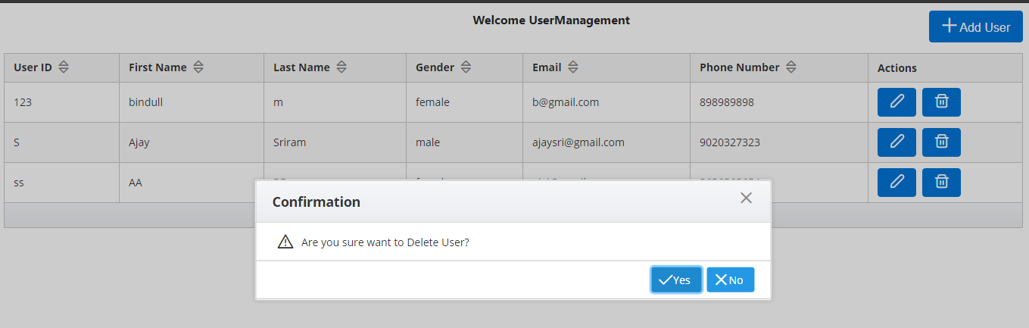

**Add Existing User: -**

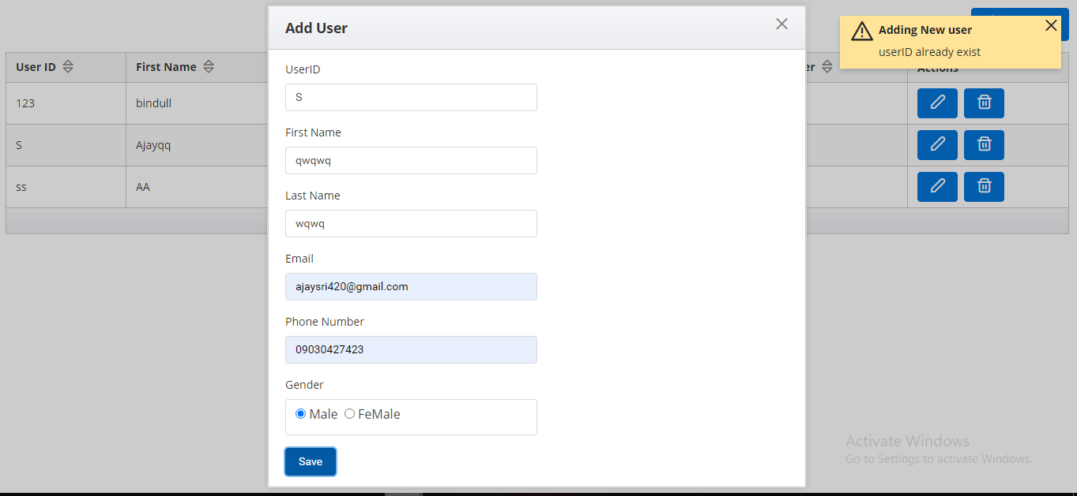

**Before Sorting On Gender: -**

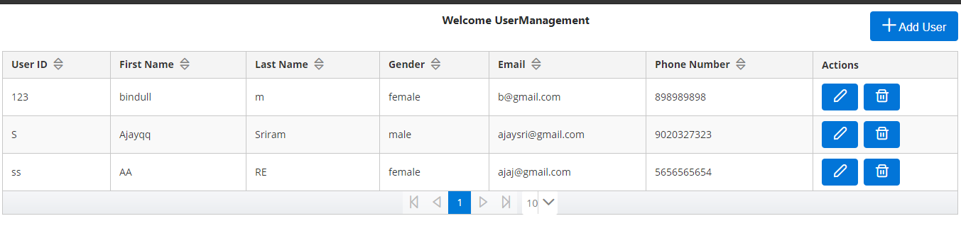

**After Sorting on gender: -**

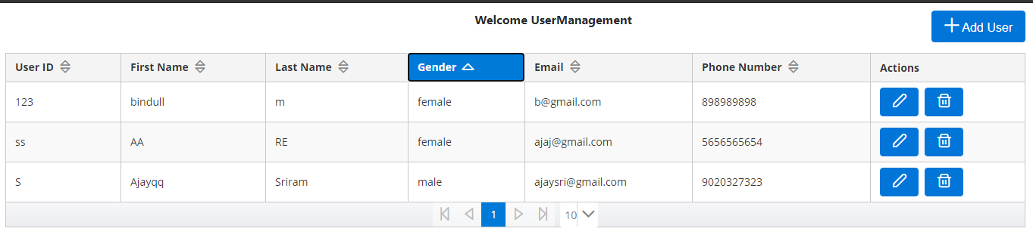

**Restricting wild card entries in routing: -**

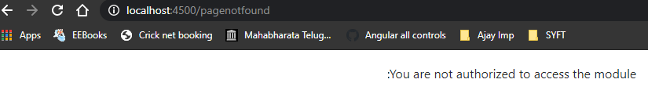

**Basic Validation: -**

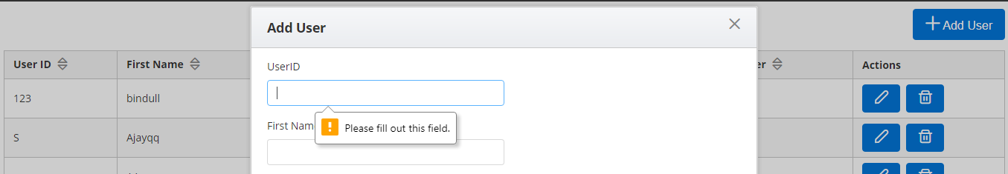

**Not Allowing Number on FirstName and LastName : -**

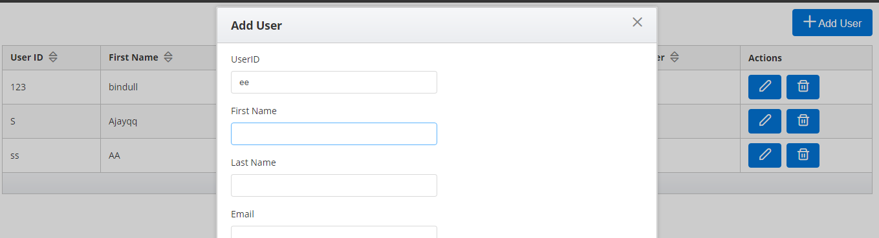

**Not Allowing alphabets on phone number: -**

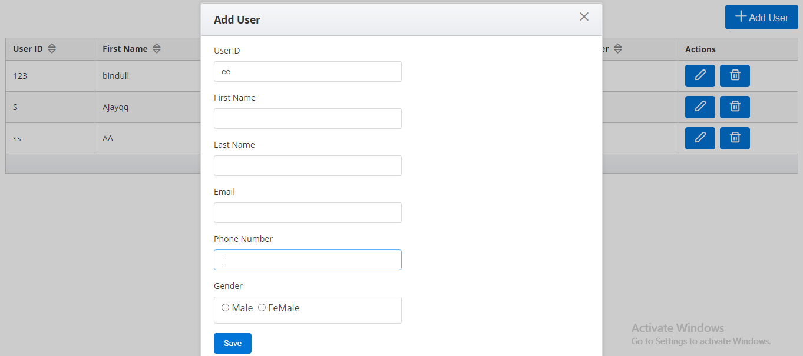

**DataBase Scripts: -**

**Tables : -**

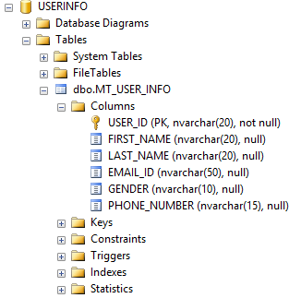

**Stored Prrocedures :-**

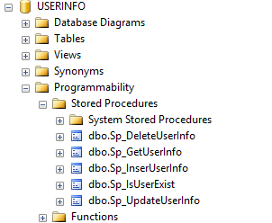

**Userlog Format/text: -**

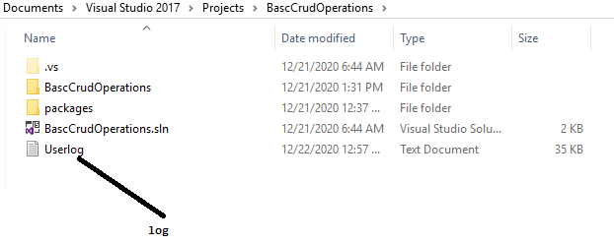

**Format/text in Userlog: -**

