**Name**: Sriram Elango

**CWID**: A20343102

**Class**: ITMD 510 Object-Oriented Application Development

**Final Project**:

Documentation

The user will first be directed to a Login screen. The Login screen will prompt for the user to enter his/her username and password.

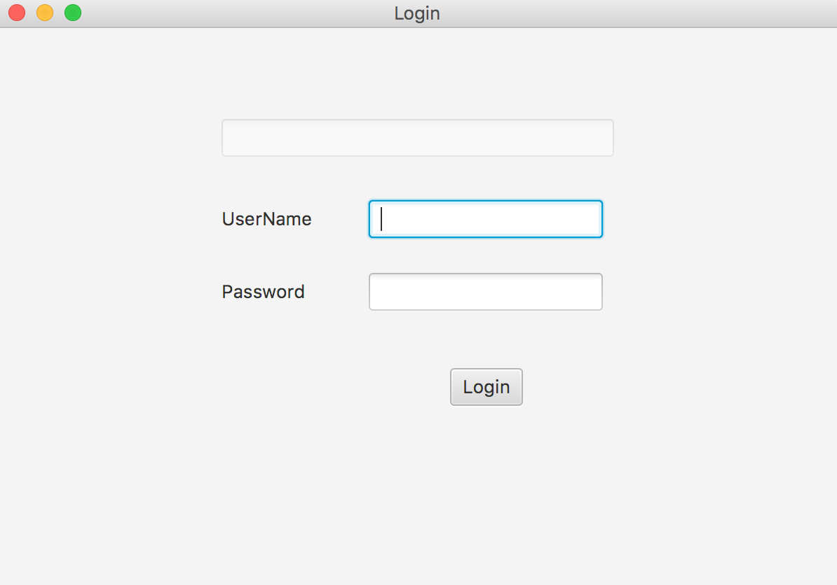

If the user enters the correct credentials, he will be taken to either a customer screen or an admin screen depending on his role as an admin or a customer, which is retrieved from the database. If the user enters the wrong username, it will display as below:

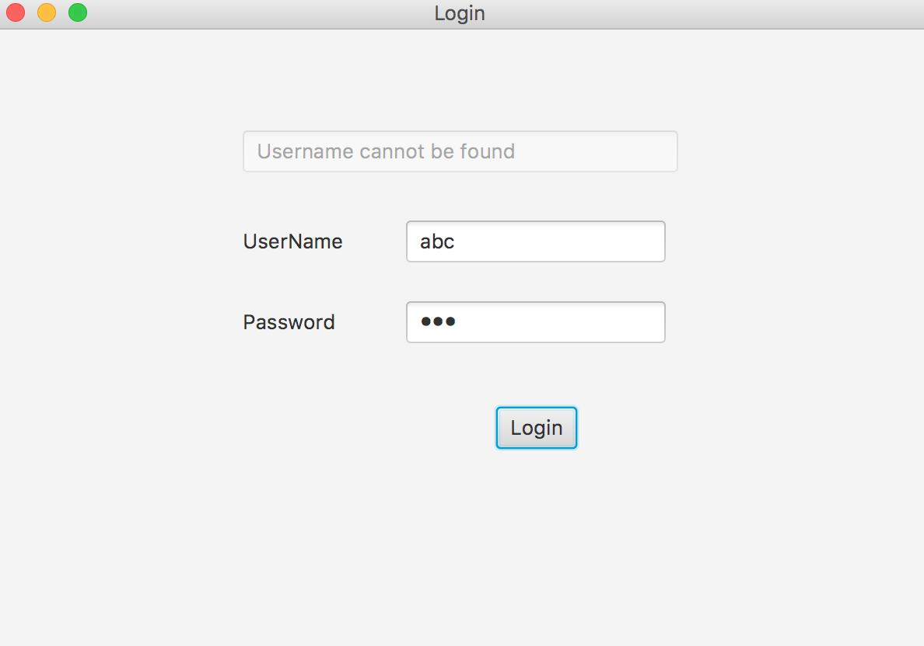

If the user enters the wrong password, it will display as below:

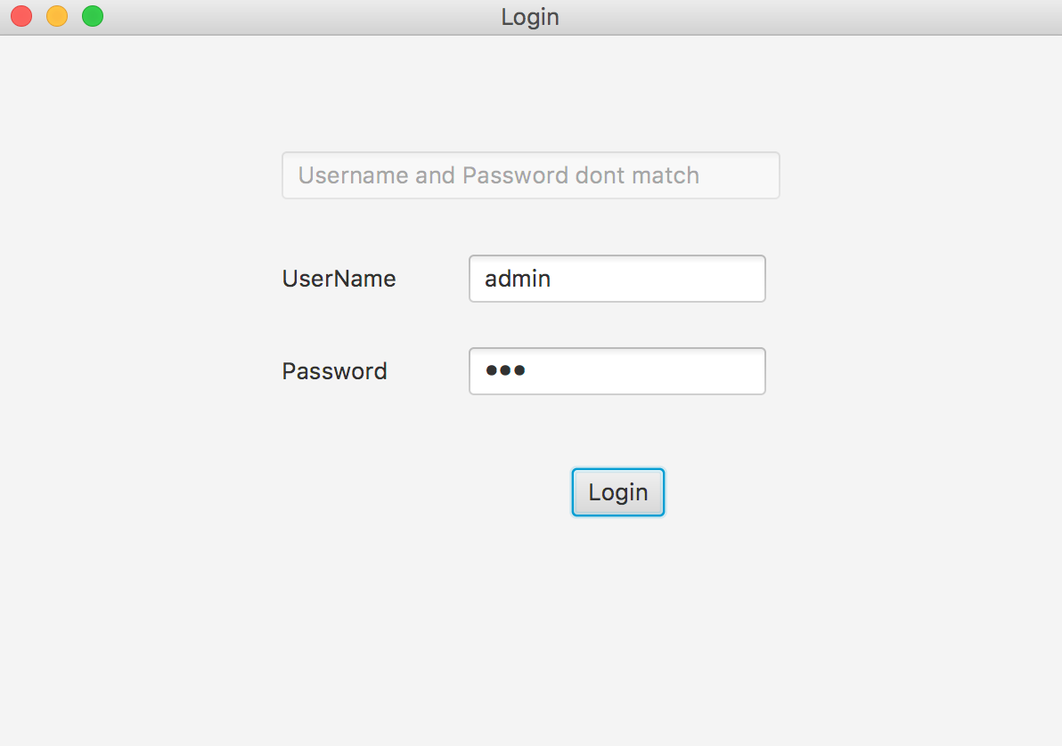

If the “admin” user enters the correct username and password, which is

UserName: admin

Password: admin

(Other usernames and passwords for admin users are “sriram” and “sriram”)

Then, it will display as below:

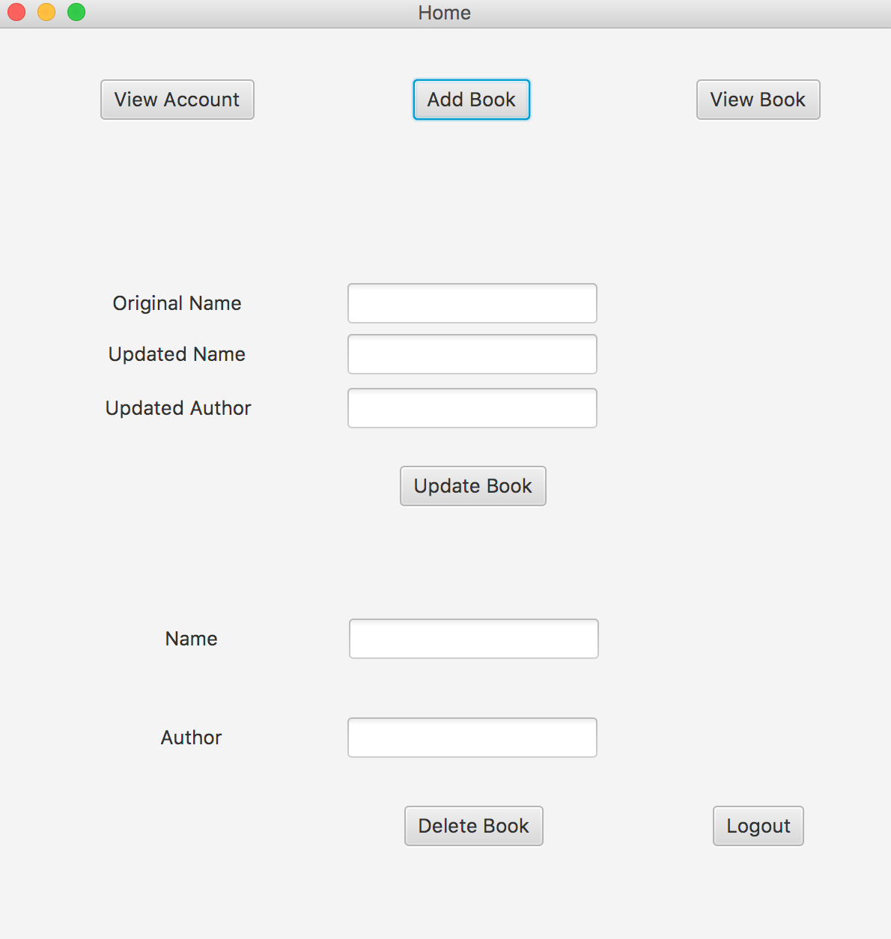

The admin user can now view accounts of all customers which are retrieved from the sriram_account table in database, add books, view books, update book, delete book and logout.

The “View Account” button will display a screen as below:

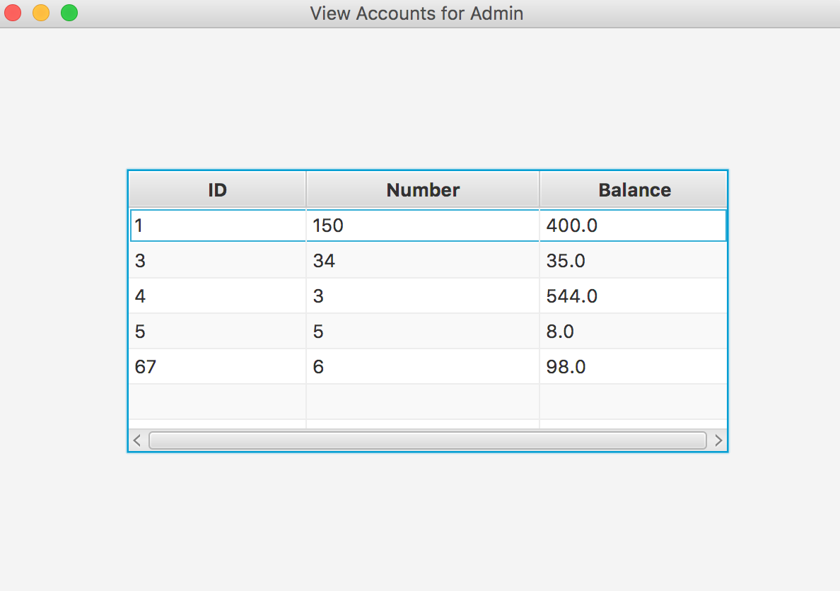

The “Add Book” button will display as below:

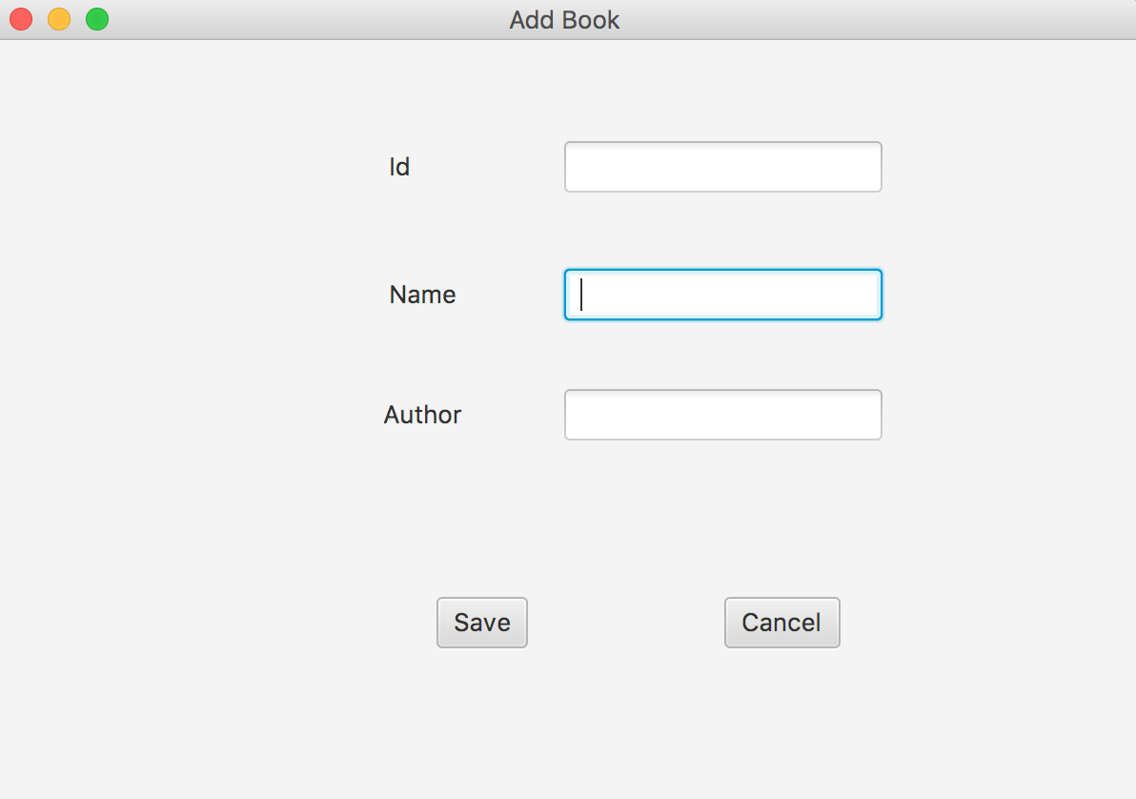

Now, if the admin user enters an Id, Name, and Author, it will be added to the sriram_book table in database and can be viewed.

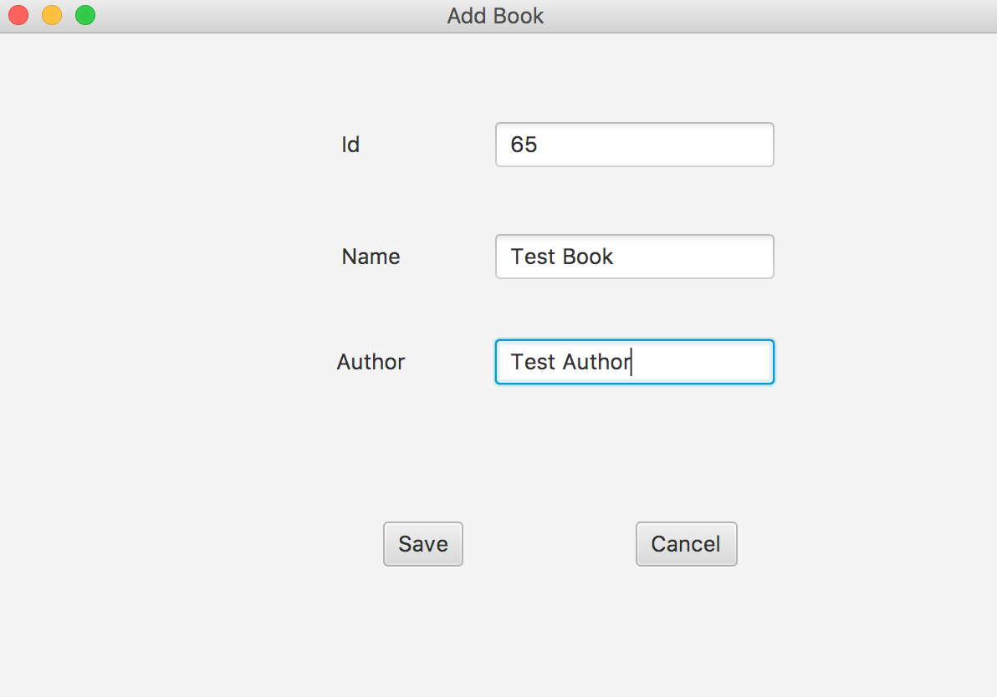

The “View Book” button will take all values from sriram_book table in database and display as below:

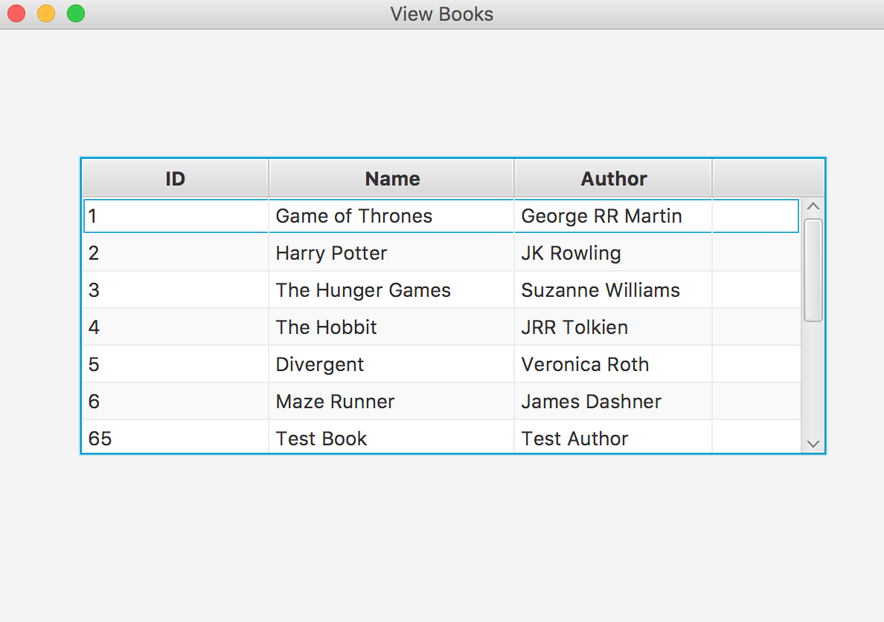

The admin user can also update a book as shown below:

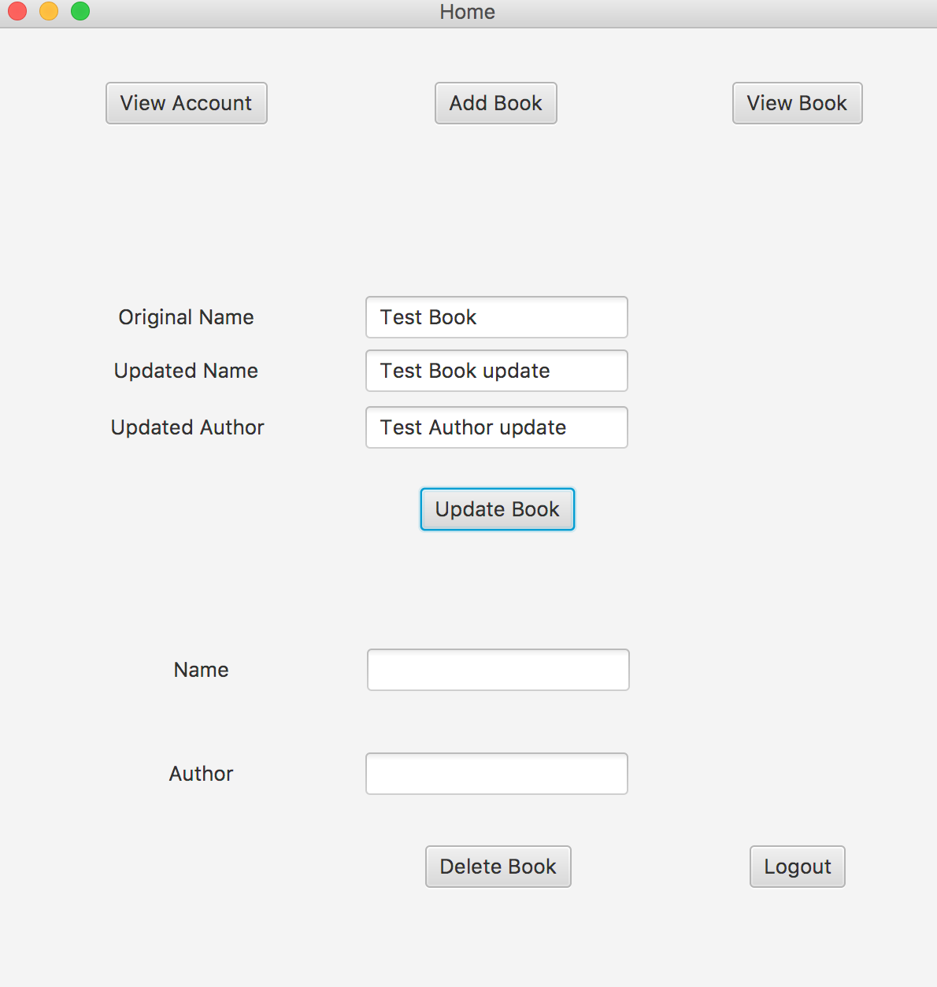

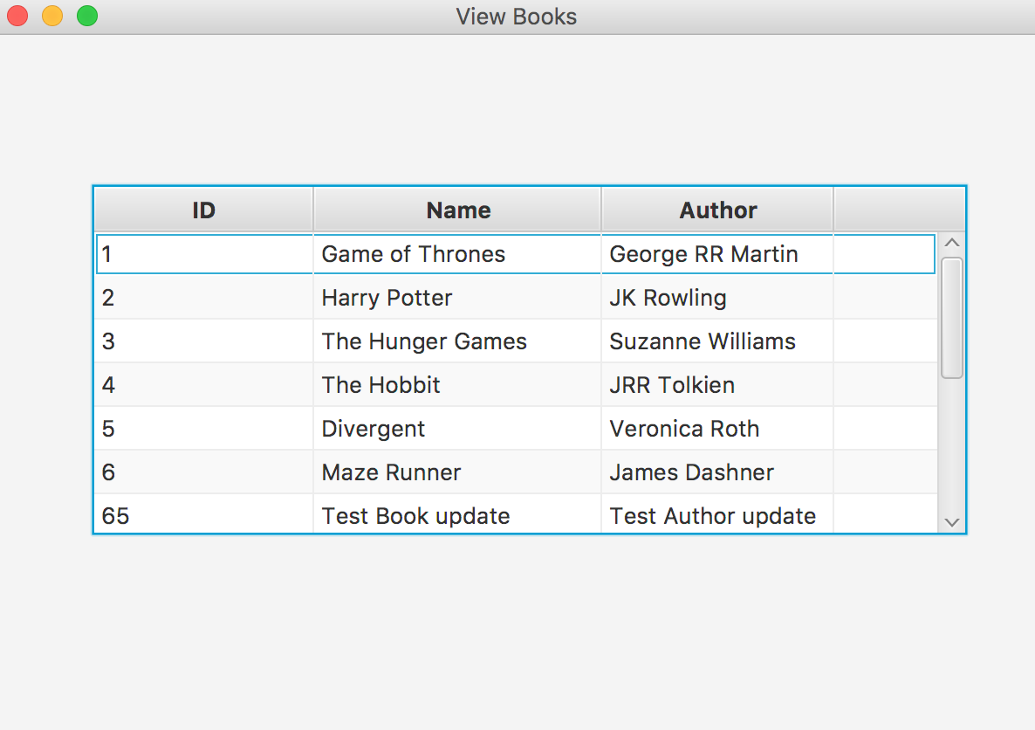

The admin user can delete a book as shown below:

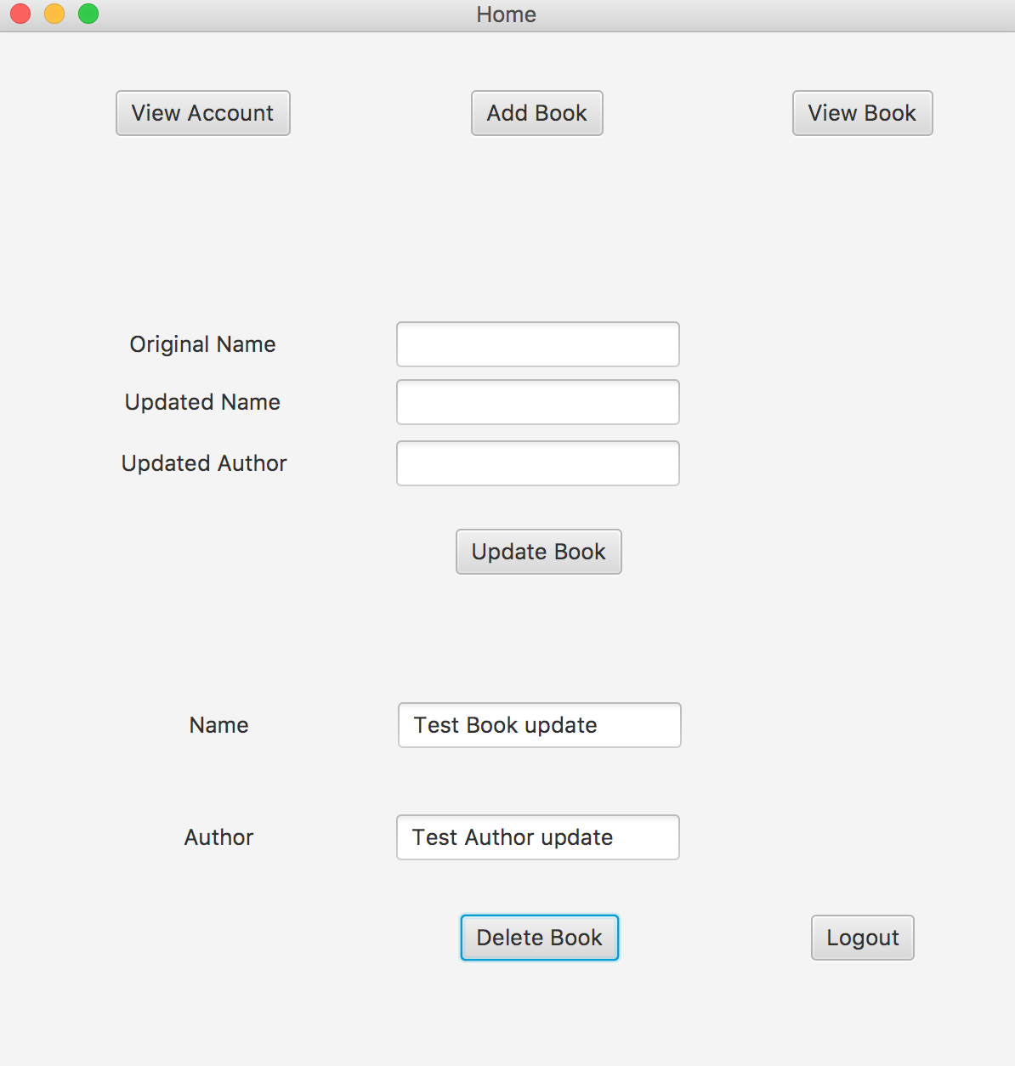

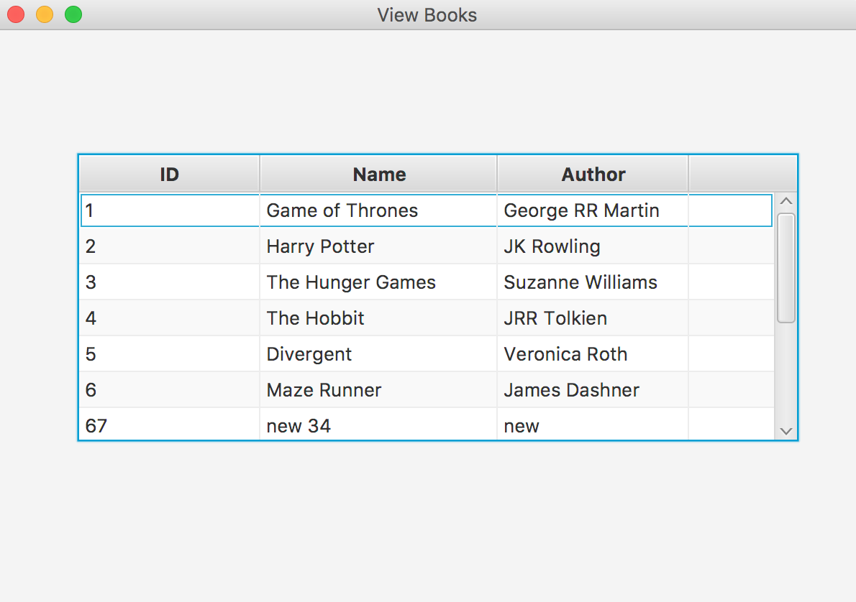

The “Logout” will logout the admin user and display the screen:

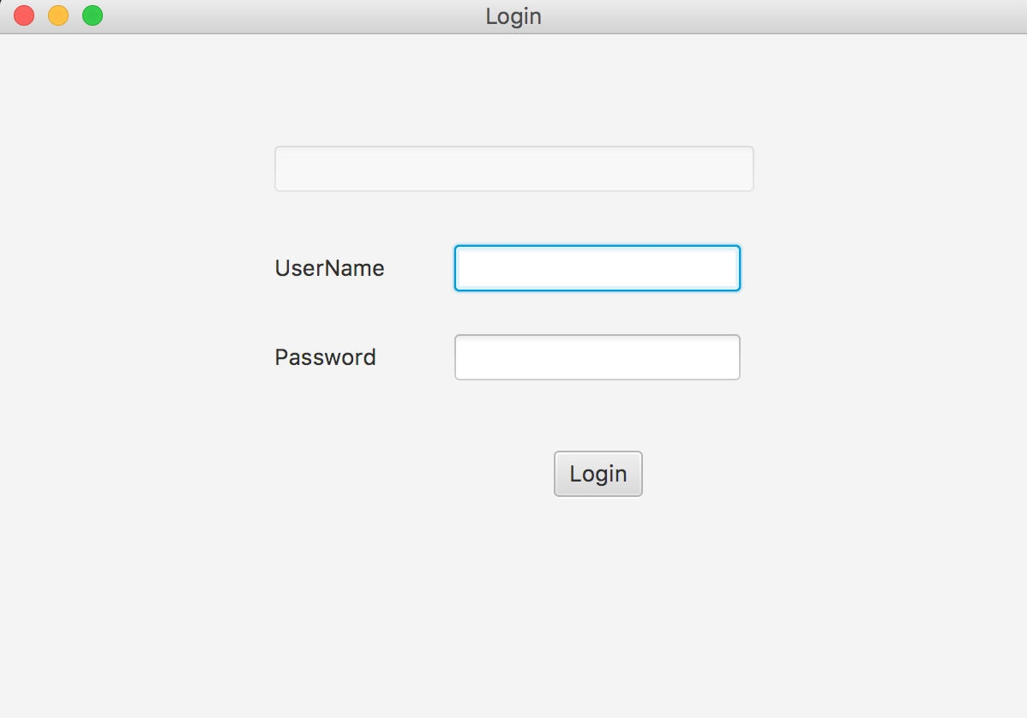

Now, if the “customer” user enters the correct username and password, which is

UserName: peter

Password: peter

(Other usernames and passwords for customer users are “john” and “john” and “customer” and “customer”)

Then, it will display as below:

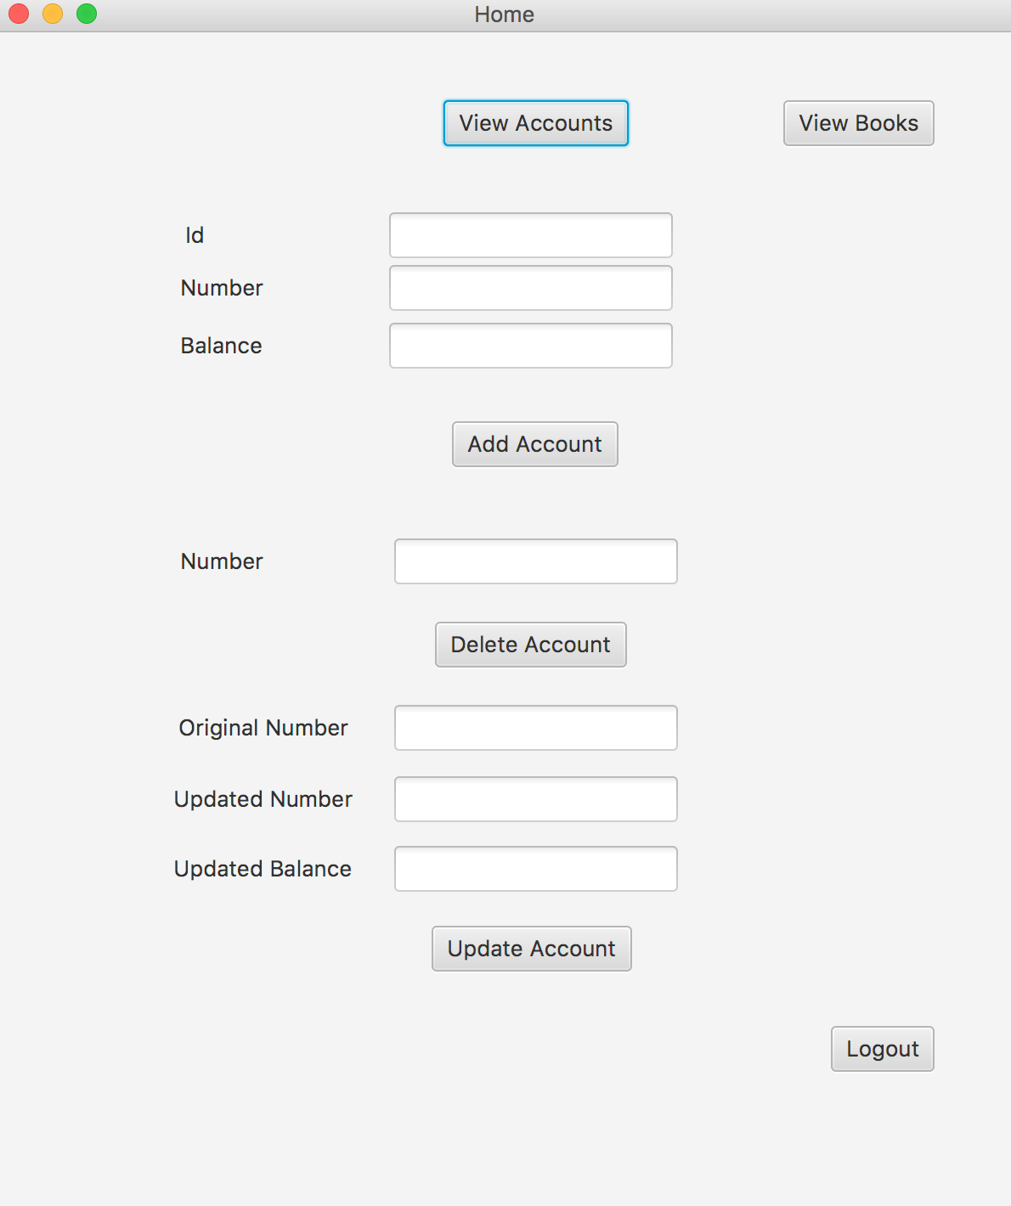

The “View Accounts” button will display the accounts of that particular user from sriram_account table in database with foreign key set to customer_Id rather than all the accounts like the button did in Admin user.

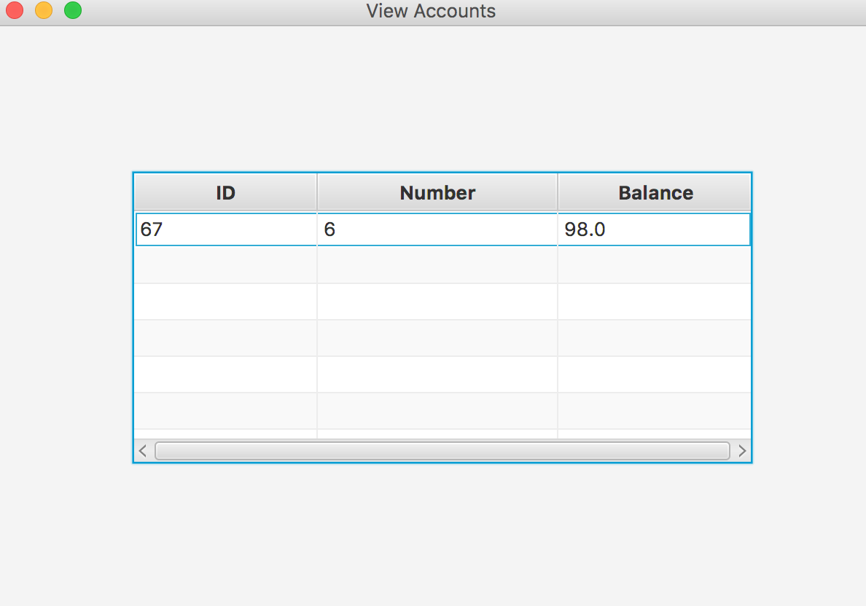

The “View Books” button will take all values from sriram_book table in database and display as below:

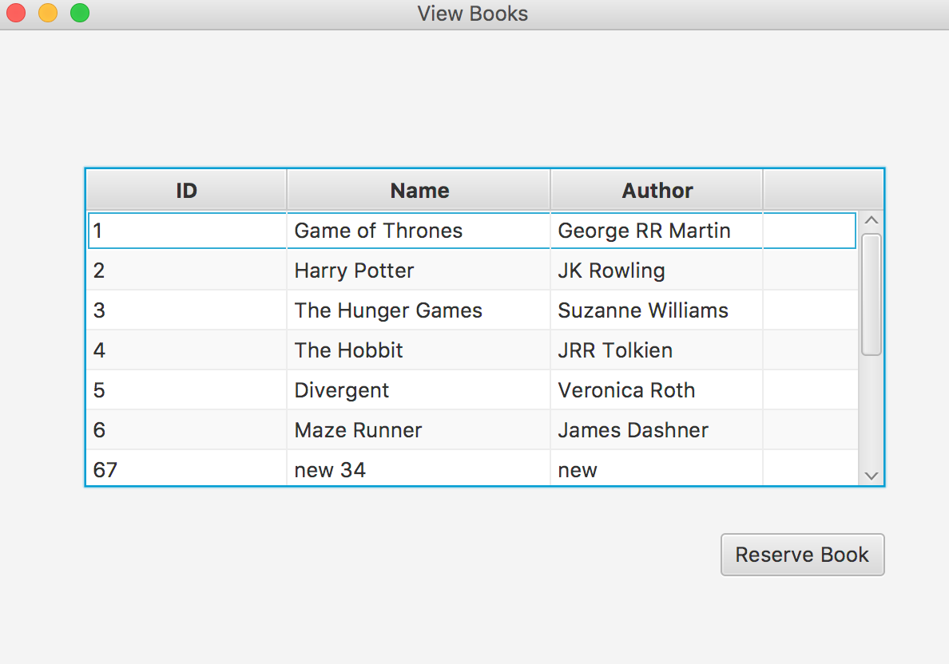

There is a difference between the view books screen of an admin user and this customer user. The customer user now can also reserve a book using the “Reserve Book” button by selecting a book from the table and clicking on the button.

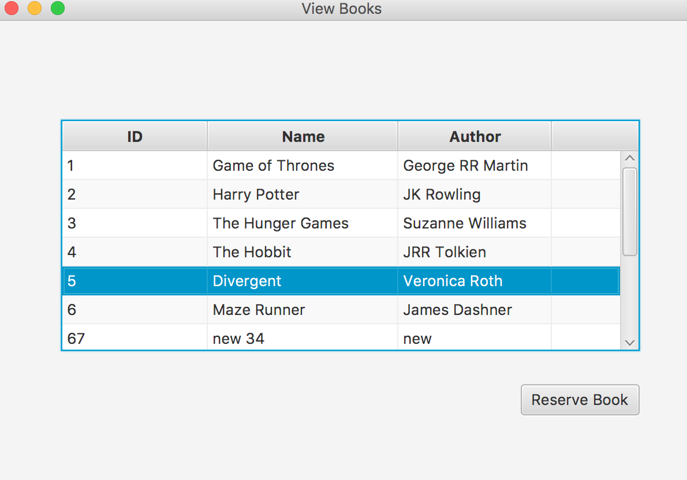

It will then add the book to the sriram_reservation table and display the message:

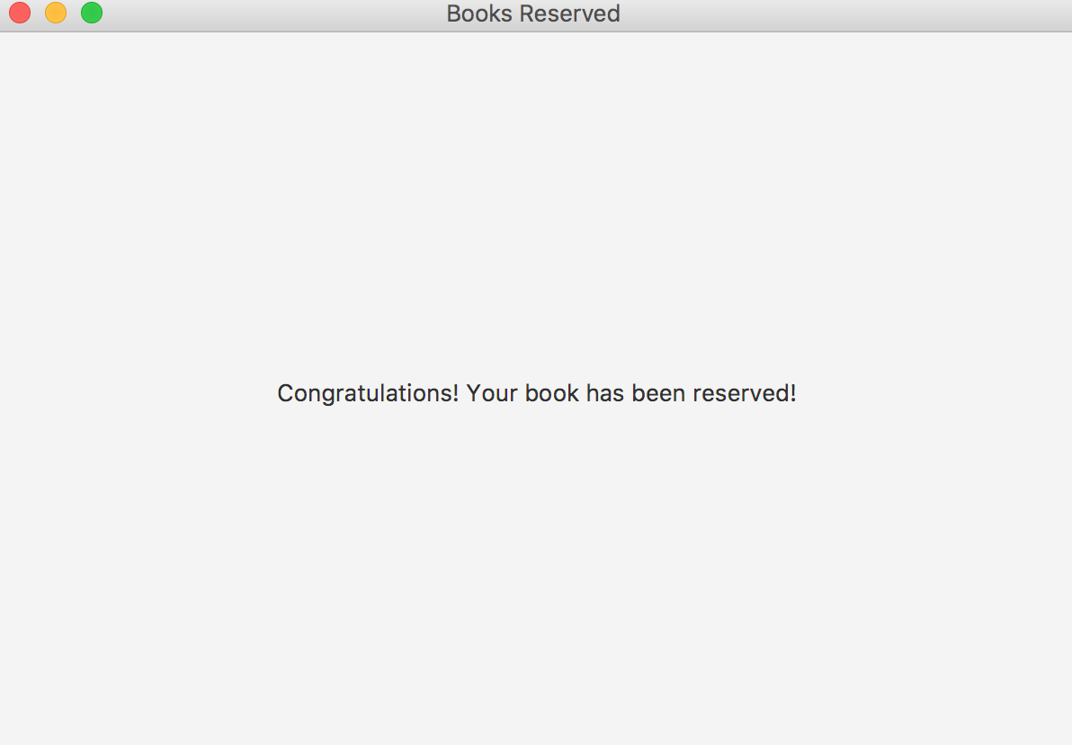

The customer user can also add an account in his accounts, delete an account or update his account as shown below:

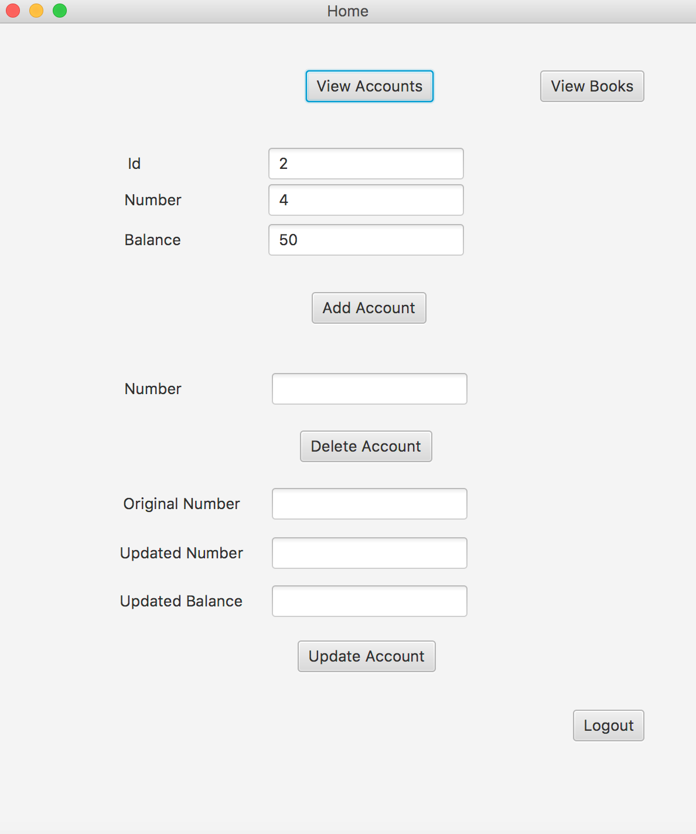

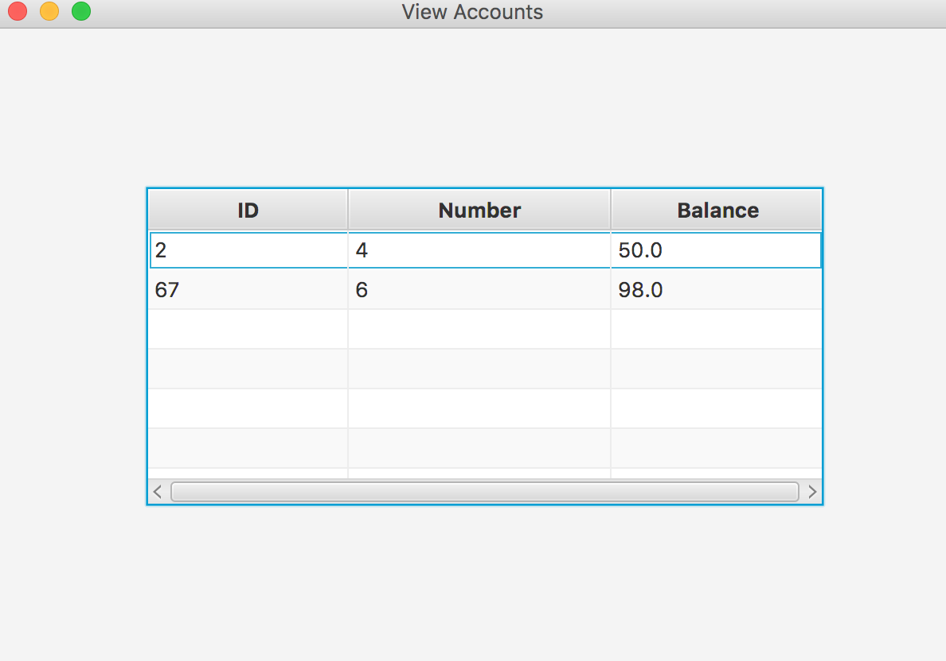

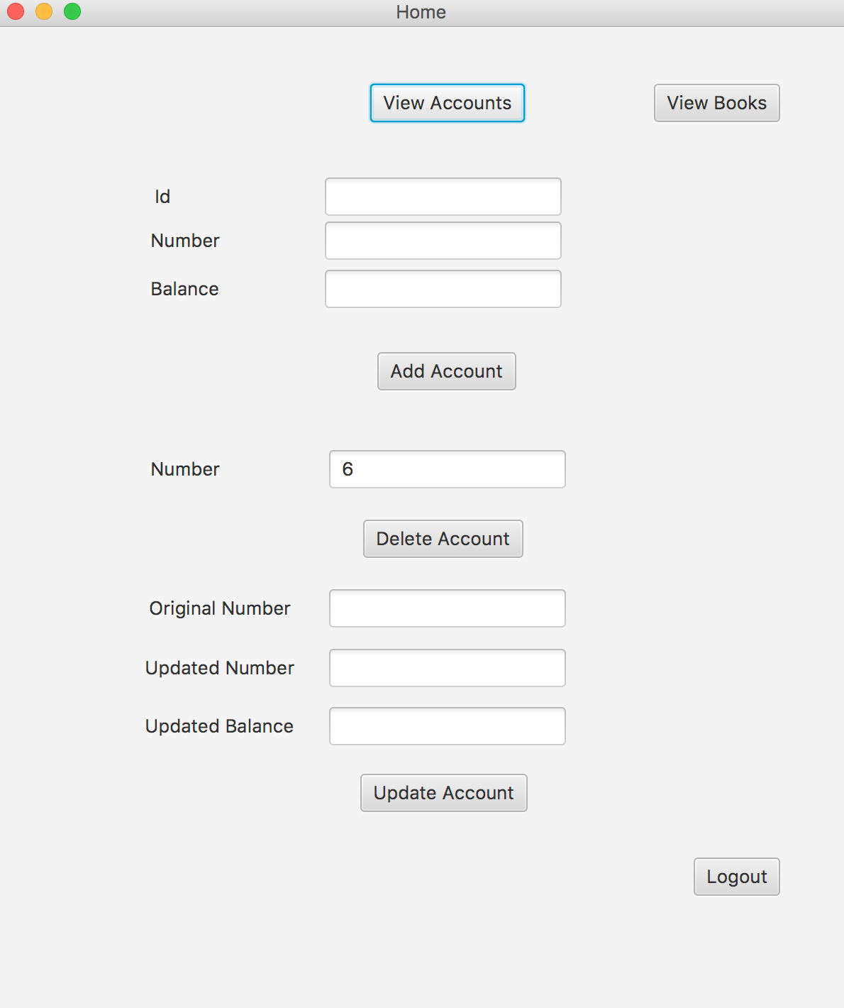

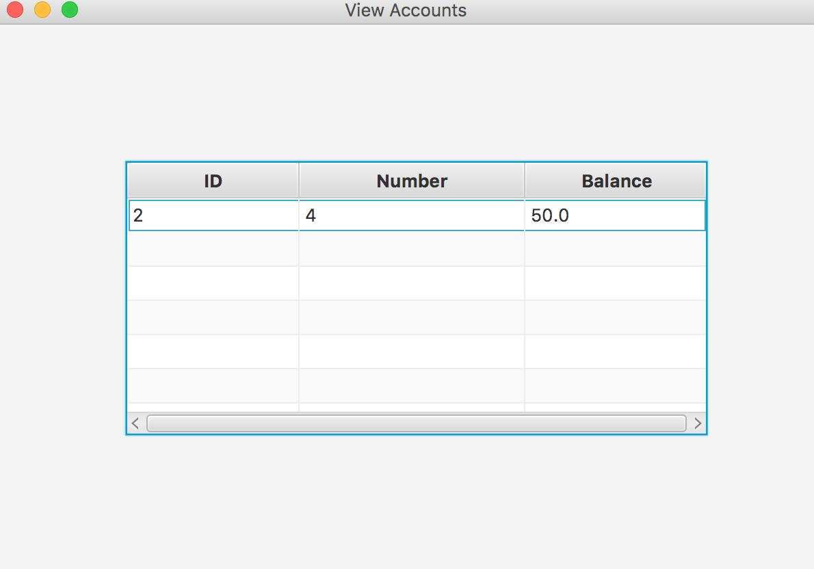

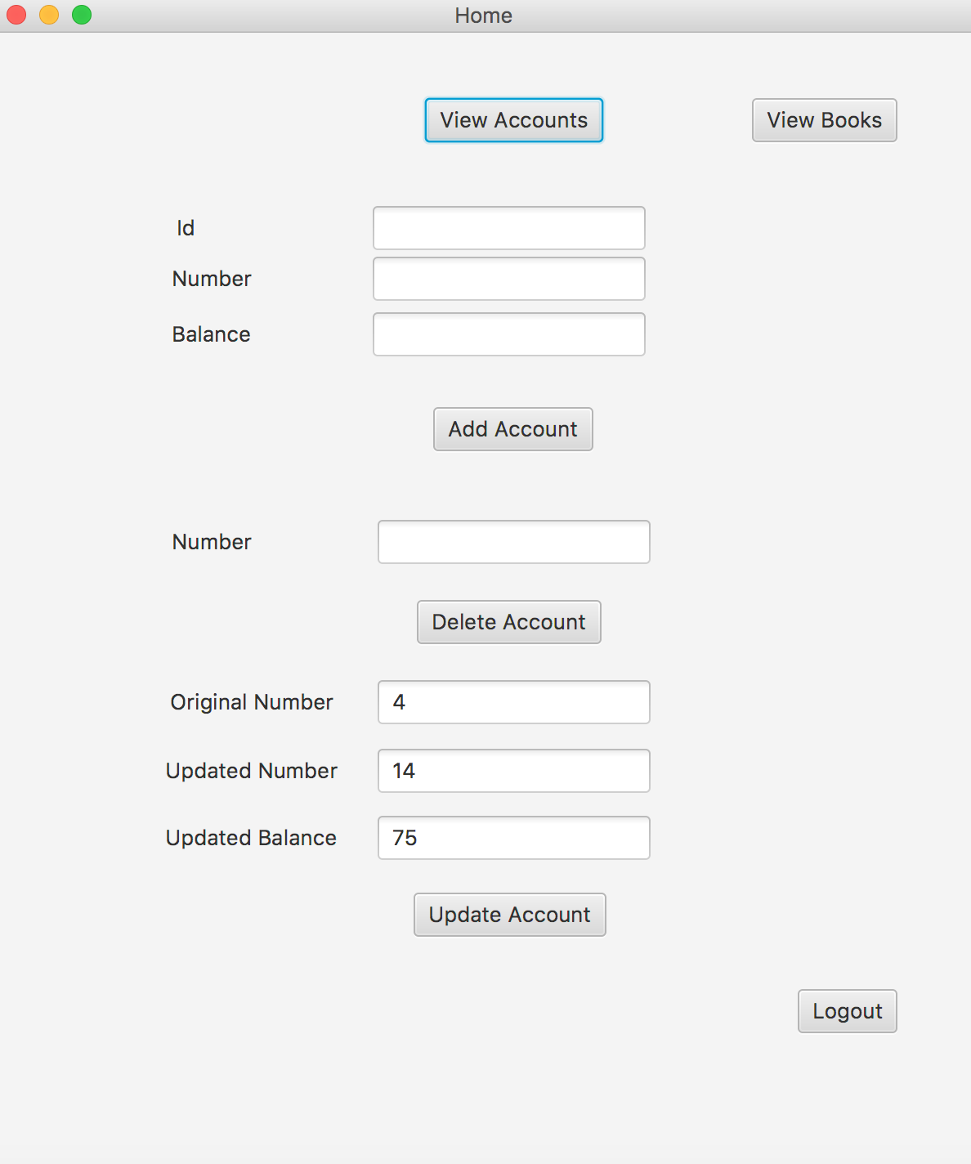

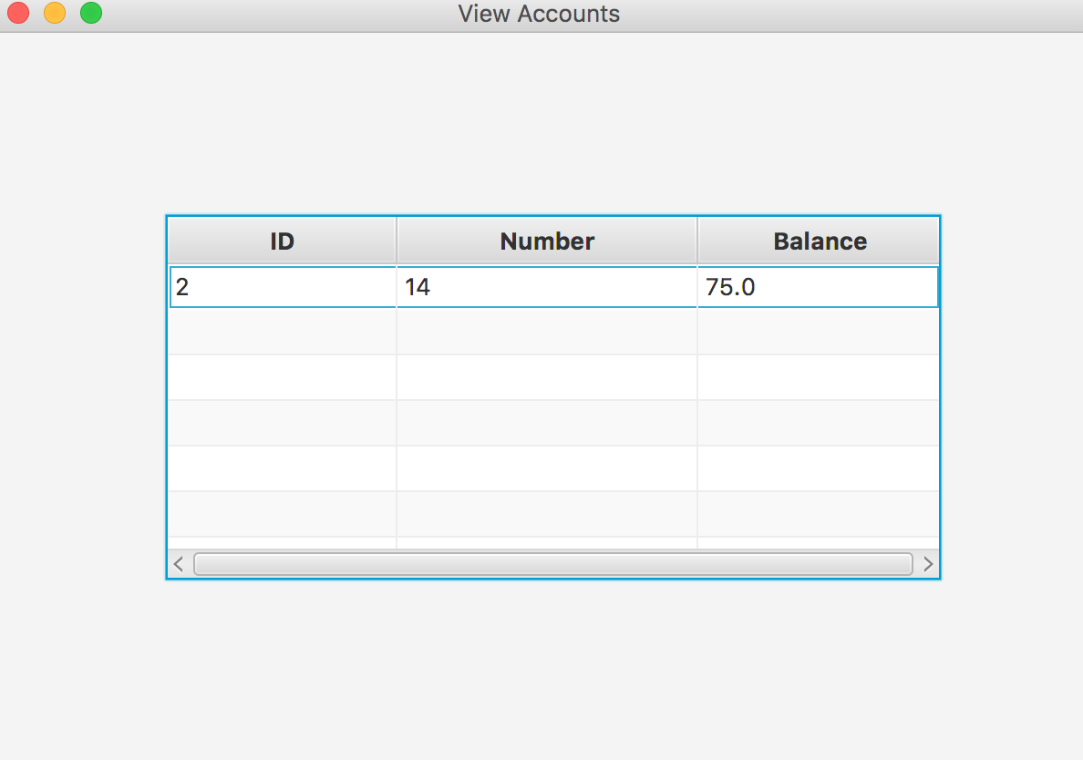

The “Logout” button will render the screen:

