SMART BUILDING AUTOMATION & MONITORING SYSTEM (SBAMS)

Session 1: Project Orientation & Problem Analysis
Smart Building Automation & Monitoring System (SBAMS) is designed to automate and monitor
community facilities such as amenities booking, complaints, visitor management, and payments.
Problem Statement:
Traditional building management systems rely on manual processes, causing delays, lack of
transparency, and inefficient resource utilization. SBAMS aims to provide a centralized digital
platform to manage all community operations effectively.
Objectives:
- Automate community services
- Improve transparency and accountability
- Provide real-time monitoring
- Enhance resident convenience

Session 2: Database Design & ER Diagram
The database is designed using relational modeling. Entities are identified based on system
requirements and normalized up to Third Normal Form (3NF).

Entities & Attributes
USER(user_id, name, email, password, role, flat_number, phone)
COMPLAINT(complaint_id, user_id, category, description, status, created_at)
VISITOR(visitor_id, resident_id, visitor_name, phone, otp, expiry_time, entry_status)
AMENITY_BOOKING(booking_id, user_id, amenity_type, date, time_slot, status)
PAYMENT(payment_id, user_id, amount, payment_date, payment_mode, payment_status)

ER Diagram (Pictorial Representation)
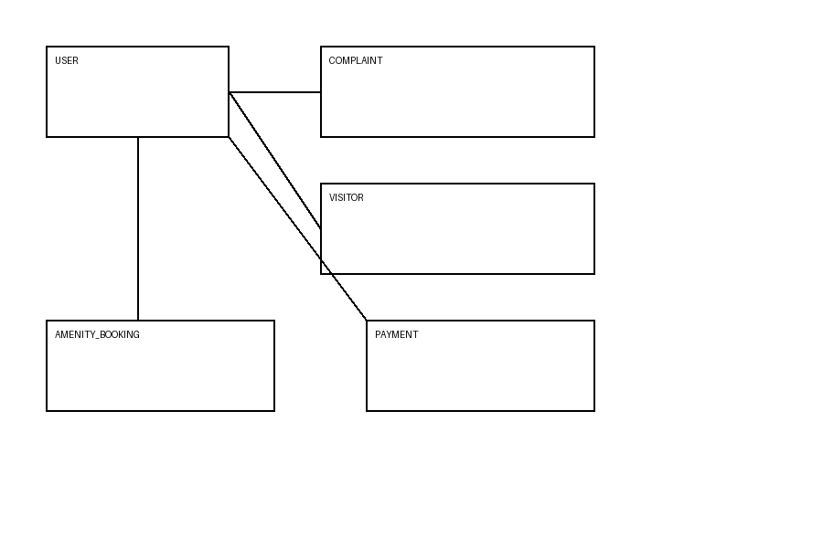

Session 3: Frontend Development
Frontend is developed using HTML, CSS, JavaScript, and React.
Key modules include:
- Login & Dashboard
- Complaints UI
- Amenities Booking UI
- Visitor OTP UI
Validation is handled using JavaScript to ensure correct user inputs.

Session 4: Backend Development
Backend is implemented using Node.js and Express with MongoDB as database.
Features:
- REST APIs
- JWT authentication
- Role-based access
- Complaint status management
- OTP validation
Security measures include input validation and role checks.

Conclusion
SBAMS provides a scalable and efficient solution for smart community management.
The system improves automation, security, and user experience while reducing manual effort.

