**API Details:**

Selected sample API from <https://github.com/public-apis/public-apis> list

Used API from <http://predictbgl.com/api/> link and designed Manual Test Cases as per instructions defined in the site and taken few test cases for automation.

They have provided only Get and Post methods (Out of all CRUD operations).So manipulated Test Scenarios and Automation with those http methods.

**Note:** There is some issue in Update log method. It’s failing even in manual process. So Test NG report will show same failure message**.**

**Sample TestNG Report:**



**Introduction on Automation framework used:**

* Created Maven project.
* Designed Hybrid Framework with the help **Rest Assured** and **HamCrust** Packages.
* Followed BDD approach for scripting. (given, when, then)
* Used TestNG predefined framework (Java Framework) for Test Case execution.

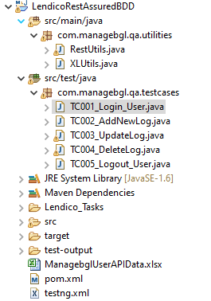

**Steps to Execute Test Scripts:**

**Prerequisite:** Java 12 should be installed in system where code need to be executed.

1. Setup entire code into eclipse from below repository

https://github.com/SriramGatiganti/Lendico_BGL_RestAssured_AutomationProjectChallange.git

There are two approaches to setup code into local.

1. Pull the code from GIT Repo from eclipse

Go to File ->Import->Select Project from GIT(Smart import)->Selct Clone URI ->Next->Enter “https://github.com/SriramGatiganti/Lendico_BGL_RestAssured_AutomationProjectChallange.git ”

->Next->Finish

1. Download ZIP file from repository

Go to Gitrepo

“https://github.com/SriramGatiganti/Lendico_BGL_RestAssured_AutomationProjectChallange.git ”

->Click Clone or download->Click Download ZIP ->Extract ZIP folder in local machine

Go to Eclipse ->Select Open Projects from File System ->Click Directory and Upload extracted folder from Git ->Click Finish

2. Once setup the project into eclipse

a. Go to LendicoRestAssuredBDD Project ->Go to TestNGSuite folder ->testng.xml ->Right click-> Run as TestNG Suite.

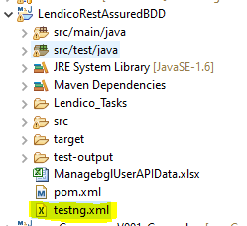

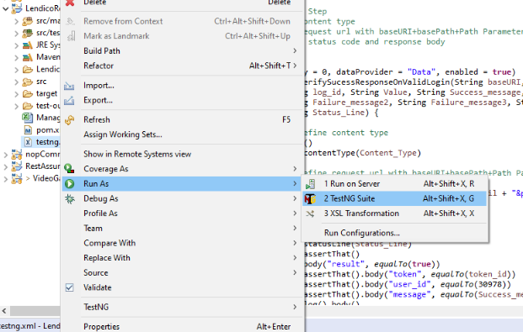

b.Go to project directory in windows and click on run.bat file.

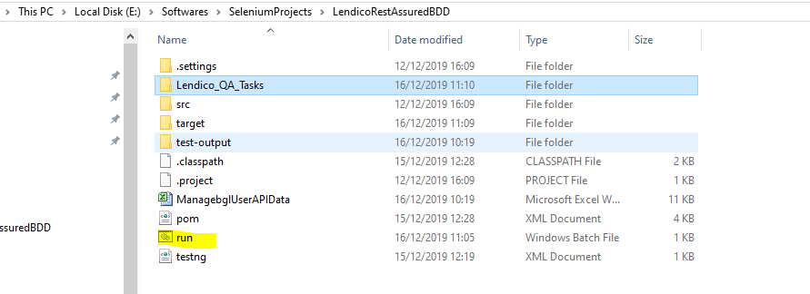

3. Once finish the execution, To check the test report

Refresh the project-> Go to test-output folder ->Select **emailable-report.html/index.html** ->Right click ->Open with Web Browser.

