UC3 — Breach Analytics Platform: Solution Design Document
DataFactZ AI Engineering Internship · Weeks 3-4 (Capstone) · Author: <Your Name> · Design Gate Draft

1. Architecture Overview
The system is a deterministic pipeline (parse, extract, match, score) with a small agentic layer invoked only at four specific decision points where judgment, iteration, or explanation is required: an Orchestrator/planner, an Exception investigator, an Entity-resolution adjudicator, and a QA auditor. Every document is either processed, quarantined with a stated reason, or escalated — nothing is silently dropped. Consequential actions (identity merges, final export sign-off) require human approval.
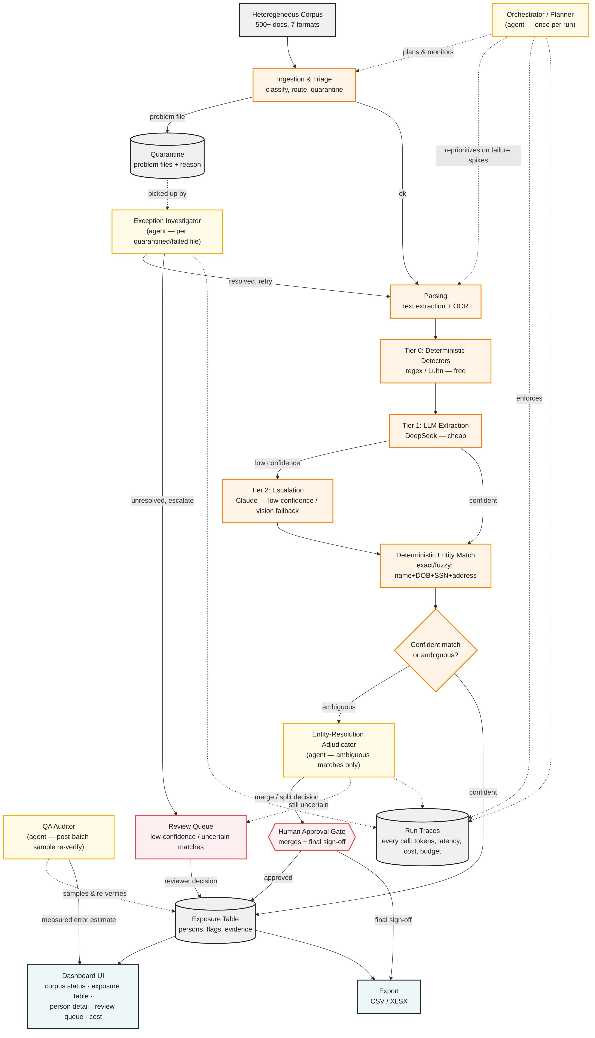
Figure 1. Deterministic pipeline (orange), agents (gold), human review/approval (red), storage (gray), UI (teal).

2. Components
Ingestion & Triage — classifies every incoming file by format and text-layer presence, routes to the correct parser, and quarantines problem files (corrupt, password-protected, zero-byte, wrong-extension, unreliable-OCR images) with a specific reason rather than dropping or crashing on them.
Parsing — text extraction (digital documents) or OCR (scanned/image documents and email attachments), reusing the verified digital/scanned detection approach from Week 2.
Tiered Extraction — Tier 0 deterministic detectors (regex, Luhn checksum) run first and free; Tier 1 sends remaining context-dependent extraction to a cheap model (DeepSeek); Tier 2 escalates low-confidence Tier 1 results, and any vision-fallback cases, to a stronger model (Claude).
Deterministic Entity Match — exact/fuzzy matching on name, DOB, address, and SSN handles the confident majority of cross-document identity linking without any agent involvement.
Entity-Resolution Adjudicator (agent) — invoked only when the deterministic matcher's similarity score lands in an ambiguous middle band; reasons over both records' full evidence and issues an explained merge/split/escalate decision, subject to human approval before it's applied.
Exception Investigator (agent) — invoked only for quarantined or failed files; tries alternate parsing/extraction strategies in a bounded loop, resolves or escalates with a diagnosis.
Orchestrator/Planner (agent) — runs once per batch, not per document: surveys the corpus, plans processing order, and reprioritizes if a file class is failing at an abnormal rate. Also enforces the per-run token/spend/step budget.
QA Auditor (agent) — after a batch completes, independently re-derives flags for a random sample against source passages and reports a measured error estimate — a structural check, not a self-report.
Review Queue & Approval Gates — low-confidence extractions and ambiguous matches route here; a human corrects/approves, and the decision is stored and reflected in the exposure table.
Exposure Table & Export — one row per resolved individual with per-category exposure flags, confidence, and evidence links; exportable to CSV/XLSX.
Run Traces — every tool call and model call, from any agent or pipeline stage, logged with tokens/latency/cost — the record that makes the whole system auditable.

3. Data Flow
- 1. A document enters the pipeline and is classified as parseable, quarantine-bound, or escalation-bound.
- 2. Parseable documents go through text extraction or OCR.
- 3. Tier 0 deterministic detectors extract well-structured fields for free.
- 4. Remaining fields go to Tier 1 (cheap model); low-confidence Tier 1 results escalate to Tier 2 (stronger model).
- 5. Extracted elements go through deterministic entity matching against known persons.
- 6. Confident matches write directly to the exposure table. Ambiguous matches go to the Entity-Resolution Adjudicator, whose merge/split decision requires human approval before being applied.
- 7. Quarantined files are picked up by the Exception Investigator, which resolves and re-enters the pipeline, or escalates to the review queue.
- 8. After a batch, the QA Auditor samples completed records and reports a measured error estimate.
- 9. Approved, resolved records are available in the exposure table and export.

4. Database Design (ERD)
EXTRACTION is deliberately generic — one row per detected element, tagged by category and extraction_tier — so per-category accuracy and per-tier cost can both be reported from the same table. FLAG is the materialized, UI-facing view (one row per person per category); the underlying evidence trail is reachable through IDENTITY_LINK -> EXTRACTION -> DOCUMENT without duplicating data. REVIEW_DECISION covers both review triggers (a corrected extraction and a resolved flag) in one table. RUN and RUN_TRACE are separated so budget enforcement is a cheap single-row check against RUN, independent of the larger trace-detail table.
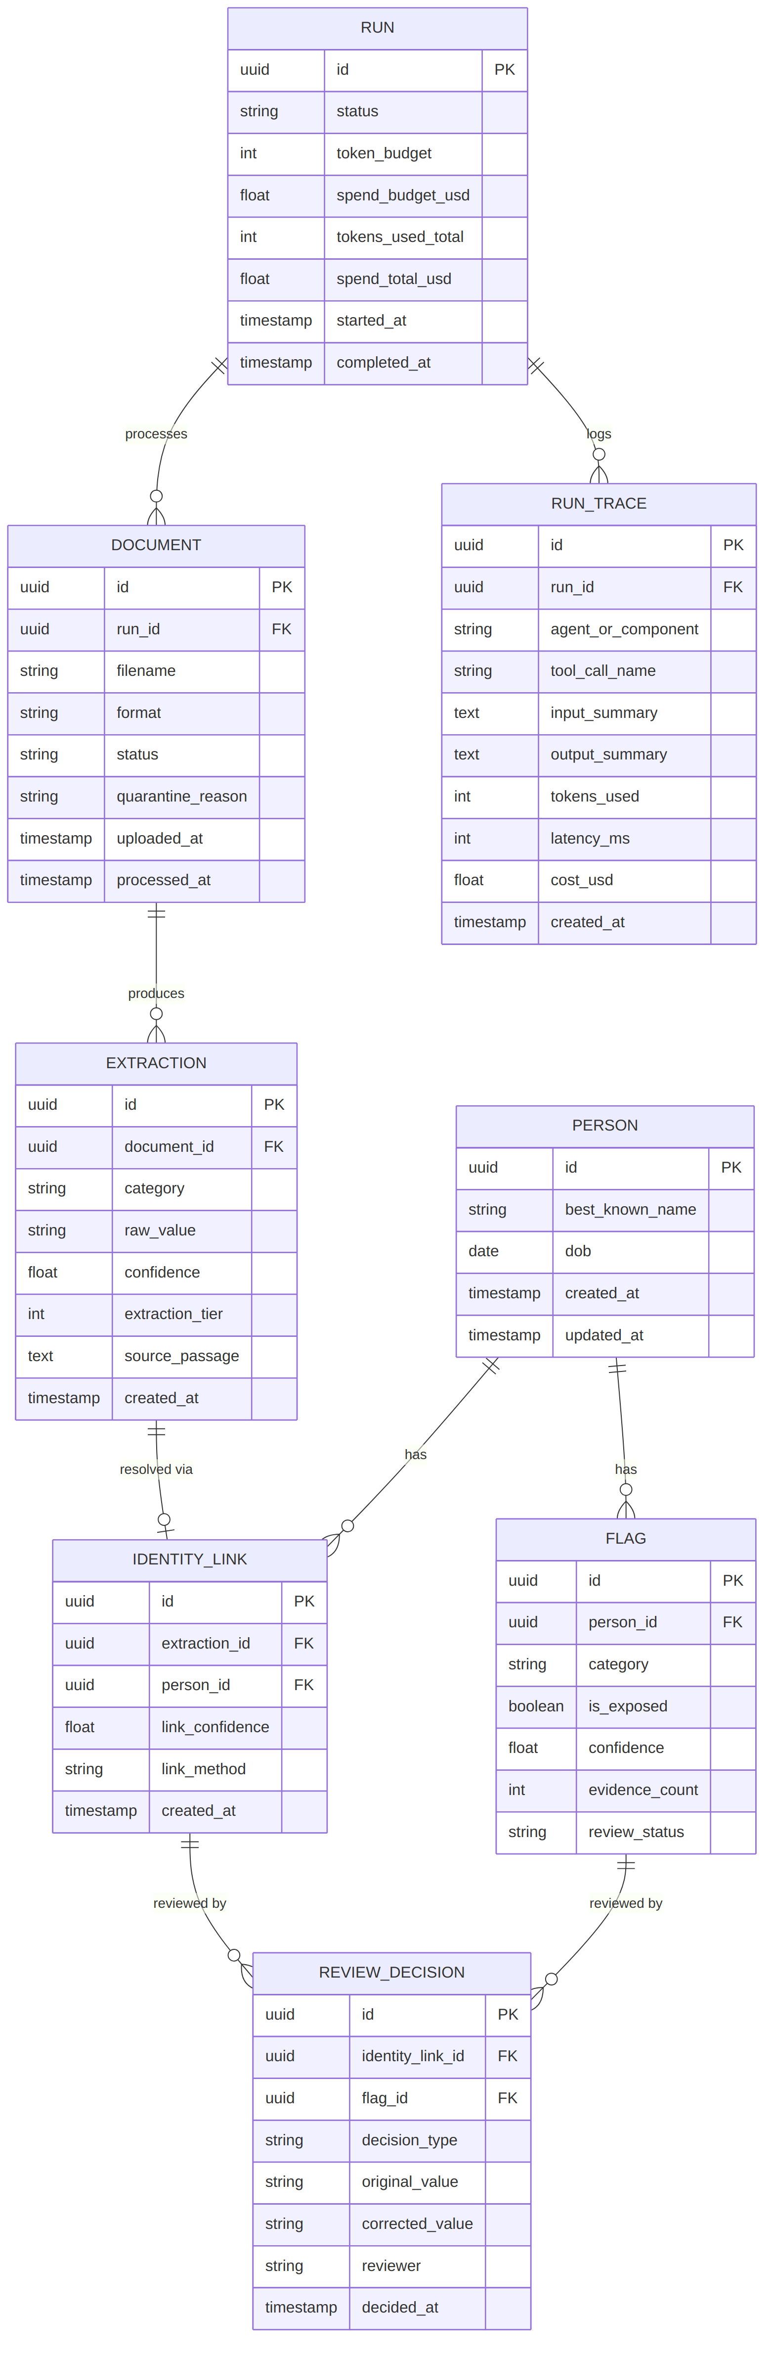
Figure 2. Entity-relationship diagram. Migrations managed via Alembic.

5. API Surface
All endpoints versioned under /api/v1, Pydantic-validated, API-key authenticated.
Method & Path | Purpose
POST /api/v1/documents | Upload one or many documents into a run
GET /api/v1/runs/{id} | Run status: budget used, documents processed, quarantine count
GET /api/v1/persons | List resolved individuals with exposure flag summary
GET /api/v1/persons/{id} | Person detail: all flags, evidence, linked extractions
GET /api/v1/review/queue | Ambiguous matches + low-confidence extractions awaiting review
POST /api/v1/review/{id}/decide | Submit a reviewer decision (correct, merge, split, escalate)
GET /api/v1/traces/{run_id} | Full run trace — every tool/model call, cost, latency
GET /api/v1/export | Exposure table export — ?format=csv|xlsx

6. Pipeline vs. Agent Boundary
This is the design gate's central question, and the rule is applied literally throughout: if there is a clear right answer or a fixed, testable threshold, it stays in the deterministic pipeline; if it genuinely requires judgment, iteration, or an explained decision, it becomes an agent. Concretely:
- Parsing, OCR, Tier 0/1/2 extraction, and the initial entity match are all deterministic — each has a clear pass/fail or a fixed confidence threshold, and running them as an agent loop would add cost and latency with no judgment benefit.
- The Entity-Resolution Adjudicator exists specifically for the shared-name-vs-same-person ambiguity a fixed threshold cannot resolve — reasoning over full evidence (address history, DOB, document context) is exactly the kind of judgment a similarity score alone can't capture.
- The Exception Investigator exists because file-failure diagnosis benefits from trying alternate strategies in a loop (different parser, OCR language setting, etc.) — a fixed retry-N-times rule would not adapt the way a real investigator does.
Rejected — agents for the entire extraction path: would make the majority-case, well-structured extraction slower and dramatically more expensive with no accuracy benefit, and harder to test deterministically.
Rejected — no agents at all, pure pipeline with fixed thresholds everywhere: fails on the shared-name collision case by design — a fixed similarity threshold cannot distinguish two different people with an identical name from one person with two slightly different name spellings; it needs a reasoning step, not a bigger threshold.

7. Stack Justification

7.1 Orchestration
Chosen: a hand-rolled orchestration layer (a shared Agent base class handling budget tracking, approval gates, and trace logging), not a framework.
Rejected — LangGraph: its state-graph abstraction pays off with many agents and unpredictable branching; here there are exactly four fixed roles with narrow jobs, so the framework's complexity isn't earned.
Rejected — Claude Agent SDK: strong harness, but Anthropic-specific — works against the tiered, multi-provider cost architecture Section 8 requires.

7.2 Tool Design
Chosen: a single MCP tool surface shared by all four agents (get_document, query_person_records, flag_category, request_human_review, merge_identities, escalate_to_stronger_model).
Rejected — separate native function-calling schemas per agent: works, but means four tool vocabularies and four call shapes for the run-trace UI to handle instead of one consistent structure.

7.3 Model Tiering
Chosen: Tier 0 deterministic (free) -> Tier 1 DeepSeek (cheap, routine documents) -> Tier 2 Claude (low-confidence escalation, vision fallback, and all four agent roles).
Rejected — one model for everything (Claude throughout): fails the brief's cost framing directly and does not scale to a 1,000,000-document extrapolation.
Rejected — cheapest model for everything, including the agents: Week 2 already produced concrete evidence that a smaller model's reliability drops exactly where structural reasoning is required (bracket omission, truncation, field confusion on a complex document) — putting the agents on the cheap tier risks the same failure mode where it matters far more: a wrong identity merge.

7.4 Infrastructure
Chosen: self-hosted Postgres + FastAPI + React, same pattern as Weeks 1-2, with Azure documented as a swap path once access exists.
Rejected — full Azure stack: Azure access still isn't provisioned; defaulting to it would block development entirely rather than limit one feature.
Rejected — a managed vector-DB or entity-resolution SaaS: would obscure the exact per-document cost measurement Section 8 requires — self-hosted components keep every cost line attributable.

8. Security
- Authentication: API-key auth on all /api/v1 endpoints; review/approval and export endpoints require the same authenticated access as ingestion.
- Synthetic data only: every document and identity in the corpus is fabricated (see corpus generator README) — this is a design constraint enforced from the data layer up, not just a policy statement.
- Approval gates: no identity merge or final export reaches a persisted, reportable state without an explicit human approval record.
- Secrets management: LLM API keys in environment variables locally, a secrets manager in a deployed environment — never committed to source control.
- Data at rest: exposure table and source documents are the most sensitive data in the system by design (that is the point of the product) — access is limited to authenticated API callers, no public endpoints, and would require encryption-at-rest in any real deployment beyond this internship engagement.

9. Scalability — What Changes at 100x / 1,000,000 Documents
At the corpus scale built for this capstone (~540 documents), synchronous-per-document processing with a small worker pool is workable. At 100,000-1,000,000 documents:
- Processing: a real job queue (Celery/RQ/arq) with autoscaled worker pools, not a single process — Tier 0/1 work parallelizes trivially; Tier 2 and agent calls need rate-limit-aware throttling.
- Entity resolution: the deterministic match step needs a proper blocking/indexing strategy (e.g., block by DOB + last-name prefix) rather than pairwise comparison, which does not scale past a few thousand people.
- Storage: source documents move to object storage; the database needs read replicas for the exposure-table/dashboard views, which are read far more than written at this scale.
- Cost control becomes the dominant constraint, not compute: the tiered-routing hit rate (what fraction of documents Tier 0/1 resolve without escalation) directly determines whether 1,000,000 documents is affordable — this is measured, not assumed, in Section 10.
- QA Auditor sampling rate must scale sub-linearly (a fixed percentage sample, not a fixed count) to keep audit cost bounded as volume grows.

10. Accuracy & Cost Measurement Plan
Accuracy methodology (planned): person-level recall/precision against the corpus manifest's 171 individuals, plus per-category flag accuracy (SSN, DOB, financial, medical, etc.) and separate reporting on the deliberate edge cases — name-variant linking success rate, collision-pair separation success rate, and false-positive trap rejection rate (from negatives.csv). Error analysis will categorize failures by root cause, following the Week 1-2 pattern of reporting the honest number alongside the headline number, not instead of it.
Cost methodology (planned): actual measured cost (from run traces, not estimates) on the full ~540-document corpus, broken down by tier, extrapolated to 100,000 and 1,000,000 documents using the corpus's measured tier-routing hit rates. At least two configurations (e.g., current tiering vs. a more aggressive escalation threshold) will be compared on a cost/accuracy curve with a recommendation.
Status: Measured — the full corpus has been live-tested (572 of 581 manifest-referenced documents; 9 email-attachment references unresolved, see 10.1). Per-category recall, a corrected false-positive framing, and an entity-linking decomposition are in 10.1–10.2 below. A two-configuration comparison has been run on a targeted sample (10.3) — it surfaced a local-test-environment caveat (Tier 1 and Tier 2 share the same model in this environment) rather than a clean production cost/accuracy curve; re-running it with a real Tier 2 provider is the one remaining open item.

10.1 Full-Corpus Live-Test Results (572 of 581 Referenced Documents)
Run against the live server across the full manifest — 572 of 581 manifest-referenced documents processed (538 physical corpus files; a handful of filenames are referenced more than once across manifest rows), covering every planted-field category in document_manifest.csv (not just the name/SSN path this report started with), all 58 negative-sample rows, and all 17 quarantine-expected files. 9 manifest rows reference email attachments via a composite filename (e.g. eml_case_0004.eml::attach_0004.pdf) that this run's filename matching never resolved to their real on-disk names; they are excluded from every count below rather than silently scored as a pass or fail.
Check | Result | Verdict
PII field extraction recall (all categories) | 1,713/1,767 planted fields (96.9%) | ~100% on every digital-text category; recall drops specifically on scanned/OCR documents and sparse name-variant notes (findings 1 and 4 below)
Entity-resolution linking (variant → same Person as primary) | 32/57 (56.1%) on a literal count | Most of the shortfall is measurement artifact, not a linking error — see finding 2
False positives on “negative” sample | 31/51 flagged | Corrected finding: most of these are real, correctly-flagged case documents reused under a narrower “negative” label than “the whole document is clean” — see finding 3
Quarantine reason correctness | 13/17 (76.5%) | All 4 misses are the same cosmetic label difference identified earlier; the quarantine action itself was correct in all 17 cases

Six findings from the full run:
- Recall is excellent on digital-text documents; failures concentrate in scanned/OCR. Every non-scanned category — phone, email, name_and_ssn, address, driver_license, financial_account, medical, passport, login_credential, bulk_export_row — landed at 99–100% recall. Every _scanned counterpart is measurably weaker (name_and_ssn_scanned 85.5%, driver_license_scanned 80.8%, passport_scanned 86.7%), and financial_account_scanned is a clear outlier at 42.3% (11/26) — more than twice the miss rate of any other category. This is the single most actionable accuracy finding here: OCR-plus-extraction reliability on financial account numbers specifically needs its own investigation before this system could be trusted on scanned financial documents in production.
- The 56.1% entity-linking number overstates the real problem. Of the 25 recorded mismatches, most fall into two non-error buckets: the variant document itself never got any resolution signal at all (same sparse-name-field cause as finding 1/4), or the designated “primary” document for that manifest person never achieved a single clean link on its own, leaving nothing valid to compare against. A small number of genuine disagreements remain (e.g. manifest persons P0088 and P0137, where two documents for the same real person landed on different database Person records) — confirmed in a live check to be a single-pass, order-dependent matching gap (a document is only compared against persons that already exist at the moment it's processed, with no later reconciliation pass), not a wrongful-merge bug. Report both the raw rate and this decomposition together; the raw number alone materially overstates the defect.
- The false-positive framing needed correcting, not just measuring. Live-checking three “template_placeholder”-labeled negative documents (docx_case_0007.docx, eml_case_0008.eml, pdf_case_0010.pdf) showed they are the exact same real, full-profile case files used elsewhere in the corpus as legitimate primary documents — complete with real SSNs, financial accounts, and medical notes, all correctly extracted and correctly flagged as exposed. These are not false positives: the corpus's negatives.csv evidently uses “negative” to mark one specific decoy value inside an otherwise-real document (via its own text column, which this test never read), not to mean the whole document is PII-free. The two negative_type categories actually built to test false-positive avoidance at the value level — order_number_lookalike and test_record — hit 0 false positives across the full corpus (9/9 and 6/6 clean), which is the real, confirmed result: the system's defense against numeric-lookalike and test-record false positives works. employee_signature and template_placeholder need a field-level re-check against negatives.csv's text column before any false-positive rate is reported for them.
- Sparse-signal name fields are the main recall gap outside OCR. name_variant (84.2%) and name_only_partial (83.3%) are the two weakest digital-text categories, both because the planted name sometimes doesn't survive Tier 1 extraction when it's the only strong identity signal in a short document (an abbreviated variant note, a partial-identity test document).
- Quarantine reason labeling is unchanged from the smaller sample. All 4 misses are sheet_photo_*.png files correctly quarantined under a more generic actual reason (low_confidence_ocr) than the manifest's specific expected label (image_of_spreadsheet_unreliable_ocr). Functionally correct in all 17 cases; cosmetic only.
- One severe performance outlier. bulk_export_01.csv took 1,483 seconds (~25 minutes) to process a single file — roughly 100x the corpus average — almost certainly because a large multi-row export is sent through the LLM extraction tiers as one document rather than being chunked. This is a real scalability risk the flat tokens/document cost model below does not capture, and needs its own investigation before a 1,000,000-document estimate can be trusted for bulk-export-shaped inputs.

10.2 Cost Extrapolation (Full Corpus)
Measured: 233,207 tokens across 572 documents (≈407.7 tokens/document average) at $0 marginal cost — the full-corpus run still used the local Ollama provider for both tiers. Applying the same per-document rate to the system's configured DeepSeek/Claude pricing (Section 7.3):
- At 100,000 documents (≈40.8M tokens): ≈$81.54 at all-Tier-1 DeepSeek pricing ($0.002/1K); ≈$611.55 at all-Tier-2 Claude pricing ($0.015/1K).
- At 1,000,000 documents (≈407.7M tokens): ≈$815.40 at all-Tier-1 pricing; ≈$6,115.50 at all-Tier-2 pricing.
Caveat: this average smooths over a workload that is not uniform — see finding 6 above. A bulk-export-heavy corpus at scale would cost and take meaningfully more than this flat per-document rate suggests. The two-configuration cost/accuracy curve comparison (current tiering vs. a more aggressive escalation threshold) is in 10.3 below.

10.3 Two-Configuration Comparison (Targeted Sample)
Compared current tiering (tier1_escalation_threshold=0.7) against a more aggressive threshold (0.9, meaning more Tier 1 results are judged not-confident-enough and escalated to Tier 2) on a targeted 60-document sample — not the full corpus — drawn from the categories the full-corpus run found weakest (financial_account_scanned, name_and_ssn_scanned, driver_license_scanned, passport_scanned, name_variant, name_only_partial). Each configuration ran under its own fresh Run so tokens are cleanly attributable.
Config | Tokens (60 docs) | Recall | Wall time
A: current (threshold 0.7) | 20,624 (343.7/doc) | 52/60 (86.7%) | 546.5s
B: aggressive (threshold 0.9) | 22,110 (368.5/doc) | 49/60 (81.7%) | 587.4s

Result: escalating more often cost 7.2% more tokens and produced 5.0 percentage points worse recall (86.7% → 81.7%), not better.
Why, and why this isn't the headline it looks like: this environment's .env has both TIER1_PROVIDER and TIER2_PROVIDER set to local, both calling the same Ollama model (llama3.2). Tier 2 in this test is not actually a stronger model — it's the same model called a second time with a different prompt. So “escalate more aggressively” here measures the effect of a redundant call to an already-weak local model, not the cost/accuracy tradeoff of a genuine cheap-vs-strong tier split. The extra token spend bought nothing, and plausibly introduced additional parsing/retry variance on documents the small model already struggles with (scanned images, sparse-signal notes) — which is itself consistent with Section 7.3's own stated reasoning for why the agents specifically need a real capability upgrade (Claude), not just a second pass from the same cheap model.
Recommendation: this comparison needs to be re-run with a real Tier 2 provider (ANTHROPIC_API_KEY configured, TIER2_PROVIDER=anthropic) before drawing any production conclusion about escalation thresholds — the current result only demonstrates that threshold tuning without a genuine model upgrade behind it does not buy accuracy, which is a real and useful finding on its own, but is not yet the cost/accuracy curve this section originally set out to produce.

11. Risk List
Risk | Likelihood | Mitigation
Small/cheap-tier model produces unreliable structured output (seen directly in Week 2) | High | Bracket-repair + non-anchoring retry pattern from Week 2, ported to Tier 1; escalate to Tier 2 on repeated failure
Entity resolution wrongly merges two different people sharing a name | Medium | Deliberate collision pairs in the corpus catch this before the demo; adjudicator decisions require human approval before applying
Cost measurement is inaccurate or not truly 'measured' vs. estimated | Medium | Every model/tool call logged to RUN_TRACE with real token counts and provider pricing, not assumed averages
Agent budget/approval gates are demoed but don't actually stop anything | Medium | Forced-failure demo specifically exercises the budget-exceeded path live, not just described in the deck
OCR/vision fallback on the messiest scanned documents is unreliable | Medium | Same detection-and-flag approach as Week 2; genuinely low-confidence OCR routes to review rather than guessing
Azure access remains unavailable through the build sprint | Low-Medium | Infrastructure decision (Section 7.4) already assumes self-hosted as the default, not a fallback improvised late

12. Week 4 Build Plan
Day | Focus
Monday | Incorporate design-gate feedback; scaffold project (backend/frontend, DB migrations from Section 4's ERD); deterministic pipeline stages 1-4 (triage, parsing, Tier 0/1 extraction)
Tuesday | Deterministic entity matching; begin agent layer (Orchestrator, Exception Investigator) against the real corpus
Wednesday | Entity-Resolution Adjudicator + approval gates; review queue UI; QA Auditor; begin accuracy measurement against the manifest
Thursday | Cost measurement and tier-routing analysis; cost/accuracy curve; exposure table + export UI polish; feature freeze; status report due 6pm
Friday | Deck, rehearsal, forced-failure demo dry run, capstone presentation + Q&A

