**Question - 1**

<!DOCTYPE html>

<html>

<body style="background-color: aquamarine;">

<div style="margin-left: auto; margin-right: auto; height: 100%;">

<h3 style="text-align: center;">The Road Not Taken</h3>

<div style="text-align: center;">

Two roads diverged in a yellow wood, <br>

And sorry I could not travel both <br>

And be one traveler, long I stood <br>

And looked down one as far as I could <br><br>

To where it bent in the undergrowth; <br>

Then took the other, as just as fair, <br>

And having perhaps the better claim, <br>

Because it was grassy and wanted wear; <br><br>

Though as for that the passing there <br>

Had worn them really about the same, <br>

And both that morning equally lay <br>

In leaves no step had trodden black. <br><br>

Oh, I kept the first for another day! <br>

Yet knowing how way leads on to way, <br>

I doubted if I should ever come back. <br>

I shall be telling this with a sigh <br><br>

Somewhere ages and ages hence: <br>

Two roads diverged in a wood, and I— <br>

I took the one less traveled by, <br>

And that has made all the difference. <br><br>

</div>

</div>

</body>

</html>

**Output**

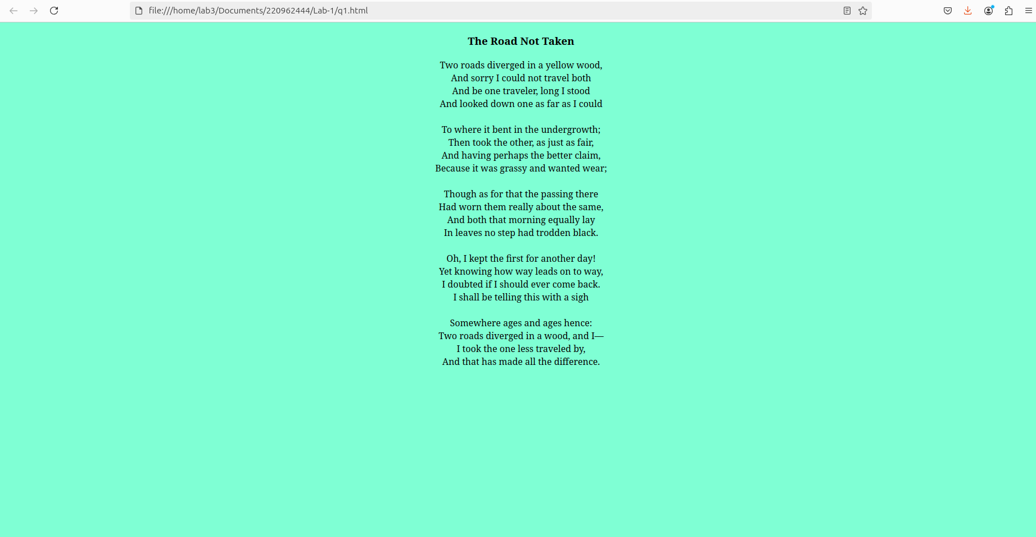

**Question - 2**

<!DOCTYPE html>

<html>

<body style="height: 500px; background-color: azure;">

<div style="height:100%; flex-direction:row; display: flex; justify-content: space-evenly; align-items: center;">

<div style="background-color: aqua; padding: 20px 20px; border-radius: 25%;">

<h3>

Additional Accessories:

</h3>

<ul>

<li>Backup tyres</li>

<li>Portable electric charger</li>

<li>Food</li>

<li>Water</li>

<li>Fuel</li>

<li>Mechanic toolkit</li>

</ul>

</div>

<div style="background-color: blueviolet; padding: 20px 20px; border-radius: 25%;">

<h3>

Travel Plans:

</h3>

<ol>

<li>Go to Bangalore</li>

<li>Take flight to Punjab</li>

<li>Visit Shimla</li>

<li>Ride horse</li>

<li>Head to Manali and stay for a week</li>

<li>Take bus to Delhi</li>

<li>Take return flight to home</li>

</ol>

</div>

</div>

</body>

</html>

**Output**

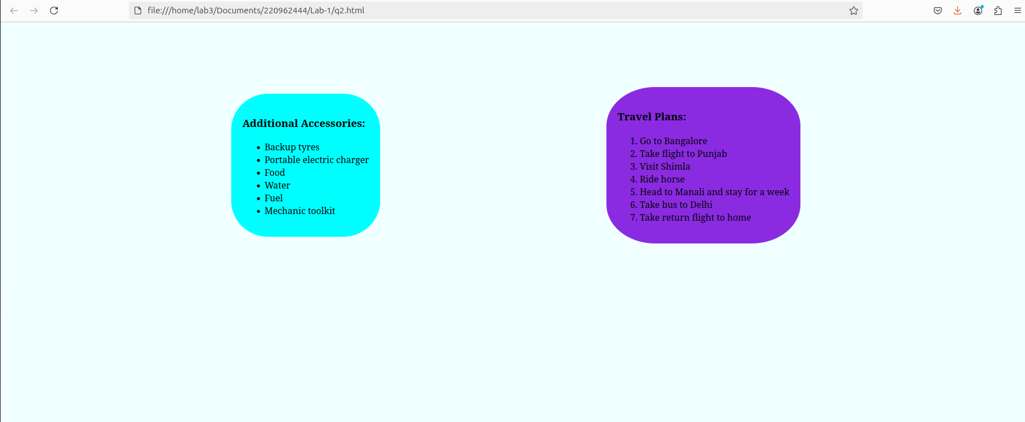

**Question - 3**

<!DOCTYPE html>

<html>

<body style="background-color: beige;">

<div style="background-color: black; padding: 0px 10px; margin-right: 10px;">

<h2 style="font-family: cursive; color: white;">Share Your Winter Vacation Videos</h2>

</div>

<div style="padding: 20px 20px; background-image: linear-gradient(to bottom,aqua, beige); margin-right: 10px;">

<h2 style="font-family: cursive;">HTML5 Videos</h3>

<div style="flex-direction: row; display: flex;">

<figure>

<video width="480" height="360" autoplay muted>

<source src="/home/lab3/Downloads/vid1.mp4">

</video>

<figcaption style="text-align: center;">Walking</figcaption>

</figure>

<figure>

<video width="480" height="360" autoplay muted>

<source src="/home/lab3/Downloads/vid2.mp4">

</video>

<figcaption style="text-align: center;">Cycling</figcaption>

</figure>

<figure>

<video width="480" height="360" autoplay muted>

<source src="/home/lab3/Downloads/vid3.mp4">

</video>

<figcaption style="text-align: center;">Forest</figcaption>

</figure>

</div>

</div>

</body>

</html>

**Output**

