**Sriram Sunderrajan**

**220962444**

**AIML – A2 (77)**

**WP – Lab**

**Week-2**

**16th January 2025**

**Question - 1**

**Code:**

<!DOCTYPE html>

<html lang="en">

<head>

<meta charset="UTF-8">

<meta name="viewport" content="width=device-width, initial-scale=1.0">

<title>Bootstrap Layout</title>

<!-- Bootstrap CSS Link -->

<link href="https://cdn.jsdelivr.net/npm/bootstrap@5.3.0-alpha1/dist/css/bootstrap.min.css" rel="stylesheet">

</head>

<body>

<!-- Top Section -->

<div class="container-fluid bg-primary text-white py-5">

<div class="row">

<div class="col text-center">

<h1>Search and Explore!</h1>

<!-- Input Group Example -->

<div class="input-group mb-3 w-50 mx-auto">

<input type="text" class="form-control" placeholder="Enter something..." aria-label="Input" aria-describedby="button-addon2">

<button class="btn btn-outline-light" type="button" id="button-addon2">Search</button>

</div>

<!-- Badge Example -->

<h3>

Notifications <span class="badge bg-warning">4</span>

</h3>

</div>

</div>

</div>

<!-- Bottom Section -->

<div class="container-fluid py-5">

<div class="row">

<!-- Left Part -->

<div class="col-md-4 mb-4">

<h3>Left Section</h3>

<p>Activities</p>

<div class="btn-group" role="group" aria-label="Button group example">

<button type="button" class="btn btn-success">Activity 1</button>

<button type="button" class="btn btn-success">Activity 2</button>

<button type="button" class="btn btn-success">Activity 3</button>

</div>

</div>

<!-- Center Part -->

<div class="col-md-4 mb-4">

<h3>Center Section</h3>

<p>Search by Username or Organization</p>

<div class="input-group">

<span class="input-group-text">@</span>

<input type="text" class="form-control" placeholder="Name" aria-label="Name" aria-describedby="basic-addon1">

</div>

</div>

<!-- Right Part -->

<div class="col-md-4 mb-4">

<h3>Right Section</h3>

<p>Avail badge after daily sign-in!</p>

<button class="btn btn-info">

Click Me <span class="badge bg-dark">New</span>

</button>

</div>

</div>

</div>

<!-- Bootstrap JS (Optional) -->

<script src="https://cdn.jsdelivr.net/npm/bootstrap@5.3.0-alpha1/dist/js/bootstrap.bundle.min.js"></script>

</body>

</html>

**Output:**

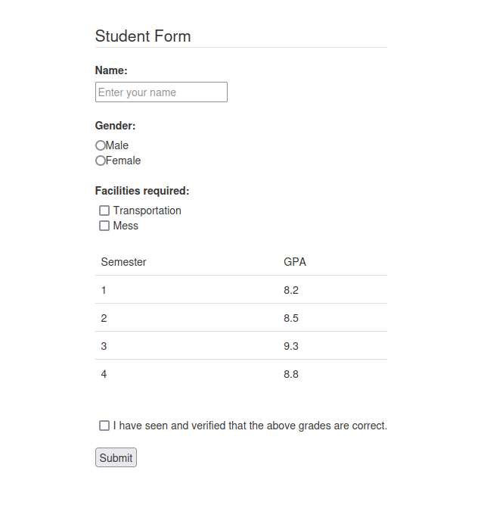

**Question - 3**

**Code:**

<!DOCTYPE html>

<html lang="en">

<head>

<meta charset="UTF-8">

<meta name="viewport" content="width=device-width, initial-scale=1.0">

<title>Bootstrap Layout</title>

<!-- Bootstrap CSS Link -->

<link href="https://cdn.jsdelivr.net/npm/bootstrap@5.3.0-alpha1/dist/css/bootstrap.min.css" rel="stylesheet">

</head>

<body>

<!-- Top Section -->

<div class="container-fluid bg-primary text-white py-5">

<div class="row">

<div class="col text-center">

<h1>Search and Explore!</h1>

<!-- Input Group Example -->

<div class="input-group mb-3 w-50 mx-auto">

<input type="text" class="form-control" placeholder="Enter something..." aria-label="Input" aria-describedby="button-addon2">

<button class="btn btn-outline-light" type="button" id="button-addon2">Search</button>

</div>

<!-- Badge Example -->

<h3>

Notifications <span class="badge bg-warning">4</span>

</h3>

</div>

</div>

</div>

<!-- Bottom Section -->

<div class="container-fluid py-5">

<div class="row">

<!-- Left Part -->

<div class="col-md-4 mb-4">

<h3>Left Section</h3>

<p>Activities</p>

<div class="btn-group" role="group" aria-label="Button group example">

<button type="button" class="btn btn-success">Activity 1</button>

<button type="button" class="btn btn-success">Activity 2</button>

<button type="button" class="btn btn-success">Activity 3</button>

</div>

</div>

<!-- Center Part -->

<div class="col-md-4 mb-4">

<h3>Center Section</h3>

<p>Search by Username or Organization</p>

<div class="input-group">

<span class="input-group-text">@</span>

<input type="text" class="form-control" placeholder="Name" aria-label="Name" aria-describedby="basic-addon1">

</div>

</div>

<!-- Right Part -->

<div class="col-md-4 mb-4">

<h3>Right Section</h3>

<p>Avail badge after daily sign-in!</p>

<button class="btn btn-info">

Click Me <span class="badge bg-dark">New</span>

</button>

</div>

</div>

</div>

<!-- Bootstrap JS (Optional) -->

<script src="https://cdn.jsdelivr.net/npm/bootstrap@5.3.0-alpha1/dist/js/bootstrap.bundle.min.js"></script>

</body>

</html>

**Output:**

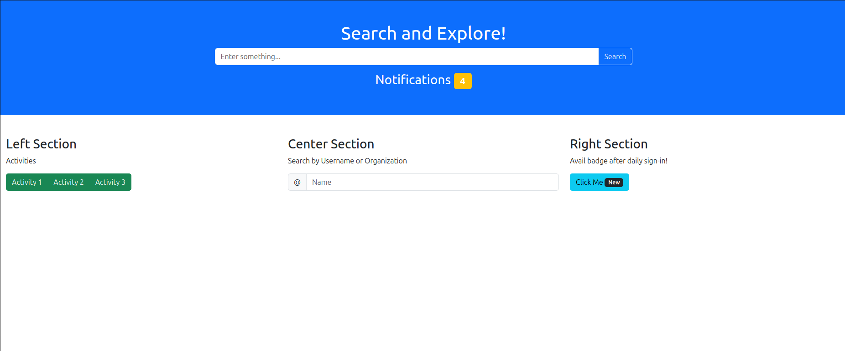

**Question – 4**

**Code:**

<!DOCTYPE html>

<html lang="en">

<head>

<title>Bootstrap Example</title>

<meta charset="utf-8">

<meta name="viewport" content="width=device-width, initial-scale=1">

<link rel="stylesheet" href="https://maxcdn.bootstrapcdn.com/bootstrap/3.4.1/css/bootstrap.min.css">

<script src="https://ajax.googleapis.com/ajax/libs/jquery/3.7.1/jquery.min.js"></script>

<script src="https://maxcdn.bootstrapcdn.com/bootstrap/3.4.1/js/bootstrap.min.js"></script>

</head>

<body style="display: flex; flex-direction: column; justify-content: center; align-content: center; align-items: center; text-align: center;">

<div class="container">

<h2>My Timetable</h2>

<div id="myCarousel" class="carousel slide" data-ride="carousel">

<!-- Indicators -->

<ol class="carousel-indicators">

<li data-target="#myCarousel" data-slide-to="0" class="active"></li>

<li data-target="#myCarousel" data-slide-to="1"></li>

<li data-target="#myCarousel" data-slide-to="2"></li>

<li data-target="#myCarousel" data-slide-to="3"></li>

<li data-target="#myCarousel" data-slide-to="4"></li>

<li data-target="#myCarousel" data-slide-to="5"></li>

</ol>

<!-- Wrapper for slides -->

<div class="carousel-inner">

<div class="item active">

<table class="table">

<thead>

<tr>

<td>Time</td>

<td>Subject</td>

</tr>

</thead>

<tbody>

<tr>

<td>8AM</td>

<td>Mathematics</td>

</tr>

<tr>

<td>9AM</td>

<td>English</td>

</tr>

<tr>

<td>10AM</td>

<td>German</td>

</tr>

<tr>

<td>11AM</td>

<td>Lunch</td>

</tr>

<tr>

<td>1PM</td>

<td>Computer Science</td>

</tr>

<tr>

<td>3PM</td>

<td>Music</td>

</tr>

<tr>

<td>4PM</td>

<td>Art & Crafts</td>

</tr>

</tbody>

</table>

<div class="carousel-caption">

<h3>Monday</h3>

</div>

</div>

<div class="item">

<table class="table">

<thead>

<tr>

<td>Time</td>

<td>Subject</td>

</tr>

</thead>

<tbody>

<tr>

<td>8AM</td>

<td>English</td>

</tr>

<tr>

<td>9AM</td>

<td>Sanskrit</td>

</tr>

<tr>

<td>10AM</td>

<td>Physical Education</td>

</tr>

<tr>

<td>11AM</td>

<td>Lunch</td>

</tr>

<tr>

<td>1PM</td>

<td>Computer Science</td>

</tr>

<tr>

<td>3PM</td>

<td>Art & Crafts</td>

</tr>

<tr>

<td>4PM</td>

<td>Mathematics</td>

</tr>

</tbody>

</table>

<div class="carousel-caption">

<h3>Tuesday</h3>

</div>

</div>

<div class="item">

<table class="table">

<thead>

<tr>

<td>Time</td>

<td>Subject</td>

</tr>

</thead>

<tbody>

<tr>

<td>8AM</td>

<td>English</td>

</tr>

<tr>

<td>9AM</td>

<td>History</td>

</tr>

<tr>

<td>10AM</td>

<td>Physical Education</td>

</tr>

<tr>

<td>11AM</td>

<td>Lunch</td>

</tr>

<tr>

<td>1PM</td>

<td>Music</td>

</tr>

<tr>

<td>3PM</td>

<td>German</td>

</tr>

<tr>

<td>4PM</td>

<td>Computer Science</td>

</tr>

</tbody>

</table>

<div class="carousel-caption">

<h3>Wednesday</h3>

</div>

</div>

<div class="item">

<table class="table">

<thead>

<tr>

<td>Time</td>

<td>Subject</td>

</tr>

</thead>

<tbody>

<tr>

<td>8AM</td>

<td>Biology</td>

</tr>

<tr>

<td>9AM</td>

<td>Physics</td>

</tr>

<tr>

<td>10AM</td>

<td>English</td>

</tr>

<tr>

<td>11AM</td>

<td>Lunch</td>

</tr>

<tr>

<td>1PM</td>

<td>Sanskrit</td>

</tr>

<tr>

<td>3PM</td>

<td>Computer Science</td>

</tr>

<tr>

<td>4PM</td>

<td>History</td>

</tr>

</tbody>

</table>

<div class="carousel-caption">

<h3>Thursday</h3>

</div>

</div>

<div class="item">

<table class="table">

<thead>

<tr>

<td>Time</td>

<td>Subject</td>

</tr>

</thead>

<tbody>

<tr>

<td>8AM</td>

<td>Physics</td>

</tr>

<tr>

<td>9AM</td>

<td>Geography</td>

</tr>

<tr>

<td>10AM</td>

<td>English</td>

</tr>

<tr>

<td>11AM</td>

<td>Lunch</td>

</tr>

<tr>

<td>1PM</td>

<td>Computer Science</td>

</tr>

<tr>

<td>3PM</td>

<td>Mathematics</td>

</tr>

<tr>

<td>4PM</td>

<td>Art & Crafts</td>

</tr>

</tbody>

</table>

<div class="carousel-caption">

<h3>Friday</h3>

</div>

</div>

<div class="item">

<table class="table">

<thead>

<tr>

<td>Time</td>

<td>Subject</td>

</tr>

</thead>

<tbody>

<tr>

<td>8AM</td>

<td>Music</td>

</tr>

<tr>

<td>9AM</td>

<td>Chemistry</td>

</tr>

<tr>

<td>10AM</td>

<td>Mathematics</td>

</tr>

<tr>

<td>11AM</td>

<td>Lunch</td>

</tr>

<tr>

<td>1PM</td>

<td>Geogrpahy</td>

</tr>

<tr>

<td>3PM</td>

<td>Physical Education</td>

</tr>

<tr>

<td>4PM</td>

<td>Computer Science</td>

</tr>

</tbody>

</table>

<div class="carousel-caption">

<h3>Saturday</h3>

</div>

</div>

</div>

<!-- Left and right controls -->

<a class="left carousel-control" href="#myCarousel" data-slide="prev">

<span class="glyphicon glyphicon-chevron-left"></span>

<span class="sr-only">Previous</span>

</a>

<a class="right carousel-control" href="#myCarousel" data-slide="next">

<span class="glyphicon glyphicon-chevron-right"></span>

<span class="sr-only">Next</span>

</a>

</div>

</div>

</body>

</html>

**Output:**

