**Sriram Sunderrajan**

**220962444**

**WP – Lab**

**Week – 3**

**23rd January 2025**

**Question – 1**

**Code:**

**HTML**

<!DOCTYPE html>

<html>

<head>

<title>Q-1</title>

<meta charset="utf-8">

<meta name="viewport" content="width=device-width, initial-scale=1">

<link rel="stylesheet" href="https://maxcdn.bootstrapcdn.com/bootstrap/3.4.1/css/bootstrap.min.css">

<script src="https://ajax.googleapis.com/ajax/libs/jquery/3.7.1/jquery.min.js"></script>

<script src="https://maxcdn.bootstrapcdn.com/bootstrap/3.4.1/js/bootstrap.min.js"></script>

<style>

body {

text-align: center;

}

input {

padding: 5 5;

}

div.v-container {

text-align: left;

display: flex;

flex-direction: column;

margin: 0px 50px;

margin-bottom: 30px;

}

div.h-container {

display: flex;

flex-direction: row;

align-items: start;

gap: 10px;

}

</style>

</head>

<body class="d-flex align-items-center">

<div style="padding: 5px 0px; margin-bottom: 20px; background-color: aquamarine;">

<h2>Online Quiz</h2>

</div>

<div class="v-container">

<b>Q1) Which is the fourth planet from the Sun?</b>

<div class="h-container">

<input type="radio" name="q1" value="Saturn">

<p>Saturn</p>

</div>

<div class="h-container">

<input type="radio" name="q1" value="Mars">

<p>Mars</p>

</div>

<div class="h-container">

<input type="radio" name="q1" value="Earth">

<p>Earth</p>

</div>

<div class="h-container">

<input type="radio" name="q1" value="Venus">

<p>Venus</p>

</div>

</div>

<div class="v-container">

<b>Q2) Who is the first Prime Minister of India?</b>

<div class="h-container">

<input type="radio" name="q2" value="Jawaharlal Nehru">

<p>Jawaharlal Nehru</p>

</div>

<div class="h-container">

<input type="radio" name="q2" value="Gandhi">

<p>Gandhi</p>

</div>

<div class="h-container">

<input type="radio" name="q2" value="Ambedkar">

<p>Ambedkar</p>

</div>

<div class="h-container">

<input type="radio" name="q2" value="Nahrandra Modi">

<p>Nahrendra Modi</p>

</div>

</div>

<div class="v-container">

<b>Q3) Who is famous for playing a pirate?</b>

<div class="h-container">

<input type="radio" name="q3" value="Keira Knightley">

<p>Keira Knightley</p>

</div>

<div class="h-container">

<input type="radio" name="q3" value="Johnny Depp">

<p>Johnny Depp</p>

</div>

<div class="h-container">

<input type="radio" name="q3" value="Orlando Bloom">

<p>Orlando Bloom</p>

</div>

<div class="h-container">

<input type="radio" name="q3" value="All of the above">

<p>All of the above</p>

</div>

</div>

<div class="v-container">

<b>Q4) What is the chemical formula of baking soda?</b>

<div class="h-container">

<input type="radio" name="q4" value="Na2C">

<p>Na2C</p>

</div>

<div class="h-container">

<input type="radio" name="q4" value="Na2CO3">

<p>Na2CO3</p>

</div>

<div class="h-container">

<input type="radio" name="q4" value="NaHCO3">

<p>NaHCO3</p>

</div>

<div class="h-container">

<input type="radio" name="q4" value="NaHCO2">

<p>NaHCO2</p>

</div>

</div>

<div class="v-container">

<b>Q5) Which of the following would you not expect to see in a circus??</b>

<div class="h-container">

<input type="radio" name="q5" value="Lion">

<p>Lion</p>

</div>

<div class="h-container">

<input type="radio" name="q5" value="Clown">

<p>Clown</p>

</div>

<div class="h-container">

<input type="radio" name="q5" value="Monkey">

<p>Monkey</p>

</div>

<div class="h-container">

<input type="radio" name="q5" value="Pirhana">

<p>Pirhana</p>

</div>

</div>

<div style="margin: 20px 0px 0px 0px; padding: 10px 0px; background-color: bisque; display: flex; flex-direction: row; gap: 30px; justify-content: center;">

<button class="button" onclick="submit();">Submit</button>

<div id="result" style="display: none; padding: 2px 5px; border-radius: 5px;"></div>

</div>

</body>

<script src="q1.js"></script>

</html>

**JS**

function submit () {

let score = 0;

let radio_value = document.querySelector('input[name="q1"]:checked').value;

if (radio_value === "Mars")

score++;

radio_value = document.querySelector('input[name="q2"]:checked').value;

if (radio_value === "Jawaharlal Nehru")

score++;

radio_value = document.querySelector('input[name="q3"]:checked').value;

if (radio_value === "All of the above")

score++;

radio_value = document.querySelector('input[name="q4"]:checked').value;

if (radio_value === "NaHCO3")

score++;

radio_value = document.querySelector('input[name="q5"]:checked').value;

if (radio_value === "Pirhana")

score++;

let result_div = document.getElementById("result");

let result_string;

if (score < 3){

result_string = "Fail";

result_div.style.backgroundColor = 'red';

}

else {

result_string = "Pass";

result_div.style.backgroundColor = 'green';

}

result_div.innerText = `Score: ${score}/5. ${result_string}!!!`;

result_div.style.display = 'block';

}

**Output:**

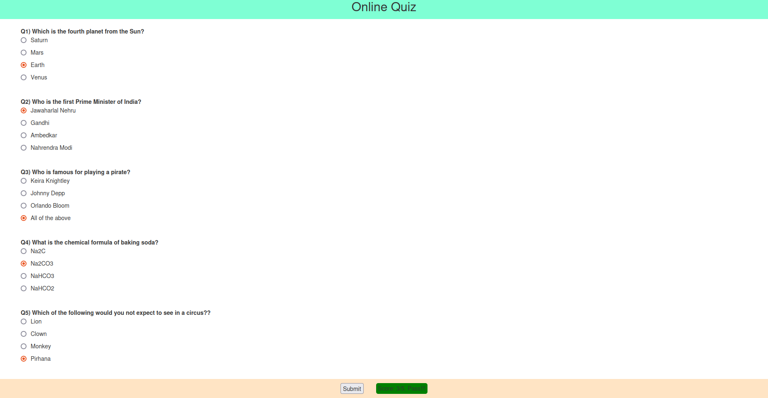

**Question – 2**

**Code:**

**HTML**

<!DOCTYPE html>

<html lang="en">

<head>

<meta charset="UTF-8">

<meta name="viewport" content="width=device-width, initial-scale=1.0">

<title>Q-2</title>

<link rel="stylesheet" href="q2.css">

</head>

<body>

<div class="container">

<h1 id="greeting"></h1>

<div class="clock" id="clock"></div>

<button class="button" onclick="wishUser();">Request a greeting!</button>

</div>

<script src="q2.js"></script>

</body>

</html>

**CSS**

/* Basic Styles */

body {

font-family: Arial, sans-serif;

background: #f0f8ff;

display: flex;

justify-content: center;

align-items: center;

height: 100vh;

margin: 0;

flex-direction: column;

}

/* Container for the greeting and clock */

.container {

text-align: center;

}

/* Greeting message style */

#greeting {

font-size: 2rem;

margin: 20px;

color: #333;

}

/* Clock style */

.clock {

font-size: 3rem;

color: #000;

font-weight: bold;

}

/* Styling for the message box */

.dialog-box {

font-size: 1.2rem;

padding: 10px;

margin-top: 20px;

border: 2px solid #2900bd;

background-color: #72e782;

}

button {

padding: 15px 15px;

background-color: darkcyan;

color: chartreuse;

}

**JS**

// Function to wish the user based on the time of the day

function wishUser() {

const today = new Date();

const hour = today.getHours();

let greeting = '';

if (hour >= 0 && hour < 12) {

greeting = 'Good Morning!';

} else if (hour >= 12 && hour < 18) {

greeting = 'Good Afternoon!';

} else {

greeting = 'Good Evening!';

}

// Display greeting in an alert

alert(greeting);

// Update greeting message on the page

document.getElementById('greeting').textContent = greeting;

}

// Function to update the clock every second

function updateClock() {

const today = new Date();

let hours = today.getHours();

let minutes = today.getMinutes();

let seconds = today.getSeconds();

// Add leading zero if necessary

hours = (hours < 10 ? '0' : '') + hours;

minutes = (minutes < 10 ? '0' : '') + minutes;

seconds = (seconds < 10 ? '0' : '') + seconds;

const timeString = hours + ':' + minutes + ':' + seconds;

// Display clock on the webpage

document.getElementById('clock').textContent = timeString;

}

// Initialize the wish and clock update

window.onload = function() {

wishUser(); // Wish the user when the page loads

setInterval(updateClock, 1000); // Update the clock every second

};

**Output:**

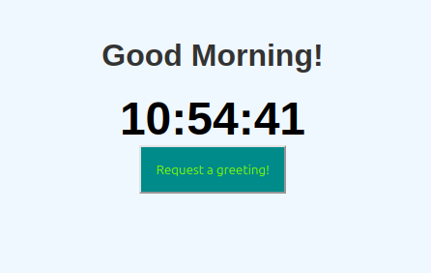

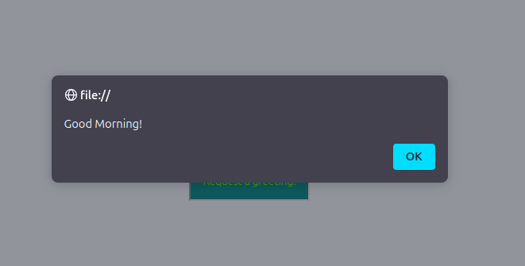

**Question – 3**

**Code:**

**HTML**

<!DOCTYPE html>

<html>

<head>

<title>Q-3</title>

<meta charset="utf-8">

<meta name="viewport" content="width=device-width, initial-scale=1">

<link rel="stylesheet" href="https://maxcdn.bootstrapcdn.com/bootstrap/3.4.1/css/bootstrap.min.css">

<script src="https://ajax.googleapis.com/ajax/libs/jquery/3.7.1/jquery.min.js"></script>

<script src="https://maxcdn.bootstrapcdn.com/bootstrap/3.4.1/js/bootstrap.min.js"></script>

<link rel="stylesheet" href="q3.css">

</head>

<body class="container align-items-center">

<form class="form">

<fieldset>

<legend>Enter your marks!</legend>

<div class="input">

<label>English</label>

<input type="number" min="0" max="100" required>

</div>

<div class="input">

<label>Mathematics</label>

<input type="number" min="0" max="100" required>

</div>

<div class="input">

<label>Computer Science</label>

<input type="number" min="0" max="100" required>

</div>

<div class="input">

<label>Science</label>

<input type="number" min="0" max="100" required>

</div>

<div style="display: flex; flex-direction: row; align-items: center;">

<button type="button" onclick="submit_form();">Submit!</button>

<div id="result" style="display: none; padding: 2px 5px; border-radius: 5px;"></div>

</div>

</fieldset>

</form>

</body>

<script src="q3.js"></script>

</html>

**CSS**

div.input {

display: flex;

flex-direction: row;

gap: 20px;

margin: 0px 30px 30px 20px;

}

button {

padding: 10px 15px;

background-color: darkcyan;

color: rgb(255, 255, 255);

margin: 0px 30px 30px 20px;

}

**JS**

function submit_form() {

let inputs = Array.from(document.getElementsByTagName('input'));

let result_div = document.getElementById("result");

const length = inputs.length;

let values = inputs.map((input_element) => input_element.value).map(Number);

const avg = values.reduce((partialSum, a) => partialSum + a, 0) / length;

console.log(avg);

let result_string;

if (avg > 90){

result_string = "A";

}

else if (avg > 80){

result_string = "B";

}

else if (avg > 70){

result_string = "C";

}

else if (avg > 60){

result_string = "D";

}

else{

result_string = "F";

}

if (result_string === "F") {

result_div.style.color = 'red';

}

else {

result_div.style.color = 'green';

}

result_div.innerText = `Grade: ${result_string}`;

result_div.style.display = 'block';

}

**Output:**

