**Question – 1**

**Code:**

**HTML**

<!DOCTYPE html>

<html lang="en">

<head>

<meta charset="UTF-8">

<meta name="viewport" content="width=device-width, initial-scale=1.0">

<title>Table and Image Move</title>

<link rel="stylesheet" href="q1.css">

</head>

<body>

<div class="container">

<table id="data-table">

<tr>

<td>1</td>

<td>2</td>

<td>3</td>

</tr>

<tr>

<td>4</td>

<td>5</td>

<td>6</td>

</tr>

<tr>

<td>7</td>

<td>8</td>

<td>9</td>

</tr>

</table>

<img width="300" src="https://cdn.i-scmp.com/sites/default/files/styles/1020x680/public/d8/images/canvas/2021/10/30/85f2cb5f-44f8-4f2f-a813-63e657e11acc_5065cac7.jpg?itok=dugQzfiu&v=1635566576" alt="Image" id="image">

</div>

<button id="move-button">Toggle</button>

<script src="q1.js"></script>

</body>

</html>

**CSS**

body {

font-family: Arial, sans-serif;

}

.container {

display: flex;

justify-content: center;

align-items: center;

position: relative;

overflow: hidden;

width: 100%;

height: 300px;

margin-top: 20px;

}

table {

border-collapse: collapse;

margin: 20px;

}

td {

padding: 10px;

border: 1px solid black;

text-align: center;

}

tr:nth-child(even) {

background-color: #be9090;

}

tr:nth-child(odd) {

background-color: #4c8496;

}

#image {

margin-left: 20px;

}

button {

display: block;

margin: 20px auto;

padding: 10px 20px;

cursor: pointer;

font-size: 16px;

background-color: #4CAF50;

color: white;

border: none;

border-radius: 5px;

}

**JS**

let img_status = 'right';

document.getElementById('move-button').addEventListener('click', function() {

const tableAndImage = document.querySelector('.container');

if (img_status === 'right') {

img_status = 'left';

// Reset animation to allow multiple clicks

tableAndImage.style.transition = 'none';

tableAndImage.offsetHeight; // Trigger reflow to reset animation

// Start the movement with a transition

tableAndImage.style.transition = 'transform 2s ease';

tableAndImage.style.transform = 'translateX(-35%)';

}

else {

img_status = 'right';

// Reset animation to allow multiple clicks

tableAndImage.style.transition = 'none';

tableAndImage.offsetHeight; // Trigger reflow to reset animation

// Start the movement with a transition

tableAndImage.style.transition = 'transform 2s ease';

tableAndImage.style.transform = 'translateX(+35%)';

}

});

**Output:**

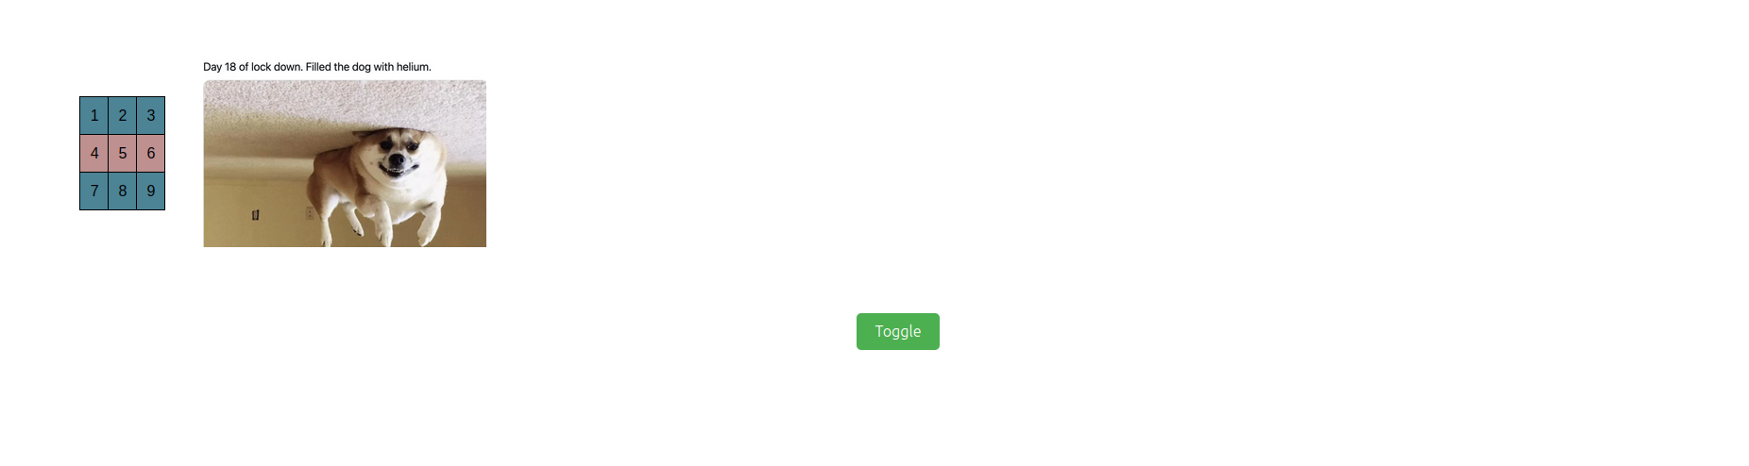

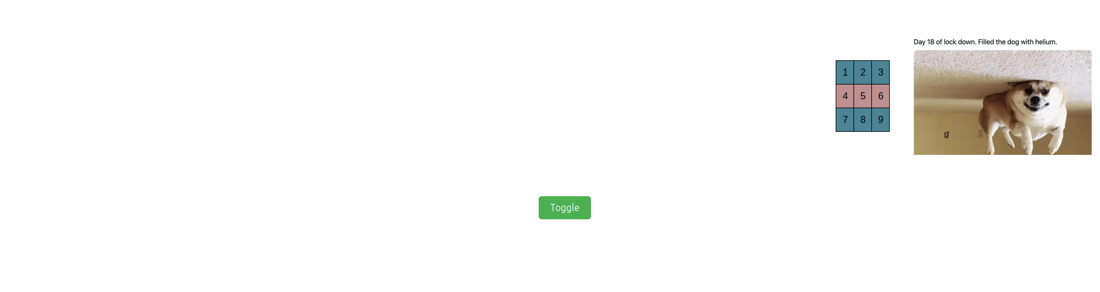

**Question – 2**

**Code:**

**HTML**

<!DOCTYPE html>

<html>

<head>

<meta charset="UTF-8">

<meta name="viewport" content="width=device-width, initial-scale=1.0">

<title>Calculator</title>

<link rel="stylesheet" href="q2.css">

</head>

<body>

<h3>

Simple Calculator

</h3>

<div id="calc_div">

<input id="disp" type="text">

<table>

<tr>

<td>

<button>1</button>

</td>

<td>

<button>2</button>

</td>

<td>

<button>3</button>

</td>

<td>

<button>+</button>

</td>

</tr>

<tr>

<td>

<button>4</button>

</td>

<td>

<button>5</button>

</td>

<td>

<button>6</button>

</td>

<td>

<button>-</button>

</td>

</tr>

<tr>

<td>

<button>7</button>

</td>

<td>

<button>8</button>

</td>

<td>

<button>9</button>

</td>

<td>

<button>x</button>

</td>

</tr>

<tr>

<td>

<button>0</button>

</td>

<td>

<button>CLR</button>

</td>

<td>

<button>=</button>

</td>

<td>

<button>/</button>

</td>

</tr>

</table>

</div>

</body>

<script src="https://code.jquery.com/jquery-3.6.3.min.js"></script>

<script src="q2.js"></script>

</html>

**CSS**

body {

display: flex;

flex-direction: column;

align-items: center;

text-align: center;

}

#calc_div {

margin-top: 10px;

background-color: aquamarine;

width: fit-content;

padding: 10px 10px;

border-radius: 3%;;

}

#disp {

border-radius: 3%;

background-color: white;

color: black;

}

button {

width: 40px;

font-family:'Courier New', Courier, monospace;

}

**JS**

const display_bar = $('#disp');

function calc(expression) {

try {

var result = eval(expression); // Calculate the result using eval

return result;

} catch (error) {

return "ERROR";

}

}

$(document).ready(function() {

// This will add an onclick function to all buttons on the page

$('button').click(function() {

var buttonText = $(this).text(); // Get the text of the clicked button

console.log(buttonText + " button clicked!");

if (buttonText === "CLR") {

display_bar.val("");

}

else if (buttonText === "=") {

let result = calc(display_bar.val());

display_bar.val(result);

}

else if (buttonText === "x") {

display_bar.val(display_bar.val() + "*");

}

else {

display_bar.val(display_bar.val() + buttonText);

}

display_bar.focus()

});

});

**Output:**

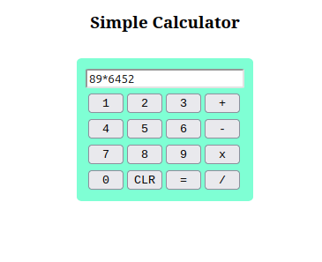

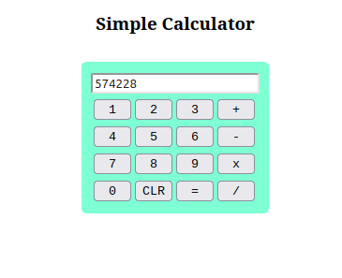

**Question – 3**

**Code:**

**HTML**

<!DOCTYPE html>

<html>

<head>

<meta charset="UTF-8">

<meta name="viewport" content="width=device-width, initial-scale=1.0">

<title>Card-Maker</title>

<link rel="stylesheet" href="q3.css">

</head>

<body>

<div class="maker">

<h3 style="font-family: 'Courier New', Courier, monospace;">

Card-Maker

</h3>

<div class="container" style="border: das;">

<label>Choose background color:</label>

<select class="color">

<option value="red">Red</option>

<option value="green">Green</option>

<option value="#3e9df0">Blue</option>

<option value="pink">Pink</option>

<option value="yellow">Yellow</option>

</select>

</div>

<div class="container">

<label>Choose text font:</label>

<select class="font">

<option value="Verdana">Verdana</option>

<option value="Arial Narrow">Arial Narrow</option>

<option value="Times New Roman">Times New Roman</option>

<option value="cursive">Cursive</option>

<option value="Brush Script">Brush Script</option>

<option value="Comic Sans MS">Comic Sans</option>

</select>

</div>

<div class="container">

<label>Choose font size:</label>

<input class="size" type="number" min="10" max="30" value="15">

</div>

<div class="container">

<label>Choose border style:</label>

<select class="border">

<option value="none">None</option>

<option value="solid">Solid</option>

<option value="double">Double</option>

<option value="dashed">Dashed</option>

<option value="dotted">Dotted</option>

</select>

</div>

<div class="container">

<label>Enter the text:</label>

<textarea class="text" rows="4" cols="50"></textarea>

</div>

<div class="container">

<label>Enter the image url:</label>

<input class="url" type="text"></textarea>

</div>

<button onclick="makeCard();">Make the card!</button>

</div>

<div class="card" id="card">

<h3 style="font-family: 'Courier New', Courier, monospace;">

Display

</h3>

<div class="text">

Text goes here...

</div>

<div class="image">

<img width="300" src="https://cdn.i-scmp.com/sites/default/files/styles/1020x680/public/d8/images/canvas/2021/10/30/85f2cb5f-44f8-4f2f-a813-63e657e11acc_5065cac7.jpg?itok=dugQzfiu&v=1635566576">

</div>

</div>

</body>

<script src="https://code.jquery.com/jquery-3.6.3.min.js"></script>

<script src="q3.js"></script>

</html>

**CSS**

body {

display: flex;

flex-direction: row;

justify-content: space-around;

align-items: center;

}

button {

width: 120px;

height: 40px;

background-color: beige;

}

div.maker {

display: flex;

flex-direction: column;

gap: 30px;

}

div.container {

display: flex;

flex-direction: row;

gap: 20px;

}

div.card {

display: flex;

flex-direction: column;

gap: 30px;

padding: 20px 20px;

}

**JS**

const card = $('#card');

const img = $('img');

const text = $('div.text');

const color_select = $('select.color');

const font_select = $('select.font');

const size_input = $('input.size');

const border_select = $('select.border');

const text_input = $('textarea');

const url_input = $('input.url');

function makeCard() {

console.log(text_input.val());

card.css({

'background-color': color_select.val(),

'border': border_select.val()

});

text.css({

'font-family': font_select.val(),

'font-size': size_input.val() + 'px'

});

text.text(text_input.val());

if (url_input.val().trim() === "") {

return;

}

else {

img.attr('src', url_input.val());

}

}

**Output:**

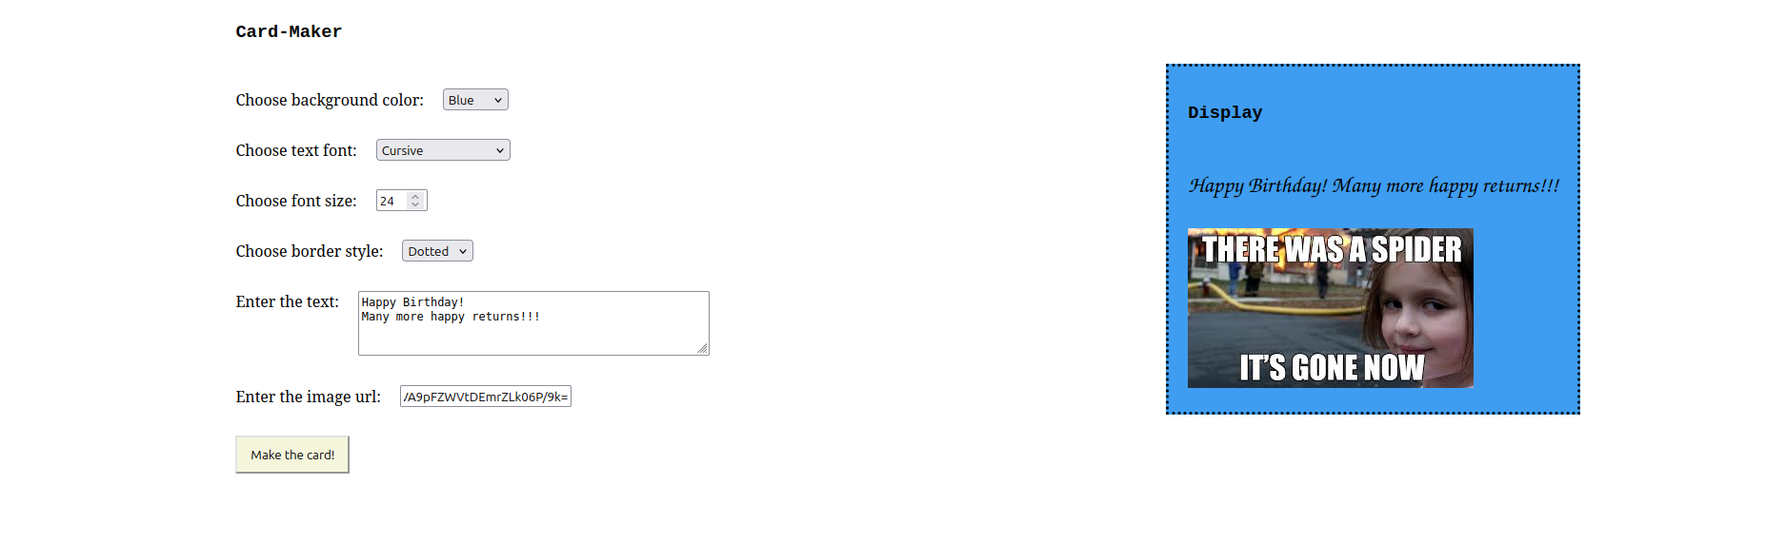

**Question – 4**

**Code:**

**HTML**

<!DOCTYPE html>

<html lang="en">

<head>

<meta charset="UTF-8">

<meta name="viewport" content="width=device-width, initial-scale=1.0">

<title>Produce Bill</title>

<link rel="stylesheet" href="q4.css">

</head>

<body>

<div class="container">

<h1>Product Billing</h1>

<div class="form-group">

<label for="brandDropdown">Select Brand:</label>

<select id="brandDropdown">

<option value="hp">HP</option>

<option value="nokia">Nokia</option>

<option value="samsung">Samsung</option>

<option value="motorola">Motorola</option>

<option value="apple">Apple</option>

</select>

</div>

<div class="form-group">

<label>Product Type:</label>

<input type="checkbox" id="mobile" value="mobile"> Mobile

<input type="checkbox" id="laptop" value="laptop"> Laptop

</div>

<div class="form-group">

<label for="quantity">Enter Quantity:</label>

<input type="number" id="quantity" min="1" value="1">

</div>

<button id="produceBillButton">Produce Bill</button>

</div>

<script src="https://code.jquery.com/jquery-3.6.0.min.js"></script>

<script src="q4.js"></script>

</body>

</html>

**CSS**

body {

font-family: Arial, sans-serif;

margin: 0;

padding: 0;

background-color: #f4f4f4;

}

.container {

width: 300px;

margin: 100px auto;

padding: 20px;

background-color: white;

box-shadow: 0px 0px 10px rgba(0, 0, 0, 0.1);

border-radius: 8px;

}

h1 {

text-align: center;

color: #333;

}

.form-group {

margin-bottom: 15px;

}

label {

font-size: 14px;

color: #555;

display: block;

margin-bottom: 5px;

}

select, input[type="number"], button {

width: 100%;

padding: 8px;

font-size: 14px;

border-radius: 4px;

border: 1px solid #ccc;

}

button {

background-color: #4CAF50;

color: white;

border: none;

cursor: pointer;

margin-top: 10px;

}

button:hover {

background-color: #45a049;

}

**JS**

$(document).ready(function() {

$('#produceBillButton').click(function() {

// Get selected brand

var selectedBrand = $('#brandDropdown').val();

// Get selected product type (mobile and/or laptop)

var mobileSelected = $('#mobile').prop('checked');

var laptopSelected = $('#laptop').prop('checked');

// Get quantity

var quantity = $('#quantity').val();

quantity = parseInt(quantity);

// Price list for each product

var prices = {

hp: { mobile: 500, laptop: 1000 },

nokia: { mobile: 400, laptop: 900 },

samsung: { mobile: 600, laptop: 1100 },

motorola: { mobile: 450, laptop: 950 },

apple: { mobile: 800, laptop: 1200 }

};

// Calculate total amount

var totalAmount = 0;

if (mobileSelected) {

totalAmount += prices[selectedBrand].mobile * quantity;

}

if (laptopSelected) {

totalAmount += prices[selectedBrand].laptop * quantity;

}

// Display the total amount in an alert

alert("Total Amount: $" + totalAmount);

});

});

**Output:**

