**Sriram Sunderrajan**

**220962444**

**Q-1:**

**Code:**

<!doctype html>

<html>

<head>

<meta charset="utf-8">

<title>Basic Site Template</title>

</head>

<body style="display: flex; flex-direction: column; align-items: center; justify-content: center; width: 100%; height: 100vh;">

<form>

<fieldset style="display: flex; flex-direction: column; gap: 30px;">

<legend><h3>Student Details Form:</h3></legend>

<div>

<label>Name:</label>

<input type="text" id="name_input">

</div>

<div>

<label>Date of birth:</label>

<input type="date" id="dob_input">

</div>

<div>

<label>Contact number:</label>

<input type="number" min="1000000000" max="9999999999" id="phone_input">

</div>

<div>

<label>Email:</label>

<input type="email" id="email_input">

</div>

<div style="text-align: left;">

<h4>Marks:</h4>

<div style="display: flex; flex-direction: column;">

<div>

<label style="margin-right: 20px;">English:</label>

<input type="number" min="0" max="100" class="subject_input">

</div>

<div>

<label style="margin-right: 20px;">Maths:</label>

<input type="number" min="0" max="100" class="subject_input">

</div>

<div>

<label style="margin-right: 20px;">Physics:</label>

<input type="number" min="0" max="100" class="subject_input">

</div>

</div>

</div>

<button type="button" onclick="submit_form();">Submit</button>

<textarea id="disp_text" style="display: none; height: fit-content;"></textarea>

<label style="display: none;">Average marks across subjects: </label>

</fieldset>

</form>

</body>

<script src="https://code.jquery.com/jquery-3.6.0.min.js"></script>

<script>

function submit_form() {

let text = "";

text += "Name: " + $('#name_input').val();

text += " Date of Birth: " + $('#dob_input').val();

text += " Phone number: +91 " + $('#phone_input').val();

text += " Email: " + $('#email_input').val();

let arr = $('input.subject_input');

let avg = 0.0;

for (var key in arr) {

if (arr.hasOwnProperty(key)) {

console.log(key + " -> " + parseFloat(arr[key]['value']));

avg += parseFloat(arr[key]['value']);

}

}

console.log(avg)

text += " Average marks across subjects: " + 4;

console.log(text);

let disp = $('textarea');

disp.html(text);

disp.css('display', 'block');

}

</script>

</html>

from django.shortcuts import render

from django.http import HttpResponse

def index(request):

return render(request, 'form.html')

**Output:**

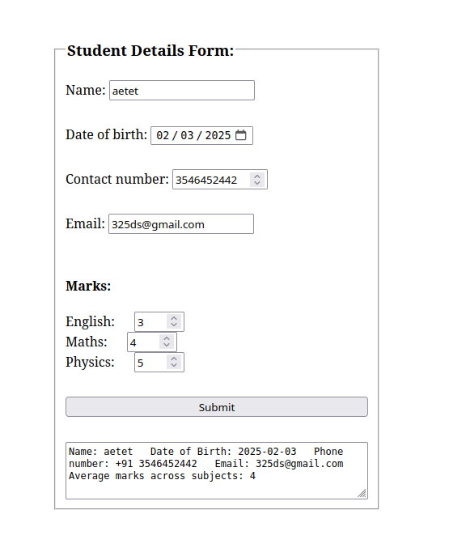s

**Q-2**

**Codes:**

**base.html**

<!DOCTYPE html>

<html>

<head>

<title>Employee Details Form</title>

</head>

<body>

<h1>Enter Employee Details</h1>

<form method="POST">

{% csrf_token %}

{{ form.as_p }}

<button type="submit">“Am I Eligible for Promotion:</button>

</form>

<!-- {% if employee_info %}

<label for="result"><h1>{{ result }}</h1></label>

{% endif %} -->

{% if result %}

<h2>Eligibility Result:</h2>

<p>Employee ID: {{ employee_info.employee_id }}</p>

<p>Date of Joining: {{ employee_info.doj }}</p>

<p>Eligibility for Promotion: {{ result }}</p>

{% endif %}

</body>

</html>

**forms.py**

**f**rom django import forms

EMPLOYEE_IDS = [

('101', 'Employee 101'),

('102', 'Employee 102'),

('103', 'Employee 103'),

('104', 'Employee 104'),

]

class EmployeeForm(forms.Form):

employee_id = forms.ChoiceField(label="Employee ID", choices=EMPLOYEE_IDS)

doj = forms.CharField(label="Date of Joining", max_length=100)

views.py

from django.shortcuts import render

from django.http import HttpResponse

from .forms import EmployeeForm

from datetime import date,datetime

def index(request):

return HttpResponse("<H2>HEY! Welcome to Edureka! </H2>")

def employee_details(request):

result = None

employee_info = None

if request.method == 'POST':

form = EmployeeForm(request.POST)

if form.is_valid():

employee_id = form.cleaned_data['employee_id']

doj = form.cleaned_data['doj']

today = date.today()

try:

date_of_joining = datetime.strptime(doj, "%d-%m-%Y").date()

except ValueError:

date_of_joining = None

difference_in_years = (today - date_of_joining).days / 365.25 # Dividing by 365.25 accounts for leap years

if difference_in_years > 5:

result = "Yes"

else:

result = "No"

# year = int(year)

# month = int(month)

# date1 = int(date1)

employee_info = {

'employee_id': employee_id,

'doj':doj,

}

else:

form = EmployeeForm()

return render(request, 'base.html', {'form': form, 'employee_info': employee_info, 'result': result})

**Output:**

