Sriram Sunderrajan

220962444

WP Lab

Week-6

20th February 2025

PROJECT FILES

settings.py

"""

Django settings for myProj project.

Generated by 'django-admin startproject' using Django 5.1.6.

For more information on this file, see

https://docs.djangoproject.com/en/5.1/topics/settings/

For the full list of settings and their values, see

https://docs.djangoproject.com/en/5.1/ref/settings/

"""

from pathlib import Path

import os

# Build paths inside the project like this: BASE_DIR / 'subdir'.

BASE_DIR = Path(__file__).resolve().parent.parent

# Quick-start development settings - unsuitable for production

# See https://docs.djangoproject.com/en/5.1/howto/deployment/checklist/

# SECURITY WARNING: keep the secret key used in production secret!

SECRET_KEY = 'django-insecure-_z-ts%wnrs7wnqd3$vo*iv^a#yr1a^y6%ld1ymo#(&q%=owvk5'

# SECURITY WARNING: don't run with debug turned on in production!

DEBUG = True

ALLOWED_HOSTS = []

# Application definition

INSTALLED_APPS = [

'django.contrib.admin',

'django.contrib.auth',

'django.contrib.contenttypes',

'django.contrib.sessions',

'django.contrib.messages',

'django.contrib.staticfiles',

]

MIDDLEWARE = [

'django.middleware.security.SecurityMiddleware',

'django.contrib.sessions.middleware.SessionMiddleware',

'django.middleware.common.CommonMiddleware',

'django.middleware.csrf.CsrfViewMiddleware',

'django.contrib.auth.middleware.AuthenticationMiddleware',

'django.contrib.messages.middleware.MessageMiddleware',

'django.middleware.clickjacking.XFrameOptionsMiddleware',

]

ROOT_URLCONF = 'myProj.urls'

TEMPLATES = [

{

'BACKEND': 'django.template.backends.django.DjangoTemplates',

'DIRS': [

os.path.join(BASE_DIR, 'Calculator/templates'),

os.path.join(BASE_DIR, 'frontCover/templates'),

os.path.join(BASE_DIR, 'bookInfo/templates'),

],

'APP_DIRS': True,

'OPTIONS': {

'context_processors': [

'django.template.context_processors.debug',

'django.template.context_processors.request',

'django.contrib.auth.context_processors.auth',

'django.contrib.messages.context_processors.messages',

],

},

},

]

STATICFILES_FINDERS = [

"django.contrib.staticfiles.finders.FileSystemFinder",

"django.contrib.staticfiles.finders.AppDirectoriesFinder",

]

# Add the following lines:

STATIC_URL = '/static/'

# Define where static files will be collected

STATICFILES_DIRS = [

BASE_DIR / 'static', # Add your project's 'static' folder here

]

STATIC_ROOT = BASE_DIR / 'staticfiles'

print(BASE_DIR)

print(STATIC_ROOT)

WSGI_APPLICATION = 'myProj.wsgi.application'

# Database

# https://docs.djangoproject.com/en/5.1/ref/settings/#databases

DATABASES = {

'default': {

'ENGINE': 'django.db.backends.sqlite3',

'NAME': BASE_DIR / 'db.sqlite3',

}

}

# Password validation

# https://docs.djangoproject.com/en/5.1/ref/settings/#auth-password-validators

AUTH_PASSWORD_VALIDATORS = [

{

'NAME': 'django.contrib.auth.password_validation.UserAttributeSimilarityValidator',

},

{

'NAME': 'django.contrib.auth.password_validation.MinimumLengthValidator',

},

{

'NAME': 'django.contrib.auth.password_validation.CommonPasswordValidator',

},

{

'NAME': 'django.contrib.auth.password_validation.NumericPasswordValidator',

},

]

# Internationalization

# https://docs.djangoproject.com/en/5.1/topics/i18n/

LANGUAGE_CODE = 'en-us'

TIME_ZONE = 'UTC'

USE_I18N = True

USE_TZ = True

# Static files (CSS, JavaScript, Images)

# https://docs.djangoproject.com/en/5.1/howto/static-files/

STATIC_URL = 'static/'

# Default primary key field type

# https://docs.djangoproject.com/en/5.1/ref/settings/#default-auto-field

DEFAULT_AUTO_FIELD = 'django.db.models.BigAutoField'

urls.py

"""

URL configuration for myProj project.

The `urlpatterns` list routes URLs to views. For more information please see:

https://docs.djangoproject.com/en/5.1/topics/http/urls/

Examples:

Function views

1. Add an import: from my_app import views

2. Add a URL to urlpatterns: path('', views.home, name='home')

Class-based views

1. Add an import: from other_app.views import Home

2. Add a URL to urlpatterns: path('', Home.as_view(), name='home')

Including another URLconf

1. Import the include() function: from django.urls import include, path

2. Add a URL to urlpatterns: path('blog/', include('blog.urls'))

"""

from django.conf import settings

from django.conf.urls.static import static

from django.contrib import admin

from django.urls import path, include, re_path

urlpatterns = [

path('admin/', admin.site.urls),

re_path(r'^admin/', admin.site.urls),

re_path(r'^Calculator/', include('Calculator.urls')),

re_path(r'^frontCover/', include('frontCover.urls')),

re_path(r'^bookInfo/', include('bookInfo.urls')),

]

# This line serves static files during development

if settings.DEBUG:

urlpatterns += static(settings.STATIC_URL, document_root=settings.STATIC_ROOT)

Question – 1

urls.py

from django.urls import re_path

from . import views

urlpatterns = [

re_path(r'^$', views.index, name='index'),

]

views.py

from django.shortcuts import render

from django.http import HttpResponse

def index(request):

return render(request, 'index.html')

CODE:

HTML

{% load static %}

<!DOCTYPE html>

<html>

<head>

<meta charset="UTF-8">

<meta name="viewport" content="width=device-width, initial-scale=1.0">

<title>Calculator</title>

<link rel="stylesheet" href="{% static 'index.css' %}">

</head>

<style>body {

display: flex;

flex-direction: column;

align-items: center;

text-align: center;

}

#calc_div {

margin-top: 10px;

background-color: aquamarine;

width: fit-content;

padding: 10px 10px;

border-radius: 3%;;

}

#disp {

border-radius: 3%;

background-color: white;

color: black;

}

button {

width: 40px;

font-family:'Courier New', Courier, monospace;

}</style>

<body>

<h3>

Simple Calculator

</h3>

<div id="calc_div">

<input id="disp" type="text">

<table>

<tr>

<td>

<button>1</button>

</td>

<td>

<button>2</button>

</td>

<td>

<button>3</button>

</td>

<td>

<button>+</button>

</td>

</tr>

<tr>

<td>

<button>4</button>

</td>

<td>

<button>5</button>

</td>

<td>

<button>6</button>

</td>

<td>

<button>-</button>

</td>

</tr>

<tr>

<td>

<button>7</button>

</td>

<td>

<button>8</button>

</td>

<td>

<button>9</button>

</td>

<td>

<button>x</button>

</td>

</tr>

<tr>

<td>

<button>0</button>

</td>

<td>

<button>CLR</button>

</td>

<td>

<button>=</button>

</td>

<td>

<button>/</button>

</td>

</tr>

</table>

</div>

</body>

<script src="https://code.jquery.com/jquery-3.6.3.min.js"></script>

<script>

const display_bar = $('#disp');

function calc(expression) {

try {

var result = eval(expression); // Calculate the result using eval

return result;

} catch (error) {

return "ERROR";

}

}

$(document).ready(function() {

// This will add an onclick function to all buttons on the page

$('button').click(function() {

var buttonText = $(this).text(); // Get the text of the clicked button

console.log(buttonText + " button clicked!");

if (buttonText === "CLR") {

display_bar.val("");

}

else if (buttonText === "=") {

let result = calc(display_bar.val());

display_bar.val(result);

}

else if (buttonText === "x") {

display_bar.val(display_bar.val() + "*");

}

else {

display_bar.val(display_bar.val() + buttonText);

}

display_bar.focus()

});

});

</script>

</html>

OUTPUT

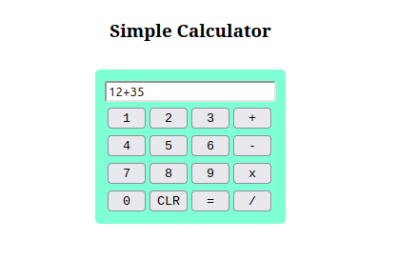

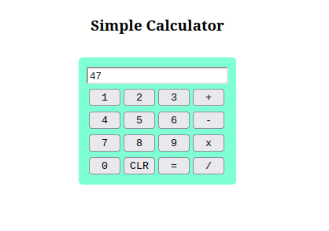

Question – 2

urls.py

from django.urls import re_path

from . import views

urlpatterns = [

re_path(r'^$', views.index, name='index'),

]

views.py

from django.shortcuts import render

from django.http import HttpResponse

def index(request):

return render(request, 'q2.html')

CODE:

HTML

{% load static %}

<!DOCTYPE html>

<html lang="en">

<head>

<meta charset="UTF-8">

<meta name="viewport" content="width=device-width, initial-scale=1.0">

<title>Magazine Front Cover Generator</title>

<link rel="stylesheet" href="{% static 'frontCover/q2.css' %}">

</head>

<body>

<div class="container">

<h1>Create Your Magazine Front Cover</h1>

<form id="coverForm">

<label for="coverImage">Choose Cover Image:</label>

<input type="file" id="coverImage" accept="image/*">

<label for="backgroundColor">Background Color:</label>

<input type="color" id="backgroundColor" value="#ffffff">

<label for="headlineText">Headline Text:</label>

<input type="text" id="headlineText" placeholder="Enter headline">

<label for="headlineFontSize">Headline Font Size:</label>

<input type="number" id="headlineFontSize" value="36" min="10" max="100">

<label for="headlineFontColor">Headline Font Color:</label>

<input type="color" id="headlineFontColor" value="#000000">

<label for="subheadingText">Subheading Text:</label>

<input type="text" id="subheadingText" placeholder="Enter subheading">

<label for="subheadingFontSize">Subheading Font Size:</label>

<input type="number" id="subheadingFontSize" value="24" min="10" max="60">

<label for="subheadingFontColor">Subheading Font Color:</label>

<input type="color" id="subheadingFontColor" value="#000000">

<button type="submit">Generate Front Cover</button>

</form>

<div id="coverPreview" class="cover-preview">

<div id="cover" class="cover">

<div id="coverContent">

<h1 id="headline">Your Headline Here</h1>

<h2 id="subheading">Your Subheading Here</h2>

</div>

</div>

</div>

</div>

<script src="{% static 'frontCover/q2.js' %}"></script>

</body>

</html>

CSS

* {

margin: 0;

padding: 0;

box-sizing: border-box;

}

body {

font-family: Arial, sans-serif;

background-color: #f0f0f0;

display: flex;

justify-content: center;

align-items: center;

min-height: 100vh;

}

.container {

width: 80%;

max-width: 1000px;

margin: 0 auto;

padding: 20px;

background-color: #fff;

border-radius: 10px;

box-shadow: 0 0 15px rgba(0, 0, 0, 0.1);

}

h1 {

text-align: center;

margin-bottom: 20px;

}

form {

display: flex;

flex-direction: column;

gap: 15px;

}

input[type="file"],

input[type="color"],

input[type="number"],

input[type="text"] {

padding: 8px;

border-radius: 5px;

border: 1px solid #ccc;

}

button {

padding: 10px;

border: none;

background-color: #4CAF50;

color: white;

border-radius: 5px;

cursor: pointer;

}

button:hover {

background-color: #45a049;

}

.cover-preview {

margin-top: 30px;

display: flex;

justify-content: center;

}

.cover {

position: relative;

width: 100%;

height: 600px;

background-size: cover;

background-position: center;

display: flex;

justify-content: center;

align-items: center;

}

#coverContent {

text-align: center;

color: white;

position: absolute;

}

#headline {

font-size: 36px;

font-weight: bold;

}

#subheading {

font-size: 24px;

margin-top: 20px;

}

JS

document.getElementById('coverForm').addEventListener('submit', function(e) {

e.preventDefault(); // Prevent form submission

// Get values from form inputs

const coverImage = document.getElementById('coverImage').files[0];

const backgroundColor = document.getElementById('backgroundColor').value;

const headlineText = document.getElementById('headlineText').value;

const headlineFontSize = document.getElementById('headlineFontSize').value;

const headlineFontColor = document.getElementById('headlineFontColor').value;

const subheadingText = document.getElementById('subheadingText').value;

const subheadingFontSize = document.getElementById('subheadingFontSize').value;

const subheadingFontColor = document.getElementById('subheadingFontColor').value;

// Set background color

const cover = document.getElementById('cover');

cover.style.backgroundColor = backgroundColor;

// Set image if selected

if (coverImage) {

const reader = new FileReader();

reader.onload = function(e) {

cover.style.backgroundImage = `url(${e.target.result})`;

};

reader.readAsDataURL(coverImage);

}

// Set headline text and styles

const headline = document.getElementById('headline');

headline.textContent = headlineText || 'Your Headline Here';

headline.style.fontSize = `${headlineFontSize}px`;

headline.style.color = headlineFontColor;

// Set subheading text and styles

const subheading = document.getElementById('subheading');

subheading.textContent = subheadingText || 'Your Subheading Here';

subheading.style.fontSize = `${subheadingFontSize}px`;

subheading.style.color = subheadingFontColor;

});

OUTPUT:

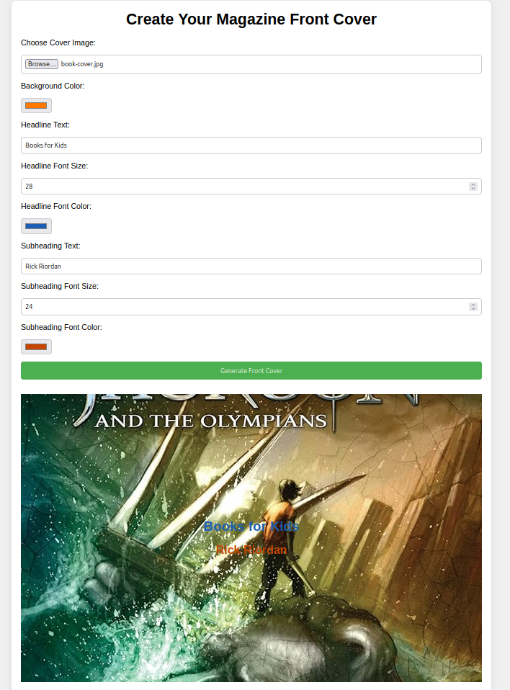

Question – 3

urls.py

from django.urls import re_path

from . import views

urlpatterns = [

re_path(r'^$', views.index, name='index'),

]

views.py

from django.shortcuts import render

from django.http import HttpResponse

def index(request):

return render(request, 'q3.html')

CODE:

HTML

{% load static %}

<!DOCTYPE html>

<html lang="en">

<head>

<meta charset="UTF-8">

<meta name="viewport" content="width=device-width, initial-scale=1.0">

<title>Book Information</title>

<link rel="stylesheet" href="{% static 'bookInfo/q3.css' %}">

</head>

<body>

<div class="container">

<!-- Home Page -->

<div id="homePage" class="page">

<h1>Book Information</h1>

<div class="book-cover">

<img src="{% static 'bookInfo/book-cover.jpg' %}" alt="Book Cover" id="bookCover">

</div>

<p>Click below to explore:</p>

<ul>

<li><a href="#" onclick="showPage('metadata')">Metadata</a></li>

<li><a href="#" onclick="showPage('reviews')">Reviews</a></li>

<li><a href="#" onclick="showPage('publisher')">Publisher Info</a></li>

</ul>

</div>

<!-- Metadata Page -->

<div id="metadataPage" class="page">

<h2>Metadata</h2>

<p><strong>Title:</strong> The Great Book</p>

<p><strong>Author:</strong> John Doe</p>

<p><strong>ISBN:</strong> 123-456-789</p>

<p><strong>Genre:</strong> Fiction</p>

<p><strong>Year:</strong> 2023</p>

<button onclick="goBackToHome()">Go to Home</button>

</div>

<!-- Reviews Page -->

<div id="reviewsPage" class="page">

<h2>Reviews</h2>

<p><strong>Reviewer 1:</strong> "An amazing book! A must-read for anyone who loves fiction."</p>

<p><strong>Reviewer 2:</strong> "Gripping plot with well-developed characters."</p>

<p><strong>Reviewer 3:</strong> "A thrilling journey from start to finish!"</p>

<button onclick="goBackToHome()">Go to Home</button>

</div>

<!-- Publisher Info Page -->

<div id="publisherPage" class="page">

<h2>Publisher Info</h2>

<p><strong>Publisher Name:</strong> XYZ Publishing</p>

<p><strong>Address:</strong> 123 Publishing St., City, Country</p>

<p><strong>Contact:</strong> +123-456-7890</p>

<button onclick="goBackToHome()">Go to Home</button>

</div>

</div>

<script src="% static 'bookInfo/q3.js' %"></script>

<script>

// Function to switch pages based on the page name

function showPage(page) {

console.log("Change Page!!!");

// Hide all pages

const pages = document.querySelectorAll('.page');

pages.forEach(page => {

page.style.display = 'none';

});

// Show the selected page

if (page === 'metadata') {

document.getElementById('metadataPage').style.display = 'block';

} else if (page === 'reviews') {

document.getElementById('reviewsPage').style.display = 'block';

} else if (page === 'publisher') {

document.getElementById('publisherPage').style.display = 'block';

}

}

// Function to go back to the home page

function goBackToHome() {

const pages = document.querySelectorAll('.page');

pages.forEach(page => {

page.style.display = 'none';

});

document.getElementById('homePage').style.display = 'block';

}

</script>

</body>

</html>

CSS

* {

margin: 0;

padding: 0;

box-sizing: border-box;

}

body {

font-family: Arial, sans-serif;

background-color: #f9f9f9;

display: flex;

justify-content: center;

align-items: center;

min-height: 100vh;

}

.container {

text-align: center;

width: 70%;

max-width: 800px;

}

h1, h2 {

color: #333;

}

.book-cover img {

width: 200px;

height: auto;

margin-bottom: 20px;

}

ul {

list-style-type: none;

}

ul li {

margin: 10px 0;

}

ul li a {

text-decoration: none;

color: #007BFF;

font-size: 18px;

}

ul li a:hover {

text-decoration: underline;

}

.page {

display: none;

}

.page button {

padding: 10px 20px;

background-color: #4CAF50;

color: white;

border: none;

border-radius: 5px;

cursor: pointer;

}

.page button:hover {

background-color: #45a049;

}

#homePage {

display: block; /* Show the home page by default */

}

JS

// Function to switch pages based on the page name

function showPage(page) {

console.log("Change Page!!!");

// Hide all pages

const pages = document.querySelectorAll('.page');

pages.forEach(page => {

page.style.display = 'none';

});

// Show the selected page

if (page === 'metadata') {

document.getElementById('metadataPage').style.display = 'block';

} else if (page === 'reviews') {

document.getElementById('reviewsPage').style.display = 'block';

} else if (page === 'publisher') {

document.getElementById('publisherPage').style.display = 'block';

}

}

// Function to go back to the home page

function goBackToHome() {

const pages = document.querySelectorAll('.page');

pages.forEach(page => {

page.style.display = 'none';

});

document.getElementById('homePage').style.display = 'block';

}

OUTPUT:

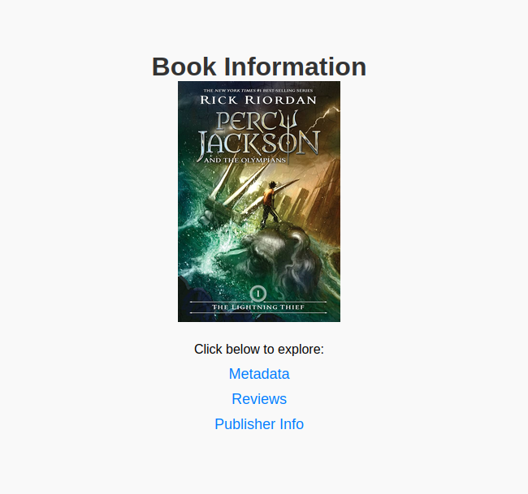d

