Question – 1

Code:

HTML

<!DOCTYPE html>
<html lang="en">
<head>
<meta charset="UTF-8">
<meta name="viewport" content="width=device-width, initial-scale=1.0">
<title>Table and Image Move</title>
<link rel="stylesheet" href="q1.css">
</head>
<body>

<div class="container">
<table id="data-table">
<tr>
<td>1</td>
<td>2</td>
<td>3</td>
</tr>
<tr>
<td>4</td>
<td>5</td>
<td>6</td>
</tr>
<tr>
<td>7</td>
<td>8</td>
<td>9</td>
</tr>
</table>
<img width="300" src="https://cdn.i-scmp.com/sites/default/files/styles/1020x680/public/d8/images/canvas/2021/10/30/85f2cb5f-44f8-4f2f-a813-63e657e11acc_5065cac7.jpg?itok=dugQzfiu&v=1635566576" alt="Image" id="image">
</div>

<button id="move-button">Toggle</button>

<script src="q1.js"></script>
</body>
</html>

CSS

body {
font-family: Arial, sans-serif;
}

.container {
display: flex;
justify-content: center;
align-items: center;
position: relative;
overflow: hidden;
width: 100%;
height: 300px;
margin-top: 20px;
}

table {
border-collapse: collapse;
margin: 20px;
}

td {
padding: 10px;
border: 1px solid black;
text-align: center;
}

tr:nth-child(even) {
background-color: #be9090;
}

tr:nth-child(odd) {
background-color: #4c8496;
}

#image {
margin-left: 20px;
}

button {
display: block;
margin: 20px auto;
padding: 10px 20px;
cursor: pointer;
font-size: 16px;
background-color: #4CAF50;
color: white;
border: none;
border-radius: 5px;
}

JS

let img_status = 'right';

document.getElementById('move-button').addEventListener('click', function() {
const tableAndImage = document.querySelector('.container');
if (img_status === 'right') {
img_status = 'left';
// Reset animation to allow multiple clicks
tableAndImage.style.transition = 'none';
tableAndImage.offsetHeight; // Trigger reflow to reset animation
// Start the movement with a transition
tableAndImage.style.transition = 'transform 2s ease';
tableAndImage.style.transform = 'translateX(-35%)';
}
else {
img_status = 'right';
// Reset animation to allow multiple clicks
tableAndImage.style.transition = 'none';
tableAndImage.offsetHeight; // Trigger reflow to reset animation
// Start the movement with a transition
tableAndImage.style.transition = 'transform 2s ease';
tableAndImage.style.transform = 'translateX(+35%)';
}
});

Output:

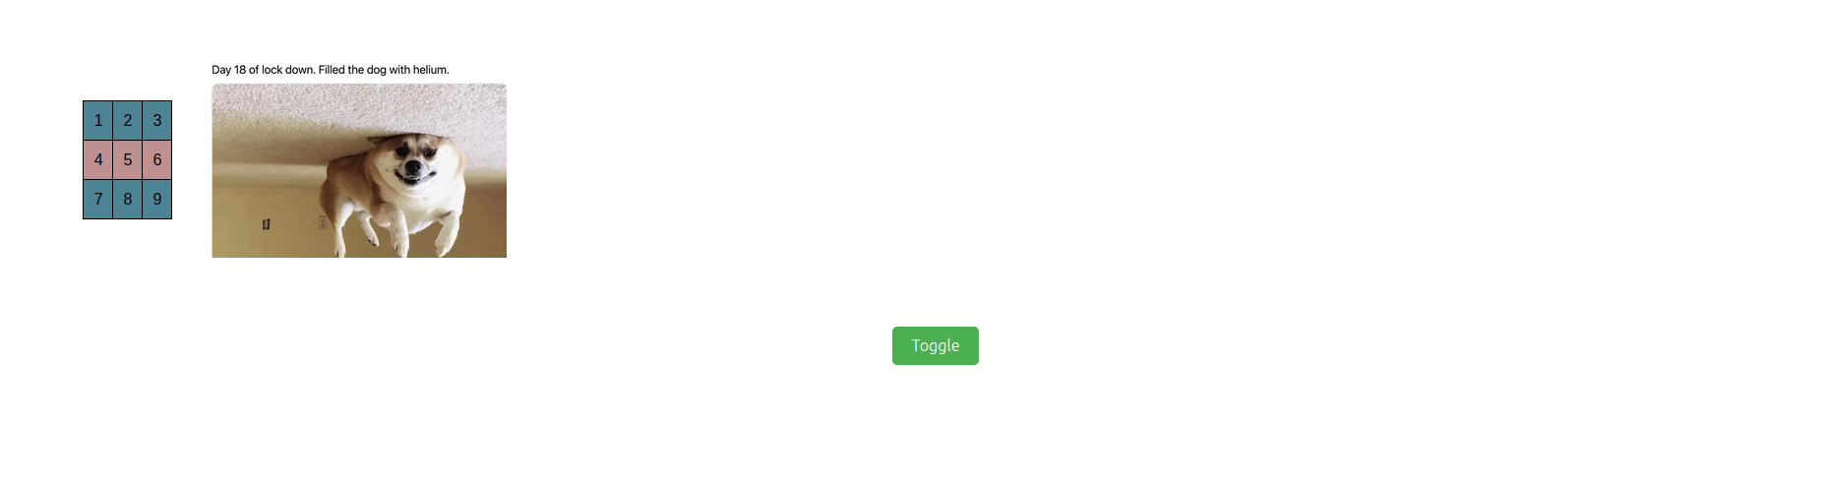

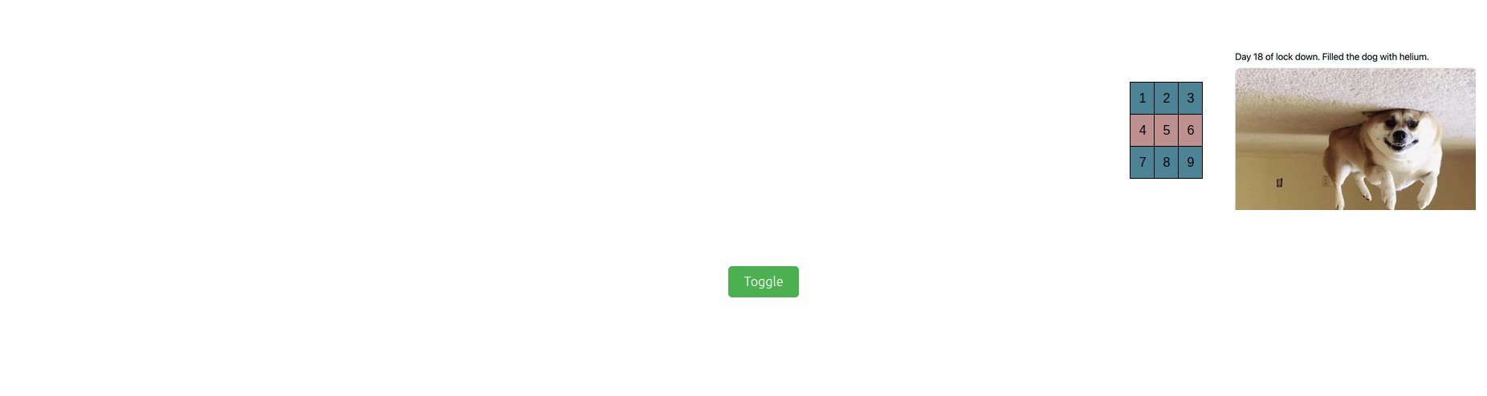

Question – 2

Code:

HTML

<!DOCTYPE html>
<html>
<head>
<meta charset="UTF-8">
<meta name="viewport" content="width=device-width, initial-scale=1.0">
<title>Calculator</title>
<link rel="stylesheet" href="q2.css">
</head>

<body>
<h3>
Simple Calculator
</h3>
<div id="calc_div">
<input id="disp" type="text">

<table>
<tr>
<td>
<button>1</button>
</td>
<td>
<button>2</button>
</td>
<td>
<button>3</button>
</td>
<td>
<button>+</button>
</td>
</tr>
<tr>
<td>
<button>4</button>
</td>
<td>
<button>5</button>
</td>
<td>
<button>6</button>
</td>
<td>
<button>-</button>
</td>
</tr>
<tr>
<td>
<button>7</button>
</td>
<td>
<button>8</button>
</td>
<td>
<button>9</button>
</td>
<td>
<button>x</button>
</td>
</tr>
<tr>
<td>
<button>0</button>
</td>
<td>
<button>CLR</button>
</td>
<td>
<button>=</button>
</td>
<td>
<button>/</button>
</td>
</tr>
</table>
</div>
</body>
<script src="https://code.jquery.com/jquery-3.6.3.min.js"></script>
<script src="q2.js"></script>
</html>

CSS

body {
display: flex;
flex-direction: column;
align-items: center;
text-align: center;
}

#calc_div {
margin-top: 10px;
background-color: aquamarine;
width: fit-content;
padding: 10px 10px;
border-radius: 3%;;
}

#disp {
border-radius: 3%;
background-color: white;
color: black;
}

button {
width: 40px;
font-family:'Courier New', Courier, monospace;
}

JS

const display_bar = $('#disp');

function calc(expression) {
try {
var result = eval(expression); // Calculate the result using eval
return result;
} catch (error) {
return "ERROR";
}
}

$(document).ready(function() {
// This will add an onclick function to all buttons on the page
$('button').click(function() {
var buttonText = $(this).text(); // Get the text of the clicked button
console.log(buttonText + " button clicked!");
if (buttonText === "CLR") {
display_bar.val("");
}
else if (buttonText === "=") {
let result = calc(display_bar.val());
display_bar.val(result);
}
else if (buttonText === "x") {
display_bar.val(display_bar.val() + "*");
}
else {
display_bar.val(display_bar.val() + buttonText);
}
display_bar.focus()
});
});

Output:

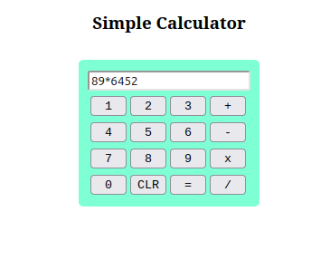

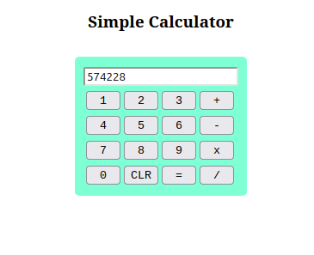

Question – 3

Code:

HTML

<!DOCTYPE html>
<html>
<head>
<meta charset="UTF-8">
<meta name="viewport" content="width=device-width, initial-scale=1.0">
<title>Card-Maker</title>
<link rel="stylesheet" href="q3.css">
</head>

<body>
<div class="maker">
<h3 style="font-family: 'Courier New', Courier, monospace;">
Card-Maker
</h3>
<div class="container" style="border: das;">
<label>Choose background color:</label>
<select class="color">
<option value="red">Red</option>
<option value="green">Green</option>
<option value="#3e9df0">Blue</option>
<option value="pink">Pink</option>
<option value="yellow">Yellow</option>
</select>
</div>

<div class="container">
<label>Choose text font:</label>
<select class="font">
<option value="Verdana">Verdana</option>
<option value="Arial Narrow">Arial Narrow</option>
<option value="Times New Roman">Times New Roman</option>
<option value="cursive">Cursive</option>
<option value="Brush Script">Brush Script</option>
<option value="Comic Sans MS">Comic Sans</option>
</select>
</div>

<div class="container">
<label>Choose font size:</label>
<input class="size" type="number" min="10" max="30" value="15">
</div>

<div class="container">
<label>Choose border style:</label>
<select class="border">
<option value="none">None</option>
<option value="solid">Solid</option>
<option value="double">Double</option>
<option value="dashed">Dashed</option>
<option value="dotted">Dotted</option>
</select>
</div>

<div class="container">
<label>Enter the text:</label>
<textarea class="text" rows="4" cols="50"></textarea>
</div>

<div class="container">
<label>Enter the image url:</label>
<input class="url" type="text"></textarea>
</div>

<button onclick="makeCard();">Make the card!</button>
</div>

<div class="card" id="card">
<h3 style="font-family: 'Courier New', Courier, monospace;">
Display
</h3>
<div class="text">
Text goes here...
</div>
<div class="image">
<img width="300" src="https://cdn.i-scmp.com/sites/default/files/styles/1020x680/public/d8/images/canvas/2021/10/30/85f2cb5f-44f8-4f2f-a813-63e657e11acc_5065cac7.jpg?itok=dugQzfiu&v=1635566576">
</div>
</div>
</body>
<script src="https://code.jquery.com/jquery-3.6.3.min.js"></script>
<script src="q3.js"></script>
</html>

CSS

body {
display: flex;
flex-direction: row;
justify-content: space-around;
align-items: center;
}

button {
width: 120px;
height: 40px;
background-color: beige;
}

div.maker {
display: flex;
flex-direction: column;
gap: 30px;
}

div.container {
display: flex;
flex-direction: row;
gap: 20px;
}

div.card {
display: flex;
flex-direction: column;
gap: 30px;
padding: 20px 20px;
}

JS

const card = $('#card');
const img = $('img');
const text = $('div.text');
const color_select = $('select.color');
const font_select = $('select.font');
const size_input = $('input.size');
const border_select = $('select.border');
const text_input = $('textarea');
const url_input = $('input.url');

function makeCard() {
console.log(text_input.val());
card.css({
'background-color': color_select.val(),
'border': border_select.val()
});
text.css({
'font-family': font_select.val(),
'font-size': size_input.val() + 'px'
});
text.text(text_input.val());
if (url_input.val().trim() === "") {
return;
}
else {
img.attr('src', url_input.val());
}
}

Output:

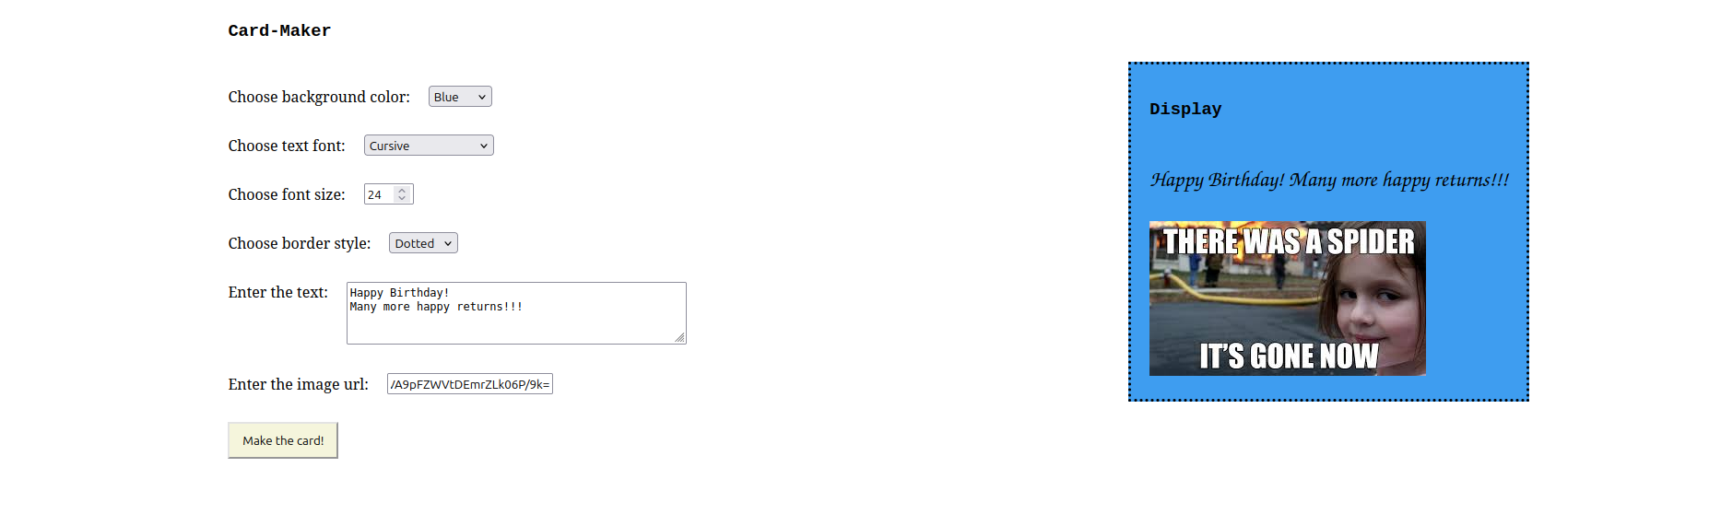

Question – 4

Code:

HTML

<!DOCTYPE html>
<html lang="en">
<head>
<meta charset="UTF-8">
<meta name="viewport" content="width=device-width, initial-scale=1.0">
<title>Produce Bill</title>
<link rel="stylesheet" href="q4.css">
</head>
<body>

<div class="container">
<h1>Product Billing</h1>

<div class="form-group">
<label for="brandDropdown">Select Brand:</label>
<select id="brandDropdown">
<option value="hp">HP</option>
<option value="nokia">Nokia</option>
<option value="samsung">Samsung</option>
<option value="motorola">Motorola</option>
<option value="apple">Apple</option>
</select>
</div>

<div class="form-group">
<label>Product Type:</label>
<input type="checkbox" id="mobile" value="mobile"> Mobile
<input type="checkbox" id="laptop" value="laptop"> Laptop
</div>

<div class="form-group">
<label for="quantity">Enter Quantity:</label>
<input type="number" id="quantity" min="1" value="1">
</div>

<button id="produceBillButton">Produce Bill</button>
</div>

<script src="https://code.jquery.com/jquery-3.6.0.min.js"></script>
<script src="q4.js"></script>
</body>
</html>

CSS

body {
font-family: Arial, sans-serif;
margin: 0;
padding: 0;
background-color: #f4f4f4;
}

.container {
width: 300px;
margin: 100px auto;
padding: 20px;
background-color: white;
box-shadow: 0px 0px 10px rgba(0, 0, 0, 0.1);
border-radius: 8px;
}

h1 {
text-align: center;
color: #333;
}

.form-group {
margin-bottom: 15px;
}

label {
font-size: 14px;
color: #555;
display: block;
margin-bottom: 5px;
}

select, input[type="number"], button {
width: 100%;
padding: 8px;
font-size: 14px;
border-radius: 4px;
border: 1px solid #ccc;
}

button {
background-color: #4CAF50;
color: white;
border: none;
cursor: pointer;
margin-top: 10px;
}

button:hover {
background-color: #45a049;
}

JS

$(document).ready(function() {
$('#produceBillButton').click(function() {
// Get selected brand
var selectedBrand = $('#brandDropdown').val();
// Get selected product type (mobile and/or laptop)
var mobileSelected = $('#mobile').prop('checked');
var laptopSelected = $('#laptop').prop('checked');

// Get quantity
var quantity = $('#quantity').val();
quantity = parseInt(quantity);

// Price list for each product
var prices = {
hp: { mobile: 500, laptop: 1000 },
nokia: { mobile: 400, laptop: 900 },
samsung: { mobile: 600, laptop: 1100 },
motorola: { mobile: 450, laptop: 950 },
apple: { mobile: 800, laptop: 1200 }
};

// Calculate total amount
var totalAmount = 0;

if (mobileSelected) {
totalAmount += prices[selectedBrand].mobile * quantity;
}
if (laptopSelected) {
totalAmount += prices[selectedBrand].laptop * quantity;
}

// Display the total amount in an alert
alert("Total Amount: $" + totalAmount);
});
});

Output:

